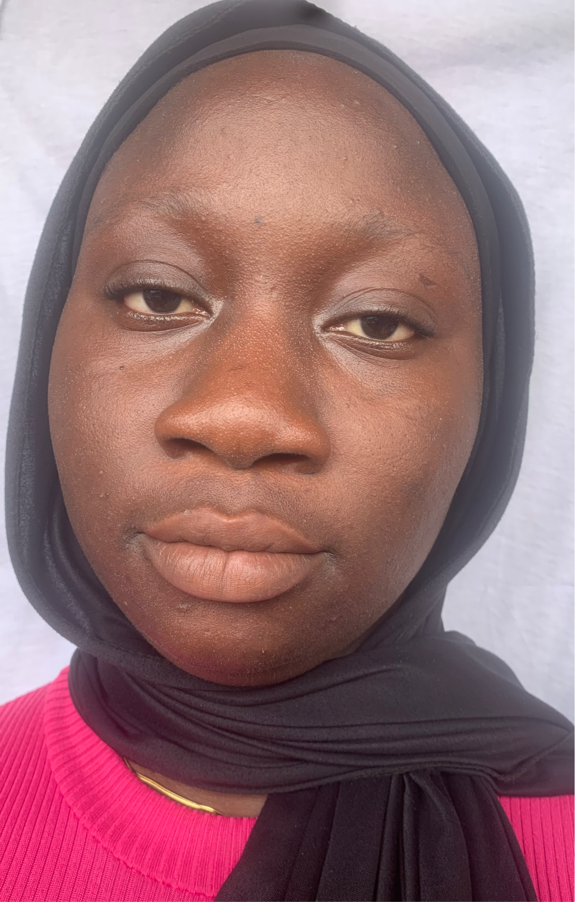

After a series of illnesses during my niece’s early childhood, I was introduced to the role of nurses. It was from here I became fascinated and realized this could be a satisfying future outlet for my empathetic self. I feel that nurses are truly dedicated professionals. They provide an inestimable service to society whilst working in a highly demanding and very challenging career, assisting individuals and their families through difficult times when they are at their most vulnerable. I am really ready to embark on this career and start to fulfill this ambition of mine to become a children’s nurse.

I believe nursing is a career in which I will excel because of my compassion for those who are at their most vulnerable state. My ability to empathize with individuals would provide a positive nurse and patient relationship, putting the child and family at ease, allowing the family to approach me for support and guidance and therefore meet specific needs of the child and their family. be highly important within a nursing career. I have the self-belief that I can learn and work under stressful conditions because I know nursing can be a stressful career where traumatic situations are common.

My work experience at The Greatest Primary School has given me the opportunity to work with children from various backgrounds . From this, I gained the skill of being responsible for young children and understanding their needs. Moreover, by working at the Primary School, I have learnt the importance of planning ahead as this helps in preparing for the challenges that I will be facing on a regular basis. It has also equipped me with the necessary skills needed in providing physical and emotional support to kids and their parents. I believe this is a skill that can be channeled into the role of nursing.

Beyond my academics, I like to read books in my free time as it allows me to improve my reading and writing skills. This will be beneficial within the Nursing environment when filling out patient profiles and keeping records of their medical needs. Moreover, I like to walk on a regular basis, which allows me to think and relieve stress on a challenging day.
As an individual, I am very hard working and organized, thus I will be able to plan and prepare for the work I will be carrying out throughout the nursing profession. In addition, I am a dedicated individual and capable of being industrious in a work environment. I hope to be an asset on the Nursing course in your esteemed institution.

