1、create table student(sno varchar(20),name varchar(10),age integer,college varchar(30));


Create table course(courseid varchar(15),coursename varchar(30),coursebeforeid varchar(15));


Create table choose(sno varchar(30),courseid varchar(30),score decimal(5,2));


2、
insert into student values ('s00001','张三',20,'计算机学院');
insert into student values ('s00002','李四',19,'通信学院');
insert into student values ('s00003','王五',21,'计算机学院');


insert into course (courseid,coursename) values ('c1','计算机引论');
insert into course (courseid,coursename,coursebeforeid) values ('c2','c语言','c1');
insert into course (courseid,coursename,coursebeforeid) values ('c3','数据结构','c2');


insert into choose values ('s00001','c1','95');
insert into choose values ('s00001','c2','80');
insert into choose values ('s00001','c3','84');
insert into choose values ('s00002','c1','80');
insert into choose values ('s00002','c2','85');
insert into choose values ('s00003','c1','78');
insert into choose values ('s00003','c3','70');
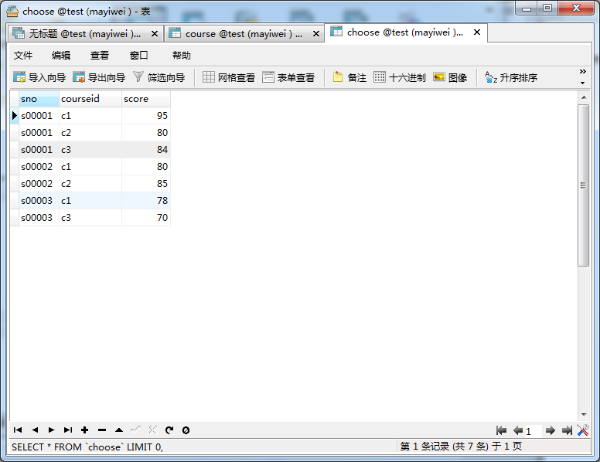

3、
select course.* from choose,student,course where student.sno = choose.sno and choose.courseid = course.courseid and student.name = '王五';
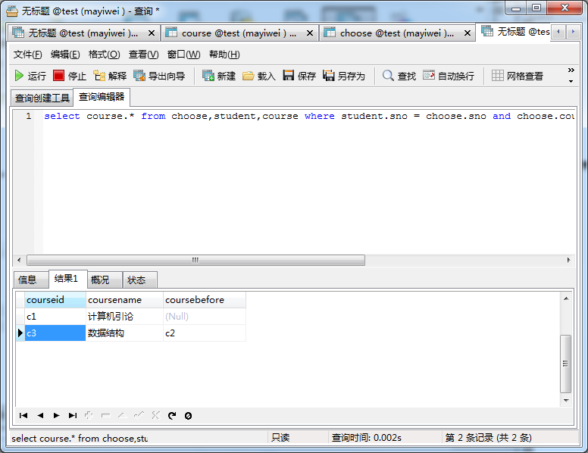

4、
update student set age = age+2 where college = '计算机学院';


5、
delete from student where name = '李四';


