CODEALPHA DATA ANALYTICS INTERNSHIP

TASK 1: WEB SCRAPING

Project Title:
E-Commerce Book Market Analysis Using Web Scraping
Prepared By:
Hiren Kachiya
Internship Domain:
Data Analytics
Organization:
CodeAlpha

E-Commerce Book Market Analysis Using Web Scraping

- Introduction
Web scraping is the process of automatically extracting data from websites.
In this project, book information was collected from the BooksToScrape website using Python and BeautifulSoup.
The collected data was analyzed to identify pricing patterns and rating distributions

- Objective
• Collect book information from multiple webpages.
• Build a custom dataset.
• Perform data cleaning and analysis.
• Visualize important insights using charts.

- Project Workflow

BooksToScrape Website
↓
Web Scraping
↓
Dataset Creation
↓
Data Cleaning
↓
Statistical Analysis
↓
Data Visualization
↓
Insights & Conclusion

- Tools Used
• Python
• Requests
• BeautifulSoup
• Pandas
• Matplotlib
• VS Code

- Dataset Information
Total Records: 1000

Columns:
• Title
• Price
• Rating

- Data Cleaning
• Removed currency symbols.
• Converted Price column into numeric format.
• Checked dataset structure.
• Validated data types.

- Key Findings
• Total Books Analyzed: 1000
• Average Price: 35.07
• Maximum Price: 59.99
• Minimum Price: 10.00
• Most Common Rating: One Star

- Most Expensive Book
Title:
The Perfect Play (Play by Play #1)

Price:
59.99

Rating:
Three

- Visualizations
- Rating_Distribution.png
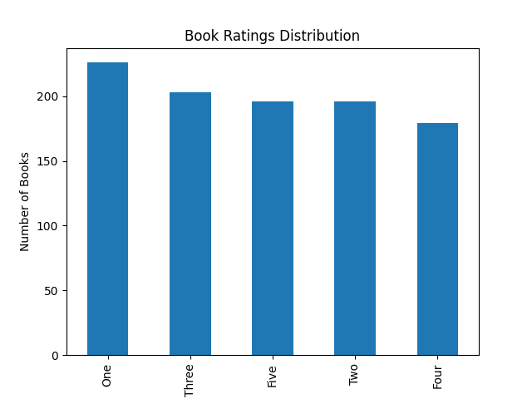

- Price_Distribution.png
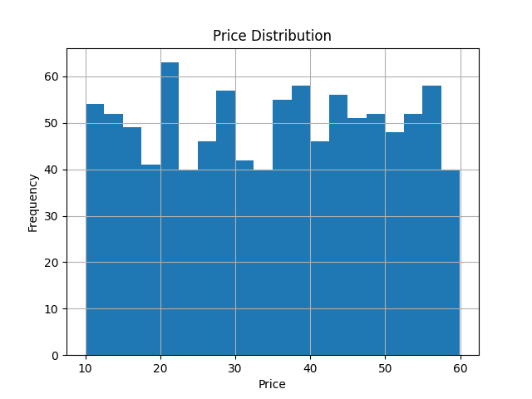

- Conclusion
The project demonstrates how web scraping can automate data collection and support data-driven analysis.
Using Python, a dataset of 1000 books was created and analyzed to identify pricing trends and rating distributions.

