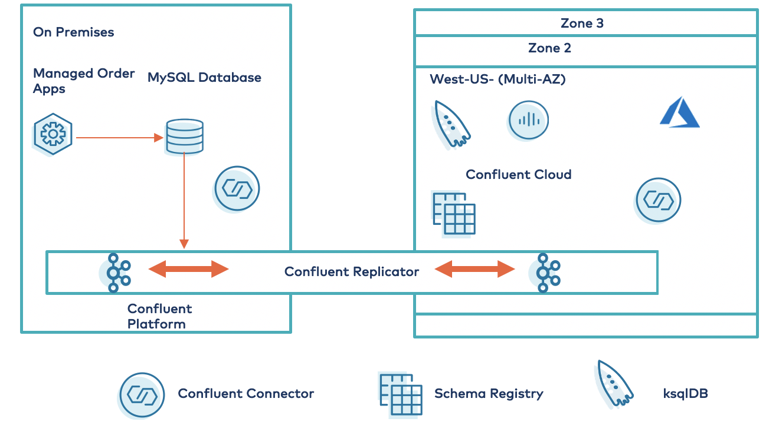

MIMIX Share is a model based data sharing solution that captures data changes in real time and replicates them between databases. ... MIMIX Share's robust replication capabilities automatically monitor for collisions, resolve conflicts to ensure data integrity, and maintain an audit trail.