INTRODUCTION
Introduction
Agility
The working environment of knowledge companies is very different to the one that gave rise to predictive project management disciplines. Nowadays corporative strategies are needed for products launching aimed at early delivery of tangible results, and the agile and flexible response needed to work in rapidly evolving markets.
Now the product is being built while it is simultaneously being modified and introducing new requirements. The client starts from a fairly clear vision, but the level of innovation required, and the speed at which the business environment moves, do not allow him to predict in detail how the final result will be.
Perhaps there are no "final products", but products in continuous evolution and improvement to maximize the client’s satisfaction
Agile project management is not formulated on the need for anticipation, but on the need for continuous adaptation
Is predictive project management, also known as waterfall, the only one possible? Do the criteria for meeting deadlines and costs always determine success? Can there be projects whose management does not seek to carry out a previously planned work, with a budget and in a previously calculated time?
Today there are product managers who do not need to know what the 200 functionalities that the final product will be, nor whether it will be finished in 12 or 16 months.
There are customers who prefer a first version with minimal functionality in a matter of weeks, instead of a complete product in one or two years. Customers whose interest is to quickly market a new concept, and to continuously develop its value.
There are projects that do not need to manage the follow-up of a plan, and whose failure may be the consequence of an inappropriate management model.
Most of the fiascos in project management are produced by applying sequential engineering and predictive management in both the acquisition process (requirements, contracting, monitoring and delivery) and the project management, to develop products that do not need predictability guarantees in execution, as much as rapid response and flexibility to operate in rapidly changing and evolving business environments.
The Agile Manifesto
In March 2001, 17 software professionals, critics of process-based production models, were summoned by Kent Beck, who had published a couple of years earlier the book explaining the new Extreme Programming (Beck, 2000) methodology.
They met in Salt Lake City to discuss the processes used by programming teams.
At the meeting, the term "Agile Methods" was coined to define those emerging as an alternative to formal methodologies: CMM-SW, (precursor to CMMI), PMBOK, SPICE (initial project of ISO 15504), which they considered excessively "Heavy" and rigid because of their normative nature and heavy reliance on detailed, pre-development planning.
The members of the meeting summarized in four postulates what has been called the "Agile Manifesto", which are the values on which these methods are based.
Up to 2005, among proponents of process models and agile models, radical stances were more prevalent, more preoccupied with disqualifying the other than knowing their respective methods.
Agile Manifesto
We are uncovering better ways of developing software, by doing it and helping others to do it. Though this work we have come to value:
■ Individuals and their interaction, above processes and tools.
■ Software that works, over and above exhaustive documentation.
■ Collaboration with the client, above contractual negotiation.
■ The response to change, beyond tracking a plan.
That is, while there is value in the items on the right, we value the items on the left more.
We value individuals and their interaction over processes and tools.
This is the most important postulate of the manifesto.
Of course, the processes help to do the job. They are an operating guide. Tools improve efficiency, but there are always tasks that require talent and need people to contribute and work with an appropriate attitude.
The process-based production aims to ensure that the quality of the result is a consequence of the "explicit" know-how deployed in the processes, rather than the knowledge provided by the people who execute them. However, in agile development processes the processes are only an aid. A support to guide the work. The extreme defence of the processes leads to the assertion that they can achieve extraordinary results with mediocre people, and the truth is that this principle is not true when creativity and innovation are needed.
We value software that works over comprehensive documentation.
Being able to anticipate how the final product will work, observing previous prototypes, or already elaborated parts, offers stimulating and enriching feedback, generating ideas that could not be conceived at first, and which could hardly be included in the drafting of a requirements document detailed at the beginning of the project.
The agile manifesto does not consider the documentation useless, only the unnecessary one. The documents support facts, they allow the transfer of knowledge, record historical information, and for many legal or regulatory issues are mandatory, but their relevance should be much less than the final product.
Communication through documents lacks the wealth and production of value that is achieved through direct communication between people and through interaction with prototypes of the product.
That is why, whenever possible, the use of documentation that consumes work effort without giving a direct value to the product should be minimized
If the organization and the teams communicate through documents, in addition to hiding the richness of the interaction with the product, they form bureaucratic barriers between departments or between people.
We value customer collaboration over contractual negotiation.
Agile practices are indicated for products that are in continuous evolution. In this kind of products, it is not possible to define in a closed requirements document how the final product should be, and it is more appropriate to take feedback continuously, and in parallel to product development, to redefine and improve the requirements of parts not yet developed according to the lessons learned with previous versions delivered to the stakeholders.
The goal of an agile project is not to control the execution to guarantee the fulfilment of the planning, but to continuously provide the highest possible value to the product.
It is therefore more appropriate a relationship of involvement and continuous collaboration with the client, than a contractual delimitation of responsibilities.
We value the response to change over following a plan
To develop products according to unstable requirements, where change and rapid and continuous evolution is inherent, responsiveness is much more valuable than tracking and assuring plans.
The main values of agile management are anticipation and adaptation, different from those of ortho
The 12 Principles of the Agile Manifesto
The agile manifesto, after the postulates of these four values on which it is based, establishes these principles:
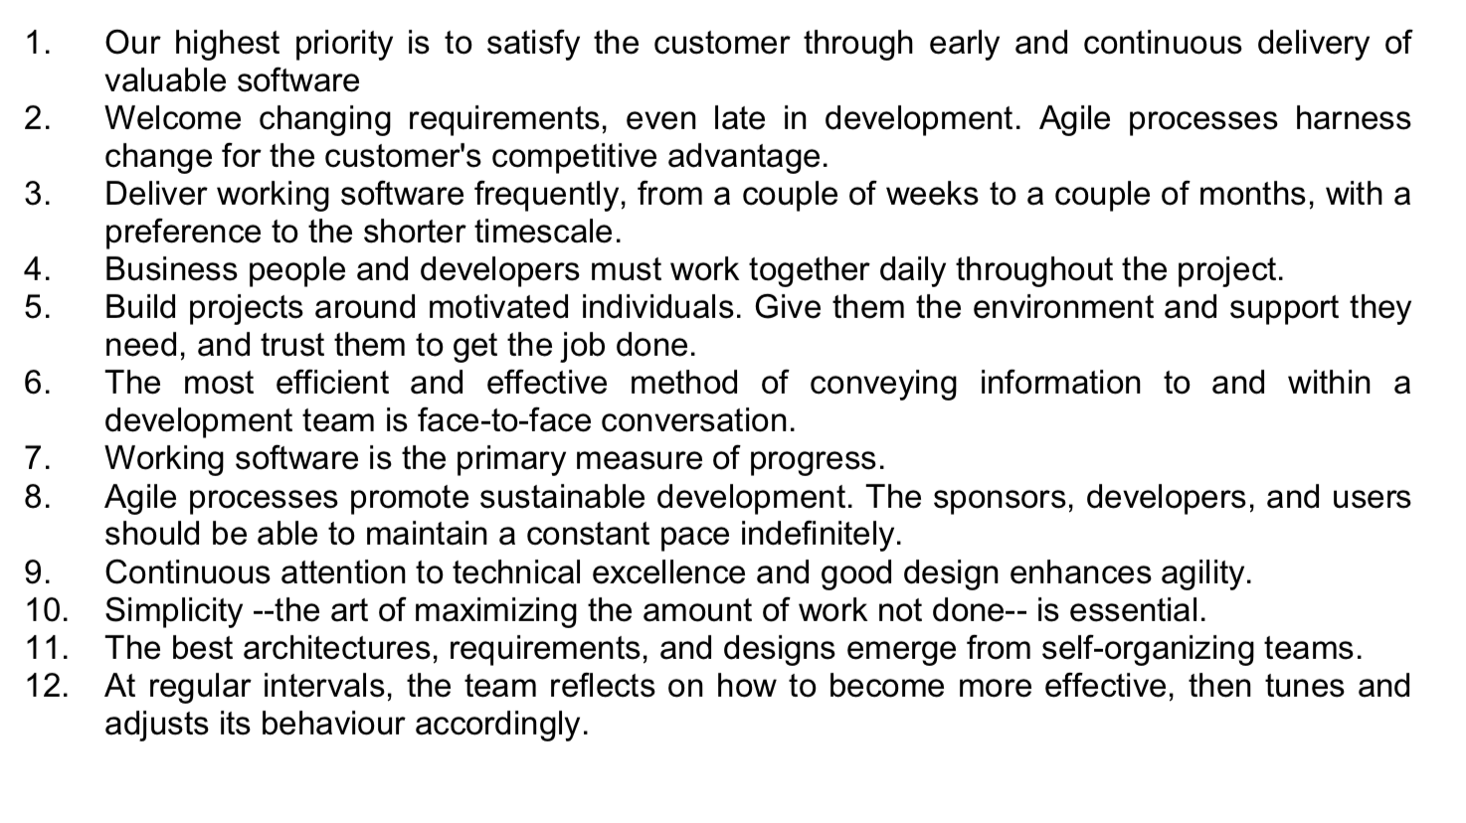

What we mean now as "scrum"
Agile self-organizing work environment
In 1986 the researchers Nonaka and Takeuchi give a polysemic dimension to the term scrum originally used in sports as rugby, when used it to baptize the principles of development that they discovered in the most innovative technological companies (Takeuchi & Nonaka, 1986).
Scrum, in the original conception of Nonaka and
Takeuchi, is characterized by the role of brilliant, self-organized and motivated teams, which approach the development of complex systems starting from a general vision and overlapping development phases.

Scrum: technical and advanced scrum
To start with scrum, it is advisable to adopt the standard framework: as it is explained in this first part, where you can find the roles, artefacts and events that configure its lifecycle model (see diagram page 20).
Once a continuous and iterative advance flow is achieved, you must consider if the goal is to go beyond what is a concurrent engineering model or to adopt scrum practices, or others that may be more appropriate to the characteristics of the project or team. It is time to unlearn standard practices, and rely on scrum values, rather than only in their technique.
This part of the book shows the basic scrum techniques: the application of rules and roles, and the events and artefacts that are used.
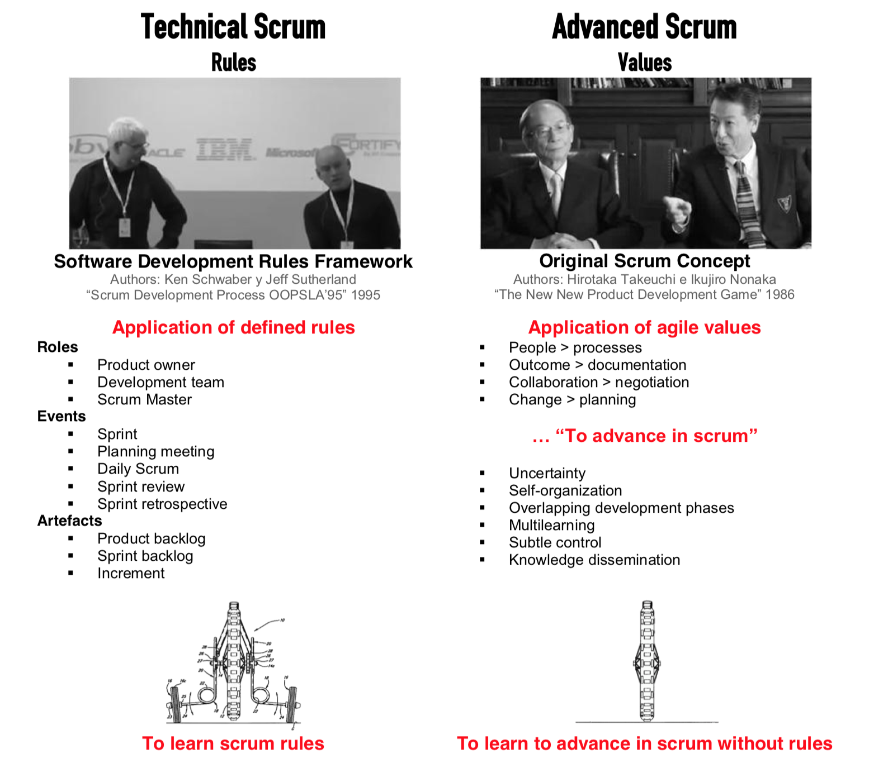

Introduction to the technical framework
The technical framework of scrum is formed by a set of practices and rules that respond to the following principles of agile development:
■ Evolutionary management of the product, instead of the traditional or predictive ones.
■ Quality of the result based on the people’s tacit knowledge, rather than on the explicit
knowledge represented by the processes and the technology used.
■ Incremental development strategy through iterations (sprints) .
It begins with the general vision of the desired result, and thereupon the functionalities that are desired to obtain in the first place are specified and details are given to build them.
Each cycle of development or iteration (sprint) ends with the delivery of an operative part of the product (increment). The duration of each sprint can be from one, up to six weeks, although it is recommended not to exceed one month.
In scrum, the team monitors the evolution of each sprint in brief daily meetings where the work done by each member on the previous day and the one planned for the current day are reviewed together. These daily meetings are closed for a maximum of 5-15 minutes, and are held standing next to a board or blackboard with the information of the tasks included in the sprint and the work pending on each of them by every team member. This meeting is called "standing meeting", "daily scrum", “stand-up meeting”, and: "daily scrum" or "morning rollcall".
Management of the evolution of the project
Scrum empirically manages the evolution of the project with the following tactics:
Review of Iterations
At the end of each sprint, the result is functionally reviewed, by all those involved in the project. It is therefore the duration of the sprint, the maximum period to discover errors, unverifiable, or misinterpretations in the functionalities of the product.
Incremental development
You do not work with designs or abstractions. Incremental development provides at the end of each iteration a piece of operational product that can be used, inspected and evaluated.
Scrum is suitable for projects with uncertain and / or unstable requirements.
Why predict the definitive version of something that is going to be evolving continuously? Scrum considers instability as a premise and adopts working techniques not only to facilitate the evolution without degrading the quality of the architecture, but also allowing it to evolve during development. During construction, the design and the architecture are debugged, not being closed in the first phase of the project. The different phases that cascade development performs sequentially, in scrum will be overlapped and performed continuously and simultaneously.
Self-organization
There are many factors in a project that could be unpredictable. Predictive management assigns to the role of project manager the global responsibility for its management and resolution.
In scrum, the teams are self-organized, with a sufficient scope of decision to adopt resolutions they deem appropriate.
Collaboration
It is an important and necessary component so that the work can be reliably managed through the self-organization without the intervention of the project manager.
All members of the team collaborate openly with each other, in accordance to their abilities and not depending of their role or position.

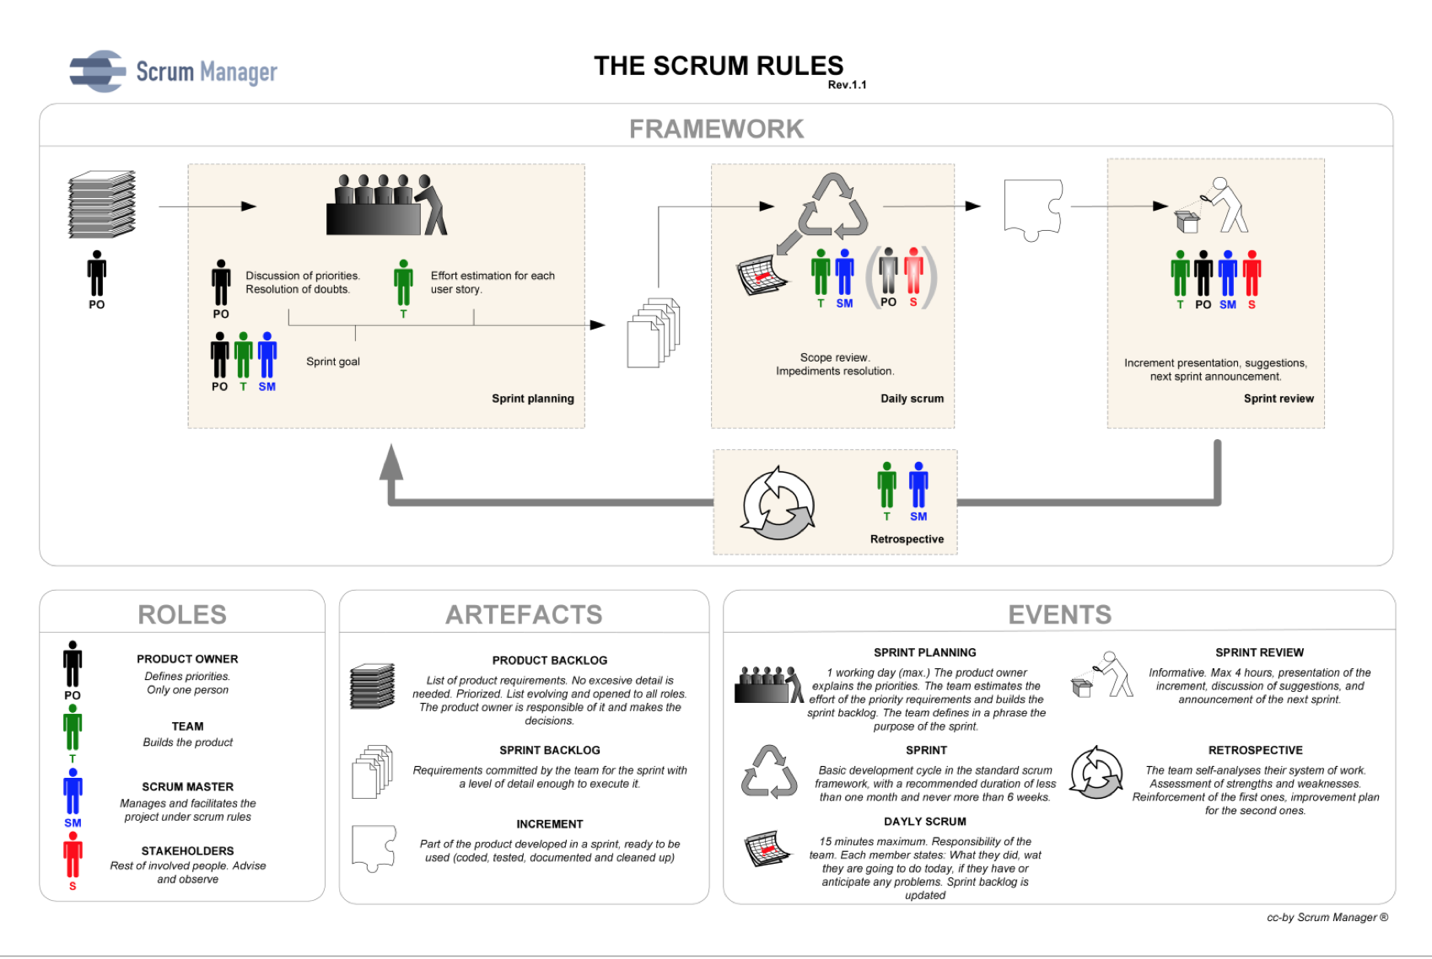

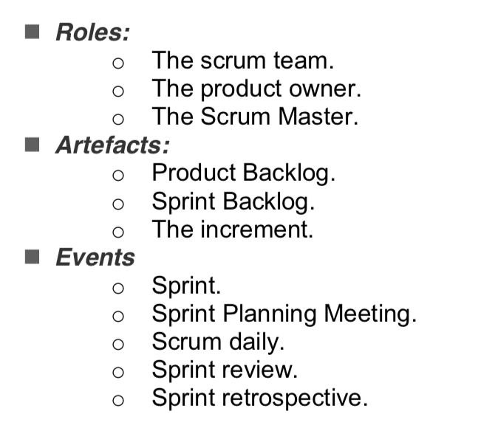

Technical scrum
The technical framework of scrum is formed by:

As will be seen later, when dealing with advanced scrum, more flexible scrum implementations may adopt two different tactics to maintain a continuous advance in the project:
- Iterative increment: based on time-based pulses (timeboxing)
- Continuous increment: based on the maintenance of a continuous flow, not marked by
pulses or sprints.
Artefacts
- Product backlog: list of user requirements, which from the initial vision of the product grows and evolves during development.
- Sprint backlog: list of tasks that the team must perform during the present sprint to generate the expected increase.
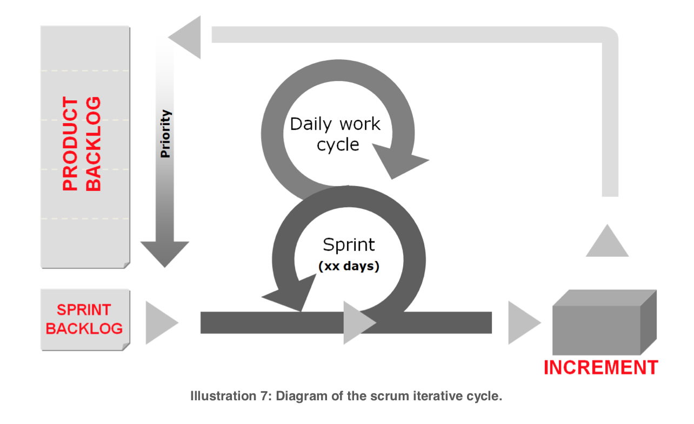
- Increment: result of each sprint.
Product backlog and sprint backlog: the requirements management in agile development.
In traditional software engineering, the system requirements are part of the acquisition process, and it is therefore the responsibility of the customer to define the problem and the functionalities that the solution must provide.
It does not matter if it is traditional or agile management. The product backlog is the responsibility of the customer, although it is dealt with a different approach in each case.

- In predictive projects, system requirements are usually specified in formal documents; While in agile projects they take the form of a product backlog or list of user stories.
- Formal system requirements are specified completely and closed at the beginning of the project; However a product backlog is a living document, which evolves during development.
The requirements of the system are developed by a person or team specialized in requirements engineering through the process of obtaining (elicitation) with the customer. In scrum the customer (product owner) shares his vision with the whole team, and the product backlog is built and evolves continuously with the contributions of all the project members .

The sprint backlog
- The user stories, which include a defined and well-known view of the product by the whole team expressed from a subjective point of view, related with one of the groups of users identified
- User stories are individually defined, prioritized, and pre-estimated.
- The product backlog is carried out and managed by the customer (product owner).
Product Backlog: Customer Requirements
The product backlog is the ordered list of everything that the product owner believes the product needs. It is the inventory of functionalities, improvements, technology and correction of errors that must be incorporated to the product through the successive sprints.
It represents everything that the customer, the users, and in general the interested parties expect. Everything that involves a task that must be done by the team must be reflected in this backlog. Possible inputs to a product backlog
-Offer to the users the consultation of the works published by a certain author.
-Reduce the time of installation of the program.
-Provide the query of a work through a web API.
The product backlog is never completed.
Before starting to iterate the product it is necessary to:
- Let the product owner have the vision of the business objective he wants to achieve, and he must share it with the team.
- Have enough user stories within the product backlog to perform the first sprint.
Usually the product backlog is created as the result of a brainstorming session, or "cross- fertilization", or an "eXtreme Programming" exploration process where the whole team collaborates, understanding and sharing the Vision of the product owner.
The product owner maintains the product backlog ordered by the priority of the elements, being the highest priority those that give more value to the product, or for some reason are more necessary, and determine the immediate development activities.
The degree of concretion of the user stories in the product backlog should be proportional to the priority. The highest priority should have sufficient detail to be able to decompose into tasks and move on to the next sprint.
Format of the product backlog
Scrum prefers verbal or direct way to writing communication. The product backlog is not a requirements document, but an information tool for the team.

The minimum information that is usually included for each user story is:
■ Description of the functionality / requirement, called "user story".
■ Priority assigned.
■ Prediction of the effort required.
Additional
■ Observations, comments and remarks
■ Validation criteria.
■ Person assigned.
■ Sprint Number in which it is planned to be performed.
■ System module or area to which it belongs ...
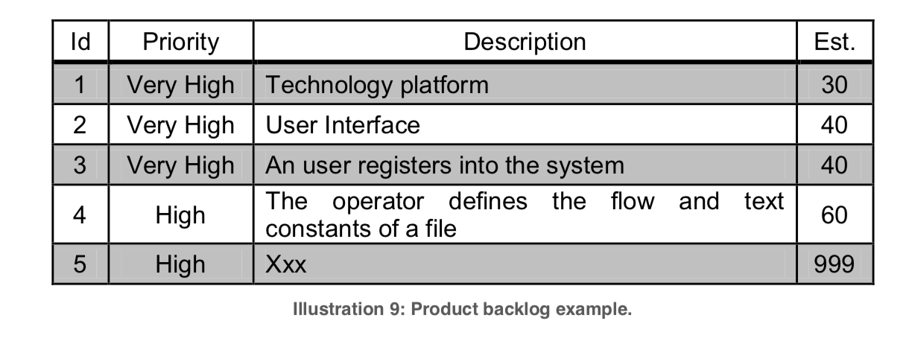
Sprint Backlog
The sprint backlog is the list of tasks needed to build the user stories to be performed in a sprint.
It is made by the team at the sprint planning meeting, indicating for each task the planned effort to do it. The sprint backlog breaks down user stories into units of adequate size to monitor progress on a daily basis, and identify risks and problems without complex management processes.
It is also a tool for direct visual communication of the team.
Conditions
- Performed jointly by all team members.
- Covers all tasks identified by the team to achieve the sprint goal.
- Only the team can modify it during the sprint.
- Too large tasks should be broken down into other tasks. In no case can a task be of such a size that it needs more than a day's work.
- It is visible to the whole team. Ideally on a board or wall in the same physical space where the team works.
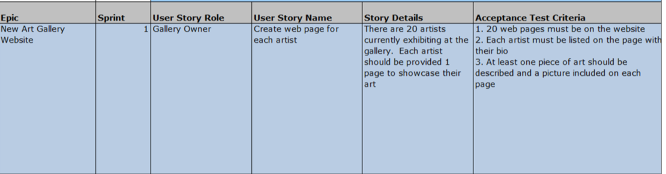
Example
During the sprint, the team daily updates the pending effort for each task.
Events
Sprint: name that receives each development iteration. It is the central nucleus that generates the pulse of advance to the rhythm of "predetermined times" (time boxing).
- Sprint Planning Meeting: A working meeting that marks the beginning of each sprint, determining the purpose of the sprint and the tasks necessary to achieve it.
- Daily Scrum: brief daily team meeting, in which each member answers three questions:
1.- The work done the day before.
2.- The work planned to perform.
3.- Things he may need, or impediments that must be eliminated to get the job done.
Each person updates in the sprint backlog the time or effort pending of their tasks, and with this information, the graph with which the team monitors sprint progress (
- Sprint review: analysis and inspection of the increase generated, and adaptation of the product backlog if necessary.
- Sprint Retrospective: review of what happened during Sprint. Meeting in which the team analyses operational aspects of the way of work and creates a plan of improvements to apply in the next sprint.
Sprint
The key scrum event to maintain a continuous pace of advancement is the sprint: the time-box period with a maximum duration of 4 weeks, during which an increment of the product is built.
The increment made during the sprint must be finished, that is being completely operational and useful for the client, in conditions to be deployed or distributed.
Scope of the sprint
When starting to work with scrum it is advisable to consider the sprint as the event container for all events: the sprint planning meeting, the daily scrum, the sprint review and the retrospective.
In this way, in addition to setting a daily rhythm of progress and visibility of the tasks (daily scrum), it also marks a fixed rhythm to check the progress and visibility of the product (planning and revision of the sprint), which is also the same to give visibility and a point of reflection and improvement to the mode of work (retrospective).
The implications of narrowing the scope, and for which the team may be interested, are:
  - To calculate the speed of the sprint considering only the working time, not including the meetings of beginning, closing and retrospective
  - To have more flexibility to perform sprints of different durations, and
  - To separate the frequency of retrospectives from that of sprints.
Sprint planning Description
This meeting is based on the client's business priorities and needs, and determines what and how the features will be incorporated into the product in the next sprint.
This meeting should address two issues:
-What will be given at the end of the sprint.
-Which is the work required to carry out the planned increment, and how the team will be carried out.
The meeting is organized in two parts of similar duration, whose aim is to answer one of these questions in each one.
First part: What will be given at the end of the sprint.
The product owner introduces the product backlog, exposing the highest priority user stories he needs and expects to be developed in the next sprint. If the product backlog has had significant changes since the previous meeting, it explains the causes that have caused them.
The goal is that the whole team knows the right level of detail and would be able to understand the work of the sprint.
Product Owner:
■ Presents the user stories of the product backlog that have the highest priority and that can be done in the sprint.
■ The presentation is made with a level of detail sufficient to transmit to the team all the information necessary to build the increment.
The team
■ Ask the questions and ask for the necessary clarifications.
■ Proposes suggestions, modifications and alternative solutions.
Part Two: How you will get done the job.
The team breaks down each functionality into tasks, and estimates the effort for each of them, thus composing the tasks that make up the sprint backlog. In this breakdown, the team takes into account the elements of design and architecture that the system must incorporate.
Team members establish what the tasks will be for the first few days of the sprint, and self-assign them based on their knowledge, interests and a homogenous distribution of work.
This second part should be considered as a "team meeting", in which all its members must be present, and they are the ones who decompose the estimation and assign the work.
Functions of the Scrum Master
The Scrum Master, or the moderator of the meeting, is responsible and guarantor for:
- Holding this meeting before each sprint.
- Ensuring that there is a product backlog prepared by the product owner.
- Helping to maintain the dialogue between the product owner and the team.
- Ensuring that an agreement is reached between the product owner and the team regarding what will include the increment.
- Helping the team to understand the vision and the business needs of the client.
- Ensuring that the team has performed a realistic decomposition and estimation of the work, and has considered the possible tasks of analysis, research or support.
- Ensuring that at the end of the meeting are objectively determined:
■ The elements of the product backlog to be executed.
■ The purpose of the sprint.
■ The sprint backlog with all estimated tasks.
■ The duration of the sprint and the date of the review meeting.
Daily Scrum
Short daily meeting, no more than 15 minutes standing, in which the team synchronizes the work and establishes the plan for the next 24 hours.
Inputs
■ Up-to-date sprint backlog and burn-down graph with information from previous meeting.
■ Information of the progress of each team member.
Results
■ Updated sprint backlog and burn-down graph.
■ Identification of possible needs and impediments.
Meeting
At this meeting each member of the development team explains:
■ What he has achieved since the previous daily scrum.
■ What he's going to do until the next day's daily scrum.
■ If he is having any problems, or if he foresee that he may encounter some impediment.
And it updates on the sprint backlog the stiffness that it estimates pending in the tasks assigned to him, or he marks as finalized those already completed.
At the end of the meeting:
■ The team refreshes the sprint's advance chart, with updated estimations of pending work,
■ The Scrum Master takes the appropriate steps to solve identified needs or impediments.

Sprint review
Meeting held at the end of the sprint to check the increment.
Goals:
- The product owner checks the progress of the system. This meeting marks, at regular intervals, the rhythm of construction, and the path that is taking the vision of the product.
- The product owner identifies user stories that can be considered "made" and those that cannot.
- When reviewing and testing the increment, the product owner, and the whole team obtain relevant feedback to check the product backlog.
- Other engineers and programmers of the company can also attend to know how the technology used works.
Preconditions
■ The sprint is concluded as planned.
■ The entire development team, the product owner, the Scrum Master and all the people involved in the project who wish to do so are present.

Results
- Feedback for the product owner: milestone tracking system construction, and information to improve the value of the product vision.
- Call for the next sprint meeting.
those that have been developed.
Retrospective
Meeting that takes place after the review meeting of each sprint, and before the planning meeting of the next, with a recommended duration of one to three hours, depending on the duration of the sprint.
Within it the team performs his own self-analysis about its way of working, and identifies strengths and weaknesses. The objective is to consolidate the positive factors, and plan improvement actions on the negative.
The fact that it was performed normally at the end of each sprint sometimes leads to mistakenly being considered as "sprint review" meetings, when it is advisable to treat them separately, because their goals are different.
The purpose of sprint review is to analyse "WHAT" is being built, while a retrospective meeting focuses on "HOW" we are constructing: "HOW" we are working, with the aim of analysing problems and improving aspects.

Roles
All people involved, with a direct or indirect relationship with the project, are classified into two groups: committed and involved. In scrum circles it is often called the first (without any pejorative connotation) "pigs" and the second "hens".
The origin of these names is in the following metaphor that graphically illustrates the difference between "commitment" and "involvement" in the project.
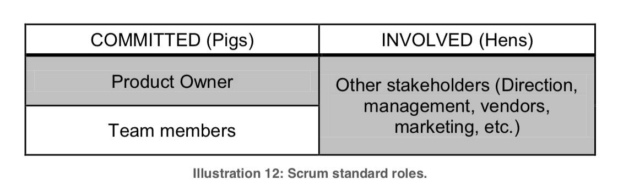
Product owner: is the person responsible for achieving the highest product value for customers, users and other people involved.
Development team: group or working groups that develop the product.
An observation on this point, on the role of Scrum Master, for being often frequent the doubt to consider if it is a "committed" or "involved" role.
Product Owner
The product owner is the decision maker of the customer. His responsibility is to maximize the value given to the product.
In order to simplify communication and decision making, this role must fall on a single person.
In summary, the product owner is who:
- Decides ultimately how the final result will be, and the order in which successive increments are constructed: what is put in and what is removed from the product backlog, and which is the priority of user stories.
- Knows the plan of the product, its possibilities and investment plan, as well as the expected return on the investment made, and is responsible for dates and functionalities of the different versions of the same.
To exercise this role it is necessary to:
- Know perfectly the business environment of the client, the needs and the objective that is pursued with the system that is being built.
- Have the vision of the product, as well as the concrete needs of the project, in order to efficiently prioritize the work.
- Have sufficient authority and knowledge over the product plan to make the necessary
decisions during the project, including to cover expected project return.
- Receive and analyse continuously feedback of the business environment (market evolution, competition, alternatives) and of the project (team suggestions, technical alternatives, tests and evaluation of each increment).
Development team
It is formed by the group of professionals who perform the increment of each sprint.
It is recommended that a scrum team has no less than 3 or more than 9 people. Beyond 9 it is difficult to maintain direct communication, and the habitual frictions of group dynamics (which begin to appear from 6 people) are more strongly manifested. In the count of the number of members of the development team neither the Scrum Master nor the product owner are considered.
A team has a spirit of collaboration and a common purpose: achieving the highest possible value for the client's vision.
A scrum team responds as a whole. It works in a cohesive and self-organized way. There is no manager to delimit, assign and coordinate tasks. The members themselves perform that.
In the team:
■ Everyone knows and understands the vision of the product owner.
■ Contribute and collaborate with the product owner in the development of the product backlog.
■ Share together the purpose of each sprint and the responsibility for achievement.
■ All members participate in decision-making.
■ The opinions and contributions of all are respected.
■ Everyone knows scrum.
Scrum Master
He is responsible for compliance with the rules of a technical scrum framework, ensuring that they are understood in the organization, and work according to them.
He provides the necessary advice and training to the product owner and the team.
He performs his work with a servile leadership model: to the service and to the help of the team and the owner of the product.
He provides:
- Counselling and training to the team, in order to work self-organized and with team responsibility.
- Review and validation of the product backlog.
- Moderation of meetings.
- Resolution of the impediments that in the sprint can hinder the execution of the tasks.
- Management of group dynamics difficulties that can be general in the team.
- Configuration, design and continuous improvement of the scrum practices in the organization.

- Respect for the organization and those involved, for the patterns of times and forms of scrum.
Scrum Values and Principles
Technical Scrum defines a framework that helps to organize people and workflow. It is the "body" or the visible interface, but the agile values are the authentic agility engine the principles that govern their way of working.
The rules of a scrum team may be those of this technical framework or others. Agility is not provided by the fulfilment of practices, but by values.
- Respect between people. Team members must trust each other and respect their knowledge and skills.
- Responsibility and self-discipline (no discipline imposed).
- Focused and value-oriented work for the client.
- Commitment.
Agile measurement and estimation
Why measure?
Information is the raw material for decision-making, and the one that can be quantified, provides objective management and monitoring criteria.
From the specific level of programming, to the most general of the overall organizational management, there are three scales or zoom levels with which the work can be measured:
■ Development and management of the technical solution.
■ Project management.
■ Management of the organization.
In the first one, it is possible to measure, for example, the proportion of polymorphism in the code of a program, in the second, the percentage of the project plan carried out, and in the third, the level of job satisfaction.
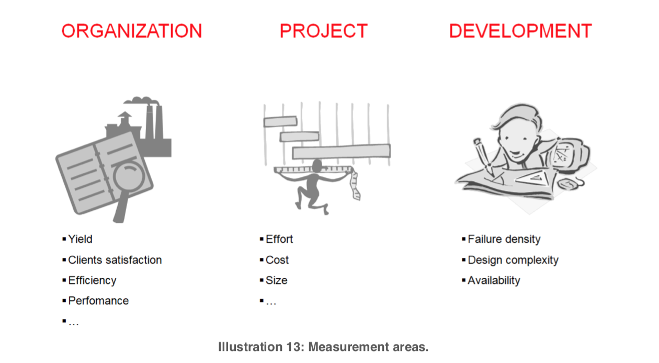

Criteria for the design and application of metrics
The fewer the better.
■ Measuring is expensive.
■ Measuring adds bureaucracy.
■ The goal of a scrum team is to offer the best value / cost ratio.
Consideration before measurement:
■ Why?
■ What is the value of this measurement?
■ How much value is lost if omitted?
Is the indicator appropriate for the purpose to be achieved?
Measuring is not, or should not be, an end itself.
What is the end?
Meeting agendas, improving team efficiency, forecasts...?
Be critical. If, after analysing it, you are not convinced, if you prefer not to incorporate an indicator, or change it: you are the manager, you decide it.
To determine what to measure is the hardest part. In the best-case scenario, erroneous decisions will only lead to avoidable management costs; but they can also worsen what is intended to be improved.
Speed, work and time
Speed, work and time are the three variables that make up the formula of speed in agile project management, defining it as the amount of work done per unit of time.
Speed = Work / Time
For example, it can be said that the speed of a team of 4 members is 20 points per week or 80 points per sprint.
Time
To maintain a continuous pace of progress, agile development employs two possible tactics: -Iterative increment
-Continuous increment.
Iterative increments keeps pace by leaning on sprint pulses. For this reason, it usually uses sprint as a unit of time, and expresses the speed as work or tasks performed in a sprint.
Continuous increment maintains a constant forward flow without dead points or bottlenecks. There are no sprints, and therefore the units of time are days, weeks or months, so that the speed is expressed in "points" (amount of work) per week, day, or month

Real time and ideal time
An important observation: the difference between "real" time and "ideal" time.
Real time is the working time. Equivalent to the working day.
For a team of four people with an eight-hour working day, the actual time in one week (five working days) is:4 * 8 * 5 = 160 hours
Ideal time, however, refers to working time under ideal conditions, that is, eliminating everything that is not strictly "work", if there are not interruptions, pauses or attention to non-task issues and that the person is in his best conditions of concentration and availability.
The ideal time is usually used in estimates, such as unit of work or effort required. Ex: "That task has a size of 3 ideal hours".
Ideal time is not a unit of time, but of work or effort required.
Work
Measuring the work may be necessary for two reasons: to record the work already done, or to estimate in advance, what should be done.
In both cases a unit, and an objective criterion of quantification is required.
Work already done
Measuring the work already done is not particularly difficult.
It can be done with units related to the product (e.g. lines of code) or the resources used (cost, working time...).
To measure it, you need just count what has already been done with the unit used: lines of code, function points, hours worked, etc.
Work to be done
Scrum measures pending work to:
■ Estimate the effort and time needed to do a job (tasks, user stories or epics).
■ Determine the progress of the project, and especially in each sprint.
Determining precisely, quantitatively and objectively the work that will need to build a requirement, is a questionable endeavour.
The work required to fulfil a requirement or a user story cannot be absolutely predicted, because the functionalities are not unique solution realities, and if it could, the complexity of the measurement would make a metric too heavy for the agile management.
And as it is not possible to accurately estimate the amount of work in a requirement, you cannot know how much time you will need, because in addition to the uncertainty of work, there are these other uncertainties inherent in "time":
- It is not realistic to talk about the quantity or quality of work performed by a person per unit of time, because the differences between people are very large.
- The same task, performed by the same person will require different times in different situations.

On these premises:
- It is not possible to estimate accurately, nor the quantity of work of a requirement, nor the time necessary to carry it out.
- The complexity of estimating techniques grows exponentially to the extent that:
The strategy used by agile management is:
- Work with approximate estimates.
- Estimate with the "expert judgment" technique.
- Break down the tasks into smaller subtasks, if the estimates exceed average ranges, or a day of real time.
Work Units
In agile management, "points" are often used as units of work, using denominations as "points of story" or simply "points".
EXtreme Programming's "Story Point" unit is defined as the amount of work done on an "ideal day".
Each organization, according to its circumstances and its criteria, institutionalizes its working metric defining the name and the units, so that it can define its unit, its "point":
- As the relative size of familiar tasks you normally employ.
Ex: The team of an internet sales system, could determine that a "point" would represent the size of a "list of invoices of a user".
- Based on the ideal time required to do the job.
Ex: A team can determine that a "point" is the work done in 4 ideal hours.
Speed
Speed is the magnitude determined by the amount of work done into a period of time.
Speed in technical scrum is the amount of work done by the team in a sprint. For example, a speed of 150 points indicates that the team performs 150 work points in each sprint.
Measurement: uses and tools
Burn-down Chart: sprint monitoring
It is updated by the work team in the daily scrum to check whether the pace of advance is foreseen or the delivery of the sprint can be compromised.
The agile strategy for monitoring the project is based on:
■ Measure the missing work, not the work done.
■ Close, frequent and direct feedback and progress tracking (daily if possible).
And this chart works with both principles:
■ Record the pending job on the Y axis.
■ It must be updated daily.

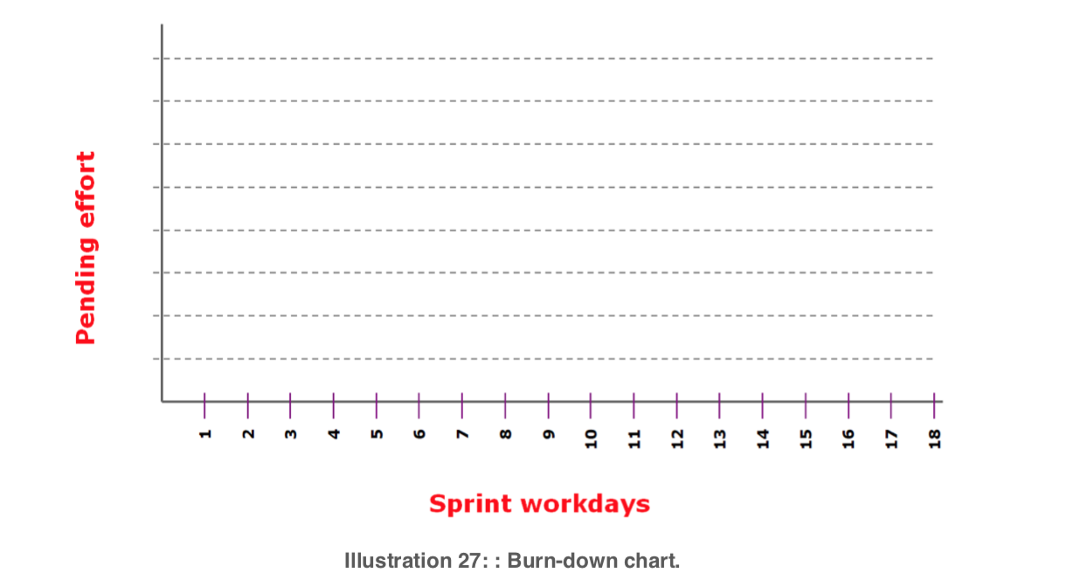

The team has in the sprint backlog, the list of tasks that they will perform, and in each one records the pending effort.
This is: on the first day, in the sprint backlog, for each task the effort is estimated, since no work has been done yet.
Day by day, each team member updates in the sprint backlog the time remaining for the tasks they are developing, until they are completed and 0 is left as pending time.
The following figure shows an example of a sprint backlog on the sixth day of the sprint: the finished tasks no longer have an outstanding effort, and the total effort planned for the sprint: 276 points (A), is currently 110 (B).
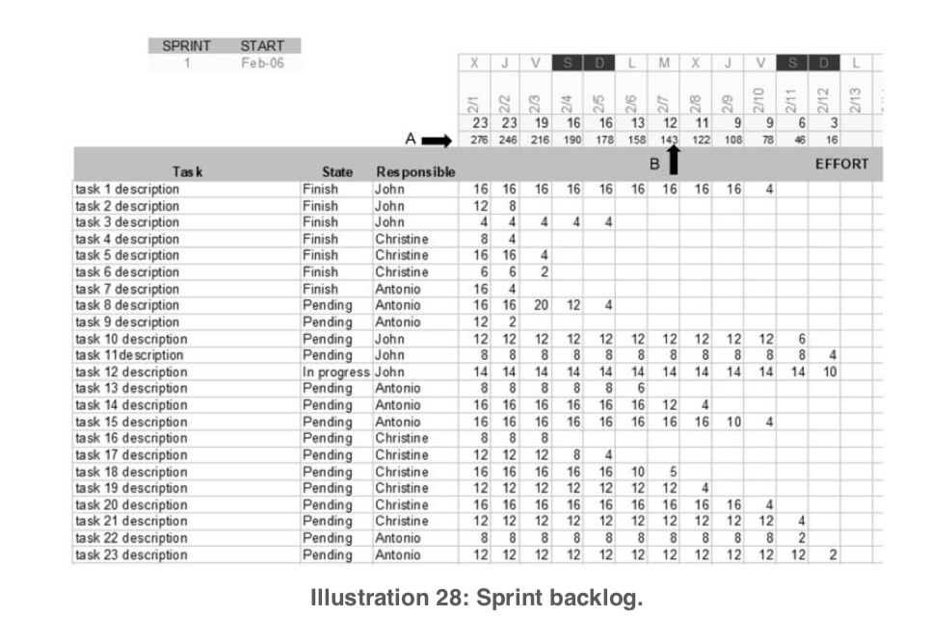

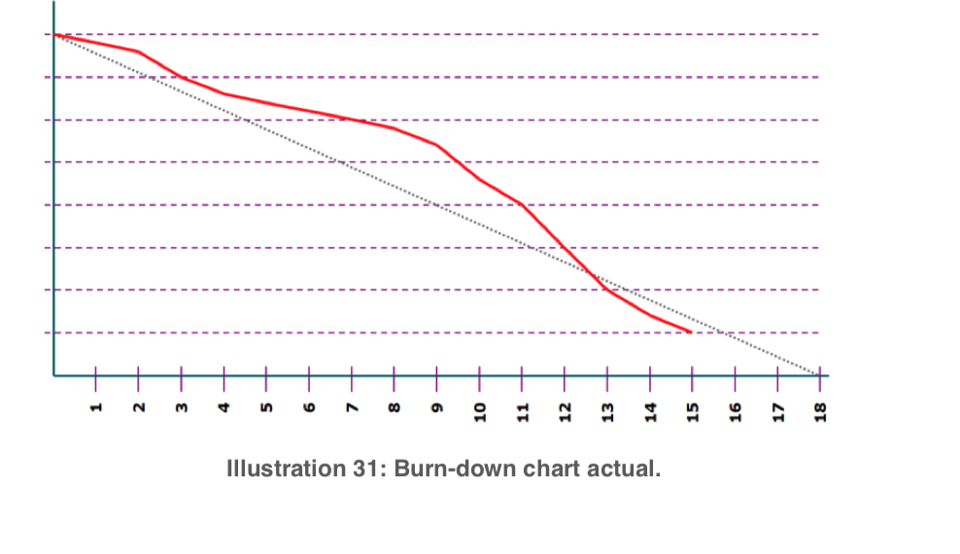
Perfect diagonal charts are very unusual, and the above image is an example of a more frequent forward pattern.

Planning Poker: An agile technique.
It is an agile practice to conduct the meetings in which the effort and duration of tasks is estimated. James Grenning devised this planning game to avoid lengthy discussions that do not end with concrete conclusions.
The initial Grenning model consists of 7 cards, with numbers 1,2,3,5,7,10 and infinity.
The operation is very simple: each participant has a set of cards, and in the estimation of each task, all face up the combination that adds the estimated effort.When it is considered that this is greater than x ideal hours (the maximum size considered by the team for a story), the card “” is lifted.
Tasks that exceed maximum size must be decomposed into smaller subtasks.
Each team or organization can use a set of cards with the appropriate numbers to the unit of effort they work with, and the maximum size of task or story to be estimated.
Variant: Fibonacci sequence
Based on the fact that increasing the size of the tasks increases uncertainty and margin of error, this variant has been developed, which consists in using only Fibonacci sequence numbers, so that:
■ The card game consists of numbers in succession of Fibonacci.
■ The estimation is not done by lifting several cards to compose the exact figure (as in the original version of Grenning), but by facing up the card with the figure closest to the estimate.
For example, if a person believes that the appropriate size of a task is 6, he is forced to reconsider and either accepts that the size can be 5, or accepts a more conservative estimate and raise the 8. To estimate tasks can be valid a card game like this:

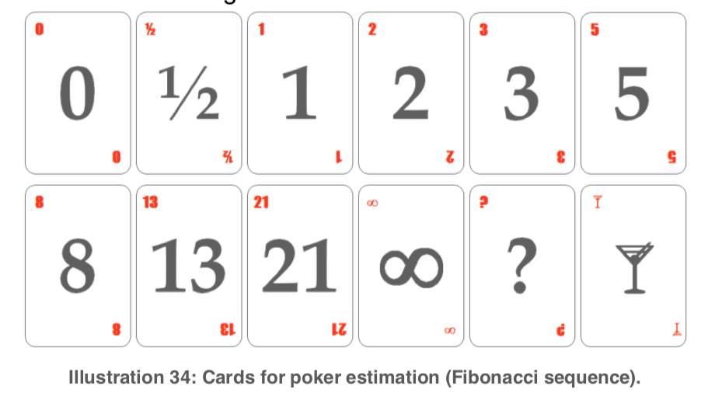
Operative
- Each meeting participant has a set of cards.
- For each task (user story or functionality, depending on the level of requirements to be estimated), the client, moderator or product owner exposes the description using a time to no exceed.
- Another additional time is set for the customer or product owner to answer the possible questions from the team.
- Each participant selects the card, or cards that represent his estimate, depending on the estimation system used, and separates them from the rest, face down.
- When everyone has made their selection, they are shown faced up.
- If the estimate is "infinite", exceeding the established maximum limit, the task must be divided into smaller subtasks.
- If the estimates are very different, who assumes responsibility for managing the meeting, with its management criteria, and based on the characteristics of the project, team, meeting, number of items still to be evaluated... can choose from:
o Asking people of extreme estimates:
Why do you think it takes so much time?, and why do you think it takes so little time? After hearing the reasons, the team must repeat the estimate.
o Setting aside the estimate of this task and resume at the end or at another time those that have remained pending.
o Asking the customer or product owner to decompose the functionality and evaluate each of the resulting functionalities.
o Taking the lowest, highest, or average estimate.

Advanced Scrum.
Knowledge in continuous evolution
Agile practice frameworks do not reach ICT projects as a "thesis" of knowledge, but as a "antithesis" to the project management practices that Software Engineering was usually developing.
In order to analyse what this means, it is necessary to put in perspective the reasons why IT projects embraced agility at the end of the last century, and their differences with process engineering; Not from the concrete practices, but from the principles they are based on, and understanding their agility strengths and weaknesses.
Achieving a vision of the reasons and principles of each methodology, beyond the concretion of a model, is the key to make the leap from technical management to expert management. That is, move from management based on the application of practices and procedures to management based on the application of our own knowledge.

Company as a system
Companies are not made up by a variable number of independent departments or areas. They are systemic realities, and their efficiency is proportional to the harmony of the work modes employed at the different departments. The consideration of scrum as the framework of work rules of the project management field, whose practices can be adopted without implications in the rest of the organization produces limited and even counterproductive results.
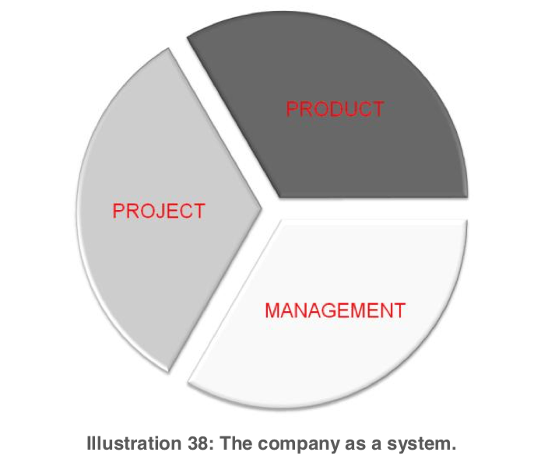

For example, in an organization whose management is based on industrial production models, and the engineering area accordingly works with process-based models with sequential or cascade life cycles, the adoption of agile practices in the area of project management will generate friction.

3.- Flexibility
The goal is not to implement a scrum framework based on rules. The goal is to reach an agile organization as a whole, being it able to "advance in scrum". Being it able to respond in work scenarios that evolve rapidly, or have high doses of uncertainty, where there are no stable requirements when designing new products or services. These are customers who need to start using a product as soon as possible and improve it continuously. These are products in which innovation is a key value.
A basic principle of the pragmatic implementation of scrum is flexibility, which is to adapt scrum practices to the organization and not the other way around. It is a question of expert management rather than technical management. A management directed from the knowledge, experience and criterion of the manager and not a management oriented to the search and set up the best model. A management focused on the person rather than the model.
To follow the evolution of professional knowledge and to continuously expand and improve the criteria and inventory of our own professional resources, it is advisable to:
■ Overcome resistance to change and avoid attitudes of adoption or dogmatic defence of a model.
■ Have a critical-constructive spirit: To continually question in an "antithetic" way the current ways, with professional knowledge and criterion, to adapt the work system itself to the characteristics of the project, team and organization.

Technical Scrum

Responsibilities

When moving from the rule-based technical scrum to the advanced scrum, which directly applies the principles of agile management with the knowledge and experience of the teams, the scope of the responsibilities to be covered goes beyond the project roles:
The organization, as a systemic reality, must respond, in a coordinated way and aligned with its vision, to responsibilities in three areas: Management, processes and production.
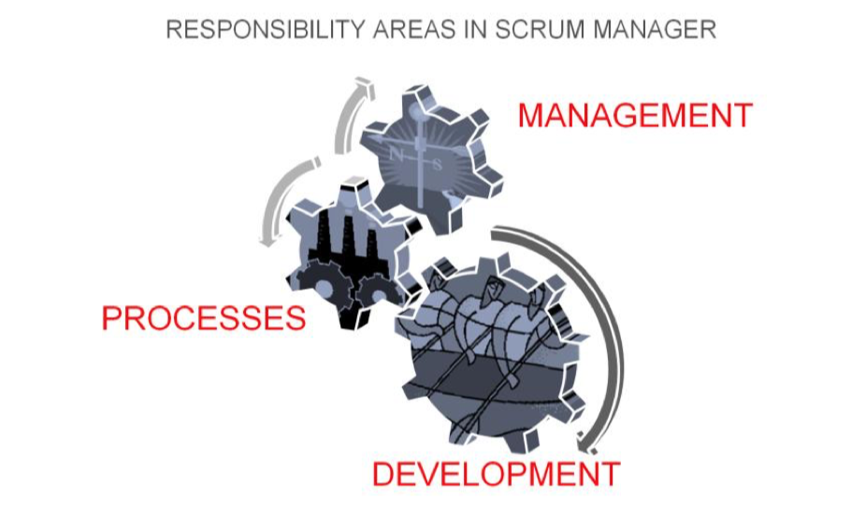

Managment
- Systemic equilibrium of the organization.
- Coherence of the model.
- Means and training.
Processes
- Flexible scrum configuration.
- Continuous improvement.
- Guarantee of scrum operation in each project (in technical scrum assigned to the role of
Scrum Master).
Production
- Product (in technical scrum assigned to the role of Product Owner).
- Self-organization (in technical scrum assigned to the team).
- Agile technology (in technical scrum assigned to the equipment).
The use of agile practices and technologies, working in self-organized teams, having a product vision defined and managed throughout the project, and ensuring the operation of scrum during execution, are responsibilities that belong to the scope of the project.
In technical scrum, the responsibilities of the project scope are assumed by defined roles:
- The scrum operation responsibility is assigned to a specific manager role for scrum operation: Scrum Master.
- The responsibility for product vision and management corresponds specifically to the role of product owner.
- The responsibility for self-organization and use of agile practices and technologies belongs to the team.

Methodologies
Concepts
1.- Development
Complete: The description of what is desired is available at the beginning of the project, is complete and detailed, serves as a basis for estimating the project plan: tasks, resources and work agenda. During execution, compliance is managed.
Incremental: The description of what you want to get is not available in a complete and detailed way at the beginning: it is complemented and evolves in parallel to the development, which generates the resulting product incrementally and can be managed with two different tactics:
- Continuous incremental development: Using techniques to achieve a continuous flow of development of functionalities or parts of the product, which are delivered to the customer on a continuous basis.
- Iterative development: Using time-stamping techniques or timeboxing to maintain the production of product increments in a cyclic and continuous way. This is the production framework used to apply the standard scrum framework, which defines as a sprint each development iteration, at the end of which there is a product increment.
2.- Work
Sequential (waterfall): Divide the work into phases, which begin at the end of the previous one.
Concurrent: Overlap in time the different phases.
3.- Knowledge
Process-based production: The knowledge or know-how, responsible for the quality of the result is to a greater extent in the processes and technology used: "The quality of the result depends on the quality of the processes used".
People-based production: The knowledge or know-how responsible for the quality of the result is to a greater extent in the tacit know-how of the people who build it.

Project Management Patterns
Predictive management
Management model whose objective is to provide predictable results: the development of the expected product, in the expected time, and investing the expected resources. It employs a complete development strategy with traditional planning practices. The main references in the knowledge development for this type of management are PMI and IPMA and the process models CMMI, ISO 15504 and SPICE among others, which employ sequential engineering and process- based production.
Evolutionary management
Management model whose objective is to deliver as soon as possible a minimum viable product, and increase its value continuously. It uses a strategy of overlapping phases of work, and an incremental development, which can be obtained by maintaining a rhythm of brief and cyclical iterations or a constant development flow. It can be carried out with process-based production (concurrent engineering) or with people-based production (agility).
This distinction is important because without it, confusing situations are generated, which come to consider agility to the simple application of the standard rules of scrum (cycle of iterative increase with roles and defined artefacts), or the simple use of kanban visual management techniques to maintain a continuous flow of tasks.

People, Processes and Technology
The body knowledge of Scrum Manager reconsiders two vertices of the classic triangle of production factors: People - Processes and Technology. Process and people.
Processes
In order to differentiate the procedures into their two possible types, we can say that in one, people help the process, and in the other processes are the practices that help people.
In the first case the process is the protagonist, the one who knows how to do the work, and the person is integrated into the system as an instrument, as an operator or supervisor.
In the second, the artificer is the person and the process is an aid, a tool that simplifies "mechanical" or routine aspects.
That is why we call the first processes and second practices.
The main difference between them is the type of knowledge they work with. Knowledge can be:
■ Explicit: content in processes and technology
■ Tacitus: The one applied by the person, based on his knowledge, practice, experience and ability.
Scrum Manager brings a consideration to the traditional people-process-technology triangle, considering that the working procedures can be:
- Processes: If their implementation provides key knowledge needed to achieve the result. Therefore the process and the technology that it employs are containers of "explicit" knowledge.
- Practices: If the procedure helps the person, who contributes with their tacit knowledge that is the "know-how" key in order to achieve the result.
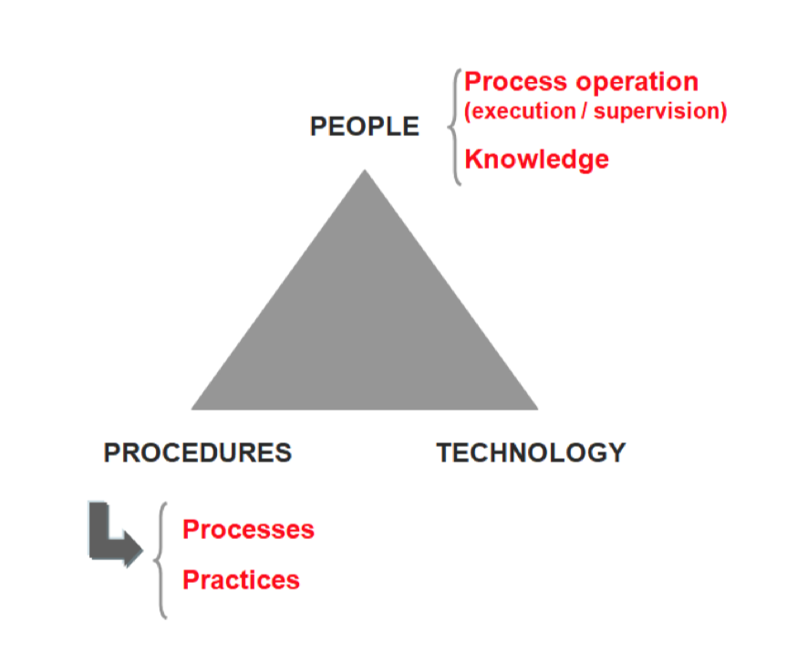

People
Organizations that need to continuously bring an innovative component, or that move in fast innovation sectors, obtain better results if they make people's talent responsible for value generation rather than process execution.
In this type of organization it is important to ensure, in addition to the level of creativity of the team, its ability to learn.
Visual management kanban for continuous increment.
Its main characteristic is the use of sprint pulses; it uses timeboxing with a defined and fixed cadence as a motor of advance, the rhythm is marked by the sequence of sprints.
The timeboxing tactic helps the team to move forward, while mitigating the usual tendency to delay expected delivery times.
Achieving a continuous flow of tasks without using sprints is not easy because bottlenecks often block the progress, causing in other areas of the team dead times in which they run out of tasks to perform.
Currently, the Kanban visual management is the most used technique to regulate a flow of continuous advance in IT projects and knowledge services managed evolutionarily without sprints.
Kanban: Definition
The Japanese term Kanban was used by Taiichi Onho (Toyota), which refers to the visualization system used in production processes that coordinate in an assembly line the timely delivery of each part just in time, avoiding overproduction and unnecessary storage of product in intermediates states. It can be translated as board or signage card, and its origin dates back to the late forties or early fifties. The term kanban applied to the agile management of projects refers to the techniques of visual representation of the information to improve the efficiency in the execution of the tasks of a project
Technical Management vs. Expert management
Some authors consider scrum and Kanban as frameworks of different rules and practices. According to Kniberg & Skarin, the following differences would be drawn
- Scrum prescribes roles, not kanban.
- Scrum works with fixed-time iterations, Kanban with cadences (simple, multiple, or event- driven).
- Scrum limits the WIP by iteration, Kanban limits the WIP by every state of the workflow.
- Scrum teams are multidisciplinary, in Kanban they can be specialists.
- Scrum does not allow to change the tasks of the sprint, in kanban the task can be altered until entering the flow.
- In scrum the product backlog must have the length of at least one sprint. In kanban the rate of tasks pulling must be attended.

- In scrum you must estimate the stories and tasks and calculate the speed, kanban does not measure tasks or speed.
- Scrum needs a prioritized product backlog, in kanban it is the next story or task dragged from the client.
- Scrum prescribes daily meetings, not kanban.
- Scrum uses burndown diagrams, not kanban.
- Scrum boards are reset at the end of each sprint, not in kanban.
Kanban boards: concepts
The kanban visual management practices are useful for:
- Managing the workflow.
- "Broadcasting" information.
1.- Characteristics of kanban to manage the workflow.
On a kanban board guidelines can be established to regulate the flow of progress of the tasks.
■ The position of each card on the board reflects the state of the work it represents.
■ The usual minimum states in a kanban board are "pending", "ongoing" and "completed"
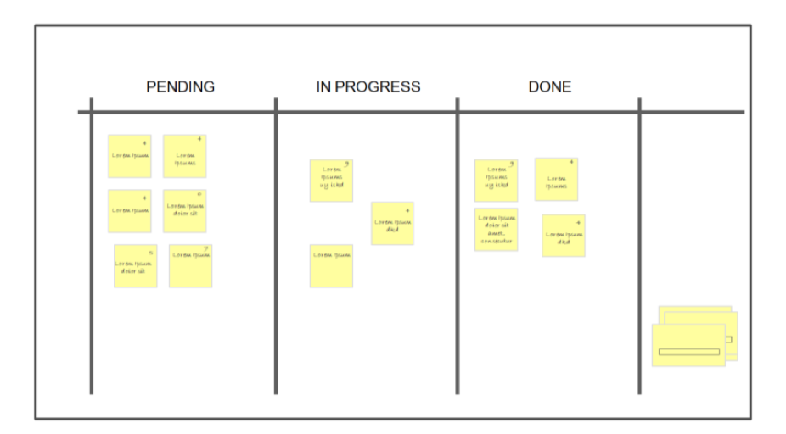
.
In some cases it is convenient to include additional states (for example, tested, validated).
The order of the works from the "pending" area reflects the expected sequence of tasks according to the priorities.The monitored works can be tasks, user stories or epics, according to the use to which the board is dedicated
Kanban brings out the information of the problems.
Conflicts in the work prioritization, problems in the flow due to impediments or workloads, incidences in development, etc. are immediately evident when updating on the board the status of the works.
Kanban Facilitates a steady pace and avoids Parkinson's law
It generates a continuous advance of work whose rhythm is not "predestined" by a temporal planning: Gantt or Sprint (iterative increase).The absence of temporary milestones avoids the usual tendency to lengthen the working time to complete the estimated time (Parkinson's law)
The work expands to fill all the time that was planned Parkinson's Law.
2.- Information broadcaster.
Kanban acts as a broadcasting tool for the project progress information:
It promotes direct communication
- It facilitates direct communication within the team by updating information in meetings in front of a kanban board.
- It shares the visibility of the evolution of the project with all those involved. It facilitates early detection of problems
Kanban continuously monitors the progress of the project. The updating of just-in-time information helps to identify at first the possible impediments, problems and risks, which otherwise go unnoticed until they start to produce delays or repercussions already inevitable.
Kanban: Operative
Sequence and polyvalence
Two are the factors that combine in a work scenario and that determine the form and the way that the kanban board must be used:
- Sequence of tasks: Do the tasks have to be done in a certain order, or can they be done in any order?
- Versatility of people: Can the team members do any kind of task? Sequence.

1. Polyvalent team that performs non-sequential tasks.
This is the easiest environment to manage: anyone on the team can do any task, and tasks can be taken in any order. In this situation, if there are bottlenecks or dead times, improvement measures should focus on optimizing the size of the team according to demand, and as far as possible, the distribution of the tasks types and times of the demand.
2.- Team of specialists who perform non-sequential tasks.
The specialization of the team brings a difficulty factor to solve bottlenecks or dead times. If there are bottlenecks, the strategy to face the type of tasks that provoke them must go in one or both of the following lines:
Sizing: either the number of people trained to perform this type of tasks, or the number of tasks of that type that can be compromised, or in the time of customer response.
Optimizing the execution process of this type of tasks.
3.- Polyvalent team that performs sequential tasks
In this case, the dependence between tasks is the main cause of tensions in the flow.
A common practice in kanban boards that manage sequential tasks is to limit the maximum number of tasks that can be found in a given phase. This is called "adjusting the WIP".
WIP is a term used in lean manufacturing, where it comes from, it is used to indicate the number of products in a step of the manufacture process that are not finished yet simultaneously.
4.- Team of specialists and work that requires a sequenced order.
This is the environment in which it is more difficult to adjust a continuous workflow, because it requires analysing and fine-tuning all possible improvement lines: dimension and balance of specialists in the team, dimension or balance of response times in the commitment, and adjustment of WIP limits in each phase.
In each of these four possible situations, the board brings problems to the surface, and the team or manager can make the adjustments in the possible lines of work taking into account the individual case and according to their criteria and the circumstances of their organization.
Practical cases of kanban boards
Dashboard to provide product development information.
In this case it is not used as a visual management tool, but only as a "broadcaster" of information.
The dashboard displays the following information regarding the state of development of the product:
- Suggested user stories, which are under evaluation without determining yet if they will be incorporated into the product.
- Approved user stories: will be added to the product.
- User stories "prepared" (already valued and prioritized) planned to be scheduled.
- User stories that are currently being programmed.
- Scheduled user histories that can be evaluated in the test environment.
- User stories already evaluated, pending of deployment.
- User stories displayed in the last two versions.
Boards for evolutionary development, with continuous increment, and with iterative increment.
Kanban, in addition to providing visual information, allows the application of techniques such as limiting the WIP, and shows the areas that need to be improved to maintain a continuous development flow. It is useful to work with continuous increase.
Case 1: Continuous increase.
The following images represent possible boards to guide the work management of a team that is developing a product with continuous increases, and which shows the following information:
■ Tasks backlog
■ "Prepared" tasks.
■ Tasks in analysis.
■ Tasks in coding.
■ Finished tasks.
■ Tasks built into the development server (labs).
■ Integrated tasks in production.
Case 2: Iterative increase.
Dashboard to guide the work management of a team working in iterative increments (sprints) and showing:
■ Tasks backlog
■ Prepared tasks.
■ Tasks in analysis.
■ Tasks in coding.
■ Finished tasks.
■ Integrated tasks on the development server (labs)
■ Integrated tasks in production.
Board for an operation and maintenance team.
Guidance board for the management of an operation and maintenance equipment that reflects:
■ Status of scheduled tasks for the week and person who is working with each one.
■ Status of unforeseen and urgent incidents, and people who are working in each one.
Tips for adjusting the flow: Muda, Mura and Muri.
Muda, Mura and Muri are three key concepts of Kaizen continuous improvement, which Lean production incorporates as key variables to increase efficiency.
■ Muda: Waste
■ Mura: Discrepancy. Workflow variability. Interruptions in the workflow. Time-out.
■ Muri: Tension. Work overload that produces bottlenecks.
Mudas
The most common mudas or wastes in IT projects are:
- Bureaucracy: Procedures, documentation and unnecessary paperwork that do not add value to the result.
- Overproduction: Develop more characteristics than necessary.
- Multiproject: Alternate the time of work between several projects and interruptions of the workflow.
- Waits: Waiting times due to lack of cadence in the workflow.
- "Start doing": Ordering work to go forward tasks not enough defined and only thus avoiding people stop working.
- Capacity misalignments: Highly talented people assigned to routine tasks, and vice versa.
- Errors: Rework for bugs.

Determinant factors of Mura and Muri
It should be noted that each organization or type of project has its own characteristics of:
-  Sequence: the tasks must be performed sequentially or not.
■ Versatility, polyvalence or specialization of the team members.
As it has been seen, teams of polyvalent members working with non-sequential tasks are the ones that can achieve a constant forward flow more easily.
When difficulties arise, the variables to be combined, depending on the possibilities in each case, are:
- Volume of demand.
- Backlog order or user story stack: if a bottleneck is produced in one phase, care should be taken to ensure that the next story to be entered on the board requires little effort from that phase.
- WIP or task limit in a given phase.
- Staffing: team size and specialization or polyvalence.
Muri
The WIP is an important variable for adjusting bottlenecks (Muri):
When using kanban to maintain a continuous increase, the concept of sprint disappears. An increase is no longer the result of a sprint, but every user story that is completed and delivered to the customer. In order to maintain a continuous flow of deliveries that increase the product in a sustained way, bottlenecks (Muri) must be avoided: thus the accumulation of tasks in a certain phase of the process. One way to do this is to limit the amount of work that can be accumulated in each phase. The parameter that indicates the maximum number of tasks in an area of the kanban board is the so-called WIP: Work In Process, or "in-process inventory". It should not be confused with Work in progress, term that designates a work that has begun but is not yet finished.
A "WIP" value too low can cause jams in other phases, especially if the system is too rigid (sequential tasks and specialist equipment).
In this sense a generally useful recommendation (in teams of multipurpose members) is to start with a WIP equal to the number of team members x 1.5, rounding the result off by excess.
It is not advisable to work with tasks whose size is expected to exceed one day of work, and if this happens it is advisable to divide them into smaller ones.
Mura
The main factors responsible for the variability of the flow and the occurrence of Mura or dead times are:
■ Degree of multifunctionality of the team members.
■ Flexibility in the order in which the different phases of each task must be done.
■ Flexibility to alter the entry order of the user stories from the product stack.

