Face recognition in Matlab for my car design.

Kacper Woloszyn

*Waterford Institute of Technology*  
*Department of Science*

Waterford,Ireland   
kacperwoloszyn4@gmail.com

# Introduction

The ADAS feature that I found to be very interesting is the face recognition. I feel like face recognition will play an important role in the future development of car technology. When we get in the car, a key-less car could be the future, and thanks to algorithms such as voice detection and face detection we would get a very easy way of starting the car. Face recognition is important, we use it in phones to make sure the correct person has access. In my car design, I use face recognition to log into the system in the car, as the car is fully autonomous, to make sure the correct person gets to decide where the car goes, by programming it in the map. Face recognition would allow users of such autonomous cars, not to worry about others deciding where to go. For example, if a person has a child, the person is safe that the child won’t get into the car and drive it somewhere, and that would be thanks to face recognition.

# Face Recognition

## What is ment by face recognition?

Firstly I would like to define what I mean by facial recognition. Facial recognition technology in my automotive design can identify or verify a person from a digital image or a video frame. Facial recognition works based on having a selected facial feature and then comparing it to a face within the database [1]. For my car, the database would consist of a few people that have access to the car and have a driving licence, so no unauthorised people have access to the car and then the facial recognition algorithm would compare the face provided by the user to the face given in the database.

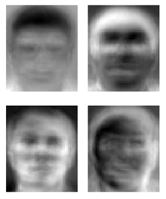

## How does face recognition work ?

The way I will complete face recognition is the traditional method, as I found only that the is a development in this area and skin texture analysis, or three-dimensional face recognition using 3D sensors are available now [2][3]. The traditional way, which I will try to show in MATLAB works based on an algorithm using eigenfaces, which analyses the relative position, size and even the shape of your facial features like eyes, nose, cheekbones and the jaw. These features are used and are compared to black and white images with matching features. I will talk about Eigen Faces in the next stage of this report. The camera in the car would detect the features of the driver and then compare to a secure database.

# Eigen Faces

Eigenfaces is the name given to a set of eigenvectors when they are used in a computer vision system as part of a face recognition algorithm. Eigenvalues and eigenvectors are terms in linear algebra. Eigenvectors or characteristics vector of a linear transformation is a non-zero vector that changes by only a scalar factor when linear transformation is applied to it. The use of eigenvectors as part of facial recognition was developed by Sirovich and Kirby in 1987 and is a vital part of the face recognition in my car design model. It was firstly used by Matthew Turk and Alex Pentland in face classification, i.e. comparing faces to database of faces [4].

## Generation

To generate eigenfaces, a math process called principal component analysis is done. This is a statistical procedure that uses orthogonal transformation to convert set of face features in my face recognition, which could be correlated, to be linearly uncorrelated variables. The eigenfaces will appear as light and dark areas that are arranged in a specific patter, and that pattern is how each feature is singled out and evaluated and scored. Patterns can arise, if there is a specific style of facial hair, but other patterns are less simple to identify and image of eigenface may look not like a face in the end [5].

1. Example of Some eigenfaces from AT&T Laboratories Cambridge [6]

## Computing Eigenvectors

The eigenvectors are firstly derived from the covariance matrix of the probability distribution over the high-dimensional vector space. A covariance matrix is a matrix whose element in the i, j position is the covariance between the i-th and the j-th element of the random vector. Covariance is the measure of the joint variability of two random variables.

A probability distribution is the mathematical function that provides the probabilities of an outcome to occur in an experiment. This is vital information as the eigenvector values I obtain are then compared and classified by comparing to the basic database.

## Implementation of Eigenfaces

Firstly, I will get a data set, I downloaded a data set of 40 people, each person has 10 pictures, each image is in greyscale and the size of the images are the same. The images of the person are taken from different angles, so the 10 pictures of the same person are not the same. This is my data set.

I load the data set using a script in MATLAB, an output_value variable is where the database is stored.

I subtract the mean, and the average image is calculated and subtracted from original image single matrix T. I then calculate the eigenvectors and eigenvalues. The eigenvalues associated with each eigenface represent how much the images in the training set vary from the mean image in that direction. We lose information by projecting the image on a subset of the eigenvectors, but we minimize this loss by keeping those eigenfaces with the largest eigenvalues.

In my dataset I have specific image dimensions of 92x112 pixels, therefore I will have 10304 eigenvectors.

Most pictures can be based on 100 – 150 eigenfaces, so most eigenvectors can be discarded.

## Why Eigenfaces?

Facial recognition was the reason for Sirovich and Kirby to develop facial recognition. Eigenfaces have advantages over other techniques available due to the systems speed and efficiency. Eigenfaces have advantages over the other methods as dimension reducing method is used. The system can represent many subjects with a small set of data. Eigenfaces are also very invariant to large reduction in image sizing, therefore it would be very secure for my cars implementation of the face recognition.

When a new face is presented to the system for classification, its own weights are found by projecting the image onto the collection of eigenfaces. This provides a set of weights describing the probe face. These weights are then classified against all weights in the gallery set to find the closest match. A nearest neighbour method is a simple approach for finding the Euclidean distance between two vectors, where the minimum can be classified as the closest subject and that is why I use Eigenfaces, for face recognition in my car design [4].

## False accepts / rejects

Thresholds are very important in face recognition, where does the algorithm know how lenient it can be or how accurate does the face recognition has to be. The false acceptance rate, is the measure of the likelihood that the face recognition system will be incorrect and accept a wrong person to the system of my car. A false reject value means that the algorithm has rejected the person that is authorized to use my car system, and the face recognition just made a mistake by disallowing the wrong person to drive, when they were the right person.

False accepts and reject values are based on scores (weights). The higher the weighting is the bigger the similarity of the database item and the face that has been recognized. [7] Access to the system of the car would only be granted if the weighting of the persons face recognition is of a higher value than a certain threshold. Face recognition false accept/reject values depend on the application, for a phone if someone unintended gets onto your system, the consequences are less severe, then a child choosing where the automated vehicle will drive, hence why the value of the correctness of the face recognition system must be very high, and the algorithm must be very accurate.

# Benchmark

Here below I show the results of running my code, on dataset of 40 people and seeing how often eigenfaces got the correct face recognised.

1. Results

| Face Recognition | | |
| --- | --- | --- |
| # of runs | Recognized | Not Recognized |
| 1 |  | X |
| 2 | X |  |
| 3 | X |  |
| 4 | X |  |
| 5 | X |  |
| 6 | X |  |
| 7 | X |  |
| 8 | X |  |
| 9 | X |  |
| 10 | X |  |
| 11 | X |  |
| 12 | X |  |
| 13 | X |  |
| 14 | X |  |
| 15 | X |  |
| 16 | X |  |
| 17 | X |  |
| 18 | X |  |
| 19 |  | X |
| 20 | X |  |
| 21 | X |  |
| 22 | X |  |
| 23 | X |  |
| 24 | X |  |
| 25 | X |  |
| 26 | X |  |
| 27 | X |  |
| 28 | X |  |
| 29 | X |  |
| 30 | X |  |
| 31 | X |  |
| 32 | X |  |
| 33 | X |  |
| 34 | X |  |
| 35 | X |  |
| 36 | X |  |
| 37 | X |  |
| 38 | X |  |
| 39 | X |  |
| 40 | X |  |
| 41 | X |  |
| 42 | X |  |
| 43 | X |  |
| 44 | X |  |
| 45 | X |  |
| 46 |  | X |
| 47 | X |  |
| 48 | X |  |
| 49 | X |  |
| 50 | X |  |

1. Results of the benchmark of my matlab code

As one can see from my benchmarks above, the eigenfaces algorithm was wrong 3/50 times, which is an accuracy rate of 94%.

The faces I used in this were all from a dataset found online, but if I had lets say made it more aimed at comparing children to adults, to make it more aimed at my car problem of detecting faces of people who should not be able to control the car, the facial features of adults and children are so distinct, I’m sure the accuracy would be increased more, making my face recognition system for the vehicle very secure.

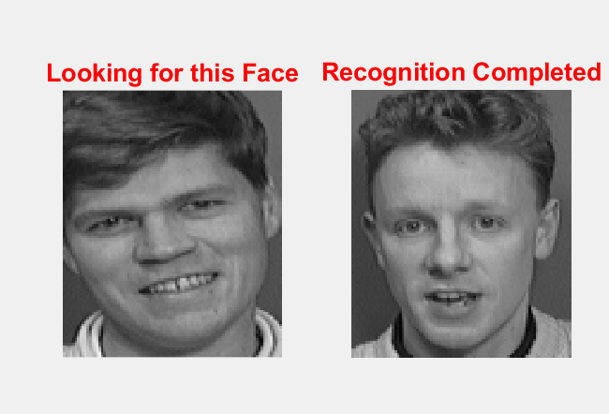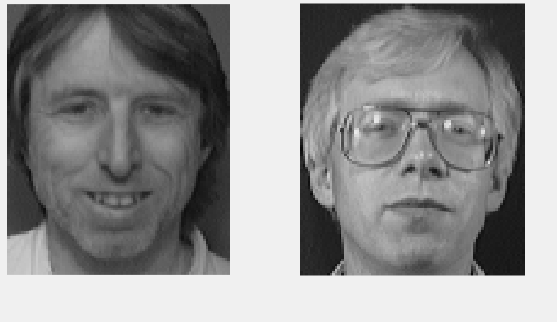

1. Wrong recognition

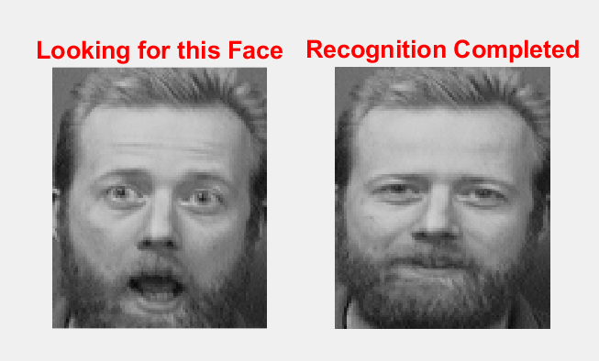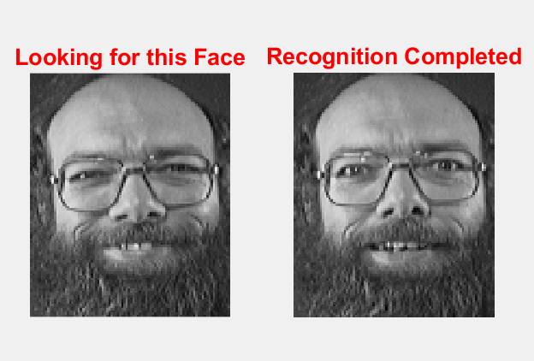

1. Correct recognition

##### References

1. Techopedia.com. 2018. What is Facial Recognition? - Definition from Techopedia. Available at: https://www.techopedia.com/definition/32071/facial-recognition. [Accessed 30 December 2018].
2. Duhn, S. von; Ko, M. J.; Yin, L.; Hung, T.; Wei, X. (1 September 2007). "Three-View Surveillance Video Based Face Modeling for Recognition". pp. 1–6. doi:10.1109/BCC.2007.4430529 – via IEEE Xplore. [Accessed 30 December 2018].
3. Bonsor, K. "How Facial Recognition Systems Work". [Accessed 30 December 2018].
4. Turk, Matthew A and Pentland, Alex P. [Face recognition using eigenfaces]. Computer Vision and Pattern Recognition, 1991. Proceedings {CVPR'91.}, {IEEE} Computer Society Conference on 1991". [Accessed 30 December 2018].
5. Sandhu, Parvinder & Kaur, Iqbaldeep & Verma, Amit & Jindal, Samriti & Kaur, Inderpreet & Kumari, Shilpi. (2009). Face Recognition Using Eigen face Coefficients and Principal Component Analysis. International Journal on Electrical and Electronics Engineering. 3. Available at: https://www.techopedia.com/definition/32071/facial-recognition. [Accessed 30 December 2018].
6. People. 2011. EigenFace. [ONLINE] Available at: http://people.ece.cornell.edu/land/courses/ece4760/FinalProjects/s2011/bjh78_caj65/bjh78_caj65/img/eigfaces.png. [Accessed 30 December 2018].
7. Biometric. 2018. False Acceptance Rate and False Recognition Rate. [ONLINE] Available at: https://www.bayometric.com/false-acceptance-rate-far-false-recognition-rate-frr/. [Accessed 30 December 2018]