Emergency Exit App incorporated with Arduino.

Final Report (semester 2)

Kacper Woloszyn

20071494

Supervisor: Caroline Cahill

BSc (Hons) in Applied Computing

Emergency Exit Mobile Application with Arduino



By Kacper Woloszyn, 20071494.

Contents

Introduction 4

Diagrams 5

Use Case 5

Domain Model 5

Technology used in my assignment 6

Arduino 6

Firebase 8

Alternatives 10

Database 10

Language 11

Buzzer 11

Cloud Services 11

Route finding 12

Map reader 12

How security will be dealt with? 12

Plan for building the application at the start of January 12

Draft user manual 13

Learning curve 13

Citations 13

Minutes from meetings 14

# 

# Introduction

I have decided to go with a mobile application for my final year project. I have developed as a student educationally over the four years in Waterford Institute of Technology and at Universidad de Malaga, to finally be able to put my own project idea combining all the things that I have studied, and the things I would like to learn, not necessarily all the things that I had learned at WIT, but also individually.

I feel the mobile application I am doing for my final year project may be very important for future generations as each of us nowadays does things on our phone more times than not. I feel there is a need in the market for an application that displays emergency exits to people in public areas and buildings in case of an emergency.

In the project I use an Arduino, the Arduino will be connected to my application and I programmed a buzzer and a sound sensor in Arduino. The buzzer will sound, and an emergency exit route is displayed on the screen, with some additional information, such as the path length or the time taken to find the route. The application is for android users, but as the projects developed in the future it could be brought to IOS devices. The application has a database of users that is stored in firebase so a connection to the internet would he a requirement. An algorithm is used in the background to find the quickest route out of the building. The algorithm used is called Dijstras. It works on having the start node, and the end node, and It picks the unvisited vertex with the lowest distance, calculates the distance through it to each unvisited neighbour, and updates the neighbour's distance if smaller. I used the knowledge from my Erasmus course in Intelligent Systems, where I learned how to programme route finding algorithms such as A* Algorithms and Dijkstra algorithm or genetic algorithms and neural networks. I take specific measures to make sure the security of the user is not breached, and that the application works as desired, by allowing logins so that I can keep track of who is on the application, and the location is not saved, so just in case someone was trying to steal the data it would be hard.

I have used a tool called magic draw to develop my diagrams which show the functioning of the application.

# Diagrams

## Use Case

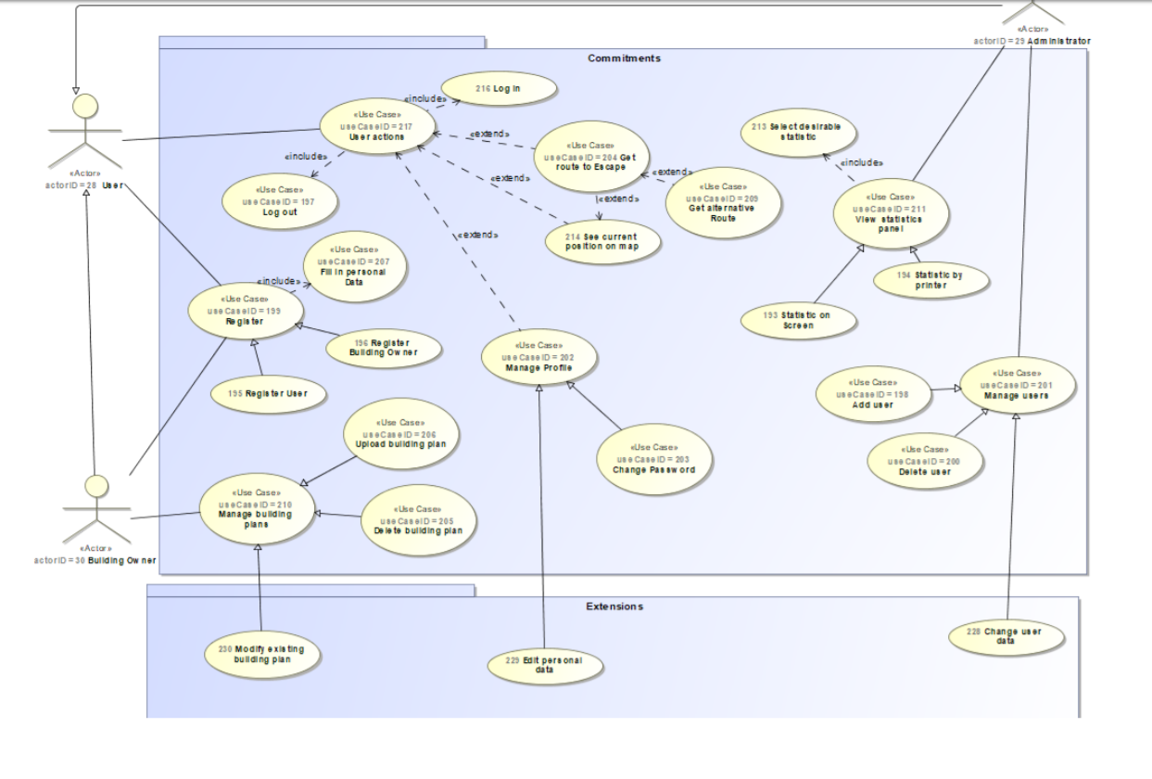

## Domain Model

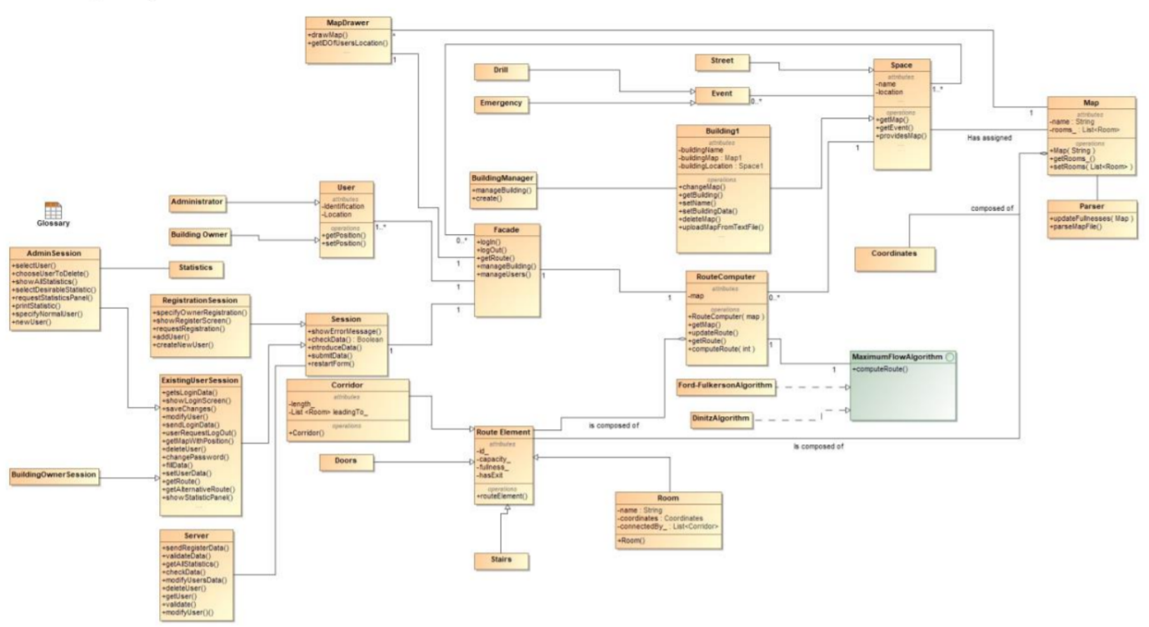

# Technology used in my assignment

## Arduino

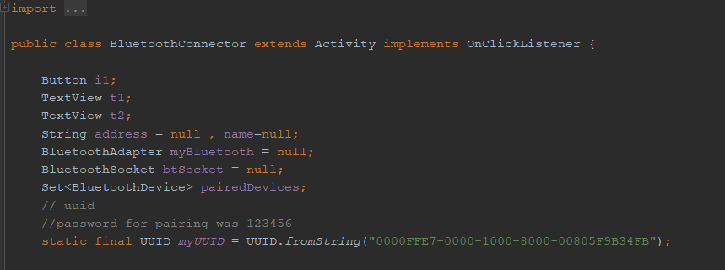

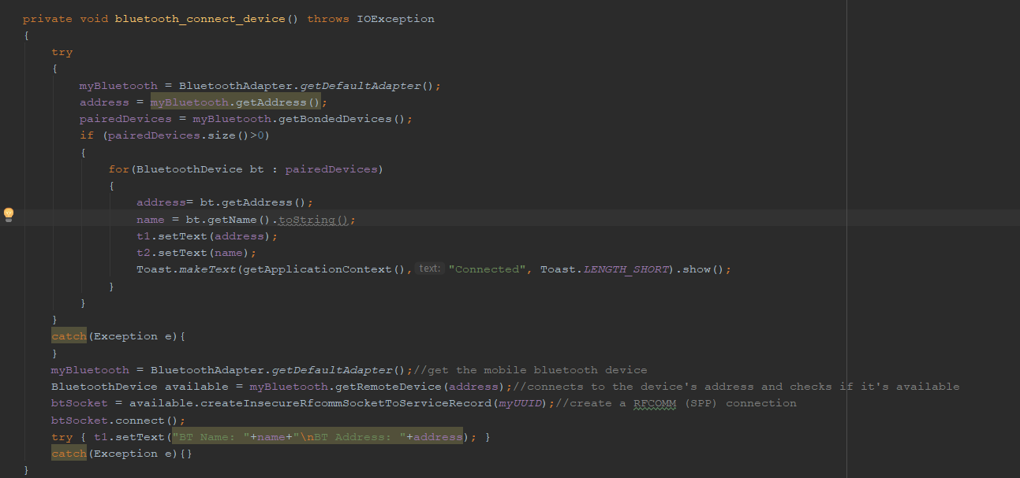

I have a method called Bluetooth_connect_device, that connects to a device, and creates a connection that’s stored in a variable. I then set the name and address fields of the application to be that of the device that has been connected. Arduino uses mostly C++ for programming, and I have programmed a connection program, that I flash the board with and a buzzer programme.

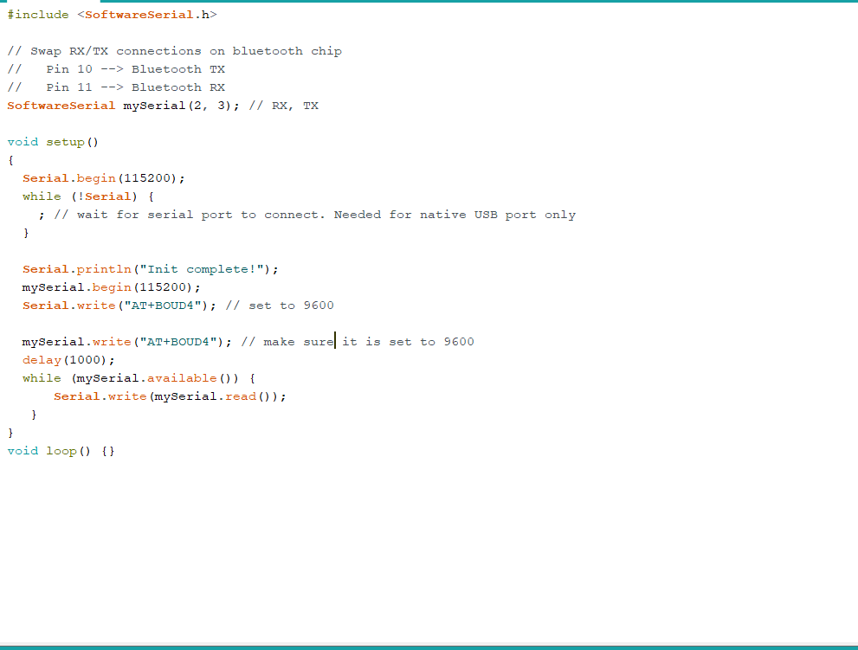

The programme above basically checks, what is connected to the pins on the Arduino board, and it flashes the board with a programme to allow for the Bluetooth module to work properly. It writes a set baud rate to make sure everything works properly and so that the Arduino board is not overheated and overclocked. To use Bluetooth features in my application, I had to declare two permissions. The first of these is BLUETOOTH. I need this permission to perform any Bluetooth communication, such as requesting a connection, accepting a connection, and transferring data. The other permission that I had to declare is ACCESS_FINE_LOCATION. A location permission is required because Bluetooth scans can be used to gather information about the location of the user.

I use a Bluetooth API, that scans for Bluetooth devices, query’s the local Bluetooth adapter and establish RFCOMM channels.

Arduino is an open-source hardware and software company that develops boards and kits for building digital devices and interactive objects that can sense and control from both the physical and digital worlds.

There are DIY kits that I use to make a buzzer sound whenever the application sends out a notification about an emergency. I could use that in the future iterations of the project so that whenever an alarm sounded the application would open, so build a sensor inside the application, but then security comes into play as the application would be listening over time.

A buzzer works like a drum, with a membrane that is stuck by a drum stick causing the device to vibrate and produce noise, but in the Arduino, the membrane is an electric current. To connect the device, firstly I connect the positive leg of the buzzer and connect it to a positive digital pin on the board. The negative leg was connected to ground on the Arduino. Tone command plays command, with two parameters, the digital pin, and the frequency of the noise. There is also a no tone command, which I would use in my assignment when there was no clear emergency.

## Firebase

Databases for mobiles need to be:

* Lightweight as storage is limited on mobile devices.
* In a form of library with no or very limited dependency (embeddable) so that it can be used when needed
* Fast and secure.
* Easy to handle through code, and option to make it private or shared with other applications.
* Low memory and power consumption.

Firebase DB is a mobile app and web app development platform developed by Firebase in 2011, and it has been bought by Google in 2014. I would consider using it as it has been bought by google so it would have many advantages, such as easier accessibility to the google play store. Firebase is used by more than 1.5 million applications (Firebase.Inc, 2018).

Firebase is a free database, hence why it has a big advantage, as probably the application could be free. “Firebase Auth” is a service that can authenticate users using only client-side code, so it wouldn’t need internet to log you in, just would need it to pull an emergency. The company provides client libraries that enable integration with Android / Java and Kotlin, hence why I would consider using it in my assignment.

Firebase Storage provides secure file uploads and downloads for Firebase apps, regardless of network quality. The developer can use it to store images, audio, video, or other user-generated content, so if I were to store a Map of a building, it would be very secure, also takin in the fact that internet connection does not have to be amazing to access the service (FirebaseStorage, 2016).

Firebase Notifications is a service that enables targeted user notifications for mobile app developers at no cost, so the user would get notified about an emergency without having to have the app opened.

In my mobile application I use firebase auth mostly, as I do not want to store the user’s location, since it would be unnecessary and could lead to very dramatic consequences if someone would hack the application. Firebase auth, basically allows users to log in and register. I do this to make sure I, the administrator of the application, know who is currently using the mobile application to avoid security breaches. Firebase stores the passwords in a salted and hashed manner, so even I do not know what a user’s password is, which is good, as it would be hard for a security breach to happen. Firebase Auth makes my application very secure, so that I know who is using the application at most of the times.

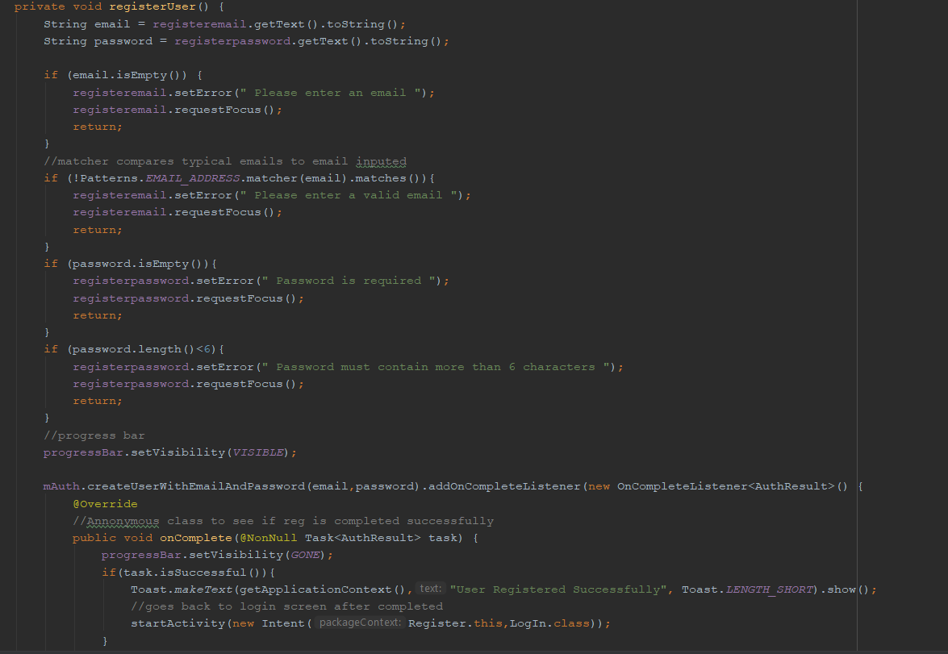

This above is the register method, I check if the email is of correct format, and I check if the password is not empty and it has more than 6 characters, as specified by the firebase authentication.

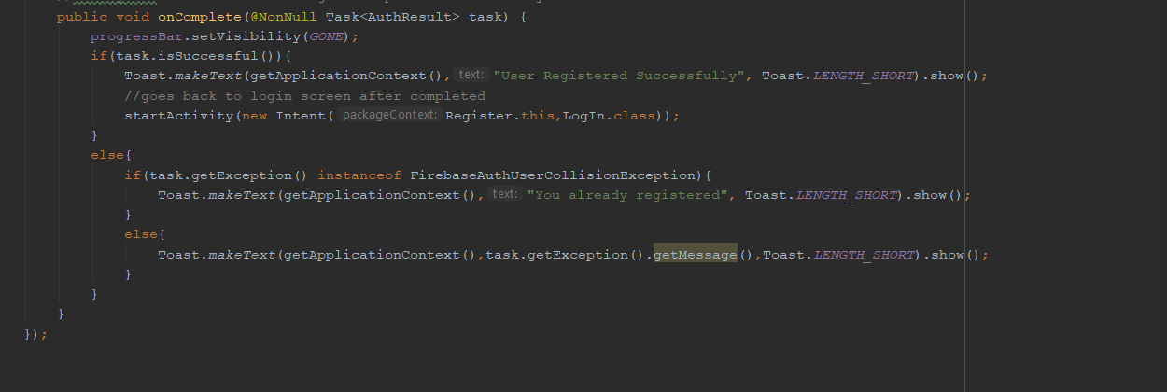

The On Complete is an anonymous class to see if the registration occurred without any errors, if no errors, the user goes to the login screen, if an error with the email already in use, the user gets a message to the screen specifying that he or she is already registered. If firebase error I display the exception.

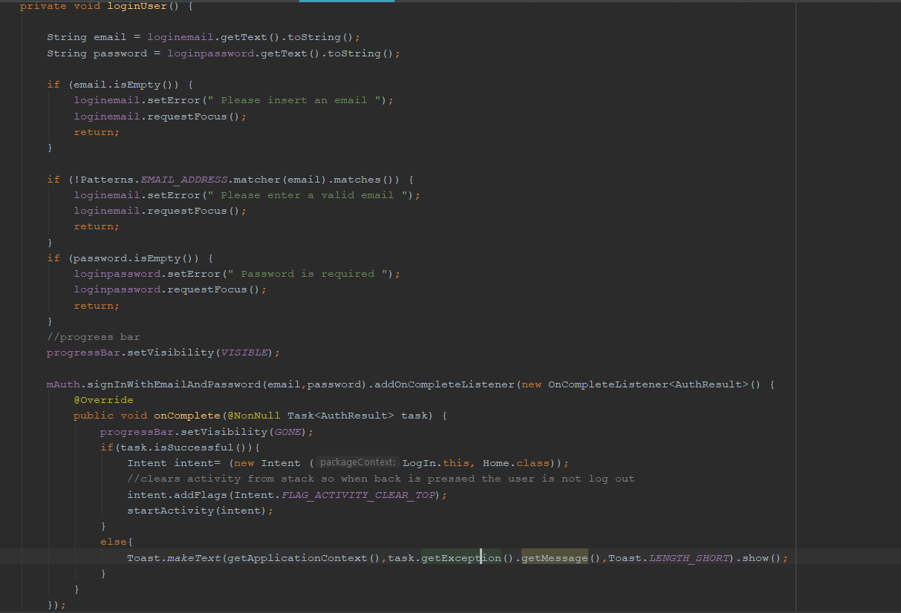

This is the login method, it checks if the email is empty, also if the email is not valid and if the password is empty. The OnComplete checks if the email is correct and if the password is correct, if so it brings the user to the home page, which contains the 3 buttons. If incorrect it gets the exception error from firebase.

## Language

I wrote the application in Java, as in second semester I learned java with android studio, but also, I had a backup language called Kotlin. Kotlin is a newer version of java, with many things just made easier for the developer to write code in. Java is used, as Kotlin is only a new language, and as much as it simplifies the creation of applications by making some of the methods easier, the language is based on Java. Java was my go to language due to the fact Java apps are more compact – in comparison to Kotlin, Java apps tend to be lighter, which is good for my final year project as I do not know what the phone of the user is going to be. A Kotlin app that includes complex computing processes in its code can turn out to work slowly on user devices with low technical specs. Java also allows top development speed, and faster build process than kotlin according to netguru (netguru, 2018). The build time for my assignment is vital as the quicker the user gets the route, and the quicker the application opens, the more chance the user would have to escape an emergency. According to Netguru Kotlin also has a small developer community, which means limited learning resources and difficulty in finding answers to questions. At looking only on stackoverflow there are only around 8000 questions tagged with Kotlin against 1.37 million questions about Java.

## Buzzer

An Arduino Uno board is usually programmed in a separate programme and I have only done it once, if I fail to get the Arduino board working, I could write a buzzing programme that I talk about in the second alternative way of working around the buzzer.

The first alternative would be using a different board than Arduino. I could use a raspberry pi. An Arduino is a microcontroller motherboard. A microcontroller is a simple computer that can run one program at a time, repeatedly. A Raspberry Pi is a general-purpose computer, usually with a Linux operating system, and the ability to run multiple programs. It is more complicated to use than an Arduino also for my final year project, it would be considered an overkill since I only need one programme that makes the buzzer sound and that is what Arduino would allow me to do. I would consider Arduino to be my main choice because I have more experience coding it, as I had two assignments in second year that involved me using the board.

A second alternative, if I fail to get the Arduino board and the Raspberry Pi to work, I could write a buzzing programme in java or Kotlin, that if a route to escape was given by the application the noise would sound on the phone, like a notification, but the volume of the phone would have to be taken into account, and if a phone is on silent the phone could then vibrate instead.

This adds complexity to the application and is a bit of topic as my main goal is to do the application and connect it to something, like an Arduino.

The application would be connected by a USB port to the computer, and so will the Arduino, I would have to buy a Bluetooth module for the Arduino to connect the app directly over the internet, and I will try to do that, but if this fails, the connection over the computer will have to be necessary and if the connections over the laptop are not enough I plan to write the buzzing programme as in the second alternative method mentioned above.

## Cloud Services

There are many web services that I could use instead of AWS such as Apache, I have chosen AWS as it is the most common one that students and applications use nowadays, but I didn’t do many cloud modules, so If one of the cloud services seems to complex I will maybe change to Apache, Heroku or Oracle. There are many advantages to using each one of the companies I mentioned, but I will stick to AWS for my project, and these would be a backup. The main reason those are backups and amazon is the main cloud service I will use is the free tier option that Amazon offers. The free tier provides enough credit to run an EC2 micro instance 24/7 all month and the amazon web service comes with s3 storage, ec2 compute hours, elastic load balancer time (aptuz,2015).

## Route finding

The user is given a route to escape, but how is the route computed. I plan to use one of the algorithms that I learned during Erasmus called Dijkstra which works by starting at one vertex and exploring adjacent nodes until the destination node is reached. Dijkstra algorithm begins with a start node and an "open set" of candidate nodes. At each step, the node in the open set with the lowest distance from the start is examined. The node is marked "closed", and all nodes adjacent to it are added to the open set if they have not already been examined.

I could also use A* algorithm which is more commonly used in games, and I have used it in an application called Robocode on Erasmus. A* assigns a weight to each open node equal to the weight of the edge to that node plus the approximate distance between that node and the finish. This approximate distance is found by the heuristic and represents a minimum possible distance between that node and the end. This allows it to eliminate longer paths once an initial path is found.

As my application would develop I could use neural networks to find the best route, if the number of users was enough, to test if the network would be enough. The users would be inputs to the neural network, and the neural network second layer could be different locations and based on the current location of the user the route would be shown. This would be an overkill for my assignment but if I had problems implementing the other methods I would use neural networks. Also, the location by the user would have to be very exact, and there could be problems with that and privacy settings as given a different location, even of by a few degrees from the latitude and longitude could give an incorrect longer escape path for the user.

## Map reader

I will have a map showing the location of the user, and a building image plan that will display the emergency exits and the current location of the user. The application will draw a route thanks to the route-finding algorithm found above. The map of the building i.e. a building plan is going to have to be an image, and there are two formats of the image I consider. PNG is the one I plan to use, as it is a lossless compression file format, which makes this format very good for line drawings, texts and it is a small file size, which makes it better for the loading time of the application which is vital. I could use a jpg format to use it, which is a lossy compressed file format, but for storing line drawings and iconic graphs at a smaller file size PNG is better, so in case there is errors for loading PNG I will use JPG, but I plan to use PNG (labnol, 2014).

# How security will be dealt with?

Security will be important for this project, as each person will be having to specify their own location. I will make sure the variables for latitude and longitude are kept in a private safe database, and that each user would have to log in, and when logged in they would only be able to see their own private location. No other person’s location could be given away, and personal information such as name and surname and other details given at the register stage could not be given away. The log in/ register feature is there to provide security to avoid many people entering the system and trying to hack the system. Thanks to the use of my database storage, firebase, I could allow users to log in with different accounts from Facebook / Gmail and those passwords are hashed and salted.

# Plan for building the application at the start of January

I plan to get Arduino connected to the application, this will be done using a java connector. The application then will be written with the connector taken care of. The app would have a database connection which I will take care of by connecting the firebase database, to keep information of users log in details and the current location.

The application would then be tested manually to see if a route is given for a user when an emergency occurs, and then if the buzzer sounds to check the connectivity.

Firstly, I plan to get the administrator and building owner rights in onto the system, admins can add building owners, and building owners can add or delete maps. The user would not have any access to adding or deleting maps, or owners. The user will only have a map of the building, and when an emergency happens the user will be able to see the path. In building the application, I would make sure basic functionality such as login into the database, are met as security of data will be

vital in my project, due to the user providing the location he is currently at.

The application at its final stage would be connected to the amazon web services to be deployed in the cloud for many users.

# Draft user manual

The user would download the application from the app store. The user then would have to register for safety reasons and for the information to be used by the application regarding location, to keep a database of the user. The user would then log into the application where both a map would be displayed, showing the current location and a building plan. If an emergency is sent from the server by the administrator to the app, the quickest route is displayed using an algorithm and graphs in java on the PNG image file. The buzzer also sounds from the Arduino board to notify the user. The app then draws a navigation path to the nearest emergency exit and that is displayed on the app.

# Learning curve

This is the first time I plan to do this project, where I must link things that I have learned throughout different subjects and combine them together to get a fully working effect. The things I learned at doing this report are vital for my future as an IT graduate. I had researched the things that I plan to do, and the things that I will do if things do not work out for me. I plan to continue this approach in different areas of my project, and I plan to use my problem-solving skills to the best of my ability. The project is a challenge to show my time keeping skills, my programming skills and my way of working around problems that will arise in the project. I will also develop an app in a language I didn’t work in before, and I will use Arduino, which is going to be an interesting challenge.

# Citations

Aptuz Technology Solutions. 2015. 6 Reasons Why We Chose AWS | Aptuz Technology Solution. [ONLINE] Available at: http://aptuz.com/blog/6-reasons-why-we-chose-aws/. [Accessed 01 December 2018]

Digital Inspiration. 2018. JPEG or PNG - Which Image Format Offers Better Quality. [ONLINE] Available at: https://www.labnol.org/software/tutorials/jpeg-vs-png-image-quality-or-bandwidth/5385/. [Accessed 01 December 2018].

Firebase. 2018. Cloud Storage | Firebase. [ONLINE] Available at: https://firebase.google.com/docs/storage/. [Accessed 01 December 2018].

Name year Dummy's Codes: Using Java RxTx library for Serial Communication with Arduino - Part 1. Available at: http://dummyscodes.blogspot.com/2014/08/using-java-rxtx-library-for-serial.html. [Accessed 10 November 2018].

Name 2018 Kotlin vs. Java: Which One You Should Choose for Your Next Android App | Netguru Blog on Kotlin. [ONLINE] Available at: https://www.netguru.co/blog/kotlin-java-which-one-you-should-choose-for-your-next-android-app. [Accessed 01 December 2018].

SourceForge. 2018. Java-Arduino Communication Library download | SourceForge.net. Available at: https://sourceforge.net/projects/javaarduinolibrary/. [Accessed 09 November 2018].

The Firebase Blog. 2018. The Firebase Blog: What’s new at Firebase Summit 2018.

Available at: https://firebase.googleblog.com/2018/10/whats-new-at-firebase-summit-2018.html. [Accessed 01 December 2018].

# Minutes from meetings

|  |  |  |  |
| --- | --- | --- | --- |
| Meeting Date | Work Completed | Y/N | Work to Do |
| 18/Oct/18 | * Discussed grading scheme of project * Discussed project Idea | Y | * Project proposal start * Technologies that I will use |

|  |  |  |  |
| --- | --- | --- | --- |
| Meeting Date | Work Completed | Y/N | Work to Do |
| 22/Oct/18 | * Discussed the diagrams of the project and what my project is about | Y | * Write up a report about the technologies that I will use |

|  |  |  |  |
| --- | --- | --- | --- |
| Meeting Date | Work Completed | Y/N | Work to Do |
| 5/Nov/18 | * Basic report completed * Done over email due to meetings and me working | Y | * Fix the things highlighted by the supervisor * Make the report more aimed at my project |

|  |  |  |  |
| --- | --- | --- | --- |
| Meeting Date | Work Completed | Y/N | Work to Do |
| 12/Nov/18 | * Report Fixed * Technologies changed and looked up * Fixed Harvard referencing. | Y | * Do minutes for all the reports? * Write about alternatives of the technologies I will use. |

|  |  |  |  |
| --- | --- | --- | --- |
| Meeting Date | Work Completed | Y/N | Work to Do |
| 30/Nov/18 | * Minutes fixed * Alternatives written up | Y | * Presentation * Spelling fixes * Citation fixes |