Some/IP Service Implementation

By Kacper Woloszyn- 20071494

GITHUB LINK AND DOCUMENTATION: <https://github.com/kacper97/SomeIp_ConnectedCar>

Contents

Introduction. 2

Specifications: 2

• Server 2

• SUB2 3

***SERVER:*** 3

Variables: 3

Void StartServer: 4

Method to get the current danger limit 5

Method to Reset the Fault 5

Method when 4 is pressed to set danger limit to 40 6

Method when 5 is pressed to set danger limit to 50 6

Method that sends the tyre pressure and gets the danger limit and sends the danger zone value if pressure is bigger than limit 7

Method that sends the danger limit and gets the pressure value and sends the danger zone value if pressure is bigger than limit 7

Method to get the current danger zone value when G is pressed 8

Method that sends the current value of danger limit to the Sub2 8

Method that sends the current danger limit zone to Sub2 8

***SUB2:*** 9

Variables: 9

On start 9

Method to get the current value of Danger Zone from server 10

Methods that Write out to the write window in the sub2. 10

Event Handler for when the reset button is pressed 11

Method to get the current danger limit value 11

Method when the r key is pressed to run the resetFaultCodeSetterMethod 11

Method for when the 4 key is pressed, to run the setDangerLimitLow method -40 12

Method for when the 5 key is pressed, to run the setDangerLimitHigh method -50 12

Get the DangerLimit Value 12

Results 13

Server Start 13

Reset Button Pressed 13

Tyre Pressure Danger Limit 0-60 14

Danger limit Event - > When Pressure is bigger than Danger limit 14

When R is pressed 15

When 4 is pressed to set danger limit to 40 16

When 5 is pressed to set danger limit to 50 17

When G is pressed 17

## Introduction.

In this report I will put in the things that I’ve included. The specifications of the assignment were followed, and all the steps were implemented. I have the ids of all the things I’ve added specified in the variables part of both server and sub2

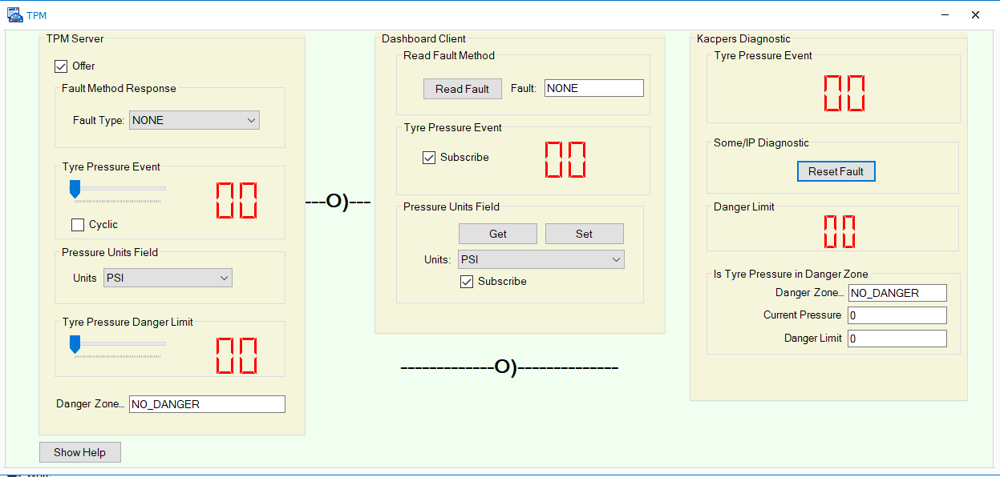 *GUI DIAGRAM*

# Specifications:

# Server

* const DWORD DANGER_PRESSURE_EVENT = 0x8003; // danger pressure event has id 0x8003
* const DWORD ZONE_EVENT = 0x8005; // zone event has id 0x8005
* const DWORD ResetSetterID = 33; // reset setter id
* const DWORD ResetGetterId = 34; // reset getter id
* const DWORD DanGetterId =35; //danger limit getter id
* const DWORD setDangerLimitlowID = 37; // setter low danger limit id
* const DWORD getDangerLimitLowID = 38; // getter low danger limit id
* const DWORD setDangerLimitHighID =40; // setter high danger limit id
* const DWORD getDangerLimitHighID =41; // getter high danger limit id
* const DWORD DanSetterId =36; // danger limit setter id
* const DWORD danZoneGetterID =45; // danger zone getter id

# SUB2

* const DWORD TYRE_PRESSURE_EVENT = 0x8001; //Tyre pressure Id
* const DWORD DANGER_PRESSURE_EVENT = 0x8003; // Danger limit id
* const DWORD ZONE_EVENT = 0x8005; // Danger zone event
* const DWORD FieldGetterID = 31; // Get Pressure id
* const DWORD ResetSetterID = 33; // Reset Id
* const DWORD setDangerLimitlowID = 37; // 40 danger limit id
* const DWORD setDangerLimithighID = 40; // 50 danger limit id

# ***SERVER:***

# Variables:

* DWORD danger_limit; // Event handle for tyre danger limit
* DWORD reset_b; // Field Handle for Reset Error
* DWORD dan_zone_limit; // Event handle for danger zone limit
* DWORD danlimit_low; // Field Handle for setting limit to 40
* DWORD danlimit_high; // field handle for setting limit to 50
* DWORD dan_limit_field; // field handle for danger
* const DWORD DANGER_PRESSURE_EVENT = 0x8003; // danger pressure event has id 0x8003
* const DWORD ZONE_EVENT = 0x8005; // zone event has id 0x8005
* const DWORD ResetSetterID = 33; // reset setter id
* const DWORD ResetGetterId = 34; // reset getter id
* const DWORD DanGetterId =35; //danger limit getter id
* const DWORD setDangerLimitlowID = 37; // setter low danger limit id
* const DWORD getDangerLimitLowID = 38; // getter low danger limit id
* const DWORD setDangerLimitHighID =40; // setter high danger limit id
* const DWORD getDangerLimitHighID =41; // getter high danger limit id
* const DWORD DanSetterId =36; // danger limit setter id
* const DWORD danZoneGetterID =45; // danger zone getter id

# Void StartServer:

//danger

danger_limit = SomeIpAddEvent(psi, DANGER_PRESSURE_EVENT,"Send_Dan_Limit");

CheckForSomeIpError();

//danger zone

dan_zone_limit = SomeIpAddEvent(psi, ZONE_EVENT, "Send_dan_zone_limit");

CheckForSomeIpError();

// adding limit to event group

SomeIpAddEventToEventgroup(peg, danger_limit);

CheckForSomeIpError();

// adding zone limit to event group

SomeIpAddEventToEventgroup(peg, dan_zone_limit);

CheckForSomeIpError();

// create another Eventgroup for the field notification

peg2 = SomeIpAddProvidedEventGroup(psi,EG2 );

CheckForSomeIpError();

//G

SomeIpAddMethod(psi,12,"onDangerZoneRequest");

CheckForSomeIpError();

// Initialise the fields to the default pressure units,Fault Type, And Danger Zone according to variable TPMS::Units

dataBuffer[0] = @TPMS::Units;;

dataBuffer[0] = @TPMS::FaultType;

dataBuffer[0] = @TPMS::DangerZone;

//Reset

SomeIpAddMethod(psi,33,"OnSomeIpResetFieldRequest");

CheckForSomeIpError();

//Danger Limit

SomeIpAddMethod(psi,34,"Dan_Limit_Field_Request");

CheckForSomeIpError();

//40

SomeIpAddMethod(psi,37,"OnFortySet");

CheckForSomeIpError();

//50

SomeIpAddMethod(psi,40,"OnFiftySet");

CheckForSomeIpError();

# Method to get the current danger limit

/*********************************************************************

* Handler for DangerLimit() method.

* Sets the field value to desired value and also update the system variable

* TPMS::DangerLimit

*********************************************************************/

void Dan_Limit_Field_Request( dword methodHandle, dword messageHandle, dword messageResponseHandle )

{

byte dataBuffer[1];

// Retrieve the method parameter from SOME/IP method call.

SomeIpGetData(messageHandle,1,dataBuffer);

CheckForSomeIpError();

@TPMS::DangerLimit = dataBuffer[0];

SomeIpSetData(dan_limit_field,1,dataBuffer);

CheckForSomeIpError();

// commit field content ... notification is sent

SomeIpCommitField(dan_limit_field);

CheckForSomeIpError();

// Echo the field value in the Setter response

SomeIpSetData (messageResponseHandle,1,dataBuffer);

CheckForSomeIpError();

}

# Method to Reset the Fault

/*********************************************************************

* Method that resets the fault type to be None when the user presses R or the button

*********************************************************************/

void OnSomeIpResetFieldRequest( dword methodHandle, dword messageHandle, dword messageResponseHandle )

{

byte dataBuffer[1];

// Retrieve the meth od parameter from SOME/IP method call.

SomeIpGetData(messageHandle,1,dataBuffer);

CheckForSomeIpError();

@TPMS::FaultType = 0;

// Echo the field value in the Setter response

SomeIpSetData (messageResponseHandle,1,dataBuffer);

CheckForSomeIpError();

}

# Method when 4 is pressed to set danger limit to 40

/*********************************************************************

* Method that sets the danger limit value to be 40 when the user presses 4

*********************************************************************/

void OnFortySet( dword methodHandle, dword messageHandle, dword messageResponseHandle )

{

byte dataBuffer[1];

// Retrieve the method od parameter from SOME/IP method call.

SomeIpGetData(messageHandle,1,dataBuffer);

CheckForSomeIpError();

@TPMS::DangerLimit = 40;

// Echo the field value in the Setter response

SomeIpSetData (messageResponseHandle,1,dataBuffer);

CheckForSomeIpError();

}

# Method when 5 is pressed to set danger limit to 50

/*********************************************************************

* Method that sets the danger limit value to be 50 when the user presses 5

*********************************************************************/

void OnFiftySet( dword methodHandle, dword messageHandle, dword messageResponseHandle )

{

byte dataBuffer[1];

// Retrieve the method od parameter from SOME/IP method call.

SomeIpGetData(messageHandle,1,dataBuffer);

CheckForSomeIpError();

@TPMS::DangerLimit = 50;

// Echo the field value in the Setter response

SomeIpSetData (messageResponseHandle,1,dataBuffer);

CheckForSomeIpError();

}

# Method that sends the tyre pressure and gets the danger limit and sends the danger zone value if pressure is bigger than limit

/**********************************************************************

* Send the tyrePressure event whenever the TPMS::Units variable changes.

* Linking the variable to a panel slider control causes the new value to

* be sent whenever the slider changes.

* if the pressure is higher or

* lower it sets the Dan_Zone_limit and triggers event

*********************************************************************/

on sysvar sysvar::TPMS::TyrePressure

{

SomeIpTriggerEvent(pev);

CheckForSomeIpError();

//DangerZone

if(@TPMS::TyrePressure>@TPMS::DangerLimit )

{

@TPMS::DangerZone=1;

SomeIpTriggerEvent(dan_zone_limit);

CheckForSomeIpError();

}

if(@TPMS::TyrePressure<@TPMS::DangerLimit)

{

@TPMS::DangerZone=0;

SomeIpTriggerEvent(dan_zone_limit);

CheckForSomeIpError();

}

}

# Method that sends the danger limit and gets the pressure value and sends the danger zone value if pressure is bigger than limit

/**********************************************************************

* Sends the current danger limit value and if the pressure is higher or

* lower it sets the Dan_Zone_limit and triggers event

*********************************************************************/

on sysvar sysvar::TPMS::DangerLimit

{

SomeIpTriggerEvent(danger_limit);

CheckForSomeIpError();

// set value of field data

//DANGER ZONE

if(@TPMS::TyrePressure>@TPMS::DangerLimit )

{

@TPMS::DangerZone=1;

SomeIpTriggerEvent(dan_zone_limit);

CheckForSomeIpError();

}

if(@TPMS::TyrePressure<@TPMS::DangerLimit)

{

@TPMS::DangerZone=0;

SomeIpTriggerEvent(dan_zone_limit);

CheckForSomeIpError();

}

}

# Method to get the current danger zone value when G is pressed

/***********************************************************************

* Danger Slider, returns the value from the slider for the G button

*********************************************************************/

void onDangerZoneRequest( dword methodHandle, dword messageHandle, dword messageResponseHandle )

{

byte dataBuffer[1];

dataBuffer[0] = @TPMS::DangerLimit;

// Return the selected fault type from the TPMS panel.

SomeIpSetData (messageResponseHandle,1,dataBuffer);

CheckForSomeIpError();

}

# Method that sends the current value of danger limit to the Sub2

/**********************************************************************

* Function that sends the current danger limit value to the Sub2.

*********************************************************************/

void Send_Dan_Limit(DWORD eventHandle, DWORD messageHandle)

{

byte dataBuffer[1];

writeEx(0,1,"\nTPMS-SOME/IP: Preparing to send danger limi event." );

// Insert danger limit value in the event message.

dataBuffer[0]=@TPMS::DangerLimit;

SomeIpSetData(messageHandle,1,dataBuffer);

CheckForSomeIpError();

}

# Method that sends the current danger limit zone to Sub2

Sends either a 0 or 1 as in the table.

/**********************************************************************

* Function that sends the current danger limit zone value to the Sub2.

*********************************************************************/

void Send_dan_zone_limit(DWORD eventHandle, DWORD messageHandle)

{

byte dataBuffer[1];

writeEx(0,1,"\nTPMS-SOME/IP: Preparing to send danger zone value event." );

// Insert danger limit value in the event message.

dataBuffer[0]=@TPMS::DangerZone;

SomeIpSetData(messageHandle,1,dataBuffer);

CheckForSomeIpError();

}

# ***SUB2:***

# Variables:

* DWORD dan_zone_limit; // event call to get limit val
* DWORD resetFaultCodeSetter; //method call to reset the fault
* DWORD setDangerLimitLow; // method call to set 40 danger limit
* DWORD setDangerLimitHigh; // method call to set 50 danger limit
* DWORD Current_dan_val_method; // global to get g val
* DWORD dan_limit; // danger limit
* const DWORD TYRE_PRESSURE_EVENT = 0x8001; //Tyre pressure Id
* const DWORD DANGER_PRESSURE_EVENT = 0x8003; // Danger limit id
* const DWORD ZONE_EVENT = 0x8005; // Danger zone event
* const DWORD FieldGetterID = 31; // Get Pressure id
* const DWORD ResetSetterID = 33; // Reset Id
* const DWORD setDangerLimitlowID = 37; // 40 danger limit id
* const DWORD setDangerLimithighID = 40; // 50 danger limit id

# On start

//Danger Limit Event

dan_limit = SomeIpCreateEventConsumer(csi,0x8003,"getDangerLimitMethod");

CheckForSomeIpError();

//Danger Zone Event

dan_zone_limit = SomeIpCreateEventConsumer(csi,0x8005,"OnZoneResponse");

CheckForSomeIpError();

//Pressure Event

gMcGetter = SomeIpCreateMethodCall(csi,FieldGetterID,"OnFieldGetterResponse");

CheckForSomeIpError();

//RESET

resetFaultCodeSetter = SomeIpCreateMethodCall(csi,ResetSetterID,"onFaultResetResponse");

CheckForSomeIpError();

//40

setDangerLimitLow = SomeIpCreateMethodCall(csi,setDangerLimitlowID,"onDanFortyResponse");

CheckForSomeIpError();

//50

setDangerLimitHigh = SomeIpCreateMethodCall(csi,setDangerLimithighID,"onDanFiftyResponse");

CheckForSomeIpError();

// G press

Current_dan_val_method = SomeIpCreateMethodCall(csi,12,"OnDangerResponse");

CheckForSomeIpError();

//Works also without any Fibex/ARXML but only with SomeIpSetData and not SomeIpSetValueDWord (online help)

SomeIpSetData(Current_dan_val_method,elCount(payload),payload);

CheckForSomeIpError();

# Method to get the current value of Danger Zone from server

/**********************************************************************

* Gets the current value of the Danger zone event from the server

*********************************************************************/

void OnZoneResponse(DWORD eventHandle, DWORD messageHandle)

{

DWORD res; // value of return parameter

char data[1];

// get the returned parameter values

res = SomeIpGetData(messageHandle,elCount(data), data);

CheckForSomeIpError();

writeEx(0,1,"\nDASH-SOME/IP: Danger zone() method return value: %d ",data[0]);

@SUB2::DangerZone= data[0];

}

# Methods that Write out to the write window in the sub2.

/**********************************************************************

* Method that writes out the Fault response

*********************************************************************/

void onFaultResetResponse(dword methodCallHandle, dword messageResponseHandle )

{

writeEx(0,1,"\nSUB2-SOME/IP: Reset Fault Code() method response received.");

}

/**********************************************************************

* Method to write out when 4 is pressed

*********************************************************************/

void onDanFortyResponse(dword methodCallHandle, dword messageResponseHandle )

{

writeEx(0,1,"\nSUB2-SOME/IP: dan_limit 40 Code() method response received.");

}

/**********************************************************************

* Method to write out when 5 is pressed

*********************************************************************/

void onDanFiftyResponse(dword methodCallHandle, dword messageResponseHandle )

{

writeEx(0,1,"\nSUB2-SOME/IP: dan_limit 50 Code() method response received.");

}

# Event Handler for when the reset button is pressed

on sysvar_update SUB2::ResetFaultCode

{

byte dataBuffer[1];

if (@this == 1) // prevent double-triggering with panel button controls

{

dataBuffer[0]=0;

// set value of field content

SomeIpSetData(resetFaultCodeSetter,1,dataBuffer);

CheckForSomeIpError();

// call setter method

SomeIpCallMethod(resetFaultCodeSetter);

CheckForSomeIpError();

}

}

# Method to get the current danger limit value

/**********************************************************************

* Method to get the current Danger Limit Value

*********************************************************************/

void getDangerLimitMethod(DWORD danHandle, DWORD messageHandle)

{

DWORD res; // value of return parameter

char data[1];

// get the returned parameter values

res = SomeIpGetData(messageHandle,elCount(data), data);

CheckForSomeIpError();

writeEx(0,1,"\nSUB2-SOME/IP: DangerPressure event data received: %d ",data[0]);

@SUB2::DangerDsp = data[0];

}

# Method when the r key is pressed to run the resetFaultCodeSetterMethod

/**********************************************************************

* When the r key is pressed the resetFaultCodeSetter Method is run

*********************************************************************/

on key 'r'

{

byte dataBuffer[1];

dataBuffer[0]=0;

{

// set value of field content

SomeIpSetData(resetFaultCodeSetter,1,dataBuffer);

CheckForSomeIpError();

// call setter method

SomeIpCallMethod(resetFaultCodeSetter);

CheckForSomeIpError();

}

}

# Method for when the 4 key is pressed, to run the setDangerLimitLow method -40

/**********************************************************************

* When the key 4 is pressed the setDangerLimitLow method is run

*********************************************************************/

on key '4'

{

byte dataBuffer[1];

dataBuffer[0]=0;

{

// set value of field content

SomeIpSetData(setDangerLimitLow,1,dataBuffer);

CheckForSomeIpError();

// call setter method

SomeIpCallMethod(setDangerLimitLow);

CheckForSomeIpError();

}

}

# Method for when the 5 key is pressed, to run the setDangerLimitHigh method -50

/**********************************************************************

* When the key 5 is pressed the setDangerLimitHigh method is run

*********************************************************************/

on key '5'

{

byte dataBuffer[1];

dataBuffer[0]=0;

{

// set value of field content

SomeIpSetData(setDangerLimitHigh,1,dataBuffer);

CheckForSomeIpError();

// call setter method

SomeIpCallMethod(setDangerLimitHigh);

CheckForSomeIpError();

}

}

# Get the DangerLimit Value

/**********************************************************************

* when G is pressed, Current_dan_val_method is triggered.

*********************************************************************/

on key 'g'

{

SomeIpCallMethod(Current_dan_val_method);

CheckForSomeIpError();

}

/**********************************************************************

* Function to handle when the g button is pressed, it writes out the danger value in the

* write window

*********************************************************************/

void OnDangerResponse(dword methodCallHandle, dword messageResponseHandle )

{

DWORD res; // value of return parameter

char data[1];

// get the returned parameter values

res = SomeIpGetData(messageResponseHandle,elCount(data), data);

CheckForSomeIpError();

writeEx(0,1,"\nDASH-SOME/IP: Get Danger limit() method return value: %d ",data[0]);

@SUB2::DangerDsp = data[0];

}

# Results

## Server Start



## Reset Button Pressed

**Before**

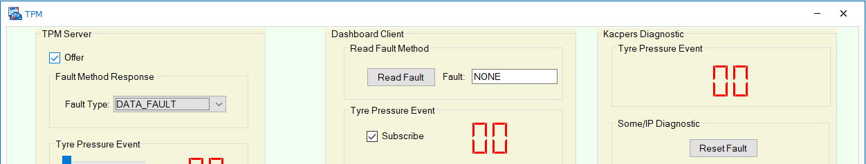

**After**

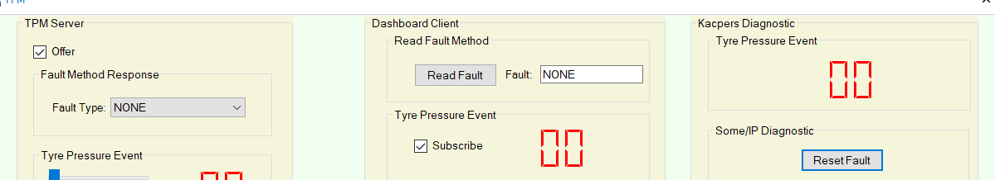

**Write Window**



## Tyre Pressure Danger Limit 0-60

**Before** 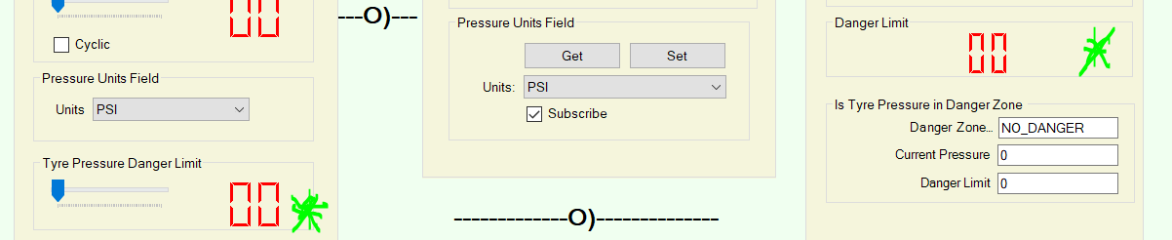

**After**

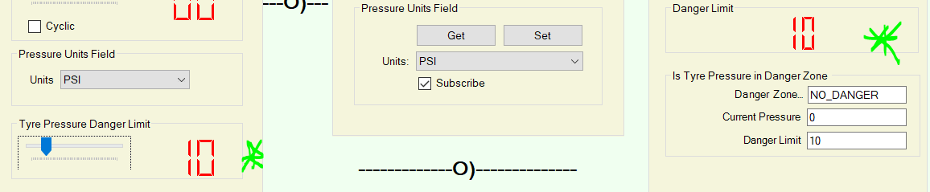

**Write Window**





## Danger limit Event - > When Pressure is bigger than Danger limit

**Before** 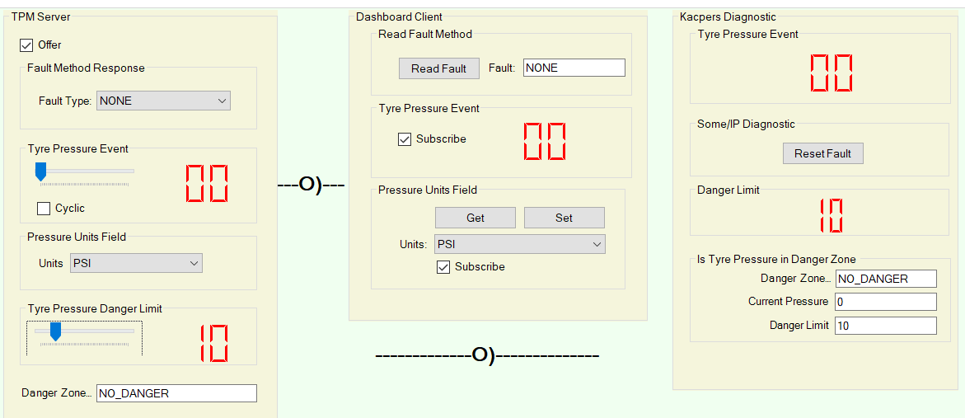

The Value of tyre pressure event is less than tyre pressure danger hence no danger is displayed, I will now change the value of tyre pressure to be greater than 10.

**After** 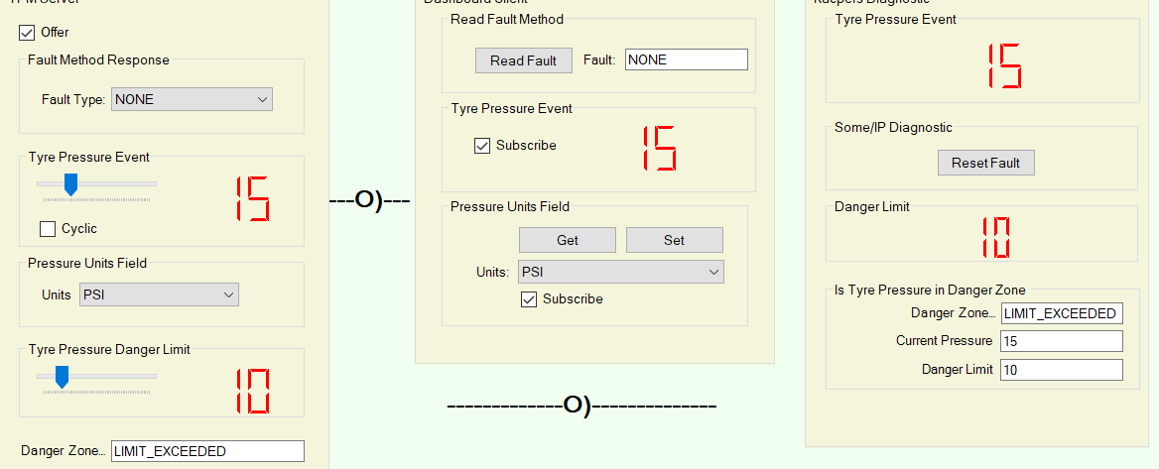

The value changed in the systems variable table from 0->1 i.e. from no danger to limit exceeded with the current pressure and danger limit visible, due to the fact that 15, tyre pressure is bigger than 10, the danger limit.

**Write Window**

* **Before** **(No Danger)**
* **After (In Danger Zone)** 

## When R is pressed

When R is pressed, and the list is the last thing used, Canoe goes to Radio Fault due to it thinking and searching the list of possibilities that start with R, so that’s Canoes bug, press anywhere on the GUI and then press R to make sure the list is not active for the to work properly.

**Before**

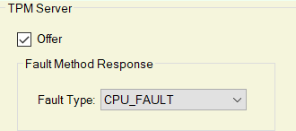

**After**

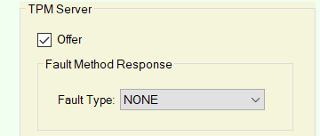

**Write Window**



## When 4 is pressed to set danger limit to 40

**Before**

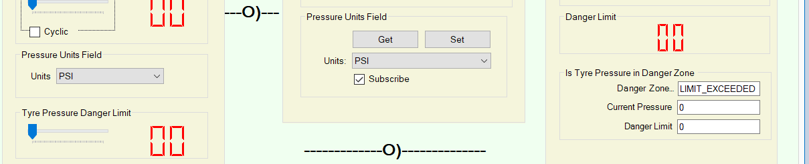

**After**

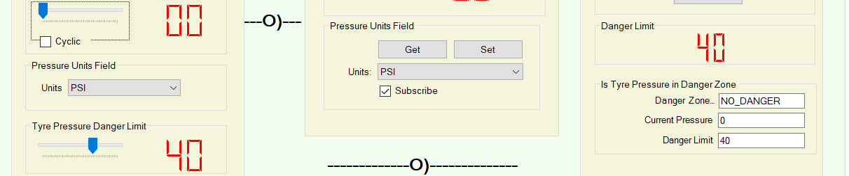

**Write Window**





## When 5 is pressed to set danger limit to 50

**Before** 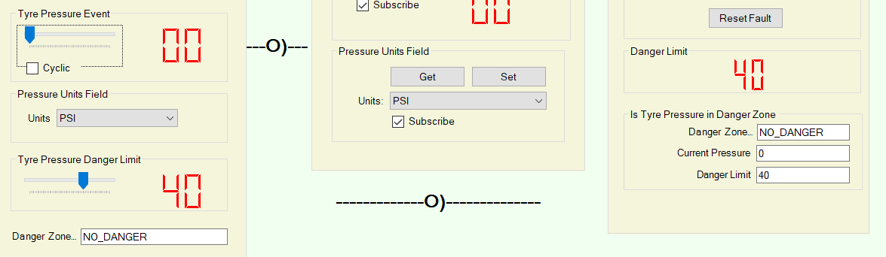

**After** 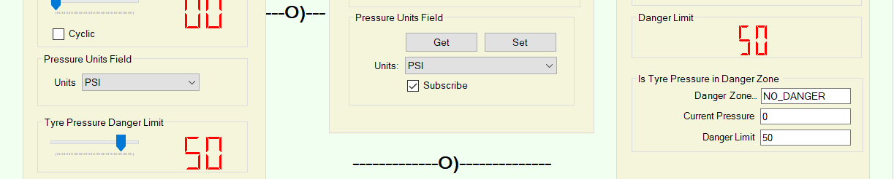

**Write Window**



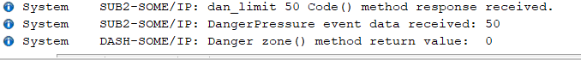

## When G is pressed

**Before**

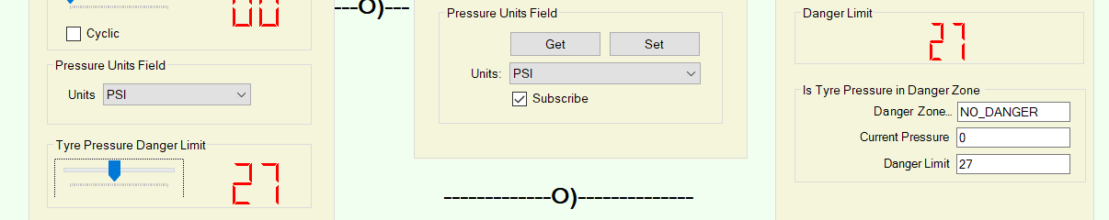

**After**



**Write Window**

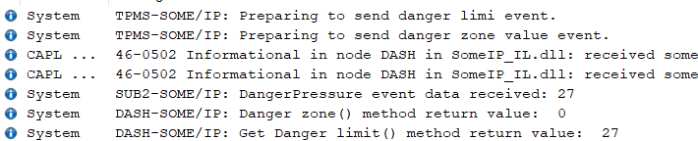

**When Value is changed**

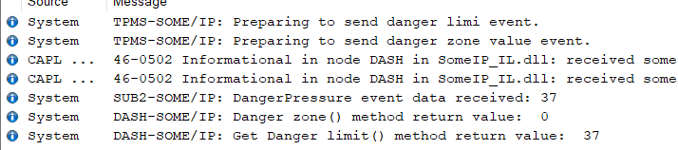

**When Value is constant**

