Memo - Manual

Features | How to play? | Credits

1. **Features of the „Memo” game**

* Made in Processing
* Five different user windows (GUI):
  + Main Menu
  + Leaderboards
  + Help Menu
  + Game interface
  + Score Menu
* Custom cursor (original) model
* Custom types of buttons:
  + Leaderboards
  + Game
  + Exit
  + Help
  + Mute
  + Back-to-menu
  + Memo (with display)
* Save functionality
* Leaderboard functionality
* Button Highlight functionality
* Button Click functionality
* Overall Sound functionality
* Mute functionality
* Mouse functionality
* Keyboard functionality
* Time functionality
* Score calculation based on timed performance (the faster you find all Memo pairs, the better)
* Randomized id allocation to Memo board
* Time display
* Keyboard input display
* Game Class
* Memo Class
* Full Screen display

1. **How to Play?**

**I have prepared a Gameplay video** for the purposes of clarity, and clear showcase of a sample gameplay of “Memo” game. You can find it in this directory with explanatory screenshots In Screenshots subdirectory).

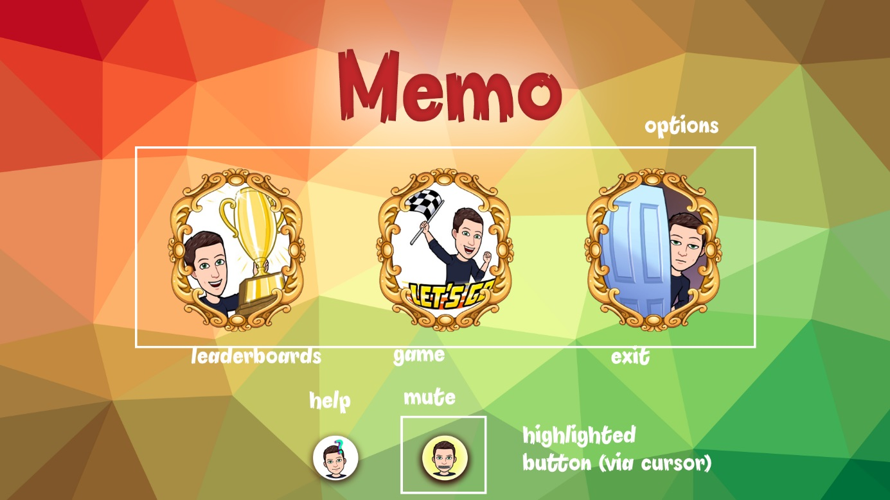

Figure 1: Game Main Menu

Game Main menu gives you five multifunctional buttons at your disposal (player can navigate back and forth via mouse clicks), including an option to go to leaderboards menu, to start the game, to exit the game, to see help menu, and to mute/unmute all sounds (highlighted Fig. 1). Please note a plethora of sounds and highlight effects on all buttons.

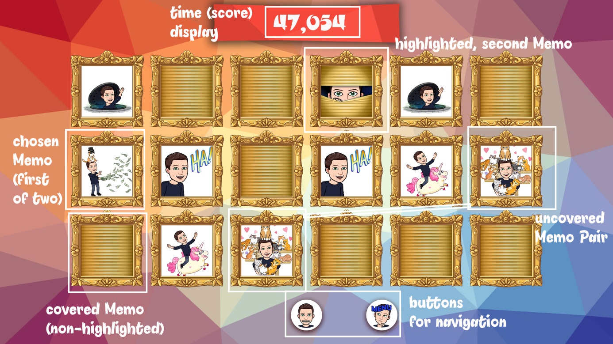

Figure 2: During the Memo round...

The above is the sample output during the Memo round after clicking Game button with the mouse. Note that you can abandon the game at any moment before winning by clicking the menu button on the bottom – after coming back, you will start a new game. The goal of this “Memo” puzzle is to uncover all pairs of of Memo images in the shortest possible period of time. The player can click any memo at first, thus uncovering it, if the second clicked memo (not the same), contains the same picture, the pair becomes visible with a pleasant sound until exiting or winning the game. If the image inside second Memo is different, however, the player will be notified by a sound and the first memo will become hidden once again.

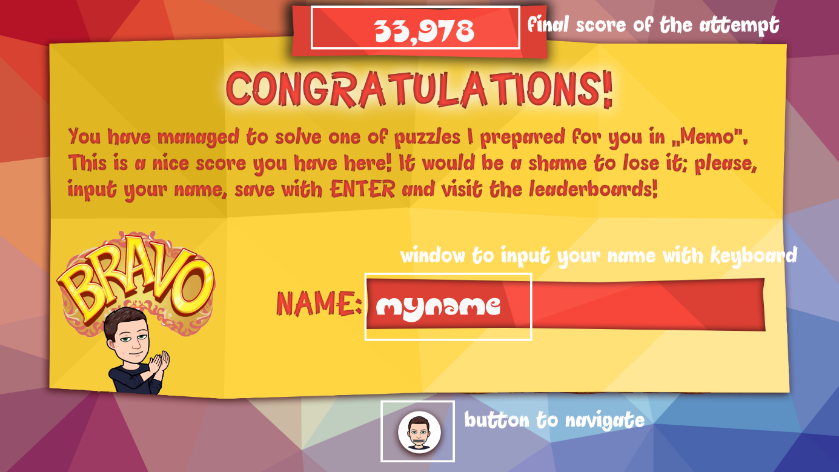

Figure 3: Name Input after winning the round.

With uncovering all the Memo pairs, the player wins the current round of Memo. Simultaneously, the time on the display stops to allow the player to see the final score. The pop-up window allows the keyboard functionality. Player can input any name up to 10 characters. Player can also delete characters with BACKSPACE and DELETE. Player saves the result with ENTER, thus also saving the score in scores.txt. The game immediately goes to the main menu after saving the score. Player can now view the Top 7 scores in the Leaderboards menu.

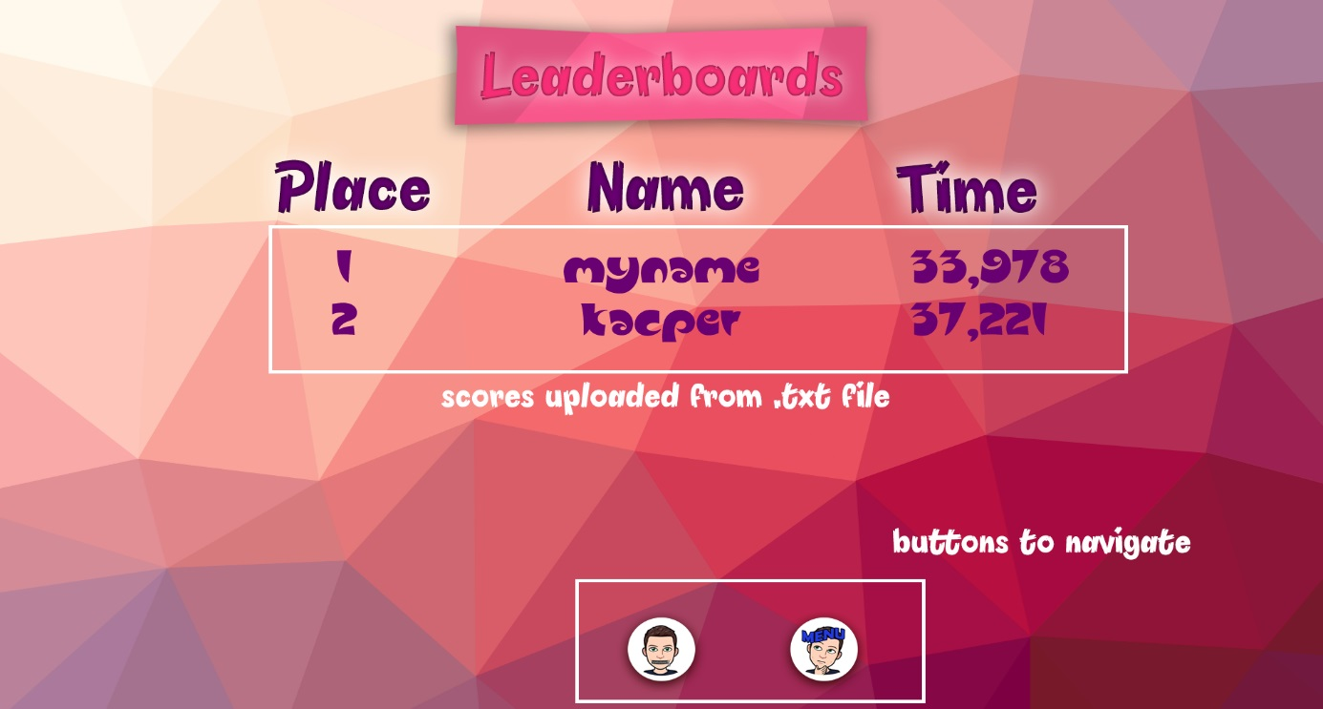

Figure 4: Leaderboards Menu with sample scores.

1. **Credits**

* Background images generated with <https://trianglify.io/>
* Memo themed images generated with Bitmoji App
* Fonts used: “Pineapple Demo” & “Slugfest NF”
* Sounds taken from The Legend of Zelda: Wind Waker & The Legend of Zelda: Breath of The wild ([https://www.sounds-resource.com/wii_u/  
  thelegendofzeldabreathofthewild/](https://www.sounds-resource.com/wii_u/thelegendofzeldabreathofthewild/))
* Game created by Kacper Madejek in Processing 3.5.3