Report on the Awards Reception 2011

What a pleasure to gather on May 23, 2011, with parents, friends and teachers of thirty (30) high school and college students and with three 50-year ACS members for our 38th Annual Awards Celebration at the Atrium of the Chemistry Building of Western Michigan University. {Our Awards Committee Chairman will deliver the certificates to our Section’s three remaining 50-year members and our one 60-year member who were unable to attend}.

It was the 29th anniversary of the Competitive Examination awards to area students who scored in the top tier on two rounds of chemistry examinations, and the 38th year of honoring Outstanding High School Chemistry Students nominated by our Section’s high school teachers and one of our Section’s high school teachers. Each awardee received a copy of the 14th edition of the Merck Index, and a monetary award and/or a gift card to a local bookstore. The young people were treated to short oral vignettes presented by our 50-year members concerning how and when they were “hooked” on Chemistry – “Chemistry Sets” were one way, motivating teachers were another.

Lending credence to the importance of an inspiring high school teacher was the fact that our 2011 High School Teacher honoree, first-year teacher David Williams of Lawton High School, was able to give recognition to his high school chemistry teacher, Doreen Odziana, who was present at the gathering and had herself been honored by our Section in a previous year. As a true teacher she prodded him to return next year with one of his students!

Recognition was given to one of our Section’s members (John B. Miller) for his selfless contributions to our Section’s outreach programs and as a two-term treasurer on the Section’s Executive Committee.

The Committee also initiated the awarding of ACS Past-Chair pins to members who have chaired the Local Section. Since this year marked the first such presentation, four such awards were made: to Marvin Grostic (50-year member, Chair 1996); James Kiddle, Chair 2008; Donald Schreiber, Chair 2008-9; Susan Stapleton, Chair 2010.

Lydia Hines
Awards Committee Chair – KACS

attachments:
photos and program with list of awardees
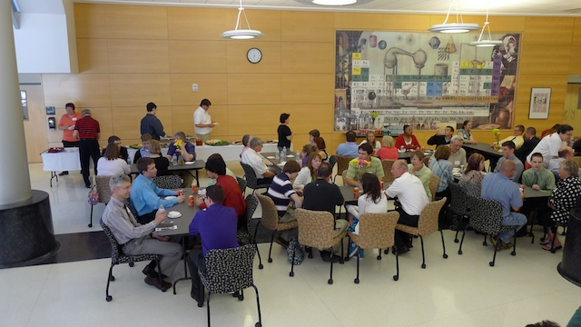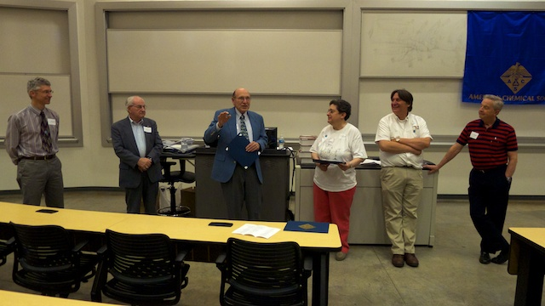
Reception for all guests in entry of Chemistry Bldg. Presentation of 50-year membership awards

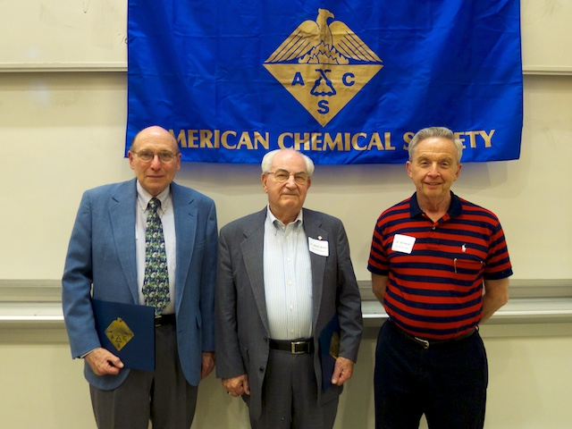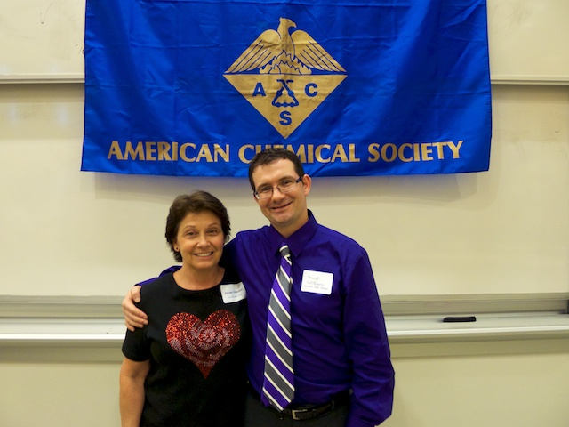
50-year members Dave Duchamp, Marv Grostic, Ed Hessler Outstanding teacher David Williams with his high school teacher Doreen Odziana, (Paw Paw HS)

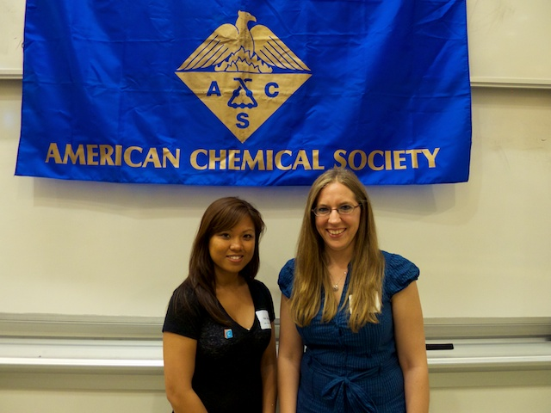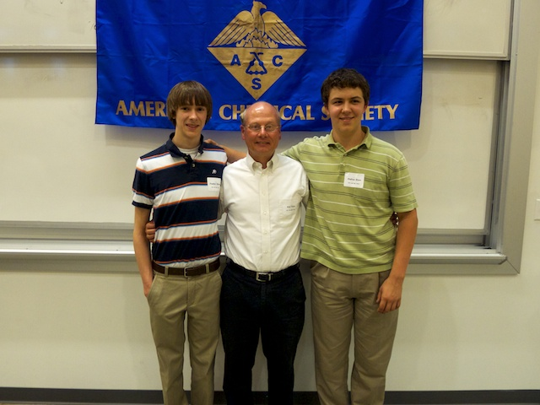
Kim Huynh (WMU) & Judith Kamm (K-College) Stephen Norton (l) and Andre Gruss (r) with HS teacher Brad Portis (Gull Lake HS)
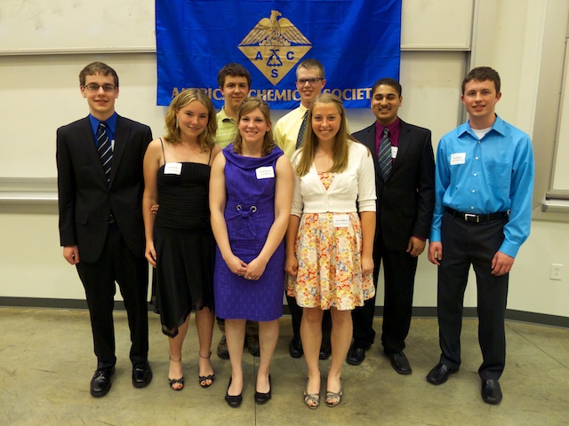
Outstanding High School Chemistry students (L to R): John West (Hackett), Katarina Haist (Comstock), Andrew Gruss (Gull Lake),, Emily Hickmkott (Decatur), Ryan Werme (Portage Northern), Kelli Veldman (Portage Central), Tibin John (Kalamazoo Central), Cole Wunderlich (KAMSC)

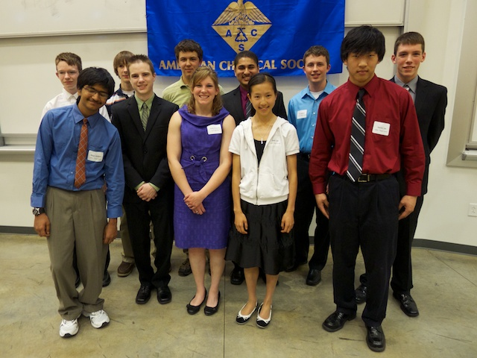
Competitive Exam winners: Back Row (L to R) Daniel Woodworth (K Central & KAMSC), Stephen Norton (Gull Lake), Andrew Gruss (Gull Lake), Tibin John (Kalamazoo Central), Cole Wunderlich (Portage Northern & KAMSC), Jager Hartman (Parchment & KAMSC); Front Row (L to R) Raoul Wadhwa (Portage Northern & KAMSC), Chad Bilicke (K Central & KAMSC), Emily Hickmott (Decatur), Katie Lee (Portage Northern & KAMC),. Keenan Lee (Portage Northern & KAMSC)
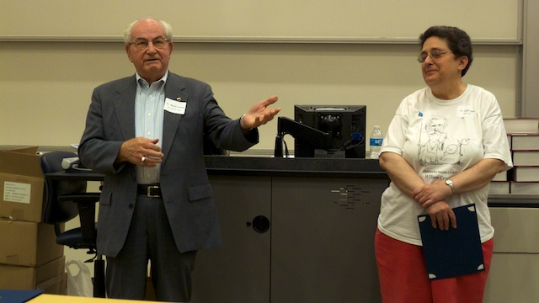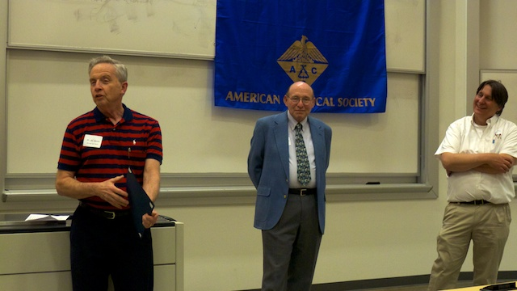
50-year member Marvin Grostic with Lydia Hines 50-year members Ed Hessler and Dave Duchamp with Don Schreiber

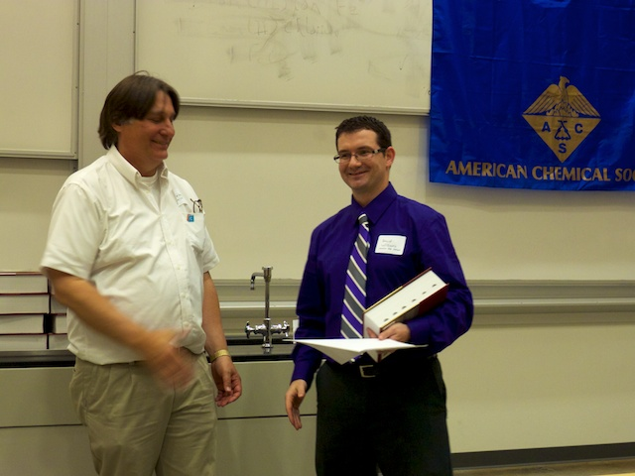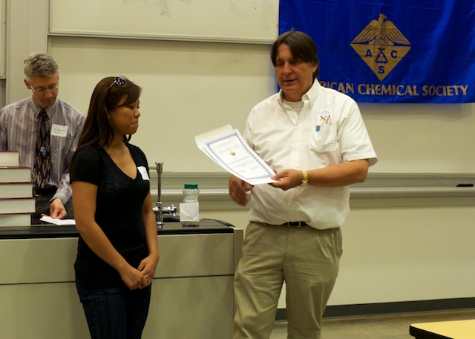
Outstanding HS teacher David Williams (Lawton) Kim Huynh (WMU)

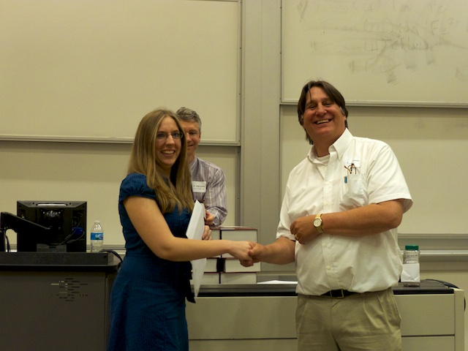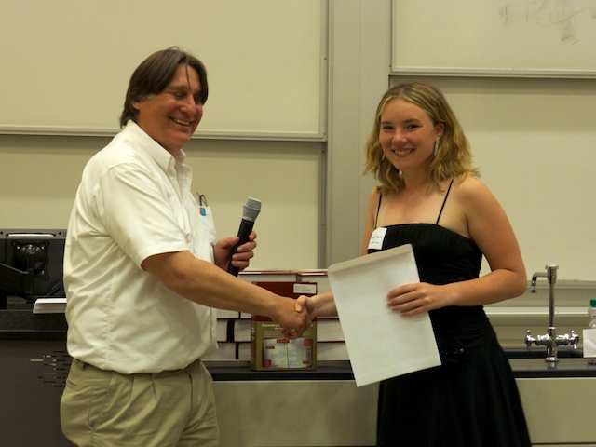
Judith Kamm (K-College) Katarina Haist (Comstock High School)

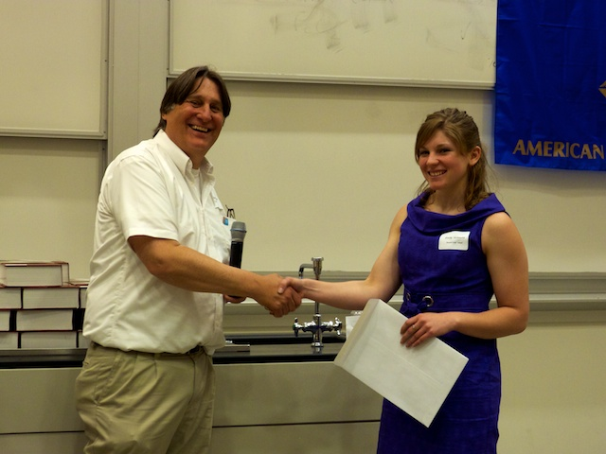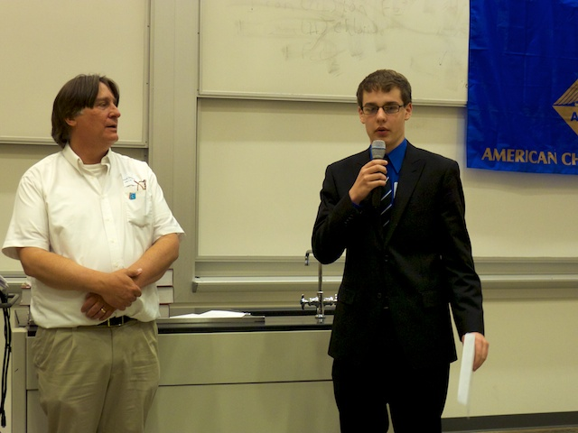
Emily Hickmott (Decatur HS) John West (Hackett Cathollic Central High School)

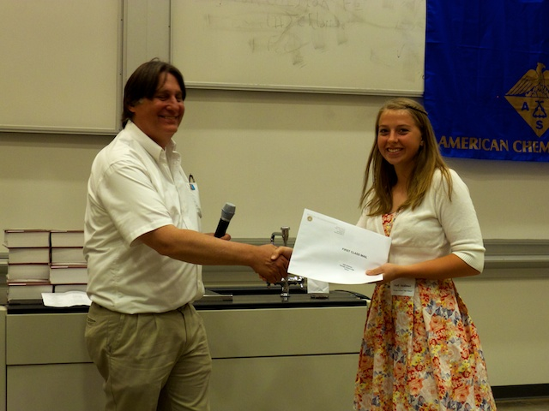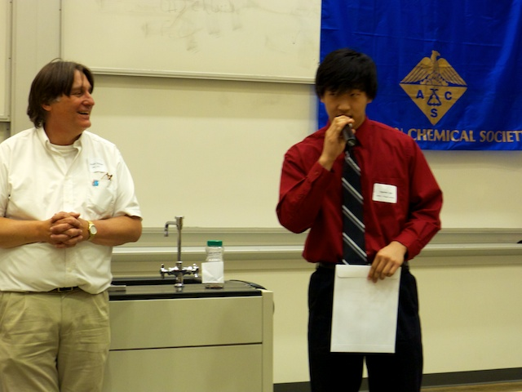
Kelli Veldman (Portage Central HS) Keenan Lee (Portage Northern and KAMSC)

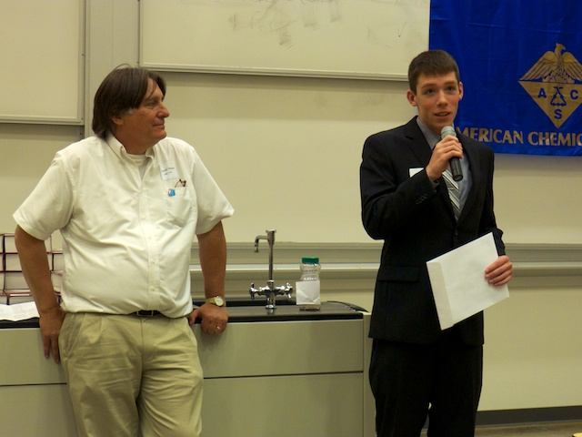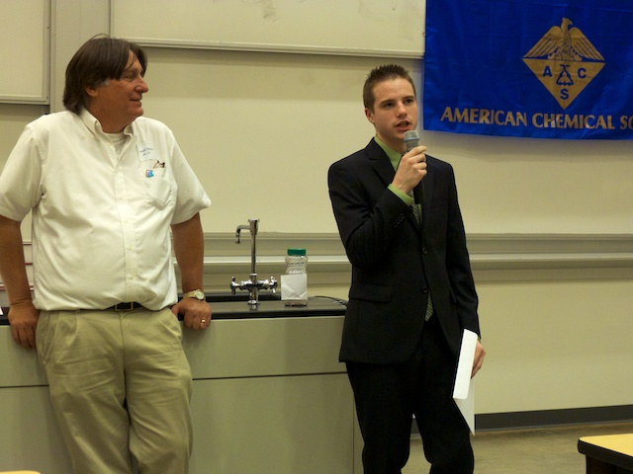
Jager Hartman (Parchment and KAMSC) Chad Bilicke (Kalamazoo Central and KAMSC)
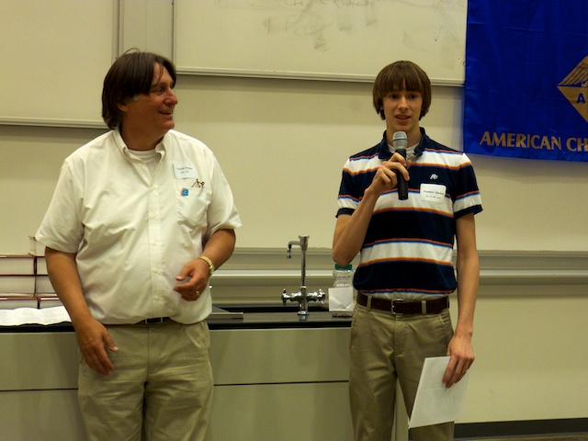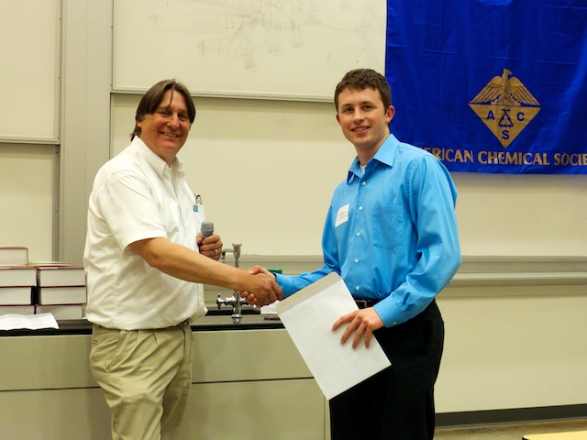
Stephen Norton (Gull Lake HS) Cole Wunderlich (Portage Northern & KAMSC)

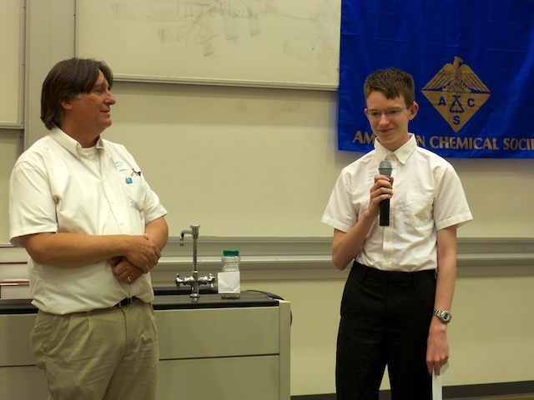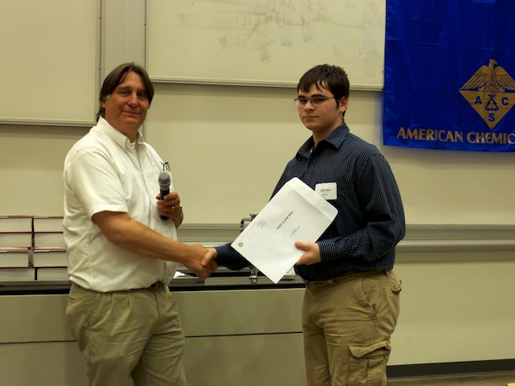
Daniel Woodworth (Kalamazoo Central and KAMSC) Josh Hirt (Paw Paw HS)

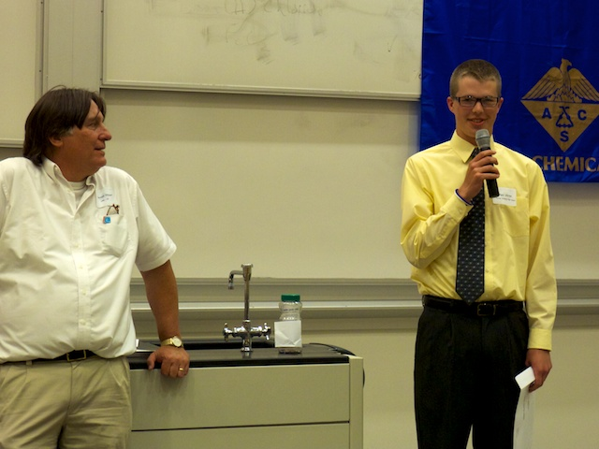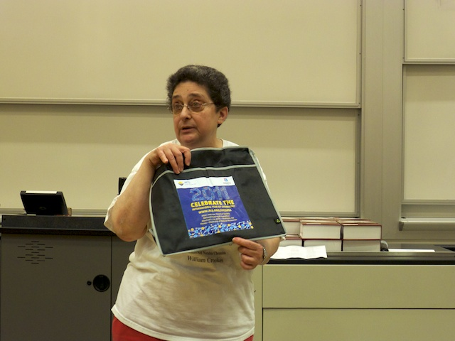
Ryan Werme (Portage Northern) Lydia Hines (councilor) explaining IYC 2011
2011 is the thirty eighth year that the Kalamazoo Section of the American Chemical Society has recognized an Outstanding Chemistry Teacher and the Outstanding Senior Students in Chemistry; it is the twenty ninth year that the Section has organized and sponsored the High School Competitive Scholarships in Chemistry. Support for the Competitive Scholarships program has been received from Pfizer Inc., the L. Perrigo Company, the A.M. Todd Company, KALSEC, Inc. and private donations. The purpose of these programs, and of our recognition of Outstanding Senior Students in Chemistry, is to acknowledge and encourage academic excellence. It is the fond expectation of the Kalamazoo Section that this recognition will stimulate a continuing interest in science, and by so doing provide to these students – regardless of their ultimate area of study – the knowledge necessary for the thoughtful evaluation of the many issues in science and technology now facing our society.

AMERICAN CHEMICAL SOCIETY
Kalamazoo Section
http://www.wmich.edu/acs/

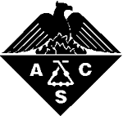

2011
High School, College and Kalamazoo Section Award Program
Monday, May 23, 2011

Chemistry Building
Western Michigan University

Outstanding College Chemistry Students
Kim Huynh, WMU
Judith Kamm, K-College

2011 KACS Outstanding High School Chemistry Teacher
Tibin John
Kalamazoo Central High School

Outstanding High School Chemistry Students

Katarina Haist
Comstock High School

Emilly Hickmott
Decatur High School

Andrew Gruss
Gull Lake High School

John West
Hackett Catholic Central High School

Tibin John
Kalamazoo Central High School

Andrew Westendorp
Kalamazoo Christian High School

Cole Wunderlich
KAMSC

Josh Hirt
Paw Paw High School

Will Fitzell
Plainwell High School

Kelli Veldman
Portage Central High School

Ryan Werme
Portage Northern High School
Awards Program
Host: Dr. Donald Schreiber
6:00 Reception
6:45 Awards
Opening Remarks

Dr. Doug Williams, Chair KACS

Fifty Year Members

Dr. Phil B. Bowman
Dr. David J. Duchamp
Dr. Marvin Ford Grostic
Dr. Gene E. Heasley
Dr. Edward J. Hessler
Mr. Steve A. Mizsak

Sixty Year Members

Dr. Donald E. Ayer

Outstanding College Chemistry Students

KACS Outstanding High School Chemistry Teacher Presentation

Outstanding High School Chemistry Students Presentation

Competitive Scholarship Presentation

Kalamazoo Section Award
2010 Competitive Scholarship Winners
Tibin John – Kalamazoo Central
First Place ($600)
Keenan Lee - Portage Northern & KAMSC
Second Place ($500)
Jager Hartman – Parchment & KAMSC
Third Place ($400)
Chad Bilicke - Kalamazoo Central & KAMSC
Fourth Place ($300)
Harmakal Singh – Wayland Union
Fifth Place ($200)
Elliot Mulder – Hamilton
Sixth Place ($100)
Cole VanHarn – Hamilton
Seveth Place ($100)
Stephen Norton – Gull Lake
Eighth Place ($100) (tie)
Cole Wunderlich - Portage Northern & KAMSC
Eighth Place ($100) (tie)
Katie Lee - Portage Northern & KAMSC
Tenth Place ($100) (tie)
Kelsey Sternberg - Hamilton
Tenth Place ($100) (tie)

Honorable Mention ($50)
Emily Bussis – Hamilton
Taylor Compton – Hamilton
Ashley Corrêa – Plainwell
Andrew Gruss – Gull Lake
Danielle Hamann – Gull Lake
Emilly Hickmott – Decature
Raoul Wadhwa – Portage Northern & KAMSC
Stuart Wheaton – Loy Norrix & KAMSC
Daniel Woodworth - Kalamazoo Central & KAMSC

