

Generic Component Framework for Qt Applications
for GCF - Version 2.0

by
Prashanth N Udupa
VCreate Logic Private Limited (www.vcreatelogic.com)
Email: 


Table of Contents
Table of Contents 2
Preface 4
Introduction 5
Thumb-Rules in software design 5
Divide and rule 5
Establish a constitution 5
Similarity in diversity 6
Re-usability 6
Bring them together 6
Component Frameworks 7
Brief history of GCF 7
Getting Started with GCF 9
How to divide and rule in GCF? 9
GCF's constitution for applications 10
Whats similar among components in GCF? 11
Reusability and GCF 11
How GCF brings them all together 12
Case Study: A simple Photo Browser application. 14
Step 1: Create application's directory structure and basic code with CreateAppTemplate 14
Step 2: Compile the application 15
Step 3: Explore ComponentLoaderComponent.xml 17
Step 4: Implement the directory browser component 19
Step 5: Implement the photo viewer component 23
Using actions, menus, toolbars 26
Using functionality exposed by other components 28
Service and Interface methods in AbstractComponent 28
Searching for functionality in GCF 29
Inter-Process Communication (IPC) in GCF 31
Key classes in GCF/IPC Layer 31
Remote-Access-Enabling Photo Browser 32
Granting permission for remote access 32
Testing remote access 33
Monitoring IPC Messages 36
Using ActiveX components in GCF 38
Customizing ActiveX creation and destruction 40
Using KParts components in GCF 41
Loading KParts 41
Customizing part creation and destruction 43
Using the Menu-Strip 45
MenuStrip is __NOT__ Ribbon 45

Preface
Graphical User Interfaces have revolutionized the way people think of and interact with computers today. Young computer users may not even be aware of the old terminal based interfaces because of the simple fact that most applications today are GUI applications.
Developing good user interfaces is a challenging task. Even more challenging is the task maintaining and upgrading huge UI applications. Any developer who has been involved in writing large scale UI application software would agree with this. There are a plethora of UI Widget Libraries available in the software world today to help ease out UI application development. There are also several application frameworks that help provide structure to UI applications and hence make it easy for maintaining and upgrading them. This document describes one such “application framework” written by the author of this document.
Generic Component Framework or GCF as it is called in the rest of the document is a framework that is built using Qt 4.4.x. Using this framework you can compose your application as a collection of components.

Introduction
Software applications today are born large and grow even larger. Developers have to architect their applications in a way that makes it easy for them to add new features, issue bug fixes, service existing features and theoretically maintain the application for ever.
More over development is usually not a one man show. Several people (developers, graphics designers, UI designers, documentation experts) work on the same project. Many a times, especially in open-source software, new features are added by developers who are not in the core group. The architecture of the application should hence support distributed development and third-party involvement.

Thumb-Rules in software design
This being the case, we must take extra care while designing large scale software applications. As with any part of software engineering, software design is done by following a bunch of thumb rules. Lets look at just five of the most often used thumb rules.
- Divide and rule
- Establish a constitution
- Similarity in diversity
- Re-usability
- Bring them together

Divide and rule
Software designers love this rule. Essentially this rule means that we should collect as many requirements of to-be-developed software and then divide them into manageable chunks. Then each chunk, or module as we would like to call it, should be worked on independently.
Divide and rule helps in minimizing the startup complexity of the design. It allows us to work on the design one step at a time.

Establish a constitution
Every application has a purpose. It hence has its own personality. The personality of an application can be best summed up by a book-of-rules that it imposes on the modules existing in it.
For example, modules in a “backup and restore” software usually have something to do with, well, backup and restore. We wouldn't expect to see a fully blown media-player module in a “backup and restore” program. Also the modules in such a program behave according to the global rules set by the program. The “backup and restore” software hence establishes some rules so that only related entities can take part in its processes. In software such rules are usually established by means of certain “compulsory” interfaces that new components have to implement or connect to.
Another example, but this one is from the real world. Every nation has a constitution. The constitution articulates the duties and rights of each and every person in that nation. A person that lives by those duties and rights is called as “citizen”. Every citizen, as long as he does his duties and makes use of his rights, has the freedom to do anything within the nation. Different nations can come together and work on certain things, provided their constitutions match. The same is the case in Software.
The “design” of a software should list out certain meaningful rules and regulations that modules can abide by and do their task.

Similarity in diversity
Even though a large scale software system comprising of several different modules, we must ensure that all the modules are atleast partly similar at some fundamental level. This makes management simple.
Programming languages provide language-constructs to describe the “similarity” aspect of modules in an application. Class hierarchies, in object oriented languages, help capture similar aspects of a range of modules in a base class, and move the specifics to subclasses. That way a “management module” can work with the base class and not worry about the specifics.

Re-usability
Software development costs time, energy and money. It would be pointless to invest in developing a module that someone else has already developed. Sure, as developers, we get kicks out of starting something from the scratch. Although I am not sure if a majority of us are comfortable with the itch caused by the scratch.
Re-usability is basically about two things
- Writing modules so that they __can__ be reused in the current application and also in others.
- Using reusable modules in software other than the one they were originally written for.
When developers write modules keeping re-usability in mind, the result is always neat code and well defined structure of the module. For modules to be reusable, they should be structured and written in a special way. They should also provide mechanisms for allowing other developers to configure the module (at compile time or at run time) before they use it in their applications. More over reusability is possible only in environments or frameworks that support it.

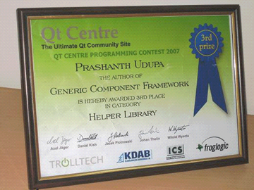
Bring them together
Although we begin with “divide and rule”, in-time we land-up looking at similar things in the divided parts. This is because at the end, we should come up with ways to bring all the parts together.
For example an “brightness-image-filter” module is of no real use unless it is used with a photoshop software. Every software design should have a plan for bringing modules together and orchestrating their functionality.

Component Frameworks
There are several libraries/frameworks/technologies out there that help make it easy for developers to follow the above rules while designing and implementing software applications. These frameworks impose certain rules and thought-paradigms on developers, forcing them to design applications for modularity, re-usability and configuration. Such frameworks are called “application frameworks” or “component frameworks”.
There are several existing component frameworks in widespread use today. Listed below are some of them
- KParts from the KDE project.
- COM from Microsoft
- XPCOM from Mozilla
- SOAP
- CORBA
Some of the above frameworks are generic, language and toolkit independent ones, example COM, SOAP, CORBA. KParts on the other hand is generic but toolkit dependent, it depends on Qt.
Generic Component Framework (aka GCF), is another name in the above list, and hopefully will become as widely used. Some of the key features of GCF are
- GCF is a Qt 4.4 based library.
- It helps compose applications as a bundle of dynamically loadable entities or components.
- It provides mechanisms to merge GUI of components into a common container.
- Components can search for objects and functionality served by any other component in the application.
- They can also communicate with objects belonging to GCF components in a remote application.
- GCF comes bundled with several inbuilt components that help you kick-start your application development.

Brief history of GCF
GCF started off as a module for VTK Designer 2. The main aim at that time was to provide an application architecture for VTK Designer 2 that would allow us to offer extensions, new functionality and bug-fixes to deployed copies of the software.
Initially GCF comprised of just the core component framework functionality. The components for VTK Designer written from scratch, just for VTK Designer. Later on, we picked up components that would make sense outside of VTK Designer and made them standard GCF components.
In January of 2007, QtCentre announced a world wide Qt programming contest. We applied for the contest in the helper library category and submitted GCF. Later that year in September, QtCentre awarded GCF a prize in the helper-library category.
Since then GCF has been used in quite a few open-source and commercial software (developed by us).
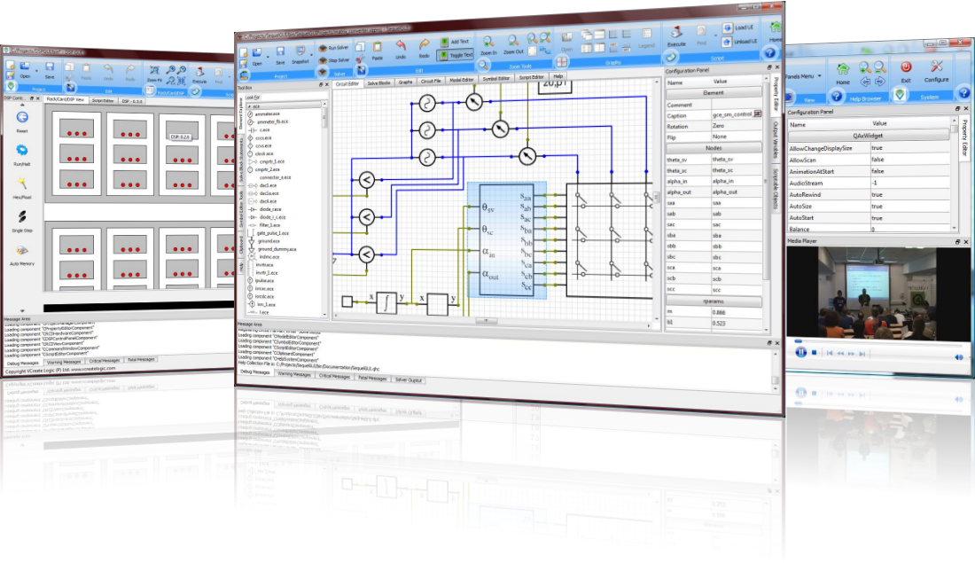Illustration 1: Screenshots of DSP View, SequelGUI built using GCF
GCF was presented at Akademy 2008 and was well received there. We really hope that KDE adopts GCF soon.
Starting from October 2008, KDAB holds the exclusive rights for selling the commercial variant of GCF as KDCF, short for KD-Components Framework. GCF and KDCF are identical in all aspects but for the class-naming convention.

Getting Started with GCF
Application developers are forced to think of development differently while using GCF. We have to think of applications as a bundle of independent, co-operating entities called “component”. Each component can be thought of as a factory for objects, where objects expose functionality via one or more interfaces. GCF is basically a manager of sorts that helps bring components together and orchestrate their tasks. The diagram(s) below summarizes this best

Keeping this in mind, lets look at how GCF helps us in adhering to the five thumb rules of software design and development.
Before we dive into GCF programming, lets look at GCF's coding standards.
- GCF include files will be available within the GCF directory.
- For each class there is a corresponding camel case header. Example: AbstractComponent is available within <GCF/AbstractComponent>
- GCF classes are contained within the GCF namespace. Example GCF::AbstractComponent.
- Standard components in GCF are available within the GCF::Components namespace.

How to divide and rule in GCF?
Once you have divided the functionality into independent entities, or components; each component becomes a subclass of GCF::AbstractComponent. Components in GCF are ones that act as factories for objects, widgets, actions etc. In code, a component in GCF would look like this.
#include <GCF/AbstractComponent>

struct MyComponentData;
class MyComponent : public GCF::AbstractComponent
{
Q_OBJECT
Q_INTERFACES(IAboutData)
GCF_DECLARE_COMPONENT(MyComponent)

public:
static MyComponent & instance();
~MyComponent();

protected:
MyComponent();
virtual QObject* fetchObject(const QString& completeName) const;
virtual QWidget* fetchWidget(const QString& completeName) const;
virtual QAction* fetchAction(const QString& completeName) const;
virtual void initializeComponent();
virtual void finalizeComponent();

private:
MyComponentData* d;
};

The last five methods are virtual methods implemented from GCF::AbstractComponent. More about these in a later section. The only thing that needs to be observed right now is that in GCF, the main responsibility of a component is to serve objects (QObject instances), widgets (QWidget instances) and actions (QAction instances).

GCF's constitution for applications
Like all frameworks, GCF imposes its own bunch of rules and regulations. Listed below are the main rules in GCF
- Every GCF application must provide a main container on which UI elements from different components can be placed. GCF provides a default MainWindow container that can be used by most applications.
- Every component should have a component class. It should be inherited from GCF::AbstractComponent.
- Component classes have to be singleton classes. The GCF_DECLARE_COMPONENT and GCF_DEFINE_COMPONENT macros help in ensuring this.
- Component classes have to be registered by
  - Making use of GCF_REGISTER_COMPONENT for statically compiled components --OR--
  - Making use of GCF_EXPORT_COMPONENT_PLUGIN macro for exporting components from plugins.
- Each GCF application should define a GUIXML directory within which GCF will look for gui-xml files.
- Each component should have a gui-xml file in this directory, and it must list the objects, widgets, actions and UI-merging hints. Normally GCF expects the component to provide a GUIXML file whose name is same as that of the component class itself.
- Component functionality must be
  - Declared as interfaces (as in a class with all methods as pure-virtual methods)
  - Implemented by implementing interfaces in one or more objects served by the component.

Whats similar among components in GCF?
In any C++ library/application; the similarity in diversity part is achieved by making use of class hierarchies. GCF classes don't have much hierarchy on their own, but they require
- Every component class in your application to inherit from GCF::AbstractComponent.
- Interfaces that are to be implemented by QObjects must inherit the IContainer interface.
- Interfaces that are not to be implemented in QObjects must inherit the IQueryable interface.
The other key thing that is common among all components are
- Each component provides a GUI XML file that lists the objects, widgets, actions etc exposed by the application.

Reusability and GCF
GCF components are self-contained entities. They offer certain functionality, described via component interfaces. They use functionality offered by other components via the interfaces exposed by other components. GCF components are hence highly decoupled and hence more reusable. As an example, the standard components that come with GCF have been used very successfully in a variety of projects. Take for example the PropertyEditor component in GCF. We have used it within VTK Designer 2, SequelGUI, DSP View and several other commercial software developed by us.
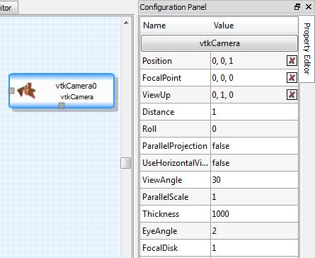Illustration 2: PropertyEditor in VTK Designer 2 | 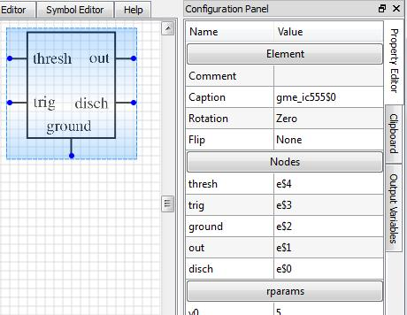Illustration 3: PropertyEditor in SequelGUI

How GCF brings them all together
One of the main strengths of GCF is that it brings together components into a single unit. The “bringing together” part is commonly referred to as GUI-Merging, and is done by
- The GCF::ComponentLoaderComponent (component) class
- The GCF::ComponentFactory class and
- The GCF::ComponentGUI class
The component loader component looks up its GUIXML file (the ComponentLoaderComponent.xml file) and figures out where to look for components and the components to actually load in the application. The component basically registers all GCF component libraries with the component factory and creates instances of the required components, as mentioned in the GUI XML file.
The component factory maintains a directory of registered, instantiated, active and inactive components in the application.
Each component, when created provides a ComponentGui. The component gui is basically a tree like structure that describes the UI of the component. Shown below is a diagram that tries to explain the structure of ComponentGui.
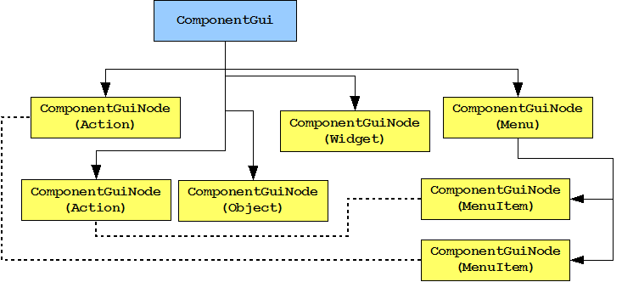
A GCF::ComponentGui object basically stores a list of GCF::ComponentGuiNode objects. Each node can hold child node objects. Every node describes one aspect (action, widget, object, menu, menu item etc) of the component's UI. Nodes can refer each other; for example a menu-item node can refer to the action node that is shown in the menu item.
GCF parses the GUIXML file associated with a component and constructs a GCF::ComponentGui object for the component. The GCF::ComponentGuis of all the components are then merged into a single tree and rendered on the main container (usually GCF::Components::MainWindow) of the application.
Considering that the component factory has knowledge of all the components in the system, and that each component provides its GUI (in a GCF::ComponentGui object), it is easy to search for objects, widgets, actions by their name. To ensure that there are no namespace collisions, GCF uses a concept called "complete name". Complete name is the name of the component and the name of the object separated by a dot (.). For example "MainWindow.leftDockWidgetArea" refers to the "leftDockWidgetArea" object within "MainWindow".
GCF provides mechanisms to search for
- Object(s) (which includes widgets, actions, menus, toolbars etc) based on their "complete name".
- Object(s) within a specific component based on their name
- Object(s) based on an interface name that it implements.
This makes searching for objects and functionality very simple.

Case Study: A simple Photo Browser application.
Lets design and implement a really simple photo browser application and understand how GCF works. A photo browser, simply put, is an application that helps in browsing photos. A really simple photo browser is an application that helps (the developer of the application ;-)) in viewing one photo at a time.
When we look at the “really simple photo browser” application, we essentially have two components to develop
- A “directory browser” component that provides us a simple directory browser and help us look for a photo file to view.
- A “photo viewer” component that helps view a specified photo.
Lets get started then.

Step 1: Create application's directory structure and basic code with CreateAppTemplate
Launch the “CreateAppTemplate” program and enter the details of the “PhotoBrowser” application as shown in the screenshot below
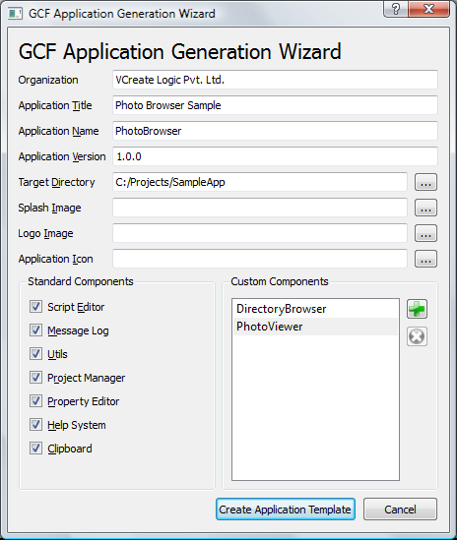
Notice the following in the above screenshot
- The application title and name are specified
- Application name does not have special characters or spaces
- A proper target directory is specified. Ideally the target directory path should not have spaces or special characters.
- All the standard components are marked for compile and use in PhotoBrowser
- Two new components “DirectoryBrowser” and “PhotoViewer” have been added.
Now, click on the “Create Application Template” button and wait as the application template is created.
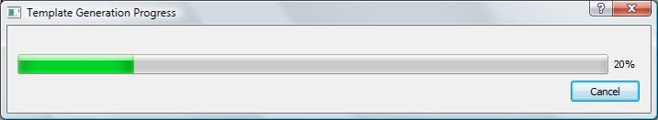
You will be able to find in the C:\Projects\SampleApp directory a working application template for PhotoBrowser.
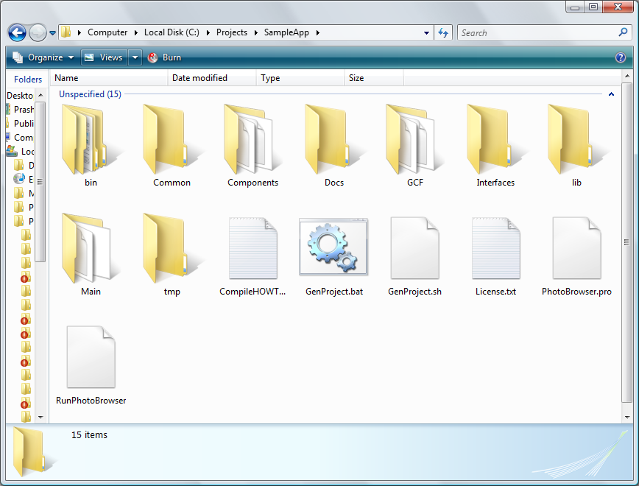

Step 2: Compile the application
Depending on whether you are on Windows or GNU/Linux, you can make use of GenProject.bat or GenProject.sh scripts to generate the Visual Studio solution or Makefile for the application. Lets use Visual Studio for now.
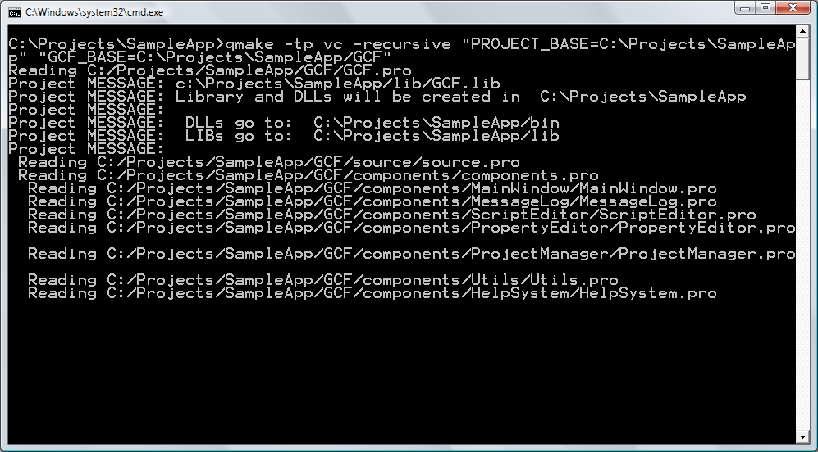
The GenProject scripts basically invoke qmake to generate the Visual Studio solution or Makefile. Lets now open PhotoBrowser solution in Visual Studio and compile it.
Once compiled, you will be able to execute the PhotoBrowser application and get a window as shown below.
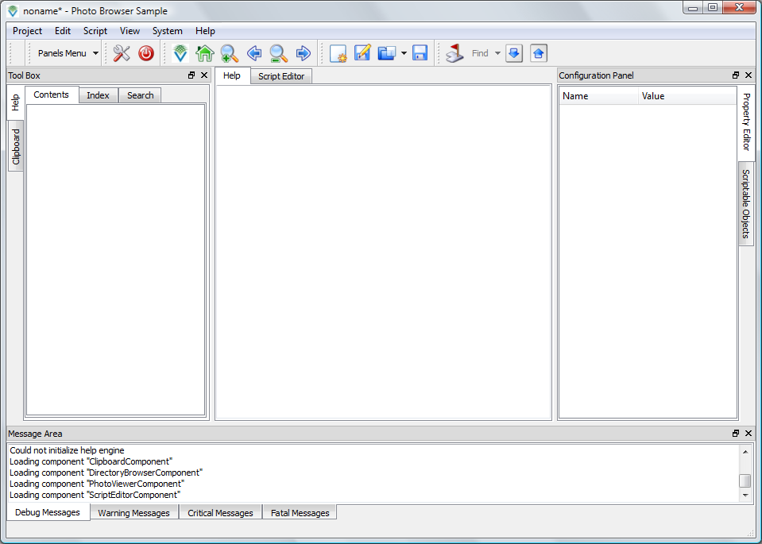
You will notice that the PhotoBrowser application is working quite well. For example go to the script editor tab and type some script and execute it.

Step 3: Explore ComponentLoaderComponent.xml
The ComponentLoaderComponent.xml file is (more or less) the first GUIXML file that is parsed. This file specifies where to look for components and also what components to load in the application. Lets take a look at this file
<component title="Component Loader Component" version="1.0"
name="ComponentLoaderComponent" >

<object name="controller" />
<method param1="${APPDIR}"
methodName="ComponentLoaderComponent.controller::addComponentDirectory" />
<method methodName="ComponentLoaderComponent.controller::registerComponents" />
<method param1="MessageLogComponent"
methodName="ComponentLoaderComponent.controller::loadComponent" />
<method param1="ProjectManagerComponent"
methodName="ComponentLoaderComponent.controller::loadComponent" />
<method param1="PropertyEditorComponent"
methodName="ComponentLoaderComponent.controller::loadComponent" />
<method param1="ProjectManagerComponent"
methodName="ComponentLoaderComponent.controller::loadComponent" />
<method param1="HelpSystemComponent"
methodName="ComponentLoaderComponent.controller::loadComponent" />
<method param1="ClipboardComponent"
methodName="ComponentLoaderComponent.controller::loadComponent" />
<method param1="DirectoryBrowserComponent"
methodName="ComponentLoaderComponent.controller::loadComponent" />
<method param1="PhotoViewerComponent”
methodName="ComponentLoaderComponent.controller::loadComponent" />
<method param1="ScriptEditorComponent"
methodName="ComponentLoaderComponent.controller::loadComponent" />

</component>
From the above file GCF will figure that it should look for GCF component libraries from the application executable's directory and load the 9 components in the same order as it is specified.
Lets remove some lines that are not useful for the PhotoBrowser application.
<component title="Component Loader Component" version="1.0"
name="ComponentLoaderComponent" >

<object name="controller" />
<method param1="${APPDIR}"
methodName="ComponentLoaderComponent.controller::addComponentDirectory" />
<method methodName="ComponentLoaderComponent.controller::registerComponents" />

<method param1="PropertyEditorComponent"
methodName="ComponentLoaderComponent.controller::loadComponent" />
<method param1="DirectoryBrowserComponent"
methodName="ComponentLoaderComponent.controller::loadComponent" />
<method param1="PhotoViewerComponent”
methodName="ComponentLoaderComponent.controller::loadComponent" />
<method param1="ScriptEditorComponent"
methodName="ComponentLoaderComponent.controller::loadComponent" />

</component>
This means that only PropertyEditor, DirectoryBrowser, PhotoViewer and ScriptEditor component are loaded. Lets restart the application now.
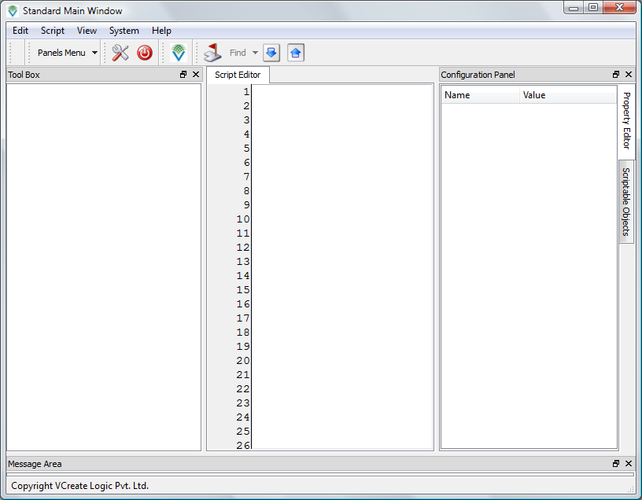
Notice that some panels or areas in the main-window are still showing up even though they are not used. For example the “Message Area” and “Tool Box” are not used. Lets remove these areas by changing the MainWindowComponent.xml file.
<component title="Standard Main Window Component" version="1.0"
name="MainWindowComponent" >

<widget title="Standard Main Window" scriptName="MainWindow" name="window"
autoDelete="false" />
<widget scriptName="StatusBar" name="statusBar" autoDelete="false" />
<!--widget title="Message Area" name="bottomDockArea" autoDelete="false" /-->
<widget name="workspace" autoDelete="false" />
<!--widget title="Tool Box" name="leftDockArea" /-->
<widget title="Configuration Panel" name="rightDockArea" />
<widget name="centralWidget" />
..........................

</component>
Notice that the “Message Area” and “Tool Box” widgets are now commented. Lets restart the application and observe the changes.
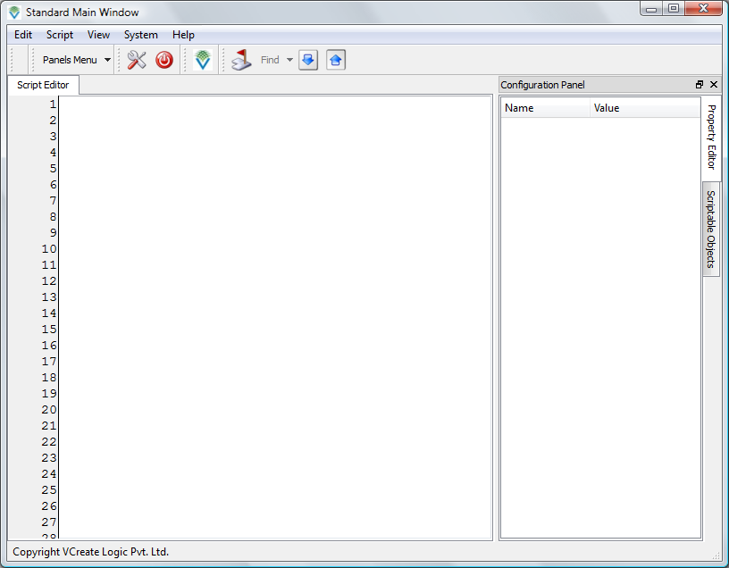

Step 4: Implement the directory browser component
Lets implement our custom components, starting with the directory browser component. The directory browser component is essentially a QTreeView showing a QDirModel. Towards this lets change the DirectoryBrowserComponent class as follows
struct DirectoryBrowserComponentData
{
QTreeView* dirView;
QDirModel* dirModel;
};

DirectoryBrowserComponent::DirectoryBrowserComponent()
{
d = new DirectoryBrowserComponentData;

d->dirView = new QTreeView;
d->dirModel = new QDirModel;

d->dirView->setModel(d->dirModel);

for(int i=1; i<d->dirModel->columnCount(); i++)
d->dirView->setColumnHidden(i, true);
}

Basically we create a QTreeView and QDirModel in the constructor and configure them. The next step is to serve the dirView (instance of QTreeView) widget from the component. For this, we update the fetchWidget() method.
QWidget* DirectoryBrowserComponent::fetchWidget(const QString& completeName) const
{
QStringList comps = completeName.split('.');

if(comps.last() == "dirView")
return d->dirView;

return 0;
}

With this we have now ensured that the dirView widget is exposed to other components and to GCF for performing GUI-Merging. Next lets update the DirectoryBrowserComponent.xml to mark this widget for GUI-Merging.
<component title="Custom Component" name="DirectoryBrowserComponent" >

<object name="controller" />

<widget name="dirView" parentWidget="MainWindowComponent.rightDockArea"
title="Directory Browser" />

</component>
After saving the changes, we recompile the solution and restart the program.
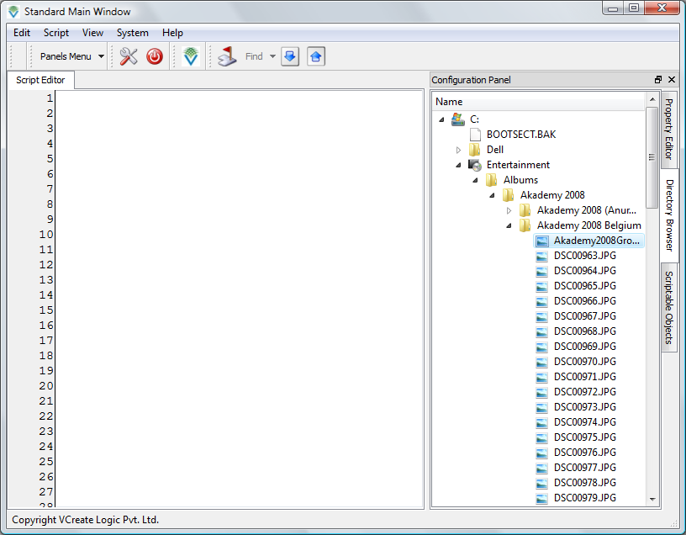
We will now be able to see the “Directory Browser” widget merged into the main window of the application. Cool isnt it?
Lets continue and make a few more changes to the directory browser component. Lets introduce a signal called fileDoubleClicked(QString) that gets emitted when ever the user double clicks on a file in the directory browser component. We will be using this signal later on while connecting PhotoViewer to this component. Towards this we make the following changes
in DirectoryBrowserComponent.h
struct DirectoryBrowserComponentData;
class DirectoryBrowserComponent : public GCF::AbstractComponent,
virtual public IAboutData
{
Q_OBJECT
Q_INTERFACES(IAboutData)
GCF_DECLARE_COMPONENT(DirectoryBrowserComponent)

public:
static DirectoryBrowserComponent & instance();
~DirectoryBrowserComponent();

signals:
void fileDoubleClicked(const QString& fileName);

protected slots:
void dirView_doubleClicked(const QModelIndex& index);
..........
and in DirectoryBrowserComponent.cpp
DirectoryBrowserComponent::DirectoryBrowserComponent()
{
d = new DirectoryBrowserComponentData;

d->dirView = new QTreeView;
d->dirModel = new QDirModel;

d->dirView->setModel(d->dirModel);

for(int i=1; i<d->dirModel->columnCount(); i++)
d->dirView->setColumnHidden(i, true);

connect(d->dirView, SIGNAL(doubleClicked(QModelIndex)),
this, SLOT(dirView_doubleClicked(QModelIndex)));
}

void DirectoryBrowserComponent::dirView_doubleClicked(const QModelIndex& index)
{
if(!index.isValid())
return;

QFileInfo fi = d->dirModel->fileInfo(index);
if(fi.isDir())
return;

QString fileName = fi.absoluteFilePath();
emit fileDoubleClicked(fileName);
};
To test whether the signal is infact getting generated or not, lets expose the directory browser component as a scriptable object. That way we can script signals in the component class and test it. To expose a component's object as a scriptable object; all you need to do is include a scriptName attribute in the component's guixml file.
<component title="Custom Component" name="DirectoryBrowserComponent" >

<object name="controller" scriptName="DirectoryBrowser" />

<widget name="dirView" parentWidget="MainWindowComponent.rightDockArea"
title="Directory Browser" />

</component>
Save the changes and restart the application. In the “Scriptable Objects” tab you can now notice “DirectoryBrowser”. Double click on the “FileDoubleClicked” event and script the event as shown in the screenshot below.
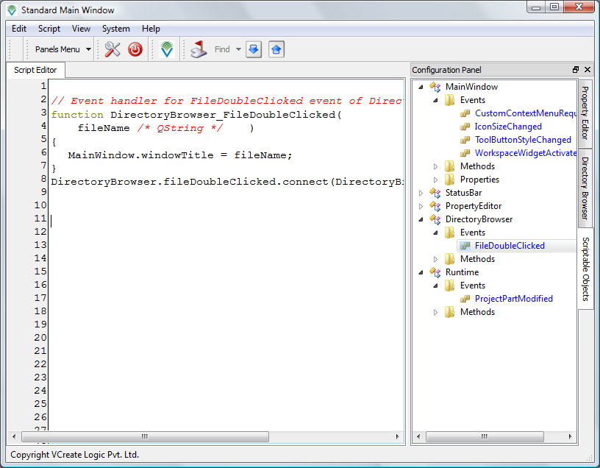
Now execute the script by clicking on “Script → Execute” menu item. From then on when ever you double click on a file in the “Directory Browser”; you will see the complete path of the file name showing up in the title bar of the main window.

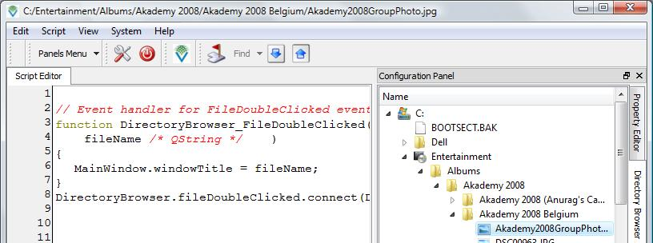
With this, we now have a confirmation that the signal actually works :)

Step 5: Implement the photo viewer component
The photo viewer component is basically a scroll area with a label shown in it. The label would show an image and the scroll area will help the user to look at any part of the image. The code for this is shown below.
Changes in PhotoViewerComponent.h
struct PhotoViewerComponentData;
class PhotoViewerComponent : public GCF::AbstractComponent, virtual public IAboutData
{
Q_OBJECT
Q_INTERFACES(IAboutData)
GCF_DECLARE_COMPONENT(PhotoViewerComponent)

public:
static PhotoViewerComponent & instance();
~PhotoViewerComponent();

public slots:
void showImage(const QString& fileName);
Changes in PhotoViewerComponent.cpp
struct PhotoViewerComponentData
{
QScrollArea* scrollArea;
QLabel* imageLabel;
};

PhotoViewerComponent::PhotoViewerComponent()
{
d = new PhotoViewerComponentData;

d->scrollArea = new QScrollArea;
d->imageLabel = new QLabel;
d->scrollArea->setWidget(d->imageLabel);
d->scrollArea->setWidgetResizable(true);
}

void PhotoViewerComponent::showImage(const QString& fileName)
{
d->imageLabel->setPixmap(QPixmap());

QPixmap pm(fileName);
if(pm.isNull())
{
d->imageLabel->setText( QString("%1 not an image file").arg(fileName) );
d->imageLabel->setFixedSize(400, 100);
}
else
{
d->imageLabel->setPixmap(pm);
d->imageLabel->setFixedSize(pm.size());
}
}

QWidget* PhotoViewerComponent::fetchWidget(const QString& completeName) const
{
QStringList comps = completeName.split('.');

if(comps.last() == "photoViewer")
return d->scrollArea;

return 0;
}
Basically we create the photo viewer (scrollarea + label) and provide a slot to show the image contained in a file. We then serve the widget from the component.
Lets modify the component's GUIXML file now.
<component title="Custom Component" name="PhotoViewerComponent" >

<object name="controller" />

<widget name="photoViewer" title="Photo Viewer"
parentWidget="MainWindowContainer.workspace" />

</component>
Now compile and restart the program.

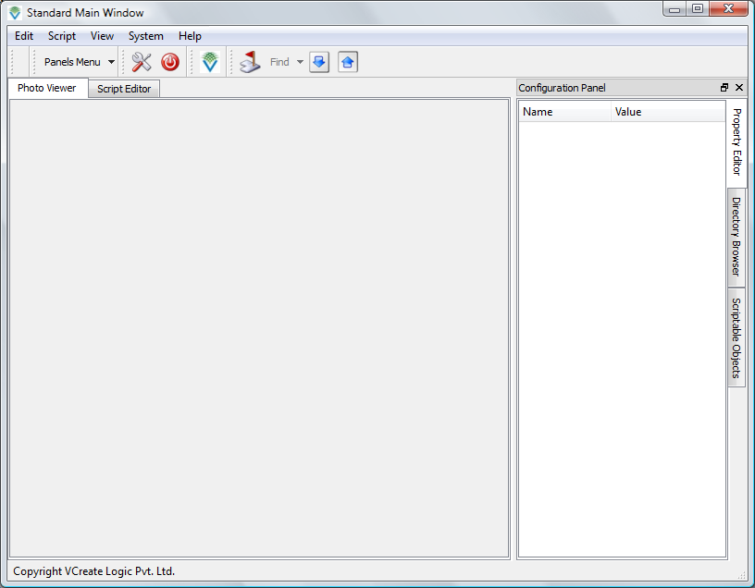
We will need to make a connection from the fileDoubleClicked(QString) signal of directory browser to the showImage(QString) slot of the photo viewer. Lets establish the connection in the guixml file.
<component title="Custom Component" name="PhotoViewerComponent" >

<object name="controller" />

<widget name="photoViewer" title="Photo Viewer"
parentWidget="MainWindowComponent.workspace" />

<connection sender="DirectoryBrowserComponent.controller::fileDoubleClicked(QString)"
receiver="PhotoViewerComponent.controller::showImage(QString)" />

</component>
The connection XML element in the guixml file helps make signal and slot connections outside of the C++ code. Notice the format in which the signals and slots are specified.
<component-name>.<object-name>::<signal/slot-signature>
Lets save the changes and restart the application. This time we can double click on any image file name in the directory browser and the photo-viewer will show the image.

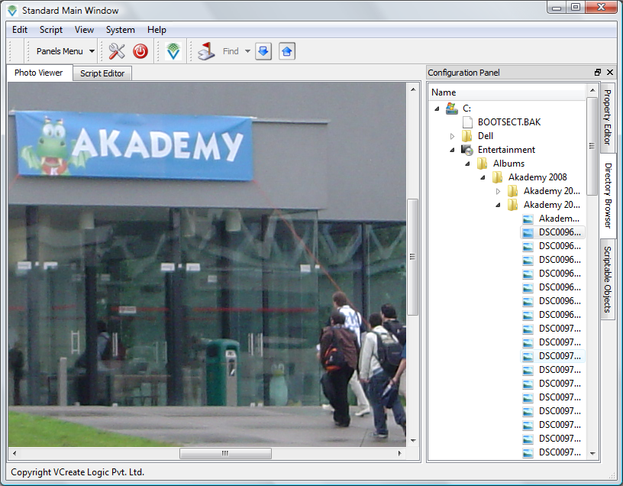

Using actions, menus, toolbars
If you want to insert custom menu/toolbar action items, you can simply edit the GUIXML file and associate the triggered/toggled signal of the action to a slot. Take a look at the modified GUIXML file for PhotoViewerComponent below
<component title="Custom Component" name="PhotoViewerComponent" >

<widget name="imageLabel" />
<action name="clearImage" title="Clear Image"
triggerSlot="PhotoViewerComponent.imageLabel::clear()"/>
<menu name="pvMenu" title="Photo">
<menuitem actionName="PhotoViewerComponent.clearImage" />
</menu>
<toolbar name="pvTools" title="Photo Tools">
<toolbaritem actionName="PhotoViewerComponent.clearImage" />
</toolbar>

</component>

Notice how the triggered signal of the clearImage action is connected to the clear() slot of the image label. To ensure that imageLabel is resolved properly, we update the fetchWidget() method as follows.

QWidget* PhotoViewerComponent::fetchWidget(const QString& completeName) const
{
QStringList comps = completeName.split('.');

if(comps.last() == "photoViewer")
return d->scrollArea;

if(comps.last() == "imageLabel")
return d->imageLabel;

return 0;
}
Lets save and restart the application to notice the newly introduced menu and toolbar.
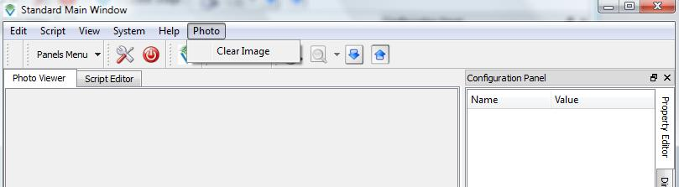
You will also notice that the "Clear Image" menu item works. When you click on it, the image in the label actually gets cleared. You can specify shortcuts using the "shortcut" attribute on the action XML element.
What if you wanted to insert the "Photo" menu before the "System" menu in the main window?. It is very simple, just make use of the "before" attribute in menu XML element.
<menu name="pvMenu" title="Photo" before="MainWindowComponent.systemMenu">
<menuitem actionName="PhotoViewerComponent.clearImage" />
</menu>
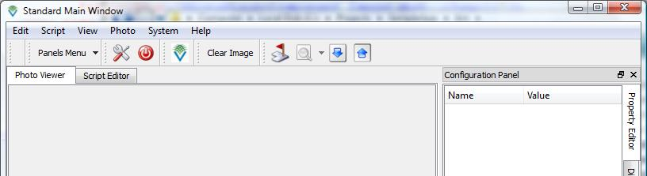
Now, what if you wanted to merge the "Photo" menu with the "Edit" menu?. You can make use of the mergeWith attribute in menu XML element.
<menu name="pvMenu" title="Photo" mergeWith="MainWindowComponent.editGroup">
<menuitem actionName="PhotoViewerComponent.clearImage" />
</menu>
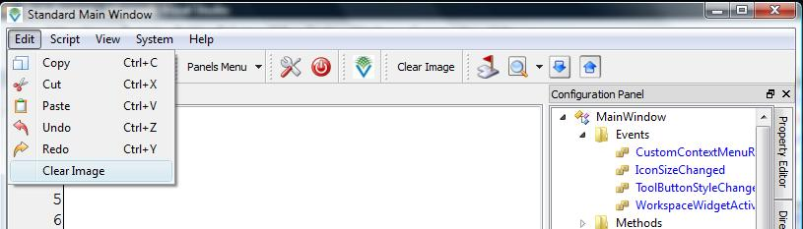
In-fact the mergeWith attribute can be used with action elements to share an existing action with your component. GCF will make use of GCF::SignalMultiplexer to ensure that the action's triggered or toggled signal is only sent to objects belonging to active components.

With this our photo browser application is complete :)
Notice how we worked on different aspects of the software and brought them together by making use of GUIXML and the component infrastructure from GCF.

Using functionality exposed by other components
Very often functionality exposed by other components might have to be used by our components. As mentioned before, functionality from a component is usually exposed via interfaces. For example the property editor's functionality is exposed via the IPropertyEditor interface.
class IPropertyEditor : virtual public IContainer
{
public:
// Establish which object to show the properties of.
virtual void setObject(QObject* object, bool recursive=false) = 0;
virtual Qobject* object() = 0;

// Methods to query property information
virtual int propertyCount() = 0;
virtual IProperty* property(int index) = 0;

// Establish the editor factory.
virtual void setEditorFactory(IValueEditorFactory* factory) = 0;
virtual IValueEditorFactory* editorFactory() = 0;

// Must be implemented as a signal.
virtual void propertyValueChanged(QObject* obj, QString propName, QVariant oldVal,
QVariant newVal) = 0;
};
If we get hold of a valid pointer to IPropertyEditor, then we will be able to invoke one or more of the above methods and make use of the property editor's functionality.

Service and Interface methods in AbstractComponent
There are essentially two types of methods in GCF::AbstractComponent.
- Interface methods
- Service Methods
Interface methods are those that GCF calls in your component to figure out what your component has to offer. These methods are usually declared as virtual in AbstractComponent. For example the fetchObject(), fetchWidget() methods.
Service methods are methods that your components can make use of to get some information from GCF. These methods are usually non-virtual and sometimes static. For example the findObject() method can be used to search for an object given its name or an interface that it implements.

Searching for functionality in GCF
In GCF, functionality means interface. To search for an interface you can make use of the findObject() method. Take a look at the code below.
#include <IPropertyEditor>

void DirectoryBrowserComponent::creationAnnounced()
{
IPropertyEditor* propEditor = 0;
QObject* propEditorObj = 0;
QString name;
GCF::AbstractComponent* propEditorComp = 0;

propEditorObj = findObject("IPropertyEditor", name, &propEditorComp);
if(propEditorObj)
propEditor = qobject_cast<IPropertyEditor*>(propEditorObj);

if(propEditor)
propEditor->setObject(d->dirView);
}
Notice how we are asking GCF to search for an object that implements the IPropertyEditor interface. If the interface was found we begin using it, without really caring about who is providing the interface implementation.
On compiling and executing the code, you will notice that upon startup; the PhotoBrowser application is showin the properties of the directory view widget (which is a QTreeView).
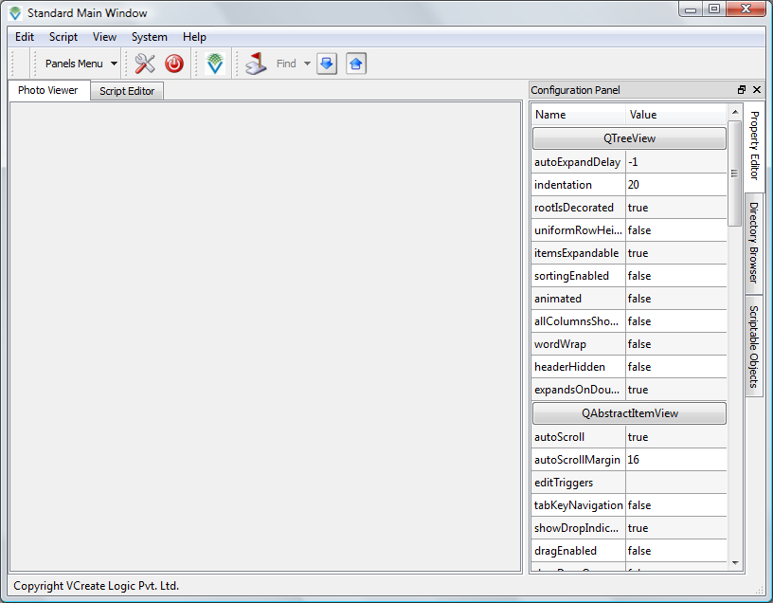
Your own components can declare component interfaces and allow other objects to search for them. We will take a look at this in a later chapter.

Inter-Process Communication (IPC) in GCF
One of the goals for GCF was to enable seamless communication between objects residing in different applications. IPC in GCF is based on the following key concepts
- Each application has an “Application Access Point” (or AAP) through which exposed objects and methods can be accessed by other applications.
- Each application can create one “Remote Application Access Point” (or RAP) for each remote application it needs to communicate with.
- From a valid “Remote Application Access Point”, an application can fetch instances of “Remote Objects” based on their object names. Using these “Remote Objects” applications can place remote method calls, connect to remote signals/slots and remotely configure object properties.
- Applications can make use of “Remote Application Discovery” service to discover applications, running on the same machine or in the local area network, with which they can communicate.
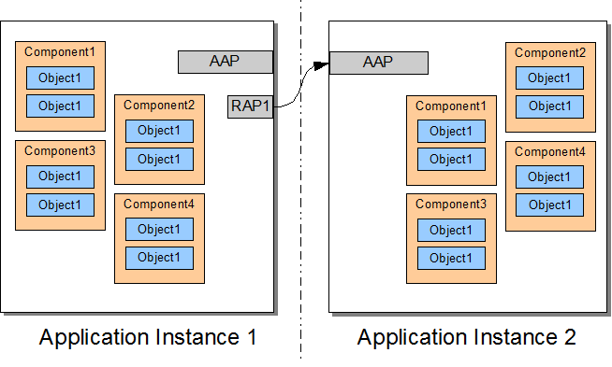

Key classes in GCF/IPC Layer
The above concepts are implemented in terms of the following classes in GCF
- GCF::AppAccessPoint. This is a singleton class that provides a socket through which remote GCF applications can access components and their objects in the local application.
- GCF::RemoteAppAccessPoint. This is a class through which the local application can access components and their objects in a remote application.
- GCF::RemoteObject. This class serves as a local representative for a remote object. Method calls, signals, slots and properties of the object residing in the remote application can be accessed via this object.
- GCF::RemoteAppDiscovery. This classes looks out for GCF applications with the same name in the local area network and emits a signal when it finds one.
- GCF::AppAccessPointComponent. This is a internal component class for managing the IPC layer in GCF.
Lets get our hands dirty and remote-access-enable our PhotoBrowser application.

Remote-Access-Enabling Photo Browser
The first thing that we need to do is enable the GCF/IPC layer. To do this, we will need to uncomment two lines in the Main/Main.cpp file.
int main(int argc, char** argv)
{
.........

// Uncomment the lines below if you want to expose your application
// for remote access
GCF::AppAccessPointComponent::instance().initialize();
GCF::AppAccessPoint::instance().setAppAccessEnabled(true);

...................
}
With this we are enabling remote application access to our application, and we are turning on remote access.
Since GCF/IPC depends on TCP/IP protocol stack, GCF internally opens a socket at a random port number and begins listening for incoming connections. You can configure your application to make use of a specific port number; but thats not really necessary.

Granting permission for remote access
Just because remote access is enabled, components in your application and their objects are not exposed to remote applications. You will need to explicitly enable remote access in each component and each of its objects. There are essentially two ways to do this
- Implement the IComponentRemoteAccessControl interface in your component class and decide on remote access for the component and on which objects to provide access to AND implement the IObjectRemoteAccessControl in remotely accessible objects and decide on which methods, signals, slots, properties within the object to provide access to.
Lets call these interfaces as RAPSI (short for RAP Security Interfaces).
---OR---
- Flag components and objects for remote access in the GUIXML file.
Obviously the latter is easier than the former. But if GCF ever notices that there is a conflicting decision between the RAPSI and GUIXML, the former wins.
For now lets just look at the second technique for enabling remote access. Lets expose the photo viewer widget for remote access. The PhotoViewerComponent.xml file is modified as follows (changes marked in bold)
<component title="Custom Component" name="PhotoViewerComponent"
allowRemoteAccess="true" >

<object name="controller"
allowRemoteAccess="true"
allowRemoteMethodInvocation="true"
allowRemoteSignalConnect="false"
allowRemoteSignalDelivery="false"
allowRemoteSetProperty="false"
allowRemoteGetProperty="false"
/>

<widget name="photoViewer" title="Photo Viewer"
parentWidget="MainWindowComponent.workspace" />

<connection sender="DirectoryBrowserComponent.controller::fileDoubleClicked(QString)"
receiver="PhotoViewerComponent.controller::showImage(QString)" />

</component>
Notice that remote access is explicitly enabled at the component and object level. When we enable remote access to an object we also have to specify what aspects of the object can be accessed remotely. By aspect we mean
- Methods (whether slots and Q_INVOKABLE methods in your object is accessible remotely)
- Signal Connect (whether signals can be connected remotely)
- Signal Delivery (whether signal emissions have to be sent across to remote applications)
- Set Property (whether properties can be set remotely)
- Get Property (whether properties can be fetched remotely)
By default, GCF assumes that none of the above aspects are enabled for remote access.
Coming back to the PhotoViewerComponent.xml; we can now notice that the component's controller object is exposed for remote access. Methods within the component can be accessed remotely.

Testing remote access
Now that we have enabled remote access and enabled PhotoViewerComponent.controller's methods to be accessed remotely; lets actually test it. Make the following changes.
To PhotoViewerComponent.h
class PhotoViewerComponent : public GCF::AbstractComponent, virtual public IAboutData
{
..............
void finalizeComponent();
void creationAnnounced();

protected slots:
void discoveredRemoteApp(GCF::RemoteAppAccessPoint* rap);
..............
};
To PhotoViewerComponent.cpp
#include <GCF/RemoteAppDiscovery>
#include <GCF/RemoteObject>
#include <GCF/RemoteAppAccessPoint>

void PhotoViewerComponent::creationAnnounced()
{
GCF::RemoteAppDiscovery& rad = GCF::RemoteAppDiscovery::instance();
connect(&rad, SIGNAL(discoveredRemoteApp(GCF::RemoteAppAccessPoint*)),
this, SLOT(discoveredRemoteApp(GCF::RemoteAppAccessPoint*)));
rad.startDiscovery();
}

void PhotoViewerComponent::discoveredRemoteApp(GCF::RemoteAppAccessPoint* rap)
{
if(!rap)
return;

// Stop discovery
GCF::RemoteAppDiscovery& rad = GCF::RemoteAppDiscovery::instance();
rad.stopDiscovery();

// Fetch pointer to a remote object.
GCF::RemoteObject* remoteObj =
rap->getRemoteObject("PhotoViewerComponent.controller");

// Remote method invocation
remoteObj->call("showImage", "C:/Windows/Web/Wallpaper/img1.jpg");

// Remote signal/slot connection
QObject* dbObj = findObject("DirectoryBrowserComponent.controller");
remoteObj->makeConnection(dbObj, SIGNAL(fileDoubleClicked(QString)),
SLOT(showImage(QString)));
}
Notice that object names in the remote object-name is nothing but its complete name. In the above code we are essentially creating a local representative (GCF::RemoteObject instance) to a remote object whose complete name is “PhotoViewerComponent.controller”. We then issue remote method calls and make signal-slot connections with the remote object.
Now compile and launch two instance of the application on your computer.
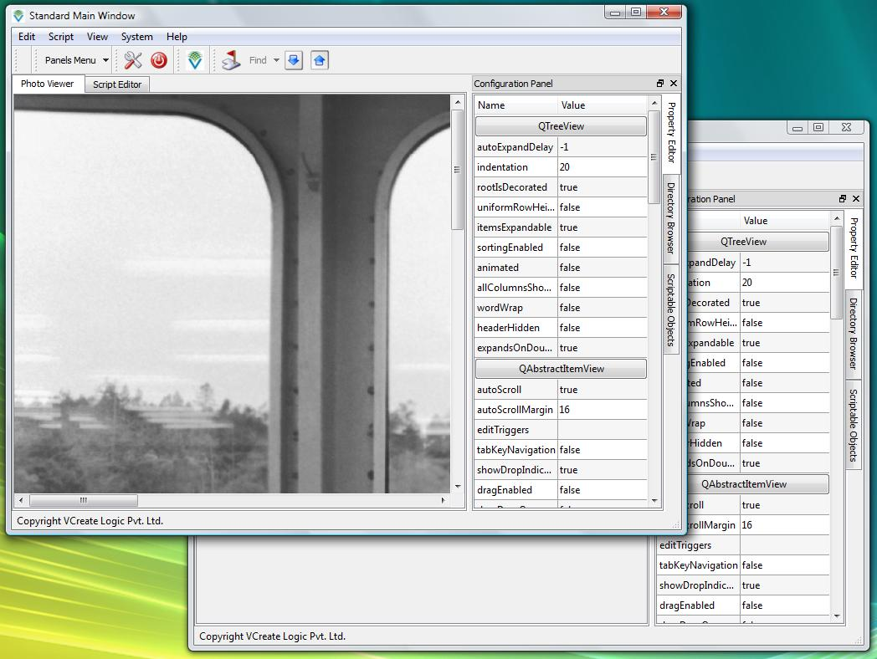
Notice how one application has remotely sent a image file name to another application. In the code we have also performed a local signal to remote slot connection. Lets test that. Basically, double clicking on an image file in one application (actually the one whose window is at the back) should show the same image in both windows.
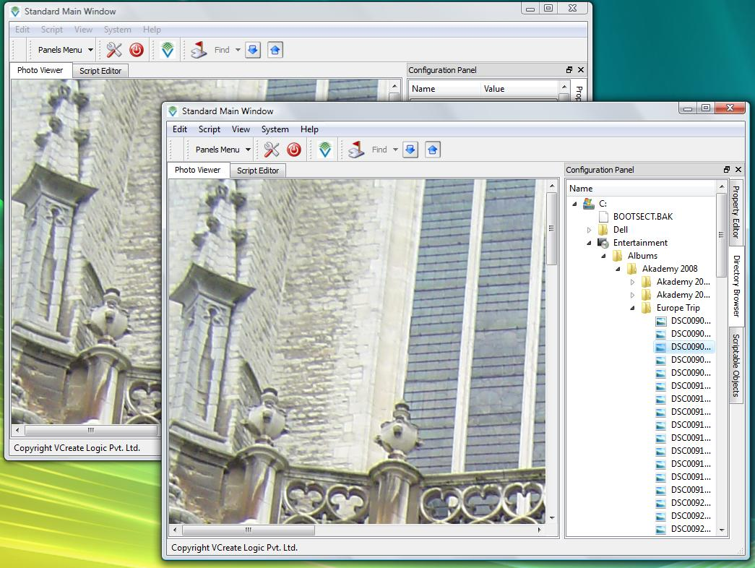
It worked :)
It needs to be stressed at this point that “ PhotoViewerComponent.controller” was accessible remotely because we had specifically allowed access to it in the guixml file. If you try accessing any other object, GCF will flag an error and stop processing messages meant for it.

Monitoring IPC Messages
The GCF/IPC layer provides a mechanism whereby you can monitor messages transacted between applications. To view these messages, open GCF/source/guixml/AppAccessPointComponent.xml and uncomment the <widget> xml element.
<component title="Application Access Point Component" version="1.0" name="AppAccessPointComponent" >

<object name="controller" />
<object name="appAccessPoint" />
<widget title="IPC Message Log" name="messageLog"
parentWidget="MainWindowComponent.workspace" />

</component>
Compile and restart your application to notice a “IPC Message Log” tab in the workspace. This tab will show a dump of all messages transacted.
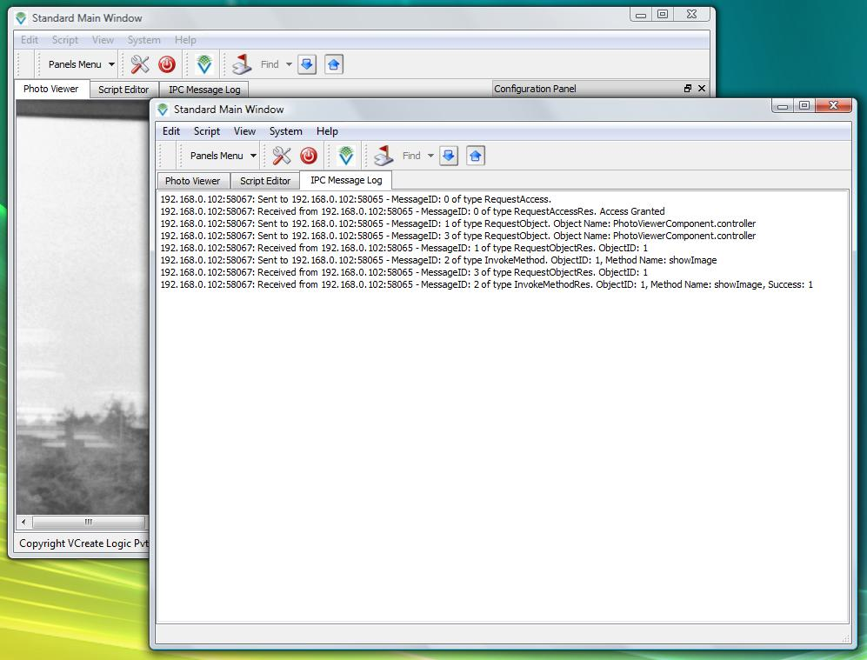

Using ActiveX components in GCF
GCF 1.6.4 introduced support for ActiveX in GCF. It is now possible to introduce an ActiveX component in your GCF applications without having to write a single line of code. Lets take our PhotoBrowser program and see how we can introduce the “Windows Media Player” ActiveX control on to the workspace.
Pick any GUIXML file and introduce a <activex> XML element. Simply specify the control's UUID, give it a name, title and parent widget.
<component title="Custom Component" name="DirectoryBrowserComponent" >

<activex control="{22D6F312-B0F6-11D0-94AB-0080C74C7E95}"
name="windowsMediaPlayer"
title="Windows Media Player"
parentWidget="MainWindowComponent.workspace" />

</component>
Save the XML file and restart the application. You will be able to see the “Media Player” control in the workspace.
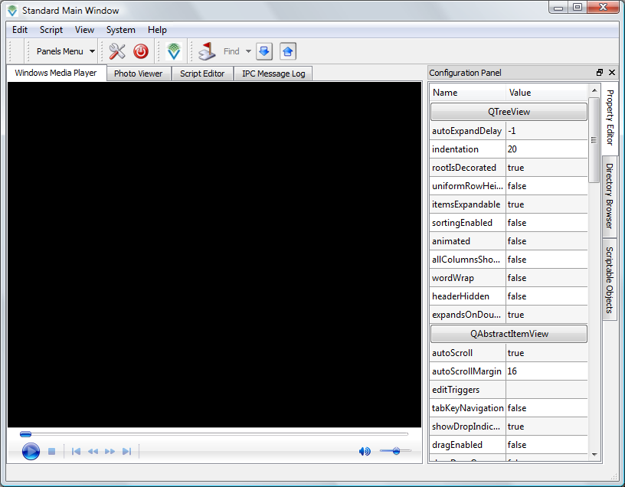
You can do more than just embedding ActiveX controls in GCF applications, you can even configure them.
<activex title="Windows Media Player"
control="{22D6F312-B0F6-11D0-94AB-0080C74C7E95}"
name="windowsMediaPlayer"
parentWidget="MainWindowComponent.workspace" />

<method methodName="DirectoryBrowserComponent.windowsMediaPlayer::Open"
param1="C:/Entertainment/Albums/Akademy 2008 Belgium/MOV01005.MPG" />
<method methodName="DirectoryBrowserComponent.windowsMediaPlayer::Play" />
The last two lines are as good as doing this in C++
windowsMediaPlayer->Open("C:/Entertainment/Albums/Akademy 2008 ”
“Belgium/MOV01005.MPG");
windowsMediaPlayer->Play();
Upon saving and restarting the application, you will now notice that the video is actually being played.
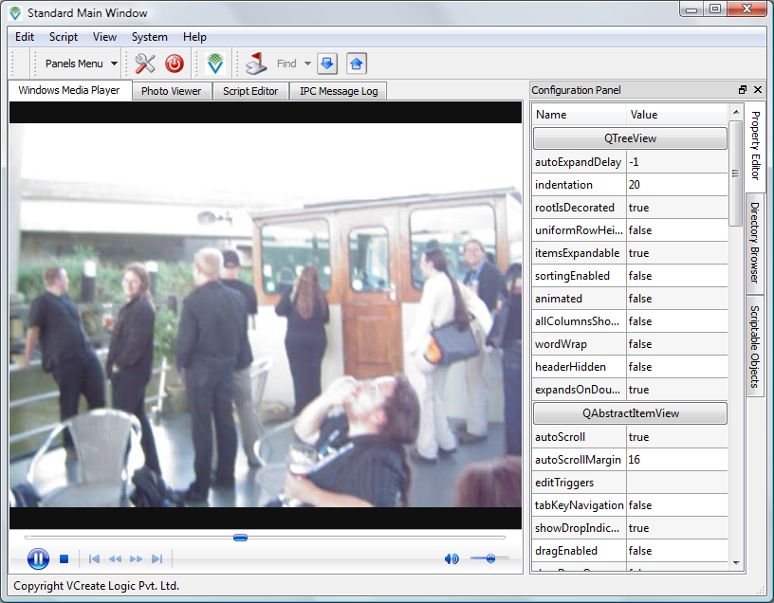
You can do even more, assign a script name the the ActiveX control and you can script events thrown by it and also invoke methods from the script.
<activex title="Windows Media Player"
control="{22D6F312-B0F6-11D0-94AB-0080C74C7E95}"
name="windowsMediaPlayer"
parentWidget="MainWindowComponent.workspace"
scriptName="WindowsMediaPlayer"/>
Save the GUIXML file and restart the program.
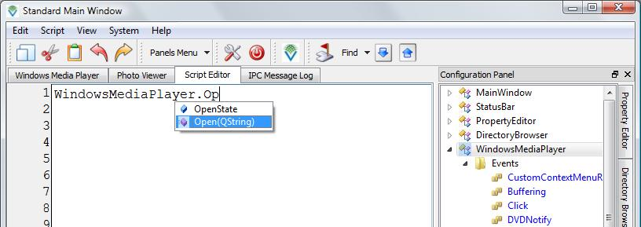
Notice how all the ActiveX events show up as scriptable events in the “Scriptable Objects” panel.

Customizing ActiveX creation and destruction
GCF provides an inbuilt mechanism for customizing ActiveX creation and destruction. If you want to customize the way ActiveX controls are created and destroyed then you can implement the IActiveXFactory interface in a component class.
class IActiveXFactory : virtual public IContainer
{
public:
virtual QAxWidget* createActiveXWidget(const QString& completeName,
const QString& control) = 0;

virtual void finalizeActiveXWidget(QAxWidget* widget,
const QString& completeName,
const QString& control) = 0;

virtual void destroyActiveXWidget(QAxWidget* widget,
const QString& completeName,
const QString& control) = 0;
};
If the above interface implementation is found in a component class whose GUIXML contains the <activex> xml elements, then GCF makes use of these methods to create, finalize and destroy ActiveX controls.
- The createActiveXWidget() method is called for creating a control.
- The finalizeActiveXWidget() method is called before the control is un-initialized
- The destroyActiveXWidget() method is called after control is un-initialized. This method must delete the control.

Using KParts components in GCF
KParts is a component technology from KDE. Part in KDE is a subclass of KParts::Part that provides
- A widget which shows the document viewed/edited by the part
- An action collection which provides QActions for accessing functionality in the part from the user interface.
- A XMLGUI document that describes how the part's UI can be merged into the part container, usually a KParts::MainWindow.
Several applications in KDE provide their core-functionality as a part. For example
- KHTMLPart – Provides the HTML rendering part used by Konqueror
- KateDocument – Provides the document part used by Kate
Since KParts and GCF are written in Qt, it would be of great value if we can use KDE's components with Qt/GCF programs. With GCF 1.6.4 and later this is possible.
To use KParts components in your GCF applications, just make use of the <kpart> XML element in a GUIXML file. You can load parts based on
- mime-type OR
- service-type OR
- library-name
For example: the “text/plain” mimetype is associated with the KatePart and the “text/html” mimetype is associated with the KHTML part.

Loading KParts
Add the following XML element in any of the GUIXML files.
<kpart mimeType="text/plain"
parentWidget="MainWindowComponent.workspace"
url="file:///home/prashanth/SampleApplication/Main/Main.cpp"
name="katePart" title="Kate" readOnly="true"
before="MainWindowComponent.helpMenu" />
Now save the XML file and restart the program, you should be able to see a KatePart embedded in the workspace of the main window. Note that we are loading a KPart associated with a mimeType.
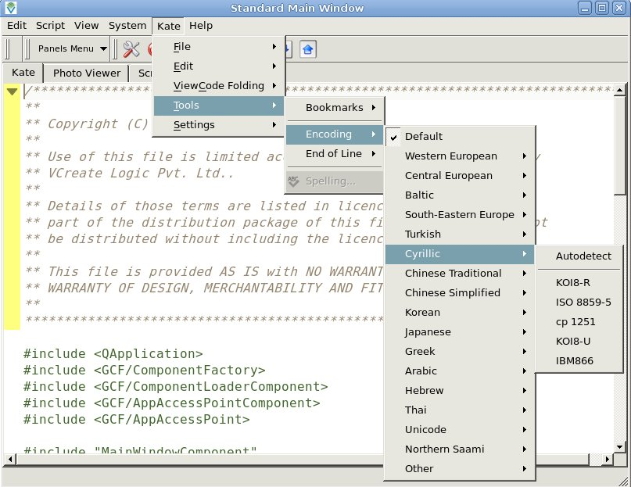
We can notice the following
- the part's widget is parented into the workspace as specified by the parentWidget attribute.
- The part's UI is consolidated into a top-level menu whose “text” as specified by the title attribute
- The top-level UI is inserted before the menu as specified by the before attribute.
- The part opens the URL specified by the url attribute.
Lets load the “text/html” part now. We will need to add the following line to the GUIXML file.
<kpart mimeType="text/html"
parentWidget="MainWindowComponent.rightDockArea"
url="http://www.vcreatelogic.com"
name="htmlPart" title="Browser" readOnly="true"
before="MainWindowComponent.helpMenu" />
After saving and restarting the application, you will notice that KDE's HTML browser component is loaded into the right dock area of the main window.
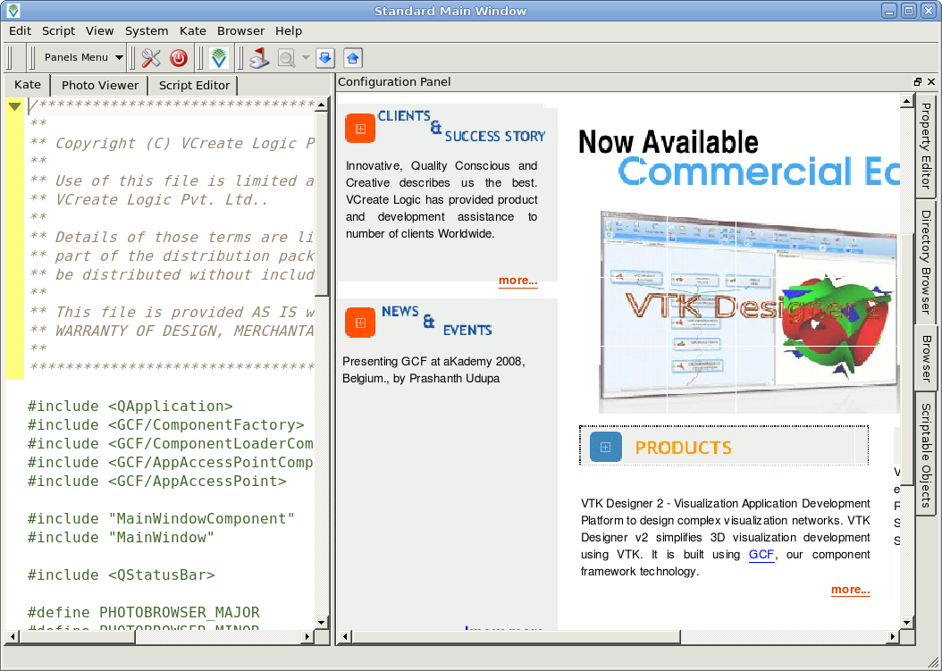
To load parts based on service-type, just use the serviceType attribute instead of the mimeType attribute in the kparts XML element. To load a part from a named library, use the libraryName attribute instead mimeType.
You can make use of method, connection and property GUIXML elements with parts as well, just as we can use them with ActiveX nodes. If you provide a scriptName attribute, then you can script parts as well.

Customizing part creation and destruction
GCF provides an in-built mechanism to create and destroy parts. If you want to customize the way parts are created and destroyed; you can implement the IKPartsFactory interface in a component class.
class IKPartsFactory : virtual public IContainer
{
public:
enum PartCreationType
{
UnknownType,
MimeType,
ServiceType,
LibraryName
};

virtual KParts::Part* createPart(const QString& completeName,
PartCreationType type,
const QString& typeStr,
bool readOnly=true) = 0;

virtual void finalizePart(KParts::Part* part,
const QString& completeName,
PartCreationType type,
const QString& typeStr,
bool readOnly=true) = 0;

virtual void destroyPart(KParts::Part* part,
const QString& completeName,
PartCreationType type,
const QString& typeStr,
bool readOnly=true) = 0;
};
If the above interface implementation is found in a component class whose GUIXML contains the <kpart> xml elements, then GCF makes use of these methods to create, finalize and destroy parts.
- The createPart() method is called for creating a part.
- The finalizePart() method is called before the UI of the part is un-merged
- The destroyPart() method is called after the UI of the part is un-merged. This method must delete the part.

Using the Menu-Strip
Modern UI applications are expected to look flashy and colorful. To help application developers create flashy UIs, GCF comes with a menu-widget replacement called GCF::MenuStrip. To use the menu strip, all you have to do is call
AbstractComponent::setMenuStripEnabled(true);
before the GCF::Components::MainWindowComponent is initialized. After you do that, you can replace <menu> and <toolbar> XML elements with <group> XML elements to merge your actions into the menu strip. Shown below is the PhotoBrowser application with menu strip enabled.
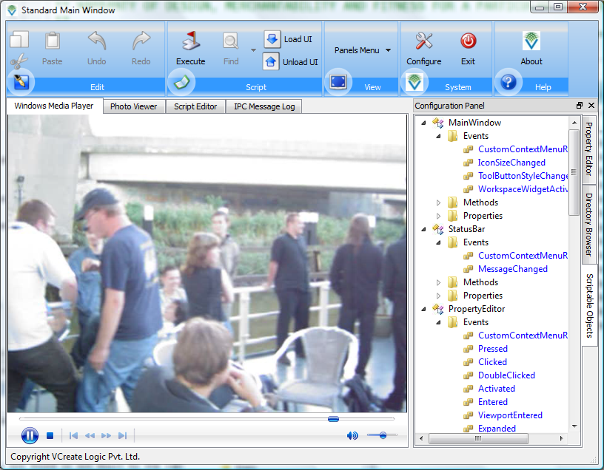

MenuStrip is __NOT__ Ribbon
Despite the fact that the menu strip looks tall and glossy-colored, it is not the Ribbon control that you can find in Microsoft Office 2007. Listed below are some major differences between Ribbon and Menu-strip
- Ribbon has tabs, Menu-strip doesn't
- Ribbon adjusts the actions contained in it when resized, Menu-strip doesn't.
- Menu-strip can be scrolled to the left or right, Ribbon cant.
- Menu-strip adjusts its color scheme depending on the application's palette, Ribbon doesn't (atleast as far as I know). Shown below is the menu-strip used within a red-palette application.
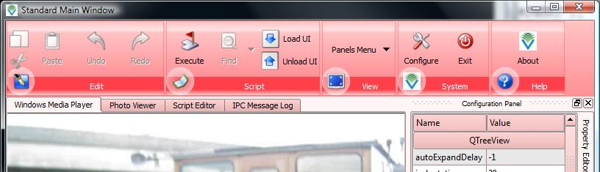

Available only if you compile GCF with Commercial Qt Desktop Editions
Currently GCF/KParts integration is available only on GNU/Linux with KDE 4.0 or later

