**Table of Contents**

1. [Create an S3 bucket](https://dev.to/mariehposa/hosting-a-static-website-with-amazon-s3-i5p#create)
2. [Upload web files to S3 bucket](https://dev.to/mariehposa/hosting-a-static-website-with-amazon-s3-i5p#upload)
3. [Secure S3 bucket through IAM policies](https://dev.to/mariehposa/hosting-a-static-website-with-amazon-s3-i5p#secure)
4. [Configure S3 bucket](https://dev.to/mariehposa/hosting-a-static-website-with-amazon-s3-i5p#configure)
5. [Serve content from S3 bucket with CloudFront](https://dev.to/mariehposa/hosting-a-static-website-with-amazon-s3-i5p#serve)

Now, let’s get into it!

**Step 1 — Create an S3 bucket**

You will need to create an S3 bucket to put your website’s files and folders.

To do this, login into your AWS management console and click on **Services** on the top navbar. From the **Services** drop-down, select **S3** from the **Storage** section. This should display the **S3** dashboard.

[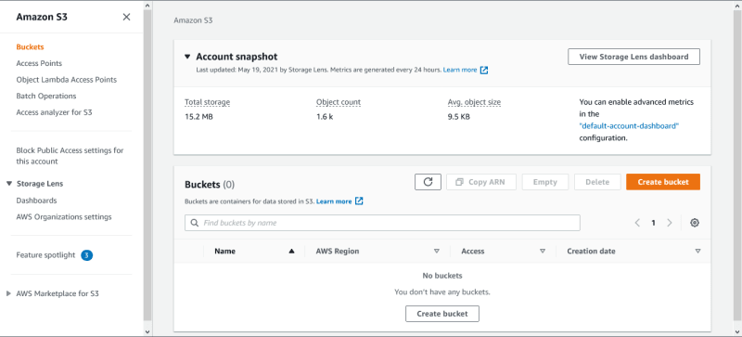](https://res.cloudinary.com/practicaldev/image/fetch/s--LPrfqEju--/c_limit%2Cf_auto%2Cfl_progressive%2Cq_auto%2Cw_800/https:/user-images.githubusercontent.com/33374159/119153245-fc67ba00-ba48-11eb-81dc-63968f5dcfd9.png)

From the S3 dashboard, click on **Create bucket**. Give the bucket a unique name, the name you choose must be globally unique (for best practice, attach your AWS account ID to the name).

Next, choose your preferred **AWS Region** from the drop-down.

[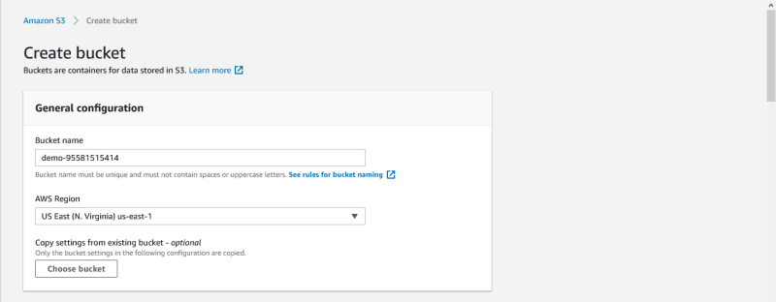](https://res.cloudinary.com/practicaldev/image/fetch/s--6k2HvE3H--/c_limit%2Cf_auto%2Cfl_progressive%2Cq_auto%2Cw_800/https:/user-images.githubusercontent.com/33374159/119145517-9f1c3a80-ba41-11eb-9c6b-f4a17a052e82.png)

Under **Block Public Access settings for this bucket** section, uncheck the **Block all public access** checkbox and accept the acknowledgement. This is done to make the bucket accessible to the public because you are going to host a website in it.

[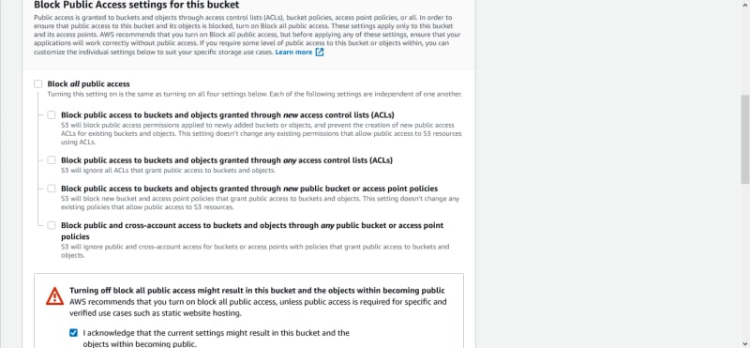](https://res.cloudinary.com/practicaldev/image/fetch/s--6R3wEjf0--/c_limit%2Cf_auto%2Cfl_progressive%2Cq_auto%2Cw_800/https:/user-images.githubusercontent.com/33374159/119145647-c115bd00-ba41-11eb-8c50-b27cfa04fbbb.png)

Click on **disable** for Bucket Versioning.

You can also **Add tag** to the bucket for easy identification.

Under **Default encryption** section, click on **disable** for Server-side encryption.

[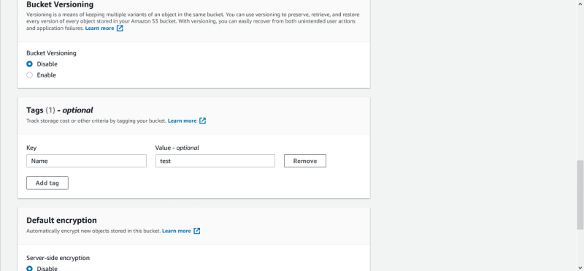](https://res.cloudinary.com/practicaldev/image/fetch/s--YKtRjQHg--/c_limit%2Cf_auto%2Cfl_progressive%2Cq_auto%2Cw_800/https:/user-images.githubusercontent.com/33374159/119145920-076b1c00-ba42-11eb-8cfb-9bd28d352e10.png)

Then click on **Create bucket**.

[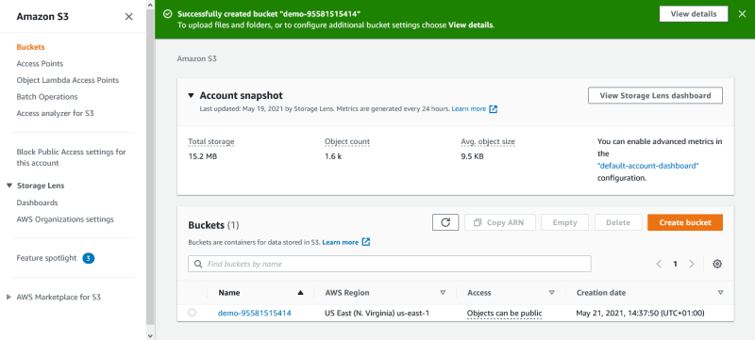](https://res.cloudinary.com/practicaldev/image/fetch/s--BzBOHB1S--/c_limit%2Cf_auto%2Cfl_progressive%2Cq_auto%2Cw_800/https:/user-images.githubusercontent.com/33374159/119146169-47ca9a00-ba42-11eb-9917-5c2fb5bb7802.png)

**Step 2 — Upload web files to S3 bucket**

After creating the bucket, you need to upload your website’s files and folders into it.

From the **S3** dashboard, click on the **name** of the bucket you just created.

On the **Objects** tab, you can see that the bucket is currently empty, click on the **Upload** button.

[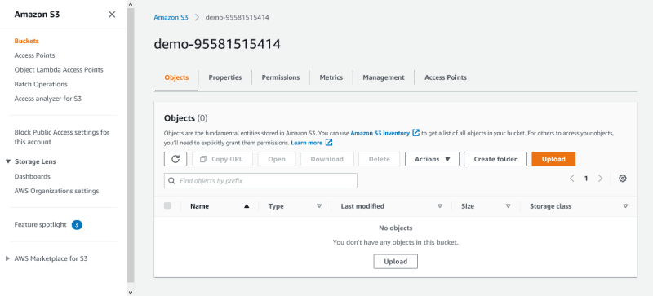](https://res.cloudinary.com/practicaldev/image/fetch/s--T-cKPFhl--/c_limit%2Cf_auto%2Cfl_progressive%2Cq_auto%2Cw_800/https:/user-images.githubusercontent.com/33374159/119146402-806a7380-ba42-11eb-903e-c24995bae41c.png)

This should take you to the **Upload** page. Click **Add files** to add the website files and use **Add folder** to add the website folders.

**Note**: The whole website folder shouldn’t be added at once. Instead, add its content one after the other. For example, with the demo project linked up top, I uploaded my **signup.html** as a file, **signup.js** as a file, **css** as a folder and **img** as a folder.

[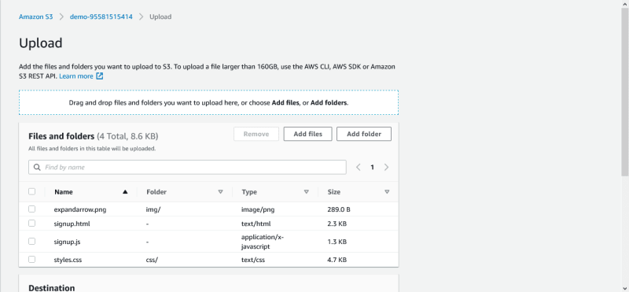](https://res.cloudinary.com/practicaldev/image/fetch/s--p_5k9Zm9--/c_limit%2Cf_auto%2Cfl_progressive%2Cq_auto%2Cw_800/https:/user-images.githubusercontent.com/33374159/119146885-fcfd5200-ba42-11eb-835a-465703daa78b.png)

After the necessary files and folders have been added, scroll down and click on **Upload**.

The uploading should be done in a few minutes depending on your network and content size. Also, please do not close the tab while the upload process is going on.

**Step 3 — Secure S3 bucket through IAM policies**

Now you need to add some policies to secure your bucket.

From the **S3** dashboard, click on the **name** of the bucket, then click on **Permissions** tab. Scroll down to the **Bucket policy** section and click on its **Edit** button.

[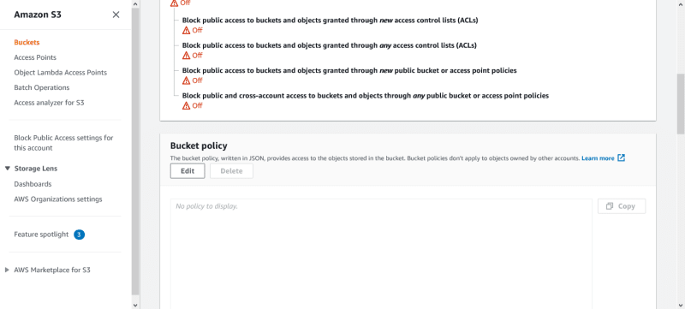](https://res.cloudinary.com/practicaldev/image/fetch/s--cvHgm0t2--/c_limit%2Cf_auto%2Cfl_progressive%2Cq_auto%2Cw_800/https:/user-images.githubusercontent.com/33374159/119147505-93ca0e80-ba43-11eb-8af4-25792cedf124.png)

Add the following bucket policy to it and make sure to replace bucket-name with the name of your bucket.

{

"Version":"2012-10-17",

"Statement":[

{

"Sid":"AddPerm",

"Effect":"Allow",

"Principal": "*",

"Action":["s3:GetObject"],

"Resource":["arn:aws:s3:::bucket-name/*"]

}

]

}

Then scroll down and click on **Save changes**.

This should change the bucket **access** to public, as shown below.

[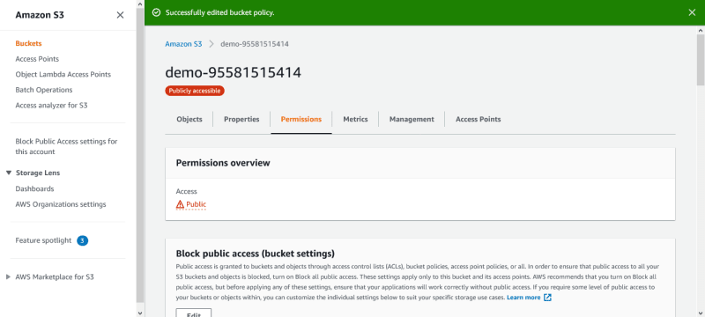](https://res.cloudinary.com/practicaldev/image/fetch/s--1p7hDXCl--/c_limit%2Cf_auto%2Cfl_progressive%2Cq_auto%2Cw_800/https:/user-images.githubusercontent.com/33374159/119148274-3da99b00-ba44-11eb-90b7-0997dc76b81a.png)

**Step 4 — Configure S3 bucket**

You need to specify the default page and error page for your website.

From the **S3** dashboard, click on the **name** of the bucket, then click on the **Properties** tab.

Scroll down to the **Static website hosting** section and click on its **Edit** button.

Select **Enable** for Static website hosting.

Also, select **Host a static website** for the Hosting type.

Enter the file for your **Index document** and **Error document**. The **Error document** is optional. I used **signup.html** for both **Index document** and **Error document**.

Scroll down and click on **Save Changes**.

[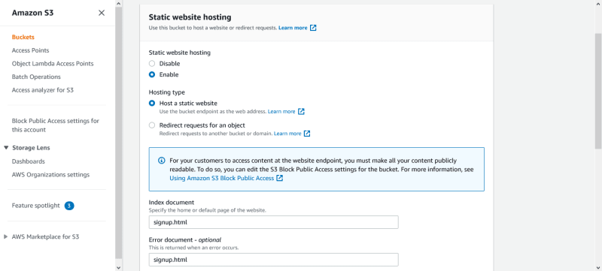](https://res.cloudinary.com/practicaldev/image/fetch/s--KvGOgW4S--/c_limit%2Cf_auto%2Cfl_progressive%2Cq_auto%2Cw_800/https:/user-images.githubusercontent.com/33374159/119148824-cb858600-ba44-11eb-9556-73525506d83a.png)

After saving, If you click on the bucket website endpoint, it would display your website.

[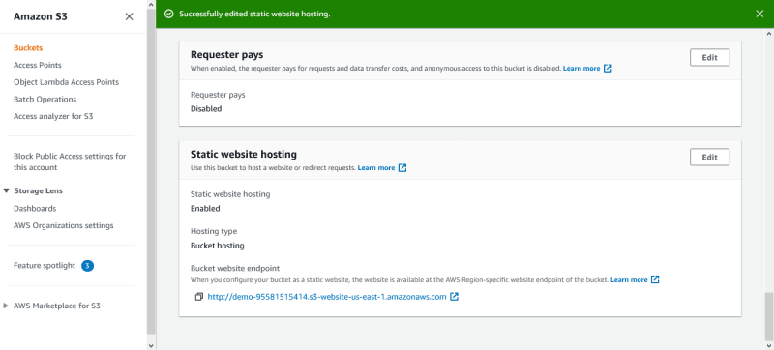](https://res.cloudinary.com/practicaldev/image/fetch/s--bMAzFJlY--/c_limit%2Cf_auto%2Cfl_progressive%2Cq_auto%2Cw_800/https:/user-images.githubusercontent.com/33374159/119149050-0982aa00-ba45-11eb-8e45-145fc9427508.png)

**Step 5 — Serve content from S3 bucket with CloudFront**

From the **Services** drop-down, scroll down to **Networking & Content Delivery** section and click on **CloudFront**. This should take you to the CloudFront dashboard.

Click on **Create Distribution**. On **Select a delivery method for your content** page, click on **Get Started** under the **Web** section.

[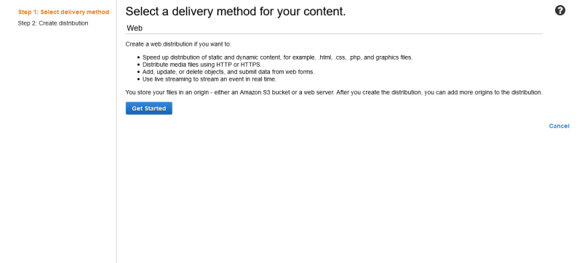](https://res.cloudinary.com/practicaldev/image/fetch/s--ygeIodM8--/c_limit%2Cf_auto%2Cfl_progressive%2Cq_auto%2Cw_800/https:/user-images.githubusercontent.com/33374159/119149298-4babeb80-ba45-11eb-8550-b06a6642dd35.png)

Under the **Origin Settings** section, click on the **Origin Domain Name** field and select the S3 bucket you created earlier. In the **Origin Path** field, enter **/** to indicate root level.

For **Restrict Bucket Access**, select **Yes**.

For **Origin Access Identity**, select **Create a New Identity**.

For **Grant Read Permissions on Bucket**, select **Yes, Update Bucket Policy**.

[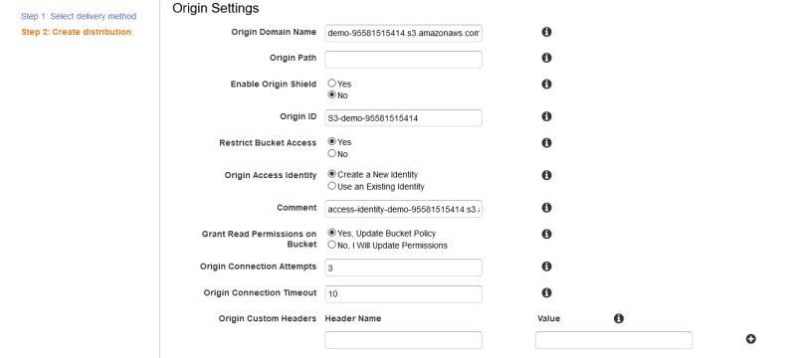](https://res.cloudinary.com/practicaldev/image/fetch/s--gXfxgvOw--/c_limit%2Cf_auto%2Cfl_progressive%2Cq_auto%2Cw_800/https:/user-images.githubusercontent.com/33374159/119150705-9aa65080-ba46-11eb-8a75-dc2b14a53807.png)

Scroll down to the **Default Cache Behavior Settings** section. For **Viewer Protocol Policy**, select **Redirect HTTP to HTTPS**.

[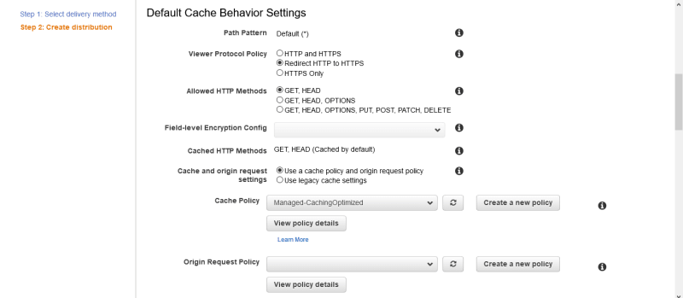](https://res.cloudinary.com/practicaldev/image/fetch/s--qEEEKId1--/c_limit%2Cf_auto%2Cfl_progressive%2Cq_auto%2Cw_800/https:/user-images.githubusercontent.com/33374159/119151046-e8bb5400-ba46-11eb-91e4-5883998b75d9.png)

Next, scroll down to the **Distribution Settings** section. Inside the **Default Root Object** field, enter the filename at the root level, which should be your landing page. I used **signup.html** as my **Default Root Object**.

Leave the rest of the options as default and click on **Create Distribution**.

[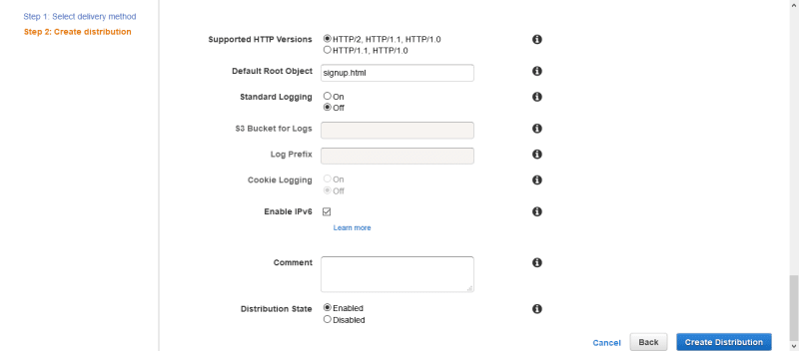](https://res.cloudinary.com/practicaldev/image/fetch/s--eXVEVvQr--/c_limit%2Cf_auto%2Cfl_progressive%2Cq_auto%2Cw_800/https:/user-images.githubusercontent.com/33374159/119151334-320ba380-ba47-11eb-9694-175a62505d7b.png)

Now, you can see the distribution you created from the CloudFront dashboard. It might take a few minutes for it to be deployed.

[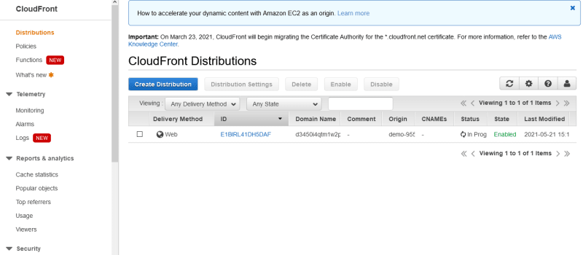](https://res.cloudinary.com/practicaldev/image/fetch/s--Iwfj8CC0--/c_limit%2Cf_auto%2Cfl_progressive%2Cq_auto%2Cw_800/https:/user-images.githubusercontent.com/33374159/119151828-a9413780-ba47-11eb-8363-f689ad363a21.png)

After the CloudFront distribution has been deployed, copy the URL from the Domain Name column and paste it into your browser. Yay!🎉 That’s it!

[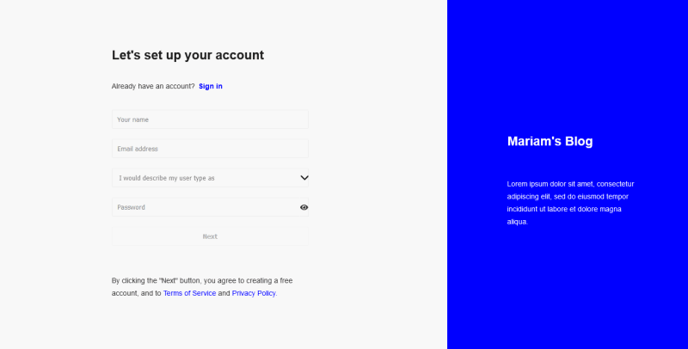](https://res.cloudinary.com/practicaldev/image/fetch/s--Gf8R-IXf--/c_limit%2Cf_auto%2Cfl_progressive%2Cq_auto%2Cw_800/https:/user-images.githubusercontent.com/33374159/119156002-afd1ae00-ba4b-11eb-9133-c652785ebcfc.png)

Now, you can access your website with:

1. CloudFront domain name e.g d3450i4qtm1w2p.cloudfront.net
2. Website endpoint e.g [http://demo-95581515414.s3-website-us-east-1.amazonaws.com](http://demo-95581515414.s3-website-us-east-1.amazonaws.com/)
3. S3 object URL e.g <https://demo-95581515414.s3.us-east-1.amazonaws.com/signup.html>

You should now know how to host a static website with Amazon S3 and speed up the content delivery using AWS CloudFront. Even though you had to go through a few steps, you did it and you're awesome!

If you’ve found this article helpful, please leave a heart or a comment. If you have any questions or constructive feedback, please let me know in the comment section.

Also, don’t forget to follow me for more articles. Thank you!

👋 Before you go

Do your career a favor. **Join DEV.** (The website you're on right now)

It takes ***one minute***, it's free, and is worth it for your career.