Prediction of Whether Mushroom is Edible or Poisonous Using Back-propagation Neural Network.

**Eyad Sameh Alkronz, Khaled A. Moghayer, Mohamad Meimeh, Mohannad Gazzaz, Bassem S. Abu-Nasser, Samy S. Abu-Naser**

Department of Information Technology,

Faculty of Engineering and Information Technology,

Al-Azhar University - Gaza, Palestine

## *Abstract: Predication is an application of Artificial Neural Network (ANN). It is a supervised learning due to predefined input and output attributes. Multi-Layer ANN model is used for training, validating, and testing of the data. In this paper, Multi-Layer ANN model was used to train and test the mushroom dataset to predict whether it is edible or poisonous. The Mushrooms dataset was prepared for training, 8124 instances were used for the training. JustNN software was used to training and validating the data. The most important attributes of the data set were identified, and the accuracy of the predication of whether Mushroom is edible or Poisonous was 99.25%.*

**Keywords**: artificial neural network, back-propagation neural network, poisonous mushroom, edible mushroom, predict.

# **Introduction**

The standard "mushroom" is the cultivated white button mushroom, Agaricus bisporus; therefore the word "mushroom" is usually applied to those fungi (Basidiomycota, Agaricomycetes) that have a stem (stipe), a cap (pileus), and gills (lamellae, sing. lamella) on the bottom of the cap. "Mushroom" as well describes a variation of other gilled fungi, with or without stems; hence the term is used to describe the fleshy fruiting bodies of some Ascomycota. These gills produce microscopic spores that aid the fungus spread across the ground [1].

Mushrooms are used widely in cooking, in various cuisines (notably Chinese, Korean, European, and Japanese). Though neither meat nor vegetable, mushrooms are acknowledged as the "meat" of the vegetable world [1].

Most mushrooms sold in supermarkets have been commercially produced on mushroom farms. The most common of these, Agaricus bisporus, is well-thought-out to be safe for utmost people to eat since it is grown in controlled, sterilized surroundings. Numerous varieties of A. bisporus are grown commercially, as well as whites, crimini, and portobello. Other cultivated species existing at many grocers include Hericium erinaceus, shiitake, maitake (hen-of-the-woods), Pleurotus, and enoki. Recently, increasing wealth in developing countries has directed to a substantial growth in attention in mushroom cultivation, which is now seen as a possibly significant economic activity for small farmers[2].

The main edible mushroom producer is China [3]. The country produces about half of all cultivated mushrooms, and around 2.7 kg of mushrooms are consumed per person per year by over a billion people[4]. In 2014, Poland was the world's largest mushroom exporter, reporting an estimated 194,000 tons annually[5].

Distinguishing edible from poisonous mushroom species needs meticulous care to detail; there is no single trait by which all toxic mushrooms can be recognized, nor one by which all edible mushrooms can be recognized. People who gather mushrooms for eating are known as mycophagists [6] and the act of gathering them for such is known as mushroom hunting, or simply "mushrooming". Even edible mushrooms may yield allergic reactions in susceptible individuals, from a mild asthmatic response to severe anaphylactic shock [7, 8]. Even the cultivated A. bisporus comprises small amounts of hydrazines, the most copious of which is agaritine (a mycotoxin and carcinogen) [9]. Nevertheless, the hydrazines are demolished by reasonable heat when cooking [10].

A number of species of mushrooms are poisonous; even though some resemble sure edible species, consuming them could be deadly. Eating mushrooms collected in the wild is risky and should only be undertaken by individuals knowledgeable in mushroom recognition. Mutual best practice is for wild mushroom pickers to focus on gathering a small number of visually distinct, edible mushroom species that cannot be simply confused with poisonous varieties [10].

# **Artificial neural networks**

Artificial neural networks (ANNs) are parallel computational models comprised of densely interconnected, adaptive processing units, characterized by an inherent propensity for learning from experience and also discovering new knowledge [11-15]. Due to their excellent capability of self-learning and self-adapting, they have been extensively studied and have been successfully utilized to tackle difficult real-world problems and are often found to be more efficient and more accurate than other classification techniques [16-20]. Classification with a neural network takes place in two distinct phases. First, the network is trained on a set of paired data to determine the input-output mapping [16-21]. The weights of the connections between neurons are then fixed and the network is used to determine the classifications of a new set of data [22-30]. Although many different models of ANNs have been proposed, the feedforward neural networks (FNNs) are the most common and widely used in a variety of applications [31-35].

Mathematically, the problem of training a FNN can be formulated as the minimization of an error function E; that is to find a minimizer [36-40]



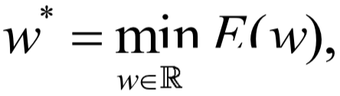

Where E is the batch error measure defined by the sum of square differences over all examples of the training set, namely

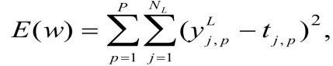

where yLj, p is the actual output of the j-th neuron that belongs to the L-th (output) layer, NL is the number of neurons of the output layer, t j , p is the desired response at the j-th neuron of the output layer at the input pattern p and P represents the total number of patterns used in the training set.

A traditional way to solve this problem is by an iterative gradient-based training algorithm which generates a sequence of weights {w } starting from an initial point W0  R using the iterative formula

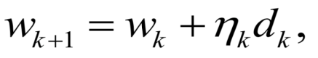

Where k is the current iteration usually called epoch, nk > 0 is the learning rate and dk is a descent search direction. Since the appearance of backpropagation a variety of approaches that use second order derivative related information was suggested for improving the efficiency of the minimization error process[41-45].

Here, we have utilized three well-known and widely used classical methods, namely the Broyden-Fletcher-Goldfarb-Shanno (BFGS), the Levenberg- Marquardt (LM) and the Resilient Backpropagation (Rprop). Moreover, we have also used a new efficient conjugate gradient algorithm, the modified spectral Perry (MSP). Due to space limitations, we are not in a position to briefly describe here the above methods. The interested reader is referred to[46-49].

The Biological Model (Neural Networks)

* Neural networks as a computing model possess the following properties[50-60]:
* **Operate in parallel**

Computing elements (neurons) work in parallel as opposed to the sequential action of Turing machines.

* **Hierarchical Multilayered Structure**

Information is transmitted not only to immediate neighbors, but also to more distant units, as opposed to CA.

* **No Program is handed over to the hardware**

The free parameters of the network have to be found adaptively - as opposed to conventional computers (which require pre-programmed algorithms to execute).

* Structure of the Neuron

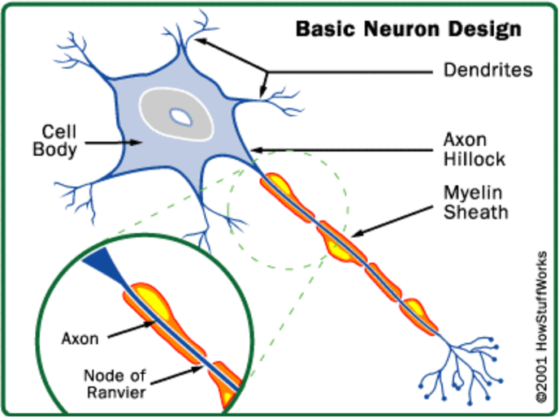

Figure 1: Cell

The cell body (soma) : "Processing" occurs here[61-65].

* Dendrites: Protrude from soma. They conduct signals to the cell body
* Axon Hillock: Extends from cell body - initial portion of the axon.
* Axon: A long fibre - generally splits into smaller branches.
* Synapse: The axon-dendrite (axon-soma; axon-axon) contact between an endbulb and the cell it impinges upon is called a synapse [66-70]. (End bulbs can be seen at the bottom right corner of the above image.)

# **Study Objectives**

The objectives of this study are:

* to determine some suitable factors that affect predicting the Validity of Mushrooms
* to transform these factors into forms suitable for an adaptive system coding
* to model an Artificial neural network that can be used to predict the Validity of Mushrooms based some given input data for a given Mushrooms.

# **Methodology**

After getting the Mushroom dataset from “the [Center for Machine Learning and Intelligent Systems](https://cml.ics.uci.edu/), University of California, Irvine”, we identified the input variables, output variables, upload the dataset, divided it to training and validating sets, determined the proper hidden layers. Then we trained and validated the sets to get the best accuracy.

**4.1 The Input Variables**

The input variables selected are those which can easily be obtained from Mushroom Database. The input variables are: cap-shape, cap-surface, cap-color, bruises?, odor, gill-attachment, gill-spacing, gill-size, gill-color, stalk-shape, stalk-root, stalk-surface-above-ring, stalk-surface-below-ring, stalk-color-above-ring, stalk-color-below-ring, veil-type, veil-color, ring-number, ring-type, spore-print-color, population, Habitat.

These factors were transformed into a format suitable for neural network analysis. The domain of the input variables used in this study shown in Table1.

**Table 1:** Input Data Transformation.

|  |  |  |
| --- | --- | --- |
| # | Input Variable | Domain |
| 1 | cap-shape | bell=b , conical=c , convex=x , flat=f , knobbed=k , sunken=s |
| 2 | cap-surface: | fibrous=f , grooves=g ,scaly=y , smooth=s |
| 3 | cap-color: | brown=n, buff=b, cinnamon=c , gray=g , green=r , pink=p , purple=u , red=e  white=w , yellow=y |
| 4 | bruises?: | bruises=t ,no=f |
| 5 | odor: | almond=a ,anise=l , creosote=c , fishy=y , foul=f , musty=m , none=n , pungent=p , spicy=s |
| 6 | gill-attachment: | attached=a ,descending=d ,free=f ,notched=n |
| 7 | gill-spacing | close=c ,crowded=w ,distant=d |
| 8 | gill-size: | broad=b ,narrow=n |
| 9 | gill-color: | black=k, brown=n, buff=b, chocolate=h, gray=g, green=r, orange=o, pink=p, purple=u, red=e, white=w, yellow=y |
| 10 | stalk-shape: | enlarging=e , tapering=t |
| 11 | stalk-root: | bulbous=b ,club=c, cup=u, equal=e, rhizomorphs=z, rooted=r, missing=? |
| 12 | stalk-surface-above-ring: | ibrous=f, scaly=y ,silky=k, smooth=s |
| 13 | stalk-surface-below-ring: | ibrous=f, scaly=y, silky=k, smooth=s |
| 14 | stalk-color-above-ring: | brown=n, buff=b, cinnamon=c, gray=g, orange=o, pink=p, red=e, white=w, yellow=y |
| 15 | stalk-color-below-ring: | brown=n,buff=b,cinnamon=c,gray=g,orange=o,pink=p,red=e,white=w,yellow=y |
| 16 | veil-type: | partial=p, universal=u |
| 17 | veil-color: | brown=n, orange=o, white=w, yellow=y |
| 18 | ring-number: | none=n, one=o, two=t |
| 19 | ring-type: | cobwebby=c, evanescent=e, flaring=f, large=l, none=n ,pendant=p, sheathing=s, zone=z |
| 20 | spore-print-color: | black=k, brown=n, buff=b, chocolate=h, green=r, orange=o, purple=u, white=w, yellow=y |
| 21 | population: | abundant=a, clustered=c, numerous=n, scattered=s, several=v, solitary=y |
| 22 | Habitat : | grasses=g, leaves=l, meadows=m, paths=p, urban=u, waste=w, woods=d |

**4.2 Output variable**

The output variable is whether the mushroom edible or poisonous.

**4.3 Neural Network Topologies**

After the data classification, the neural network topology was built based on the Multilayer Perceptron with one input layer, three hidden layers (2x1x3) and one output layer as shown in Figure 5.

**4.4 Evaluation of the study**

First of all, for the evaluation our study, we used a sample of 8124 mushrooms representing edible and non-edible mushrooms. Most of the mushrooms are Poisonous in order to examine whether the Mushroom is edible or not edible, we develop a model able to differentiate between editable and poisonous mushrooms. Our model uses a neural network with one input layer, three hidden layer and one output layer. As input data for predicting the Validity of Mushrooms we used attribute as shown in Figure 1.

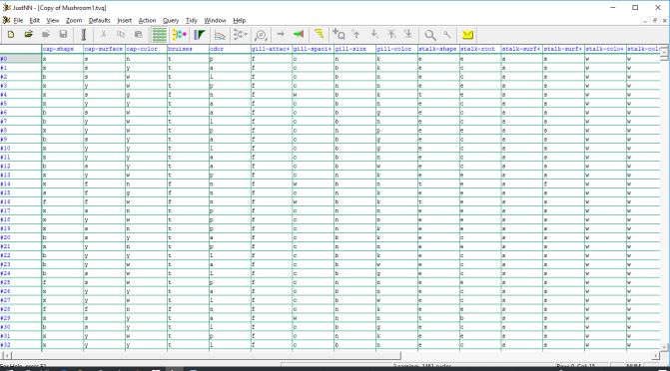

**Figure 2: Dataset in JNN environment**

Our task was to predict the result belongs based on the 22 input variables. We conducted a series of tests in order to establish the number of hidden layers and the number of neurons in each hidden layer. Our tests give us that the best results are obtained with three hidden layers.

We used a sample of (8,124 records): 5724 training samples and 2400 validating samples. The network structure was found on a trial and error basis. We started with a small network and gradually increased its size. Finally, we found that the best results are obtained for a network with the following structure: 22I-3H-1O, i.e. 22 input neurons, 3 hidden layers with (2x1x3) neurons, and an output layer with 1 neuron.

For this study we used Just Neural Network (JNN). We trained the network for 161501 epochs (as shown in Figure 4) on a regular computer with 4 GB of RAM memory under the Windows 10 operating system. We get accuracy of 99.25%

**4.5 Relative Importance:**

Figure 3 shows the factors, their importance and relative importance that affect the mushroom artificial Neural Model using Just NN environment.

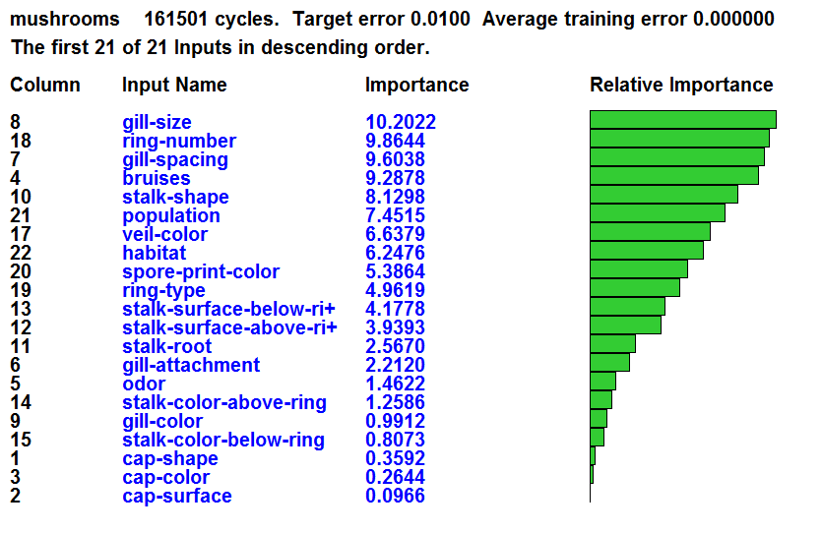

**Figure 3:** relative importance of the factors affecting the mushroom model

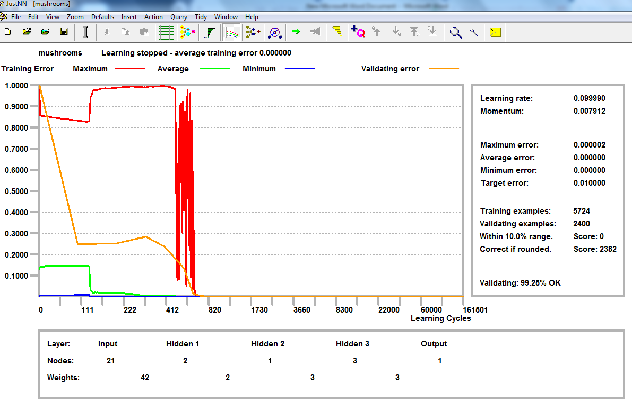

**Figure 4:** Training and validating of mushroom ANN model

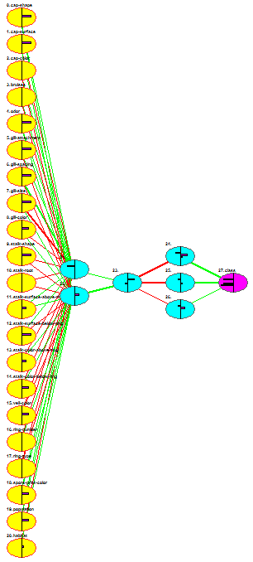

**Figure 5: Architecture of the Mushroom network**

# **Conclusion**

In This paper, we used the prediction power of a neural network to classify whether a mushroom is edible or poisonous. Our network achieved an accuracy of over 99%. We used the JustNN environment for building the network that was a feed forward Multi-Layer Perceptron with one input layer, three hidden layer and one output layer. The average predictability rate was 99.25% for Prediction of Whether the Mushroom is Edible or Poisonous.

# **REFERANCES**

1. Haas EM, James P (2009). [More Vegetables, Please!: Delicious Recipes for Eating Healthy Foods Each & Every Day](https://books.google.com/books?id=15ikzjLo4wYC&pg=PA22). Oakland, California: New Harbinger Publications. p. 22. [ISBN](https://en.wikipedia.org/wiki/International_Standard_Book_Number) [978-1-57224-590-7](https://en.wikipedia.org/wiki/Special:BookSources/978-1-57224-590-7).
2. [Making Money by growing Mushrooms](ftp://ftp.fao.org/docrep/fao/011/i0522e/i0522e00.pdf)
3. ["Production of Cultivated Edible Mushroom in China With Emphasis on Lentinula edodes - isms.biz"](http://www.isms.biz/articles/production-of-cultivated-edible-mushroom-in-china-with-emphasis-on-lentinula-edodes/). isms.biz. Retrieved 2017-01-25.
4. Hall et al., 2003, p. 25.
5. ["Poland: The world's largest mushroom exporter"](http://www.freshplaza.com/article/137929/Poland-The-worlds-largest-mushroom-exporter). Fresh Plaza. 8 April 2015. Retrieved 23 September 2016.
6. Metzler V, Metzler S (1992). [Texas Mushrooms: a Field Guide](https://books.google.com/books?id=HRtfvVigMmsC&pg=PA37). Austin, Texas: University of Texas Press. p. 37. [ISBN](https://en.wikipedia.org/wiki/International_Standard_Book_Number) [0-292-75125-7](https://en.wikipedia.org/wiki/Special:BookSources/0-292-75125-7). Retrieved 2010-08-04.
7. Hall et al., 2003, pp. 22–24.
8. Schulzova, V; Hajslova, J; Peroutka, R; Hlavasek, J; Gry, J; Andersson, H.C. (2009). "Agaritine content of 53 Agaricus species collected from nature". Food Additives & Contaminants: Part A. 26 (1): 82–93. [doi](https://en.wikipedia.org/wiki/Digital_object_identifier):[10.1080/02652030802039903](https://doi.org/10.1080%2F02652030802039903). [PMID](https://en.wikipedia.org/wiki/PubMed_Identifier) [19680875](https://www.ncbi.nlm.nih.gov/pubmed/19680875).
9. Siegered, AA, ed. (January 1998). ["Spore Prints #338"](http://www.psms.org/sporeprints/sp338.html). Bulletin of the Puget Sound Mycological Society. Retrieved 2010-07-04.
10. Baker, B.D. and Richards, C.E., 1999. A comparison of conventional linear regression methods and neural networks for forecasting educational spending, Economics of Education Review, 18, pp. 405-415.
11. Calvo-Flores, M.D, Galindo, E.G., Pegalajar Jiménez, M.C. and Piñeiro, O.P., 2006. Predicting students’ marks from Moodle logs using neural network models, A. Méndez-Vilas, A. Solano Martín, J.A. Mesa González and J. Mesa González (eds.) Current Developments in Technology-Assisted Education, pp. 586-590.
12. Cooper, C.I., 2010. A Generalizable Neural Network for Predicting Student Retention, Professional Papers Proceedings Archive, Available at: http://www.asee.org/documents/zones/zone1/2010/professional/AGeneralizable-Neural-Network-for-Predicting-Student-Retention.pdf, 17.01.2013.
13. Halachev, P., 2012. Prediction of e-Learning Efficiency by Neural Networks, Cybernetics and information technologies, Volume 12, No 2, pp. 98-108.
14. Heaton, J., 2011. Programming Neural Networks with Encog3 in Java, 2nd Edition, Heaton Research.
15. Igel, C., Hüsken, M., 2000. Improving the Rprop Learning Algorithm, Proceedings of the Second International Symposium on Neural Computation, pp. 115–121, ICSC Academic Press
16. Abu-Naser, S., Al-Masri, A., Sultan, Y. A., & Zaqout, I. (2011). A prototype decision support system for optimizing the effectiveness of elearning in educational institutions. International Journal of Data Mining & Knowledge Management Process (IJDKP), 1, 1-13.
17. Abu Naser, S., Zaqout, I., Ghosh, M. A., Atallah, R., & Alajrami, E. (2015). Predicting Student Performance Using Artificial Neural Network: in the Faculty of Engineering and Information Technology. International Journal of Hybrid Information Technology, 8(2), 221-228.
18. Elzamly, A., Abu Naser, S. S., Hussin, B., & Doheir, M. (2015). Predicting Software Analysis Process Risks Using Linear Stepwise Discriminant Analysis: Statistical Methods. Int. J. Adv. Inf. Sci. Technol, 38(38), 108-115.
19. Abu Naser, S. S. (2012). Predicting learners performance using artificial neural networks in linear programming intelligent tutoring system. International Journal of Artificial Intelligence & Applications, 3(2), 65.
20. Elzamly, A., Hussin, B., Abu Naser, S. S., Shibutani, T., & Doheir, M. (2017). Predicting Critical Cloud Computing Security Issues using Artificial Neural Network (ANNs) Algorithms in Banking Organizations. International Journal of Information Technology and Electrical Engineering, 6(2), 40-45.
21. Abu Naser, S. S., & Al-Bayed, M. H. (2016). Detecting Health Problems Related to Addiction of Video Game Playing Using an Expert System. World Wide Journal of Multidisciplinary Research and Development, 2(9), 7-12.
22. Abu Ghali, M. J., Mukhaimer, M. N., Abu Yousef, M. K., & Abu Naser, S. S. (2017). Expert System for Problems of Teeth and Gums. International Journal of Engineering and Information Systems (IJEAIS), 1(4), 198-206.
23. Abu Naser, S., & Akkila, A. N. (2008). A Proposed Expert System for Skin Diseases Diagnosis. INSInet Publication. Journal of Applied Sciences Research, 4(12), 1682-1693.
24. El Agha, M., Jarghon, A., & Abu Naser, S. S. (2017). Polymyalgia Rheumatic Expert System. International Journal of Engineering and Information Systems (IJEAIS), 1(4), 125-137.
25. Abu Naser, S., Al-Dahdooh, R., Mushtaha, A., & El-Naffar, M. (2010). Knowledge management in ESMDA: expert system for medical diagnostic assistance. AIML Journal, 10(1), 31-40.
26. Almurshidi, S. H., & Abu-Naser, S. S. (2018). EXPERT SYSTEM FOR DIAGNOSING BREAST CANCER. Al-Azhar University, Gaza, Palestine.
27. Abu Naser, S. S., & Alawar, M. W. (2016). An expert system for feeding problems in infants and children. International Journal of Medicine Research, 1(2), 79-82.
28. Al Rekhawi, H. A., Ayyad, A. A., & Abu Naser, S. S. (2017). Rickets Expert System Diagnoses and Treatment. International Journal of Engineering and Information Systems (IJEAIS), 1(4), 149-159.
29. Abu Naser, S. S., & AlDahdooh, R. M. (2016). Lower Back Pain Expert System Diagnosis and Treatment. Journal of Multidisciplinary Engineering Science Studies (JMESS), 2(4), 441-446.
30. Nabahin, A., Abou Eloun, A., & Abu Naser, S. S. (2017). Expert System for Hair Loss Diagnosis and Treatment. International Journal of Engineering and Information Systems (IJEAIS), 1(4), 160-169.
31. Abu Naser, S. S., & Alhabbash, M. I. (2016). Male Infertility Expert system Diagnoses and Treatment. American Journal of Innovative Research and Applied Sciences, 2(4).
32. Qwaider, S. R., & Abu Naser, S. S. (2017). Expert System for Diagnosing Ankle Diseases. International Journal of Engineering and Information Systems (IJEAIS), 1(4), 89-101.
33. Abu Naser, S. S., & Al-Hanjori, M. M. (2016). An expert system for men genital problems diagnosis and treatment. International Journal of Medicine Research, 1(2), 83-86.
34. Naser, S. S. A., & Hasanein, H. A. A. (2016). Ear Diseases Diagnosis Expert System Using SL5 Object. World Wide Journal of Multidisciplinary Research and Development, 2(4), 41-47.
35. Nassr, M. S., & Abu Naser, S. S. (2018). Knowledge Based System for Diagnosing Pineapple Diseases. International Journal of Academic Pedagogical Research (IJAPR), 2(7), 12-19.
36. Abu Naser, S. S., & El-Najjar, A. E. A. (2016). An expert system for nausea and vomiting problems in infants and children. International Journal of Medicine Research, 1(2), 114-117.
37. Elqassas, R.,& Abu-Naser, S. S. (2018). Expert System for the Diagnosis of Mango Diseases. International Journal of Academic Engineering Research (IJAER) 2 (8), 10-18.
38. Naser, S. S. A., & Hilles, M. M. (2016). An expert system for shoulder problems using CLIPS. World Wide Journal of Multidisciplinary Research and Development, 2(5), 1-8.
39. Musleh, M. M., & Abu-Naser, S. S. (2018). Rule Based System for Diagnosing and Treating Potatoes Problems. International Journal of Academic Engineering Research (IJAER) 2 (8), 1-9.
40. Abu Naser, S. S., & Hamed, M. A. (2016). An Expert System for Mouth Problems in Infants and Children. Journal of Multidisciplinary Engineering Science Studies (JMESS), 2(4), 468-476.
41. Almadhoun, H., & Abu-Naser, S. (2017). Banana Knowledge Based System Diagnosis and Treatment. International Journal of Academic Pedagogical Research (IJAPR), 2(7), 1-11.
42. Abu Naser, S. S., & Mahdi, A. O. (2016). A proposed Expert System for Foot Diseases Diagnosis. American Journal of Innovative Research and Applied Sciences, 2(4), 155-168.
43. Dahouk, A. W., & Abu-Naser, S. S. (2018). [A Proposed Knowledge Based System for Desktop PC Troubleshooting](javascript:void(0)). International Journal of Academic Pedagogical Research (IJAPR) 2 (6), 1-8
44. Abu Naser, S. S., & Ola, A. Z. A. (2008). AN EXPERT SYSTEM FOR DIAGNOSING EYE DISEASES USING CLIPS. Journal of Theoretical & Applied Information Technology, 4(10).
45. Bakeer, H., & Abu-Naser, S. S. (2017). Photo Copier Maintenance Expert System V. 01 Using SL5 Object Language. International Journal of Engineering and Information Systems (IJEAIS) 1 (4), 116-124.
46. Abu Naser, S. S., & Shaath, M. Z. (2016). Expert system urination problems diagnosis. World Wide Journal of Multidisciplinary Research and Development, 2(5), 9-19.
47. Khella, R., & Abu-Naser, S. S. (2017). Rule Based System for Chest Pain in Infants and Children. International Journal of Engineering and Information Systems 1 (4), 138-148.
48. Abu-Naser, S. S., El-Hissi, H., Abu-Rass, M., & El-Khozondar, N. (2010). An expert system for endocrine diagnosis and treatments using JESS. Journal of Artificial Intelligence; Scialert, 3(4), 239-251.
49. Mrouf, A., Albatish, I., Mosa, M., & Abu Naser, S. S. (2017). Knowledge Based System for Long-term Abdominal Pain (Stomach Pain) Diagnosis and Treatment. International Journal of Engineering and Information Systems (IJEAIS) 1 (4), 71-88.
50. Abu Naser, S. S., Baraka, M. H.,& Baraka, A. R. (2008). A Proposed Expert System For Guiding Freshman Students In Selecting A Major In Al-Azhar University, Gaza.Journal of Theoretical & Applied Information Technology 4(9).
51. Abu-Nasser, B. S., & Abu-Naser, S. S. (2018). Cognitive System for Helping Farmers in Diagnosing Watermelon Diseases. International Journal of Academic Information Systems Research (IJAISR) 2 (7), 1-7.
52. Abu Naser, S. S., Alamawi, W. W., & Alfarra, M. F. (2016). Rule Based System for Diagnosing Wireless Connection Problems Using SL5 Object. International Journal of Information Technology and Electrical Engineering 5(6), 26-33.
53. Akkila, A. N., & Abu Naser, S. S. (2016). Proposed Expert System for Calculating Inheritance in Islam. World Wide Journal of Multidisciplinary Research and Development 2 (9), 38-48.
54. Abu Naser, S. S., & Zaqout, I. S. (2016). Knowledge-based systems that determine the appropriate students major: In the faculty of engineering and information technology, World Wide Journal of Multidisciplinary Research and Development 2 (10), 26-34.
55. AbuEl-Reesh, J. Y., & Abu Naser, S. S. (2017). A Knowledge Based System for Diagnosing Shortness of Breath in Infants and Children. International Journal of Engineering and Information Systems (IJEAIS) 1 (4), 102-115.
56. Abu Naser, S. S., & Bastami, B. G. (2016). A proposed rule based system for breasts cancer diagnosis. World Wide Journal of Multidisciplinary Research and Development 2 (5), 27-33.
57. Abu-Nasser, B. S. (2017). Medical Expert Systems Survey. International Journal of Engineering and Information Systems, 1(7), 218-224.
58. Abu Naser, S. S., & ALmursheidi, S. H. (2016). A Knowledge Based System for Neck Pain Diagnosis. World Wide Journal of Multidisciplinary Research and Development (WWJMRD), 2(4), 12-18.
59. Azaab, S., Abu Naser, S., & Sulisel, O. (2000). A proposed expert system for selecting exploratory factor analysis procedures. Journal of the College of Education 4 (2), 9-26.
60. Abu-Naser, S. S., Kashkash, K. A., & Fayyad, M. (2010). Developing an expert system for plant disease diagnosis. Journal of Artificial Intelligence, 3 (4), 269-276.
61. Barhoom, A. M., & Abu-Naser, S. S. (2018). Black Pepper Expert System. International Journal of Academic Information Systems Research, (IJAISR) 2 (8), 9-16.
62. AlZamily, J. Y., & Abu-Naser, S. S. (2018). A Cognitive System for Diagnosing Musa Acuminata Disorders. International Journal of Academic Information Systems Research, (IJAISR) 2 (8), 1-8.
63. Alajrami, M. A., & Abu-Naser, S. S. (2018). Onion Rule Based System for Disorders Diagnosis and Treatment. International Journal of Academic Pedagogical Research (IJAPR), 2 (8), 1-9.
64. Al-Shawwa, M., Al-Absi, A., Abu Hassanein, S., Abu Baraka, K., & Abu-Naser, S. S. (2018). Predicting Temperature and Humidity in the Surrounding Environment Using Artificial Neural Network. International Journal of Academic Pedagogical Research (IJAPR), 2(9), 1-6.
65. Salah, M., Altalla, K., Salah, A., & Abu-Naser, S. S. (2018). Predicting Medical Expenses Using Artificial Neural Network. International Journal of Engineering and Information Systems (IJEAIS), 2(20), 11-17.
66. Marouf, A., & Abu-Naser, S. S. (2018). Predicting Antibiotic Susceptibility Using Artificial Neural Network. International Journal of Academic Pedagogical Research (IJAPR), 2(10), 1-5.
67. Jamala, M. N., & Abu-Naser, S. S. (2018). Predicting MPG for Automobile Using Artificial Neural Network Analysis. International Journal of Academic Information Systems Research (IJAISR), 2(10), 5-21.
68. Kashf, D. W. A., Okasha, A. N., Sahyoun, N. A., El-Rabi, R. E., & Abu-Naser, S. S. (2018). Predicting DNA Lung Cancer using Artificial Neural Network. International Journal of Academic Pedagogical Research (IJAPR), 2(10), 6-13.
69. Metwally, N. F., AbuSharekh, E. K., & Abu-Naser, S. S. (2018). Diagnosis of Hepatitis Virus Using Artificial Neural Network. International Journal of Academic Pedagogical Research (IJAPR), 2(11), 1-7.
70. Heriz, H. H., Salah, H. M., Abdu, S. B. A., El Sbihi, M. M., & Abu-Naser, S. S. (2018). English Alphabet Prediction Using Artificial Neural Networks. International Journal of Academic Pedagogical Research (IJAPR), 2(11), 8-14.
71. El_Jerjawi, N. S., & Abu-Naser, S. S. (2018). Diabetes Prediction Using Artificial Neural Network. International Journal of Advanced Science and Technology, 124, 1-10.
72. Ashqar, B. AM, & Abu-Naser, S. S. (2019). [Image-Based Tomato Leaves Diseases Detection Using Deep Learning](javascript:void(0)). International Journal of Academic Engineering Research (IJAER) 2 (12), 10-16.
73. Al-Shawwa, M., & Abu-Naser, S. S. (2019). Predicting Birth Weight Using Artificial Neural Network. International Journal of Academic Health and Medical Research (IJAHMR), 3(1), 9-14.
74. Al-Mubayyed, O. M., Abu-Nasser, B. S., & Abu-Naser, S. S. (2019). Predicting Overall Car Performance Using Artificial Neural Network. International Journal of Academic and Applied Research (IJAAR), 3(1), 1-5.
75. Afana, M., Ahmed, J., Harb, B., Abu-Nasser, B. S., & Abu-Naser, S. S. (2018). Artificial Neural Network for Forecasting Car Mileage per Gallon in the City. International Journal of Advanced Science and Technology, 124, 51-59.
76. Alghoul, A., Al Ajrami, S., Al Jarousha, G., Harb, G., & Abu-Naser, S. S. (2018). Email Classification Using Artificial Neural Network. International Journal of Academic Engineering Research (IJAER), 2(11), 8-14.
77. Al-Massri, R., Al-Astel, Y., Ziadia, H., Mousa, D. K., & Abu-Naser, S. S. (2018). Classification Prediction of SBRCTs Cancers Using Artificial Neural Network. International Journal of Academic Engineering Research (IJAER), 2(11), 1-7.
78. Sadek, R. M., Mohammed, S. A., Abunbehan, A. R. K., Ghattas, A. K. H. A., Badawi, M. R., Mortaja, M. N., . . . Abu-Naser, S. S. (2019). Parkinson’s Disease Prediction Using Artificial Neural Network. International Journal of Academic Health and Medical Research (IJAHMR), 3(1), 1-8.