ABC Demo Company
Staff Movement and Cost Analysis Report (Hotel Ops)
As at May 31, 2023




- Headcount
A Property
Total HC
19,333

9,393 49%
6,634 34%
3,306 17%



B Property


C Property

- Budget Headcount
Position Level |  | Budget Headcount (a) | Existing Headcount (b) | Future Termination (c) | Future Hire  ( d ) | Net  (a-b+c-d) |  | Budget Payroll (MOP)  (e) | Current Payroll MOP (w/ future movement)  (f) | Variance  ( e-f )
Level A |  | 13 | 13 | - | - | - |  | 5,634,077 | 4,967,800 | 666,277
Level B |  | 39 | 36 | 1 | - | 4 |  | 6,760,893 | 5,961,360 | 799,533
Level C |  | 334 | 321 | 5 | 1 | 17 |  | 8,113,071 | 7,153,632 | 959,439
Level D |  | 1,388 | 1,133 | 10 | 30 | 235 |  | 9,735,685 | 8,584,358 | 1,151,327
Level E |  | 6,789 | 6,333 | 33 | 60 | 429 |  | 11,682,822 | 10,301,230 | 1,381,592
Level F |  | 11,333 | 11,497 | 53 | 90 | (201) |  | 14,019,387 | 12,361,476 | 1,657,911
Total |  | 19,896 | 19,333 | 102 | 181 | 484 |  | 55,945,935 | 49,329,857 | 6,616,078
As XX hotel opening soon, expecting high volume coming on board.
Upcoming Onboarding:

Jun | July | Aug | Sep | Total
99 | 63 | 18 | 1 | 181

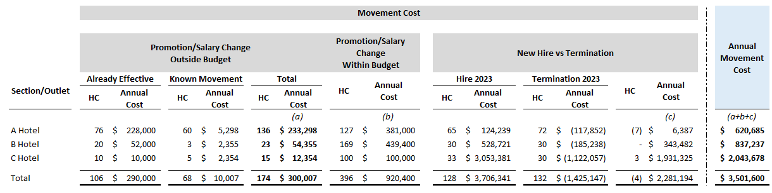
- Movement
XX Hotel opening soon, expecting in Sep, will backfill the budget headcount on upcoming month, for around 180 pax coming on board, some senior staff transfer with promotion from A and B hotel during Mar to May.

110 pax transfer from A&B hotel with promotion.

by location
by level
Turnover: 132 (Year-to-Date)

- Work Injury
Month | # of cases | Claim Amount | Leave Amount
Jan | 16 | 119,398.38 | 113,514.33
Feb | 19 | 23,298.33 | 95,354.21
Mar | 23 | 96,100.05 | 58,858.31
Apr | 33 | 451,883.57 | 958,858.31
May | 39 | 96,511.83 | 98,858.31
Total | 130 | 571,281.95 | 1,325,443.47

