ABC Demo Company
Staff Movement and Cost Analysis Report
As at May 31, 2023
- Headcount

Position Level |  | Existing Headcount (a) | Future Termination (b) | Future Hire  ( c ) | HC with future movement  (a-b+c)
Level A |  | 13 | - | - | 13
Level B |  | 89 | 1 | - | 88
Level C |  | 921 | 5 | 1 | 917
Level D |  | 5,133 | 98 | 60 | 5,095
Level E |  | 6,255 | 154 | 160 | 6,249
Level F |  | 8,497 | 233 | 260 | 8,524
Total |  | 20,908 | 491 | 481 | 20,866

Jun | July | Aug | Sep | Total
266 | 123 | 81 | 11 | 481
- Future Movement
Upcoming Onboarding:

Hire Top 3 Position
F&B attendant | 73
Security Officer | 22
Steward | 11
Top 3 Total | 106
Separation Top 3 Position
Dealer | 33
Cage Cashier | 32
FO attendant | 12
Top 3 Total | 77

ABC restaurant re-opens with restructuring in May, and XX Hotel opening soon, which will result in promotion and pay increases in March and April, and some senior staff transfer with promotion from A and B hotel during Mar to May

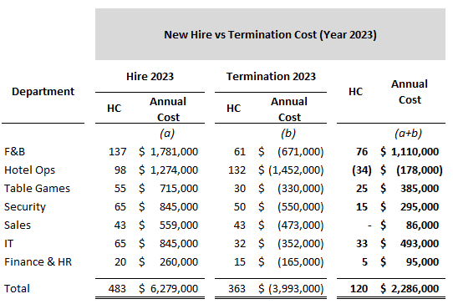

A new IT project will be implemented in 2023, with the aim of increasing IT security.

Forecast based on 2023 budget project and last year trending.

- Leave Taken & Balance
Total Sick Leave Balance (hours) |  | Outstanding AL Balance (hours) |  | Outstanding Comp Leave Balance(hours)
7,666 |  | 365,215 |  | 1,203

Leave | Balance Hours | Equivalent MOP
Sick Leave | 7,666 | 996,580
AL | 365,215 | 45,651,875
Comp Leave | 1,203 | 120,300
Total | 374,084 | 46,768,755

Last year AL balance needed to be clean before Jun 30. Excepting Jun will have high volume on AL clearance.

