ABC Demo Company
Staff Movement and Cost Analysis Report (F&B)
As at May 31, 2023




- Headcount
Services
Total HC
4,963

3,323 49%
1,334 34%
306 17%



Culinary


Stewarding

- Budget Headcount
Position Level |  | Budget Headcount (a) | Existing Headcount (b) | Future Termination (c) | Future Hire  ( d ) | Net  (a-b+c-d) |  | Budget Payroll (MOP)  (e) | Current Payroll MOP (w/ future movement)  (f) | Variance  ( e-f )
Level B |  | 3 | 3 | - | - | - |  | 634,077 | 634,077 | -
Level C |  | 9 | 9 | 1 | - | 1 |  | 760,893 | 961,360 | 69,533
Level D |  | 34 | 21 | 5 | 1 | 17 |  | 133,071 | 103,632 | 29,439
Level E |  | 1,500 | 133 | 10 | 30 | 47 |  | 735,685 | 384,358 | 351,327
Level F |  | 3,497 | 3,497 | 53 | 60 | (7) |  | 2,019,387 | 2,361,476 | (342,089)
Total |  | 5,043 | 4,963 | 69 | 91 | 58 |  | 4,283,113 | 4,174,903 | 108,210
ABC restaurant rename with restructure in current month.
Upcoming Onboarding:

Jun | July | Aug | Sep | Total
59 | 23 | 8 | 1 | 91

- Movement
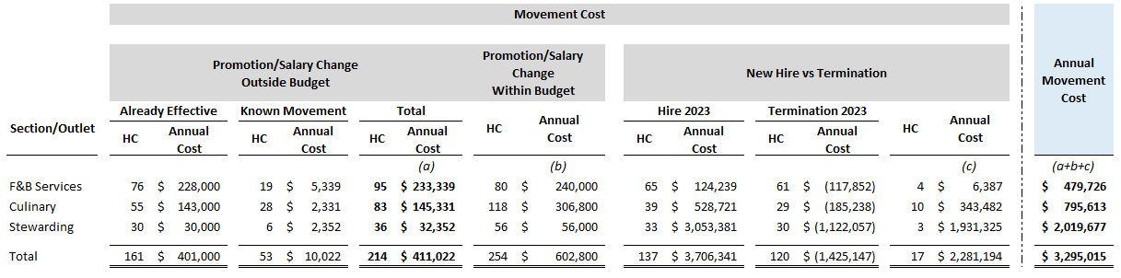
ABC restaurant re-opens with restructuring in May, which will result in promotion and pay increases in March and April, and with extra 161 headcount (annual cost around 400k) and will remain stable thereafter.

by location
by level
Turnover: 120 (Year-to-Date)

- Work Injury

Month | # of cases | Claim Amount | Leave Amount
Jan | 16 | 19,000.38 | 73,514.3
Feb | 22 | 20,298.33 | 95,354.2
Mar | 23 | 86,100.05 | 58,858.1
Apr | 33 | 51,883.57 | 98,858.1
May | 39 | 96,511.83 | 108,858.3
Total | 133 | 273,794.16 | 435,443.0
New Outlet XXX Opened

