**Kavita Daga**

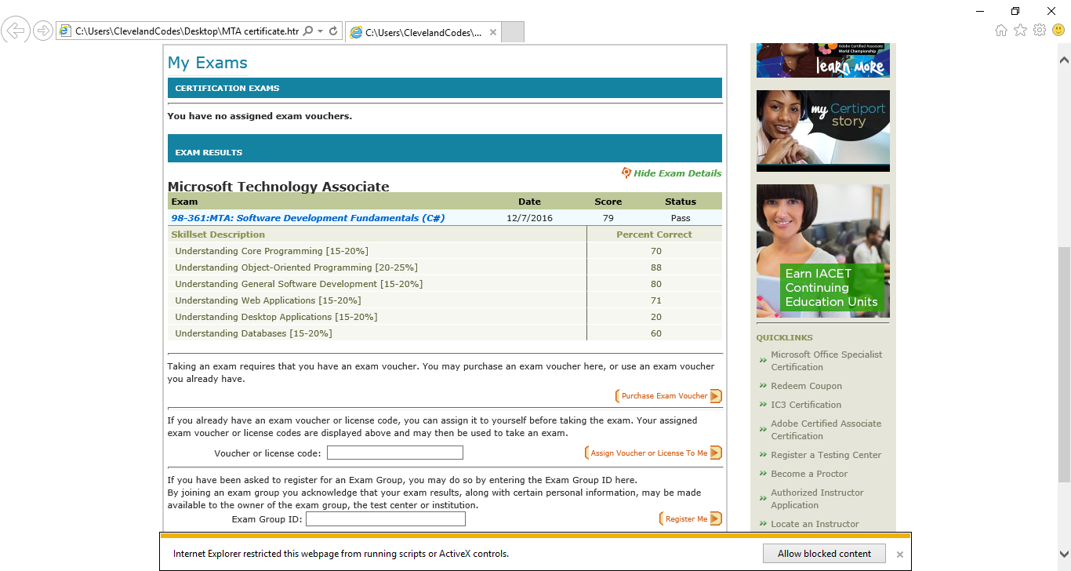

**To see projects Ctrl + click on the links they will take to the one-drive link.**

1. [**Heart of Gold**](https://1drv.ms/v/s!AsvjBduYW7OlhGjBWNi0HoHcq4YC)  **ASP.net, T-SQL, C#, MVC, Code First**
2. **Contoso University ASP.net, C#, MVC, Database First**
3. [**Music Store selling DVD’s of various**](https://1drv.ms/v/s!AsvjBduYW7OlhGuz51E9J0M9Zj7Q)  **ASP.net, C#, MVC, Seeded**

**Genres and shopping cart**

1. [**Mono Game3.4**](https://1drv.ms/v/s!AsvjBduYW7OlhGOWChlvzSdqBJZm)  **bouncing teddies, burgers shooting C#, .net, Mono Game**

**Fries on teddies and exploding them with loud sound.**

1. [**Standard Calculator**](https://1drv.ms/v/s!AsvjBduYW7OlhGpmbOG8v3DipaaS)**:**

**Addition, subtraction, multiplication, division, C#, GUI, Window Forms**

**Inverse, square root, square, and negation.**

1. **Rock Paper and Scissors C#, .net, Console Application**
2. **Deck of cards C#, .net, Classes And Objects**
3. [Block Juck Game Under Construction](https://1drv.ms/v/s!AsvjBduYW7OlhGyt_bLCykifTyO_)  **C#, .net, Mono Game**