Shubhayu Shrestha, Amay Kadakia, Dylan Dinh

Team 4

Iteration 2

Mavs in japan

# Table of Contents

Project Plan…………………………………………………………………………………………………………………………….2-4

Competitors…………………………………………………………………………………………………………………..2

Risks………….………………………………………………………………………………………………………………..3-4

Specifications & Design…….…………………………………………………………………………………………………….4-8

Changes………….……………………………………………………………………………………………………………..4

MoSCoW Requirements.………………………………………………………………………………………………..4

Use Case Diagram…………………………………………………………………………………………………………..5

Transition Diagram/Screen Shots……………………………………………………………………………………6

Code & Tests………………………………………………………………………………………………………………………..…7-9

Important Links………………………………………………………………………………………………………………7

Compiling & Running a Local Instance…………………………………………………………………………….7

Test Cases…………………………………………………………………………………………………………….……7-9

Data Structures………………………………………………………………………………………………………………9

Inputs/Outputs……………………………………………………………………………………………………………….9

Customers & Users………………………………………………………………………………………………………………….12

Description………………….……………………………………………………………………………………………….12

Feedback…………………….……………………………………………………………………………………………….12

# **Project Plan**

## Iterations

Considering our MoSCoW requirements (later discussed on Pg. 4), we then separated the four requirements into our different iterations.

Iteration 1:

* Initial web app
* Offline Functionality
* Contact Information

Iteration 2:

* Translations
* Itinerary
* Maps (Begin)

Iteration 3:

* Maps (Finish)
* Admin Logins

Iteration 4:

* Itinerary Management
* Image Sharing (If time permits)
* Messaging Feature (If time permits)

Sticking to our strict plan and implementing deliverable dates will allow us to minimize our risk exposure and allows us to deliver a higher quality user experience.

## Competitors

Two of our biggest competitors for our application are Google Travel and Wanderlog.

Below is a table with key differences among the tools:

|  |  |  |
| --- | --- | --- |
| **Mavs In Japan** | **Google Travel** | **Wanderlog** |
| Allows for a group itinerary  Able to access offline (Progressive Web App)  Do not need an account  Has a central location for announcements for travelers | Does not have group itinerary capabilities  Unable to access offline (Only Website)  Need an account  Nowhere to post important details or announcements | Allows for group itinerary  Able to access offline (Application)  Need an account  Nowhere to post important details or announcements |

## Risks (With Ranking)

1. **Risk:** Due to our lack of web development and front-end experience and learning how to do so can take much time which can take up the short time we have to work on the application.

**Management:** We will work ahead of schedule to make sure we have time to learn how to work on our web-development skills through utilizing online sources such as YouTube.

Probability: 100%

Effect: 30 hours

RE = 1.0 * 30 hours = 30 hours

1. **Risk:** We could over scope our capabilities and unrealistically try to complete more than what we can achieve.

**Management:** By utilizing the MoSCoW requirements to prioritize our functionalities, we will plan out the essential capabilities our website absolutely needs, and we will diversify that work among the 4 iterations, working on through the “must-haves” and saving the “could-have’ extra features for the end. Furthermore, by communicating effectively to the group and post updates on our progress, we can also have a better idea on what we have done. By also working ahead, we can allow for iteration 3 and 4 as a recovery iteration.

Probability: 50%

Effect: 20 hours

RE = 0.5 * 40 hours = 20 hours

1. **Risk:** Due to our group members all being full-time CSE students and balancing jobs, it can be hard for us to meet during the times we are all free.

**Management:** We created a Microsoft Teams chat as well as a GroupMe to stay connected and post updates about our projects progress. We also have committed to making weekly goals for this project and meeting every week to showcase our progress.

Probability: 80%

Effect: 15 hours

RE = .8 * 15 hours = 12 hours

1. **Risk:** The requirements that Professor Aiken would like in her project could change, as new ideas are come up with every day. She could want a feature to be removed or added.

**Management:** To mitigate this risk, we will work ahead of schedule and showcase our progress to Professor Aiken and ask for feedback on if she would like a change in functionalities.

Probability: 100%

Effect: 10 hours

RE = 1.0 * 10 hours = 10 hours

1. **Risk:** Since our website is running on the uta.cloud servers, if those servers go down, we will lose access to our website, causing us the inability to test our website.

**Management:** We will work ahead of schedule to make sure we have time to recover and continue working on our website. We also have the contact information of uta.cloud if needed.

Probability: 50%

Effect: 20 hours

RE = .5 * 20 hours = 10 hours

1. **Risk:** Due to human nature, it is possible that we (the development team) have misunderstood Professor Aiken’s requirements. There is a non-zero probability that we did not properly implement the requirements that Professor Aiken outlined.

**Management:** This issue can be mitigated by effectively communicating with Professor Aiken during the entire process, keeping her informed on what we are doing and what else she may want.

Probability: 30%  
 Effect: 10 hours  
 RE = 0.3 * 10 hours = 3 hours

# **Specification and Design**

## MoSCoW Requirements

When constructing our project plan (Pg. 2), we began by considering the MoSCoW requirements.

After discussing with Professor Aiken, we decided that we…

Must Have:

* Offline Functionality (Progressive Web App)
* An Itinerary
* A Map
* Login Requirement (For Admins)

Should Have:

* Key Translations (English to Japanese)
* Emergency Contact Information

Could Have:

* Website search feature

Won’t Have:

* Messaging feature

Use Case Diagram

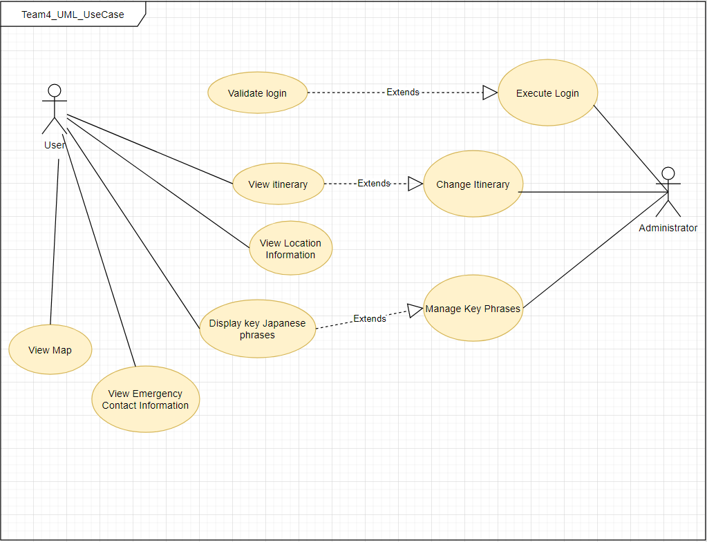

## Transition Diagram/Screen Shots

# **Graphical user interface, application Description automatically generatedCode & Tests**

## Important Links

GitHub Link: <https://github.com/shubshres/CSE-3311-Team-4>

Progressive Web App: <https://mavsinjapan.uta.cloud/>

## Compiling & Running a Local Instance

At the moment, we have not figured out how to deploy our app in a local instance. Since we have been working with the uta cloud servers, we haven’t run into a need to deploy locally yet. We plan to add instructions on how to run the app locally in Iteration 3.

## Test Cases

|  |  |  |
| --- | --- | --- |
| Test Case | Observed Output | Expected Output |
| iOS Offline Functionality | User can view website offline | User is able to load website offline, after accessing it online at least once |
| Android Offline Functionality | User can view website offline | User is able to load website offline, after accessing it online at least once |
| View Itinerary | User can see what is happening on any day with the itinerary after clicking on the designated entry in the navbar. | User should be able to view any of the 28 days of the itinerary, and see what is occurring on any given day |
| View Itinerary Offline | Partially implemented, does not fully work yet | User should be able to view aforementioned test case, without internet. They must have already loaded the itinerary with internet before doing so. |
| View Emergency Contact Information | User can see emergency contact information in the appropriate tab | User should be able to view emergency contact information, from the nav bar, in the case of an emergency. |
| View Emergency Contact Information Offline | User is able to view emergency contact information without an internet connection | User should be able to view aforementioned test case, without an internet connection. They must have already loaded the contact information with an internet connection before doing so. |
| View Translations | User is able to view quick translations pdf and download it. | User should be able to view a pdf of the quick translations from English to Japanese. |
| View Translations Offline | Not Fully Implemented, does not work at the moment | User should able to view quick translations without an internet connections. They must have already loaded the translations with an internet connection beforehand. |
| View Maps | Partially implemented, user can see maps but not correct information placed. | User should be able to view a map of the places stated in the itinerary |
| View Maps Offline | Not implemented yet | User should be able to view maps of relevant areas in Japan offline, after caching it. |

## Data Structures

Due to the nature of how we are developing the web app with Drupal, we do not need to interact with the underlying data structures that the web-app will use.

## Inputs/Outputs

|  |  |  |
| --- | --- | --- |
| Feature | Input | Output |
| Admin Login | Administrator login credentials | Additional administrative feature will be enabled, should the login be successful. Otherwise, an error message will appear. |
| Itinerary | Tapping on a specific day to view | A new page will appearing, filled with information for that given day. |
| Map | Tap on the map button in the menu | A new page will appear that should contain a map of Japan with relevant locations marked. |
| Translations | Tap on the translation button in the menu | A new page will appear that contains a pdf of the Japanese to English translations curated by Dr. Aiken. |
| Contact Information | Tap on the Emergency Contact Information button in the menu | A new page will appear that has the relevant contact information. |
| Dorm Info | Tap on the dorm information button in the sub-menu for itinerary. | A new page will appear that has lodging information during the trip. |
| Landing Page | Tap on the UTA Logo/Mavs In Japan title | The user should be taken back to the landing page of the website, with a pdf about the trip. |

Progressive Web App (on iOS) Steps to Test

1. Go to <https://mavsinjapan.uta.cloud/>
2. Press the share button (square with arrow pointing up)
3. Tap ‘Add to Home Screen’
4. Add to home screen by pressing ‘Add’ at the top’ right
5. Tap on the app on the home screen
6. Close the app
7. Put phone on airplane mode
8. Reopen app

Progressive Web App (on Android) Steps to Test

1. Go to <https://mavsinjapan.uta.cloud/>
2. Tap on ‘Add Mavs in Japan to Home screen’ pop-up
3. Tap ‘Install’ on Install app popup
4. Go to home screen
5. Tap on the app on the home screen
6. Close the app
7. Put phone on airplane mode
8. Reopen app

# **Customers & Users**

## Description:

Customer: Professor Aiken is Professor at UTA planning a study abroad trip to Japan.

Users: Professor Aiken’s study abroad class who will need to be able view an itinerary for their trip.

## Feedback:

For iteration 2, we received more feedback, primarily discussing how we want to go about implementing the apps feature on our app. We also wanted to ensure that the layout for the itinerary page was something that was user-friendly and encapsulated the information that Professor Aiken wants to convey to her students. And as always, we wanted to make sure that we were not missing any requirements. As of right now, we have yet to get any real user feedback, but we have plans for Iteration 3 to get feedback from real users, which should help us design a better interface for maps and the itinerary.