**Overview :**

E-Pariksha is web-based application provides facility to conduct online examination. It provides a common platform where teacher and student can contribute different level examination. E-Pariksha help to analyse performance of student so that teacher and administrator can take action in that direction.

The Administrator can manage Students as well as teachers. Admin can manage subjects and can analyse performance of students.

The first thing when you conduct the online exams is **easy scheduling and planning**. In the **online exam system**, the teachers can plan, prepare and publish the exams in advance, hence on configured dates only tests will be enabled to the students.

Student can register, login and attend the exam with his PRN No on scheduled date. Also students can see the score after submitting the exam. Students can view all previous exam scores.

We made the project by using the hybrid approach wherein we have combined multiple technologies according to use. We used Html, CSS, react for our front end layer, j2ee & spring boot for the business layer, and MySQL for the backend layer.

Git URL of the project: - <https://github.com/kadampritam17/E-Pariksha>

**USE CASE DIAGRAM**

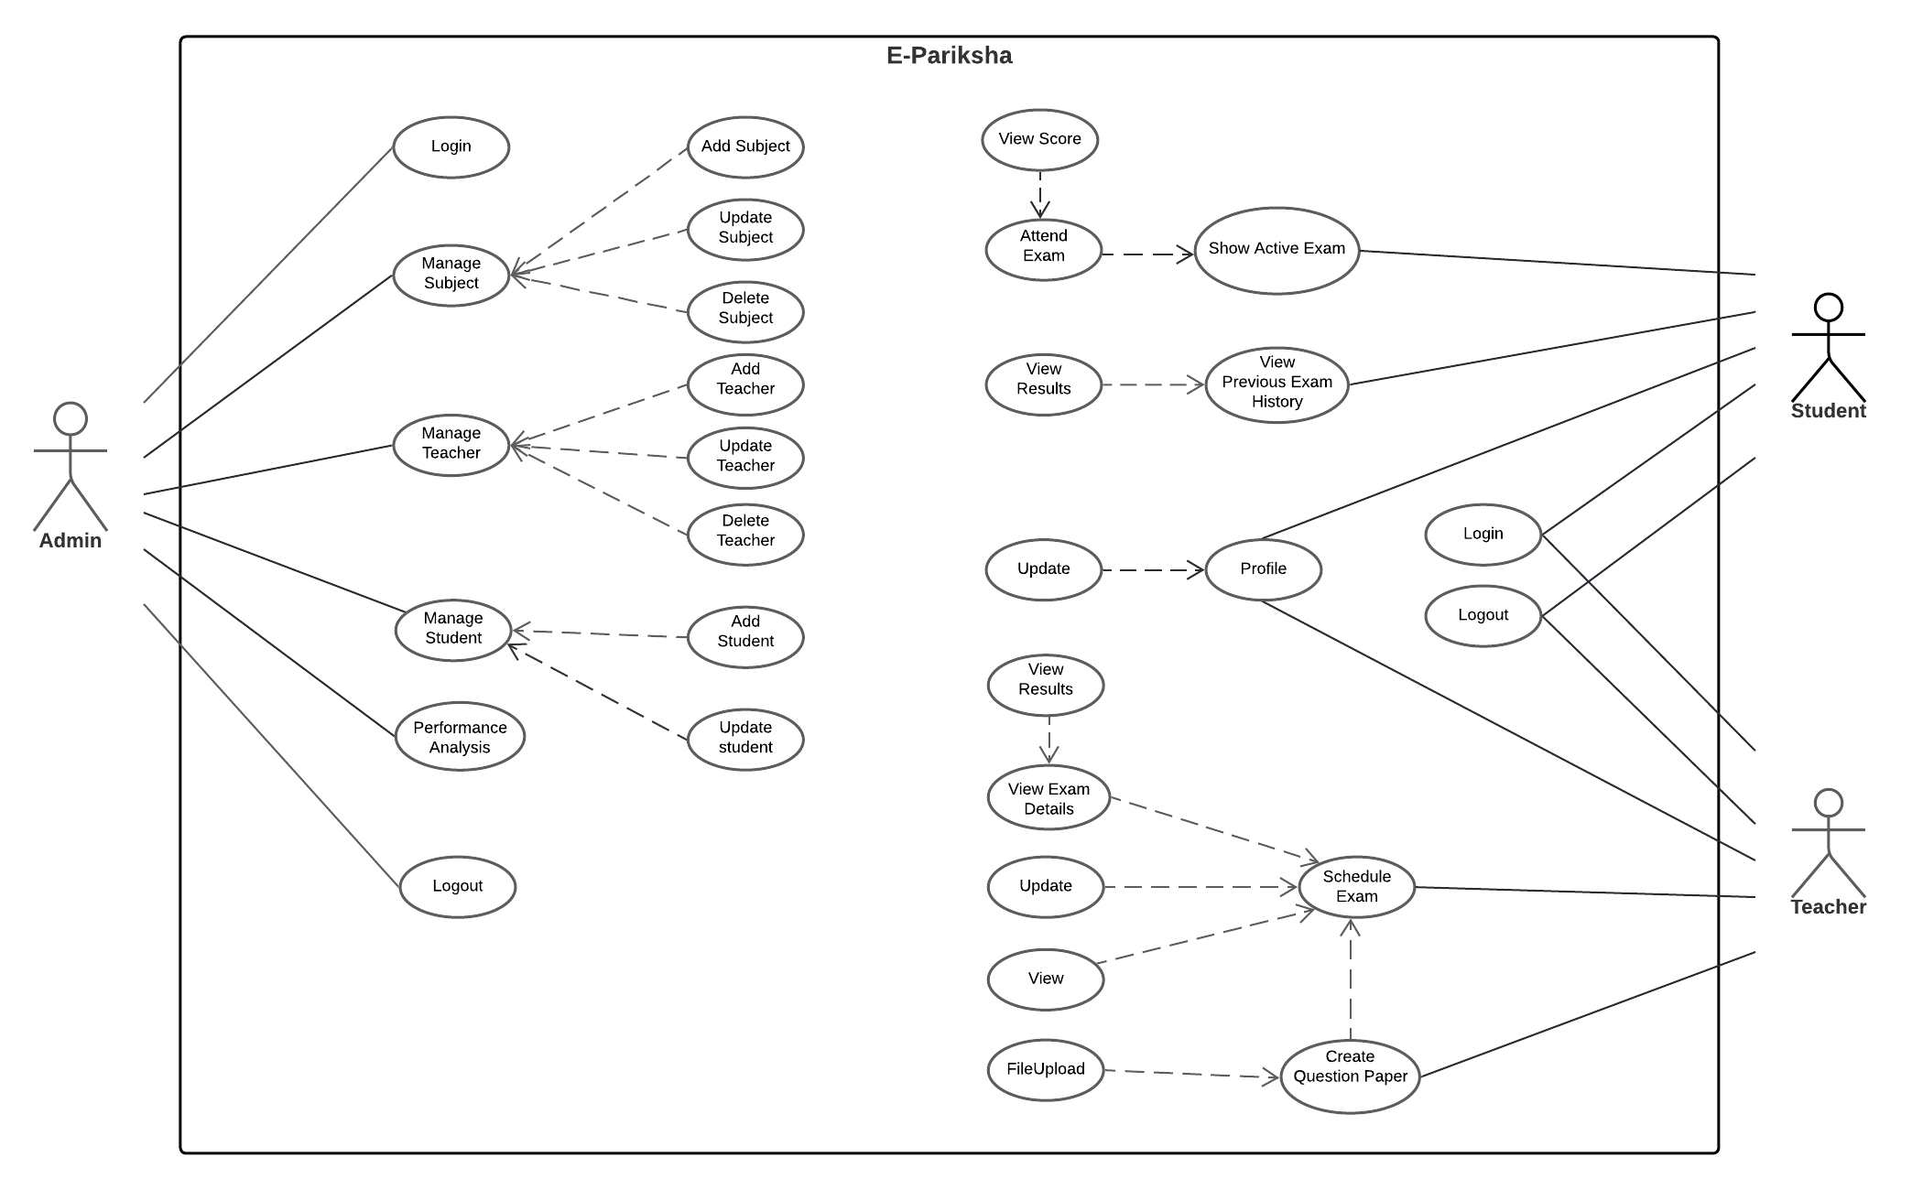

**SCOPE**

1. Login Authentication(admin/student/teacher)
2. Register Student and Teacher
3. Create and Schedule Exam, Set exam (Add questions/Add questions in batch using CSV files or xlsx)
4. Auto submit exam
5. Result analysis (visual format)

**Functionality:**

**E-Pariksha is an online examination portal, whose main objective is to provide platform where students can register/login and can give online exam easily with instant result.**

**There are 3 main modules:**

1. **Admin Module:**

Admin module contains admin login/register page. After, login admin has dashboard containing options such like add/update Students, Teachers and Subjects. Admin Module has its own profile information with update option and logout option.

1. **Student Module:**

Student module contains student login/register page. After, login Student has dashboard containing options such like attend exam and view score, profile information with update, view previous test result history, feedback, logout.

1. **Teacher Module:**

Teacher module contains login/register page. After, login Teacher has dashboard containing options such like add/update questions to test, view questions, schedule exam, profile information of teacher with update option and logout.

**DATABASE SCHEMA**

**DB Name**: - EXAMDB

**Tables**: -

1. ADMIN (USERID, PASSWORD)
2. STUDENT (STUDENT_ID, STUDENT_FIRSTNAME, STUDENT_LASTNAME, STUDENT_MOBILE, STUDENT_DOB, STUDENT_USERNAME, STUDENT_PASSWORD, STUDENT_EMAIL_ID, SSC_MARKS, HSC_MARKS, DEGREE_MARKS, ADDED_DATE)
3. TEACHER (TEACHER_ID, TEACHER_FIRSTNAME, TEACHER_LASTNAME, TEACHER_MOBILE, TEACHER_DOB, TEACHER_USERNAME, TEACHER_PASSWORD, TEACHER_EMAIL_ID, TEACHER_QUALIFICATION, YEAR_OF_EXPERIANCE, ADDED_DATE)
4. EXAM (EXAM_ID, SUBJECT ID, TEACHER_ID, EXAM_NAME, EXAM_DATE, NO_OF_QUESTIONS, MARKS, ACTUAL_TIME, LOGIN_TIME, EXAM_STATUS, EXAM_LEVEL)
5. SUBJECT (SUBJECT ID, SUBJECT NAME)
6. QUESTIONS (QUESTION ID, SUBJECT ID, QUESTION, OPTION1, OPTION2, OPTION3, OPTION4, ANSWER, QUESTION_TYPE)
7. RESULT (RESULT_ID, STUDENT_ID, MARKS, EXAM_ID)
8. TEACHER_SUBJECT_TBL (TEACHER_ID, SUBJECT_ID)
9. EXAM_QUESTION_MAP_TBL (QUESTION_ID, EXAM_ID)

**Git Repository Link :** [https://github.com/kadampritam17/E-Pariksha.git](https://github.com/kadampritam17/C-ExamPlus.git)