**Program 12: Demonstrate create, concatenaton, membership and iteration operations on a tuple**

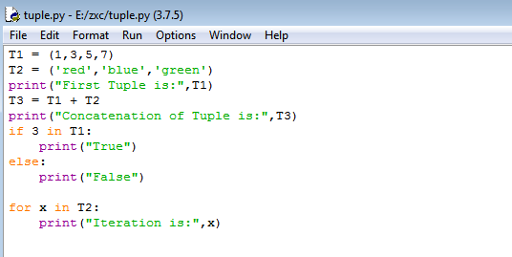

**Output:**

