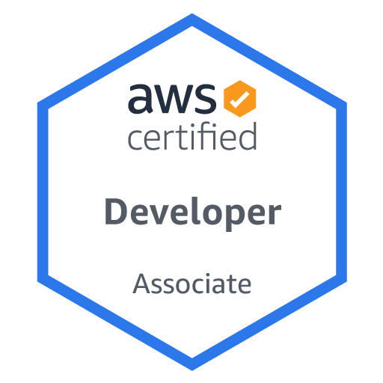

**SHIVAM S. KADAM**

(248)-832-1917 | kadamshivam007@gmail.com | https://www.[linkedin](https://www.linkedin.com/in/kadamshivam/).com/in/kadamshivam/

**EDUCATION**

**University of Dayton Dayton, OH**

*Masters in computer science August 2021 – May 2023*

* **Relevant Courses:** Advanced Programming and Data Structures, Database Management Systems I, Database Management Systems II, Algorithm Design, Mobile and Pervasive Computing , Distributed Computing with Big Data.

**Shivaji University Sangli, India**

*Bachelor’s in Information Technology July 2015 – June 2019*

* **Relevant Courses:** Data Structure, Digital System and Microprocessor, Computer Networks, Discrete Mathematics, Automata Theory, Operating System, Object Oriented Modeling and Design, Software Testing and Quality Assurance.

**SKILLS & INTERESTS**

**Programming Skills:** Python , JavaScript ES6.

**Web Technologies:** HTML, XML, CSS, Bootstrap, Node.js, React.

**Frameworks:** Tailwind CSS, Mocha.

**Database:** MySQL, MongoDB, Microsoft SQL Server.

**Other:** GIT, AWS, Docker, Kubernetes, JIRA, Linux, Figma.

**Certifications:** AWS Developer Associate, React.js Essential Training , Career Essentials in Software Development by Microsoft.

**Interests:** App Development, Soccer, Volleyball, Hiking, Investing.

**PROFESSIONAL EXPERIENCE**

**Devoir Software Solutions, LLC Chesterfield, MO**

*Software Engineer Intern January 2023 – May 2023*

* Worked on Real-time chat and Customer Support module to enable instant communication between users & support agents.
* Implemented user authentication and authorization mechanisms to ensure only authorized users can access chats.
* Maintained as well as Debugged 10k+ lines of code for multiple legacy products enhancing product performance by 20%.
* Analyzed performance bottlenecks in 5+ existing back-end systems, like database queries and storage solutions.
* Done design, development, and testing phases of Software Development using Agile Methodology.

Technical Stack: HTML, CSS, JavaScript, React, MongoDB.

**Visa E-com Multiservices Pune, India**

*Software Development Engineer**June 2019 – May 2021*

* Collaborated with the Customer Relationship Management team to integrate customer feedback into development process.
* Optimized user interface design and responsiveness by implementing more than 50 features as defined by the product team.
* Helped 5 different development teams on 4 new project designs and feature improvements.
* Suggested 20+ improvements to product design and functionality as informed by UX reporting.
* Implemented distributed services, high concurrency grids, parallel programming, performance tuning, and scalability optimizing performance by 30%.
* Introduced Test Driven Design concepts and mentored team on utilizing Cypress for end-to-end testing and jest and React Testing Library for testing components making testing and maintenance 40% easier.
* Resolved 100+ client tickets which included 30+ critical issues ensuring customer satisfaction and maintaining quality.

Technical Stack: HTML, CSS, JavaScript, React.js, JIRA.

**PROJECTS & OUTSIDE EXPERIENCE**

**Recipo Dayton, Ohio**

*Course Project: Web application where users can share and discover recipes. August 2022 – December 2022*

* Used **Express.js** as a backend framework for handling API routes, authentication, and data validation.
* Built the user interface and components by using the **React.js** frontend framework resulting in rich user interface.
* Interacted with **MongoDB** database using Mongoose Object Data Modeling Library.

**Result Analyzer Sangli, India**

*College Project: Web application where students can analyze their results. November 2018 – January 2019*

* Developed a Web application using **ASP.NET** for a college project with a team of 3 members where I was leading the team by managing the backend and helping to design the pages.
* Utilized efficient indexing and query optimization techniques, resulting in a 40% reduction in query response time.
* This application helped around 100’s of students from different engineering branches to know their results, analyze them, and know their progress and standings in our college.