# **Kadar Gayle 1/20/2025**

# **Intervention report**

# **Nina Carducci**

# **I - Lighthouse Score**

## **Lighthouse score before optimisation**

**

## **Score Lighthouse after optimisation**

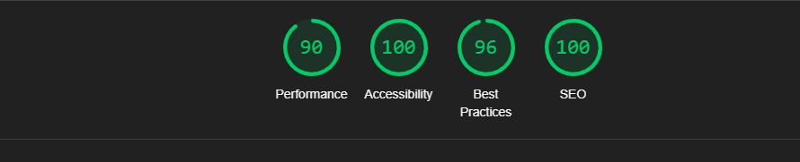

## **II - Details of optimisations and interventions carried out**

## **1 - Images**

The project originally contained 14 images with a total size of 22.43 MB.   
We have made the following changes to the images:

● I changed the format of the images from .jpg to .webp to conserve memory.

● I labeled photos alt = ‘…’ for better accessability

● I changed the pixels of the images by labeling the width and height of the photo to have better cellular data and improve load time.

After the modifications, the total weight of the images is *XX* MB, a gain of *XX%* .

## **2 –**

The total weight is 2.22 MB after the modifications and a gain of 10%.

# **III - Site accessibility**

## **Accessibility before optimisation**

## 

## **Accessibility after optimisation**

## 

## **Changes made**

* The alt attribute needed to be added to the image éléments.
* The HTML document didn’t have a title element so I needed to add a title.
* Form éléments do not have associated labels so I had to add them.
* I added a name to the social media links

# **IV - Details of additional work carried out at the customer's request**

## **1 –**

The gallery’s previous and next image navigation system buttons didn’t work so I had to add code in Javascript in order for it to work. Also, when you change filters to display images, the selected category is not visible. The category should normally have a gold background. So, I modified that in CSS once the user clicks on the category filter.

# **V - Acceptance log**

SEO

# **Document doesn’t have a <title> element**

I added a title to the index.html page

* <title>Nina Carducci - Professional photographer in Bordeaux</title>

# **Document does not have a meta description**

I added a meta description on the index.html page

* <meta name="description" content="Website of Nina Carducci, professional photographer, based in Bordeaux">

# **Image éléments do not have [alt] description**

In the div= ‘gallery’ I added an alt description to all the images. Then, I added alt description to all the images in other classes.

* <img data-gallery-tag="Concert" class="gallery-item" src="./assets/images/gallery/concerts/concert_1.webp" alt = "Concert Image" width="400" height="400" />

# Accessibility

# **Image éléments do not have [alt] attributes**

* <img data-gallery-tag="Concert" class="gallery-item" src="./assets/images/gallery/concerts/concert_1.webp" alt = "Concert Image" width="400" height="400" />
* **Document doesn’t have a <title> element**
* <title>Nina Carducci - Professional photographer in Bordeaux</title>
* **Form éléments do not have associated labels**
* <input type="text" name="Name" id="Name" required placeholder="For Name">
* **Links do not have a discernable name**
* I put a arial-label on the link to the nav class and all the social media link of the instagram has a arial-label as well.
* <nav class="nav" aria-label="navigation">
* <li><a class="social-link" href="https://www.instagram.com/ninacarducci.photo/?hl=fr" aria-label="instagram" target="_blank"><img src="assets/images/instagram.png" alt=""></a>

Performance

* **Serve images in next-gen formats**
* I converted the .jpg images in the images file to .webp
* **Properly size images**
* I changed the pixels of the images in order to resize the images and save memory space.
* **Images do not have explicit width and height**
* I made sure the images have an explicit number of width and height.
* **Minify CSS**
* I used a minify css site in order to minify the CSS code.
* **Minify Javascript**
* I used a minify javascript site in order to minify the javascript code.

# **Appendix**

## **Full Lighthouse audit report**

First, I started making changes on the SEO since it seemed like the easier tasks to complete were in that category. The Score originally was a 73. The steps to debug the SEO were the following, document doesn’t have a <title> element. Document does not have a meta description, and Image éléments do not have [alt] attributes. Once, I completed debugging those steps it went to 100 score. Then, I moved on to the accessibility category. The score was a 70. The debugging task were the image éléments do not have [alt] attributes. Document doesn’t have a <title> element. Form éléments do not have a associated labels. Links do not have a discrenible name. I also had to debug the tasks that the links do not have a discernible name. So, I had to add arial-label to all the links in the index.html file. The score went up from a 70 to 100 once I finished debugging.

Lastly, I had to debug the performance part of the page. The score was originially 70. I minified the CSS and Javascript files in the document. Avoid large layout shifts, properly size images by changing the pixels width and height. I also had to fix the Largest Contentful Paint element. The score went to a 90 after I was able to adjust and debug all the problems on the performance.