Content-Adaptive Video Encoding with FFmpeg / x264
CS5185 group project — draft report
Date: 2026-11-09 Group: ______ Members: ______

1. Task and constraints
Compress the twelve provided 1280x720, 30 fps, silent clips to 5% and 2% of their original file size, using only FFmpeg's libx264 encoder. The system analyses content, chooses x264 parameters from the target budget, encodes, verifies size/decodability/quality, and re-encodes when the budget is missed. Removing frames or shortening clips is not allowed.
All encoding and muxing is done by FFmpeg. Python, OpenCV and NumPy are used only for metadata, feature extraction, quality measurement and logging.

2. System design
The pipeline is a closed loop. Each stage is a separate module so that decisions and measurements can be traced from the logs:
- probe: read duration/size from the dataset metadata (or ffprobe), compute target_bytes = floor(S*r) and video_bps = 0.98*8*target_bytes/T.
- features: per-frame mean absolute grayscale difference (temporal change) and edge-pixel fraction (spatial detail), written as CSV and a timeline figure.
- decision: content-dependent candidate set (preset medium / veryslow, plus either an AQ-motion or a long-GOP candidate), each candidate encoded and measured.
- encode: two-pass x264 with a hard VBV cap (-maxrate = target bitrate, -bufsize = 2x), feedback re-encoding up to the attempt budget; every candidate is kept on disk.
- evaluate: aggregate PSNR-Y (squared error summed over all pixels and frames) and MS-SSIM, plus aligned reference/output frame export.

3. Content analysis
Two cheap features already separate the development clips into three regimes: static meeting scenes, smooth low-detail motion, and fast/shaky motion with dense texture.
Video | Mean frame difference | Mean edge fraction
01_FourPeople | 2.76 | 0.263
02_Beauty | 7.20 | 0.097
03_Bosphorus | 6.08 | 0.246
04_HoneyBee | 1.86 | 0.267
07_Mobcal | 17.22 | 0.540
08_Shields | 20.11 | 0.488
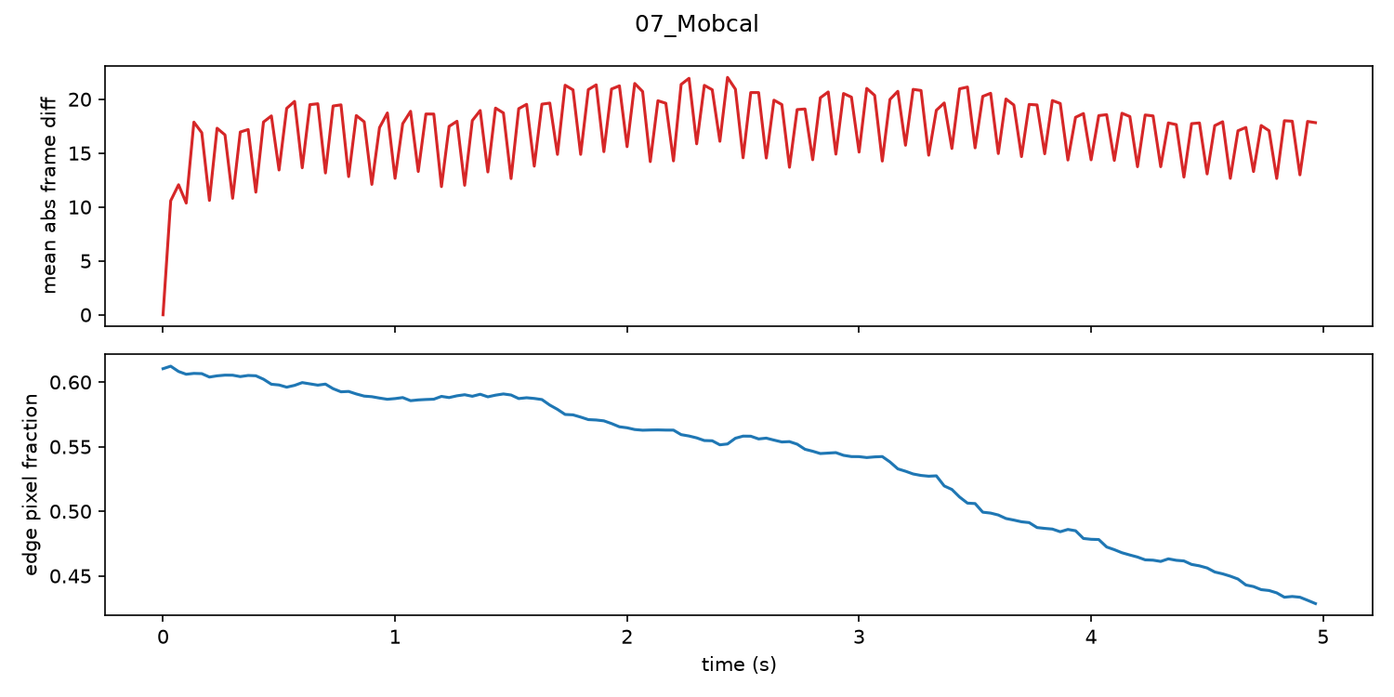
Figure 1 — Feature timeline for 07_Mobcal: periodic frame-difference spikes from camera shake, edge fraction falling as the camera pulls back.

4. Parameter decision and feedback
The first baseline attempt used plain two-pass ABR. On these five-second clips it consistently overshot the budget by 40-50% (e.g. 4,890 kbps requested, 7,319 kbps produced; 6,828 requested, 9,534 produced). The fix was a VBV constraint tied to the target bitrate. With -maxrate and -bufsize the size error fell from +5.0% to +0.2% on the worst case and PSNR improved, because bits were no longer wasted on a few over-allocated frames.
The adaptive controller then searches a small candidate set per clip: medium-default, veryslow-default, and one content-specific candidate (AQ-motion for high-motion clips, long-GOP for static clips). Each candidate is encoded at the target bitrate and measured; the best result inside the +-3% size window is kept. This makes the adaptive run, by construction, never worse than the baseline apart from measurement noise.

5. Experiments

5.1 Unified baseline (development set)
Video | Ratio | Target | Actual | Error | PSNR-Y | MS-SSIM
01_FourPeople | 2% | 1.28 MB | 1.25 MB | 2.17% | 39.829 | 0.99566
01_FourPeople | 5% | 3.19 MB | 3.15 MB | 1.43% | 41.31 | 0.99687
02_Beauty | 2% | 1.74 MB | 1.71 MB | 1.55% | 38.574 | 0.98927
02_Beauty | 5% | 4.35 MB | 4.35 MB | 0.17% | 39.476 | 0.9921
03_Bosphorus | 2% | 1.29 MB | 1.26 MB | 2.24% | 36.946 | 0.98936
03_Bosphorus | 5% | 3.23 MB | 3.14 MB | 2.90% | 40.097 | 0.99537
04_HoneyBee | 2% | 1.45 MB | 1.43 MB | 1.34% | 41.849 | 0.99728
04_HoneyBee | 5% | 3.63 MB | 3.57 MB | 1.73% | 42.4 | 0.99765
07_Mobcal | 2% | 1.95 MB | 1.90 MB | 2.42% | 34.402 | 0.99401
07_Mobcal | 5% | 4.86 MB | 4.72 MB | 2.91% | 35.792 | 0.99556
08_Shields | 2% | 1.99 MB | 1.97 MB | 1.06% | 33.904 | 0.99156
08_Shields | 5% | 4.97 MB | 4.91 MB | 1.24% | 35.185 | 0.99383

5.2 Adaptive vs baseline (development set)
Both runs are constrained to the same size budget, so PSNR is directly comparable. The adaptive search wins on 8 of 12 cases, with a mean gain of only +0.03 dB while encoding time grows about 5x. In other words, on this dataset parameter choice at a fixed budget moves quality far less than the budget itself does.
Video | Ratio | Baseline | Adaptive | Delta | Candidate
01_FourPeople | 2% | 39.829 | 39.873 | +0.044 | medium-default
01_FourPeople | 5% | 41.31 | 41.297 | -0.013 | medium-default
02_Beauty | 2% | 38.574 | 38.679 | +0.105 | veryslow-default
02_Beauty | 5% | 39.476 | 39.548 | +0.072 | aq-motion
03_Bosphorus | 2% | 36.946 | 36.991 | +0.045 | veryslow-default
03_Bosphorus | 5% | 40.097 | 40.17 | +0.073 | veryslow-default
04_HoneyBee | 2% | 41.849 | 41.832 | -0.017 | medium-default
04_HoneyBee | 5% | 42.4 | 42.396 | -0.004 | medium-default
07_Mobcal | 2% | 34.402 | 34.409 | +0.007 | medium-default
07_Mobcal | 5% | 35.792 | 35.805 | +0.013 | medium-default
08_Shields | 2% | 33.904 | 33.905 | +0.001 | veryslow-default
08_Shields | 5% | 35.185 | 35.174 | -0.011 | medium-default
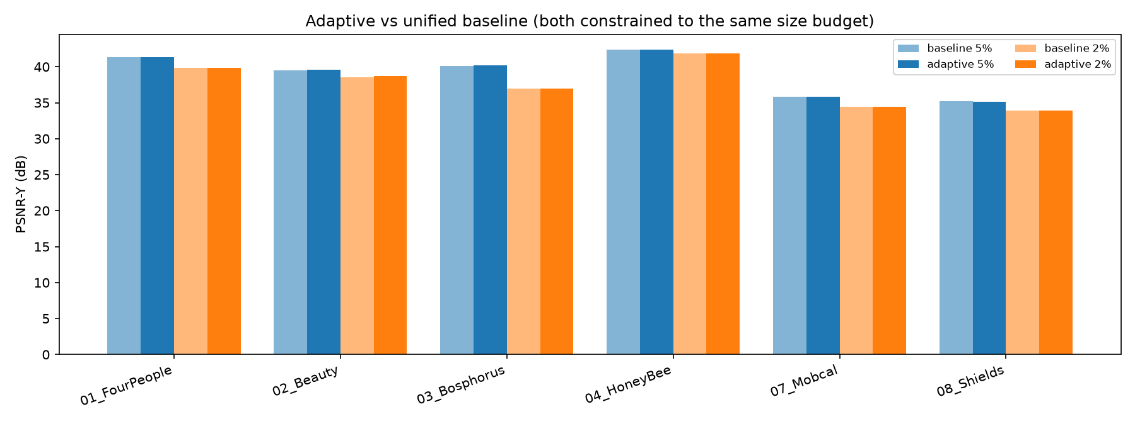
Figure 2 — PSNR-Y at matched size budgets.

5.3 Held-out test set
The final controller was applied once to the reserved clips (05, 06, 09, 10) without any tuning. All eight outputs met the budget; 09_Parkrun is the hardest case, losing roughly 3.6 dB between the two ratios.
Video | Ratio | Actual | Error | PSNR-Y | Candidate
05_Jockey | 2% | 1.43 MB | 0.50% | 38.13 | veryslow-default
05_Jockey | 5% | 3.47 MB | 2.26% | 41.248 | medium-default
06_ShakeNDry | 2% | 0.83 MB | 0.55% | 36.014 | veryslow-default
06_ShakeNDry | 5% | 2.04 MB | 0.74% | 39.026 | veryslow-default
09_Parkrun | 2% | 2.29 MB | 1.08% | 24.884 | medium-default
09_Parkrun | 5% | 5.68 MB | 1.97% | 28.51 | medium-default
10_Stockholm | 2% | 1.93 MB | 2.75% | 33.533 | medium-default
10_Stockholm | 5% | 4.93 MB | 0.81% | 34.368 | aq-motion
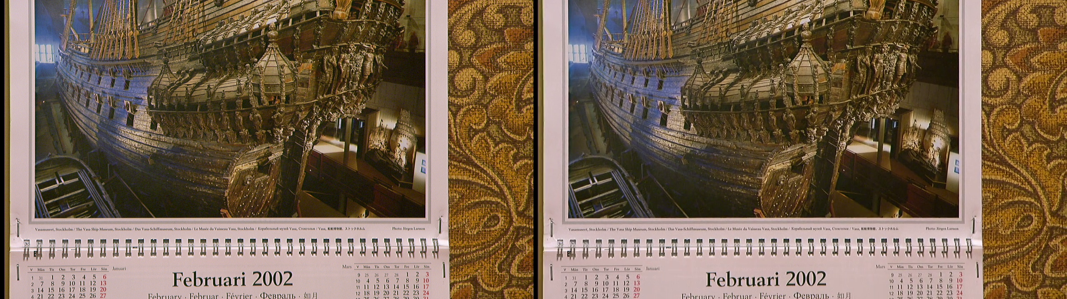
Figure 3 — 07_Mobcal at 2%: reference (left) and decoded output (right) at t=2.5 s.

6. Discussion
- Budget headroom matters far more than parameter tuning: the same clip loses 0.5-3.6 dB when the budget drops from 5% to 2%, while preset/AQ changes at a fixed budget are worth ~0.1 dB.
- Content sensitivity is very uneven. 04_HoneyBee (static, fine texture) loses 0.55 dB from 5% to 2%, while 03_Bosphorus loses 3.15 dB on the same budget change, which is exactly the kind of clip an adaptive allocation should protect.
- VBV is essential for short clips; without it two-pass ABR overshoots by up to 50%.
- The search-based controller is simple and reproducible but costs ~5x encode time; the veryslow candidate rarely wins at 5%, and wins more often at 2%.

7. Limitations and reproducibility
- Features are global per-clip statistics; no per-shot segmentation or VLM reasoning is used yet.
- Quality is measured with aggregate PSNR-Y and MS-SSIM. A subjective scoring kit (reports/subjective/index.html, six side-by-side sheets) was prepared; the scores still need to be filled in by the group.
- Commands: python -m src.probe, python -m src.pipeline --split dev --ratios 0.05 0.02 [--baseline], python -m scripts.summarize, python -m scripts.compare.
- FFmpeg build and Python package versions are recorded in the repository (tools/ is not committed).

8. Contributions and third-party sources
Member contributions are listed in the supplementary document (section 9); each member should confirm the percentages.
Dataset: CS5185 course package (Xiph, SVT, NTIA and Sintel sources; see data/.../licenses). Tools: FFmpeg/libx264, OpenCV, NumPy, Matplotlib. No third-party code was copied into this project.

9. Supplementary experiments
A companion document, CS5185_Experiments_Addendum.docx, contains the full tables: test-set baseline, GOP sensitivity, per-video decision table, 2x2 ablation, subjective comparison sheets and the optional LLM decision experiment. The key results are summarised here.

9.1 Baseline GOP sensitivity
Baseline | Mean PSNR (12 dev tasks) | Adaptive vs it
medium / default GOP 250 / AQ1 | 38.94 dB | +0.026 dB, 8/12
medium / GOP 60 / AQ1 | 38.81 dB | +0.161 dB, 12/12

GOP60 is 0.135 dB worse than the default GOP on these 5-second clips because it inserts about two extra I-frames at a fixed bitrate. The adaptive gain therefore looks larger against GOP60, but that is a weaker baseline, not a stronger method.

9.2 Test set with baseline
Video | Ratio | Baseline PSNR | Adaptive PSNR | Delta
05_Jockey | 5% | 41.243 | 41.248 | +0.005
05_Jockey | 2% | 38.077 | 38.130 | +0.053
06_ShakeNDry | 5% | 38.815 | 39.026 | +0.211
06_ShakeNDry | 2% | 35.873 | 36.014 | +0.141
09_Parkrun | 5% | 28.475 | 28.510 | +0.035
09_Parkrun | 2% | 24.842 | 24.884 | +0.042
10_Stockholm | 5% | 34.527 | 34.368 | -0.159
10_Stockholm | 2% | 33.528 | 33.533 | +0.005

Adaptive wins 7 of 8 held-out tasks (+0.042 dB on average); the only loss is 10_Stockholm @5% (-0.159 dB), where both methods select medium and the gap comes from the rate-control landing point rather than from the parameter choice.

9.3 2x2 ablation and decision table
The ablation (medium/slow x AQ1/AQ2, default GOP) shows that AQ is the dominant knob: AQ2 changes PSNR by +0.02 to +0.03 dB on 01, about -0.01 dB on 03, and -0.18 to -0.19 dB on 07_Mobcal, whose edge fraction is 0.54. Slow changes PSNR by at most 0.05 dB in most cases. The per-video table shows that the content-specific candidate wins only once (aq-motion on 02_Beauty @5%), which explains the modest overall gain.

