Deep Learning methods for speaker recognition
Software Architecture & Design Specification
Version: 0.2
Date: 2015.12.06.
Status: Added Class level structure

Created by: Kedves Nándor

Created by |  |  | Approved by
Name: |  |  | Name:
Date: |  |  | Date:
Signature: |  |  | Signature:

History

Versions
Version | Date | Author | Description
0.1 | 2015.12.05. | Kedves Nándor | Initial version
0.2 | 2015.12.06 | Blénesi Attila | Added Class level structure
1.0 | <Date> | <Name> | Released after review
1.1 | <Date> | <Name> | <Description of changes >
1.2 | <Date> | <Name> | <Description of changes >
2.0 | <Date> | <Name> | Released after review

Contents

Contents
1 History 2
1.1 Versions 2
2 Contents 3
2.1 Contents 3
3 Introduction 4
3.1 Purpose of the document 4
3.2 References 4
4 Structure of project’s components 5
4.1 Overview 5
4.2 Diagram 5
5 Class-level structure 6
5.1 Overview 6
5.2 Diagram 6

Introduction

Purpose of the document
The purpose of the Software Architecture and Design Specification is to give an overview of the known technical details of the implementation, structure and components of the project in order to lead to a better understanding about interactions between these components.

References
[1] | Requirement Specification v1.1  2015.12.05  https://github.com/triqla/deep-learning-bbse2015/blob/master/doc/RequirementSpecification.doc
[2] | Project Plan v1.0  2015.12.05  https://github.com/triqla/deep-learning-ubbse2015/blob/master/doc/ProjectPlan.doc
[3] | Project management board website  2015.12.05  https://waffle.io/triqla/deep-learning-ubbse2015

Structure of project’s components

Overview
The project’s structure contains three components, by name: Deep-Learing, Back-End and Client. The project is realized within these components and interactions between them.
The core processing part is the Back-End component. This component is responsible for initializing the communications between clients and to provide data necessary for voice recognition.
The Client component, as its name suggests, represents the client who can connect to the server and communicate with another clients. The Client component gets all necessary data from the Back-End component.
The Deep-Learning component provides the neural network for the voice recognition algorithm. The Back-End component communicates with the Deep-Learning component: it can get the configuration data for the neural network and provide it to the Client component via the Data Access Objects module.

Diagram
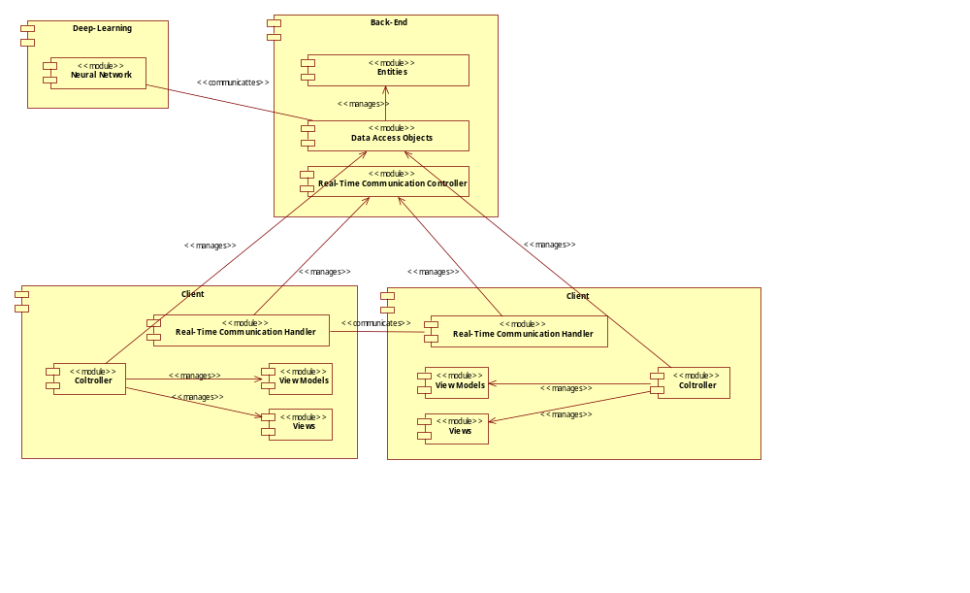

Class-level structure

Overview
The following UML Class diagram represents the entities used in the project, which describe the persisted data that will bee provided from the back-end to the clients.

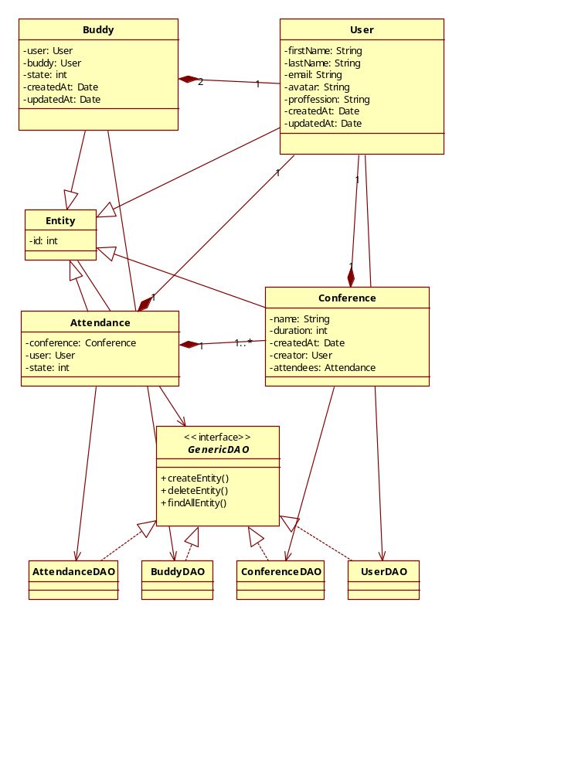
Diagram

