Johnny Li

Lab 10 Section: Tue. P10-11

Description: Final Project

Section 10.4 Pre-Lab Requirements

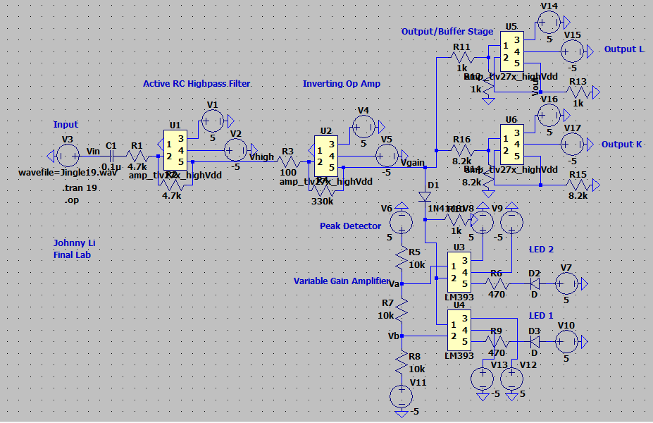

Input Voltage

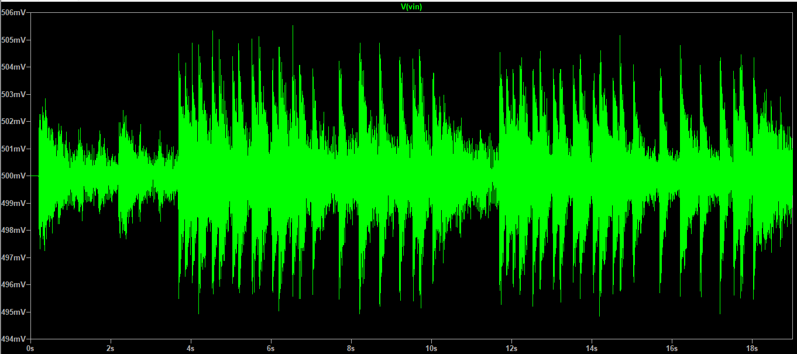

Output of the Highpass Filter

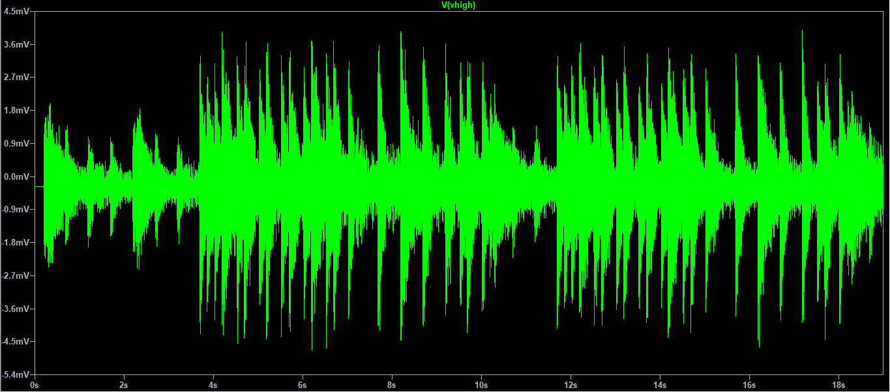

Output of the Variable Gain Amplifier

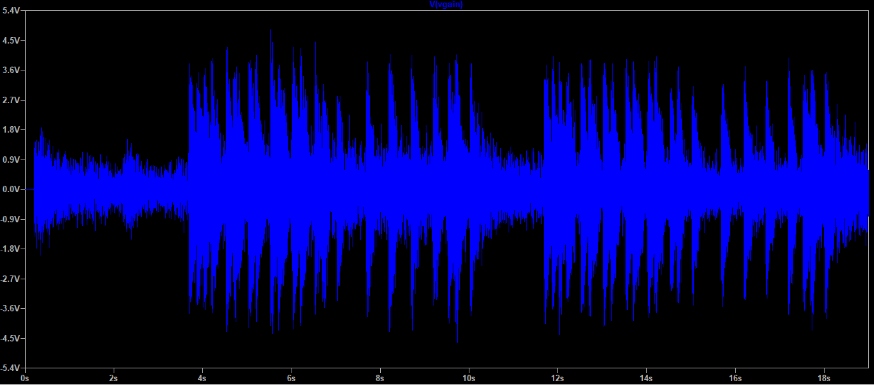

Output of the Buffer Stage (at least one)

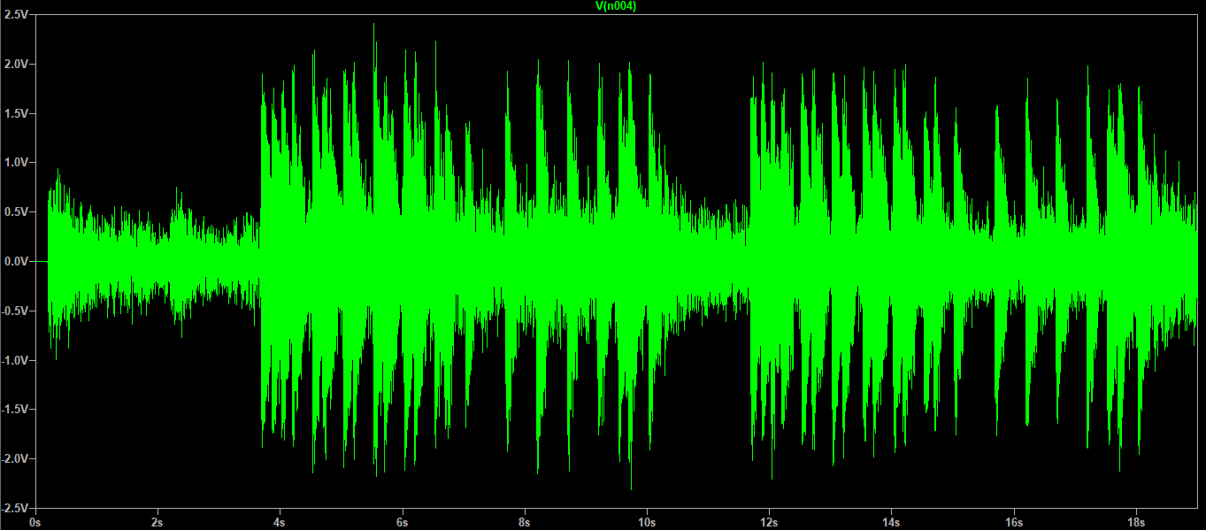

Current of LED 1

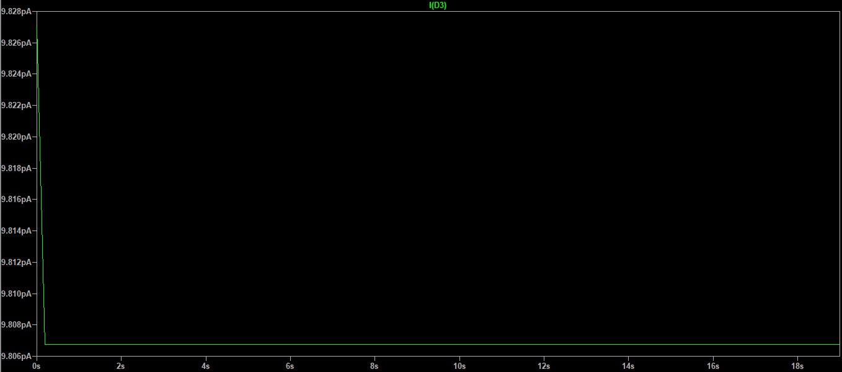

Current of LED 2

