Johnny Li

Lab 2 Section: Tue. P10-11

Description: LTSpice Pre-Lab

Section 2.4.1 Modeling Simple Circuits

|  |  |
| --- | --- |
| Table 1: Node Voltages | |
| Node | Voltage (V) |
| A | 4.404 V |
| B | 3.135 V |
| C | 1.865 V |
| D | 0.596 V |

1.

Table 1: Result of running a DC operating point simulation to generate the node voltages at nodes A, B, C, and D. Design based on Figure 2.4.1.

|  |  |
| --- | --- |
| Table 2: Node Voltages (1Ma) | |
| Node | Voltage (V) |
| A | 4.385 V |
| B | 3.122 V |
| C | 1.858 V |
| D | 0.594 V |

2a)

Table 2: Result of running a DC operating point simulation to generate the node voltages at nodes A, B, C, and D with a 1Meg resistor at node A. Design based on Figure 2.4.1 a.

|  |  |
| --- | --- |
| Table 3: Node Voltages (1Mb) | |
| Node | Voltage (V) |
| A | 4.394 V |
| B | 3.106 V |
| C | 1.848 V |
| D | 0.591 V |

b)

Table 3: Result of running a DC operating point simulation to generate the node voltages at nodes A, B, C, and D with a 1Meg resistor at node B. Design based on Figure 2.4.1 b.

|  |  |
| --- | --- |
| Table 4: Node Voltages (1Mc) | |
| Node | Voltage (V) |
| A | 4.400 V |
| B | 3.124 V |
| C | 1.848 V |
| D | 0.591 V |

c)

Table 4: Result of running a DC operating point simulation to generate the node voltages at nodes A, B, C, and D with a 1Meg resistor at node C. Design based on Figure 2.4.1 c.

|  |  |
| --- | --- |
| Table 5: Node Voltages (1Md) | |
| Node | Voltage (V) |
| A | 4.403 V |
| B | 3.133 V |
| C | 1.864 V |
| D | 0.594 V |

d)

Table 5: Result of running a DC operating point simulation to generate the node voltages at nodes A, B, C, and D with a 1Meg resistor at node D. Design based on Figure 2.4.1 d.

Section 2.4.2 LTspice Variables

1. Figure 2.3: Layout design (part a- top, part b- bottom)

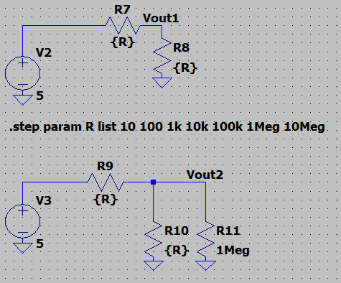

3. Figure 1: Graphed result for Vout1 (Blue) and Vout2 (Green). Vout1 is constant at 2.5V while Vout2 has an exponential decline from 2.5V to 0V.

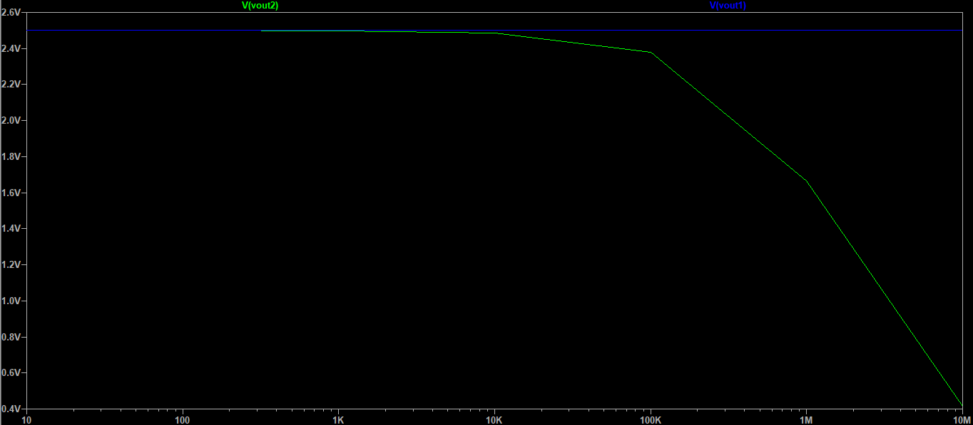

Section 2.4.3 Monte Carlo Simulations

1. Figure 2.4: Layout Design-Resistor ladder with the values replaced by the LTspice Monte Carlo function.

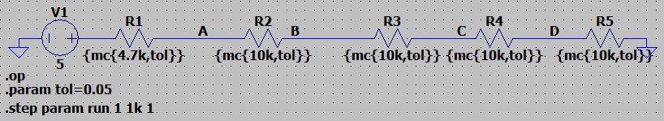

3. Figure 2: Graphed result of nodes’ voltages based on design figure 2.4. Node voltages, A-D, on separate plot planes to view.

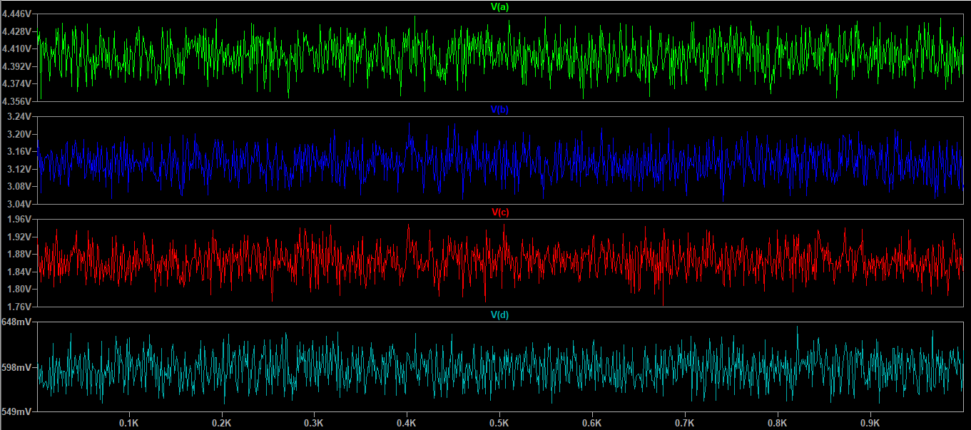

|  |  |
| --- | --- |
| Table 6: Node Voltages Range | |
| Node | Voltage Range (V) |
| A | 0.090 V |
| B | 0.19 V |
| C | 0.20 V |
| D | 0.099 V |

Table 6: Result of running a DC operating point simulation to generate the node voltages at nodes A, B, C, and D with Monte Carlo function. Design based on Figure 2.4.3.