Johnny Li

Lab 4 Section: Tue. P10-11

Description: Controlled Sources

Section 4.4.1 Simulating a Controlled Source

|  |  |  |
| --- | --- | --- |
| Table 1: Voltages of the Different configurations for a VCVS | | |
| Configurations | Vi (V) | V0 (V) |
| A | 1 V | 10 V |
| B | 1 V | 10 V |
| C | 1 V | 10 V |
| D | 0.9950 V | 0.0495 V |

1-4.

Table 1: Result of running a DC operating point simulation to generate the node voltages at nodes Vi and Vo in the VCVS. Design based on Figure 4.3.

5. Figure 1: Graphed result for the voltage of Vi (Green) when step through different values of Ri from 0.1 to 1Meg in powers of 10. Best value for the input resistance is 1 Meg ohms, resulting in the highest voltage. Based on Figure 4.3 d).

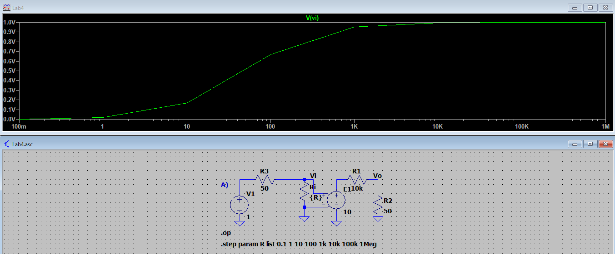

6. Figure 2: Graphed result for the voltage of Vo (Blue) when step through different values of Ri from 0.1 to 1Meg in powers of 10. Best value for the input resistance is 0.1 ohms, resulting in the highest voltage. Based on Figure 4.3 d).

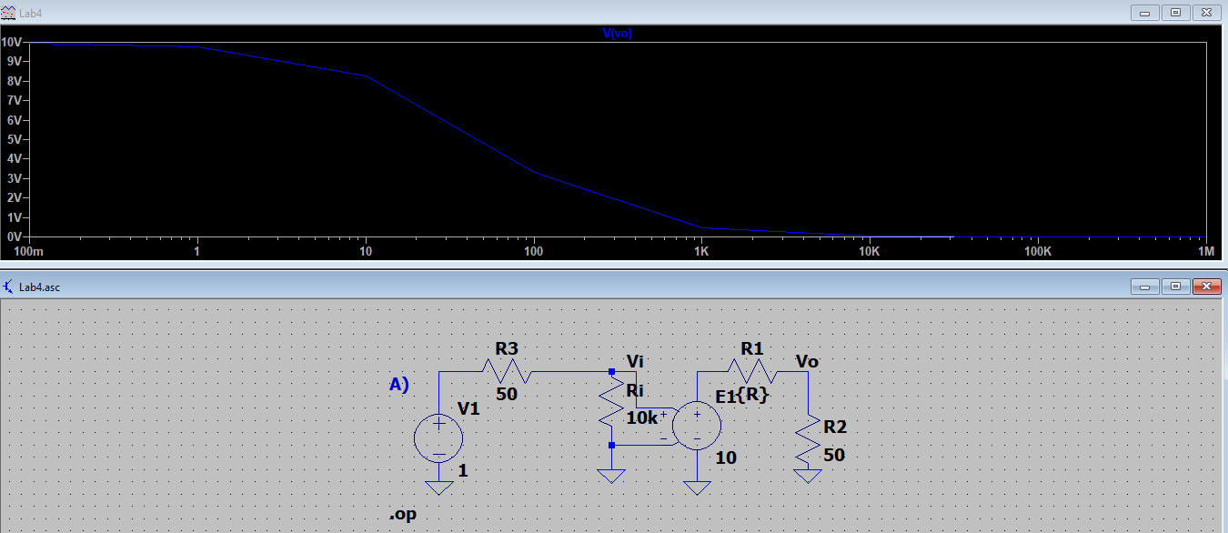

Section 4.4.2 Monte Carlo Simulations

1. Figure 3: Graphed result of the Monte Carlo simulation for the gain, E, of the VCVS. Tolerance set to 0.1 (10%) and run the simulation for 1000 iterations where E = {mc{10,tol}}. Based on Figure 4.4.

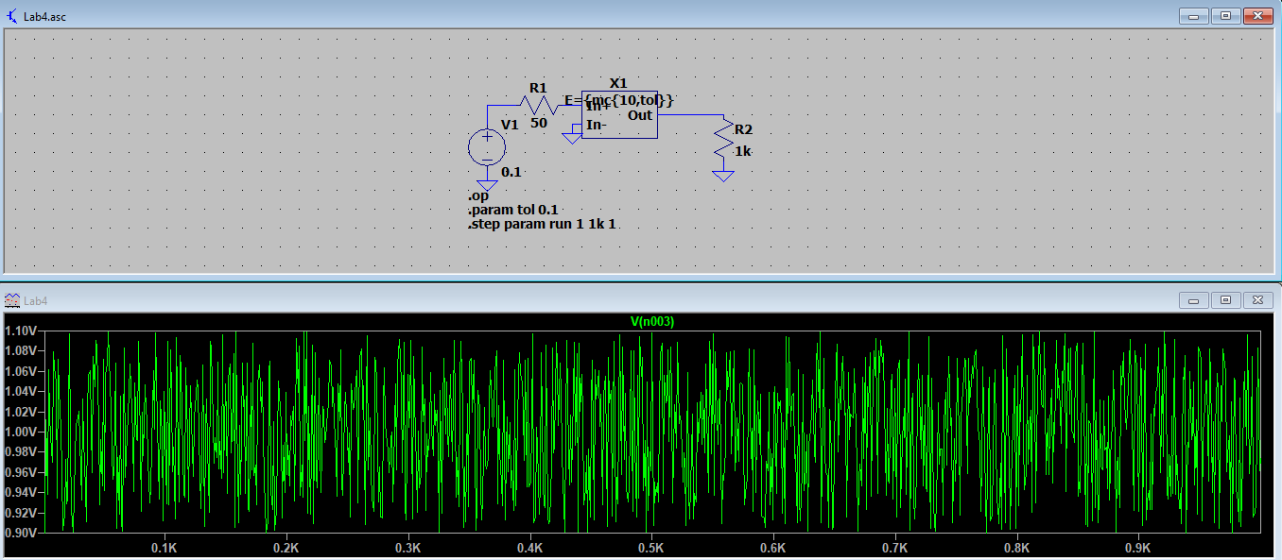

1. Figure 4: Graphed result of the Monte Carlo simulation for the input resistance, Ri. of the VCVS. Tolerance set to 1 Meg and run the simulation for 1000 iterations where Ri = {mc{1 Meg,tol}}. Based on Figure 4.4.

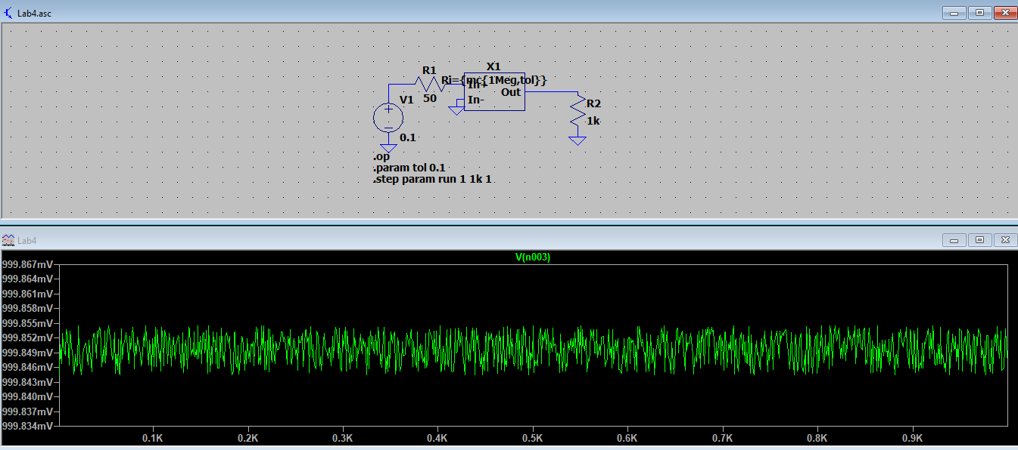

1. Figure 5: Graphed result of the Monte Carlo simulation for the input resistance, Ro. of the VCVS. Tolerance set to 0.1 and run the simulation for 1000 iterations where Ro = {mc{0.1,tol}}. Based on Figure 4.4.

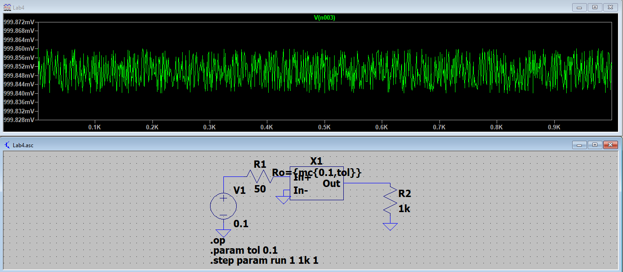

Section 4.4.3 Feedback

1. Figure 6: Graphed result of the Monte Carlo simulation for the gain, E, of the VSVS model. Gain set to 10E5, tolerance to 0.3 (30%), and run the simulation for 1000 iterations. Based on Figure 4.5 a).

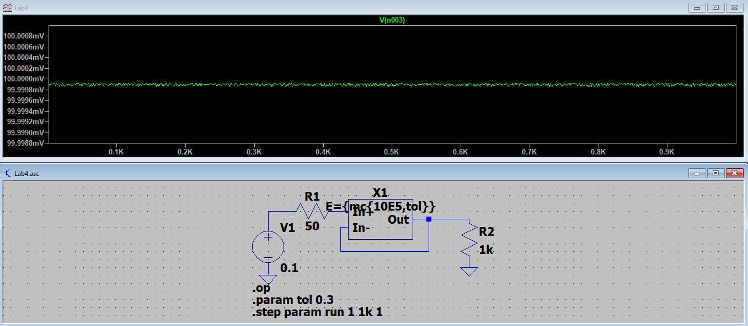

1. Figure 7: Graphed result of the Monte Carlo simulation for the gain, E, of the VSVS model. Gain set to 10E5, tolerance to 0.3 (30%), and run the simulation for 1000 iterations. Based on Figure 4.5 b).

