Johnny Li

Lab 5 Section: Tue. P10-11

Description: Operational Amplifiers

Section 5.5.1 LTspice TLV272 Op Amp Model

|  |  |
| --- | --- |
| Table 1: Voltage Offset | |
| Vin (V) | Vout (µV) |
| 0 V | -280.43 µV |

4.

Table 1: Voltage output when running a DC operating point simulation (.op) when Vin is zero volts; effectively calculating the offset voltage. Based on Figure 5.3 in the lab manual.

|  |  |  |  |
| --- | --- | --- | --- |
| Table 2: Voltage Output with Amplitude Pulse | | | |
| Vin (V) | Vout (V) | Time (µs) | Slew Rate (V/µs) |
| 1 V | 1 V | 4 µs | 1/4 V/µs |

5.

Table 2: Result when the voltage follower configuration, Figure 5.3 in the lab manual, set Vin to a 1 V amplitude pulse. Vinitial (V): 0, Von(V): 1, Tdelay (s): 0.5m, and the remaining variables blank.

Figure 1: Plot of the input (blue) and output (green) voltage from 495 µs to 505 µs of the Voltage Output with Amplitude Pulse. Based on Figure 5.3 in the lab manual.

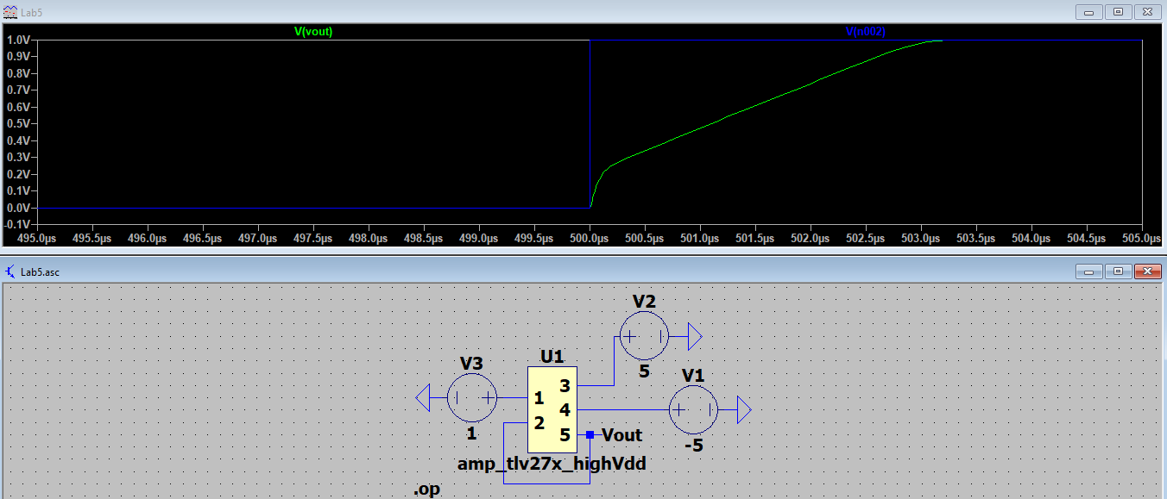

|  |  |  |  |
| --- | --- | --- | --- |
| Table 3: Voltage Output of Inverting Amplifier | | | |
| Vin (V) | Vout Max (V) | Vout Min (V) | Max Output Swing |
| 0 V | 5 V | -5 V | -5V<Vout<5V |

6.

Table 3: Result when the voltage follower configuration, Figure 5.2 (a) in the lab manual, with a gain of 10 by setting R2= 10k and R1=1k. The input voltage is a sine wave with the following parameters, DC offset (V): 0, Amp (V): 1, Freq (Hz): 1k, and the remaining variables blank.

Figure 2: Plot the input (blue) and output (green) voltage of the Voltage Output of Inverting Amplifier. Based on Figure 5.2 (a) in the lab manual.

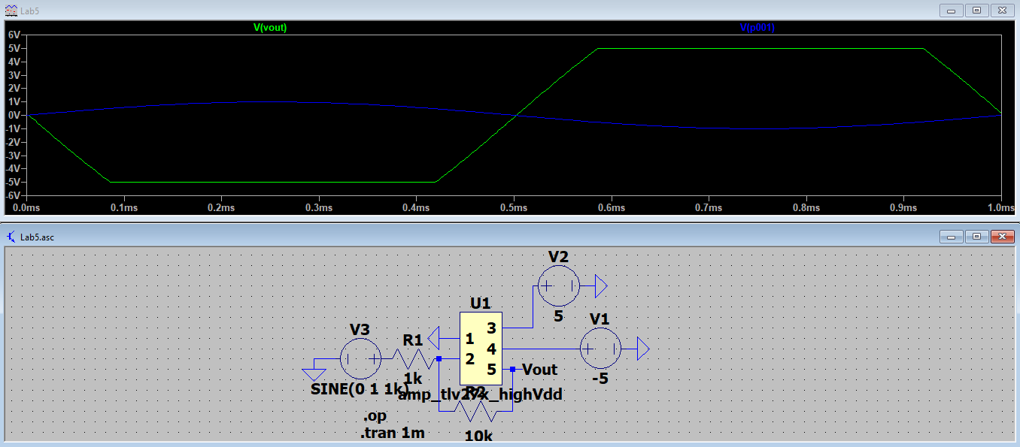

|  |  |  |
| --- | --- | --- |
| Table 4: Voltage Output of Inverting Amplifier 2 | | |
| Vin (V) | Vout (V) | Effective Gain (-Vout/Vin) |
| 0.1 V | -1 V | 10 V |

7.

Table 4: Result when the voltage follower configuration, Figure 5.2 (a) in the lab manual, with a gain of 10 by setting R2= 10k and R1=1k. The input voltage is a sine wave with the following parameters, DC offset (V): 0.1, Amp (V): 1, Freq (Hz): 1k, and the remaining variables blank.

Figure 3: Plot the input (blue) and output (green) voltage of the Voltage Output of Inverting Amplifier 2. Based on Figure 5.2 (a) in the lab manual.

