Johnny Li

Lab 6 Section: Tue. P10-11

Description: Operational Amplifiers

Section 6.5.1 Buffering

|  |  |
| --- | --- |
| Table 1: Voltage Output at Voltage Node | |
| Voltage Node | Voltage Output (V) |
| VA | 2.5 V |
| VB | 1.667 V |
| VC | 2.499 V |

Table 1: Voltage output of voltage node VA, VB, and VC when running a DC operating point simulation (.op) Based on Figure 6.3 in the lab manual.

Figure 1: Image of the circuits design based on Figure 6.3: a, b, and c.

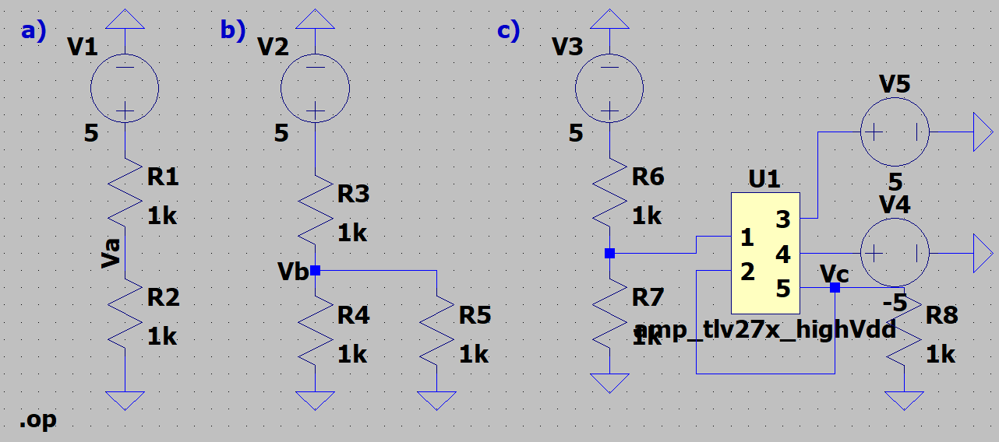

1. Two of the voltages, VA and VC, are approximately 2.5 V but one, VB, is not because VB has a resistor load that reduces the amount of voltage at node VB. Node VA does not have a load, thus its voltage is unaffected, while VC’s load is taken into account is the design so it is already balanced out.

Section 6.5.2 Level Shifting

1. Figure 2: Image of the circuit design based on Figure 6.4 (a) using a transient analysis with a stop time of 1m (.tran 1m) and a plot of the input (green) and output (blue) voltage.

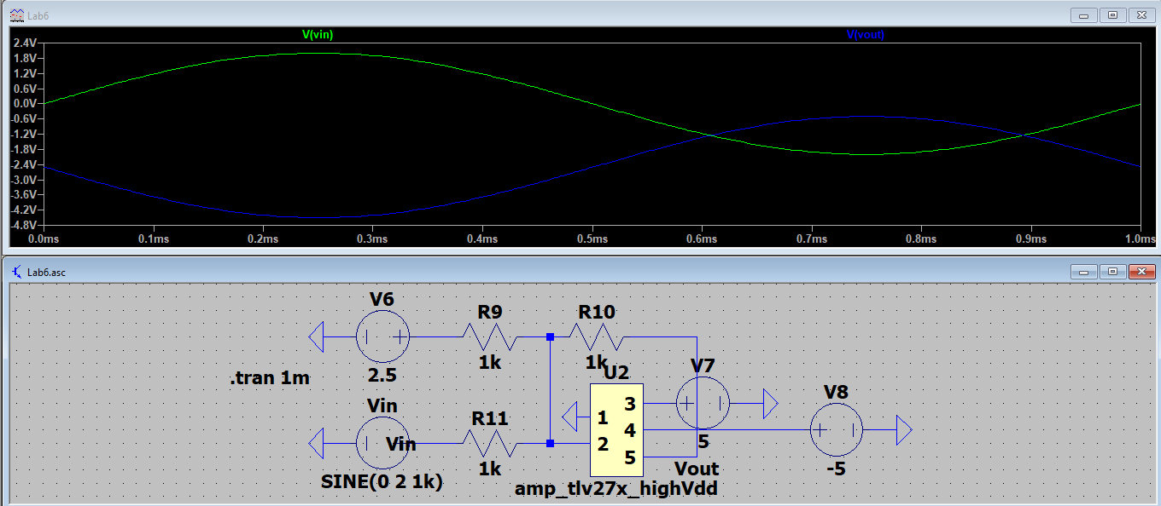

1. The resistor divider in Figure 6.4 (b) uses -5V instead of 5V because the first op amp is a non-inverting amp as opposed to an inverting amp, so the equivalent negative value voltage from Figure 6.4 (a) can also be obtained.
2. Figure 3: Image of the circuit design based on Figure 6.4 (b) using a transient analysis with a stop time of 1m (.tran 1m) and a plot of the input (blue) and output (green) voltage.

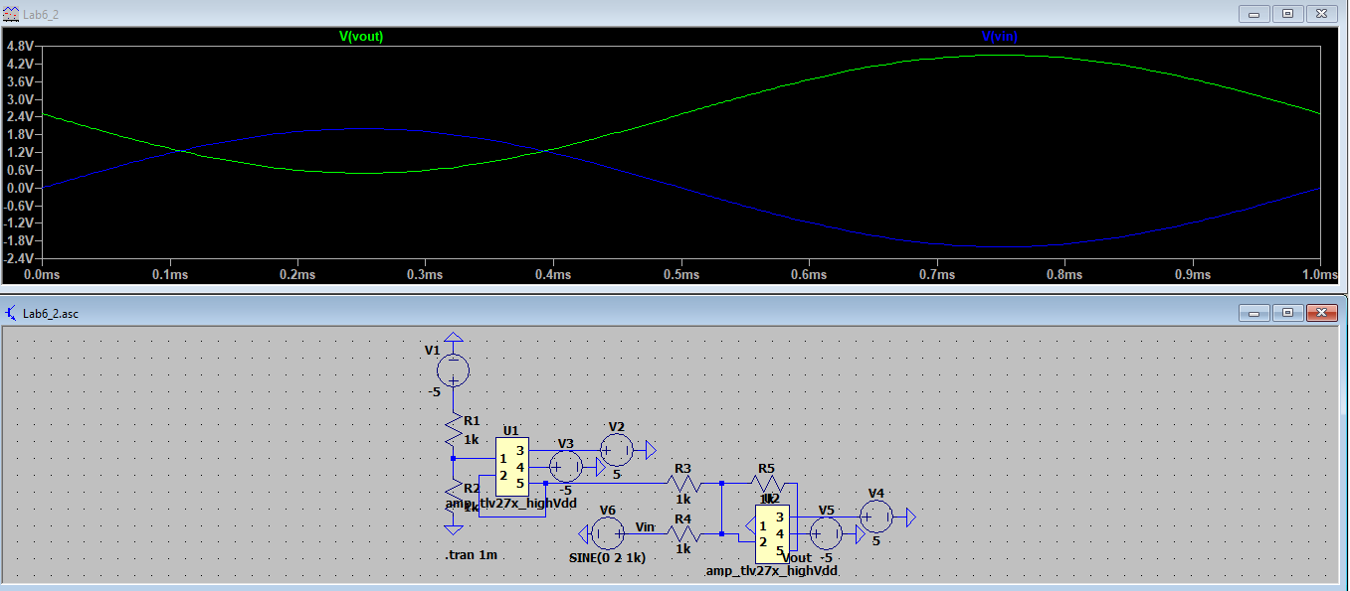

4. Figure 4: Plot of the input (blue) and output (orange) on the scope of construct the circuit in Figure 6.4 (b) on a breadboard.

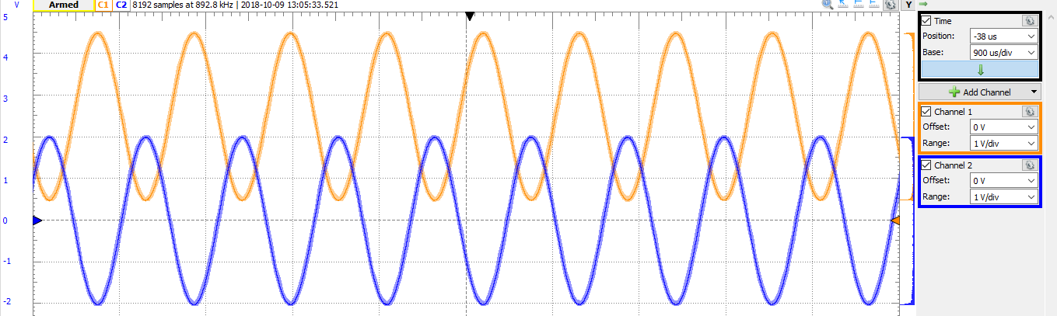

5. Figure 5: Image of the circuit design based on Figure 6.5, a DC level shifter configured to convert the full range of +/-5 to +5/0, using a transient analysis with a stop time of 1m (.tran 1m) and a plot of the input (blue) and output (green) voltage.

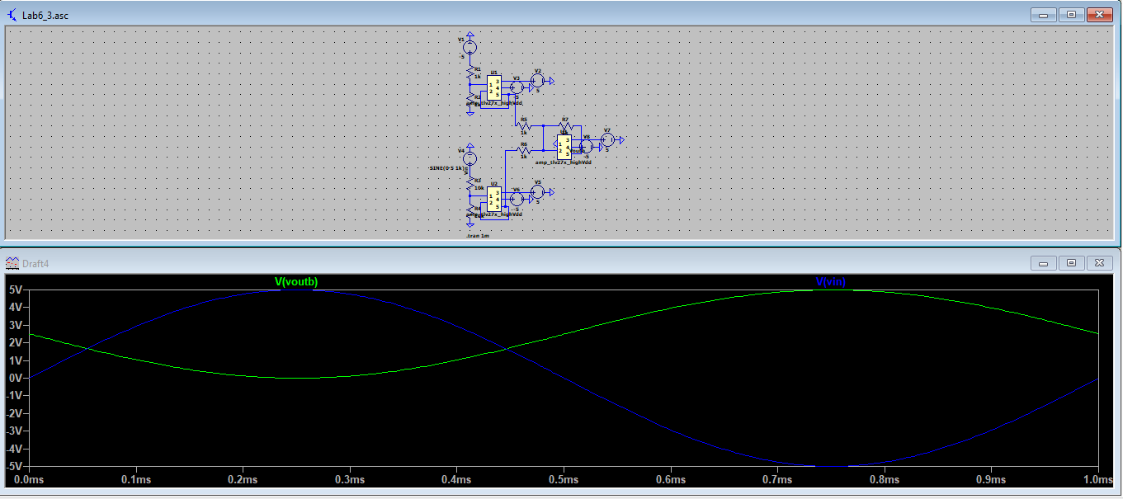

Section 6.5.3 Differential to Single Ended Conversion

1. Figure 6: Image of the circuit design based on Figure 6.6 (a), a difference amplifier that converts a differential signal to single ended, and a plot of the input 1 (blue), input 2 (green) and output (red) voltage.

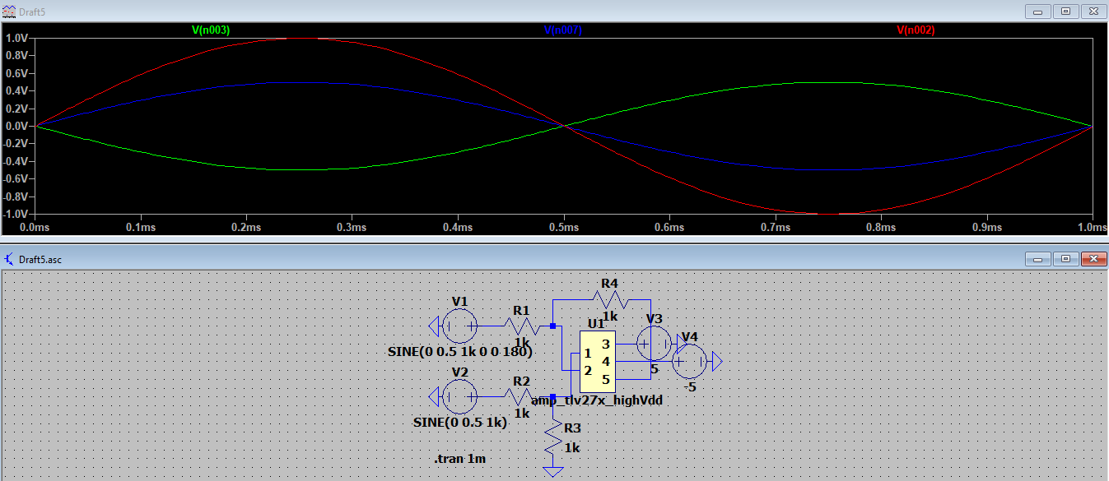

2. Figure 7: Image of the circuit design based on Figure 6.6 (b), a difference amplifier that converts a differential signal to single ended, and a plot of the input 1 (blue), input 2 (green) and output (red) voltage.

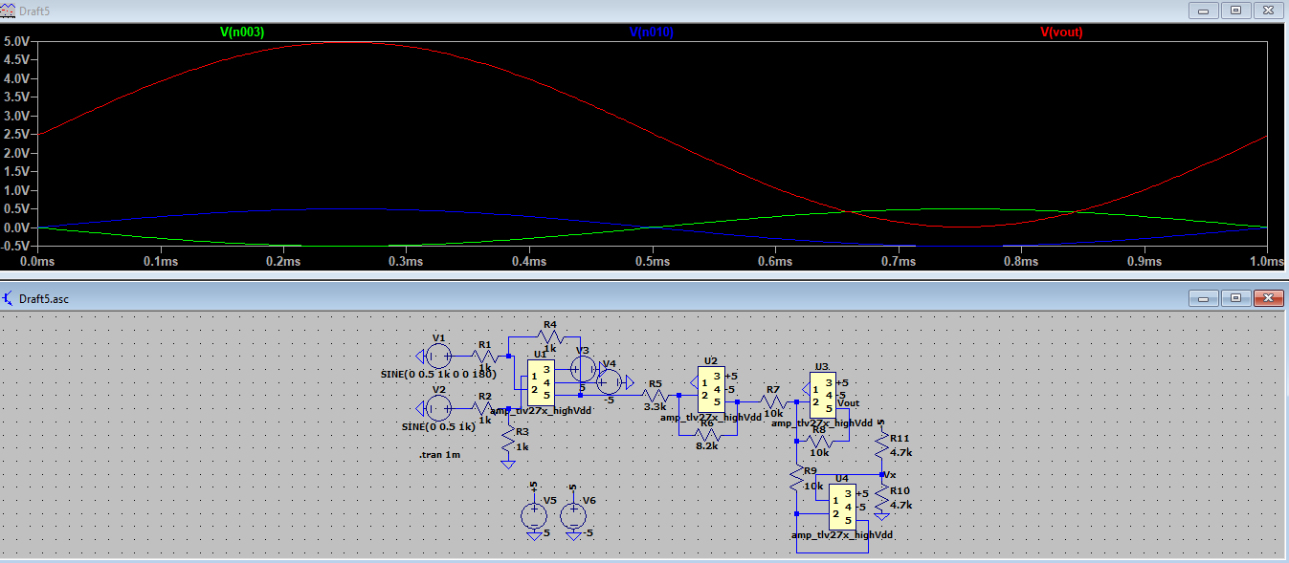

4. The circuit in Figure 6.6 (b) works by taking the two fluctuating and opposite voltage sources and add them together, amplifying them as well. The top op amp, with the 10k ohm resistor above the op amp with a voltage divider, is used to shift the fluctuating output voltage so its range is between 5V and 0V.