Johnny Li

Lab 7 Section: Tue. P10-11

Description: Capacitor Applications

Section 7.5.1 LTspice Simulations

2. Figure 1: An image of the circuit and a plot of the input (blue) and output (green) voltage based on the mono-stable configuration from Figure 7.3.

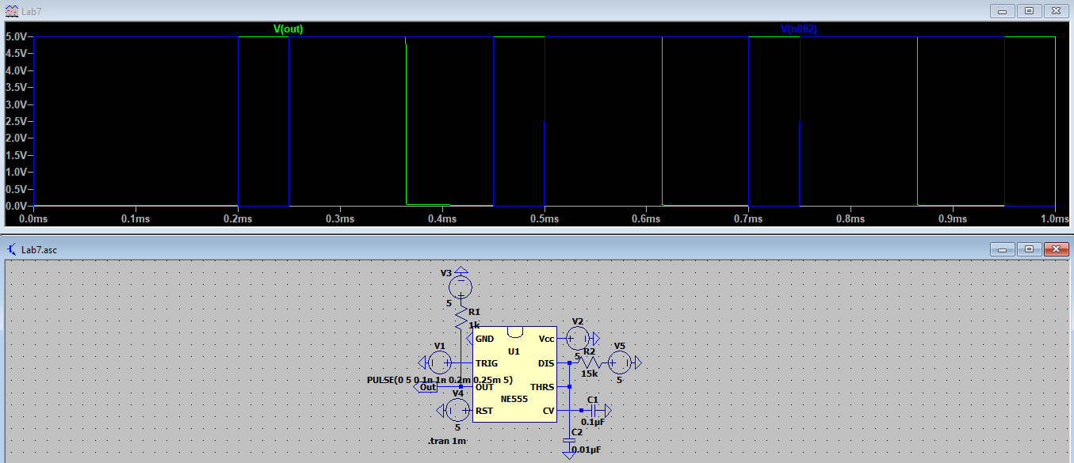

3. Figure 2: An image of the circuit and a plot of the input (blue) and output (green) voltage based on the mono-stable configuration from Figure 7.3 with RA and CL so that the output pulse duration is approximately 200μs for a 100 kHz input;

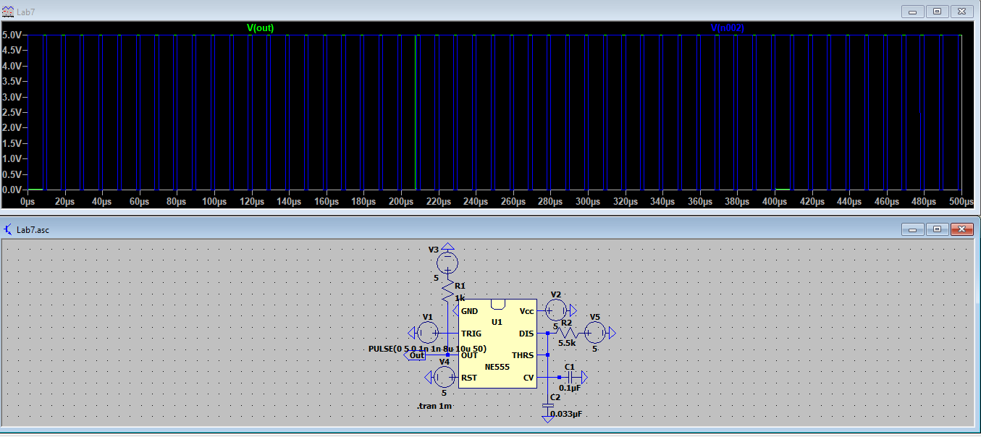

4. Figure 3: An image of the circuit and a plot of the output (green) voltage based on the a-stable configuration from Figure 7.4.

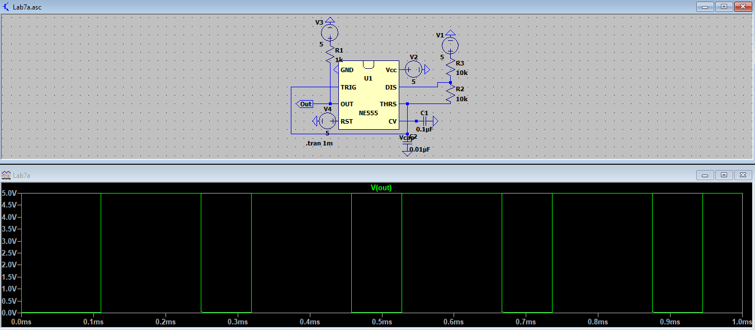

5. Figure 4: An image of the circuit and a plot of the output (green) voltage based on the a-stable configuration from Figure 7.4 with RA, RB, and CL so that the frequency of the output pulses is 10 kHz.

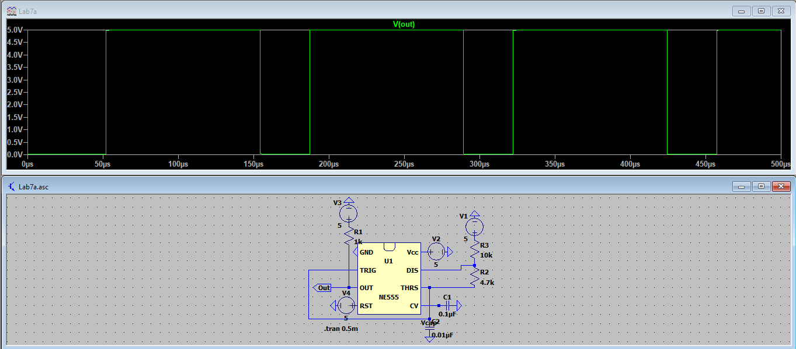

Table 1: Table of theoretical pulse durations/periods based on circuit designs in Figure 2-4.

|  |  |
| --- | --- |
| Circuit Configurations | Output Voltage Pulse Duration (ms) |
| 2. Mono-stable | 0.165 ms |
| 3. Mono-stable | 0.203 ms |
| 4. A-stable | 0.140 ms |
| 5. A-stable | 0.102 ms |