Johnny Li

Lab 8 Section: Tue. P10-11

Description: Diode Applications

Section 8.5.1 LTspice Simulations

1. Figure 1: Half wave rectifier, image of the circuit and the plot of the input (green) and output (blue) voltage from Figure 8.2a when the input is set to a 1 kHz, 5 V amplitude sine wave and run a transient simulation with a stop time of 1m.

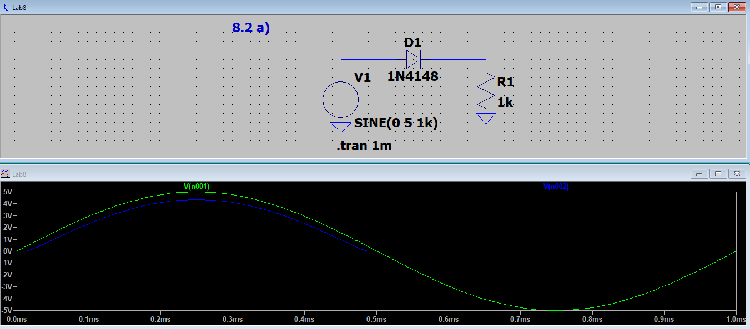

2. Figure 2: Half wave rectifier with output smoothing, image of the circuit and the plot of the input (green) and output (blue) voltage from Figure 8.3a when the input is set to a 100 kHz, 5 V amplitude sine wave and run a transient simulation with a stop time of 50u.

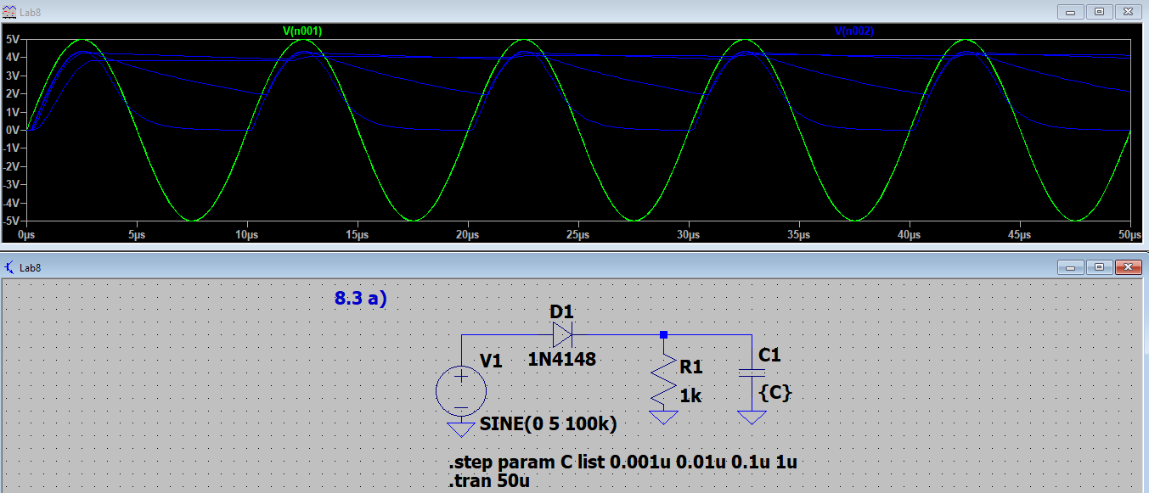

3. Figure 3: Clipping circuit, image of the circuit and the plot of the input and output voltage (a) and current (b) from Figure 8.4 when the input is set to 1 kHz, 5 V amplitude sine wave and run a transient solution with a stop time of 2m.

.

Figure 3a: Voltage- the input (red), diode A (blue), and diode B (green).

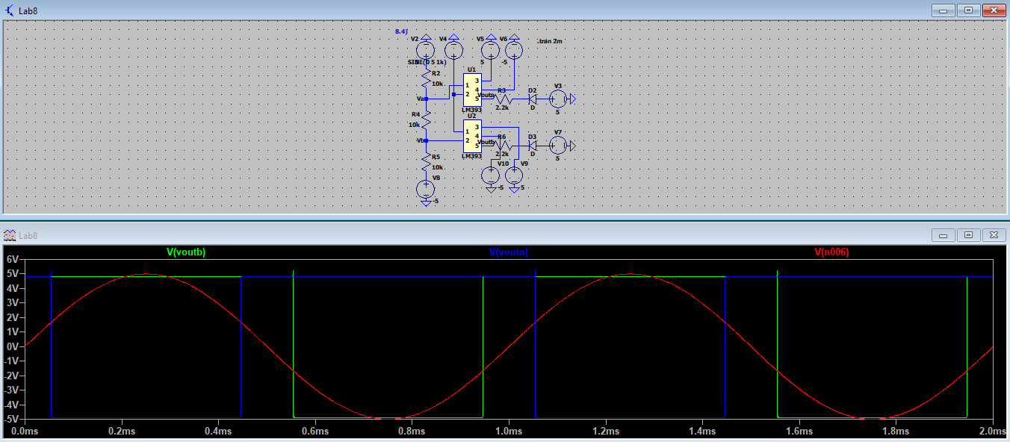

Figure 3b: Current- the input (blue), diode A (green), and diode B (purple).

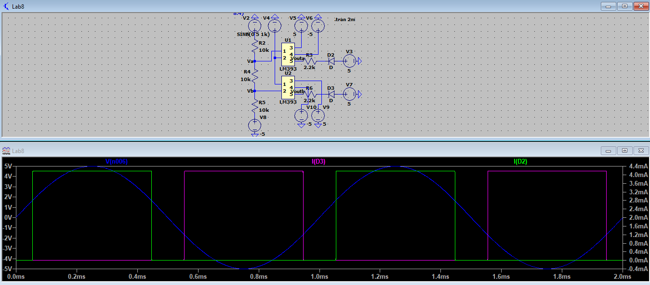

4. Figure 4: Variable gain amplifier with clip detector, image of the circuit and the plot of the input and output from Figure 8.7 when the input is set to a 1kHz, 0.1 V amplitude sine wave and run a transient solution with a stop time of 2m.

Plot the input voltage (green), output of the op amp (blue), positive (teal) and negative (red) inputs to the comparator, and the current through diode A (purple) and diode B (grey).

