Johnny Li

Lab 9 Section: Tue. P10-11

Description: Filters

Section 9.5.1 LTspice Simulations

2. Figure 1: Simple RC lowpass filter, image of the circuit and the plot of the output (green) voltage from Figure 9.2a when the input is set R = 10 k and C =0.001μF with AC amplitude of 1 and run an AC analysis with the following settings: Decade, 100, 1, 1Meg.

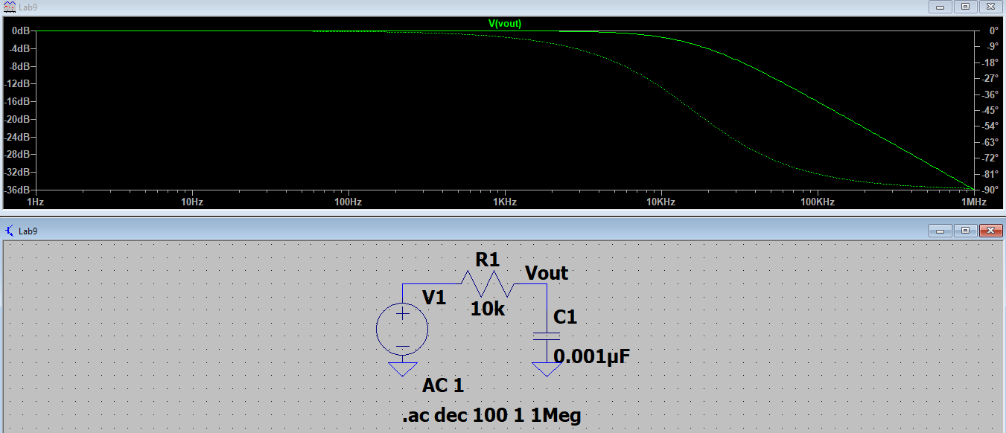

3. Figure 2: Simple RC highpass filter, image of the circuit and the plot of the output (green) voltage from Figure 9.2b when the input is set R = 15 k and C =0.01μF with AC amplitude of 1 and run an AC analysis with the following settings: Decade, 100, 1, 1Meg.

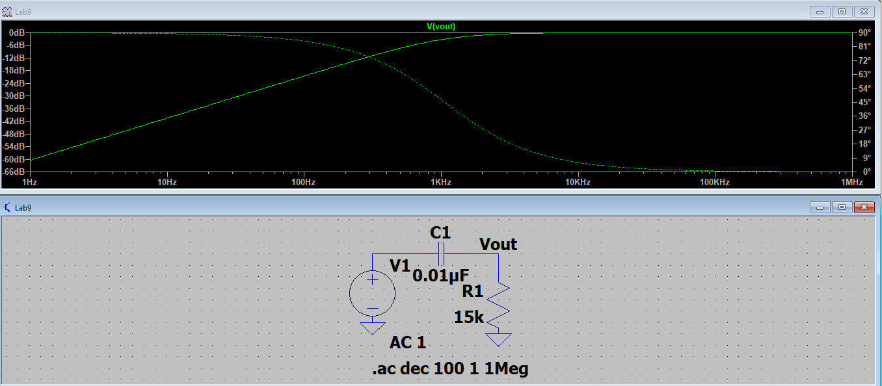

4. Figure 3: Active RC lowpass filter, image of the circuit and the plot of the output (green) voltage from Figure 9.3a when the input is set C1=0.1μF and a gain of -1 V/V (0 dB) and f0=1.59 kHz with AC amplitude of 1 and run an AC analysis with the following settings: Decade, 100, 1, 1Meg.

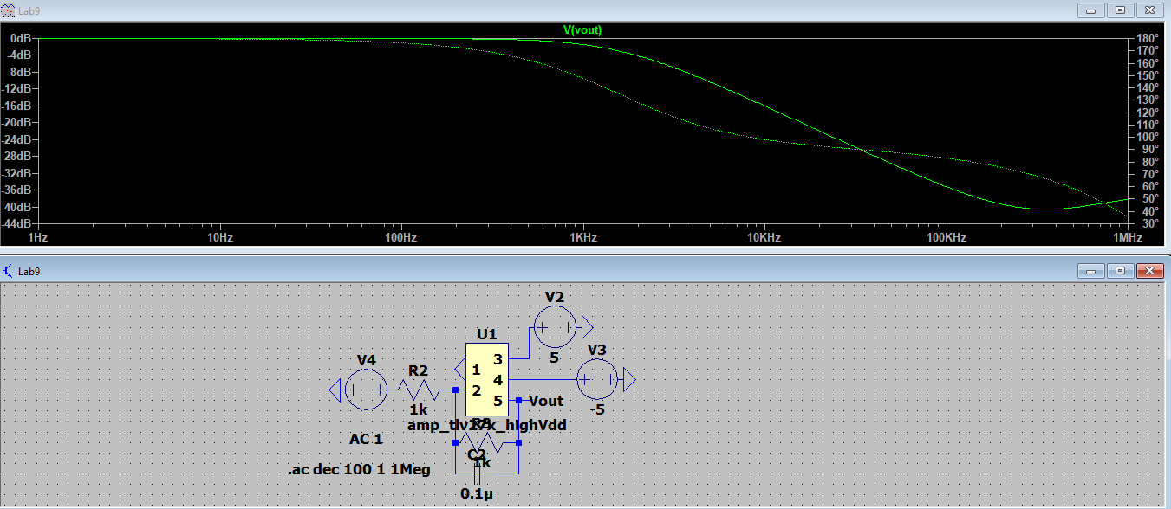

5. Figure 4: Active RC highpass filter, image of the circuit and the plot of the output (green) voltage from Figure 9.3b when the input is set C1=0.1μF and a gain of -10 V/V (0 dB) and f0=482.3 Hz with AC amplitude of 1 and run an AC analysis with the following settings: Decade, 100, 1, 1Meg.

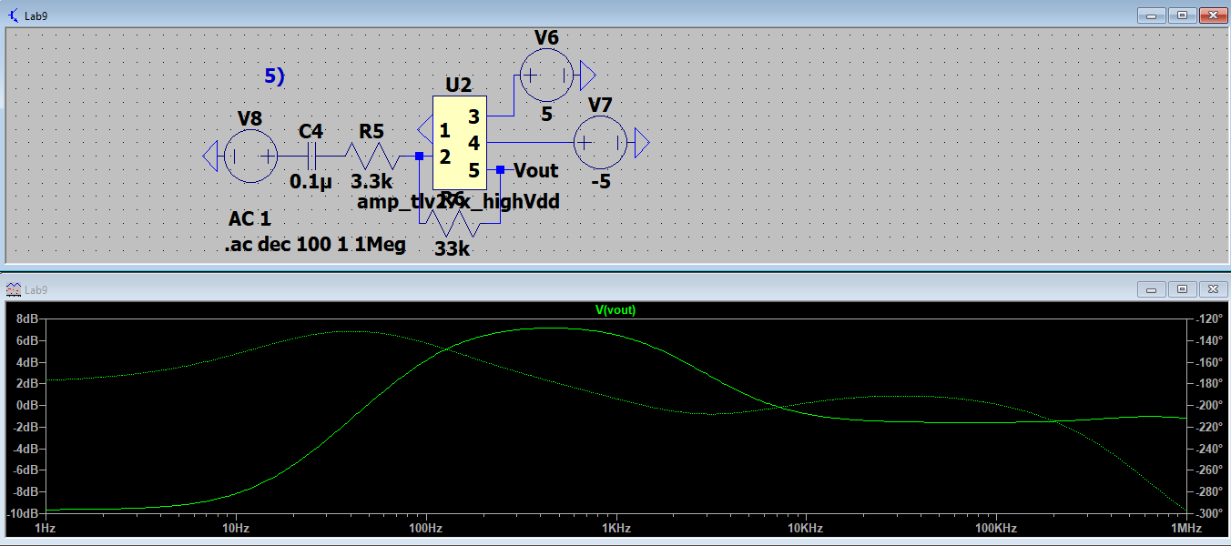

Table 1: Table of 3 dB frequencies

|  |  |
| --- | --- |
| Circuit Design | 3 dB Frequencies (Hz) |
| 2. Simple RC lowpass filter | 15915.5 Hz |
| 3. Simple RC highpass filter | 1061.0 Hz |
| 4. Active RC lowpass filter | 1591.5 Hz |
| 5. Active RC highpass filter | 482.3 Hz |

Section 9.5.2 Breadboard implementation

3. Figure 5: Active RC lowpass filter, image of the circuit and the plot of the output (blue) voltage from Section 9.5.1 - Item 4 when the input is set the start frequency to 100 Hz, stop frequency to 100 kHz, and the samples to 100.

