Some notes to take care of while running the project.

***Install***

This project requires Python 2.7 with the following libraries installed

* Numpy
* Sklearn
* Keras
* Theano

***Data***

The dataset used here is the German Traffic Sign Recognition Benchmark (GTRSB). Here is the link: -

<http://benchmark.ini.rub.de/?section=gtsrb&subsection=dataset>

***Run***

python profinal.py should run the program properly, but if it won't, it means you haven't set your directories properly.

Your directories should be in the following fashion.

Path | |profinal.py |utils.py |vgg16.py | |GTSRB ---> |train |valid |results |sample (Optional)

Train folder will be the one containing the images with all classes, valid folder will be filled by the code.

Just as an example I’ve shared my path with you.

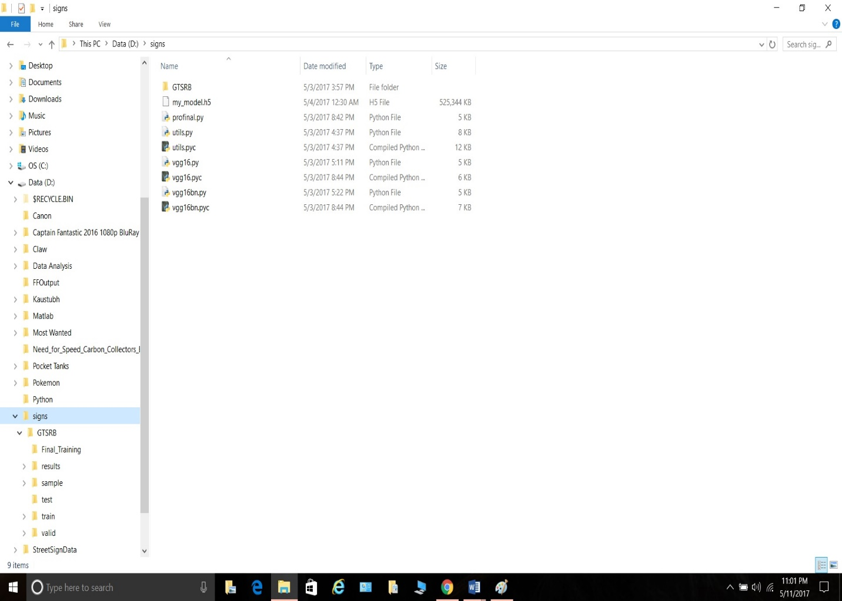

Warning: - It will take a lot of time to train the networks. The VGG itself will take up to 2 days. I would’ve shared the weights with you but they are quite large and hence I cannot upload them. The classifier training may take up to 2 hours.