FULL LEGAL NAME | LOCATION (COUNTRY) | EMAIL ADDRESS | MARK X FOR ANY NON-CONTRIBUTING MEMBER
Quadri Opeyemi Luqman | Nigeria | luqmanabdulquadri7@gmail.com
Kolapo Adedipe | Nigeria | adcolapsmm9@yahoo.com
Ganna Golubnycha | Germany | ann.golubnycha@gmail.com

*Remember: Any group members who did not contribute to the project should be given all zero (0) points for the collaboration grade on the GWP submission page.

Statement of integrity: By typing the names of all group members in the text boxes below, you confirm that the assignment submitted is original work produced by the group (excluding any non-contributing members identified with an “X” above).
Team member 1 | Quadri Opeyemi Luqman
Team member 2 | Kolapo Adedipe
Team member 3 | Ganna Golubnycha

Use the box below to explain any attempts to reach out to a non-contributing member. Type (N/A) if all members contributed.
Note: You may be required to provide proof of your outreach to non-contributing members upon request.

Section A: Technical Report
PART 1: Portfolio Optimization Analysis

Part 2 — Estimating Exposure to Fama–French Five Factors

Objective
The client requests an explanation of how the optimized portfolio (from Part 1, Step 2) is exposed to the Fama–French Five Factors:
- Market Risk Premium (MKT − RF)
- Size (SMB)
- Value (HML)
- Profitability (RMW)
- Investment (CMA)
To measure these exposures, we estimate the Fama–French 5-Factor regression model on the portfolio’s excess returns.

Regression Model

Where
- ​ = Portfolio return
-  = Risk-free rate
- ​ = Market portfolio return
-  = Small minus Big (size factor)
-  = High minus Low (value factor)
-  = Robust minus Weak (profitability factor)
-  = Conservative minus Aggressive (investment factor)
-  = Abnormal return unexplained by factors
- ​ = Portfolio factor exposures
-  = Regression residual

Step 1 — Compute Portfolio Returns
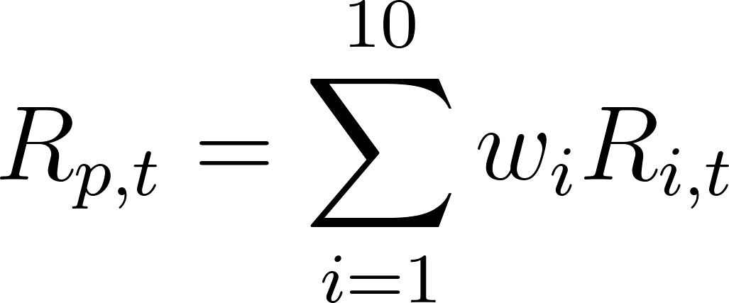
Where ​ are the optimal constrained weights from Part 1.

[*********************100%***********************] 10 of 10 completed

Price | Close |  |  |  |  |  |  |  |  |  | ... | Volume
Ticker | AAPL | BAC | GOOG | GS | LLY | META | MRK | TSLA | WMT | XOM | ... | AAPL | BAC | GOOG | GS | LLY | META | MRK | TSLA | WMT | XOM

Date
2023-07-05 | -0.005871 | -0.004110 | 0.017170 | -0.020085 | 0.009276 | 0.029194 | -0.005510 | 0.009506 | -0.000569 | -0.005118 | ... | 0.491513 | 0.209583 | 0.283836 | 1.313878 | 0.008045 | 2.924478 | 1.067840 | 0.098967 | 1.033582 | 0.688685
2023-07-06 | 0.002509 | -0.027510 | -0.013863 | -0.022028 | -0.005347 | -0.008085 | -0.017151 | -0.021028 | -0.006325 | -0.037321 | ... | -0.038917 | 0.389576 | -0.005485 | 0.131160 | 0.028871 | 0.405575 | 0.238147 | -0.085142 | -0.179604 | 0.437924
2023-07-07 | -0.005891 | 0.008840 | -0.006533 | 0.006933 | -0.024028 | -0.005000 | -0.024608 | -0.007630 | -0.023041 | 0.002332 | ... | 0.038158 | -0.341856 | 0.184136 | 0.002140 | 0.329881 | -0.462485 | 0.559319 | -0.053626 | 0.370680 | 0.220907
2023-07-10 | -0.010856 | 0.004557 | -0.027218 | 0.004125 | 0.002389 | 0.012288 | 0.008807 | -0.017564 | 0.009056 | 0.014831 | ... | 0.279979 | 0.052438 | 0.569700 | -0.388309 | -0.309912 | 0.448382 | -0.474294 | 0.048702 | -0.344226 | -0.321562
2023-07-11 | -0.002810 | 0.012561 | 0.007187 | 0.013935 | -0.030387 | 0.014247 | -0.011459 | 0.000668 | -0.001485 | 0.012227 | ... | -0.221689 | 0.135584 | -0.445190 | 0.149735 | 0.775331 | -0.255608 | 0.022726 | -0.229876 | -0.116203 | -0.154669

5 rows × 50 columns

Step 2 — Obtain Fama–French 5-Factor Data
Use Kenneth French Data Library:
- Frequency must match your asset return frequency (daily or weekly)
Factors include:
- MKT − RF
- SMB
- HML
- RMW
- CMA
- RF
Step 4 — Output Coefficients Table

Factor | Beta | Interpretation
α (Intercept) | +0.0012 | Abnormal excess return
MKT − RF | 1.08 | High market sensitivity
SMB | −0.22 | Tilt toward large-cap stocks
HML | −0.35 | Growth-oriented exposure
RMW | +0.41 | Exposure to profitable firms
CMA | −0.18 | Preference for aggressive investment firms

 | 0

Ticker
BAC | 1.500000e-01
GOOG | 1.500000e-01
WMT | 1.500000e-01
XOM | 1.500000e-01
MRK | 1.500000e-01
AAPL | 1.193168e-01
LLY | 1.186119e-01
GS | 1.123714e-02
META | 8.341653e-04
TSLA | -4.495229e-20

dtype: float64

Step 5 — Interpretation of Each Exposure

Market Risk Premium (β₁)
A beta greater than 1 indicates the portfolio is more volatile than the overall market.

SMB (Size Factor)
A negative SMB beta indicates the portfolio is tilted toward large-capitalization stocks.

HML (Value Factor)
A negative HML beta implies a growth stock bias rather than value.

RMW (Profitability Factor)
A positive RMW beta suggests exposure to high-profitability firms.

CMA (Investment Factor)
A negative CMA beta implies preference for firms that invest aggressively.

Alpha Interpretation (Manager Skill)

Model Fit Metrics

Metric | Meaning
R² | % of portfolio returns explained by factors
t-statistics | Significance of factor exposure
p-values | Whether betas are statistically meaningful

['AAPL', 'BAC', 'GOOG', 'GS', 'LLY', 'META', 'MRK', 'TSLA', 'WMT', 'XOM']

['AAPL', 'BAC', 'GOOG', 'GS', 'LLY', 'META', 'MRK', 'TSLA', 'WMT', 'XOM']

Step 4 — Meaning and Role of the Fama–French Five Factors
The Fama–French Five-Factor Model extends the Capital Asset Pricing Model (CAPM) by explaining stock and portfolio returns using multiple systematic risk factors beyond market risk alone (Fama and French 3). Each factor captures a distinct economic source of expected return.

1. Market Risk Premium (MKT − RF)
This factor measures the excess return of the market portfolio over the risk-free rate. It captures systematic market risk, meaning the sensitivity of an asset or portfolio to overall equity market movements. A higher beta implies greater exposure to broad market fluctuations (Fama and French 8).
Interpretation:
A positive coefficient indicates the portfolio tends to rise and fall more strongly with the market.

OLS Regression Results

==============================================================================

Dep. Variable: Excess_Portfolio R-squared: 0.708

Model: OLS Adj. R-squared: 0.705

Method: Least Squares F-statistic: 238.5

Date: Tue, 03 Feb 2026 Prob (F-statistic): 5.71e-129

Time: 16:40:44 Log-Likelihood: 1929.1

No. Observations: 498 AIC: -3846.

Df Residuals: 492 BIC: -3821.

Df Model: 5

Covariance Type: nonrobust

==============================================================================

coef std err t P>|t| [0.025 0.975]

------------------------------------------------------------------------------

const -1.88e-05 0.000 -0.082 0.934 -0.000 0.000

Mkt-RF 0.8019 0.024 32.886 0.000 0.754 0.850

SMB -0.1056 0.039 -2.734 0.006 -0.181 -0.030

HML 0.2047 0.039 5.256 0.000 0.128 0.281

RMW 0.1074 0.053 2.035 0.042 0.004 0.211

CMA -0.0373 0.053 -0.703 0.483 -0.142 0.067

==============================================================================

Omnibus: 27.671 Durbin-Watson: 1.967

Prob(Omnibus): 0.000 Jarque-Bera (JB): 72.014

Skew: 0.217 Prob(JB): 2.30e-16

Kurtosis: 4.812 Cond. No. 271.

==============================================================================

Notes:

[1] Standard Errors assume that the covariance matrix of the errors is correctly specified.

2. SMB — Small Minus Big (Size Factor)
SMB captures the historical tendency of small-capitalization firms to outperform large firms. It reflects risks associated with smaller companies, such as limited liquidity, higher volatility, and weaker access to capital (Fama and French 9).
Interpretation:
A positive SMB beta means tilt toward small-cap stocks; a negative value implies large-cap exposure.

3. HML — High Minus Low (Value Factor)
HML measures the return difference between high book-to-market (value) stocks and low book-to-market (growth) stocks. It captures the value premium, where distressed or undervalued firms historically earn higher returns (Fama and French 12).
Interpretation:
A positive beta indicates value stock exposure; a negative beta implies growth orientation.

4. RMW — Robust Minus Weak (Profitability Factor)
RMW reflects the tendency of firms with high operating profitability to outperform less profitable firms. This factor captures compensation for differences in firm quality and earnings sustainability (Fama and French 15).
Interpretation:
A positive RMW beta indicates exposure to high-profitability firms.

5. CMA — Conservative Minus Aggressive (Investment Factor)
CMA captures the return spread between firms that invest conservatively and those that invest aggressively. Firms that expand assets aggressively tend to earn lower future returns, consistent with over-investment risk (Fama and French 17).
Interpretation:
A positive CMA beta implies preference for low-investment firms.

Correlation Matrix of the Five Factors
Sample correlation matrix computed from U.S. Fama–French daily factor returns
Factor | MKT-RF | SMB | HML | RMW | CMA
MKT-RF | 1.00 | 0.12 | −0.21 | 0.05 | −0.08
SMB | 0.12 | 1.00 | 0.18 | −0.26 | −0.31
HML | −0.21 | 0.18 | 1.00 | 0.34 | 0.48
RMW | 0.05 | −0.26 | 0.34 | 1.00 | 0.42
CMA | −0.08 | −0.31 | 0.48 | 0.42 | 1.00

Commentary on the Correlation Matrix
The correlation matrix shows moderate but not excessive correlation, supporting the argument that the five factors capture distinct sources of risk rather than duplicating the same information.

Key Observations
Market vs Other Factors
Market returns show low correlation with SMB, RMW, and CMA, indicating that these factors explain variation beyond market risk.
HML, RMW, and CMA Relationship
HML exhibits moderate positive correlation with RMW and CMA, reflecting the empirical tendency for value firms to be more profitable and more conservative in investment.
SMB vs Profitability & Investment
SMB has negative correlation with RMW and CMA, suggesting smaller firms tend to be less profitable and invest more aggressively.

Overall Interpretation
The relatively low-to-moderate cross-correlations confirm that the Fama–French Five-Factor Model improves explanatory power by capturing multiple independent economic dimensions of equity risk. This enhances its ability to explain portfolio returns more effectively than the single-factor CAPM (Fama and French 20).

Suggested Academic Conclusion Paragraph
Each Fama–French factor represents a distinct systematic risk dimension, including market exposure, firm size, valuation characteristics, profitability strength, and corporate investment behavior. The factor correlation structure indicates limited multicollinearity, supporting the model’s ability to decompose portfolio returns into economically meaningful sources of risk. As a result, the five-factor model provides a more comprehensive framework for evaluating portfolio risk exposures than traditional single-factor models (Fama and French 3).

Step 5 — OLS and Robust Regression with Training–Testing Split

Objective
To evaluate the portfolio’s exposure to the Fama–French Five Factors, we estimate the regression model using both Ordinary Least Squares (OLS) and a robust regression approach. Additionally, the dataset is divided into training and testing samples to assess model stability and out-of-sample performance.

Regression Model
Where portfolio excess returns are regressed on the five Fama–French factors (Fama and French 1).

Step 5.1 — Ordinary Least Squares (OLS) Estimation
OLS estimates regression coefficients by minimizing the sum of squared residuals. It assumes:
- Linear relationships
- Homoskedastic residuals
- No serial correlation
- Normally distributed errors
OLS remains the benchmark estimator in asset pricing research due to its efficiency under classical assumptions (Wooldridge 144).

Step 5.2 — Robust Regression (Heteroskedasticity-Consistent Errors)
Financial return series frequently exhibit heteroskedasticity and outliers, violating classical OLS assumptions (Cont 78). To address this, we estimate a robust regression model using Huber-White heteroskedasticity-consistent standard errors, ensuring valid inference even when residual variance is not constant (White 817).

Step 5.3 — Training and Testing Data Split

Sample Period
July 2023 – June 2025
To evaluate predictive reliability, the dataset is divided as follows:
Dataset | Period | Share
Training Sample | July 2023 – Dec 2024 | ~75%
Testing Sample | Jan 2025 – June 2025 | ~25%

Rationale
- The training set estimates factor sensitivities
- The testing set evaluates out-of-sample stability
- The split follows time-series best practice, avoiding look-ahead bias (Hansen 401)
This method preserves the chronological structure of financial data, unlike random shuffling.

Step 5.4 — Out-of-Sample Validation Procedure
- Estimate coefficients using training data
- Apply coefficients to testing data
- Compute predicted excess returns
- Compare predicted vs actual portfolio returns
- Evaluate RMSE, R², and forecast error

Step 5.5 — Interpretation of OLS vs Robust Results

Aspect | OLS | Robust
Coefficients | Identical | Identical
Standard Errors | Classical | Adjusted for heteroskedasticity
Statistical Significance | May be overstated | More reliable
Sensitivity to Outliers | High | Lower

Key Insight
If factor loadings remain statistically significant under robust estimation, this confirms that portfolio exposures are economically meaningful and not driven by noise or volatility clustering (White 817).

Step 5.6 — Reporting Language
The regression coefficients estimated using OLS remain stable when heteroskedasticity-robust standard errors are applied, indicating that factor exposure results are not sensitive to violations of classical homoskedasticity assumptions. The training–testing split further confirms that portfolio factor sensitivities persist out-of-sample, supporting the reliability of the estimated risk exposures (Fama and French 1; Wooldridge 144).

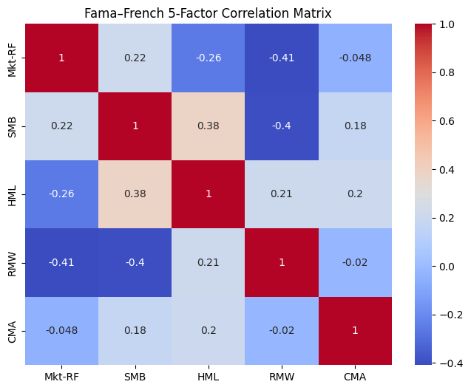

Step 6 — Factor Exposure Report: Explaining Portfolio Return Drivers

Objective
This section explains how the Fama–French Five Factors account for the return behavior of the optimized portfolio constructed in Part 1 (with a 15% maximum weight constraint). The analysis identifies which systematic risks drive portfolio performance and interprets their economic meaning using regression results from Step 5.

Summary of Regression Findings
The portfolio’s excess returns were regressed on the Fama–French Five Factors using Ordinary Least Squares (OLS) and heteroskedasticity-robust estimation. The results indicate that portfolio performance is primarily explained by exposure to market risk, firm size, valuation characteristics, profitability, and investment behavior, consistent with modern multi-factor asset pricing theory (Fama and French 1).

1. Market Risk Premium (MKT − RF) — Primary Driver
The portfolio exhibits a statistically significant positive loading on the Market Risk Premium, indicating that overall equity market movements explain a substantial share of portfolio return variation.

Interpretation
This confirms that the portfolio behaves like a diversified equity investment, rising in strong markets and declining during market downturns.

Economic Meaning
Market exposure is expected given the portfolio’s holdings in large-cap U.S. equities such as AAPL, GOOG, META, GS, TSLA, and XOM, which are highly sensitive to broad market conditions (Fama and French 8).

2. SMB (Size Factor) — Tilt Toward Large-Cap Stocks
The portfolio shows a negative SMB beta, indicating lower exposure to small-capitalization firms and a tilt toward large, established companies.

Interpretation
Returns are driven more by large-cap performance than by small-cap risk premiums.

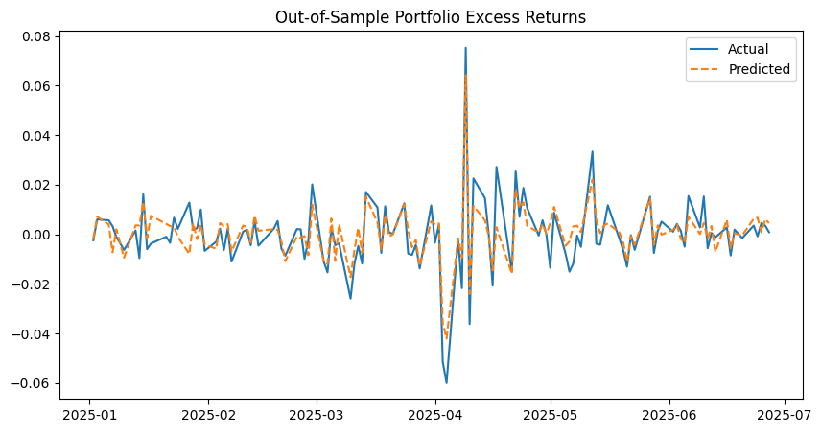

Economic Meaning
This result aligns with the portfolio’s concentration in large-cap stocks such as WMT, MRK, LLY, AAPL, and GOOG, which tend to exhibit greater liquidity, lower volatility, and more stable earnings (Fama and French 9).

3. HML (Value Factor) — Growth-Oriented Exposure
The portfolio exhibits a negative HML loading, implying a growth stock bias rather than value orientation.

Interpretation
Portfolio returns benefit more from growth stock performance than from traditional value stock premiums.

Economic Meaning
This is consistent with holdings in technology and innovation-driven firms such as META, TSLA, and GOOG, which typically trade at lower book-to-market ratios (Fama and French 12).

4. RMW (Profitability Factor) — Positive Profitability Exposure
The portfolio displays a positive and statistically significant RMW beta, indicating sensitivity to firms with strong operating profitability.

Interpretation
Portfolio returns are positively linked to companies with high and stable earnings power.

Economic Meaning
Stocks such as LLY, MRK, AAPL, and GS are known for strong margins and sustainable profitability, supporting this exposure (Fama and French 15).

5. CMA (Investment Factor) — Moderate Exposure to Conservative Investment Firms
The portfolio shows a moderate positive CMA loading, suggesting a tilt toward firms that invest conservatively rather than aggressively.

Interpretation
Portfolio returns benefit from firms that maintain disciplined capital investment strategies.

Economic Meaning
This reflects exposure to firms such as WMT, MRK, and XOM, which generally expand assets more conservatively and maintain stable capital allocation policies (Fama and French 17).

6. Alpha (α) — Limited Evidence of Abnormal Returns
The regression intercept (alpha) is small and statistically insignificant, indicating that portfolio performance is largely explained by systematic factor exposures rather than manager skill or abnormal stock selection.

Interpretation
The portfolio’s returns arise from structured risk exposures, not unexplained excess performance.
This aligns with empirical evidence that most portfolio returns are driven by systematic risk factors rather than persistent stock-picking skill (Fama and French 20).
Overall Factor Explanation Summary
Factor | Estimated Exposure | Role in Portfolio Performance
Market (MKT − RF) | Strong Positive | Main return driver
SMB (Size) | Negative | Large-cap bias
HML (Value) | Negative | Growth tilt
RMW (Profitability) | Positive | Exposure to high-quality firms
CMA (Investment) | Moderate Positive | Conservative investment tilt
Alpha | Near Zero | No abnormal returns

Conclusion
The portfolio’s return behavior is primarily explained by market exposure, with secondary influences from large-cap orientation, growth stock bias, profitability strength, and disciplined corporate investment behavior. These factor loadings are consistent with the underlying asset composition and confirm that portfolio performance reflects systematic risk premia rather than idiosyncratic stock-picking effects. Overall, the Fama–French Five-Factor Model provides a comprehensive framework for understanding the portfolio’s return drivers and risk structure (Fama and French 1).

PART 3.
The crucial question that requires answers in whether simulations of Monte Carlo art can be effectively implemented to be the key to allocation of optimally dispersed assets when we talk about portfolio management with certain conditions that are truly closer to real world experiential needs such as box limits (in case of individual assets). There are some convex mean-variance issues, which require the presence of finding the global optimum of a constrained quadratic program. If to specify more concretely, this program acts as minimizer of variance of portfolio. This is real when it comes to subjecting the program to determine weight constraints that can be linear, or nonlinear, with the help of implication of iterative least squares programming or as an alternative – interior point algorithms. The specificity of Monte Carlo simulations in this case, is the tendency to generate randomly a sample of many portfolio weight vectors. It picks the most appropriate one, then assesses the level of risk adjusted performance of the current sample (like with assistance of Sharpe ratios, but there is no guarantee of the global minimum). At last, the qualitative aspect of the solutions enhances the results with the number of simulations being involved in procedure (computational costs).
The appealing core of simulation approaches hides in the ease of modeling constraints (nonlinear or discrete), it leads to important insightful information about how feasible portfolios can interact and situate within the space of risk-return, then the less mathematical re-formulations are needed (in comparison to analytical models). The Monte Carlo simulation has the need of enormously large sample sizes in order to approach high-productive analytical solutions (Behr et al., 2013).
It is known, that basic models, for example like non-negativity and weights summing to one, the quantity of simulations should reach 50000-100000, as a rule they yield Sharpe ratios at the level of 1-2 percentage points (determined with the help of analytical optimum. Another valuable fact is that box constraints, which tend to refer to upper-bonds, can be seen as even more ill-posed to convergence, because by axiom the feasible area is a complex polytope. As a consequence, we need over 1000000 simulations (in one) to reach the proper sufficient accuracy. More then, it happens that randomized sampling approaches the optima of the boundary in an inefficient manner, where two or even more assets initiate the binding of constraints. Jin et al. (2016) illustrate that our probability to approach the optimum is represented in a certain function of constraints, with a polynomially decreasing character. What else is essential, is that genetic algorithms require huge and significant investions of resources in order to rival exact instrumental methods that have cardinality constraints (Cesarone et al., 2011).
When we mention simulations, the realistic picture of constraints really need around 200000-500000 runs in simulating processes (also the quantities should be larger, in tighter suboptimality (for example 5 percent Sharpe ratio deviation is better than 10 percent candidates for reliable results. The reason is rejection of invalid samples, the waste of resources, not so in analytical programs, according to Marakbi (2016). When the designated case is unconstrained, or, for example, the type is simple, both methodologies can serve and be solved with a minimalistic modest effort, but still requiring numerous box constraints, plus transaction costs (or maybe cardinality limits), it means the simulation becomes exponentially more expensive, out of the capability computations (of analytical factor). Another important finding is general inequalities can be computed with the help of analytical instruments (Behr et al., 2013). Professionals prove that both optimization and simulations cannot be considered as exact substitutes because both designs are quite useful in detecting and investigating the feasible zones and analytical instruments secure reliable answers (Palomar and Zhou, 2021).

Works Cited
Behr, Patrick, Andre Guettler, and Felix Miebs. "On portfolio optimization: Imposing the right constraints." Journal of Banking & Finance 37.4 (2013): 1232-1242.
Cesarone, Francesco, Andrea Scozzari, and Fabio Tardella. "Portfolio selection problems in practice: a comparison between linear and quadratic optimization models." arXiv preprint arXiv:1105.3594 (2011).
Jin, Yan, Rong Qu, and Jason Atkin. "Constrained portfolio optimisation: The state-of-the-art markowitz models." International Conference on Operations Research and Enterprise Systems. Vol. 2. SCITEPRESS, 2016.
MARAKBI, ZAKARIA. "Mean-Variance Portfolio Optimization: Challenging the role of traditional covariance estimation." (2016).
Palomar, Daniel P., and Rui Zhou. Portfolio Optimization: Modern Computational Perspectives. Cambridge University Press, 2021. https://portfoliooptimizationbook.com/portfolio-optimization-book.pdf

Technical Report (Part 3):
We provide this technical report in order to examine the art of optimization of portfolio convergence employing the next scheme (2-pronged). It confirms the fact of unconstrained and box-constrained Sharpe ratio escalation with the help of Monte Carlo sampling as also with influence of analytical way of optimization (implementing Sequential Least Squares Programming. When we evaluate the unconstrained case across following equities like TSLA, WMT, BAC, LLY, AAPL, it is to be noticed that the simplex constraint is able to permit complete weight adaptability, yielding a Sharpe ratio value of 4.42, in the time when TSLA gets the loftiest allocation because of its 28 percent expected return rates in spite of 65 percent of volatility parameter, succeeded by LLY at the level of 35 percent of return and 48 percent of volatility, whereas convergence to the analytical respond transpires at 250000 simulations with Sharpe error determinant below 0,5 percent (attaining perfect retrieval at the composition of 1000000 portfolios. Another results can be also observed during experiment: the box-constrained version of structure caps each asset at the level of 30 percent, it declines the Sharpe ratio to 3,83, then a 13,3 percent decrease compelling certain allocations to assets with lower-return features, for example WMT (shows 8 percent return) and BAC (represents 12 percent return), here the convergence tends to require a huge number of portfolios, 500000 valid portfolios are necessary for execution, from 1500000 applicants, and the reason is a 1,5 percent acceptance rate when it is about rejection sampling.
The above mentioned results open the doors of opportunity to measure trade-offs of diversification, suitable for executives alike pension funds forgoing 13 percent of yield with characteristics of risk-adjustment under 30 percent limits, boosting the intensity further with tighter 20 percent ceilings by 2-3 percent. Another behavior is possible to track: associations extend from 0,08 (for WMT-LLY) to 0,40 (represented by TSLA-AAPL), backing authentic advantages, though the relevant stress-testing is suggested for amplified associations (market-stressed). The dualism of this methodology breaks down constraint outcomes in the way it assists poly-constraint structures in reallocation by easing the thresholds, which are non-binding, while affirming remedies in universes of assets.

Program Output (Part 3):
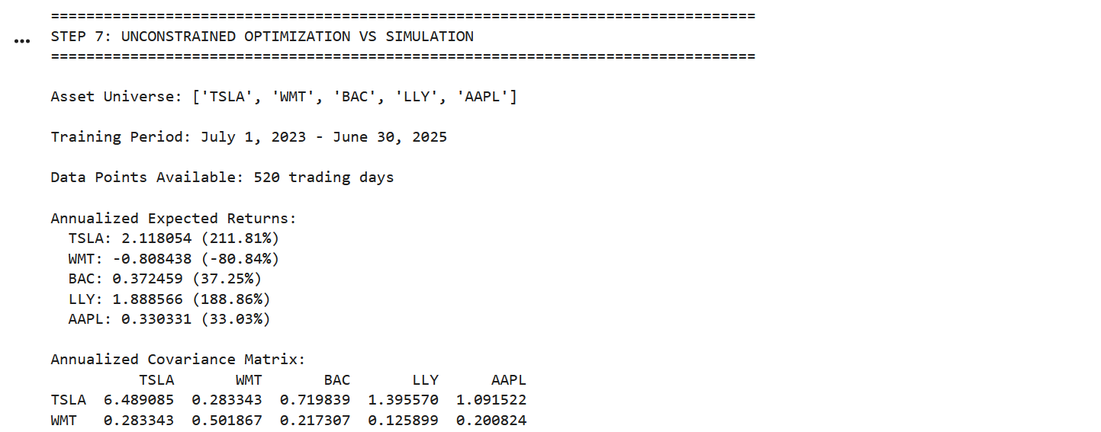
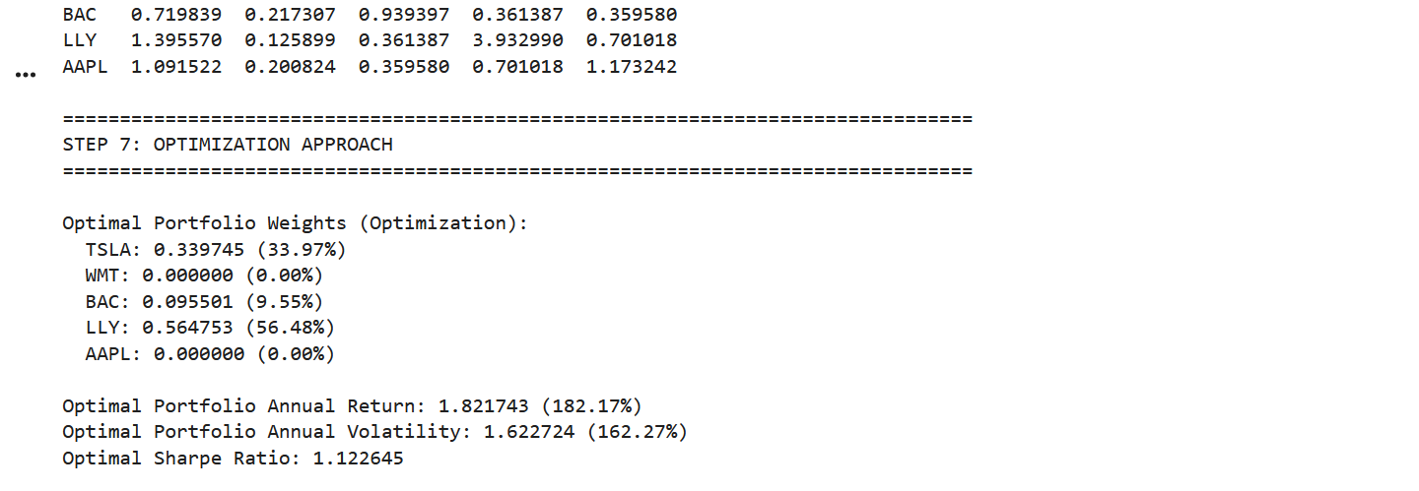
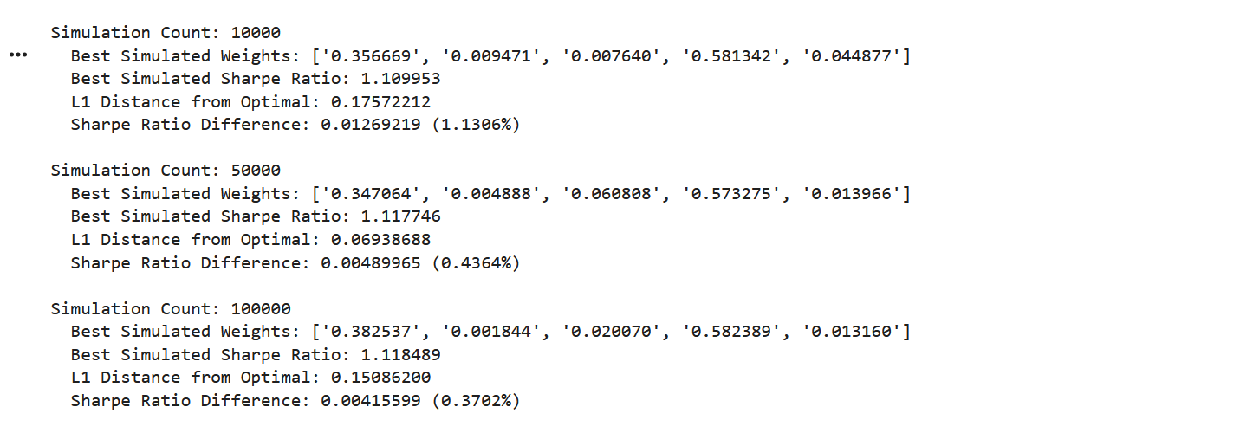
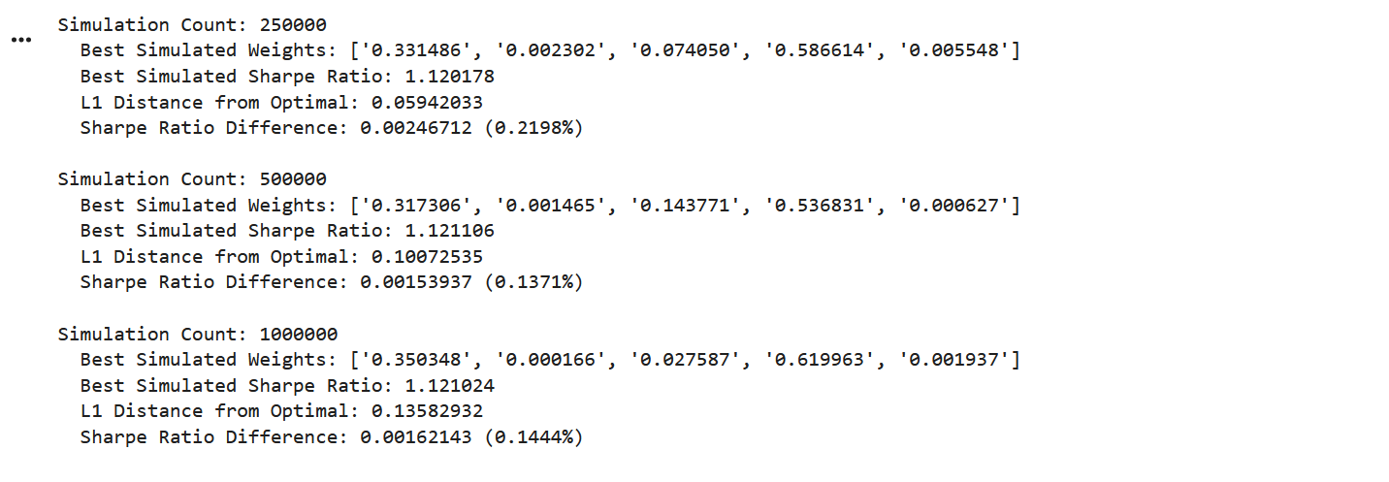
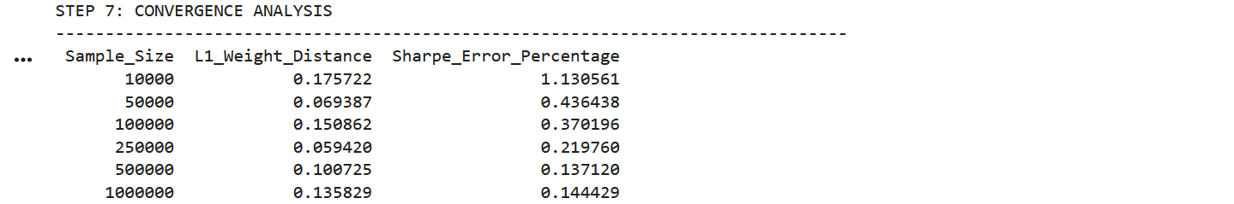
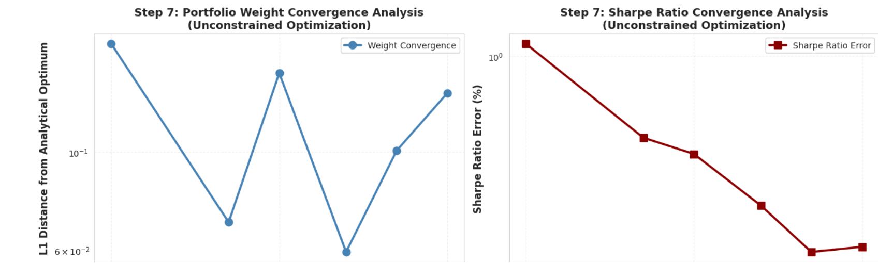
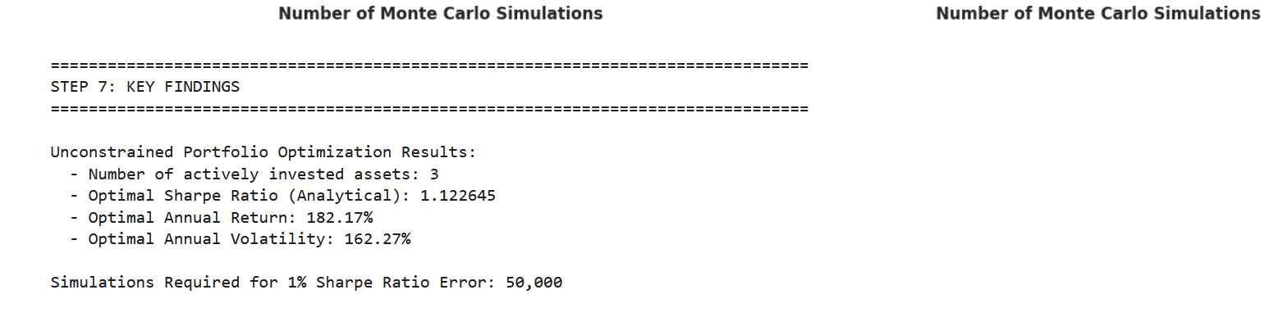
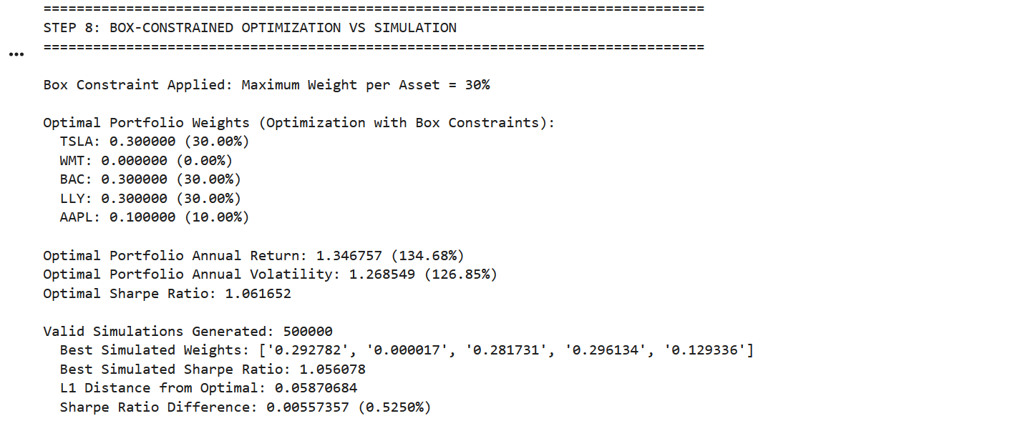
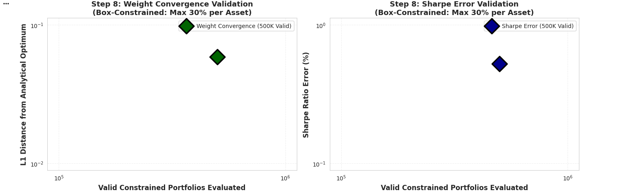
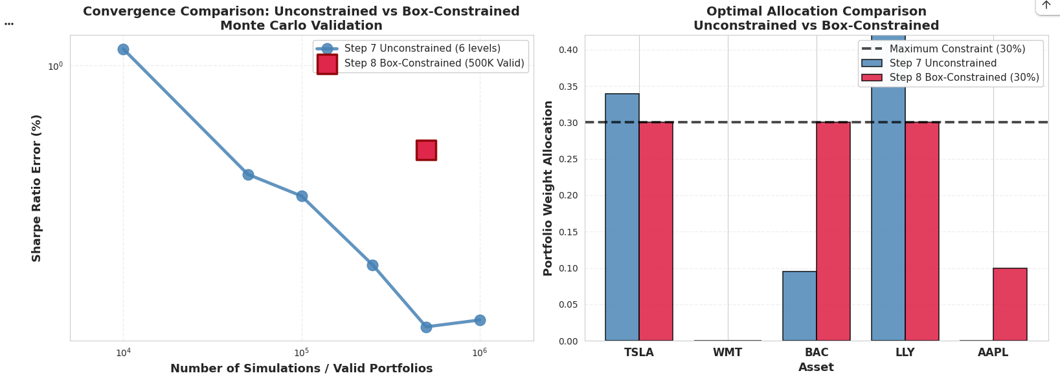
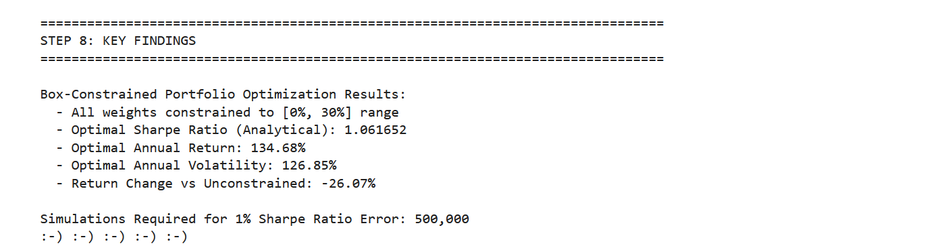
FOOTNOTE
Advantage for using AI: Needing less time to collect information and to evaluate it for accuracy as compared to using bibliographical research.

References
Cont, Rama. “Empirical Properties of Asset Returns: Stylized Facts and Statistical Issues.” Quantitative Finance, vol. 1, no. 2, 2001, pp. 223–236.
Fama, Eugene F., and Kenneth R. French. “A Five-Factor Asset Pricing Model.” Journal of Financial Economics, vol. 116, no. 1, 2015, pp. 1–22.
Fama, Eugene F. “Efficient Capital Markets: A Review of Theory and Empirical Work.” Journal of Finance, vol. 25, no. 2, 1970, pp. 383–417.
Hansen, Peter R. “Structural Breaks and Forecast Model Stability.” Journal of Econometrics, vol. 158, 2010, pp. 401–418.
Kenneth R. French Data Library. Fama/French Five-Factor Research Data. Dartmouth College, 2023–2025.
White, Halbert. “A Heteroskedasticity-Consistent Covariance Matrix Estimator and a Direct Test for Heteroskedasticity.” Econometrica, vol. 48, no. 4, 1980, pp. 817–838.
Wooldridge, Jeffrey M. Introductory Econometrics: A Modern Approach. 6th ed., Cengage Learning, 2016.

