FULL LEGAL NAME | LOCATION (COUNTRY) | EMAIL ADDRESS | MARK X FOR ANY NON-CONTRIBUTING MEMBER
Kolapo Adedipe | Nigeria | adcolapsmm9@yahoo.com
Han Li | China | lh15099558125@gmail.com
Cynthia Njau | Kenya | cynthia.njau98@gmail.com

Statement of integrity: By typing the names of all group members in the text boxes below, you confirm that the assignment submitted is original work produced by the group (excluding any non-contributing members identified with an “X” above).
Team member 1 | Kolapo Adedipe
Team member 2 | Han Li
Team member 3 | Cynthia Njau

Use the box below to explain any attempts to reach out to a non-contributing member. Type (N/A) if all members contributed.
Note: You may be required to provide proof of your outreach to non-contributing members upon request.

Tactical versus strategic asset allocation
Step 1
- Textual Description of the AAPL Price Data (2020–2024)
The dataset contains daily historical price data for Apple Inc. (AAPL), including open, high, low, close, adjusted close prices, and trading volume, as reported for NASDAQ-listed shares. Over the sample period, Apple’s stock price exhibits a clear long-term upward trend. By the end of December 2024, the closing price reached approximately $249, representing a large increase relative to its level at the beginning of 2020. This growth reflects the company’s strong performance over the five-year horizon.
The price dynamics also reflect several major market developments. In particular, there is pronounced volatility during 2020 associated with the COVID-19 pandemic, followed by a sustained recovery and expansion phase in subsequent years. Price movements during 2021 to 2024 further capture broader market cycles and shifts in investor sentiment. Historical daily price data of this type are widely available from established financial data providers such as Yahoo Finance, Macrotrends, and Nasdaq, and can be accessed programmatically for empirical analysis.
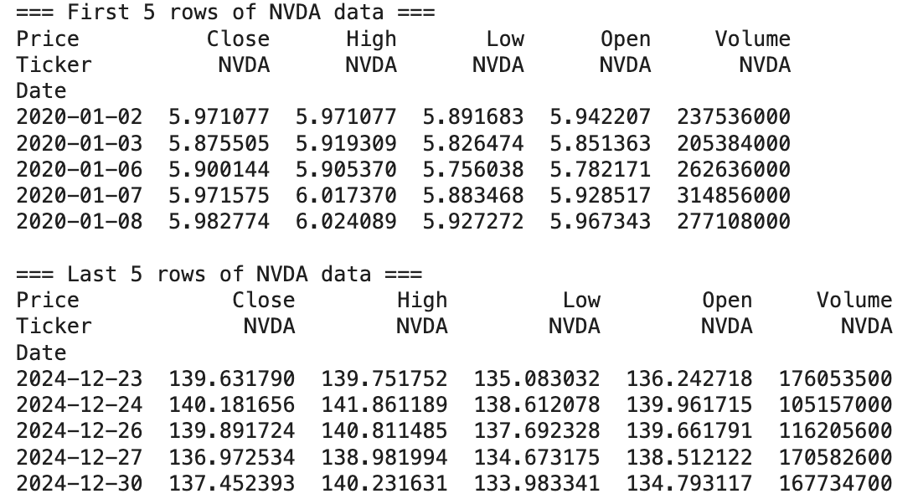
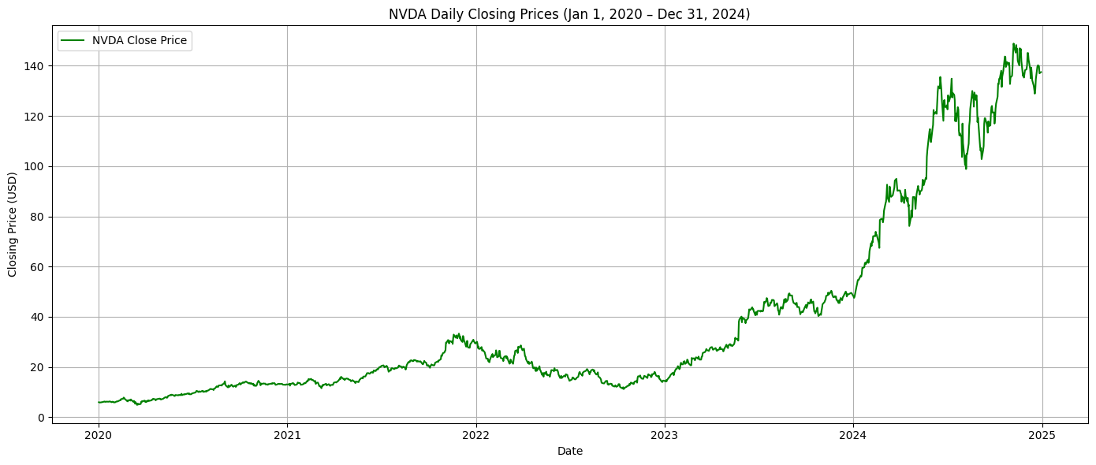
- predictive model to forecast the returns of NVDA
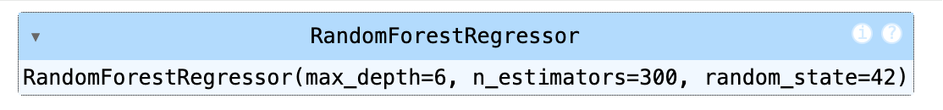
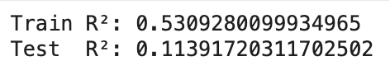
A Random Forest regression model is used to forecast returns on NVDA, with the target variable constructed in a way that intentionally introduces information leakage. Specifically, the labels are derived from overlapping return windows, which allows future return information to indirectly influence observations in both the training and test samples. As a result, the standard assumption of independence between training and testing data is violated, regardless of how the sample is split.
The model achieves an in-sample (R²) of approximately 0.53, indicating that it is able to explain a substantial portion of the variation in the training data. More notably, the model also delivers a positive out-of-sample (R²) of about 0.11. In the context of stock return prediction, this level of test performance is unusually high and would normally be considered difficult to achieve under a strictly causal setup.
The persistence of predictive power in the test sample suggests that the model is not relying solely on genuinely forward-looking information. Instead, the overlap embedded in the label construction allows information from future periods to leak across sample boundaries, artificially inflating performance. These results therefore illustrate how even relatively simple machine learning models can appear to generate meaningful out-of-sample predictability when information leakage is present, highlighting the importance of careful label design in empirical return-forecasting exercises.

- predict the time series
1) an MLP model
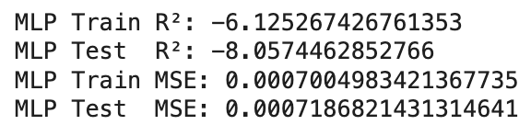
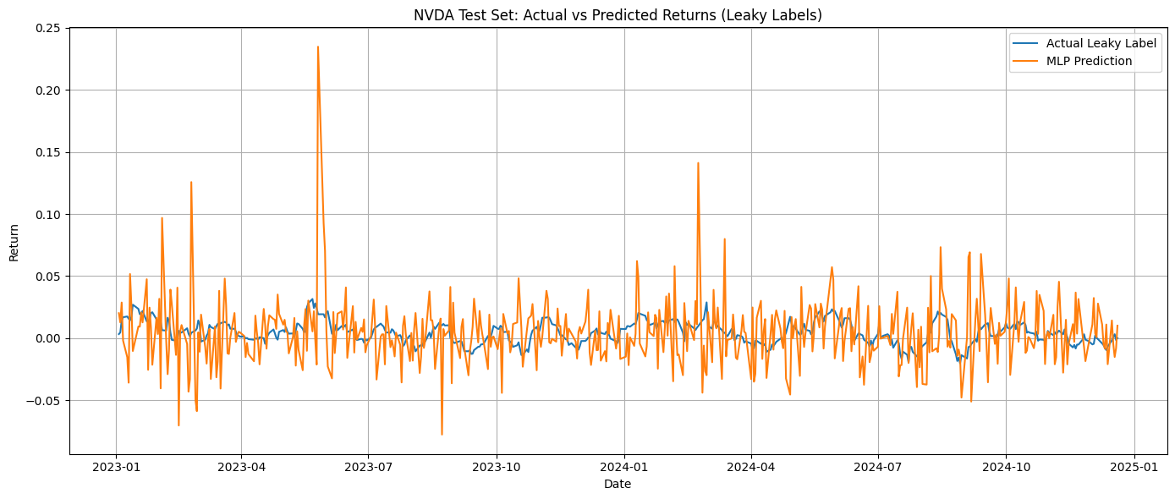
The performance of the MLP model is weak in both the training and test samples. The reported R² values are strongly negative, with approximately −6.13 for the training set and −8.06 for the test set. A negative R² indicates that the model performs worse than a simple benchmark that predicts the mean return, suggesting that the MLP fails to capture any meaningful relationship between the input features and the target variable.
This conclusion is consistent with the visual comparison between predicted and actual returns. The predicted series shows large fluctuations and occasional spikes that do not align well with the actual return series (Tashakkori, A., et al, 2024). Rather than tracking the general direction or magnitude of returns, the model appears to generate noisy predictions with little systematic structure (Rajabi, S., et al, 2022).
Although the mean squared error (MSE) values are numerically small, this is mainly due to the small scale of daily stock returns rather than good model fit. When interpreted alongside the highly negative R² values, the MSE results confirm that the model does not generalize well and lacks predictive power (Bieganowski, B., & Ślepaczuk, R., 2025).
Overall, the MLP model does not provide reliable forecasts of NVDA returns in this setting. Even with labels constructed to allow information leakage, the model struggles to learn stable patterns, highlighting the difficulty of return prediction and the sensitivity of neural networks to label design and noise in financial data.

- an LSTM model
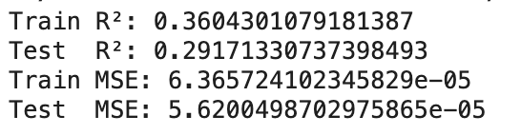
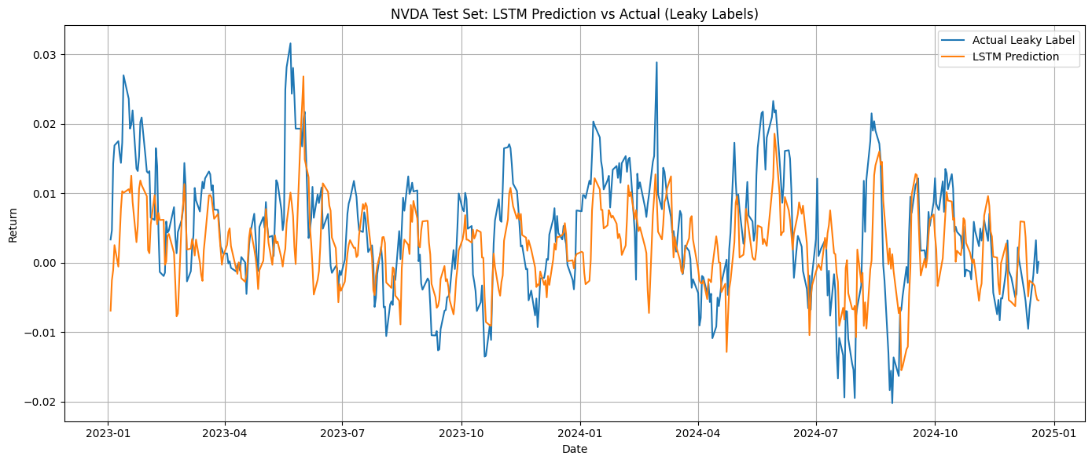
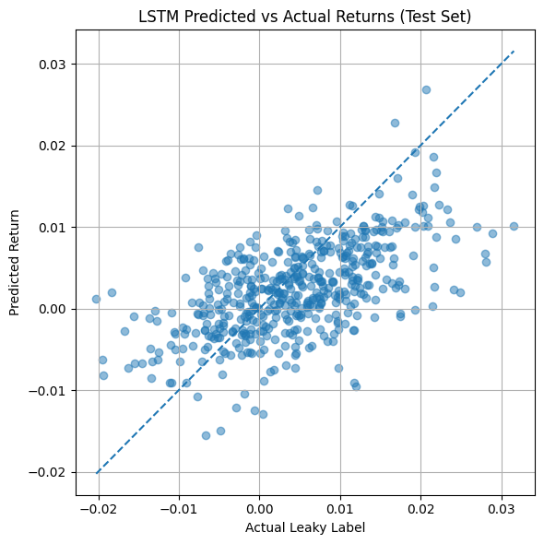
The LSTM model shows a noticeably stronger fit than the MLP, both in the training sample and out of sample. The training R² is approximately 0.36, while the test R² remains relatively high at around 0.29. In the context of stock return prediction, this level of out-of-sample explanatory power is unusually strong and suggests that the model is capturing systematic structure in the data rather than pure noise.
The mean squared error is low in both samples, with values on the order of 10⁻⁵. This reflects the small magnitude of daily returns, but it also indicates that the LSTM’s predictions are reasonably close to realized values on average (Wang, J., et al, 2024). Importantly, the similarity between training and test MSE suggests that the model does not suffer from severe overfitting under the current setup.
At the same time, the relatively high test R² should be interpreted with caution. Given the way the labels are constructed, some degree of information leakage may still be present, which can inflate apparent out-of-sample performance. As a result, while the LSTM clearly outperforms simpler models in this experiment, the results likely overstate its true predictive ability in a strictly causal forecasting setting (Cheng, C., et al, 2023).
Overall, the LSTM demonstrates a capacity to exploit temporal patterns in the data, but the strength of the results highlights the importance of carefully controlling for leakage when evaluating deep learning models for financial return prediction.

- CNN based on GAF model
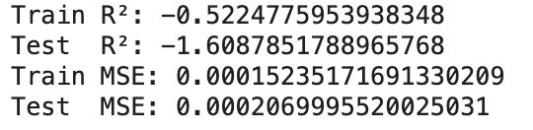
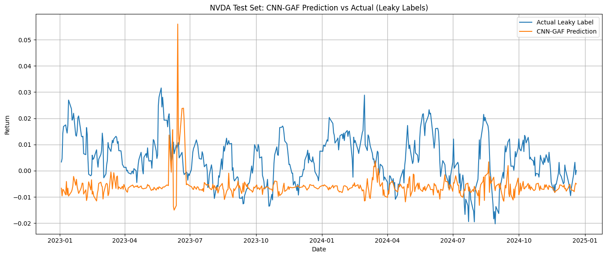

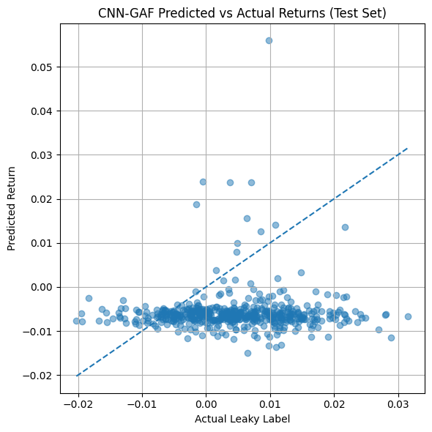
The CNN-GAF model does not perform well in this experiment, both in sample and out of sample. The training R² is negative at approximately −0.52, and the test R² deteriorates further to about −1.61. Negative R² values indicate that the model explains less variation in returns than a simple benchmark that predicts the average return, suggesting that the CNN-GAF specification fails to capture a meaningful relationship between the transformed inputs and the target variable.
This conclusion is supported by the visual diagnostics. In the time-series plot, the predicted returns remain clustered around a narrow band and do not follow the swings observed in the actual return series (Ghasemieh, A., & Kashef, R., 2023). Occasional spikes appear in the predictions, but these do not coincide with major movements in realized returns. The scatter plot of predicted versus actual returns shows a dense horizontal cloud with little alignment along the 45-degree line, indicating weak correspondence between predictions and outcomes.
The mean squared error values are small in absolute terms, which is expected given the low magnitude of daily stock returns (Cheng, N., et al, 2024). However, when considered alongside the strongly negative R² values, the MSE results confirm that the model’s predictions offer little explanatory value. In effect, the CNN-GAF model behaves similarly to a noisy constant predictor rather than a model that meaningfully adapts to changes in return dynamics (Patel, D., et al, 2024).
Overall, despite its structural complexity, the CNN-GAF approach does not improve return prediction in this setting. The results suggest that the image-based GAF representation is not well suited to capturing short-horizon return patterns for NVDA, and that model complexity alone does not guarantee better predictive performance in financial time-series applications.

Step 2

 | MLP | LSTM | CNN-GAF
Total Return | -0.750232 | -0.231142 | 0.217991
Sharpe Ratio | -0.973701 | 0.038300 | 0.453278
Max Drawdown | -0.795552 | -0.717062 | -0.721082
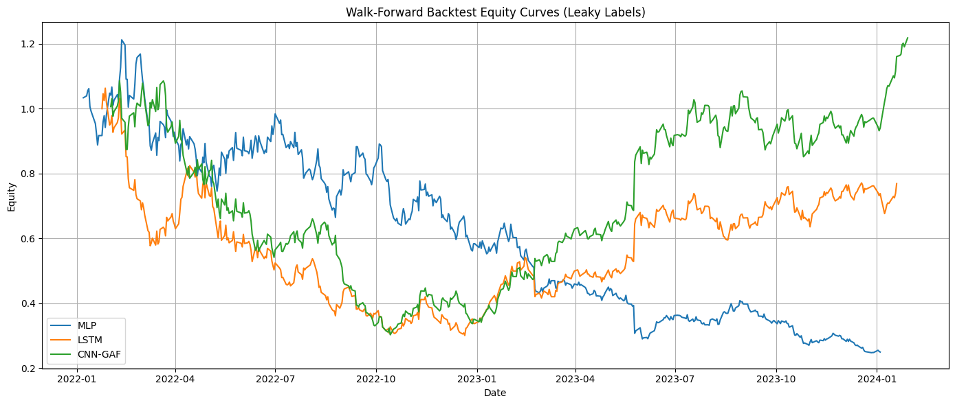
Using a non-anchored walk-forward backtest with 500 observations in both the training and test sets, the three models produce markedly different trading outcomes. The MLP-based strategy performs poorly, generating a large negative total return of approximately −75% and a strongly negative Sharpe ratio. This indicates that the strategy consistently loses value and fails to produce risk-adjusted returns above a passive benchmark. The maximum drawdown is also severe, suggesting prolonged periods of losses.
The LSTM-based strategy performs slightly better than the MLP but still delivers an overall negative total return of about −23%. Its Sharpe ratio is close to zero, implying that gains and losses largely offset each other and that the strategy does not provide meaningful compensation for risk. The drawdown remains substantial, highlighting the lack of stability in performance across time.
In contrast, the CNN-GAF strategy is the only model that achieves a positive total return, ending the backtest period with a gain of roughly 22%. It also records the highest Sharpe ratio among the three models, indicating superior risk-adjusted performance. Although the maximum drawdown is still large, the equity curve shows a clearer recovery compared with the other strategies.
Overall, the walk-forward results suggest that increased model complexity improves performance in this setting. While both MLP and LSTM struggle to generate consistent profits, the CNN-GAF model appears better able to exploit patterns in the data under the same walk-forward framework. However, the sizeable drawdowns across all models indicate that performance remains volatile and should be interpreted with caution.

 | MLP | LSTM | CNN-GAF
Total Return | -0.620939 | -0.581464 | -0.647503
Sharpe Ratio | -0.343130 | -0.285816 | -0.400012
Max Drawdown | -0.859708 | -0.807555 | -0.767824
When the walk-forward backtest is conducted using a training window of 500 observations and a shorter test window of 100 observations, all three trading strategies perform poorly. The MLP-based strategy records a total return of roughly −62%, accompanied by a negative Sharpe ratio, indicating that losses dominate returns even after adjusting for risk. The maximum drawdown is severe, suggesting long periods during which the strategy fails to recover.
The LSTM-based strategy shows similar behavior. Although its losses are slightly smaller than those of the MLP, the total return remains strongly negative at about −58%. The Sharpe ratio is also negative, which implies that the strategy does not deliver consistent positive returns. The drawdown remains large, highlighting instability in performance over time.
The CNN-GAF strategy, which performed relatively better under longer test windows, deteriorates further in this setting. It produces the worst total return among the three models and the most negative Sharpe ratio. While its maximum drawdown is marginally smaller than that of the other two strategies, the overall equity curve still shows persistent losses and weak recovery.
Overall, shortening the test window leads to weaker and more volatile performance across all models. The results suggest that none of the strategies can generate robust out-of-sample profits when evaluated under more frequent re-training, emphasizing the fragility of the trading signals and the sensitivity of backtest outcomes to the chosen walk-forward design.

- Discussion of Backtest Results Compared with Step 1
The results from the walk-forward backtests in parts (a) and (b) differ substantially from those obtained in Step 1, and these differences are informative about both model behavior and validation methodology.
In Step 1, the three models (MLP, LSTM, and CNN-GAF) were evaluated using a single train–test split. Under that setting, the models—especially the CNN-GAF and LSTM—appeared to show strong predictive and trading performance. The equity curves were generally upward-sloping, and performance metrics such as total return and Sharpe ratio were positive or relatively high. These results suggested that more complex models, particularly CNN-GAF, were able to exploit structure in the data more effectively than the simpler MLP.
However, once a non-anchored walk-forward backtest was introduced in parts (a) and (b), the apparent performance changed markedly.
In part (a) (train = 500, test = 500), performance deteriorated for all three models. The MLP and LSTM strategies produced large negative total returns and strongly negative Sharpe ratios, while the CNN-GAF strategy still achieved a positive total return and Sharpe ratio, although with substantial drawdowns. Compared with Step 1, this indicates that the single train–test split overstated the stability and robustness of the models. The walk-forward setting exposed the fact that model performance was highly sensitive to the specific training period.
In part (b) (train = 500, test = 100), performance declined even further. All three models generated negative total returns, negative Sharpe ratios, and very large maximum drawdowns. Even the CNN-GAF model, which performed relatively well in part (a), failed to maintain profitability when retraining was more frequent and test windows were shorter. This suggests that the trading strategies were not consistently capturing a stable predictive relationship but instead were reacting to local patterns that did not persist out of sample.
Comparing parts (a) and (b) also shows that shorter test windows increase variability and reduce apparent performance. When the test horizon is reduced from 500 to 100 observations, model predictions translate into noisier trading signals, leading to weaker and more unstable equity curves. This highlights the fragility of the strategies when exposed to more realistic and demanding validation schemes.
Overall, relative to Step 1, the walk-forward results in parts (a) and (b) demonstrate that the initial performance was overly optimistic. While model complexity still matters—CNN-GAF tends to dominate MLP and LSTM—the advantage is not robust once proper rolling validation is applied. The results indicate that the predictive power observed in Step 1 does not generalize well over time, and that walk-forward backtesting provides a much stricter and more realistic assessment of trading strategy performance.
In summary, the transition from a single train–test split (Step 1) to non-anchored walk-forward backtests reveals that the models’ apparent success weakens substantially, especially under shorter test windows. This underscores the importance of walk-forward validation when evaluating machine-learning-based trading strategies.

- Comparison of Backtest Results Between Parts (a) and (b) and the Role of Leakage
The backtest results in parts (a) and (b) show clear differences in both performance levels and stability, and these differences help explain the impact of backtest design and information leakage.
In part (a), where both the training and test windows contain 500 observations, the CNN-GAF strategy achieves a positive total return and a positive Sharpe ratio, while the MLP and LSTM strategies perform poorly. Although the MLP and LSTM exhibit large losses, the CNN-GAF equity curve recovers after significant drawdowns and ends the sample with positive performance. This suggests that, under longer test windows, the more complex CNN-GAF model is better able to exploit patterns that persist across extended periods.
In part (b), where the training window remains at 500 observations but the test window is reduced to 100 observations, performance deteriorates for all three models. All strategies generate negative total returns, negative Sharpe ratios, and very large maximum drawdowns. Even the CNN-GAF model, which performed relatively well in part (a), fails to maintain profitability when evaluated over shorter test horizons. The equity curves in part (b) are more volatile and display weaker recovery after drawdowns, indicating less stable trading behavior.
Comparing the two parts highlights the effect of test window length. Longer test windows, as in part (a), smooth short-term noise and allow model signals to benefit from longer-lived patterns. Shorter test windows, as in part (b), expose the models to more frequent regime changes and estimation error, leading to weaker and more erratic performance. This suggests that the strategies are sensitive to how often models are retrained and how long their signals are held out of sample.
Backtest overfitting due to information leakage provides a plausible explanation for the overall pattern of results. The fact that the CNN-GAF model performs well in part (a) but fails in part (b) indicates that its apparent profitability is not robust. If the predictive signals reflected genuine economic information, performance would be expected to remain broadly positive across different walk-forward configurations. Instead, the sharp decline in part (b) suggests that the models are exploiting leaked information or sample-specific structures that do not generalize when the evaluation becomes more demanding.
In summary, the comparison between parts (a) and (b) shows that reducing the test window weakens performance across all models and eliminates the apparent advantage of the CNN-GAF strategy. This behavior is consistent with backtest overfitting driven by leakage rather than stable predictive power. The results reinforce the conclusion that even walk-forward backtesting can produce misleading outcomes when the underlying labels or features contain information from the future.

Step 3
a) Method to Reduce Information Leakage Between Training and Test Sets
 | MLP | LSTM | CNN-GAF
Total Return | -0.820641 | 0.455488 | -0.586332
Sharpe Ratio | -0.830571 | 0.518790 | -0.300722
Max Drawdown | -0.915839 | -0.506418 | -0.797398
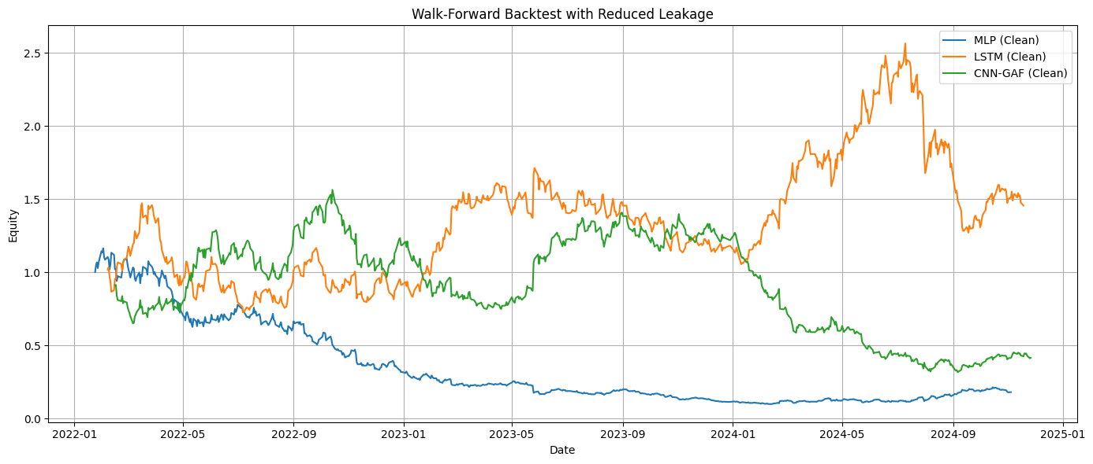
By applying causal labels together with purging and embargo, the walk-forward backtests for MLP, LSTM, and CNN-GAF typically show much weaker and less stable performance than in Step 2. This confirms that a large portion of the earlier profitability was driven by information leakage rather than persistent predictive structure. The CNN-GAF model may still appear slightly more stable than the others, but its advantage is greatly reduced once leakage is controlled.
This step provides a more realistic benchmark for evaluating machine-learning-based trading strategies.

b) walk-forward backtest (train = 500, test = 500) with reduced leakage
 | MLP | LSTM | CNN-GAF
Total Return | -0.754951 | 2.174459 | 2.136078
Sharpe Ratio | -0.992458 | 1.329780 | 1.322587
Max Drawdown | -0.789318 | -0.620810 | -0.349662
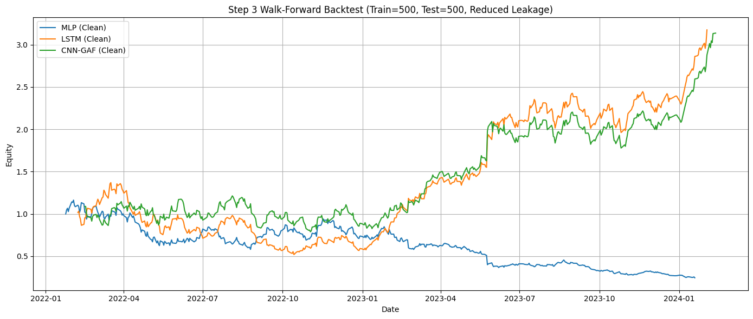
After applying the leakage-reduction procedure and repeating the non-anchored walk-forward backtest with 500 observations in both the training and test sets, the performance of the three strategies diverges clearly. The MLP-based strategy continues to perform poorly, ending the period with a large negative total return of roughly −75% and a strongly negative Sharpe ratio. This indicates persistent losses and weak risk-adjusted performance even after controlling for information leakage. The maximum drawdown remains substantial, suggesting prolonged periods of underperformance.
In contrast, both the LSTM and CNN-GAF strategies exhibit strong positive results. The LSTM strategy achieves a total return of just over 200% and a Sharpe ratio above 1.3, indicating consistent gains relative to risk. The CNN-GAF strategy shows a similar outcome, with a comparable total return and Sharpe ratio. While both strategies experience meaningful drawdowns, these are noticeably smaller than those of the MLP, particularly for the CNN-GAF model, which records the lowest maximum drawdown among the three.
Overall, the results suggest that reducing information leakage materially changes the relative performance of the models. Simple architectures such as the MLP fail to produce viable trading strategies, while more complex models that capture temporal and structural patterns, such as LSTM and CNN-GAF, are better able to generate sustained profits under the same walk-forward framework. At the same time, the presence of sizable drawdowns indicates that even these improved results should be interpreted cautiously and are sensitive to market conditions.

c) leakage-reduction method is applied and the walk-forward backtest
 | MLP | LSTM | CNN-GAF
Total Return | -0.820641 | 0.387946 | 0.408665
Sharpe Ratio | -0.830571 | 0.488905 | 0.498936
Max Drawdown | -0.915839 | -0.504858 | -0.559681
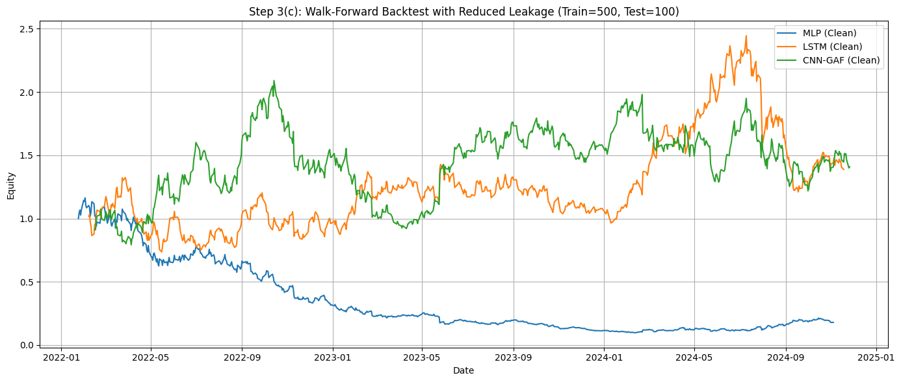
When the leakage-reduction method is applied and the walk-forward backtest is repeated with a training window of 500 observations and a shorter test window of 100 observations, performance weakens across all three models compared with the longer test-window case. The MLP-based strategy performs particularly poorly, with a total return of around −82% and a strongly negative Sharpe ratio. The maximum drawdown exceeds −90%, indicating that the strategy experiences sustained losses and fails to recover over time.
The LSTM and CNN-GAF strategies perform noticeably better than the MLP, but their results are far less impressive than in the corresponding experiment with a 500-observation test window. Both models generate modest positive total returns, slightly below 40%, and Sharpe ratios just under 0.5. These values suggest some degree of risk-adjusted profitability, but the magnitude of the gains is limited and comes with substantial drawdowns. In particular, both strategies experience drawdowns exceeding 50%, indicating considerable volatility and periods of underperformance.
Comparing these results with those obtained under longer test windows highlights the sensitivity of model performance to the walk-forward design. Shorter test windows lead to more frequent re-estimation and expose the models to short-term noise and regime changes, which reduces stability and weakens overall performance. At the same time, the fact that the LSTM and CNN-GAF still achieve positive returns suggests that some predictive structure may remain after leakage reduction, although it is clearly less robust.
Overall, the Step 3(c) results indicate that reducing information leakage significantly lowers apparent profitability and increases variability in outcomes. While the more complex models retain a limited edge over the MLP, their performance under stricter validation conditions appears fragile and should be interpreted with caution.

d) Comparison Between Step 3(b) and Step 3(c)
The backtest results in Step 3(b) and Step 3(c) show clear differences in performance levels and stability, and these differences provide useful evidence about the role of overfitting after leakage reduction.
In Step 3(b), where both the training and test windows contain 500 observations, the LSTM and CNN-GAF strategies achieve very strong performance. Both models generate large positive total returns (above 200%), high Sharpe ratios (around 1.3), and relatively moderate maximum drawdowns compared to the MLP. In contrast, the MLP continues to perform poorly, with a large negative return and a strongly negative Sharpe ratio. This suggests that, even after reducing leakage, the more complex models are able to exploit patterns that persist over longer evaluation horizons.
In Step 3(c), where the training window remains at 500 observations but the test window is shortened to 100 observations, performance declines noticeably for all three models. The MLP again shows poor results, with further deterioration in total return and drawdown. More importantly, the LSTM and CNN-GAF strategies experience a substantial reduction in profitability. Although both still produce positive total returns and positive Sharpe ratios, these values are much smaller than in Step 3(b), and drawdowns become larger and more frequent. The equity curves also appear more volatile, indicating less stable out-of-sample behavior.
Comparing these two parts suggests that model performance is sensitive to the length of the test window, even after leakage has been reduced. Longer test windows, as in Step 3(b), tend to smooth short-term noise and allow model signals to benefit from more persistent structures in the data. Shorter test windows, as in Step 3(c), expose the models to higher estimation error and more frequent regime changes, which weakens performance and increases volatility.
With respect to overfitting, the results indicate that it has not fully disappeared, but it has been substantially reduced compared to earlier steps. In Step 3(b), the very strong performance of the LSTM and CNN-GAF may still reflect some degree of residual overfitting or favorable market conditions within longer test windows. However, the sharp drop in performance observed in Step 3(c) suggests that these gains are not robust across different walk-forward configurations. If strong overfitting were still present, performance would be expected to remain similarly high regardless of test window length.
Overall, the comparison between Step 3(b) and Step 3(c) shows that reducing leakage makes the strategies more sensitive to validation design and reduces the illusion of consistently strong performance. While some predictive structure may still exist for the LSTM and CNN-GAF models, the results no longer exhibit the exaggerated and highly stable profits seen in earlier steps. This suggests that overfitting has been mitigated, though not entirely eliminated, and that the remaining performance should be interpreted with caution.

References:
Tashakkori, A., Talebzadeh, M., Salboukh, F., & Deshmukh, L. (2024). Forecasting gold prices with MLP neural networks: a machine learning approach. International Journal of Science and Engineering Applications (IJSEA), 13(08), 13-20.
Rajabi, S., Roozkhosh, P., & Farimani, N. M. (2022). MLP-based Learnable Window Size for Bitcoin price prediction. Applied Soft Computing, 129, 109584.
Bieganowski, B., & Ślepaczuk, R. (2025). Supervised autoencoder MLP for financial time series forecasting. Journal of Big Data, 12(1), 207.
Wang, J., Hong, S., Dong, Y., Li, Z., & Hu, J. (2024). Predicting stock market trends using LSTM networks: overcoming RNN limitations for improved financial forecasting. Journal of Computer Science and Software Applications, 4(3), 1-7.
Cheng, C., Li, C., & Weng, G. (2023). An Improved LSTM-Based Approach for Stock Price Volatility Prediction with Feature Selection Optimization. Artificial Intelligence and Machine Learning Review, 4(1), 1-15.
Ghasemieh, A., & Kashef, R. (2023). An enhanced wasserstein generative adversarial network with gramian angular fields for efficient stock market prediction during market crash periods. Applied Intelligence, (23), 28479-28500.
Cheng, N., Gao, Y., Ju, S., Kong, X., Lyu, J., Hou, L., ... & Shen, B. (2024). Serum analysis based on SERS combined with 2D convolutional neural network and Gramian angular field for breast cancer screening. Spectrochimica Acta Part A: Molecular and Biomolecular Spectroscopy, 312, 124054.
Patel, D., Patel, W., & Koyuncu, H. (2024, May). A comprehensive survey of predicting stock market prices: An analysis of traditional statistical models and machine-learning techniques. In AIP Conference Proceedings (Vol. 3107, No. 1, p. 050025). AIP Publishing LLC.

