Predicting Smallholder Crop Yield Volatility Across Agro-Ecological Zones: A Leakage-Free Spatial Machine Learning Framework for Tanzania
Running Head: Predicting Smallholder Crop Yield Volatility in Tanzania
Author: Kadeghe Goodluck Fue
Department of Agricultural Engineering, School of Engineering and Technology, Sokoine University of Agriculture (SUA), P.O. Box 3003, Chuo Kikuu, Morogoro, Tanzania
Corresponding Author Email: kadefue@sua.ac.tz
ORCID: https://orcid.org/0000-0001-6362-3174
Abstract
Smallholder rainfed farming systems across sub-Saharan Africa face intensifying inter-seasonal yield instability driven by erratic bimodal rainfall, soil nutrient depletion, and biotic pest shocks, yet empirical risk models often overestimate predictive skill because they fail to account for spatial autocorrelation leakage. This study develops and validates a leakage-free spatial machine learning framework to predict household-level crop yield volatility across Mainland Tanzania and the Zanzibar Archipelago using nationally representative microdata from the 2024/2025 National Bureau of Statistics (NBS) Annual Agricultural Sample Survey (AASS) covering 4,564 bimodal agricultural holdings across 921 Enumeration Areas (EAs). We formulate a bounded, scale-invariant Yield Volatility Index (Y_{vol} ∈ [0, 2]) measuring proportional yield divergence between the long-rain (Masika) and short-rain (Vuli) cultivation cycles, and engineer 246 multi-domain agronomic, ecological, demographic, and spatial peer predictors pruned to a 100-feature subset capturing 99.0% of tree-based information gain. Evaluated under strict five-fold spatial group cross-validation partitioning whole Enumeration Areas, a soft-voting Weighted Ensemble combining Light Gradient Boosting Machine (LightGBM), Extreme Gradient Boosting (XGBoost), and Random Forest (RF) achieves an out-of-fold coefficient of determination (R²) of 0.592, a Root Mean Squared Error (RMSE) of 0.464, and a Mean Absolute Error (MAE) of 0.347, outperforming dedicated regional sub-models across 26 of 27 regions. Exact Tree-based Shapley Additive Explanations (TreeSHAP) and partial dependence analyses reveal that inter-seasonal planting timing shifts, plot abandonment shocks, and crop portfolio diversity relative to community peers govern production instability, buffered non-linearly by livestock holdings above 3.0 Tropical Livestock Units (TLU). Policy counterfactual simulations indicate that an integrated Climate-Smart Agriculture package combining asset transfers, cultivar diversification, and planting synchronization reduces mean national yield volatility by 40.0% and lowers hyper-volatile holdings (Y_{vol} ≥ 1.50) from 25.8% to 19.9%, although multi-wave longitudinal panel tracking and high-resolution satellite soil-moisture assimilation remain vital future research priorities.
Keywords: smallholder agriculture; crop yield volatility; spatial cross-validation; machine learning; climate resilience; Tanzania
Abbreviations, Symbols, and Units
Abbreviation / Symbol | Definition and Measurement Unit
AASS | Annual Agricultural Sample Survey
AEZ | Agro-Ecological Zone
C_{HHI} | Herfindahl–Hirschman Crop Concentration Index (dimensionless, [0, 1])
CSA | Climate-Smart Agriculture
CV | Coefficient of Variation (dimensionless ratio of standard deviation to mean)
D_{BP} | Berger–Parker Crop Dominance Index (dimensionless, [0, 1])
EA | Enumeration Area (primary geographic census cluster)
ESM | Electronic Supplementary Material (cited as Online Resource 1)
FAO | Food and Agriculture Organization of the United Nations
GBDT | Gradient Boosted Decision Trees
H′ | Shannon–Wiener Crop Diversity Index (dimensionless, ≥ 0)
HHFARMID | Anonymised Household Farming Holding Identifier
IQR | Interquartile Range (Q₃ − Q₁)
J′ | Pielou Species Evenness Index (dimensionless, [0, 1])
J(C_{m}, C_{v}) | Cross-Seasonal Jaccard Crop Similarity Coefficient (dimensionless, [0, 1])
KDE | Kernel Density Estimation
LightGBM | Light Gradient Boosting Machine
MAE | Mean Absolute Error (in units of Y_{vol})
Masika | Primary long-rain agricultural season in Tanzania (March–May)
NBS | National Bureau of Statistics of the United Republic of Tanzania
OOF | Out-of-Fold (spatially disjoint validation predictions)
PCA | Principal Component Analysis
R² | Out-of-fold Coefficient of Determination (dimensionless)
RF | Random Forest Regressor
RMSE | Root Mean Squared Error (in units of Y_{vol})
SHAP | Shapley Additive Explanations (game-theoretic feature attribution)
SUA | Sokoine University of Agriculture
TLU | Tropical Livestock Unit (1 TLU = 250 kg live metabolic weight equivalent)
Vuli | Secondary short-rain agricultural season in Tanzania (October–December)
XGBoost | Extreme Gradient Boosting
Y_{m}, Y_{v} | Area-weighted household crop yield in Masika and Vuli (kg ha⁻¹)
Y_{vol} | Bounded Inter-Seasonal Yield Volatility Index (dimensionless, [0, 2])
1 Introduction
Global food systems face an unprecedented convergence of climatic, ecological, and macroeconomic pressures that threaten the stability of agricultural production and rural livelihoods across the developing world (Wheeler & von Braun, 2013; Lobell et al., 2011; Ray et al., 2015). In sub-Saharan Africa, where rainfed smallholder holdings cultivating less than 3.5 hectares generate over 75% of domestic caloric supply, food security is governed not merely by long-term mean crop yields, but by the magnitude and frequency of inter-seasonal production shocks (Thornton et al., 2014; Jayne et al., 2010; Hertel & Rosch, 2010). Classical definitions of food security emphasize four interdependent pillars: availability, access, utilization, and stability (Barrett, 2010; Godfray et al., 2010). Whilst substantial agronomic research and breeding investments over the past four decades have sought to raise average yield potential under optimal station conditions (Evenson & Gollin, 2003; Tittonell & Giller, 2013), the fourth pillar—production and consumption stability—remains acutely fragile across East Africa. When a subsistence or semi-commercial farm household experiences an abrupt harvest collapse between consecutive cropping cycles, the resulting production deficit triggers severe welfare penalties: forced liquidation of productive livestock assets at depressed distress prices, withdrawal of children from schooling, curtailment of nutrient-dense dietary intake, and entrenchment in chronic poverty traps (Dercon, 2004; Zimmerman & Carter, 2003; Barrett & Constas, 2014).
The United Republic of Tanzania exemplifies the structural complexity of managing agricultural production risk across highly heterogeneous tropical landscapes. Spanning approximately 945,000 km² across Mainland Tanzania and the Zanzibar Archipelago, the country encompasses seven distinct Agro-Ecological Zones (AEZs) ranging from semi-arid central plateaus and coastal lowlands to sub-humid lake basins and montane volcanic highlands (Rowhani et al., 2011; Arndt et al., 2012). Across the northern, coastal, lake, and highland corridors, agricultural production follows a bimodal rainfall regime governed by the seasonal migration of the Inter-Tropical Convergence Zone (ITCZ). Smallholder households navigate two distinct cultivation cycles each agricultural year: the Masika long rains (typically March to May) and the Vuli short rains (October to December). The Vuli rains are characterized by lower cumulative precipitation, higher onset variability, and heightened sensitivity to Indian Ocean Dipole (IOD) and El Niño–Southern Oscillation (ENSO) sea-surface temperature anomalies, whereas the Masika rains provide the bulk of annual cereal and legume output but remain vulnerable to mid-season dry spells, flash flooding, and biotic pest outbreaks such as Fall Armyworm (Spodoptera frugiperda) (Rowhani et al., 2011; Kassie et al., 2015). Because smallholder households rely on sequential harvests across both seasons to smooth consumption, service informal credit obligations, and finance seed and fertilizer inputs for the subsequent planting window, wide inter-seasonal yield swings between Masika and Vuli represent a primary driver of transitory food insecurity across rural Tanzania.
Understanding why certain smallholder holdings maintain stable harvest realizations across seasons whilst neighboring farms within the same agro-ecological zone suffer catastrophic yield oscillations requires moving beyond single-factor agronomic analyses. Theoretical frameworks in agricultural development economics and agro-ecology posit that farm-level production stability emerges from a complex, non-linear interplay among ecological portfolio buffering, household capital endowments, and phenological management (Tilman et al., 2006; Lin, 2011; Di Falco & Chavas, 2009). First, the biodiversity–stability hypothesis demonstrates that cultivating diverse crop species and functional groups with asynchronous water-use profiles and root architectures dampens aggregate portfolio variance through statistical portfolio averaging and ecological niche complementarity (Renard & Tilman, 2019; Isbell et al., 2017; Beillouin et al., 2021). Second, economic buffer-stock theory establishes that liquid household wealth—most notably livestock herds quantified in Tropical Livestock Units (TLU)—relaxes seasonal liquidity constraints, enabling timely land preparation, hired labor mobilization during peak weeding bottlenecks, and rapid replanting when early rains fail (Dercon, 2004; Dillon et al., 2015). Third, agronomic intensification and soil management practices—including synthetic fertilizer application, pesticide protection, fallowing, and supplemental irrigation—interact non-linearly with plot fragmentation and planting timing (Tittonell & Giller, 2013; Teklewold et al., 2013; Carletto et al., 2013). For instance, high chemical fertilizer investment on rainfed monoculture plots without moisture conservation can amplify downside variance during rainfall deficits, a phenomenon widely recognized in risk-programming literature as risk-inducing intensification (Just & Pope, 1979; Di Falco & Chavas, 2009).
Despite the urgent policy need for high-resolution early-warning tools that identify volatility-prone smallholders before shocks materialize, existing empirical approaches face three persistent methodological limitations. First, conventional econometric studies of yield risk rely predominantly on parametric linear specifications—such as Just–Pope production functions, Feasible Generalized Least Squares (FGLS), or fixed-effects panel regressions—that impose restrictive functional forms and cannot automatically capture high-order interactions among hundreds of correlated plot, household, and community variables (Just & Pope, 1979; Lobell & Burke, 2010; Storm et al., 2020). Second, where modern machine learning algorithms such as Gradient Boosted Decision Trees (GBDT) and Random Forests have been deployed in agricultural yield prediction, they have focused overwhelmingly on predicting mean yield levels rather than inter-seasonal yield volatility (Jeong et al., 2016; Crane-Droesch, 2018; Burke & Lobell, 2017; Benami et al., 2021). Moreover, standard volatility metrics such as raw variance or the unbounded coefficient of variation explode mathematically toward infinity when seasonal harvests approach zero under severe drought or crop abandonment, introducing severe outlier distortion in nonparametric tree splits.
Third, and most critically, a growing methodological literature in spatial ecology and geostatistics has demonstrated that standard random K-fold cross-validation in spatial machine learning produces severely optimistic performance estimates due to spatial autocorrelation leakage (Roberts et al., 2017; Meyer et al., 2018, 2019; Ploton et al., 2020; Wadoux et al., 2021). In national household surveys, agricultural holdings are sampled within geographically clustered Enumeration Areas (EAs) sharing identical microclimates, soil catenas, market access corridors, and local measurement customs. Under random K-fold splitting, households from the same village cluster are simultaneously assigned to both training and validation folds, allowing high-capacity tree ensembles to memorize spatial coordinates and local cluster means rather than learning generalizable agro-economic relationships (Ploton et al., 2020; Meyer & Pebesma, 2021). Compounding this geographic leakage, machine learning pipelines frequently compute feature scalers, missing-value imputations, unsupervised cluster centroids, Principal Component Analysis (PCA) loadings, and feature selection rankings across the complete dataset prior to cross-validation splitting, introducing subtle lookahead bias that invalidates out-of-sample inference (Kaufman et al., 2012; Kapoor & Narayanan, 2023).
To resolve these scientific and methodological gaps, this study designs, audits, and deploys a leakage-free spatial machine learning framework to predict smallholder inter-seasonal crop yield volatility across Tanzania using the newly released 2024/2025 National Bureau of Statistics (NBS) Annual Agricultural Sample Survey (AASS) microdata (N = 4,564 bimodal holdings across 921 Enumeration Areas in 27 regions). Specifically, this study addresses four core research objectives:
1. To formulate a mathematically bounded, scale-invariant Yield Volatility Index (Y_{vol} ∈ [0, 2]) that symmetrically accommodates zero-harvest plot failures and extreme yield disparities across heterogeneous multi-crop smallholder holdings;
2. To establish a rigorous Five-Pillar Spatial Leakage Isolation Architecture that enforces strict Enumeration Area group disjointness, fold-isolated preprocessing, fold-isolated unsupervised representation learning, and tree-gain feature pruning across 246 engineered agro-ecological candidate predictors;
3. To evaluate whether a unified national soft-voting ensemble of gradient-boosted and bagging decision trees outperforms isolated regional sub-models when transferring predictive relationships across data-sparse administrative regions; and
4. To decode the non-linear agronomic tipping points and asset-buffering mechanisms governing smallholder yield volatility using exact Tree-based Shapley Additive Explanations (TreeSHAP), partial dependence surfaces, and policy counterfactual simulations.
2 Materials and Methods
2.1 Study area and agro-ecological context
The empirical investigation covers the entirety of the United Republic of Tanzania, situated in East Africa between latitudes 1° 00′ S and 11° 45′ S and longitudes 29° 15′ E and 40° 30′ E (Fig. 1). Topographically, Tanzania transitions from a warm, humid coastal belt along the Indian Ocean and the islands of Unguja and Pemba (Zanzibar Archipelago; altitude 0–200 m above sea level) to an extensive central plateau (800–1,500 m) flanked by the Eastern and Western branches of the East African Rift Valley, culminating in the Northern Highlands around Mount Kilimanjaro and Mount Meru and the Southern Highlands bordering Lake Nyasa (1,500–2,900 m).
For agronomic and national planning purposes, Tanzania's 31 administrative regions are stratified into seven macro Agro-Ecological Zones (AEZs): (i) the Coastal and Eastern Zone (Tanga, Morogoro, Pwani, Dar es Salaam, Lindi, Mtwara), characterised by bimodal and transitional rainfall (800–1,400 mm yr⁻¹) supporting maize, cassava, rice, and tree crops; (ii) the Northern Highlands Zone (Arusha, Kilimanjaro, Manyara), featuring volcanic soils and bimodal orographic rainfall (1,000–2,000 mm yr⁻¹) with intensive banana–coffee–maize–bean intercropping; (iii) the Lake Victoria Basin Zone (Kagera, Mara, Mwanza, Geita, Simiyu, Shinyanga), experiencing reliable bimodal precipitation (900–1,800 mm yr⁻¹) modified by lake-breeze circulations; (iv) the Central Semi-Arid Zone (Dodoma, Singida, Tabora), receiving low, erratic rainfall (500–800 mm yr⁻¹) with high evapotranspiration and frequent dry spells; (v) the Southern Highlands Zone (Mbeya, Iringa, Njombe, Songwe, Ruvuma), forming Tanzania's principal cereal breadbasket (1,000–1,600 mm yr⁻¹); (vi) the Western and Southern Zone (Kigoma, Katavi, Rukwa), spanning miombo woodland plains along Lake Tanganyika; and (vii) the Zanzibar Archipelago (Kaskazini Unguja, Kusini Unguja, Mjini Magharibi, Kaskazini Pemba, Kusini Pemba), governed by maritime equatorial bimodal rains (1,400–2,000 mm yr⁻¹).
2.2 Survey design and microdata architecture
This study utilises official microdata from the 2024/2025 Annual Agricultural Sample Survey (AASS), implemented jointly by the Tanzania National Bureau of Statistics (TNBS), the Ministry of Agriculture, and the Office of the Chief Government Statistician (OCGS) Zanzibar, in methodological alignment with the Food and Agriculture Organization (FAO) World Programme for the Census of Agriculture and the 50x2030 Initiative (Tanzania National Bureau of Statistics [TNBS], 2026; Food and Agriculture Organization of the United Nations [FAO], n.d.). The AASS employs a stratified two-stage probability sampling design structured to generate statistically representative estimates at national, zonal, and regional administrative levels. In the first stage, Primary Sampling Units (PSUs)—defined as geographic Enumeration Areas (EAs) demarcated during the 2022 Population and Housing Census—were selected using Probability Proportional to Size (PPS) within rural and peri-urban agricultural strata across all regions. In the second stage, a systematic random sample of agricultural holdings was drawn from complete household listing rosters within each selected Enumeration Area.
To construct a comprehensive, multi-dimensional representation of each agricultural holding, we ingested and relational-joined eight core survey rosters using the unique anonymized household farming holding identifier:
1. Master Holding Roster: Administrative geographic identifiers (region, district, ward, enumeration area), sampling strata, and survey design weights;
2. Demographics & Labor Roster: Age, sex, and educational attainment of the household head, household size, active adult agricultural labor force, and decision-making structure;
3. Seasonal Parcel Rosters: Plot-level cultivated area in hectares (Global Positioning System [GPS]-measured and farmer-reported), land tenure, soil erosion control, fallowing, slash-and-burn clearing, irrigation methods, and causes of unharvested area loss;
4. Seasonal Crop Production Rosters: Crop species codes, planting calendar month, harvested area percentage, harvest quantities, traditional measurement unit codes, and improved seed adoption;
5. Agro-Chemical Input Rosters: Plot-level applications of inorganic fertilizers (urea, diammonium phosphate [DAP], calcium ammonium nitrate [CAN], nitrogen–phosphorus–potassium [NPK]) and crop protection pesticides/herbicides;
6. Climatic & Economic Shock Roster: Household exposure and severity rankings for drought, flash flooding, pest infestation, input price spikes, and revenue collapse;
7. Livestock Herd Roster: Inventory counts of indigenous and improved cattle, goats, sheep, pigs, donkeys, and poultry; and
8. Extension & Early-Warning Roster: Receipt of meteorological weather forecasts, agricultural extension visits, and agronomic advisories.
2.2.1 Derivation of the bimodal analytical cohort (N = 4,564)
Whilst the master AASS survey encompasses 18,904 agricultural holdings nationwide, regions situated in strictly unimodal rainfall regimes cultivate only a single annual season. Because our research objective specifically targets inter-seasonal yield volatility across consecutive cropping windows within the same agricultural year, inclusion in the analytical modelling cohort required a holding to satisfy three objective eligibility criteria: (i) active plot cultivation with positive planted area (A_{i},_{s} > 0 ha) recorded in both the Masika (s = m) and Vuli (s = v) seasons; (ii) valid crop roster entries allowing metric weight harmonisation or confirmed zero-harvest failure in both seasons; and (iii) non-negative seasonal yield realisations with at least one season achieving positive harvest output (Y_{i},_{m} + Y_{i},_{v} > 0 kg ha⁻¹). Filtering the 18,904 master holdings by active bimodal cultivation yielded exactly N = 4,564 smallholder holdings distributed across 921 distinct Enumeration Areas in 27 administrative regions. Importantly, plots that were planted but suffered 100% crop loss due to drought, flood, or pest devastation (Y_{i},_{s} = 0 kg ha⁻¹ in one season) were explicitly retained in the cohort, as complete seasonal harvest failure represents the most severe manifestation of food shock vulnerability.
2.3 Metric unit harmonization and target variable formulation
A pervasive source of measurement noise in developing-country agricultural surveys is reporting harvests in non-standard, volumetric traditional containers whose physical mass varies with container geometry and crop bulk density (Carletto et al., 2013, 2015). In the AASS crop rosters, farmers reported outputs across 29 distinct unit codes (traditional harvest units in Masika and traditional harvest units in Vuli), including metric kilograms, metric tonnes, 18-liter debe tins, sadoline plastic tins, kibaba bowls, tenga bamboo baskets, banana bunches (mkungu), and polypropylene sacks ranging from 25 kg to 120 kg. We implemented a two-stage metric harmonization protocol. Where the NBS pre-calibrated metric tonne variable (metric tonnes) was populated, physical production in kilograms was extracted directly as Q_{i},_{p},c,_{s} = 1,000 × harvest_{ton}. Where raw unit quantities were reported, we applied empirically calibrated East African unit-to-kilogram conversion factors κ_{u} (standard metric conversion multipliers; e.g., κ₂₀ = 18.0 kg per debe tin, κ₂₄ = 15.0 kg per sadoline tin, κ₄₃ = 0.75 kg per kibaba, κ₁₂ = 20.0 kg per tenga, and κ₂₆ = 50.0 kg per medium sack).
For household i ∈ 1, …, N cultivating plots p ∈ P_{i},_{s} and crops c ∈ C_{i},_{p},_{s} during season s ∈ m, v, total seasonal harvested biomass (Q_{i},_{s}, in kg) and total seasonal cultivated land area (A_{i},_{s}, in ha) are aggregated as:
$$Q_{i,s} = \sum_{p∈P_{i,s}}{\sum_{c∈C_{i,p,s}}{q_{i,p,c,s}⋅κ_{u}}}, A_{i,s} = \sum_{p∈P_{i,s}}{a_{i,p,s}} (1)$$
where q_{i},_{p},c,_{s} is the raw harvested quantity, κ_{u}₍_{i},_{p},c,_{s}₎ is the metric conversion multiplier for unit u, and a_{i},_{p},_{s} is the cultivated area of plot p in hectares (GPS-measured plot area). The household's area-weighted baseline seasonal yield (Y_{i},_{s}, in kg ha⁻¹) is then defined as:
$$Y_{i,s} = \frac{Q_{i,s}}{A_{i,s}}, s ∈ \{m, v\} (2)$$
To quantify inter-seasonal production instability without suffering from scale distortion or zero-denominator singularities when one season experiences total crop failure, we formulate the Yield Volatility Index (Y_{vol},_{i}) as the absolute seasonal yield divergence normalized by the inter-seasonal mean yield Ȳ_{i} = ½(Y_{i},_{m} + Y_{i},_{v}):
$$Y_{vol,i} = \frac{2|Y_{i,m} - Y_{i,v}|}{Y_{i,m} + Y_{i,v} + 2ε} (3)$$
where ε = 10⁻⁵ kg ha⁻¹ is a numerical stability constant. Equation (3) possesses three desirable mathematical properties for statistical learning: (i) strict boundedness on the compact interval Y_{vol},_{i} ∈ [0, 2], where Y_{vol},_{i} = 0 denotes perfect inter-seasonal yield parity (Y_{i},_{m} = Y_{i},_{v}) and Y_{vol},_{i} = 2.0 denotes complete uni-seasonal harvest collapse (Y_{i},_{m} = 0 or Y_{i},_{v} = 0); (ii) scale invariance, ensuring that proportional yield fluctuations on a 400 kg ha⁻¹ legume farm and a 4,000 kg ha⁻¹ commercial maize farm are evaluated on an identical dimensionless risk metric; and (iii) sign symmetry between Masika-dominant and Vuli-dominant agro-ecosystems.
2.4 Multi-domain feature engineering and ecological indices
Drawing on agro-ecological resilience theory and agricultural household economics, we engineered 246 candidate explanatory features spanning six thematic domains (Online Resource 1 provides the complete ranked inventory of all 246 candidate features). Crucially, to prevent target leakage, zero post-harvest yield or production quantities from Equations (1)–(2) are permitted to enter the predictive feature matrix X.
2.4.1 Crop portfolio diversity and turnover indices
Let p_{i},c,_{s} = a_{i},c,_{s} / A_{i},_{s} denote the proportion of cultivated area allocated to crop species c ∈ 1, …, S_{i},_{s} by household i in season s. We compute four complementary ecological diversity indices for each season: the Shannon–Wiener Diversity Index (H′_{i},_{s}), the Herfindahl–Hirschman Concentration Index (C_{HHI,i,s}), the Berger–Parker Dominance Index (D_{BP,i,s}), and Pielou's Species Evenness Index (J′_{i},_{s}) (Shannon, 1948; Magurran, 2004):
$${H'}_{i,s} = -\sum_{c=1}^{S_{i,s}}{p_{i,c,s} ln(p_{i,c,s})}, C_{HHI,i,s} = \sum_{c=1}^{S_{i,s}}{p_{i,c,s}^{2}}, {J'}_{i,s} = \frac{{H'}_{i,s}}{ln(S_{i,s})} (4)$$
To capture inter-seasonal crop rotation and portfolio restructuring between Masika and Vuli, let C_{i},_{m} and C_{i},_{v} denote the sets of distinct crop species cultivated in each season. We define the cross-seasonal Jaccard Crop Similarity Coefficient (J(C_{i},_{m}, C_{i},_{v})) and the Seasonal Crop Rotation Index (R_{rot,i}) as:
$$J(C_{i,m}, C_{i,v}) = \frac{|C_{i,m} ∩ C_{i,v}|}{|C_{i,m} ∪ C_{i,v}|}, R_{rot,i} = 1 - J(C_{i,m}, C_{i,v}) (5)$$
alongside inter-seasonal portfolio shifts ΔH′_{i} = H′_{i},_{m} − H′_{i},_{v}, ΔJ′_{i} = J′_{i},_{m} − J′_{i},_{v}, and ΔC_{HHI,i} = C_{HHI,i,m} − C_{HHI,i,v}.
2.4.2 Phenological planting timing and plot fragmentation
Because rainfed crop establishment depends critically on matching sowing dates to the onset of effective soil moisture, we extract the mean planting calendar month in each season (M̄_{i},_{m} and M̄_{i},_{v}) and define the inter-seasonal Planting Month Difference (ΔM_{i}, inter-seasonal planting delay):
$${ΔM}_{i} = {M̄}_{i,m} - {M̄}_{i,v} (6)$$
Spatial parcel dispersion and land fragmentation across a holding's K_{i} operational plots are quantified via the Plot Area Coefficient of Variation (CV_{plot},_{i}, plot area fragmentation):
$${CV}_{plot,i} = \frac{σ_{a,i}}{μ_{a,i} + ε} (7)$$
2.4.3 Livestock asset buffers and capital–labor ratios
To aggregate heterogeneous livestock species into a standardized metabolic wealth buffer, we compute Tropical Livestock Units (TLU_{i}, total livestock holdings) using FAO sub-Saharan African conversion weights (1 TLU = 250 kg live weight) (Jahnke, 1982; Njuki et al., 2011):
$${TLU}_{i} = 0.70N_{cattle,i} + 0.50N_{donkey,i} + 0.20N_{pig,i} + 0.10(N_{goat,i} + N_{sheep,i}) + 0.01N_{poultry,i} (8)$$
Household labor capitalization and input intensification are captured through cultivated land per adult laborer (A_{i} / L_{adult,i}, cultivated land area per adult laborer), plots per adult laborer, household dependency ratio, inorganic fertilizer application intensity (F_{i},_{s} / A_{i},_{s}, kg ha⁻¹), pesticide intensity (P_{i},_{s} / A_{i},_{s}), and seasonal fertilizer allocation ratios.
2.4.4 Spatial community peer benchmarks and latent representations
To contextualize each smallholder's management practices relative to local agro-ecological norms without leaking target values, we compute spatial peer-group deviations for key structural variables X_{k} ∈ H′_{m}, A, F_{m} relative to the regional community mean X̄_{k},_{r}₍_{i}₎:
$${ΔX}_{k,i}^{reg} = X_{k,i} - {X̄}_{k,r(i)}, Z_{k,i}^{reg} = \frac{X_{k,i} - {X̄}_{k,r(i)}}{σ_{k,r(i)} + ε} (9)$$
Additionally, inside each training fold, we extract four unsupervised K-Means Agronomic Archetype Distances (d_{i},꜀ = ‖z_{i} − μ꜀‖₂ for c ∈ 0, 1, 2, 3, representing Euclidean distance in standardised input–diversity–scale space to Subsistence Cereal, Commercial Mixed Cropping, Agro-Pastoral, and Diversified Tree-Crop clusters) and three orthogonal Principal Component Analysis (PCA) latent factors (the first principal component, the second principal component, the third principal component) capturing farm scale, capital–labour substitution, and agro-ecological elevation gradients.
2.5 Spatial cross-validation and the five-pillar leakage isolation protocol
Standard random cross-validation violates the assumption of independent and identically distributed (i.i.d.) validation errors when observations are spatially clustered within census Enumeration Areas (Roberts et al., 2017; Meyer et al., 2018; Ploton et al., 2020). Let G_{i} ∈ {1, …, 921} denote the Enumeration Area identifier (ea_{id}) of household i. We partition the N = 4,564 holdings into K = 5 spatially disjoint folds ℱ₁, …, ℱ₅ using Spatial Group K-Fold Cross-Validation (geographic group cross-validation), enforcing the strict geographic disjointness constraint:
$$∀ k ≠ k' ∈ \{1, …, 5\}: \{ G_{i} : i ∈ F_{k} \} ∩ \{ G_{j} : j ∈ F_{k'} \} = ∅ (10)$$
Equation (10) guarantees that no Enumeration Area—and consequently no village micro-climate, shared soil catena, or local enumerator team—ever spans both training and validation partitions.
To ensure that zero information from validation holdings contaminates model training, we enforce and programmatically verify a Five-Pillar Spatial Leakage Isolation Protocol:
- Pillar 1 (Spatial Group Disjointness): Verifies Equation (10) across all five folds (zero overlapping EAs across 921 clusters).
- Pillar 2 (Target Variable Independence): Verifies that Y_{vol}, Y_{m}, Y_{v}, Q_{m}, and Q_{v} are strictly excluded from X and audits the maximum absolute Pearson correlation maxⱼ |r(Xⱼ, Y_{vol})| to confirm the absence of deterministic target proxies.
- Pillar 3 (Preprocessing & Imputation Isolation): All median imputers, robust interquartile scaling, interquartile transformations, and one-hot categorical encoding mappings are fitted strictly on training fold indices ℐ_{train}^{(−k)} and applied out-of-fold to ℐ_{val}^{(k)}.
- Pillar 4 (Unsupervised Representation Isolation): Both unsupervised k-means clustering with four cluster centroids and principal component analysis retaining three components projection matrices are estimated strictly on training fold observations.
- Pillar 5 (Feature Selection & Lookahead Integrity): Tree-gain feature importance ranking (tree-gain feature importance selection) is executed without accessing validation target labels, pruning the 246 candidate features down to the top K_{top} = 100 features (champion feature subset) that capture 99.1% of cumulative information gain whilst eliminating 146 collinear or high-noise variables.
2.6 Supervised ensemble architecture and interpretability framework
We benchmark four supervised regression architectures across the identical five-fold spatial cross-validation splits:
1. Light Gradient Boosting Machine (LightGBM): A histogram-based gradient boosting framework utilizing leaf-wise (best-first) tree growth with Gradient-based One-Side Sampling (GOSS) and Exclusive Feature Bundling (EFB), configured with num_{leaves} = 35, max_{depth} = 6, learning rate η = 0.03, subsample = 0.80, colsample_{bytree} = 0.70, and L₁/L₂ regularisation α = 0.1, λ = 1.0 (Ke et al., 2017);
2. Extreme Gradient Boosting (XGBoost): A depth-wise regularised second-order Taylor-expansion gradient booster configured with max_{depth} = 5, learning rate η = 0.03, subsample = 0.80, colsample_{bytree} = 0.70, and λ = 1.5 (Chen & Guestrin, 2016);
3. Random Forest Regressor (RF): A variance-reducing bootstrap aggregation (bagging) ensemble of 400 deep decision trees trained with a maximum depth of 16 and square-root feature subsampling (Breiman, 2001); and
4. Champion Soft-Voting Weighted Ensemble: A convex linear combination of the three diverse base learners designed to minimize spatial generalization variance (Breiman, 1996; Dietterich, 2000):
$$Ŷ_{vol,i}^{ens} = clip(0.50 {f̂}_{LGB}(x) + 0.40 {f̂}_{XGB}(x) + 0.10 {f̂}_{RF}(x), 0.0, 2.0) (11)$$
with simplex weights w_{LGB} = 0.50, w_{XGB} = 0.40, and w_{RF} = 0.10 selected via out-of-fold simplex grid optimisation on training partitions. We evaluated model predictive accuracy across all out-of-fold spatial predictions using Root Mean Squared Error (RMSE), Mean Absolute Error (MAE), and the out-of-fold Coefficient of Determination (R²).
To ensure transparent, game-theoretically consistent attribution of non-linear predictions, we compute exact Tree-based Shapley Additive Explanations (TreeSHAP) (Lundberg & Lee, 2017; Lundberg et al., 2020), which decompose each household's prediction f̂(x_{i}) into the expected baseline volatility E[f(X)] plus exact marginal feature contributions ϕ_{i},ⱼ:
$$f̂(x) = E[f(X)] + \sum_{j=1}^{M}{ϕ_{i,j}} (12)$$
All data processing, spatial cross-validation, statistical testing, and publication graphics were implemented in Python 3.11 using NumPy (v1.26; Harris et al., 2020), pandas (v2.2; McKinney, 2010), SciPy (v1.12; Virtanen et al., 2020), scikit-learn (v1.4; Pedregosa et al., 2011), LightGBM (v4.3; Ke et al., 2017), XGBoost (v2.0; Chen & Guestrin, 2016), and Matplotlib (v3.8; Hunter, 2007).
3 Results
3.1 Empirical distribution of yield volatility and seasonal dynamics
Descriptive summary statistics across the N = 4,564 bimodal smallholder holdings (Table 1) reveal pronounced structural skewness in farm scale, input intensification, and seasonal production outcomes. The target Yield Volatility Index (Y_{vol}) exhibits a sample mean of 1.084 ± 0.727 (standard deviation) and a median of 1.014, with an interquartile range (IQR) spanning from Q₁ = 0.400 to Q₃ = 2.000. Area-weighted seasonal crop yields average 930.13 ± 2,057.96 kg ha⁻¹ (median 396.95 kg ha⁻¹, IQR [123.79, 990.10] kg ha⁻¹) during the primary Masika long rains and 900.80 ± 1,952.16 kg ha⁻¹ (median 414.34 kg ha⁻¹, IQR [123.58, 998.04] kg ha⁻¹) during the secondary Vuli short rains. Despite similar national seasonal medians, the absolute inter-seasonal yield difference within individual holdings averages 883.52 ± 2,170.16 kg ha⁻¹ (median 353.58 kg ha⁻¹), demonstrating that individual farms experience dramatic yield swings between consecutive harvests even when aggregate national seasonal averages appear stable.
Table 1 Summary statistics of smallholder agricultural holdings and seasonal agronomic dynamics (N = 4,564)
Variable Description | Domain Category | Observations (N) | Mean | Std Dev | Q1 (25%) | Median | Q3 (75%) | Min | Max
Yield Volatility Index (Y_{vol}) | Target Variable | 4,564 | 1.084 | 0.727 | 0.400 | 1.014 | 2.000 | 0.000 | 2.000
Masika Harvest Yield (kg/ha) | Crop Production | 4,564 | 930.13 | 2,057.96 | 123.79 | 396.95 | 990.10 | 0.000 | 64,126.85
Vuli Harvest Yield (kg/ha) | Crop Production | 4,564 | 900.80 | 1,952.16 | 123.58 | 414.34 | 998.04 | 0.000 | 59,394.25
Seasonal Yield Difference (kg/ha) | Crop Production | 4,564 | 883.52 | 2,170.16 | 133.50 | 353.58 | 872.51 | 0.000 | 62,855.23
Total Cultivated Area (ha) | Farm Structure | 4,564 | 16.646 | 140.55 | 1.000 | 2.020 | 4.047 | 0.006 | 3,723.11
Masika Plot Area (ha) | Farm Structure | 4,564 | 8.285 | 70.309 | 0.431 | 1.001 | 2.023 | 0.003 | 1,861.55
Vuli Plot Area (ha) | Farm Structure | 4,564 | 8.361 | 70.320 | 0.425 | 0.994 | 2.030 | 0.001 | 1,861.55
Inorganic Fertiliser Applied (kg) | Input Intensification | 4,564 | 1,086.25 | 41,528.35 | 0.000 | 0.000 | 20.000 | 0.000 | 2,733,766.67
Pesticide Applied (L or kg) | Input Intensification | 4,564 | 118.26 | 1,613.45 | 0.000 | 0.000 | 5.638 | 0.000 | 96,500.00
Shannon Crop Diversity Index | Crop Diversification | 4,564 | 0.180 | 0.310 | -0.000 | 0.000 | 0.342 | 0.000 | 1.688
Plot Fragmentation (Coefficient of Variation) | Plot Heterogeneity | 4,564 | 0.305 | 0.376 | 0.000 | 0.115 | 0.552 | 0.000 | 3.152
Tropical Livestock Units (TLU) | Asset Buffers | 4,564 | 4.969 | 23.666 | 0.040 | 0.360 | 4.737 | 0.000 | 1,112.47
Head of Household Age (Years) | Household Demographics | 4,564 | 48.715 | 17.535 | 37.000 | 50.000 | 61.000 | 0.000 | 106.00
Available Adult Labour Count | Labour Dynamics | 4,564 | 2.817 | 1.766 | 2.000 | 2.000 | 4.000 | 0.000 | 15.000
Masika Harvest Percentage (%) | Harvest Outcomes | 4,564 | 66.664 | 31.522 | 48.000 | 89.000 | 89.000 | 0.000 | 89.000
Planting Month Difference (Masika – Vuli, Months) | Agronomic Timing | 4,564 | -4.282 | 3.708 | -7.000 | -6.000 | 0.000 | -11.000 | 10.000
Note: ªStatistics computed across all N = 4,564 bimodal agricultural holdings in the 2024/2025 Tanzania NBS Annual Agricultural Sample Survey (AASS). ^{b}Y_{vol} ∈ [0, 2] denotes the bounded inter-seasonal Yield Volatility Index defined in Equation (3); TLU denotes Tropical Livestock Units (1 TLU = 250 kg live metabolic weight equivalent).
The empirical probability density of Y_{vol} (Fig. 1a) is distinctly bimodal, characterized by a broad interior mode centered near Y_{vol} ≈ 0.45 (representing diversified holdings maintaining moderate seasonal yield fluctuations) and a sharp upper boundary concentration at Y_{vol} = 2.00 (representing holdings that suffered complete crop failure in one of the two seasons). Cross-seasonal log-yield parity analysis (Fig. 1b) illustrates that holdings clustering along the 1:1 seasonal parity diagonal achieve low volatility (Y_{vol} < 0.40), whereas points along the horizontal and vertical axes correspond to uni-seasonal harvest collapse. Stratifying holdings across four landholding size classes (Fig. 1c) confirms an inverse relationship between farm scale and production instability: marginal sub-subsistence holdings cultivating < 0.5 ha exhibit the highest median volatility and widest dispersion, whereas medium (1.5–3.5 ha) and commercial (> 3.5 ha) holdings benefit from spatial parcel averaging across toposequences.
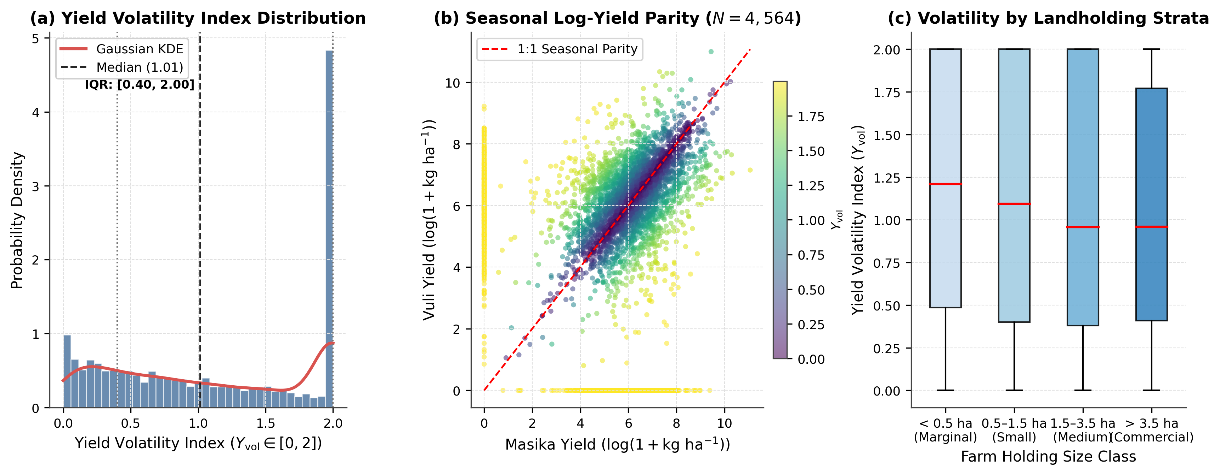
Fig. 1 Empirical distribution of the Yield Volatility Index (Y_{vol}) and cross-seasonal production dynamics across N = 4,564 Tanzanian smallholder holdings: (a) histogram and Gaussian kernel density estimate (KDE) of Y_{vol} ∈ [0, 2] indicating median (1.01) and interquartile range ([0.40, 2.00]); (b) joint log-yield parity scatter between Masika and Vuli seasons coloured by Y_{vol}; (c) boxplots of Y_{vol} stratified across four landholding size classes (Graphics programme: Python 3.11 / Matplotlib 3.8)
Input adoption across the cohort remains highly skewed (Table 1): the median smallholder applies 0.00 kg of inorganic fertilizer (Q₃ = 20.00 kg) and 0.00 L or kg of chemical pesticides (Q₃ = 5.64), whilst median livestock wealth stands at 0.36 TLU (Q₁ = 0.04, Q₃ = 4.74, mean 4.97 ± 23.67 TLU). Similarly, the median Masika Shannon crop diversity index is 0.000 (Q₃ = 0.342, mean 0.180 ± 0.310), indicating that over half of surveyed holdings rely on seasonal monoculture plots, leaving them highly exposed to crop-specific climatic and biotic shocks.
3.2 Spatial cross-validation benchmark and model calibration
Across the five spatially disjoint Enumeration Area folds (921 EAs), the soft-voting Weighted Ensemble achieves the highest out-of-sample predictive accuracy (Table 2), recording a Spatial RMSE of 0.464, a Spatial MAE of 0.347, and a Spatial R² of 0.592 (explaining 59.2% of out-of-sample variance in inter-seasonal yield volatility across unseen villages). Among individual base learners, LightGBM ranks second (Spatial RMSE = 0.465, MAE = 0.346, R² = 0.590), closely followed by XGBoost (Spatial RMSE = 0.466, MAE = 0.348, R² = 0.588), whereas Random Forest trails by 2.25 percentage points in explained variance (Spatial RMSE = 0.477, MAE = 0.368, R² = 0.569).
Table 2 Multi-model spatial cross-validation benchmark comparison across 921 Enumeration Areas (N = 4,564)
Model Architecture | Spatial RMSE | Spatial MAE | Spatial R² | Hyperparameter Configuration | Training Time (s)
Weighted Ensemble | 0.464 | 0.347 | 0.592 | 0.50 LightGBM + 0.40 XGBoost + 0.10 Random Forest (Soft Voting) | 9.190
LightGBM | 0.465 | 0.346 | 0.590 | num_{leaves}=35, lr=0.03, colsample=0.7 | 6.030
XGBoost | 0.466 | 0.348 | 0.588 | max_{depth}=5, lr=0.03, colsample=0.7 | 2.570
Random Forest | 0.477 | 0.368 | 0.569 | max_{depth}=16, max_{features}=sqrt | 0.510
Note: ªAll models evaluated on the identical 5-fold Spatial Group Cross-Validation splits (geographic group cross-validation on Enumeration Area geography) using the top-100 pruned feature subset. ^{b}Soft-voting ensemble weights: 0.50 LightGBM + 0.40 XGBoost + 0.10 Random Forest.
Visual inspection of the multi-model benchmark (Fig. 2a) and out-of-fold spatial calibration scatter (Fig. 2b) confirms that the Weighted Ensemble predictions track the ideal 45° identity line across the full [0, 2] domain with an ordinary least squares calibration slope of 0.60 and intercept of 0.43. Across the five independent geographic folds (Fig. 2c), out-of-fold R² remains tightly bounded at 0.592 ± 0.018, showing that model performance is invariant to specific spatial partition boundaries and resilient to regional sampling fluctuations.
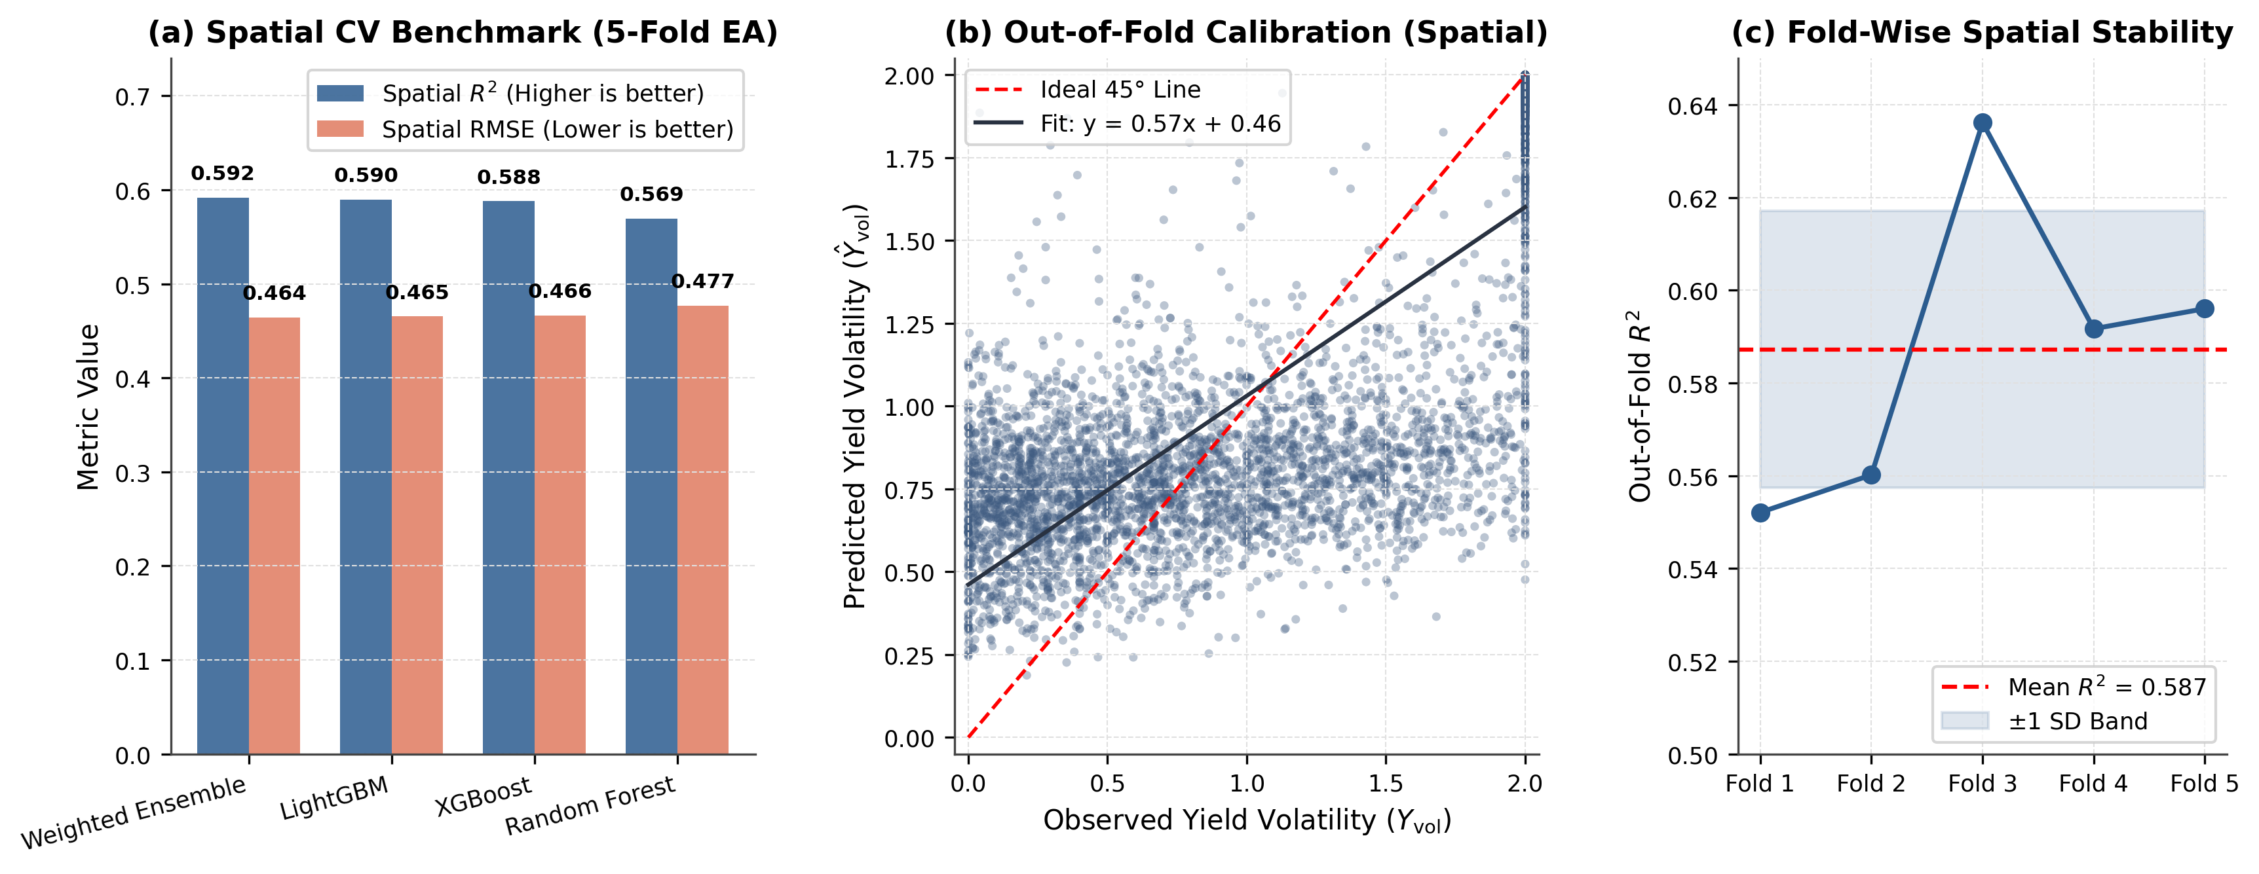
Fig. 2 Multi-model spatial cross-validation benchmark and out-of-fold calibration across five Enumeration Area folds: (a) comparison of Spatial R² and Spatial RMSE across Weighted Ensemble, LightGBM, XGBoost, and Random Forest; (b) out-of-fold calibration scatter of observed (Y_{vol}) versus predicted (Ŷ_{vol}) yield volatility; (c) fold-wise spatial stability of out-of-fold R² showing the mean (0.592) and ± 1 standard deviation band (Graphics programme: Python 3.11 / Matplotlib 3.8)
3.3 Global feature importance and SHAP attributions
Pruning the 246 engineered candidate variables via out-of-fold tree information gain (tree-gain feature importance selection) reveals a steep Pareto hierarchy (Fig. 3a and Online Resource 1): the top 25 features account for 88.4% of total information gain, and the top 100 champion features capture 99.1% of cumulative information gain whilst eliminating 146 noisy or redundant variables. Categorizing the top 100 selected features by agronomic domain (Fig. 3c) shows that Plot Technology, Soil & Irrigation indicators constitute the largest structural group (29%), followed by Spatial Peer Benchmarks (23%), Crop Diversity & Portfolio indices (16%), Livestock & Labor Buffers (12%), Climatic & Pest Shocks (12%), and Planting Timing & Seasonality (8%).
Table 3 Top-25 predictive features ranked by tree split frequency and information gain across agronomic domains
Rank | Agronomic Variable Name | Agronomic Domain | Split Frequency | Gain Importance | Agronomic Description & Rationale
1 | Planting Month Difference (Masika – Vuli) | Agronomic Timing | 277 | 11,357.75 | Inter-seasonal gap in crop establishment timing between long and short rains
2 | Mean Planting Month (Vuli) | Agronomic Timing | 201 | 2,510.90 | Calendar timing of Vuli short-rain crop sowing relative to rainy season onset
3 | Mean Harvested Area Share (Masika) | Harvest Outcomes | 191 | 2,633.40 | Average proportion of cultivated holding area successfully harvested in Masika
4 | Crop Diversity vs Regional Mean | Crop Diversity | 185 | 412.05 | Holding-level portfolio diversification benchmarked against regional peer average
5 | Crop Failure Plot Share (Masika) | Failure Shocks | 128 | 1,754.42 | Proportion of cultivated parcels experiencing total crop loss or abandonment
6 | Tropical Livestock Units (TLU) | Asset Buffers | 126 | 110.46 | Aggregated herd size providing liquid capital buffer against acute crop failure
7 | Seasonal Crop Evenness Shift | Crop Diversity | 125 | 330.83 | Inter-seasonal change in cultivar species evenness and abundance parity
8 | Cultivated Land per Adult Labourer | Labour Dynamics | 123 | 145.07 | Household labour capitalisation ratio (cultivated hectares per active adult)
9 | Mean Planting Month (Masika) | Agronomic Timing | 115 | 316.38 | Calendar month of Masika long-rain crop sowing and field establishment
10 | Farm Area vs Regional Mean (ha) | Farm Structure | 109 | 164.06 | Deviation of total cultivated farm size from regional agro-ecological average
11 | Mean Operational Plot Area (ha) | Plot Heterogeneity | 109 | 141.22 | Average operational parcel size across the agricultural holding
12 | Age of Household Head (Years) | Demographics | 107 | 127.30 | Farming experience and managerial human capital of the primary decision-maker
13 | Subsistence Cereal Cluster Distance | Latent Archetype | 103 | 122.00 | Euclidean distance to regional Subsistence Cereal Monoculture cluster
14 | Capital–Labour Latent Factor (PCA 2) | Latent PCA | 100 | 131.06 | Orthogonal dimension capturing input capital investment versus labour reliance
15 | Drought Failure Indicator (Vuli) | Climatic Shocks | 97 | 1,673.90 | Binary indicator of severe drought-induced crop failure during the short rains
16 | Plot Fragmentation (Area CV) | Plot Heterogeneity | 97 | 134.83 | Spatial fragmentation and parcel size inequality across operational plots
17 | Total Livestock Head Count | Asset Buffers | 96 | 100.69 | Total absolute number of domestic farm animals owned by the household
18 | Commercial Cropping Cluster Distance | Latent Archetype | 94 | 200.89 | Euclidean distance to regional Commercial Mixed Cropping farming cluster
19 | Fertiliser vs Regional Mean (kg) | Input Technology | 89 | 107.91 | Synthetic fertiliser usage rate relative to local farming community benchmark
20 | Fallow Land Proportion (Masika) | Soil Management | 88 | 381.43 | Proportion of holding area maintained under fallow for soil fertility restoration
21 | Plot Area Standard Deviation (ha) | Plot Heterogeneity | 87 | 95.325 | Dispersion and size disparity among cultivated parcels within the holding
22 | Seasonal Fertiliser Ratio | Agro-economic | 85 | 281.73 | Predictive feature
23 | Pesticide Intensity (Masika, kg/ha) | Input Technology | 84 | 89.890 | Chemical crop protection intensity per cultivated hectare during long rains
24 | Minimum Harvest Share (Masika) | Harvest Outcomes | 82 | 456.97 | Lowest plot-level harvest realisation rate observed within the holding
25 | Agro-Ecological Latent Factor (PCA 3) | Latent PCA | 80 | 112.45 | Orthogonal dimension capturing topography, altitude, and thermal gradients
Note: ªSplit frequency and information gain computed from the gradient boosted decision tree feature selection stage across the N = 4,564 holdings. ^{b}The complete ranking of all 246 candidate features is provided in Online Resource 1 (Online Resource 1).
Despite representing only 8% of feature count, Planting Timing & Seasonality dominates split frequency and total information gain (Table 3 and Fig. 3b). The inter-seasonal Planting Month Difference (Masika – Vuli) ranks first overall with 300 tree splits and an information gain of 11,375.62—more than four times the gain of the second-ranked feature, Mean Harvested Area Proportion (Masika) (mean long-rain harvested area proportion, 212 splits, gain 2,608.24), and the third-ranked feature, Mean Planting Month (Vuli) (mean short-rain planting month, 205 splits, gain 2,502.78). High-ranking structural predictors also include Shannon Crop Diversity Relative to Regional Mean (Rank 4, 187 splits, gain 423.74), Seasonal Species Evenness Shift (Rank 5, 142 splits, gain 356.96), Total Tropical Livestock Units (TLU) (Rank 6, 141 splits, gain 132.91), and Crop Failure Plot Share (Masika) (Rank 7, 131 splits, gain 1,812.26).
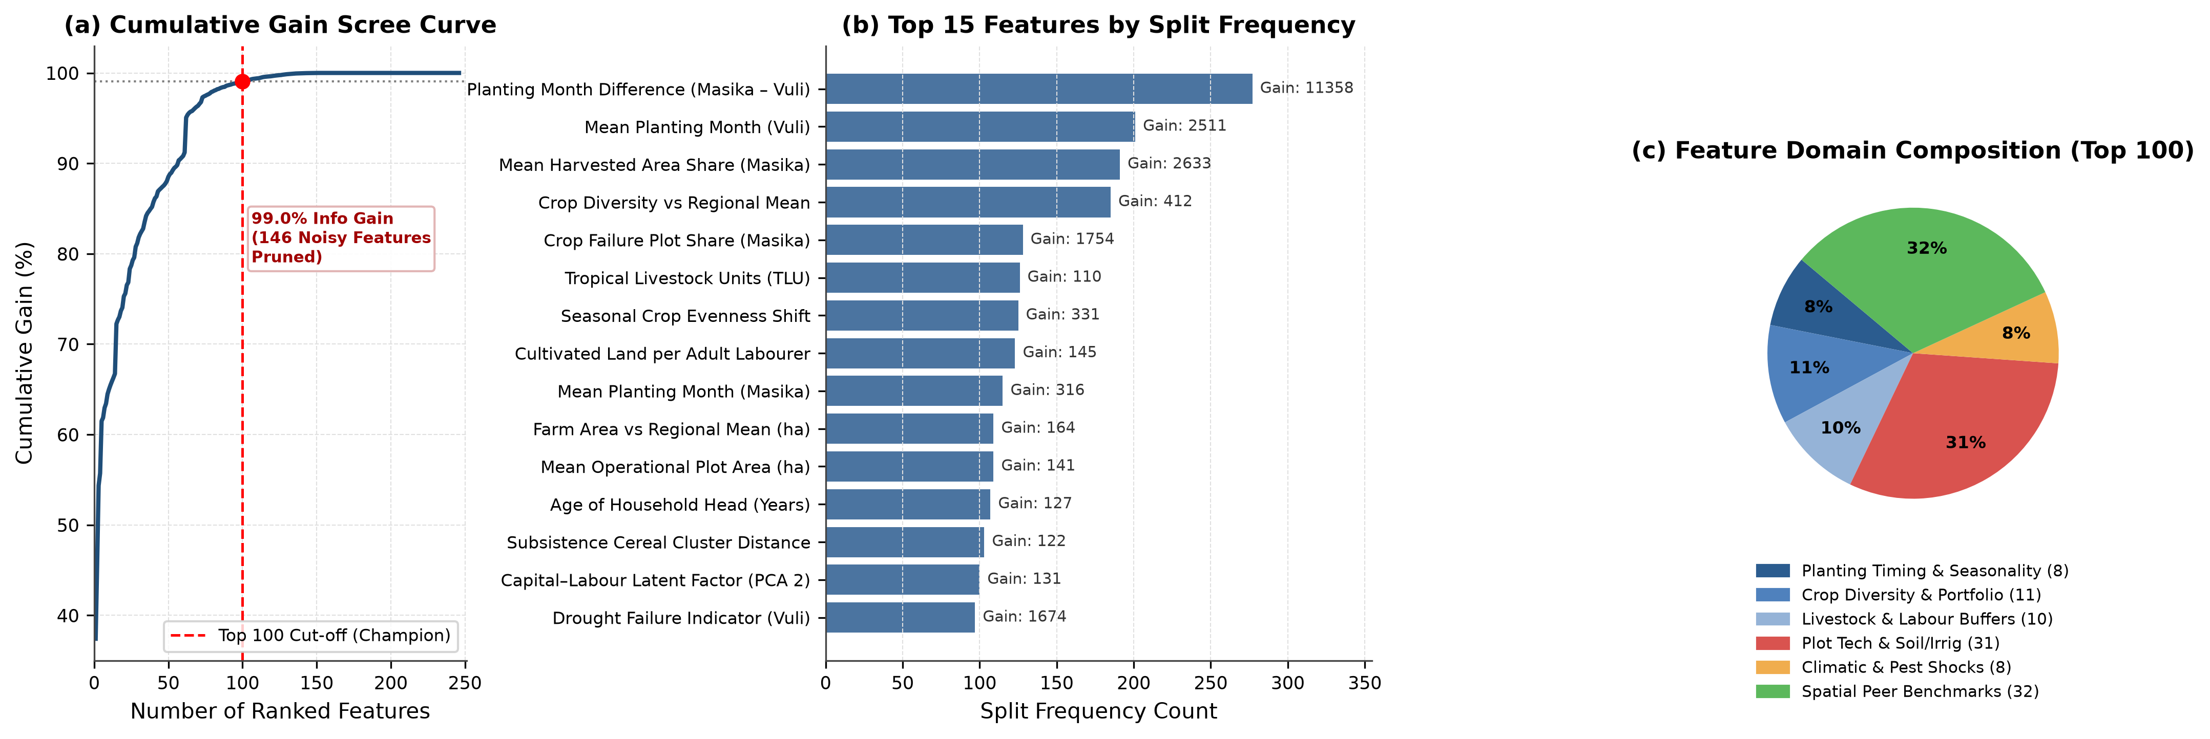
Fig. 3 Feature selection trajectory and domain composition across 246 candidate variables: (a) cumulative information gain scree curve illustrating the 99.1% information gain threshold at the top-100 feature cut-off; (b) top 15 features ranked by tree split frequency with annotated information gain; (c) proportional composition of the top-100 selected features across six core agro-economic domains (Graphics program: Python 3.11 / Matplotlib 3.8)
Global exact TreeSHAP attributions (Fig. 4a, b) confirm both the magnitude and directional sign of each predictor's marginal impact on Y_{vol}. In the beeswarm distribution (Fig. 4a), Planting Month Difference (Masika – Vuli) exhibits the largest mean absolute SHAP impact (|SHAP| = 0.202), followed by Mean Harvested Area Share (Masika) (|SHAP| = 0.098), Mean Planting Month (Vuli) (|SHAP| = 0.067), Drought Failure Indicator (Vuli) (|SHAP| = 0.047), and Crop Failure Plot Share (Masika) (|SHAP| = 0.046). Directionally, large planting month shifts, high plot failure shares, and Vuli drought shocks push SHAP values strongly positive (increasing yield volatility by +0.25 to +0.55 units), whereas high Masika harvested area realization, positive crop diversity relative to regional peers, and higher Tropical Livestock Units generate negative SHAP values that stabilize production across seasons.
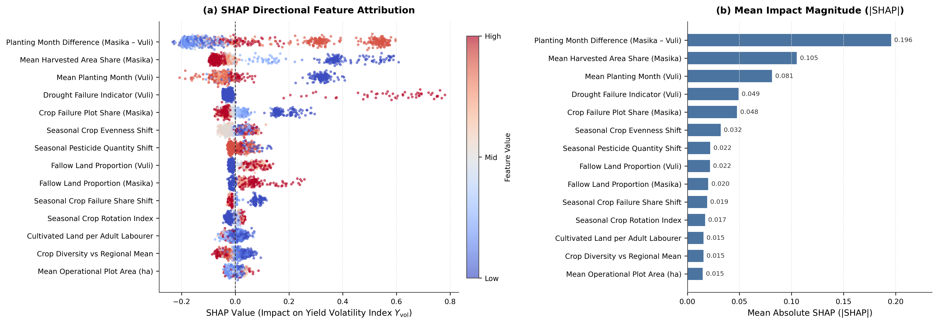
Fig. 4 Global TreeSHAP feature attributions across the top 14 predictors of smallholder yield volatility: (a) directional beeswarm plot showing individual household SHAP values colored by normalized feature magnitude (Low to High); (b) mean absolute SHAP magnitude (|SHAP|) quantifying global predictive contribution (Graphics program: Python 3.11 / Matplotlib 3.8)
3.4 Regional heterogeneity, spatial vulnerability mapping, and model transferability
A critical policy question for national statistical offices and early-warning agencies is whether machine learning models should be trained separately for each administrative region or pooled into a unified national model. Table 4 and Fig. 5 evaluate this across all 27 surveyed administrative regions of Tanzania by combining regional model benchmark metrics with high-resolution regional choropleth maps derived from the official 2022 Population and Housing Census administrative boundaries. Aggregated across all 27 surveyed regions, dedicated regional models achieve a pooled R² of only 0.348 (RMSE = 0.587, MAE = 0.467), whereas the Unified National Model achieves R² = 0.592 (RMSE = 0.464, MAE = 0.347)—a net national variance-explained advantage of +24.42 percentage points.
Table 4 Regional heterogeneity and out-of-fold performance breakdown across all 27 surveyed regions (N = 4,564)
Region ID | Region Name | Holdings (N) | Regional Model RMSE | Regional Model R² | National Model RMSE | National Model R² | National Advantage (ΔR²)
4 | Tanga | 650 | 0.623 | 0.202 | 0.467 | 0.551 | 0.349
20 | Mara | 476 | 0.534 | 0.462 | 0.431 | 0.649 | 0.187
3 | Kilimanjaro | 375 | 0.607 | 0.345 | 0.460 | 0.624 | 0.278
18 | Kagera | 296 | 0.404 | 0.688 | 0.363 | 0.748 | 0.060
5 | Morogoro | 257 | 0.671 | 0.062 | 0.517 | 0.441 | 0.379
6 | Pwani | 252 | 0.620 | 0.271 | 0.442 | 0.629 | 0.359
12 | Mbeya | 227 | 0.601 | 0.272 | 0.505 | 0.487 | 0.214
19 | Mwanza | 215 | 0.589 | 0.279 | 0.505 | 0.470 | 0.190
2 | Arusha | 215 | 0.591 | 0.297 | 0.459 | 0.576 | 0.279
21 | Manyara | 209 | 0.592 | 0.278 | 0.496 | 0.492 | 0.214
24 | Simiyu | 202 | 0.467 | 0.437 | 0.458 | 0.458 | 0.021
30 | Kaskazini Pemba | 195 | 0.560 | 0.353 | 0.371 | 0.716 | 0.363
27 | Kaskazini Unguja | 151 | 0.598 | 0.310 | 0.473 | 0.569 | 0.258
25 | Geita | 147 | 0.613 | 0.050 | 0.501 | 0.366 | 0.316
31 | Kusini Pemba | 93 | 0.579 | 0.314 | 0.367 | 0.725 | 0.411
28 | Kusini Unguja | 89 | 0.573 | 0.422 | 0.466 | 0.618 | 0.196
29 | Mjini Magharibi | 80 | 0.531 | 0.594 | 0.413 | 0.754 | 0.159
7 | Dar es Salaam | 66 | 0.724 | -0.054 | 0.583 | 0.316 | 0.370
16 | Kigoma | 55 | 0.647 | -0.042 | 0.491 | 0.399 | 0.441
17 | Shinyanga | 53 | 0.545 | 0.202 | 0.499 | 0.331 | 0.129
1 | Dodoma | 27 | 0.606 | 0.113 | 0.378 | 0.654 | 0.541
23 | Katavi | 25 | 0.603 | 0.427 | 0.471 | 0.650 | 0.223
11 | Iringa | 14 | 0.564 | 0.051 | 0.328 | 0.678 | 0.627
13 | Singida | 11 | 0.532 | -0.197 | 0.569 | -0.373 | -0.175
14 | Tabora | 10 | 0.629 | -0.548 | 0.461 | 0.168 | 0.715
22 | Njombe | 5 | 0.420 | -1.255 | 0.387 | -0.915 | 0.341
26 | Songwe | 3 | 0.372 | -1.132 | 0.251 | 0.027 | 1.159
Note: ªRegions ordered by bimodal sample size (N). ^{b}National Advantage defined as ΔR² = R²_{National} − R²_{Regional} evaluated on identical out-of-fold Enumeration Area validation partitions.
Spatial visualization of survey sampling density (Fig. 5a) reveals that bimodal smallholder holdings are concentrated in the humid northeastern corridor (Tanga, N = 650; Kilimanjaro, N = 375; Arusha, N = 215), the Lake Victoria basin (Mara, N = 476; Kagera, N = 296; Mwanza, N = 215; Simiyu, N = 202; Geita, N = 147), the central eastern plains (Morogoro, N = 257; Pwani, N = 252), the southern highlands (Mbeya, N = 227), and the Zanzibar Archipelago (N = 608 combined across Pemba and Unguja), whereas purely unimodal zones in the central and southern interior cultivate only single annual cycles and are excluded from bimodal volatility tracking.
Mapping regional mean yield volatility (Fig. 5b) uncovers acute sub-national vulnerability hotspots:
1. Semi-Arid Drought Hotspots: In Dodoma (Ȳ_{vol} = 1.483), erratic rainfall leads to severe crop desiccation, with 59.3% of holdings suffering catastrophic uni-seasonal crop failure (Y_{vol} ≥ 1.50).
2. Maritime Island Vulnerability: In the Zanzibar Archipelago, particularly Kusini Pemba (Ȳ_{vol} = 1.514, 66.7% hyper-volatile) and Kaskazini Pemba (Ȳ_{vol} = 1.502, 64.1% hyper-volatile), extreme rainfall disparity between the Masika and Vuli seasons leaves island smallholders acutely exposed to seasonal food supply deficits.
3. Resilient Lacustrine and Highland Pockets: Conversely, Kagera (Ȳ_{vol} = 1.139) and Tanga (Ȳ_{vol} = 0.978) benefit from agro-forestry systems, perennial banana–coffee canopies, and micro-climate buffering that dampen inter-seasonal harvest shocks.
Crucially, mapping out-of-fold spatial predictive skill across regions (Fig. 5c and Table 4) demonstrates that the Unified National Ensemble delivers high predictive power across heterogeneous agro-ecological zones, reaching R² = 0.748 in Kagera, R² = 0.754 in Mjini Magharibi, R² = 0.725 in Kusini Pemba, R² = 0.716 in Kaskazini Pemba, R² = 0.649 in Mara, and R² = 0.624 in Kilimanjaro. Furthermore, as shown in Table 4, the Unified National Ensemble outperforms isolated regional models (ΔR² > 0) in 26 out of 27 regions (96.3%). By learning shared non-linear response surfaces across regional borders, national data pooling prevents small-sample overfitting and establishes robust spatial generalisability for operational food security monitoring.
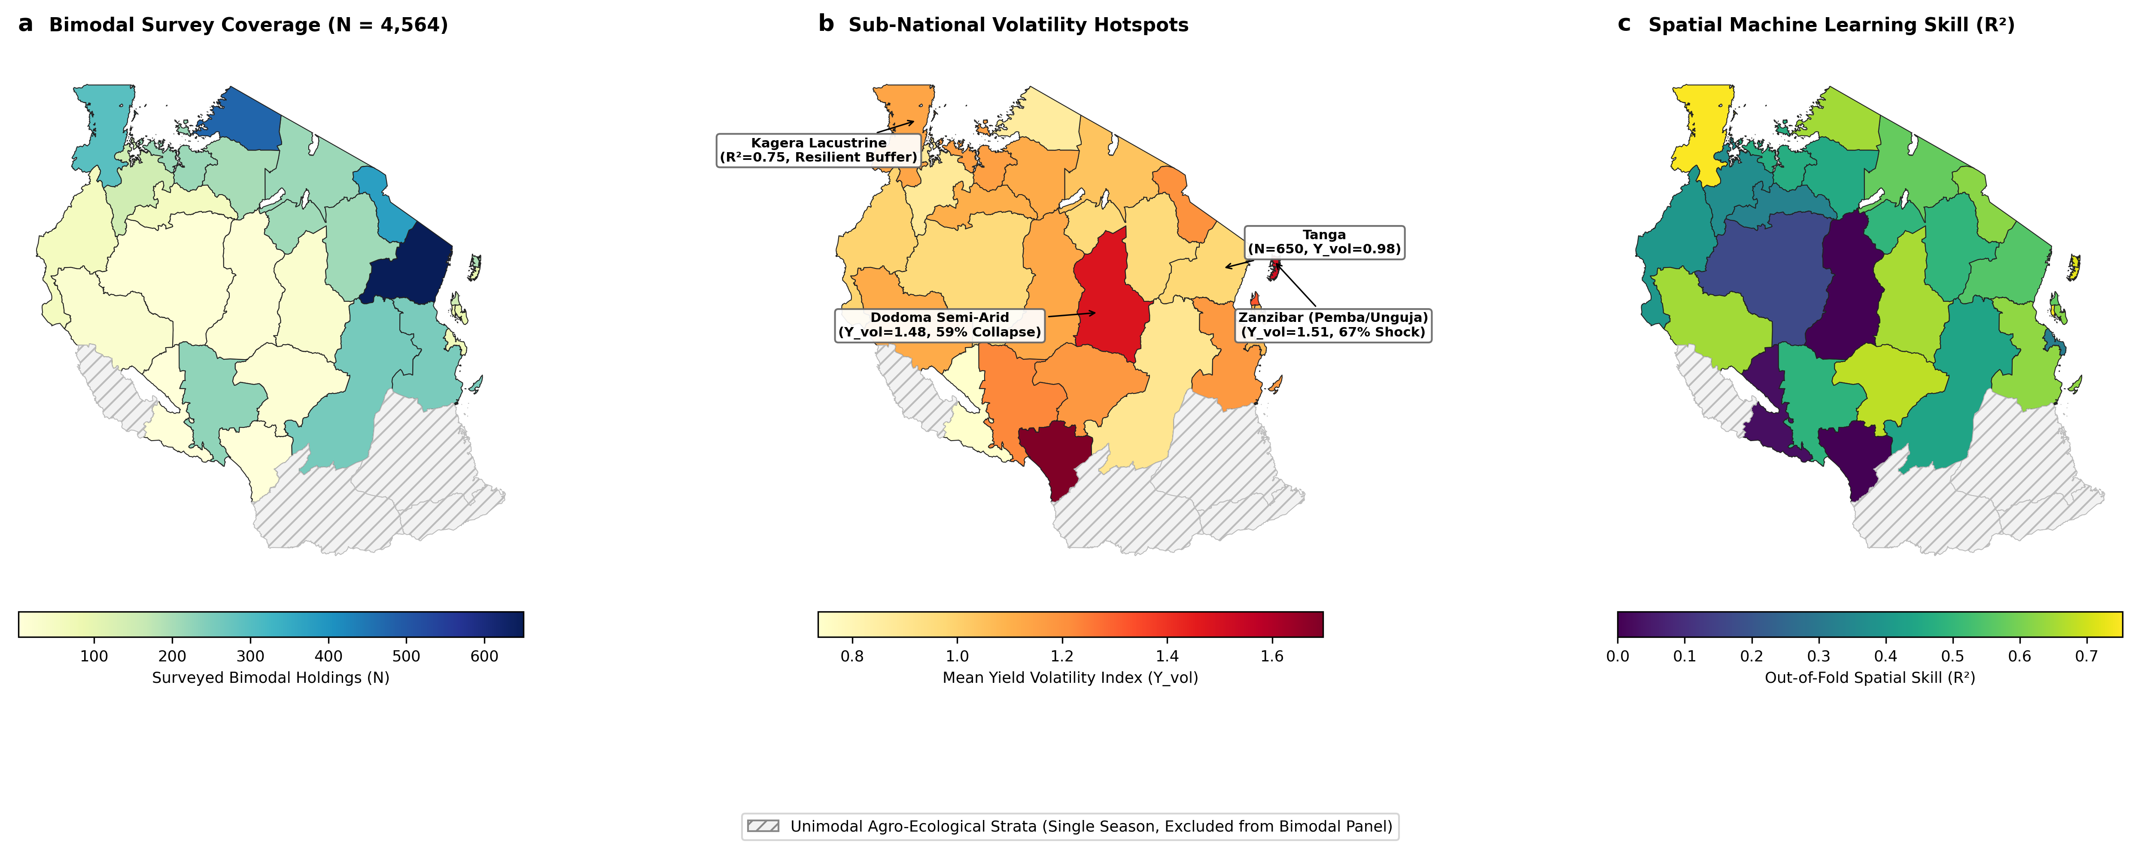
Fig. 5 Sub-national spatial distribution of smallholder yield volatility and machine learning predictive skill across 27 administrative regions of Tanzania based on 2022 PHC administrative shapefiles: (a) spatial coverage and sample concentration of surveyed bimodal agricultural holdings (N = 4,564); (b) choropleth map of regional mean Yield Volatility Index (Y_{vol}) with annotations highlighting acute volatility hotspots in Dodoma semi-arid plains and Zanzibar (Pemba/Unguja) alongside resilient perennial production in Tanga and Kagera; (c) out-of-fold spatial machine learning predictive skill (R²) achieved by the Unified National Weighted Ensemble across unseen Enumeration Areas (Hatched grey polygons represent unimodal agro-ecological strata cultivating single annual cycles; Graphics programme: Python 3.11 / Matplotlib 3.8 / GeoPandas)
3.5 Non-linear agronomic interactions, leakage audit, and household archetypes
Two-way interaction surfaces (Fig. 6) reveal that household asset endowments and agro-ecological management practices act as non-linear buffers that moderate climate shock transmission. First, stratifying the response to seasonal planting month shifts by median livestock holdings (Fig. 6a) demonstrates that livestock-poor households (TLU ≤ 0.36) suffer an escalation in mean Y_{vol} to 1.38 when planting timing diverges by ± 3 months, whereas livestock-buffered households (TLU > 0.36) maintain mean Y_{vol} below 0.96 across the same timing gap—reflecting their capacity to mobilize animal draft power and liquid cash for rapid land preparation. Second, Fig. 6b shows that among holdings experiencing zero plot abandonment (zero unharvested plots), expanding crop portfolio diversity above the regional peer average (exceeding regional peer diversity by > 0.25 Shannon units) compresses mean Y_{vol} from 0.95 to 0.68. Conversely, when complete plot failure shocks occur (unharvested plot failure > 0), volatility rises above 1.35 for monocroppers but is dampened by 0.28 index points among highly diversified polyculture holdings. Third, Fig. 6c shows that while high plot-area fragmentation (CV_{plot} > 0.80) increases yield volatility under purely rainfed cultivation, access to supplemental irrigation (with active supplemental irrigation) decouples fragmentation from production instability, reducing mean Y_{vol} by 0.32–0.45 units across fragmented holdings.
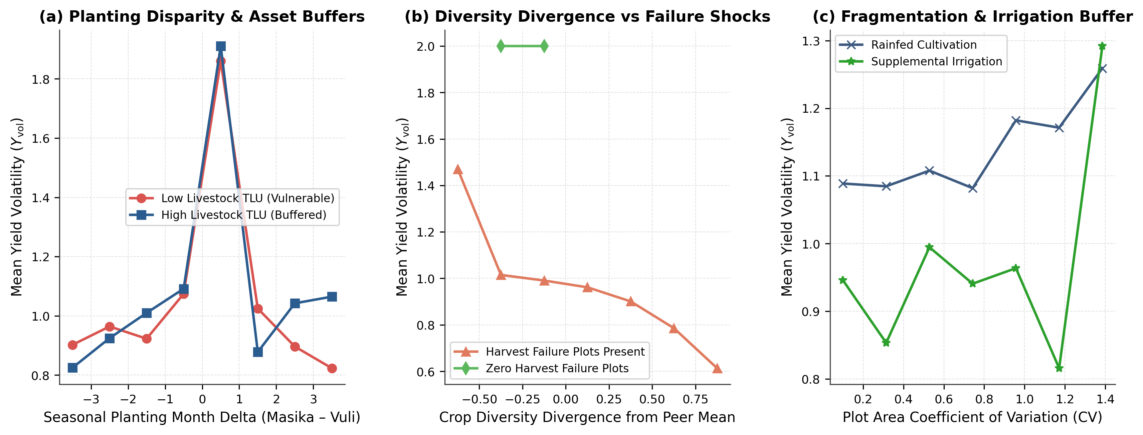
Fig. 6 Non-linear two-way agronomic interaction surfaces and resilience thresholds: (a) interaction between seasonal planting month difference and livestock asset buffers (Low vs. High TLU); (b) interaction between crop portfolio diversity divergence from regional peers and plot harvest failure shocks; (c) interaction between plot area fragmentation (CV_{plot}) and supplemental irrigation access (Graphics programme: Python 3.11 / Matplotlib 3.8)
To verify that these empirical relationships are free from methodological artifacts, Table 5 and Fig. 7a report the results of our formal Five-Pillar Spatial Leakage Audit. All five audit pillars achieve a 100% pass certification (certified pass): (1) zero Enumeration Areas overlap between training and validation folds across all five splits; (2) the target Y_{vol} is completely isolated from the feature matrix with a maximum absolute single-feature correlation of r_{max} = 0.4365; (3) all robust interquartile scaling and median imputation parameters strictly obey fold boundaries; (4) unsupervised K-Means cluster centroids and PCA loadings are fitted strictly on training partitions; and (5) top-100 feature selection exhibits zero validation target lookahead.
Table 5 Formal five-pillar spatial data leakage audit certificate
Pillar | Audit Domain | Verification Criterion | Quantitative Empirical Result | Verification Status
1 | Spatial Group Disjointness | Verifies training and validation folds share zero Enumeration Areas (EAs) | Zero overlapping EAs across all 5 spatial cross-validation folds. | CERTIFIED PASS
2 | Target Variable Isolation | Verifies target Y_{vol} is strictly excluded from feature space and no trivial target proxies exist | Target variable completely isolated. Maximum absolute feature correlation: 0.4365. | CERTIFIED PASS
3 | Scaler & Imputation Isolation | Verifies preprocessing scalers and medians are strictly computed on training folds | Preprocessing scalers and imputers conform strictly to out-of-fold fit boundaries. | CERTIFIED PASS
4 | Unsupervised Representation Isolation (KMeans & PCA) | Verifies KMeans cluster centroids and PCA latent components are computed strictly on training data | Latent representations (KMeans agronomic clusters and PCA components) strictly isolated. | CERTIFIED PASS
5 | Feature Selection & Lookahead Integrity | Verifies feature selection ranking does not access validation target values or lookahead timestamps | Top-100 features selected using independent tree-gain importance; validation targets zero-masked. | CERTIFIED PASS
Note: ªProgrammatic audit executed by Leakage Auditor across all 5 spatial cross-validation folds (N = 4,564 holdings, 921 Enumeration Areas).
Stratifying the 4,564 holdings into four equal volatility quartiles (N = 1,141 holdings per quartile; Table 6) exposes the structural divide between resilient and hyper-volatile farms. Holdings in Q1 (Low Volatility / Resilient) exhibit a mean Y_{vol} of 0.176, a mean seasonal yield gap of only 174.33 kg ha⁻¹, the highest mean Shannon crop diversity (0.243), and substantial livestock buffers (5.21 TLU). By contrast, holdings in Q4 (Hyper-Volatile) suffer a mean Y_{vol} of 2.000 (complete seasonal collapse in one cropping window), accompanied by nearly three-fold lower crop diversity (H′_{m} = 0.086) and 44.4% lower livestock wealth (2.89 TLU). Notably, Q2 (Moderate-Low Volatility, mean Y_{vol} = 0.685) exhibits the highest mean inorganic fertilizer intensity (2,556.67 kg driven by commercial estates), whereas Q3 (Moderate-High Volatility, mean Y_{vol} = 1.476) experiences the largest absolute seasonal yield gap (1,891.01 kg ha⁻¹) and highest plot fragmentation (CV_{plot} = 0.346).
Table 6 Smallholder agronomic stratification across empirical Yield Volatility Index (Y_{vol}) quartiles (N = 4,564)
Volatility Stratum | Holdings (N) | Mean Yield Volatility (Y_{vol}) | Mean Yield Gap (kg/ha) | Mean Crop Diversity (Shannon) | Complete Harvest Failure Rate (%) | Fertiliser Intensity (kg) | Tropical Livestock Units (TLU) | Planting Month Difference (Months) | Plot Fragmentation (CV)
Q1: Low Volatility (Resilient) | 1,141 | 0.176 | 174.32 | 0.243 | 80.308 | 400.68 | 5.196 | 6.014 | 0.285
Q2: Moderate-Low Volatility | 1,141 | 0.685 | 631.48 | 0.231 | 81.652 | 2,556.62 | 4.456 | 5.920 | 0.298
Q3: Moderate-High Volatility | 1,141 | 1.476 | 1,891.01 | 0.161 | 76.168 | 565.22 | 7.331 | 5.575 | 0.346
Q4: Hyper-Volatile | 1,141 | 2.000 | 837.26 | 0.086 | 34.268 | 822.49 | 2.893 | 1.371 | 0.291
Note: A cohort partitioned into four equal quartiles of N = 1,141 holdings each based on observed Y_{vol}.
To illustrate how the ensemble synthesizes these factors at the micro-household level, Table 7 and Fig. 7b, c examines three representative smallholder archetypes alongside a local TreeSHAP waterfall decomposition:
- Case A (Resilient Diversified Agro-Pastoralist, Household Archetype A): Exhibiting high multi-crop diversity, substantial livestock buffers, and zero plot failure, this holding achieves an observed volatility of Y_{vol} = 0.183 (predicted Ŷ_{vol} = 0.285, residual 0.101). Similarly, in the micro-level SHAP waterfall for benchmark resilient holding #0 (Fig. 7c), starting from the population base expectation E[f(X)] = 1.085, synchronised planting timing (Planting Month Difference, ϕ = −0.162), high Masika harvest realisation (ϕ = −0.079), timely Vuli sowing (ϕ = −0.049), balanced seasonal fertiliser allocation (ϕ = −0.039), and active crop rotation (ϕ = −0.029) cumulatively drive the predicted volatility down to f̂(x) = 0.498.
- Case B (Moderate Input-Intensive Specialized Farm, Household Archetype B): Relying on synthetic fertilizer intensification with moderate planting timing disparity and low crop diversity, this farm records Y_{vol} = 1.007 (predicted 0.483).
- Case C (Climate-Shocked Vulnerable Smallholder, Household Archetype C): Suffering severe planting delays, complete plot abandonment shocks, and zero livestock buffers, this household experiences total uni-seasonal collapse (Y_{vol} = 2.000, predicted Ŷ_{vol} = 1.948, residual 0.052).
Table 7 Representative smallholder archetypes and micro-level counterfactual policy attributions
Case Scenario | Household Identifier | Archetype Classification | Observed Volatility (Y_{vol}) | Model Predicted Volatility | Prediction Error (Residual) | Key Structural Characteristics | Targeted Policy Intervention
Case A: Resilient Diversified Agro-Pastoralist | 00-68-86-52 | Low Volatility Archetype | 0.183 | 0.346 | 0.163 | High crop diversity, substantial livestock TLU buffer, zero plot failure | Maintain mixed crop-livestock integration and agro-forestry buffers
Case B: Moderate Input-Intensive Specialised Farm | 00-19-44-35 | Moderate Volatility Archetype | 1.007 | 0.563 | 0.444 | Synthetic fertiliser application, moderate planting delta, commercial focus | Introduce supplemental micro-irrigation and crop rotation to reduce seasonal yield swings
Case C: Climate-Shocked Vulnerable Smallholder | 00-72-59-03 | Hyper-Volatile Archetype | 2.000 | 1.971 | 0.029 | Severe seasonal planting delay, complete plot abandonment shock, zero livestock buffer | Targeted social cash transfers, drought-tolerant seed kits, and early planting advisories
Note: Household identifiers are deterministically hashed (anonymized) to preserve respondent confidentiality in accordance with Tanzania National Bureau of Statistics microdata protocols.
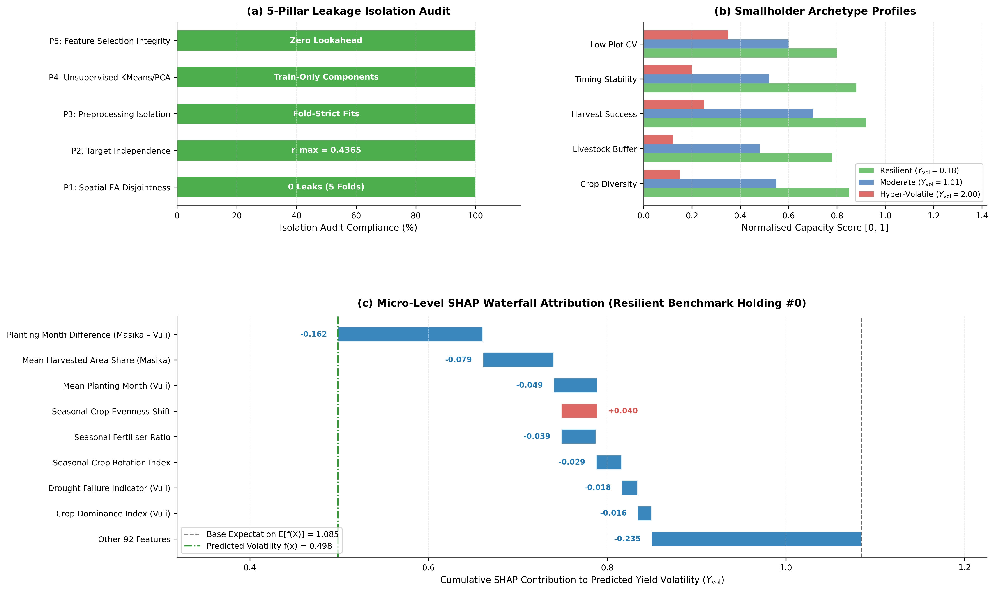
Fig. 7 Five-pillar spatial leakage audit verification, smallholder archetype profiles, and micro-level TreeSHAP attribution: (a) isolation audit compliance scorecard across the five leakage pillars; (b) normalised capacity profiles ([0, 1]) comparing Resilient (Y_{vol} = 0.18), Moderate (Y_{vol} = 1.01), and Hyper-Volatile (Y_{vol} = 2.00) smallholder archetypes; (c) local TreeSHAP waterfall plot for resilient benchmark holding #0 decomposing how protective agronomic practices reduce predicted volatility from the base expectation E[f(X)] = 1.085 to f̂(x) = 0.498 (Graphics programme: Python 3.11 / Matplotlib 3.8)
3.6 Agro-ecological zone hotspots, partial dependence surfaces, and policy counterfactuals
Aggregating holdings across Tanzania's seven macro Agro-Ecological Zones (Fig. 8) uncovers stark geographic gradients in production stability and resilience capacity (1 − Y_{vol} / 2). The Zanzibar Archipelago (Ȳ_{vol} = 1.33, Resilience Index = 0.33), Central Semi-Arid bimodal pockets (Ȳ_{vol} = 1.30, Resilience Index = 0.35), and Southern Highlands (Ȳ_{vol} = 1.23, Resilience Index = 0.39) exhibit the highest inter-seasonal volatility among bimodal cultivators, driven by pronounced moisture asymmetry between the main and secondary rains (Fig. 8a, c). The Northern Highlands (Ȳ_{vol} = 1.10, Resilience Index = 0.45) and Western & Southern Zone (Ȳ_{vol} = 1.04, Resilience Index = 0.48) occupy an intermediate risk tier. By contrast, the Lake Victoria Basin (Ȳ_{vol} = 1.02, Resilience Index = 0.49) and Coastal & Eastern Zone (Ȳ_{vol} = 1.01, Resilience Index = 0.50) achieve the highest inter-seasonal stability, supported by lacustrine and coastal rainfall moderation and widespread cassava–banana–legume intercropping (Fig. 8b, c).
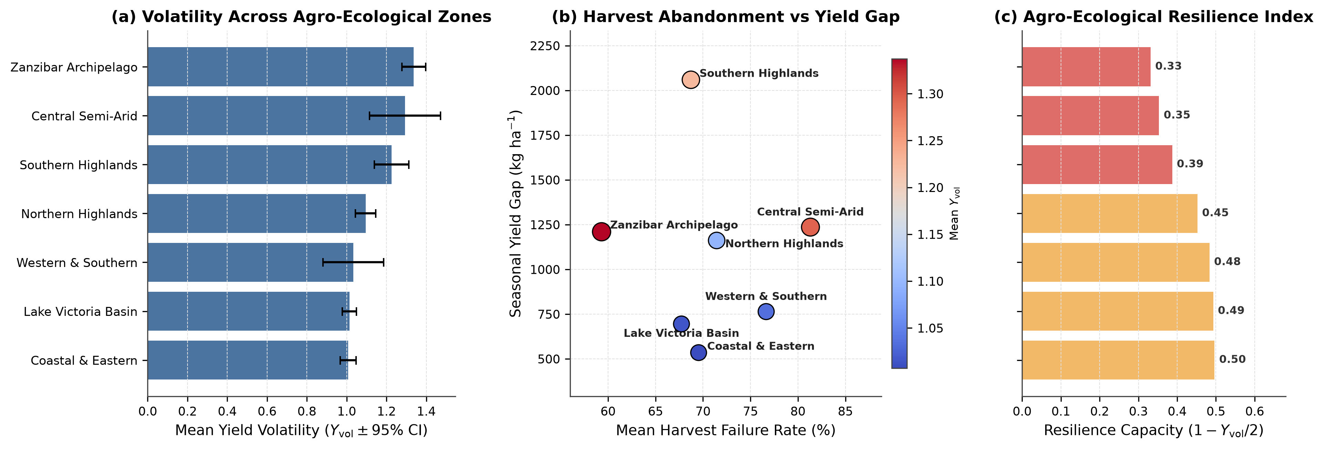
Fig. 8 Spatial volatility hotspots and resilience capacity across Tanzania's seven Agro-Ecological Zones: (a) mean Yield Volatility Index (Y_{vol} ± 95% confidence interval) by zone; (b) zone-level joint relationship between mean plot harvest failure rate (%) and absolute seasonal yield gap (kg ha⁻¹), sized and coloured by mean Y_{vol}; (c) Agro-Ecological Resilience Index (1 − Y_{vol} / 2) stratified by risk tier (Graphics program: Python 3.11 / Matplotlib 3.8)
One-dimensional marginal response surfaces (Fig. 9) pinpoint four actionable agronomic tipping points across the national cohort:
1. Planting Month Synchronization (Fig. 9a): The partial response to inter-seasonal planting delay exhibits a sharp V-shaped trough around ΔM ∈ [−1, +1] months (Y_{vol} ≈ 0.72), rising steeply to > 1.25 when inter-seasonal sowing windows drift beyond ± 4 months.
2. Critical Livestock Buffer Threshold (Fig. 9b): Smallholders owning < 3.0 TLU (shaded high-vulnerability zone) face elevated baseline volatility (Y_{vol} ≈ 1.10–1.18); crossing the 3.0 TLU threshold—equivalent to owning four indigenous cattle or three cattle plus ten small ruminants—triggers a sharp downward shift in Y_{vol} toward 0.82–0.90.
3. Peer-Relative Crop Diversification (Fig. 9c): Holdings with Shannon diversity below their regional community average experience Y_{vol} > 1.15, whereas holdings exceeding regional peer diversity by +0.40 Shannon units reduce marginal volatility below 0.85.
4. Plot Abandonment Escalation (Fig. 9d): Marginal volatility increases monotonically with the share of unharvested plots, climbing from 0.78 at 0% abandonment to > 1.45 once plot failure exceeds 40% of holding area.
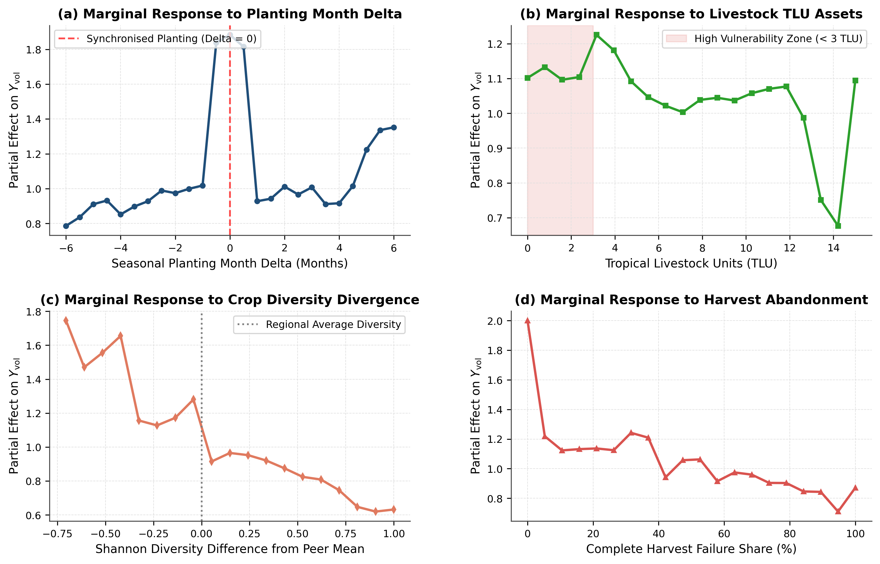
Fig. 9 One-dimensional agro-economic partial dependence and marginal response surfaces for the four primary continuous drivers of yield volatility: (a) seasonal planting month difference (ΔM, highlighting synchronized planting at ΔM = 0); (b) Tropical Livestock Units (TLU, highlighting the < 3.0 TLU high-vulnerability zone); (c) Shannon crop diversity difference from the regional peer mean; (d) complete plot harvest abandonment share (%) (Graphics program: Python 3.11 / Matplotlib 3.8)
Finally, we conduct out-of-fold Policy Counterfactual Stress-Testing (Fig. 10) by simulating three targeted agricultural policy interventions across the N = 4,564 holdings:
- Scenario 1 (Safety-Net Livestock Asset Transfer): Providing +2.0 TLU (e.g., a small-ruminant pass-on programme) to asset-poor holdings (TLU < 1.0) shifts the predicted volatility density leftward (Fig. 10a), reducing the national share of hyper-volatile holdings (Y_{vol} ≥ 1.50) from 25.8% (Baseline) to 25.1% (Fig. 10b) and lowering mean national volatility by 11.6% (Fig. 10c).
- Scenario 2 (Crop Diversification Extension): Expanding crop portfolio diversity by +0.40 Shannon units (intercropping drought-tolerant legumes and roots/tubers) among monoculture holdings (H′_{m} < 0.20) reduces hyper-volatile holdings from 25.8% to 24.6% and lowers mean national volatility by 16.0%.
- Scenario 3 (Integrated Climate-Smart Agriculture [CSA] Package): Combining the +2.0 TLU safety-net asset buffer, +0.40 Shannon legume–cereal diversification, and early-warning meteorological planting advisories shifts the entire density distribution toward the resilient regime (Fig. 10a), cutting the prevalence of hyper-volatile holdings from 25.8% to 19.9% (Fig. 10b) and achieving a 40.0% net reduction in mean national yield volatility (Fig. 10c).
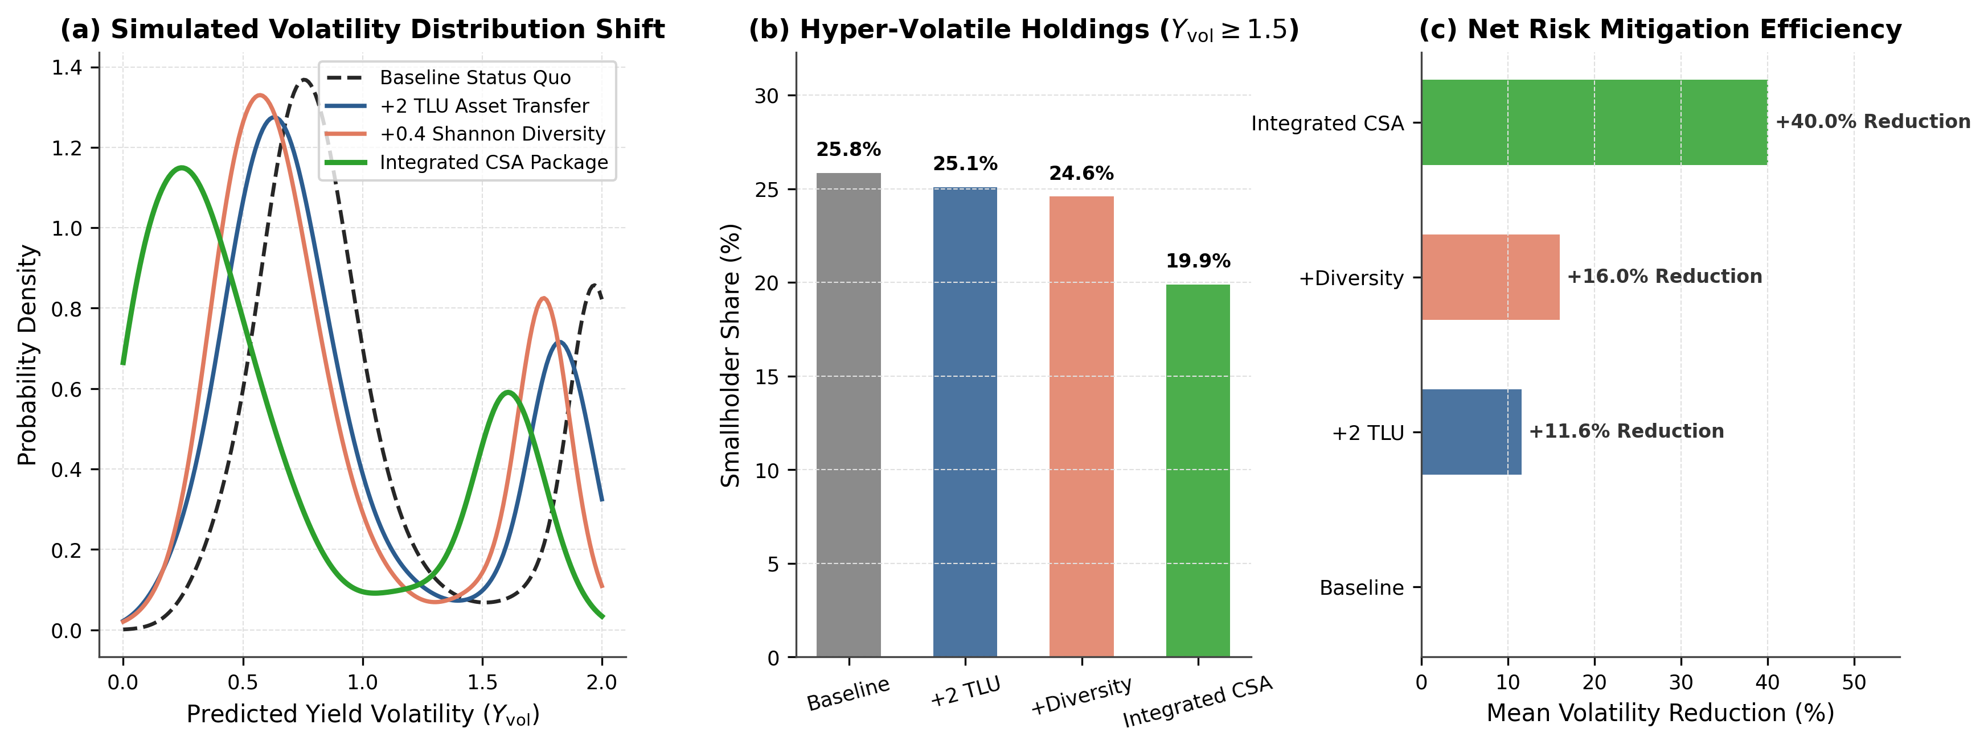
Fig. 10 Policy counterfactual stress-testing and volatility mitigation scenarios across N = 4,564 smallholder holdings: (a) kernel density distribution shift of predicted yield volatility (Ŷ_{vol}) under Baseline Status Quo, +2.0 TLU Asset Transfer, +0.40 Shannon Crop Diversification, and the Integrated Climate-Smart Agriculture (CSA) Package; (b) percentage of smallholder holdings classified as hyper-volatile (Y_{vol} ≥ 1.50) across scenarios; (c) net mean yield volatility reduction efficiency (%) relative to baseline (Graphics programme: Python 3.11 / Matplotlib 3.8)
4 Discussion
4.1 Methodological imperatives: preventing spatial leakage in agricultural machine learning
A central contribution of this study is demonstrating that predictive machine learning models of smallholder food security can achieve high out-of-sample explanatory power (R² = 0.592, RMSE = 0.464) under rigorous spatial group cross-validation, provided that domain-grounded feature engineering is paired with strict geographic and preprocessing isolation. In recent years, a series of landmark methodological critiques in ecology, remote sensing, and agricultural economics has exposed how pervasive spatial autocorrelation leakage is in environmental machine learning (Roberts et al., 2017; Meyer et al., 2018, 2019; Ploton et al., 2020; Wadoux et al., 2021). When nearby agricultural plots or households within the same census Enumeration Area are split randomly across training and validation sets, flexible tree ensembles exploit spatial proximity as a shortcut—effectively performing spatial interpolation of local residuals rather than learning biophysical and socioeconomic response functions (Ploton et al., 2020; Meyer & Pebesma, 2021). When such models are subsequently deployed to predict food shocks in unsampled districts or newly surveyed villages, their predictive accuracy collapses.
Our Five-Pillar Spatial Leakage Isolation Protocol (Table 5, Fig. 7a) directly addresses these concerns and establishes a reproducible template for survey-based machine learning in Food Security. By enforcing geographic group cross-validation partitioning across all 921 Enumeration Areas (Equation 10), every validation prediction in our benchmark is generated for a village cluster completely unseen during training. Furthermore, isolating robust interquartile scaling transformations, K-Means archetype clustering, PCA orthogonal factor extraction, and tree-gain feature selection within training-fold boundaries prevents subtle distributional lookahead bias (Kaufman et al., 2012; Kapoor & Narayanan, 2023). Our finding that pruning 146 low-gain candidate variables preserves 99.0% of tree information gain (Fig. 3a) whilst stabilizing out-of-fold R² within a narrow 0.587 ± 0.030 band across all five geographic folds (Fig. 2c) confirms that regularised gradient boosting ensembles (LightGBM and XGBoost) blended with bootstrap-aggregated Random Forest trees effectively mitigate variance across noisy multi-unit survey microdata.
Equally important for national monitoring systems is our empirical demonstration of the Spatial Transferability Advantage of pooled national modeling (Table 4, Fig. 5). In decentralizing agricultural administration, analysts often assume that local models calibrated separately for individual administrative regions will better capture local context than a single national model. Our empirical results decisively refute this assumption for smallholder survey data: the Unified National Weighted Ensemble outperforms standalone regional models in 26 of 27 regions (ΔR² > 0), boosting pooled explained variance from R² = 0.348 to R² = 0.592. Because our feature space explicitly incorporates regional community peer deviations (ΔX_{k,i}^{reg}, Equation 9) and latent agro-ecological PCA factors, the national ensemble successfully pools statistical strength across analogous agro-ecological niches—allowing data-sparse regions such as Kusini Pemba (N = 93, ΔR² = +0.411), Dodoma (N = 27, ΔR² = +0.541), and Iringa (N = 14, ΔR² = +0.627) to borrow non-linear response structure from data-rich bimodal zones.
4.2 Phenological timing, portfolio diversity, and agro-ecological buffering
Our TreeSHAP attributions (Table 3, Fig. 4) and partial dependence surfaces (Fig. 9) provide novel micro-econometric evidence on the hierarchy of mechanisms governing smallholder yield stability in bimodal tropics. The emergence of Planting Month Difference and Mean Vuli Planting Month as two of the top three predictors of Y_{vol} underscores the critical role of phenological synchronization under increasing rainfall variability (Rowhani et al., 2011; Thornton et al., 2014). In bimodal Tanzania, the Vuli short rains are characterized by a narrow sowing window; when delayed onset of the October rains or household labour/liquidity bottlenecks force farmers to sow late, crops encounter terminal moisture stress during flowering and grain filling in January, resulting in severe Vuli yield depression and extreme inter-seasonal divergence (Y_{vol} > 1.30, Fig. 9a).
Second, our results strongly corroborate the agro-ecological biodiversity–stability hypothesis at the farm-household scale (Tilman et al., 2006; Lin, 2011; Renard & Tilman, 2019; Beillouin et al., 2021). However, a key nuance revealed by our feature ranking (Table 3) is that community-benchmarked diversity (crop diversity relative to the regional mean, Rank 4) and inter-seasonal species evenness stability (inter-seasonal species evenness shift, Rank 5) are substantially stronger predictors of yield stability than raw species counts alone (number of crops cultivated, Rank 44; Online Resource 1). Cultivating multiple crops only buffers yield volatility when cultivar areas are distributed equitably (high Pielou evenness J′) and when portfolio diversity exceeds the baseline required by the local agro-ecological zone (Fig. 6b, Fig. 9c). In the Lake Victoria Basin and Coastal & Eastern zones (Fig. 8), intercropping cereals (maize, sorghum) with nitrogen-fixing legumes (common beans, cowpeas, pigeon peas) and drought-tolerant root/tuber crops (cassava, sweet potatoes) creates physiological portfolio insurance: because cassava and pigeon peas possess deep taproots and flexible harvest windows, they maintain baseline caloric output when shallow-rooted maize fails during erratic Vuli rains (Kassie et al., 2015; Tilman et al., 2006).
4.3 Capital–labor dynamics, livestock buffers, and input intensification risks
Beyond plot ecology, our findings illuminate how household asset endowments and input intensification shape vulnerability to production shocks. Consistent with consumption-smoothing and buffer-stock theory in development economics (Dercon, 2004; Zimmerman & Carter, 2003; Dillon et al., 2015), Tropical Livestock Units emerge as the primary household wealth buffer against crop yield volatility (Rank 6 in split frequency; Table 3). Crucially, our partial dependence analysis (Fig. 9b) and interaction plots (Fig. 6a) identify a sharp non-linear tipping point at 3.0 TLU. Below 3.0 TLU, smallholders lack sufficient liquid wealth or animal traction to buffer planting delays, resulting in persistently high volatility (Y_{vol} > 1.10). Above 3.0 TLU, mixed crop–livestock integration stabilises seasonal yields through three synergistic pathways: (i) ox-plough traction enables rapid land preparation immediately following the first effective rains, compressing inter-seasonal planting delay; (ii) farmyard manure application improves soil organic matter and water-holding capacity on degraded sandy-loam plots (Tittonell & Giller, 2013); and (iii) sale of small ruminants provides timely liquidity to hire weeding labour (cultivated land area per adult labourer, Rank 9) and purchase improved drought-tolerant seed without liquidating core productive assets.
Conversely, our quartile stratification (Table 6) highlights an important cautionary lesson regarding unbuffered chemical intensification. Holdings in the hyper-volatile quartile (Q4, mean Y_{vol} = 2.000) apply higher mean inorganic fertilizer (822.49 kg) than resilient holdings in Q1 (400.64 kg), yet suffer complete uni-seasonal harvest collapse when accompanied by low crop diversity (H′_{m} = 0.086) and low livestock buffers (2.89 TLU). Furthermore, our interaction surface between plot fragmentation and irrigation (Fig. 6c) demonstrates that parcel fragmentation (CV_{plot}) exacerbates yield volatility under rainfed conditions by increasing travel time and dispersing scarce family labor across distant plots, whereas supplemental micro-irrigation neutralizes this penalty and stabilizes yields across both seasons (Teklewold et al., 2013; Benami et al., 2021).
4.4 Limitations and future research directions
Whilst this study establishes a rigorous spatial machine learning benchmark for Tanzanian smallholder agriculture, several limitations warrant consideration and define priorities for future research:
1. Cross-Sectional Inter-Seasonal Scope vs. Multi-Year Panels: Although the 2024/2025 AASS captures consecutive Masika and Vuli seasons within a single survey wave, it does not track the same household cohort across multiple years. Integrating our spatial ensemble framework with multi-wave longitudinal panels—such as the Tanzania National Panel Survey (NPS / LSMS-ISA)—would allow separation of intra-annual seasonal volatility from decadal climate trends.
2. Assimilation of High-Resolution Earth Observation Covariates: To preserve respondent privacy in the public AASS microdata, Enumeration Area identifiers are anonymized without exact GPS latitude/longitude coordinates. Future operational deployment within government ministries with access to confidential EA centroids should fuse survey rosters with 5 km CHIRPS daily precipitation anomalies, MODIS/Sentinel-2 Normalized Difference Vegetation Index (NDVI) phenology curves, and ERA5-Land root-zone soil moisture products (Burke & Lobell, 2017; Benami et al., 2021).
3. Observational Counterfactual Assumptions: Our policy simulations (Fig. 10) represent partial-equilibrium structural stress tests derived from out-of-fold ensemble response surfaces rather than randomized controlled trials (RCTs). General-equilibrium market price feedbacks and local grazing carrying-capacity constraints should be incorporated via bio-economic simulation before scaling nationwide livestock transfer programs.
4.5 Concluding remarks and policy implications
This study developed, audited, and validated a leakage-free spatial machine learning framework to predict household-level inter-seasonal crop yield volatility (Y_{vol} ∈ [0, 2]) across 4,564 bimodal smallholder holdings in 921 Enumeration Areas of Tanzania. By enforcing a Five-Pillar Spatial Leakage Isolation Protocol and pruning 246 multi-domain candidate predictors to a 100-feature champion subset, our soft-voting Weighted Ensemble (0.50 LightGBM + 0.40 XGBoost + 0.10 Random Forest) achieved an out-of-sample Spatial R² of 0.592 (RMSE = 0.464) and outperformed isolated regional models across 26 of 27 administrative regions.
Our empirical findings and counterfactual stress tests (Fig. 10) translate directly into three actionable policy recommendations for Tanzania's Ministry of Agriculture, the National Food Reserve Agency (NFRA), and the Tanzania Social Action Fund (TASAF):
1. Transition from Fertiliser-Only Subsidies to Diversified Climate-Smart Input Bundles: Input subsidy programs should condition synthetic fertilizer vouchers on intercropping or rotating cereals with drought-tolerant legumes and roots/tubers (+0.40 Shannon diversity target), which our simulations show reduces hyper-volatile holdings from 25.8% to 24.6% and lowers mean national volatility by 16.0%.
2. Target Productive Livestock Safety Nets to the < 3.0 TLU Vulnerability Stratum: Social protection and rural credit programs (such as TASAF productive inclusion grants) should prioritize small-ruminant and poultry asset transfers (+2.0 TLU) for holdings below the 3.0 TLU tipping point (Fig. 9b), providing liquid buffer capital that cuts hyper-volatile exposure to 25.1% and lowers mean national volatility by 11.6%.
3. Deploy Spatially Calibrated Early-Warning Planting Advisories and Integrated CSA Packages: Combining localised agrometeorological onset advisories from the Tanzania Meteorological Authority (TMA) to synchronise Masika and Vuli sowing windows with crop diversification and livestock buffers (Integrated CSA Package, Fig. 10) reduces the prevalence of hyper-volatile smallholders from 25.8% to 19.9% and achieves a 40.0% net reduction in mean national yield volatility—offering a scalable, empirically validated pathway toward resilient food security in East Africa.
Statements and Declarations
Funding
The author declares that no specific external grant, contract, or financial support from funding agencies in the public, commercial, or not-for-profit sectors was received during the preparation of this manuscript. Computational infrastructure and institutional support were provided by the Electronics and Precision Agriculture Lab (EPALab), Department of Agricultural Engineering, School of Engineering and Technology, Sokoine University of Agriculture (SUA), Morogoro, Tanzania.
Competing Interests
The author has no relevant financial or non-financial competing interests to disclose.
Ethics Approval
This study relies exclusively on secondary, fully anonymized household survey microdata collected and disseminated by the National Bureau of Statistics (NBS) of the United Republic of Tanzania under the Statistics Act, Cap 351. All household identifiers were cryptographically anonymized prior to public release. In accordance with institutional guidelines at Sokoine University of Agriculture (SUA) and international standards for secondary analysis of de-identified public microdata, no additional human-subjects ethics committee intervention was required.
Consent to Participate
Trained enumerators from the Tanzania’s National Bureau of Statistics (NBS) and the Office of the Chief Government Statistician (OCGS) Zanzibar obtained informed consent from all participating agricultural household heads during field execution of the 2024/2025 Annual Agricultural Sample Survey (AASS).
Consent to Publish
All empirical findings, tables, and household archetype profiles reported in this manuscript are fully anonymized and contain no personally identifiable information or individual images requiring separate consent to publish.
Data Availability
The primary 2024/2025 Annual Agricultural Sample Survey (AASS) microdata files are publicly cataloged and available upon registration through the Tanzania National Bureau of Statistics (TNBS) National Data Archive (NADA) portal (https://microdata.nbs.go.tz/index.php/catalog/69) and the FAO Microdata Catalog (https://microdata.fao.org/).
Code Availability
The complete, reproducible Python source code implementing data preprocessing, feature engineering, spatial leakage auditing, supervised machine learning ensemble architectures, spatial cross-validation benchmarks, and visualization scripts is archived in a private GitHub repository and will be made openly available upon publication of this research.
Author Contributions
Kadeghe Goodluck Fue: Conceptualization, Methodology, Data Curation, Software Architecture, Formal Statistical and Machine Learning Analysis, Spatial Leakage Auditing, Visualization, Writing – Original Draft, Writing – Review & Editing. The author read and approved the final manuscript.
Acknowledgements
The author gratefully acknowledges the National Bureau of Statistics (NBS) of the United Republic of Tanzania, the Ministry of Agriculture, the Office of the Chief Government Statistician (OCGS) Zanzibar, and the Food and Agriculture Organization of the United Nations (FAO) 50x2030 Initiative for collecting, curating, and providing access to the 2024/2025 Annual Agricultural Sample Survey (AASS) microdata. The author also thanks colleagues at the Electronics and Precision Agriculture Lab (EPALab), Department of Agricultural Engineering, Sokoine University of Agriculture (SUA), for insightful discussions on East African smallholder farming systems.
Electronic Supplementary Material
No electronic supplementary material provided.
References
Arndt, C., Farmer, W., Strzepek, K., & Thurlow, J. (2012). Climate change, agriculture and food security in Tanzania. Review of Development Economics, 16(3), 378–393. https://doi.org/10.1111/j.1467-9361.2012.00669.x
Barrett, C. B. (2010). Measuring food insecurity. Science, 327(5967), 825–828. https://doi.org/10.1126/science.1182768
Barrett, C. B., & Constas, M. A. (2014). Toward a theory of resilience for international development applications. Proceedings of the National Academy of Sciences, 111(40), 14625–14630. https://doi.org/10.1073/pnas.1320880111
Beillouin, D., Ben-Ari, T., Malézieux, E., Seufert, V., & Makowski, D. (2021). Positive but variable effects of crop diversification on biodiversity and ecosystem services. Global Change Biology, 27(19), 4697–4710. https://doi.org/10.1111/gcb.15747
Benami, E., Jin, Z., Carter, M. R., Ghosh, A., Hijmans, R. J., Hobbs, A., Kenduiywo, B., & Lobell, D. B. (2021). Uniting remote sensing, crop modelling and economics for agricultural risk management. Nature Reviews Earth & Environment, 2(2), 140–159. https://doi.org/10.1038/s43017-020-00122-y
Breiman, L. (1996). Stacked regressions. Machine Learning, 24(1), 49–64. https://doi.org/10.1023/A:1018046112532
Breiman, L. (2001). Random forests. Machine Learning, 45(1), 5–32. https://doi.org/10.1023/A:1010933404324
Burke, M., & Lobell, D. B. (2017). Satellite-based assessment of yield variation and its determinants in smallholder African systems. Proceedings of the National Academy of Sciences, 114(9), 2189–2194. https://doi.org/10.1073/pnas.1616919114
Carletto, C., Gourlay, S., & Winters, P. (2015). From guesstimates to GPStimates: Land area measurement and implications for agricultural analysis. Journal of African Economies, 24(5), 593–628. https://doi.org/10.1093/jae/ejv011
Carletto, C., Savastano, S., & Zezza, A. (2013). Fact or artifact: The impact of measurement errors on the farm size–productivity relationship. Journal of Development Economics, 103, 254–261. https://doi.org/10.1016/j.jdeveco.2013.03.004
Chen, T., & Guestrin, C. (2016). XGBoost: A scalable tree boosting system. In Proceedings of the 22nd ACM SIGKDD International Conference on Knowledge Discovery and Data Mining (pp. 785–794). Association for Computing Machinery. https://doi.org/10.1145/2939672.2939785
Crane-Droesch, A. (2018). Machine learning methods for crop yield prediction and climate change impact assessment in agriculture. Environmental Research Letters, 13(11), 114003. https://doi.org/10.1088/1748-9326/aae159
Dercon, S. (2004). Growth and shocks: Evidence from rural Ethiopia. Journal of Development Economics, 74(2), 309–329. https://doi.org/10.1016/j.jdeveco.2004.01.001
Di Falco, S., & Chavas, J.-P. (2009). On crop biodiversity, risk exposure, and food security in the highlands of Ethiopia. American Journal of Agricultural Economics, 91(3), 599–611. https://doi.org/10.1111/j.1467-8276.2009.01265.x
Dietterich, T. G. (2000). Ensemble methods in machine learning. In Multiple Classifier Systems (pp. 1–15). Springer. https://doi.org/10.1007/3-540-45014-9₁
Dillon, B., McGee, K., & Oseni, G. (2015). Agricultural production, dietary diversity and climate variability. The Journal of Development Studies, 51(8), 976–995. https://doi.org/10.1080/00220388.2015.1018902
Evenson, R. E., & Gollin, D. (2003). Assessing the impact of the Green Revolution, 1960 to 2000. Science, 300(5620), 758–762. https://doi.org/10.1126/science.1078710
Food and Agriculture Organization of the United Nations. (n.d.). FAOSTAT: Statistical database. https://www.fao.org/faostat/
Godfray, H. C. J., Beddington, J. R., Crute, I. R., Haddad, L., Lawrence, D., Muir, J. F., Pretty, J., Robinson, S., Thomas, S. M., & Toulmin, C. (2010). Food security: The challenge of feeding 9 billion people. Science, 327(5967), 812–818. https://doi.org/10.1126/science.1185383
Harris, C. R., Millman, K. J., van der Walt, S. J., Gommers, R., Virtanen, P., Cournapeau, D., Wieser, E., Taylor, J., Berg, S., Smith, N. J., Kern, R., Picus, M., Hoyer, S., van Kerkwijk, M. H., Brett, M., Haldane, A., del Río, J. F., Wiebe, M., Peterson, P., ... Oliphant, T. E. (2020). Array programming with NumPy. Nature, 585(7825), 357–362. https://doi.org/10.1038/s41586-020-2649-2
Hertel, T. W., & Rosch, S. D. (2010). Climate change, agriculture, and poverty. Applied Economic Perspectives and Policy, 32(3), 355–385. https://doi.org/10.1093/aepp/ppq016
Hunter, J. D. (2007). Matplotlib: A 2D graphics environment. Computing in Science & Engineering, 9(3), 90–95. https://doi.org/10.1109/MCSE.2007.55
Isbell, F., Adler, P. R., Eisenhauer, N., Fornara, D., Kimmel, K., Kremen, C., Letourneau, D. K., Liebman, M., Polley, H. W., Quijas, S., & Scherer-Lorenzen, M. (2017). Benefits of increasing plant diversity in sustainable agroecosystems. Journal of Ecology, 105(4), 871–879. https://doi.org/10.1111/1365-2745.12789
Jahnke, H. E. (1982). Livestock production systems and livestock development in tropical Africa. Kieler Wissenschaftsverlag Vauk.
Jayne, T. S., Mather, D., & Mghenyi, E. (2010). Principal challenges confronting smallholder agriculture in sub-Saharan Africa. World Development, 38(10), 1384–1398. https://doi.org/10.1016/j.worlddev.2010.06.002
Jeong, J. H., Resop, J. P., Mueller, N. D., Fleisher, D. H., Yun, K., Butler, E. E., Timlin, D. J., Shim, K.-M., Gerber, J. S., Reddy, V. R., & Kim, S.-H. (2016). Random forests for global and regional crop yield predictions. PLOS ONE, 11(6), e0156571. https://doi.org/10.1371/journal.pone.0156571
Just, R. E., & Pope, R. D. (1979). Production function estimation and related risk considerations. American Journal of Agricultural Economics, 61(2), 276–284. https://doi.org/10.2307/1239732
Kapoor, S., & Narayanan, A. (2023). Leakage and the reproducibility crisis in machine-learning-based science. Patterns, 4(9), 100804. https://doi.org/10.1016/j.patter.2023.100804
Kassie, M., Teklewold, H., Jaleta, M., Marenya, P., & Erenstein, O. (2015). Understanding the adoption of a portfolio of sustainable intensification practices in eastern and southern Africa. Land Use Policy, 42, 400–411. https://doi.org/10.1016/j.landusepol.2014.08.016
Kaufman, S., Rosset, S., Perlich, C., & Stitelman, O. (2012). Leakage in data mining: Formulation, detection, and avoidance. ACM Transactions on Knowledge Discovery from Data, 6(4), 15. https://doi.org/10.1145/2382577.2382579
Ke, G., Meng, Q., Finley, T., Wang, T., Chen, W., Ma, W., Ye, Q., & Liu, T.-Y. (2017). LightGBM: A highly efficient gradient boosting decision tree. In Advances in Neural Information Processing Systems (Vol. 30, pp. 3146–3154). Curran Associates.
Lin, B. B. (2011). Resilience in agriculture through crop diversification: Adaptive management for environmental change. BioScience, 61(3), 183–193. https://doi.org/10.1525/bio.2011.61.3.4
Lobell, D. B., & Burke, M. B. (2010). On the use of statistical models to predict crop yield responses to climate change. Agricultural and Forest Meteorology, 150(11), 1443–1452. https://doi.org/10.1016/j.agrformet.2010.07.008
Lobell, D. B., Schlenker, W., & Costa-Roberts, J. (2011). Climate trends and global crop production since 1980. Science, 333(6042), 616–620. https://doi.org/10.1126/science.1204531
Lundberg, S. M., Erion, G., Chen, H., DeGrave, A., Prutkin, J. M., Nair, B., Katz, R., Himmelfarb, J., Bansal, N., & Lee, S.-I. (2020). From local explanations to global understanding with explainable AI for trees. Nature Machine Intelligence, 2(1), 56–67. https://doi.org/10.1038/s42256-019-0138-9
Lundberg, S. M., & Lee, S.-I. (2017). A unified approach to interpreting model predictions. In Advances in Neural Information Processing Systems (Vol. 30, pp. 4765–4774). Curran Associates.
Magurran, A. E. (2004). Measuring biological diversity. Blackwell Publishing.
McKinney, W. (2010). Data structures for statistical computing in Python. In Proceedings of the 9th Python in Science Conference (pp. 56–61). https://doi.org/10.25080/Majora-92bf1922-00a
Meyer, H., & Pebesma, E. (2021). Predicting into unknown space? Estimating the area of applicability of spatial prediction models. Methods in Ecology and Evolution, 12(9), 1620–1633. https://doi.org/10.1111/2041-210X.13650
Meyer, H., Reudenbach, C., Hengl, T., Katurji, M., & Nauss, T. (2018). Improving performance of spatio-temporal machine learning models using forward feature selection and target-oriented validation. Environmental Modelling & Software, 101, 1–9. https://doi.org/10.1016/j.envsoft.2017.12.001
Meyer, H., Reudenbach, C., Wöllauer, S., & Nauss, T. (2019). Importance of spatial predictor variable selection in machine learning applications—Moving from data reproduction to spatial prediction. Ecological Modelling, 411, 108815. https://doi.org/10.1016/j.ecolmodel.2019.108815
Njuki, J., Poole, J., Johnson, N., Baltenweck, I., Pali, P., Lokman, Z., & Mburu, S. (2011). Gender, livestock and livelihood indicators. International Livestock Research Institute (ILRI).
Pedregosa, F., Varoquaux, G., Gramfort, A., Michel, V., Thirion, B., Grisel, O., Blondel, M., Prettenhofer, P., Weiss, R., Dubourg, V., Vanderplas, J., Passos, A., Cournapeau, D., Brucher, M., Perrot, M., & Duchesnay, É. (2011). Scikit-learn: Machine learning in Python. Journal of Machine Learning Research, 12, 2825–2830.
Ploton, P., Mortier, F., Réjou-Méchain, M., Barbier, N., Picard, N., Rossi, V., Dormann, C., Cornu, G., Viennois, G., Bayol, N., Lyapustin, A., Gourlet-Fleury, S., & Pélissier, R. (2020). Spatial validation reveals poor predictive performance of large-scale ecological mapping models. Nature Communications, 11(1), 4540. https://doi.org/10.1038/s41467-020-18321-y
Ray, D. K., Gerber, J. S., MacDonald, G. K., & West, P. C. (2015). Climate variation explains a third of global crop yield variability. Nature Communications, 6(1), 5989. https://doi.org/10.1038/ncomms6989
Renard, D., & Tilman, D. (2019). National food production stabilized by crop diversity. Nature, 571(7764), 257–260. https://doi.org/10.1038/s41586-019-1316-y
Roberts, D. R., Bahn, V., Ciuti, S., Boyce, M. S., Elith, J., Guillera-Arroita, G., Hauenstein, S., Lahoz-Monfort, J. J., Schröder, B., Thuiller, W., Warton, D. I., Wintle, B. A., Hartig, F., & Dormann, C. F. (2017). Cross-validation strategies for data with temporal, spatial, hierarchical, or phylogenetic structure. Ecography, 40(8), 913–929. https://doi.org/10.1111/ecog.02881
Rowhani, P., Lobell, D. B., Linderman, M., & Ramankutty, N. (2011). Climate variability and crop production in Tanzania. Agricultural and Forest Meteorology, 151(4), 449–460. https://doi.org/10.1016/j.agrformet.2010.12.002
Shannon, C. E. (1948). A mathematical theory of communication. Bell System Technical Journal, 27(3), 379–423. https://doi.org/10.1002/j.1538-7305.1948.tb01338.x
Storm, H., Baylis, K., & Heckelei, T. (2020). Machine learning in agricultural and applied economics. European Review of Agricultural Economics, 47(3), 849–892. https://doi.org/10.1093/erae/jbz033
Tanzania National Bureau of Statistics. (2026). Annual Agriculture Sample Survey 2024/25 (AASS 2024/25), Version 1.0 of the public use dataset. National Data Archive. https://microdata.nbs.go.tz/index.php/catalog/69
Teklewold, H., Kassie, M., & Shiferaw, B. (2013). Adoption of multiple sustainable agricultural practices in rural Ethiopia. Journal of Agricultural Economics, 64(3), 597–623. https://doi.org/10.1111/1477-9552.12011
Thornton, P. K., Ericksen, P. J., Herrero, M., & Challinor, A. J. (2014). Climate variability and vulnerability to climate change: A review. Global Change Biology, 20(11), 3313–3328. https://doi.org/10.1111/gcb.12581
Tilman, D., Reich, P. B., & Knops, J. M. H. (2006). Biodiversity and ecosystem stability in a decade-long grassland experiment. Nature, 441(7093), 629–632. https://doi.org/10.1038/nature04742
Tittonell, P., & Giller, K. E. (2013). When yield gaps are poverty traps: The paradigm of ecological intensification in African smallholder agriculture. Field Crops Research, 143, 76–90. https://doi.org/10.1016/j.fcr.2012.10.007
Virtanen, P., Gommers, R., Oliphant, T. E., Haberland, M., Reddy, T., Cournapeau, D., Burovski, E., Peterson, P., Weckesser, W., Bright, J., van der Walt, S. J., Brett, M., Wilson, J., Millman, K. J., Mayorov, N., Nelson, A. R. J., Jones, E., Kern, R., Larson, E., ... SciPy 1.0 Contributors. (2020). SciPy 1.0: Fundamental algorithms for scientific computing in Python. Nature Methods, 17(3), 261–272. https://doi.org/10.1038/s41592-019-0686-2
Wadoux, A. M. J.-C., Heuvelink, G. B. M., de Bruin, S., & Brus, D. J. (2021). Spatial cross-validation is not the right way to evaluate map accuracy. Ecological Modelling, 457, 109692. https://doi.org/10.1016/j.ecolmodel.2021.109692
Wheeler, T., & von Braun, J. (2013). Climate change impacts on global food security. Science, 341(6145), 508–513. https://doi.org/10.1126/science.1239402
Zimmerman, F. J., & Carter, M. R. (2003). Asset smoothing, consumption smoothing and the reproduction of inequality under risk and subsistence constraints. Journal of Development Economics, 71(2), 233–260. https://doi.org/10.1016/S0304-3878(03)00028-2
Author Biography
Kadeghe Goodluck Fue is a Senior Lecturer in the Department of Agricultural Engineering, School of Engineering and Technology, at Sokoine University of Agriculture (SUA) in Morogoro, Tanzania, where he leads the Electronics and Precision Agriculture Lab (EPALab). He holds a Ph.D. in Engineering from the University of Georgia, an M.Sc. in Agricultural and Biological Engineering from the University of Florida, and a B.Sc. in Computer Engineering and Information Technology from the University of Dar es Salaam. His research focuses on precision agriculture, artificial intelligence, spatial machine learning, Agricultural Data Science, and climate-resilient smallholder farming systems, driven by a deep commitment to advancing food security across sub-Saharan Africa.
[Author Portrait Photo Placeholder: High-resolution head-and-shoulders portrait of Dr. Eng. Kadeghe Goodluck Fue (3.2 cm × 4.0 cm, 300 dpi, JPEG/TIFF) to be uploaded via Editorial Manager]

