Kaden Hendrickson | u1200510

[U1200510@utah.edu](mailto:U1200510@utah.edu)

Homework 1

**Problem 1**

Critique:

1. Each data point in this visualization represents the total number of nonfarm payrolls that were lost/gained with respect to the previous month. For example, the April 2020 data point indicates that in April 2020 there were 20.7M less nonfarm payrolls than in March 2020.
2. The visualizations answer the questions “How many nonfarm jobs were lost between March 2020 and April 2020?” and “How many nonfarm jobs were created between April 2020 and May 2020?” Though it answers the second question in a rather confusing way.
3. The visualization effectively represents a change in the number of nonfarm payrolls in April 2020
4. The visualization does a poor job of illustrating the total number of nonfarm jobs and presents the change in nonfarm payroll in a confusing way.
5. I dislike this visualization because of how easily the data could be misunderstood. The May 2020 data point being above the 0M line intuitively feels like the loss of nonfarm payrolls in April 2020 had recovered – when that is not the case.

Redesign:

Ultimately this data visualization was trying to communicate the change in the number of nonfarm payroll jobs. Part of its ineffectiveness was displaying each datapoint respective to the previous month. This redesigned visualization represents the change in the total nonfarm payrolls in general. It more effectively represents the data by showing the last data point as still being in the negative, rather than in the positive.

**Problem 2**

Selected Visualization:

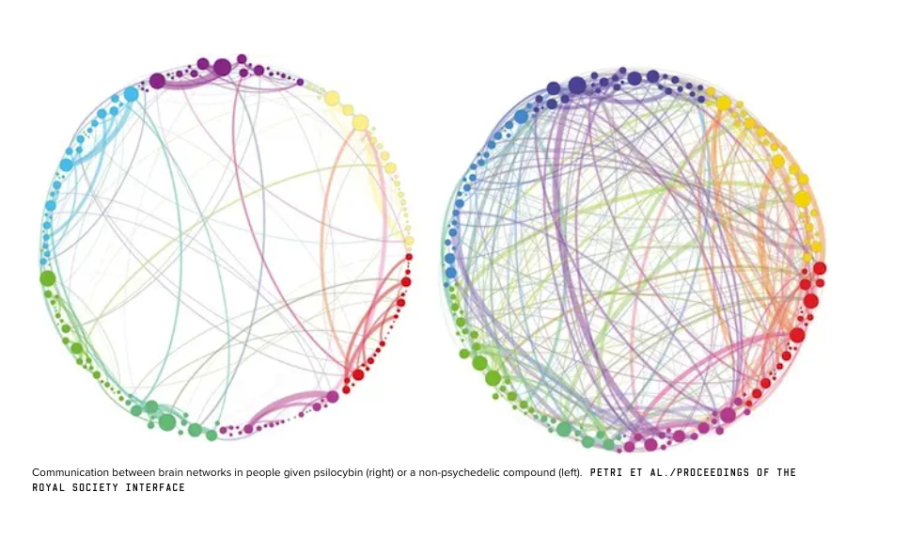

Link: <https://www.wired.com/2014/10/magic-mushroom-brain/>

Critique:

1. The data represented in the above graphic demonstrates how psilocybin changes the relationship between networks in the brain – causing a cross-linking between networks that didn’t originally exist.
2. This visualization in part answers the question “How does psilocybin alter the way we perceive reality?” It does so by showing cross-communication of networks in the brain, which causes “synesthesia” – the experience of sensory mix-up.
3. The before/after of this visualization is effective because it clearly shows that psilocybin causes some sort of change in brain activity.
4. I think the way the lines are drawn is ineffective and misleading, because it looks like the circle on the right has significantly more lines than the one on the left – which isn’t the case. Rather, the circle on the right just has lines linking to many more parts of the brain.
5. I like this visualization because it’s simple, nice to look at, and makes sense for common folk that are trying to understand how psilocybin affects their brain

This redesign is a tad sloppy, but it’s attempting to indicate that this visualization needs some level of interaction to demonstrate the communication pathways splitting – rather than multiplying. The data should initially be represented by the original visualization, and when a user hovers over a particular pathway, it should animate and split the pathway into many. There should also be some text indicating that the number of pathways before/after is the same – they’ve just split out to communicate with other networks.