Genotype-dependent zinc partitioning and biochemical responses in tomato under excess zinc
Allouche A.¹*, Arbaoui M.², Touati A.³, Yahia N.¹
¹ Rhizobium Biotechnology and Plant Breeding Laboratory, Department of Biotechnology, College of Natural and Life Sciences, University of Oran 1 Ahmed Ben Bella, Oran, 31023, Algeria
² University Abdelhamid Ibn Badis, Mostaganem, Algeria
³ Department of Applied Molecular Genetics, Faculty of Natural Sciences & Life, University of Sciences and Technology of Oran Mohamed-Boudiaf, USTO-MB, El Mnaouer, BP 1505, 31000, Oran, Algeria
*Corresponding author: A. Allouche; allouche.abdelkader@univ-oran1.dz

Highlights
- Zn strongly altered tomato biochemical traits without major growth effects.
- Saint-Pierre accumulated more Zn in leaves than Heinz under excess Zn.
- Heinz retained more Zn in roots at the highest Zn treatment.
- Saint-Pierre showed higher constitutive guaiacol peroxidase activity.
- Tissue Zn was strongly associated with chlorophyll loss across treatments.

Abstract
Zinc (Zn) is an essential micronutrient that becomes phytotoxic when present in excess. This study compared Zn accumulation and biochemical responses in two contrasting tomato genotypes, Heinz and Saint-Pierre (ST-P), exposed to 0, 100 and 250 mg ZnSO₄·7H₂O kg⁻¹ substrate under greenhouse conditions for 55 days. The experiment followed a randomized complete block design with two genotypes, three Zn treatments and three blocks, with three plants per experimental unit. Growth traits, soluble proteins, chlorophylls, carotenoids, tissue Zn, and guaiacol peroxidase (POD) activity were measured. Statistical inference was based on experimental-unit means; the three plants within each experimental unit were treated as subsamples. Zn treatment strongly affected leaf and root soluble proteins, chlorophyll a and b, total chlorophyll, tissue Zn and POD activity, whereas most morphological traits were not significantly affected. Leaf Zn increased to 252.4 ± 2.8 mg kg⁻¹ DW in Heinz and 310.7 ± 12.8 mg kg⁻¹ DW in ST-P at Zn250. Root Zn reached 339.1 ± 44.1 mg kg⁻¹ DW in Heinz and 249.1 ± 18.0 mg kg⁻¹ DW in ST-P, yielding translocation factors of 0.74 and 1.25, respectively. POD activity was constitutively higher in ST-P and increased with Zn in both genotypes. Across nine block × treatment means obtained after averaging the two genotypes, leaf and root Zn were strongly negatively associated with total chlorophyll (r = −0.967 and −0.983, respectively), while root Zn was positively associated with POD activity (r = 0.984). These findings indicate genotype-dependent Zn partitioning and antioxidant responses, but the measured variables do not by themselves establish the underlying transporter or subcellular sequestration mechanisms.

Keywords
Solanum lycopersicum; zinc excess; zinc partitioning; translocation factor; peroxidase; chlorophyll; oxidative stress

Graphical abstract
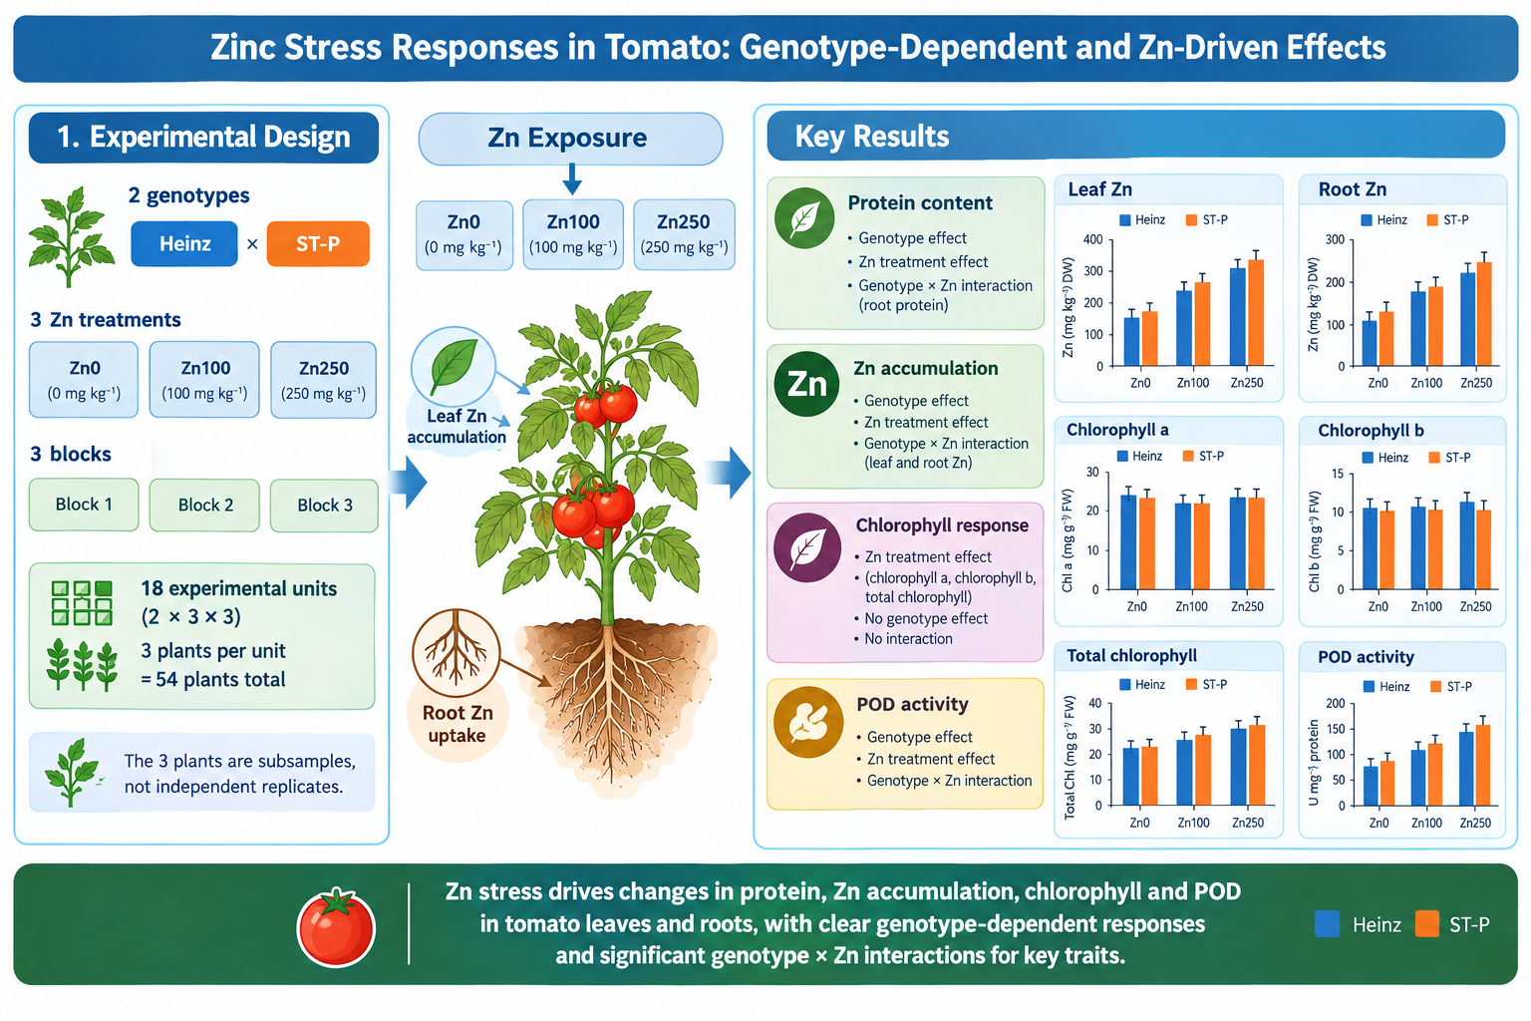

1. Introduction
Zinc (Zn) is an essential micronutrient required for numerous enzymatic and regulatory functions in plants, but excessive Zn availability can disrupt mineral homeostasis and cellular metabolism. Elevated Zn in agricultural soils can arise from mining, industrial emissions, fertilizers and other anthropogenic inputs. Tomato (Solanum lycopersicum L.) is an economically important crop whose genetic diversity can produce substantial differences in responses to abiotic stress.
Excess Zn can affect root development, photosynthetic pigments, protein metabolism and cellular redox balance. Plants respond through a combination of uptake regulation, cell-wall binding, intracellular chelation, compartmentation and antioxidant defenses. Transport systems involving heavy-metal ATPases and metal tolerance proteins contribute to Zn homeostasis, but their relative importance is genotype- and tissue-dependent. Because the present study measured tissue Zn concentrations rather than transporter expression or subcellular localization, these mechanisms are considered as possible explanations rather than demonstrated processes.
The translocation factor (TF), calculated here as the ratio of leaf to root Zn concentration, provides a simple descriptor of Zn partitioning between below- and above-ground tissues. A TF below one indicates greater Zn retention in roots than leaves, whereas a TF above one indicates greater concentration in leaves. Antioxidant enzymes, including guaiacol peroxidase (POD), can provide complementary information on physiological responses to metal exposure.
Low and moderate metal exposures can sometimes produce non-linear responses, including transient stimulation of selected metabolic processes before inhibition at higher exposure. Such biphasic responses should be interpreted cautiously and should not be equated automatically with a mechanistically demonstrated hormetic process.
This study compared the industrial tomato genotype Heinz and the traditional genotype Saint-Pierre (ST-P) under three ZnSO₄·7H₂O concentrations. We hypothesized that the genotypes would differ in Zn partitioning and antioxidant responses, and that biochemical variables would respond more strongly than gross morphological traits. The objectives were to quantify effects of Zn on growth and water status, characterize changes in soluble proteins and photosynthetic pigments, compare Zn accumulation and partitioning between roots and leaves, and determine whether POD activity was associated with Zn exposure.

2. Materials and methods

2.1. Plant material and experimental conditions
Two tomato genotypes were used: Heinz (Hnz), an industrial determinate-growth cultivar, and Saint-Pierre (ST-P), a traditional indeterminate-growth cultivar. Seeds were surface-sterilized in 5% sodium hypochlorite for 10 min, rinsed three times in sterile distilled water, and germinated in a sterilized peat/sand mixture (1:1, v/v). Seedlings at the 3–5 true-leaf stage (21 days after germination) were transplanted into 1-kg pots filled with substrate and grown under controlled greenhouse conditions with a natural photoperiod and a reported night/day temperature range of 15–20 °C.

2.2. Experimental design and Zn treatments
A randomized complete block design was used with genotype (Heinz and ST-P) and Zn treatment (Zn0, Zn100 and Zn250) as experimental factors and three blocks. ZnSO₄·7H₂O (purity ≥99%) was applied at nominal concentrations of 0, 100 and 250 mg kg⁻¹ substrate, corresponding to 0, 439 and 1099.5 mg ZnSO₄·7H₂O per pot, respectively, via fertigation over four weeks. Each genotype × treatment combination was represented in each of three independent blocks. Each experimental unit contained three plants, giving 18 experimental units and 54 plants in total. The treatment period was 55 days after transplanting, corresponding to the full-flowering stage.

2.3. Morphological measurements
At harvest, stem length, root length, numbers of ramifications, branches and flowers, fresh weights of roots and shoots, dry weights, and relative water content (RWC) were recorded. Dry weight was determined after oven-drying according to the laboratory protocol. RWC was calculated as RWC = [(FW − DW)/(TW − DW)] × 100, where FW is fresh weight, TW is turgid weight after 24 h in distilled water, and DW is dry weight.

2.4. Biochemical analyses
Leaf and root tissues were sampled at the end of the experiment, immediately placed on ice and processed under refrigerated conditions (4 °C). Soluble proteins were quantified by the Bradford method using bovine serum albumin as the standard, with absorbance measured at 595 nm. Chlorophylls and carotenoids were extracted in 80% acetone (v/v) following Lichtenthaler and Wellburn and quantified spectrophotometrically.
Zn concentrations in leaf and root tissues were determined by flame atomic absorption spectrometry (FAAS) at 213.9 nm after acid digestion with HNO₃ (65%) and H₂O₂ (30%) at 120 °C, using an AAnalyst 400 spectrometer. Quality assurance included procedural blanks, a Zn calibration range of 0.05–5.0 mg L⁻¹ (R² = 0.9997), spike recovery of 97.3 ± 3.1% (n = 6), LOD of 0.02 mg kg⁻¹ and LOQ of 0.07 mg kg⁻¹, and analysis of NIST SRM 1573a tomato leaves (measured Zn = 30.8 ± 1.2 mg kg⁻¹ versus certified 30.9 ± 0.7 mg kg⁻¹). The translocation factor was calculated as TF = [Zn]leaf/[Zn]root.

2.5. Peroxidase activity
Guaiacol peroxidase (POD; EC 1.11.1.7) activity was measured spectrophotometrically following Chance and Maehly. The 3-mL reaction mixture contained phosphate buffer (0.1 M, pH 7.0), 1% guaiacol, 0.3% H₂O₂ and crude enzyme extract. Absorbance at 470 nm was monitored for 120 s, and the initial linear phase was used for activity calculations. The molar extinction coefficient of tetraguaiacol (ε = 26.6 mM⁻¹ cm⁻¹) was used. One unit of activity was defined as the amount of enzyme catalyzing oxidation of 1 μmol guaiacol min⁻¹ under the assay conditions.

2.6. Statistical analysis
Statistical analyses were performed using SPSS v. 26.0 and R v. 4.3.1. Because three plants were nested within each experimental unit, individual plants were treated as subsamples rather than independent biological replicates. For inferential analyses, values from the three plants within each experimental unit were averaged, producing 18 experimental-unit means (2 genotypes × 3 treatments × 3 blocks). Responses were analyzed using a randomized complete block ANOVA with genotype, Zn treatment and genotype × treatment interaction as fixed effects and block as a blocking factor. Tukey-adjusted comparisons were used for post hoc mean separation at α = 0.05. Partial eta-squared (η²p) was used as an effect-size measure.
Pearson correlations were calculated from experimental-unit means. For pooled correlations, Heinz and ST-P values were first averaged within each block × treatment combination, yielding nine observations (3 blocks × 3 treatments; n = 9). For genotype-specific correlations, the three experimental units per treatment were retained across the three blocks, giving n = 9 per genotype. Thus, no individual plant within an experimental unit was treated as an independent replicate in the correlation analyses.

3. Results

3.1. Morphological responses
Zn exposure did not significantly affect stem length, root length, numbers of ramifications, branches or flowers, or fresh weights in the randomized complete block analysis. Relative water content was also unaffected by genotype, treatment or their interaction (genotype F = 0.31, p = 0.588; treatment F = 0.12, p = 0.886; interaction F = 1.62, p = 0.245). Dry weight showed no significant genotype effect after block adjustment (F = 4.26, p = 0.066), and no significant treatment or genotype × treatment effects were detected. Thus, the corrected RCBD analysis supports the conclusion that gross morphology was comparatively stable over the tested exposure range.

3.2. Soluble proteins
Leaf soluble protein concentration was strongly affected by genotype (F = 675.77, p < 0.001, η²p = 0.985) and Zn treatment (F = 974.37, p < 0.001, η²p = 0.995), whereas the genotype × treatment interaction was not significant (F = 0.81, p = 0.470). Across genotypes, leaf protein increased from 20.83 ± 3.26 mg mL⁻¹ at Zn0 to 27.91 ± 3.51 mg mL⁻¹ at Zn100 (+34.0%), then decreased to 14.52 ± 3.66 mg mL⁻¹ at Zn250 (−30.3% relative to Zn0). Root soluble protein was also strongly affected by genotype (F = 352.20, p < 0.001, η²p = 0.972) and treatment (F = 320.44, p < 0.001, η²p = 0.985), with a significant genotype × treatment interaction (F = 20.88, p < 0.001, η²p = 0.807). Root protein increased by approximately 62.9% at Zn100 and remained above the control at Zn250 when genotypes were considered together. The biphasic pattern is consistent with a dose-dependent metabolic response, but the present measurements do not identify the specific proteins responsible.

3.3. Zn accumulation and partitioning
Leaf Zn was strongly affected by genotype (F = 25.90, p < 0.001, η²p = 0.721), Zn treatment (F = 733.93, p < 0.001, η²p = 0.993), and their interaction (F = 10.35, p = 0.004, η²p = 0.674). At Zn250, leaf Zn reached 252.4 ± 2.8 mg kg⁻¹ DW in Heinz and 310.7 ± 12.8 mg kg⁻¹ DW in ST-P. Root Zn was likewise affected by genotype (F = 11.75, p = 0.006, η²p = 0.540), treatment (F = 204.98, p < 0.001, η²p = 0.976), and their interaction (F = 6.83, p = 0.014, η²p = 0.577). At Zn250, root Zn was 339.1 ± 44.1 mg kg⁻¹ DW in Heinz compared with 249.1 ± 18.0 mg kg⁻¹ DW in ST-P.
At Zn250, the calculated TF was 0.74 for Heinz and 1.25 for ST-P. This indicates greater root retention in Heinz and greater relative partitioning of Zn to leaves in ST-P. These TF values describe tissue-level partitioning and do not by themselves demonstrate xylem loading, vacuolar sequestration, or transporter activity.

3.4. Photosynthetic pigments
Chlorophyll a was strongly affected by Zn treatment (F = 82.60, p < 0.001, η²p = 0.943), whereas genotype (F = 1.42, p = 0.261) and genotype × treatment interaction (F = 0.24, p = 0.794) were not significant. Chlorophyll a decreased from 19.13 ± 2.92 μg mL⁻¹ at Zn0 to 13.67 ± 1.65 μg mL⁻¹ at Zn100 and 9.65 ± 1.06 μg mL⁻¹ at Zn250, corresponding to reductions of 28.6% and 49.6%, respectively.
Chlorophyll b was also strongly affected by treatment (F = 17.13, p < 0.001, η²p = 0.774), with no significant genotype or interaction effect. Mean chlorophyll b declined from 8.36 ± 2.76 μg mL⁻¹ at Zn0 to 5.10 ± 2.18 μg mL⁻¹ at Zn100 and 3.11 ± 0.86 μg mL⁻¹ at Zn250. Carotenoids were not significantly affected by genotype, treatment or their interaction (treatment F = 1.49, p = 0.272). Total chlorophyll was strongly affected by Zn treatment (F = 147.75, p < 0.001, η²p = 0.967), without significant genotype or interaction effects.

3.5. Peroxidase activity
POD activity was strongly affected by genotype (F = 1512.89, p < 0.001, η²p = 0.993), Zn treatment (F = 941.43, p < 0.001, η²p = 0.995), and genotype × treatment interaction (F = 11.16, p = 0.003, η²p = 0.691). Mean POD activity increased in Heinz from 0.077 U mL⁻¹ at Zn0 to 0.101 U mL⁻¹ at Zn100 and 0.116 U mL⁻¹ at Zn250. In ST-P, corresponding values were 0.105, 0.132 and 0.153 U mL⁻¹. Thus, ST-P had approximately 35.5% higher constitutive POD activity at Zn0. Specific POD activity was also significantly affected by genotype, treatment and their interaction (F = 35.38, 1365.39 and 48.20, respectively; all p ≤ 0.001).

3.6. Correlation analysis
Correlation analyses were performed using nine pooled block × treatment means after averaging Heinz and ST-P within each block × treatment combination. Leaf Zn was strongly and negatively associated with total chlorophyll (r = −0.967, p < 0.001, n = 9), as was root Zn (r = −0.983, p < 0.001, n = 9). Root Zn was strongly positively associated with POD activity (r = 0.984, p < 0.001, n = 9). In contrast, leaf protein and POD activity were not significantly correlated under the corrected analysis (r = −0.384, p = 0.308, n = 9).
Genotype-specific analyses also showed strong negative associations between leaf Zn and total chlorophyll: Heinz, r = −0.964 (p < 0.001, n = 9); ST-P, r = −0.948 (p < 0.001, n = 9). Because Zn concentration and chlorophyll both changed strongly with treatment, these correlations should be interpreted as associations across the experimental gradient rather than evidence of a direct causal relationship.

4. Discussion

4.1. Biochemical sensitivity despite limited morphological effects
The corrected RCBD analysis indicates that the tested Zn concentrations produced much stronger biochemical than morphological responses. Most growth variables and RWC remained statistically stable, whereas soluble proteins, chlorophylls, tissue Zn and POD activity showed large treatment effects. This dissociation is consistent with the concept that metabolic and biochemical responses can precede conspicuous morphological injury, although the present experiment does not establish a temporal sequence because measurements were made at harvest.
The absence of a significant dry-weight treatment effect after accounting for block is particularly important. The previously reported genotype effect for dry weight (F = 5.114, p = 0.043) resulted from an analysis that did not account for the blocking structure. With block included in the RCBD model, the genotype effect was not statistically significant (F = 4.26, p = 0.066). Accordingly, the manuscript no longer interprets dry weight as demonstrating a genotype difference.

4.2. Biphasic protein response
Soluble proteins increased at Zn100 and declined at Zn250, particularly in leaves, while root proteins remained elevated at the highest dose. This pattern is compatible with a biphasic dose response and may reflect transient metabolic adjustment at moderate exposure followed by stronger perturbation at higher exposure. However, because individual stress proteins, protein synthesis rates and proteolysis were not measured, explanations involving metallothioneins, heat-shock proteins or oxidative proteolysis remain hypotheses rather than demonstrated mechanisms.

4.3. Genotype-dependent Zn partitioning
The clearest genotype-dependent response concerned Zn partitioning. Heinz accumulated more Zn in roots at Zn250, whereas ST-P accumulated more Zn in leaves and showed a TF above one. Root retention can reduce delivery of Zn to aerial tissues, whereas greater shoot partitioning may allow different downstream detoxification processes. Cell-wall binding, chelation, xylem loading and vacuolar storage are all plausible mechanisms described for plant Zn homeostasis, but none was directly measured here. Therefore, the present data support a difference in tissue partitioning, not a definitive assignment of transporter-mediated xylem loading or vacuolar sequestration.
The contrasting TF values should also be considered in relation to crop use. A genotype that partitions more Zn to shoots may tolerate soil Zn without major growth effects while simultaneously increasing the potential for Zn entry into edible tissues. Consequently, tolerance and food safety are not necessarily equivalent traits.

4.4. Chlorophyll loss and POD response
Chlorophyll a and b declined substantially with increasing Zn, while genotype effects were not significant. The strong negative associations between tissue Zn and total chlorophyll across the nine pooled means reinforce the link between Zn exposure and pigment loss, but they do not distinguish among possible mechanisms such as altered mineral nutrition, pigment biosynthesis, chloroplast damage or oxidative effects.
POD activity showed a different genotype pattern. ST-P had higher constitutive activity and maintained a higher absolute POD activity at all Zn treatments, while both genotypes increased POD with Zn exposure. The strong positive association between root Zn and POD across the pooled treatment gradient is compatible with induction of antioxidant capacity as Zn accumulation increases. Nevertheless, ROS concentrations and additional antioxidant enzymes were not measured, so the data demonstrate POD responsiveness rather than a complete characterization of oxidative stress.
Importantly, the corrected correlation analysis no longer supports a significant relationship between leaf soluble protein and POD activity. The previous association was therefore removed from the manuscript. This illustrates the importance of basing correlation inference on independent experimental units rather than pooled plant-level observations.

4.5. Implications for genotype selection
Taken together, the results identify two measurable phenotypic dimensions of Zn response: tissue partitioning and antioxidant capacity. ST-P combined greater shoot Zn partitioning with higher constitutive POD activity, whereas Heinz retained more Zn in roots at the highest treatment. These traits may be useful as candidate indicators in comparative screening, but their predictive value for field tolerance requires validation across additional genotypes, Zn regimes and environmental conditions.
Future experiments should directly quantify Zn localization at the cellular and subcellular levels and examine expression or activity of candidate transport systems such as HMA and MTP proteins. Such measurements would test whether the observed TF contrast is associated with differential xylem loading, vacuolar sequestration or other processes. Measurements of ROS, membrane damage and a broader antioxidant panel would also help determine how Zn partitioning is connected to redox regulation.

5. Conclusions
Excess Zn produced pronounced biochemical responses in Heinz and ST-P tomato despite limited effects on gross morphology and water status. Zn strongly altered soluble proteins, chlorophylls, tissue Zn accumulation and POD activity. At Zn250, Heinz retained more Zn in roots (TF = 0.74), whereas ST-P showed greater relative partitioning to leaves (TF = 1.25) and higher constitutive POD activity. The corrected experimental-unit analysis further showed strong negative associations between tissue Zn and total chlorophyll and a strong positive association between root Zn and POD activity across the experimental gradient. These results support genotype-dependent differences in Zn partitioning and antioxidant responsiveness, while avoiding attribution of unmeasured transporter or subcellular mechanisms. Further physiological and molecular studies are needed to determine how these phenotypes arise and whether they can be exploited reliably in tomato breeding.

Tables
Variable | Genotype F (p) | η²p | Zn treatment F (p) | η²p | G × T F (p) | η²p
Dry weight | 4.26 (0.066) | 0.299 | 0.48 (0.630) | 0.088 | 0.38 (0.692) | 0.071
RWC | 0.31 (0.588) | 0.030 | 0.12 (0.885) | 0.024 | 1.62 (0.245) | 0.245
Leaf soluble protein | 675.77 (<0.001) | 0.985 | 974.37 (<0.001) | 0.995 | 0.81 (0.470) | 0.140
Root soluble protein | 352.20 (<0.001) | 0.972 | 320.44 (<0.001) | 0.985 | 20.88 (<0.001) | 0.807
Leaf Zn | 25.90 (<0.001) | 0.721 | 733.93 (<0.001) | 0.993 | 10.35 (0.004) | 0.674
Root Zn | 11.75 (0.006) | 0.540 | 204.98 (<0.001) | 0.976 | 6.83 (0.014) | 0.577
Chlorophyll a | 1.42 (0.261) | 0.125 | 82.60 (<0.001) | 0.943 | 0.24 (0.794) | 0.045
Chlorophyll b | 0.38 (0.550) | 0.037 | 17.13 (<0.001) | 0.774 | 0.30 (0.749) | 0.056
Total chlorophyll | 0.14 (0.716) | 0.014 | 147.75 (<0.001) | 0.967 | 0.50 (0.620) | 0.091
Carotenoids | 0.41 (0.536) | 0.039 | 1.49 (0.272) | 0.229 | 0.35 (0.716) | 0.065
POD activity | 1512.89 (<0.001) | 0.993 | 941.43 (<0.001) | 0.995 | 11.16 (0.003) | 0.691
POD specific activity | 35.38 (<0.001) | 0.780 | 1365.39 (<0.001) | 0.996 | 48.20 (<0.001) | 0.906

Table 1. Corrected randomized complete block ANOVA based on 18 experimental-unit means (three plants averaged within each experimental unit). Block was included as a blocking factor. η²p, partial eta-squared.
Variable | Genotype | Treatment | Mean ± SD | Unit
Leaf soluble protein | Heinz | Zn0 | 17.831 ± 0.643 | mg mL⁻¹
Leaf soluble protein | Heinz | Zn100 | 24.618 ± 0.800 | mg mL⁻¹
Leaf soluble protein | Heinz | Zn250 | 11.144 ± 0.411 | mg mL⁻¹
Leaf soluble protein | ST-P | Zn0 | 23.836 ± 0.277 | mg mL⁻¹
Leaf soluble protein | ST-P | Zn100 | 31.192 ± 0.485 | mg mL⁻¹
Leaf soluble protein | ST-P | Zn250 | 17.888 ± 0.315 | mg mL⁻¹
Root soluble protein | Heinz | Zn0 | 22.847 ± 0.629 | mg mL⁻¹
Root soluble protein | Heinz | Zn100 | 37.649 ± 1.875 | mg mL⁻¹
Root soluble protein | Heinz | Zn250 | 24.858 ± 0.432 | mg mL⁻¹
Root soluble protein | ST-P | Zn0 | 29.037 ± 0.271 | mg mL⁻¹
Root soluble protein | ST-P | Zn100 | 46.897 ± 1.371 | mg mL⁻¹
Root soluble protein | ST-P | Zn250 | 39.369 ± 0.806 | mg mL⁻¹
Leaf Zn | Heinz | Zn0 | 25.851 ± 5.145 | mg kg⁻¹ DW
Leaf Zn | Heinz | Zn100 | 214.176 ± 14.075 | mg kg⁻¹ DW
Leaf Zn | Heinz | Zn250 | 252.400 ± 2.782 | mg kg⁻¹ DW
Leaf Zn | ST-P | Zn0 | 20.066 ± 0.788 | mg kg⁻¹ DW
Leaf Zn | ST-P | Zn100 | 251.053 ± 20.292 | mg kg⁻¹ DW
Leaf Zn | ST-P | Zn250 | 310.698 ± 12.787 | mg kg⁻¹ DW
Root Zn | Heinz | Zn0 | 25.604 ± 4.618 | mg kg⁻¹ DW
Root Zn | Heinz | Zn100 | 226.252 ± 23.272 | mg kg⁻¹ DW
Root Zn | Heinz | Zn250 | 339.089 ± 44.085 | mg kg⁻¹ DW
Root Zn | ST-P | Zn0 | 33.577 ± 6.948 | mg kg⁻¹ DW
Root Zn | ST-P | Zn100 | 196.080 ± 1.927 | mg kg⁻¹ DW
Root Zn | ST-P | Zn250 | 249.108 ± 17.964 | mg kg⁻¹ DW
Chlorophyll a | Heinz | Zn0 | 18.853 ± 0.951 | µg mL⁻¹
Chlorophyll a | Heinz | Zn100 | 13.024 ± 0.797 | µg mL⁻¹
Chlorophyll a | Heinz | Zn250 | 9.494 ± 0.794 | µg mL⁻¹
Chlorophyll a | ST-P | Zn0 | 19.413 ± 2.526 | µg mL⁻¹
Chlorophyll a | ST-P | Zn100 | 14.316 ± 0.959 | µg mL⁻¹
Chlorophyll a | ST-P | Zn250 | 9.807 ± 0.809 | µg mL⁻¹
Chlorophyll b | Heinz | Zn0 | 8.982 ± 0.886 | µg mL⁻¹
Chlorophyll b | Heinz | Zn100 | 5.230 ± 0.500 | µg mL⁻¹
Chlorophyll b | Heinz | Zn250 | 3.050 ± 0.809 | µg mL⁻¹
Chlorophyll b | ST-P | Zn0 | 7.748 ± 2.463 | µg mL⁻¹
Chlorophyll b | ST-P | Zn100 | 4.965 ± 2.340 | µg mL⁻¹
Chlorophyll b | ST-P | Zn250 | 3.174 ± 0.325 | µg mL⁻¹
Total chlorophyll | Heinz | Zn0 | 27.835 ± 1.619 | µg mL⁻¹
Total chlorophyll | Heinz | Zn100 | 18.254 ± 0.302 | µg mL⁻¹
Total chlorophyll | Heinz | Zn250 | 12.544 ± 0.754 | µg mL⁻¹
Total chlorophyll | ST-P | Zn0 | 27.160 ± 2.201 | µg mL⁻¹
Total chlorophyll | ST-P | Zn100 | 19.281 ± 1.382 | µg mL⁻¹
Total chlorophyll | ST-P | Zn250 | 12.980 ± 1.121 | µg mL⁻¹
POD activity | Heinz | Zn0 | 0.077 ± 0.001 | U mL⁻¹
POD activity | Heinz | Zn100 | 0.101 ± 0.002 | U mL⁻¹
POD activity | Heinz | Zn250 | 0.116 ± 0.003 | U mL⁻¹
POD activity | ST-P | Zn0 | 0.105 ± 0.001 | U mL⁻¹
POD activity | ST-P | Zn100 | 0.132 ± 0.001 | U mL⁻¹
POD activity | ST-P | Zn250 | 0.153 ± 0.002 | U mL⁻¹

Table 2. Means ± SD calculated from the three independent experimental units within each genotype × treatment combination. For biochemical variables, each experimental-unit value is the mean of three subsampled plants.
Variables | Pearson r | p | n | Analysis
Leaf Zn × total chlorophyll | −0.967 | <0.001 | 9 | Pooled block × treatment means
Root Zn × total chlorophyll | −0.983 | <0.001 | 9 | Pooled block × treatment means
Root Zn × POD | +0.984 | <0.001 | 9 | Pooled block × treatment means
Leaf protein × POD | −0.384 | 0.308 | 9 | Pooled block × treatment means
Heinz: leaf Zn × total chlorophyll | −0.964 | <0.001 | 9 | Genotype-specific
ST-P: leaf Zn × total chlorophyll | −0.948 | <0.001 | 9 | Genotype-specific

Table 3. Corrected Pearson correlations based on experimental-unit means. For pooled analyses, Heinz and ST-P values were averaged within each block × treatment combination.

Supplementary-style calculated descriptors
Genotype | Zn treatment | Leaf Zn (mg kg⁻¹ DW) | Root Zn (mg kg⁻¹ DW) | TF
Heinz | Zn250 | 252.4 | 339.1 | 0.74
ST-P | Zn250 | 310.7 | 249.1 | 1.25

TF = leaf Zn/root Zn. These values are descriptive partitioning indices and do not establish a specific cellular mechanism.

Figures
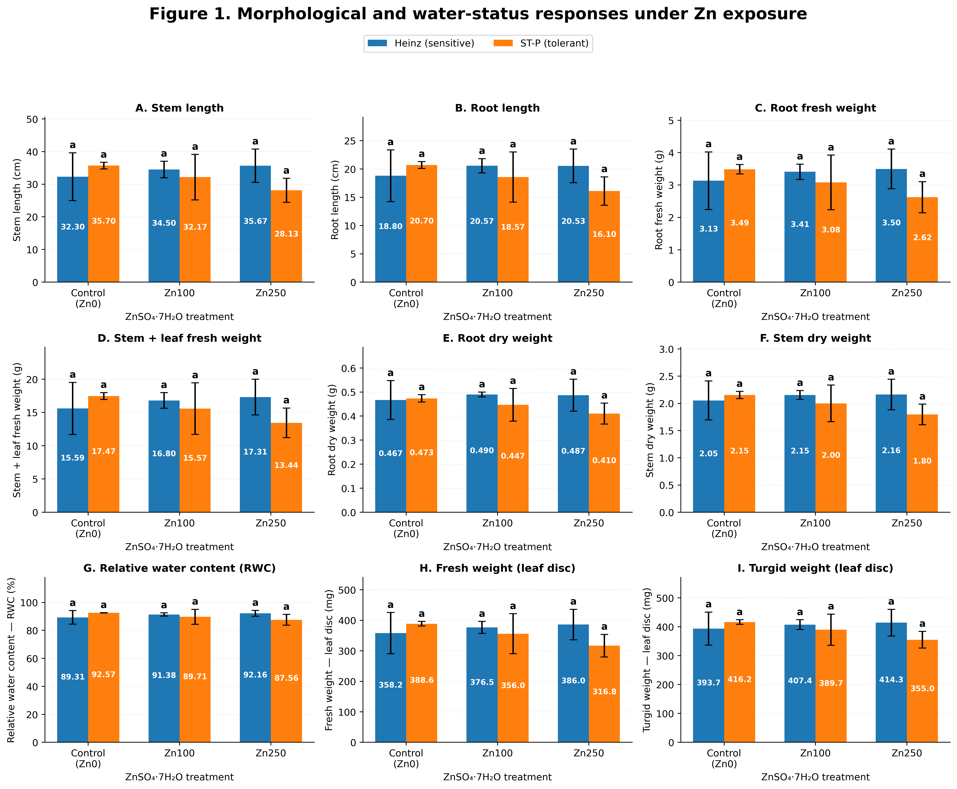
Figure 1. Morphological and water-status responses of Heinz and Saint-Pierre tomato plants under Zn0, Zn100 and Zn250 treatments. Values are based on experimental-unit means; error bars should represent SD or SE consistently with the final artwork.
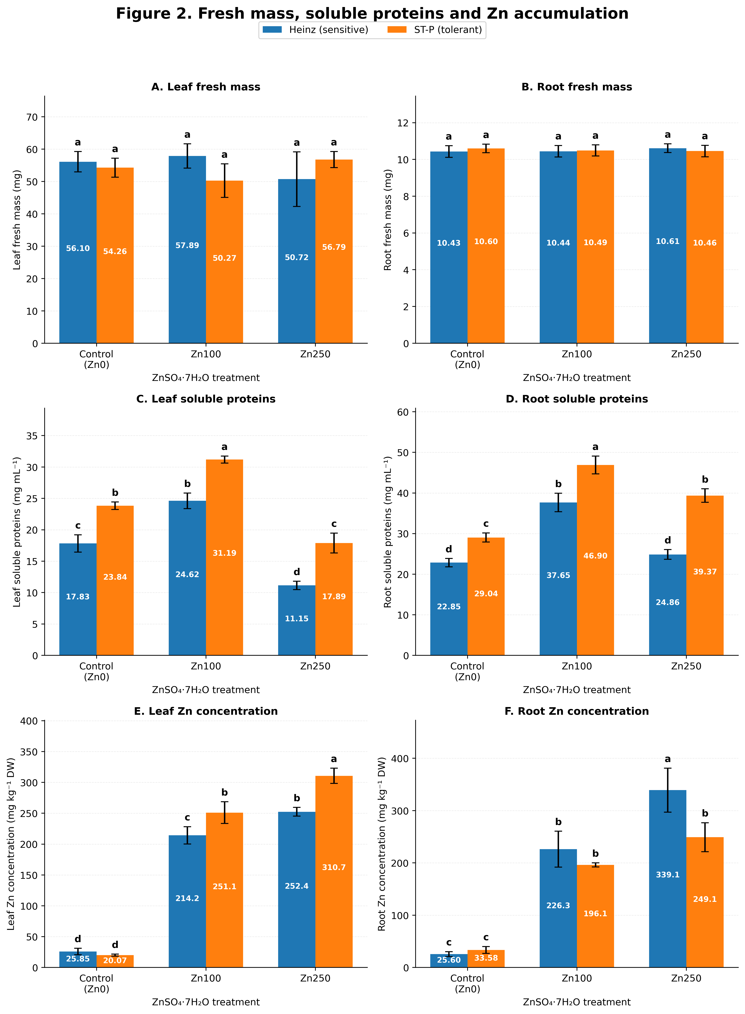
Figure 2. Soluble protein concentrations and Zn accumulation in leaves and roots of Heinz and Saint-Pierre under Zn stress. The inset reports the translocation factor (TF = leaf Zn/root Zn).
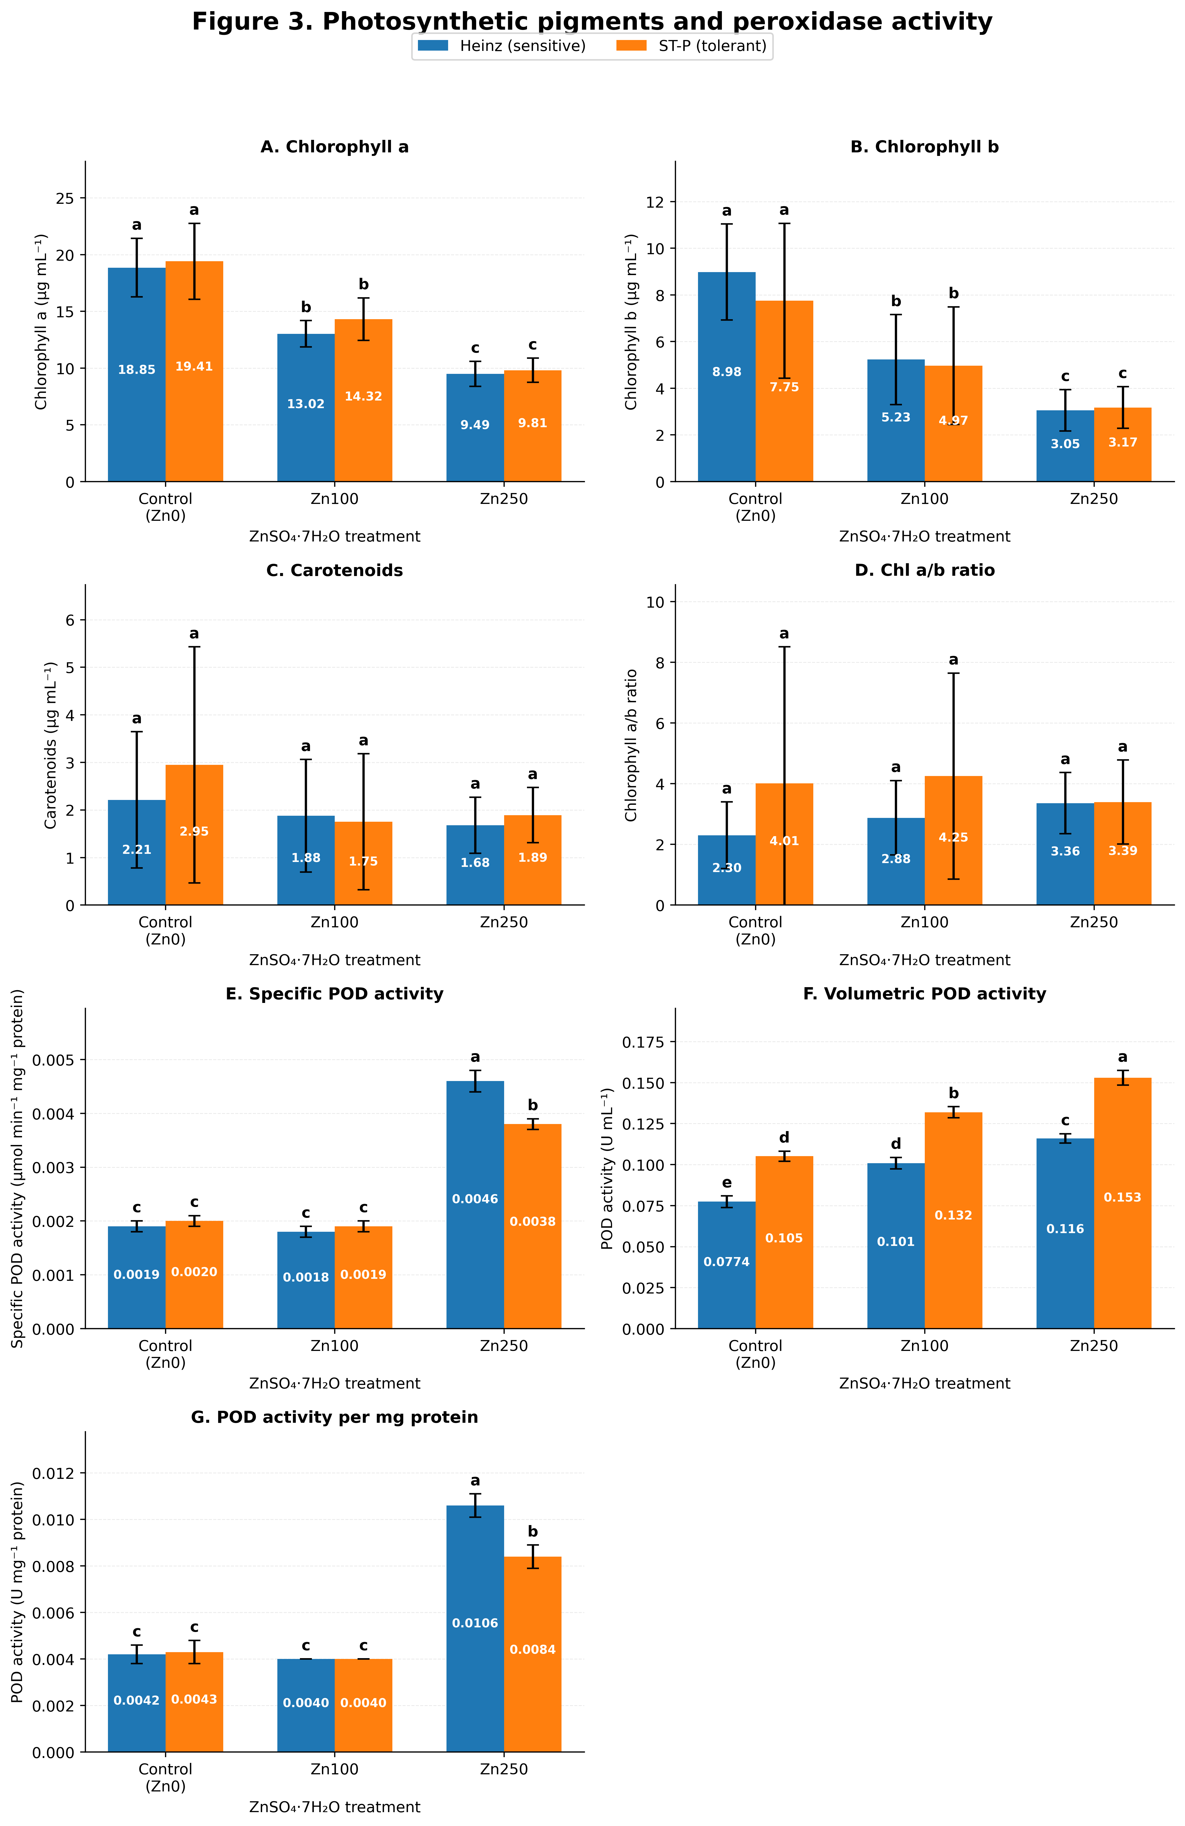
Figure 3. Effects of Zn treatment on chlorophyll a, chlorophyll b, carotenoids and guaiacol peroxidase activity in Heinz and Saint-Pierre.
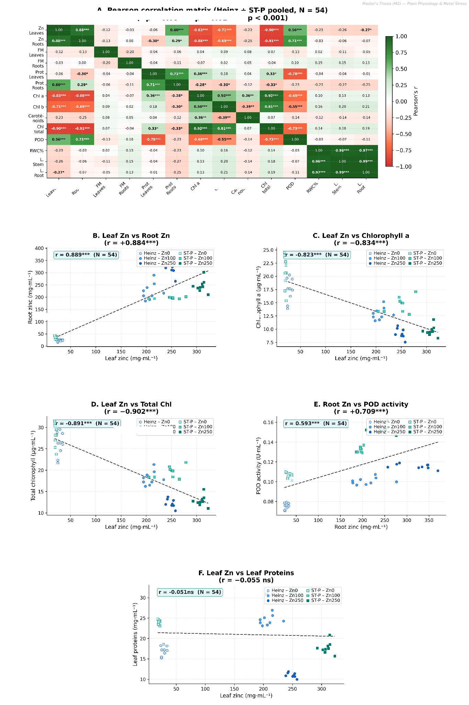
Figure 4. Relationships among tissue Zn, total chlorophyll and POD activity based on corrected experimental-unit means. Pooled correlations use nine block × treatment means.
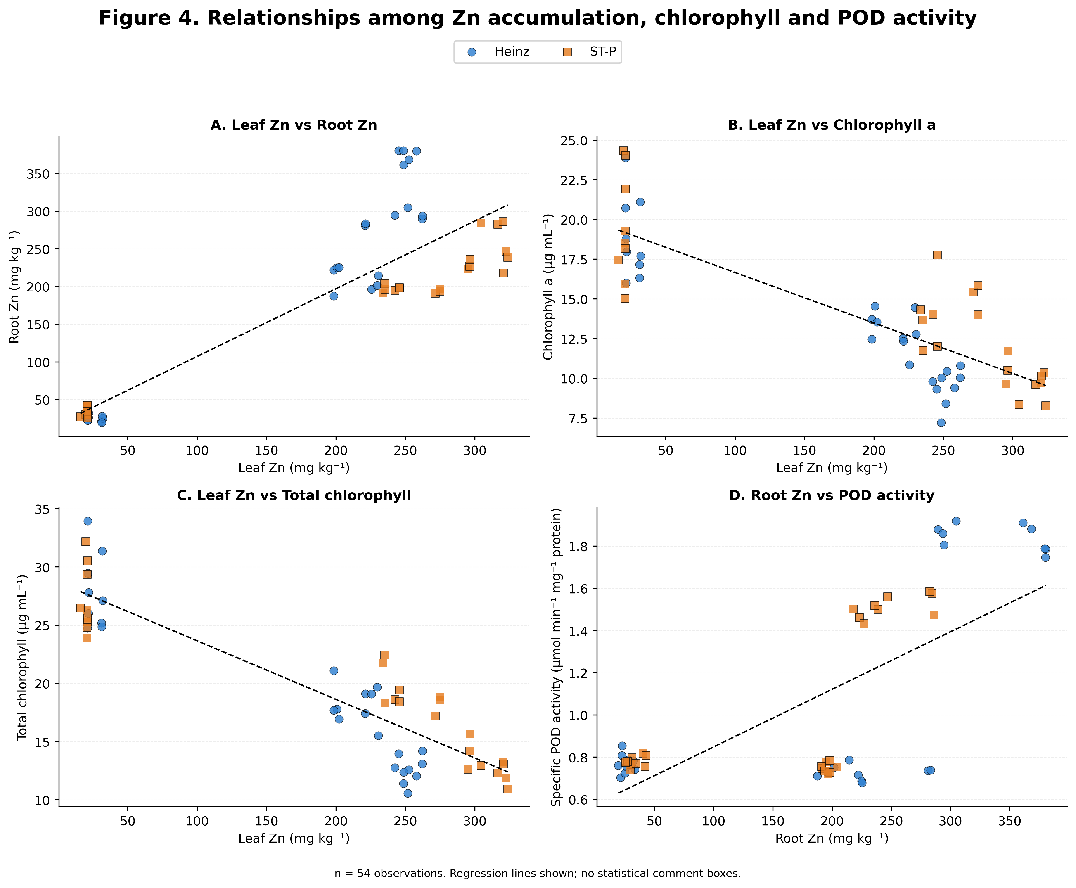
Figure 5. Corrected correlation analyses between tissue Zn, photosynthetic pigments and guaiacol peroxidase activity, recomputed from the corrected experimental-unit means.
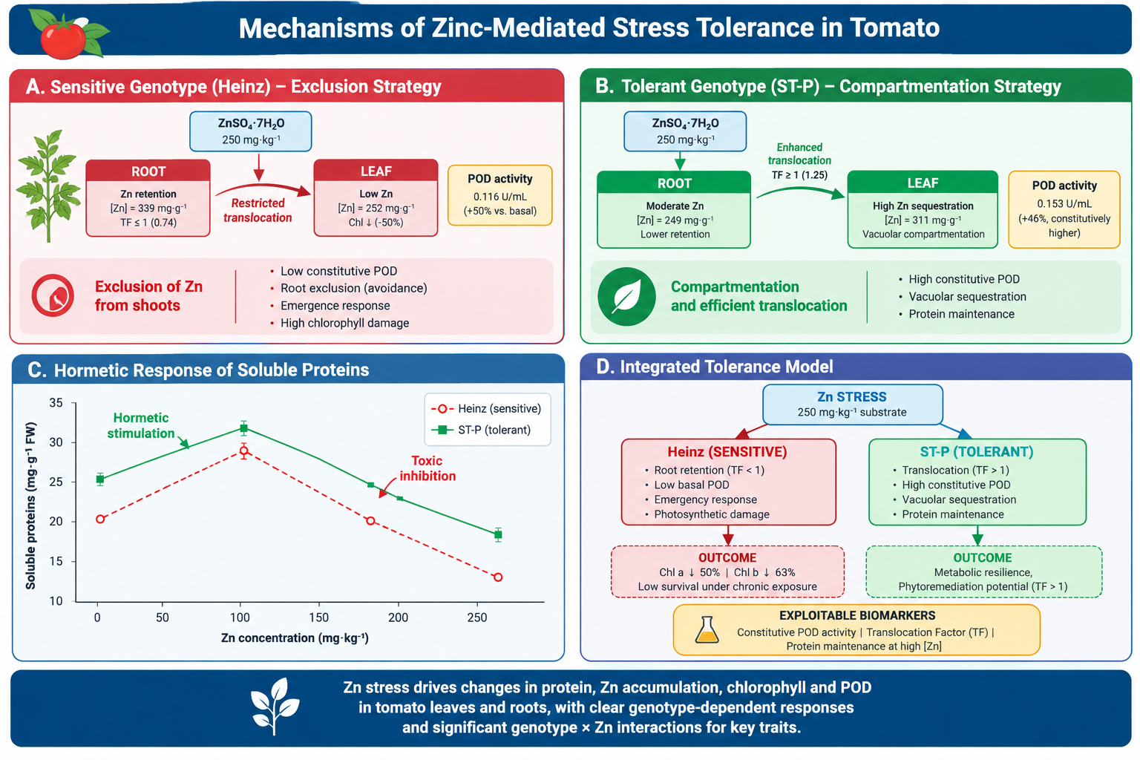
Figure 6. Conceptual model of genotype-dependent Zn responses: (A) root-retention strategy of Heinz (TF < 1, low constitutive POD, stronger photosynthetic damage); (B) translocation strategy of Saint-Pierre (TF > 1, high constitutive POD); (C) biphasic soluble-protein response; (D) integrated summary of the measurable descriptors. The model is a descriptive synthesis of the measured traits and does not assert unmeasured transporter or subcellular mechanisms.

Statements and declarations

Competing interests
The authors declare that they have no known competing financial interests or personal relationships that could have appeared to influence the work reported in this paper.

Funding
This research received no specific grant from any funding agency in the public, commercial, or not-for-profit sectors.

Author contributions
A.A. conceptualized the study, conducted the experiments, performed data analysis and wrote the original draft. Y.N. and M.A. supervised the research, provided methodological guidance, reviewed and edited the manuscript, and contributed to resource acquisition. M.A. and A.T. contributed to biochemical assays and data interpretation. All authors read and approved the final manuscript.

Data availability
The datasets generated and analyzed during the current study are available from the corresponding author on reasonable request.

Ethics approval
This article does not contain any studies with human participants or animals performed by any of the authors.

Acknowledgements
The authors thank the staff of the Rhizobium Biotechnology and Plant Breeding Laboratory, University of Oran 1 Ahmed Ben Bella, for technical support during greenhouse experiments and biochemical analyses.

References
1. Ahmed DAE, Slima DF, Al-Yasi HM, Hassan LM, Galal TM (2023) Risk assessment of trace metals in Solanum lycopersicum L. (tomato) grown under wastewater irrigation conditions. Environ Sci Pollut Res Int 30:42255–42266. https://doi.org/10.1007/s11356-023-25157-8
2. Alloway BJ (2013) Heavy Metals in Soils: Trace Metals and Metalloids in Soils and their Bioavailability, 3rd edn. Springer, Dordrecht. https://doi.org/10.1007/978-94-007-4470-7
3. Barrs HD, Weatherley PE (1962) A re-examination of the relative turgidity technique for estimating water deficits in leaves. Aust J Biol Sci 15:413–428. https://doi.org/10.1071/BI9620413
4. Bauchet G, Causse M (2012) Genetic diversity in tomato (Solanum lycopersicum and wild relatives). In: Genetic Diversity in Plants. IntechOpen, pp 133–162.
5. Bradford MM (1976) A rapid and sensitive method for the quantitation of microgram quantities of protein utilizing the principle of protein-dye binding. Anal Biochem 72:248–254. https://doi.org/10.1016/0003-2697(76)90527-3
6. Broadley MR, White PJ, Hammond JP, Zelko I, Lux A (2007) Zinc in plants. New Phytol 173:677–702. https://doi.org/10.1111/j.1469-8137.2007.01996.x
7. Calabrese EJ, Baldwin LA (2001) Hormesis: U-shaped dose responses and their centrality in toxicology. Trends Pharmacol Sci 22:285–291. https://doi.org/10.1016/S0165-6147(00)01719-3
8. Chance B, Maehly AC (1955) Assay of catalases and peroxidases. Methods Enzymol 2:764–775. https://doi.org/10.1016/S0076-6879(55)02300-8
9. Clemens S, Palmgren MG, Kramer U (2002) A long way ahead: understanding and engineering plant metal accumulation. Trends Plant Sci 7:309–315. https://doi.org/10.1016/S1360-1385(02)02295-1
10. Cobbett C, Goldsbrough P (2002) Phytochelatins and metallothioneins: roles in heavy metal detoxification and homeostasis. Annu Rev Plant Biol 53:159–182. https://doi.org/10.1146/annurev.arplant.53.100301.135154
11. Coleman JE (1992) Zinc proteins: enzymes, storage proteins, transcription factors, and replication proteins. Annu Rev Biochem 61:897–946. https://doi.org/10.1146/annurev.bi.61.070192.004341
12. Cuypers A, Karen S, Jos R, Kelly H, Tony R, Nele H, Jaco V (2011) The cellular redox state as a modulator in cadmium and copper responses in Arabidopsis thaliana seedlings. J Plant Physiol 168:309–316. https://doi.org/10.1016/j.jplph.2010.07.010
13. Cuypers A, Hendrix S, Amaral dos Reis R, De Smet S, Deckers J, Gielen H, Jozefczak M, Loix N, Vercampt H, Vangronsveld J, Keunen E (2016) Hydrogen peroxide, signaling in disguise during metal phytotoxicity. Front Plant Sci 7:470. https://doi.org/10.3389/fpls.2016.00470
14. Dat J, Vandenabeele S, Vranova E, Van Montagu M, Inze D, Van Breusegem F (2000) Dual action of the active oxygen species during plant stress responses. Cell Mol Life Sci 57:779–795. https://doi.org/10.1007/s000180050041
15. El-Sappah AH, Elrys AS, Desoky EM, Zhao X, Bingwen W, El-Sappah HH, Zhu Y, Zhou W, Zhao X, Li J (2021) Comprehensive genome wide identification and expression analysis of MTP gene family in tomato (Solanum lycopersicum) under multiple heavy metal stress. Saudi J Biol Sci 28:6946–6956. https://doi.org/10.1016/j.sjbs.2021.07.073
16. Foyer CH, Noctor G (2005) Redox homeostasis and antioxidant signaling: a metabolic interface between stress perception and physiological responses. Plant Cell 17:1866–1875. https://doi.org/10.1105/tpc.105.033589
17. Frank HA, Cogdell RJ (1996) Carotenoids in photosynthesis. Photochem Photobiol 63:257–264. https://doi.org/10.1111/j.1751-1097.1996.tb03022.x
18. Gasic K, Korban SS (2006) Expression of Arabidopsis phytochelatin synthase in Indian mustard (Brassica juncea) plants enhances tolerance for Cd and Zn. Planta 225:1277–1285. https://doi.org/10.1007/s00425-006-0421-y
19. Hall JL (2002) Cellular mechanisms for heavy metal detoxification and tolerance. J Exp Bot 53:1–11. https://doi.org/10.1093/jexbot/53.366.1
20. Hussain D, Haydon MJ, Wang Y, Wong E, Sherson SM, Young J, Camakaris J, Harper JF, Cobbett CS (2004) P-type ATPase heavy metal transporters with roles in essential zinc homeostasis in Arabidopsis. Plant Cell 16:1327–1339. https://doi.org/10.1105/tpc.020487
21. Kabata-Pendias A, Mukherjee AB (2007) Trace Elements from Soil to Human. Springer, Berlin. https://doi.org/10.1007/978-3-540-32714-1
22. Krzeslowska M (2011) The cell wall in plant cell response to trace metals: polysaccharide remodeling and its role in defense strategy. Acta Physiol Plant 33:35–51. https://doi.org/10.1007/s11738-010-0521-8
23. Kupper H, Kupper F, Spiller M (1996) Environmental relevance of heavy metal-substituted chlorophylls using the example of water plants. J Exp Bot 47:259–266. https://doi.org/10.1093/jxb/47.2.259
24. Lichtenthaler HK, Wellburn AR (1983) Determinations of total carotenoids and chlorophylls a and b of leaf extracts in different solvents. Biochem Soc Trans 11:591–592. https://doi.org/10.1042/bst0110591
25. Marschner H (1995) Mineral Nutrition of Higher Plants, 2nd edn. Academic Press, London.
26. Mittler R (2002) Oxidative stress, antioxidants and stress tolerance. Trends Plant Sci 7:405–410. https://doi.org/10.1016/S1360-1385(02)02312-9
27. Murtic S, Zahirovic C, Civic H, Karic L, Jurkovic J (2018) Uptake of heavy metals by tomato plants (Lycopersicum esculentum Mill.) and their distribution inside the plant. Agric For 64:251–261. https://doi.org/10.17707/AgricultForest.64.4.25
28. Poschenrieder C, Barcelo J (1999) Water relations in heavy metal stressed plants. In: Prasad MNV, Hagemeyer J (eds) Heavy Metal Stress in Plants. Springer, Berlin, pp 207–229. https://doi.org/10.1007/978-3-662-07745-0_10
29. Roosens NH, Willems G, Saumitou-Laprade P (2008) Using Arabidopsis to explore zinc tolerance and hyperaccumulation. Trends Plant Sci 13:208–215. https://doi.org/10.1016/j.tplants.2008.02.006
30. Sharma SS, Dietz KJ (2006) The significance of amino acids and amino acid-derived molecules in plant responses and adaptation to heavy metal stress. J Exp Bot 57:711–726. https://doi.org/10.1093/jxb/erj073
31. Stanton C, Sanders D, Krämer U, Podar D (2022) Zinc in plants: integrating homeostasis and biofortification. Mol Plant 15:65–85. https://doi.org/10.1016/j.molp.2021.12.008
32. Tabassam Q, Ahmad MSA, Alvi AK, Awais M, Kaushik P, El-Sheikh MA (2023) Accumulation of different metals in tomato (Lycopersicon esculentum L.) fruits irrigated with wastewater. Appl Sci 13:9711. https://doi.org/10.3390/app13179711
33. Terzopoulos PJ, Bebeli PJ (2008) Genetic diversity analysis of Mediterranean tomato landraces using 10 highly polymorphic SSR markers. Sci Hortic 116:272–277. https://doi.org/10.1016/j.scienta.2008.01.003
34. USEPA (1996) Method 3050B: Acid Digestion of Sediments, Sludges, and Soils. United States Environmental Protection Agency, Washington, DC.
35. Valizadeh M, Ahmadi A, Rousta MJ (2019) Antioxidant enzymes activity in wheat genotypes under zinc stress conditions. Cereal Res Commun 47:478–489. https://doi.org/10.1556/0806.47.2019.24
36. Van Assche F, Clijsters H (1990) Effects of metals on enzyme activity in plants. Plant Cell Environ 13:195–206. https://doi.org/10.1111/j.1365-3040.1990.tb01304.x
37. Verbruggen N, Hermans C, Schat H (2009) Molecular mechanisms of metal hyperaccumulation in plants. New Phytol 181:759–776. https://doi.org/10.1111/j.1469-8137.2008.02748.x
38. Vallee BL, Auld DS (1990) Zinc coordination, function, and structure of zinc enzymes and other proteins. Biochemistry 29:5647–5659. https://doi.org/10.1021/bi00476a001

Author submission note — statistical correction
The manuscript above uses the supplied Stats_Stress_Zn_Tomate_COMPLET.xlsx as the data source and treats the 18 block × genotype × treatment combinations as experimental units. The three plants nested within each experimental unit were averaged before inferential analysis. The pooled correlation analysis uses nine observations because Heinz and ST-P were averaged within each block × treatment combination, exactly as confirmed by the authors.
Before journal submission, the authors should verify the FAAS quality-control values, greenhouse details, funding statement, author contributions and figure artwork against laboratory records and the final submission package. No unverified cultivar lot/accession identifiers are included in this version.

