Mosses

2024-07-05

# Loading everything in and checking current wd, change it if it’s not set correctly

library(tidyverse)

## ── Attaching core tidyverse packages ──────────────────────── tidyverse 2.0.0 ──  
## ✔ dplyr 1.1.4 ✔ readr 2.1.5  
## ✔ forcats 1.0.0 ✔ stringr 1.5.1  
## ✔ ggplot2 3.5.1 ✔ tibble 3.2.1  
## ✔ lubridate 1.9.3 ✔ tidyr 1.3.1  
## ✔ purrr 1.0.2   
## ── Conflicts ────────────────────────────────────────── tidyverse_conflicts() ──  
## ✖ dplyr::filter() masks stats::filter()  
## ✖ dplyr::lag() masks stats::lag()  
## ℹ Use the conflicted package (<http://conflicted.r-lib.org/>) to force all conflicts to become errors

library(RColorBrewer)  
getwd()

## [1] "/Users/kanes/Desktop/REU"

# setwd()

# Data fetch

CurrentData <- read_csv("GeneralColumns.csv")

## Rows: 146 Columns: 19  
## ── Column specification ────────────────────────────────────────────────────────  
## Delimiter: ","  
## chr (3): CuttingNumber, Direction, Transect  
## dbl (13): PatchNumber, Elevation, Slope, CapsuleCount, ShootLength, LeafSize...  
## lgl (3): Species, In Herbarium?, In Fog Chamber?  
##   
## ℹ Use `spec()` to retrieve the full column specification for this data.  
## ℹ Specify the column types or set `show_col_types = FALSE` to quiet this message.

Cuttings <- read_csv("Cuttings.csv")

## Rows: 32 Columns: 11  
## ── Column specification ────────────────────────────────────────────────────────  
## Delimiter: ","  
## chr (1): Transect  
## dbl (10): Cutting #, Cutting Length, Cutting Width, # of Branches, Major Bra...  
##   
## ℹ Use `spec()` to retrieve the full column specification for this data.  
## ℹ Specify the column types or set `show_col_types = FALSE` to quiet this message.

# Checking on the data, confirming the read-in went correctly

glimpse(CurrentData)

## Rows: 146  
## Columns: 19  
## $ PatchNumber <dbl> 1, 2, 3, 4, 5, 6, 7, 8, 9, 10, 11, 12, 13, 14, 15, 1…  
## $ CuttingNumber <chr> "1", "1", "1", "1", "2", "2", "2", "2", "2", "2", "2…  
## $ Elevation <dbl> 1196, 1196, 1196, 1196, 1194, 1194, 1194, 1194, 1194…  
## $ Slope <dbl> -60, -60, -60, -60, -70, -70, -70, -70, -70, -70, -7…  
## $ Direction <chr> "S", "S", "S", "S", "SW", "SW", "SW", "SW", "SW", "S…  
## $ Transect <chr> "coastal", "coastal", "coastal", "coastal", "coastal…  
## $ Species <lgl> NA, NA, NA, NA, NA, NA, NA, NA, NA, NA, NA, NA, NA, …  
## $ CapsuleCount <dbl> 0, 2, 0, 1, 0, 0, 0, 0, 0, 0, 3, 0, 0, 0, 0, 0, 0, 0…  
## $ ShootLength <dbl> 11.62, 12.46, 10.80, 15.74, 1.56, 3.37, 12.00, 8.15,…  
## $ LeafSize <dbl> 7.24, 6.97, 5.62, 7.99, 1.02, 1.54, 2.95, 5.58, 3.22…  
## $ PatchSize <dbl> 344.7, 960.6, 954.6, 428.3, 11.1, 11.8, 271.8, 609.9…  
## $ PatchesonCutting <dbl> 4, 4, 4, 4, 9, 9, 9, 9, 9, 9, 9, 9, 9, 6, 6, 6, 6, 6…  
## $ CuttingLength <dbl> 111.5, 111.5, 111.5, 111.5, 360.1, 360.1, 360.1, 360…  
## $ CuttingWidth <dbl> 7.3, 7.3, 7.3, 7.3, 11.0, 11.0, 11.0, 11.0, 11.0, 11…  
## $ CuttingBranches <dbl> 4, 4, 4, 4, 31, 31, 31, 31, 31, 31, 31, 31, 31, 10, …  
## $ Lat <dbl> 37.68876, 37.68876, 37.68876, 37.68876, 37.41190, 37…  
## $ Long <dbl> 122.4374, 122.4374, 122.4374, 122.4374, 122.2616, 12…  
## $ `In Herbarium?` <lgl> NA, NA, NA, NA, NA, NA, NA, NA, NA, NA, NA, NA, NA, …  
## $ `In Fog Chamber?` <lgl> NA, NA, NA, NA, NA, NA, NA, NA, NA, NA, NA, NA, NA, …

head(CurrentData)

## # A tibble: 6 × 19  
## PatchNumber CuttingNumber Elevation Slope Direction Transect Species  
## <dbl> <chr> <dbl> <dbl> <chr> <chr> <lgl>   
## 1 1 1 1196 -60 S coastal NA   
## 2 2 1 1196 -60 S coastal NA   
## 3 3 1 1196 -60 S coastal NA   
## 4 4 1 1196 -60 S coastal NA   
## 5 5 2 1194 -70 SW coastal NA   
## 6 6 2 1194 -70 SW coastal NA   
## # ℹ 12 more variables: CapsuleCount <dbl>, ShootLength <dbl>, LeafSize <dbl>,  
## # PatchSize <dbl>, PatchesonCutting <dbl>, CuttingLength <dbl>,  
## # CuttingWidth <dbl>, CuttingBranches <dbl>, Lat <dbl>, Long <dbl>,  
## # `In Herbarium?` <lgl>, `In Fog Chamber?` <lgl>

#This is Elevation & Patch Count- Done for the symposium, now with the Complete dataset!  
ggplot(Cuttings, aes(x = factor(MossPatches), y = Elevation, color = Transect, fill = Transect)) + geom_dotplot(binaxis = "y", stackdir = "center", binwidth = 7) + xlab("Moss Patches") + ggtitle("Elevation and Count of Patches of Moss per Cutting")

## Warning: Removed 12 rows containing missing values or values outside the scale range  
## (`stat_bindot()`).

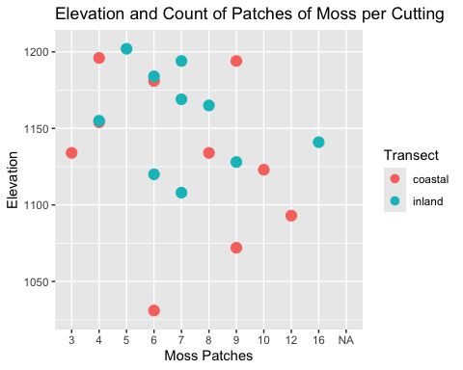

# This next one I’m more sure about- though not necessarily in this format, and currently it has no appropriate theme or legend layers - and facetwrap may be pointless if it turns out we only have 1 or 2 sp.

# Comparison of shoot length at different elevations, colored and separeted by transect  
ggplot(CurrentData, aes(x = ShootLength, y = Elevation, color = Transect)) +  
 geom_line() + facet_wrap( ~ Transect)

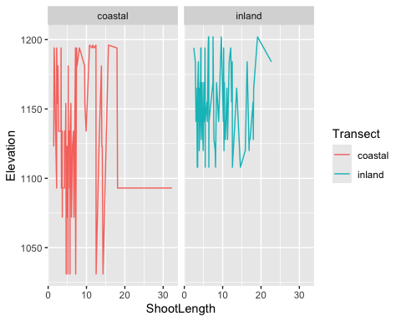

# Variant for leaf size  
# ggplot(CurrentData, aes(x=LeafSize, y=Elevation, color=Transect)) + geom_line() + facet_wrap( ~ Transect)

#Slope direction coloring on the size of moss plot, not very helpful?  
 ggplot(CurrentData, aes(x = ShootLength, y = LeafSize, color = Direction )) +  
 geom_point() +  
 facet_wrap(~Transect)

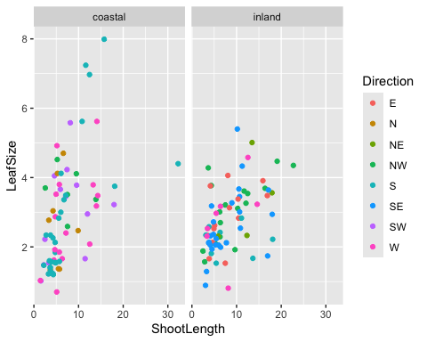 # Other plots instead?

# To re-stack, just disable facetwrap layer - alternately, could divide by transect instead  
ggplot(CurrentData, aes(ShootLength,LeafSize, fill = Direction, color = Direction)) + geom_line() + facet_wrap( ~ Direction)

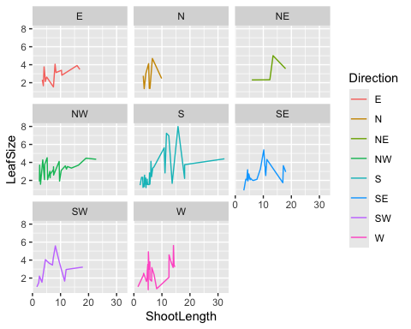

# + facet_wrap( ~ Transect)

#Complicating things here- Shootlength compared with slope colored by transect and divided by the direction facing  
# To re-stack, just disable facetwrap layer - alternately, could divide by transect instead  
ggplot(CurrentData, aes(ShootLength, Slope, color = Transect)) + geom_line() + facet_wrap( ~ Direction)

## Warning: Removed 1 row containing missing values or values outside the scale range  
## (`geom_line()`).

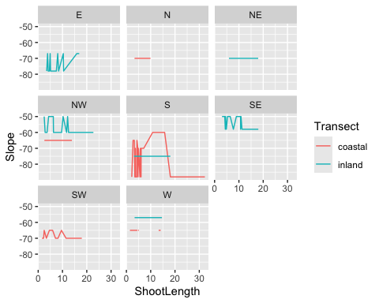

# + facet_wrap( ~ Transect)

#Alt. w/ leafsize  
# To re-stack, just disable facetwrap layer - alternately, could divide by transect instead  
ggplot(CurrentData, aes(LeafSize, Slope, color = Transect)) + geom_line() + facet_wrap( ~ Direction)

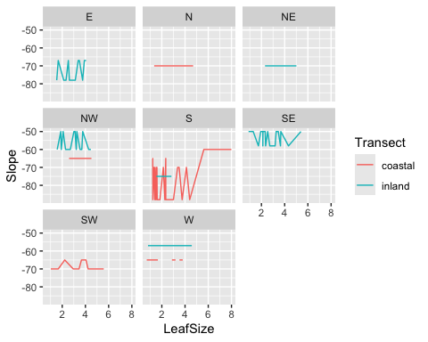

# + facet_wrap( ~ Transect)

#Alt w/ patch size  
# To re-stack, just disable facetwrap layer - alternately, could divide by transect instead  
ggplot(CurrentData, aes(PatchSize, Slope, color = Transect)) + geom_line() + facet_wrap( ~ Direction)

## Warning: Removed 3 rows containing missing values or values outside the scale range  
## (`geom_line()`).

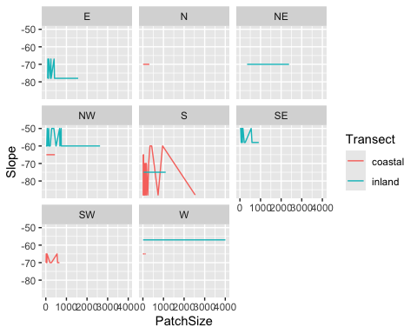

# + facet_wrap( ~ Transect)

#Patchsize + Latitude  
# To re-stack, just disable facetwrap layer - alternately, could divide by transect instead  
ggplot(CurrentData, aes(PatchSize, Lat, color = Transect)) + geom_point() + facet_wrap( ~ Direction)

## Warning: Removed 10 rows containing missing values or values outside the scale range  
## (`geom_point()`).

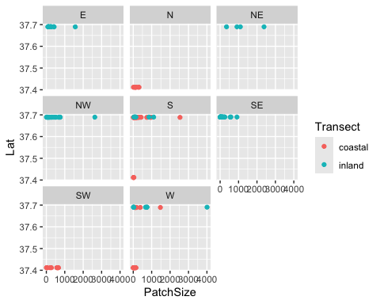

# + facet_wrap( ~ Transect)

#Patchsize + Longitude  
# To re-stack, just disable facetwrap layer - alternately, could divide by transect instead  
ggplot(CurrentData, aes(PatchSize, Long, color = Transect)) + geom_point() + facet_wrap( ~ Direction)

## Warning: Removed 10 rows containing missing values or values outside the scale range  
## (`geom_point()`).

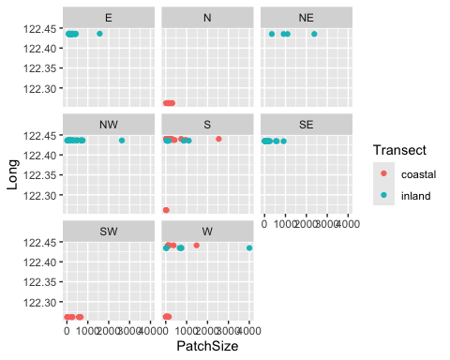

# + facet_wrap( ~ Transect)

#One of the first plots written and then run with real data, now with both transects!  
 ggplot(CurrentData, aes(x = ShootLength, y = LeafSize, color = Transect)) + geom_point()

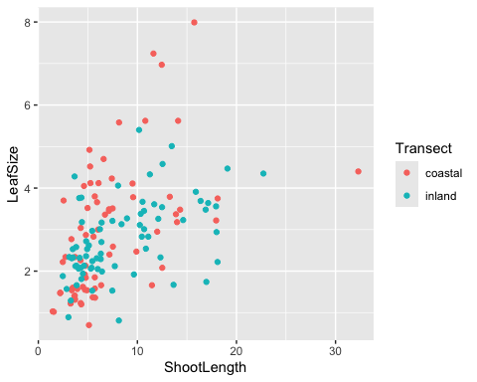

#Doing very similar things, just seeing shoot length and patch size together here  
ggplot(CurrentData, aes(x = PatchSize, y = ShootLength , color = Transect)) + geom_point()

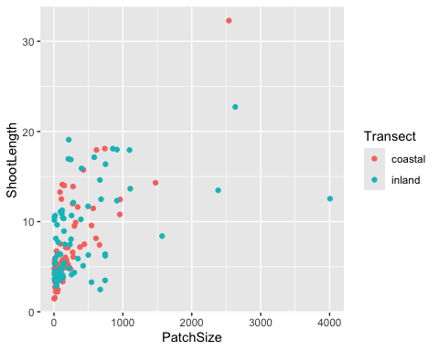

#Now leaves  
ggplot(CurrentData, aes(x = PatchSize, y = LeafSize , color = Transect)) + geom_point()

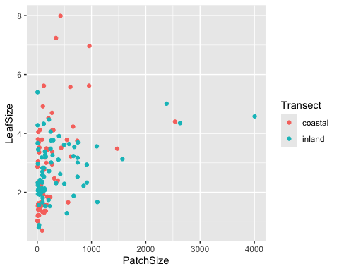

#Presence of Sporophytes on different size patches, separated by transect  
ggplot(CurrentData, aes(y = CapsuleCount, x=PatchSize, color = Transect)) +  
 geom_line() + facet_wrap( ~ Transect)

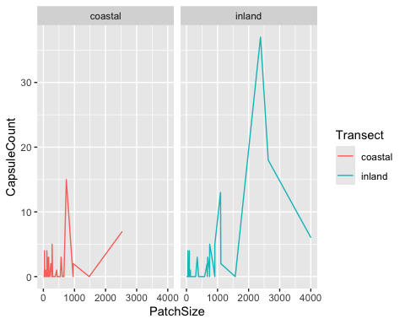

#Presence of Sporophytes @ different elevations, colored and separated by directionality of slope  
ggplot(CurrentData, aes(y = CapsuleCount, x=Elevation, color = Direction)) +  
 geom_line() + facet_wrap( ~ Direction)

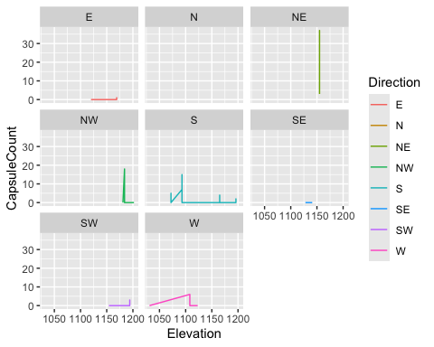

#Direction Without Elevation  
ggplot(CurrentData, aes(CapsuleCount, color = Direction, fill = Direction)) + geom_density() + facet_wrap( ~ Direction)

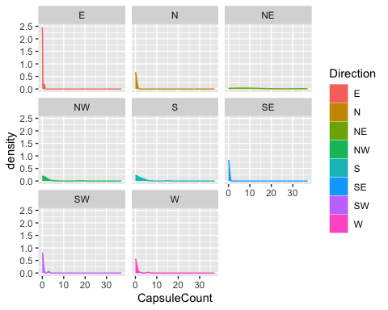

#Elevation without Direction  
ggplot(CurrentData, aes(CapsuleCount, color = Elevation, fill = Elevation)) + geom_density() + facet_wrap( ~ Elevation)

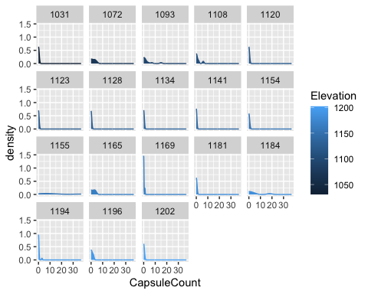

#Patchsize Density  
ggplot(CurrentData, aes(PatchSize, by = Transect, fill = Transect)) + geom_density() + facet_wrap( ~ Transect)

