DATABASE : company_db

TABLE: department

Queries

1. SELECT * FROM company_db.department;

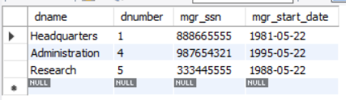

TABLE: dependent

2. SELECT * FROM company_db.dependent;

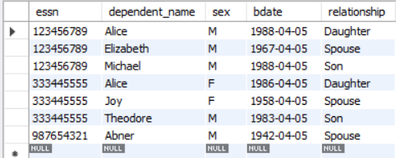

TABLE: dept_locations

3. SELECT * FROM company_db.dept_locations;

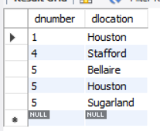

TABLE: employee

4. SELECT * FROM company_db.employee;

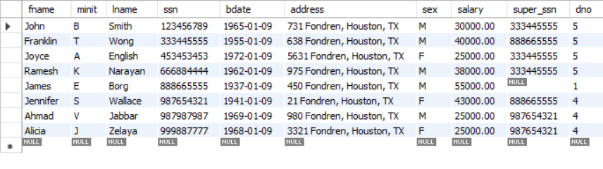

TABLE: works_on

5. SELECT * FROM company_db.works_on;

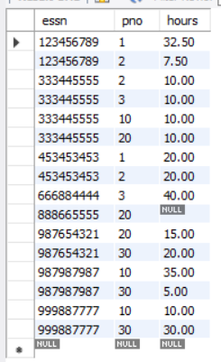

TABLE: project

6. SELECT * FROM company_db.project;

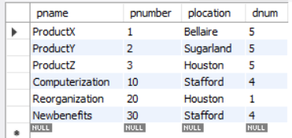

**DATA RETRIEVAL**

USE company_db;

1.SELECT * FROM tablename ;

2.SELECT COUNT(essn) FROM works_on WHERE hours < 13 ;

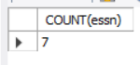

3. SELECT COUNT(DISTINCT hours) FROM works_on ;

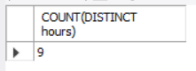

4. SELECT COUNT(sex) FROM dependent ;

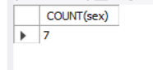

5. SELECT * FROM works_on ORDER BY hours DESC ;

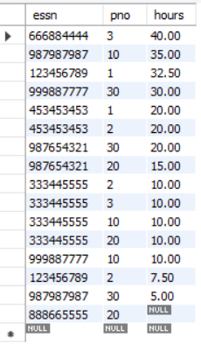

6. SELECT * FROM works_on ORDER BY hours DESC LIMIT 5 ;

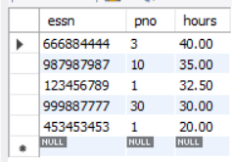

**DATA AGGREGATION (GROUP BY, HAVING, COUNT, SUM, AVG, MIN, MAX)**

1.SELECT COUNT(dependent_name) FROM dependent ;

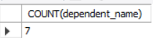

2. SELECT SUM(salary) AS TOTALSUMSALARY FROM employee ;

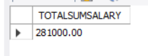

3. SELECT AVG(salary) AS averagesalary FROM employee ;



4. SELECT lname,salary FROM employee

WHERE salary =( SELECT MAX(salary) FROM employee ) ;

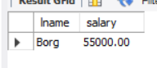

5. SELECT lname,salary FROM employee

WHERE salary =( SELECT MIN(salary) FROM employee ) ;

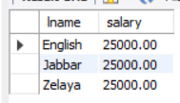

6. SELECT MAX(salary) AS highest_salary , MIN(salary) AS lowest_salary FROM employee ;

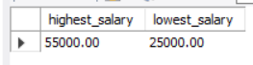

7. SELECT sex ,COUNT(sex) FROM employee GROUP BY sex ;

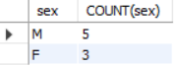

8. SELECT sex ,COUNT(sex) FROM employee GROUP BY sex

HAVING COUNT(sex) > 4 ;



**JOINS (combination of multiple tables)**

**Inner join:**

1. SELECT dname FROM department

INNER JOIN dept_locations

ON department.dnumber=dept_locations.dnumber ;

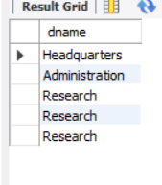

**Outer Joins**

1.Left Inner Join.

SELECT department.dname ,dept_locations.dlocation

FROM department

LEFT JOIN dept_locations

ON department.dnumber = dept_locations.dnumber ;

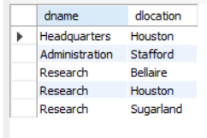

2.Right Inner Join

SELECT department.dname ,dept_locations.dlocation, department.mgr_ssn

FROM department

RIGHT JOIN dept_locations

ON department.dnumber = dept_locations.dnumber ;

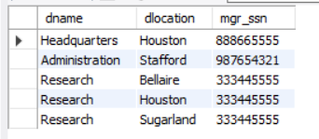

3.Left Outer Join.

SELECT department.dname ,dept_locations.dlocation, department.mgr_ssn, department.mgr_start_date

FROM department

LEFT OUTER JOIN dept_locations

ON department.dnumber = dept_locations.dnumber ;

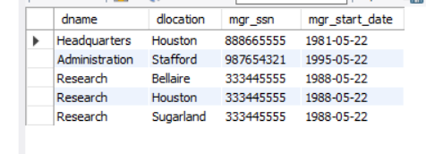

4.Right Outer Join.

SELECT department.dname ,dept_locations.dlocation, department.mgr_ssn, department.mgr_start_date

FROM department

RIGHT OUTER JOIN dept_locations

ON department.dnumber = dept_locations.dnumber ;

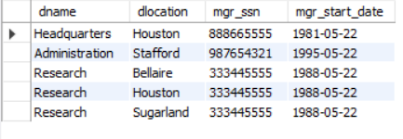

**Common Table Expressions (CTEs)**

**1**. WITH male_employee AS (

SELECT dependent_name ,bdate

FROM dependent WHERE sex = "M" )

SELECT * FROM male_employee ;

