1a,10a .Led blinking
Code:-
ORG 0000H
up:SETB P2.0
ACALL DELAY
CLR P2.0
ACALL DELAY
SJMP UP
DELAY:MOV R4,#35
H1:MOV R3,#125
H2:DJNZ R3,H2
DJNZ R4,H1
RET
END
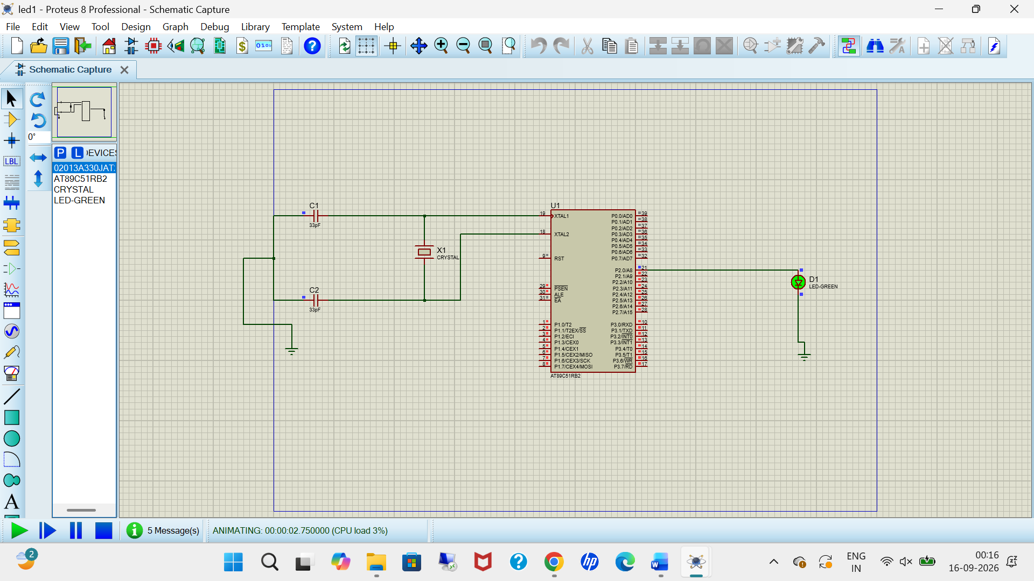

2a,11a,19a .Square wave
Code:-
ORG 0000H
UP: SETB P2.0
ACALL DELAY
CLR P2.0
ACALL DELAY
SJMP UP
DELAY: MOV R4,#35
H1:MOV R3,#255
H2:DJNZ R3,H2
DJNZ R4,H1
RET
END
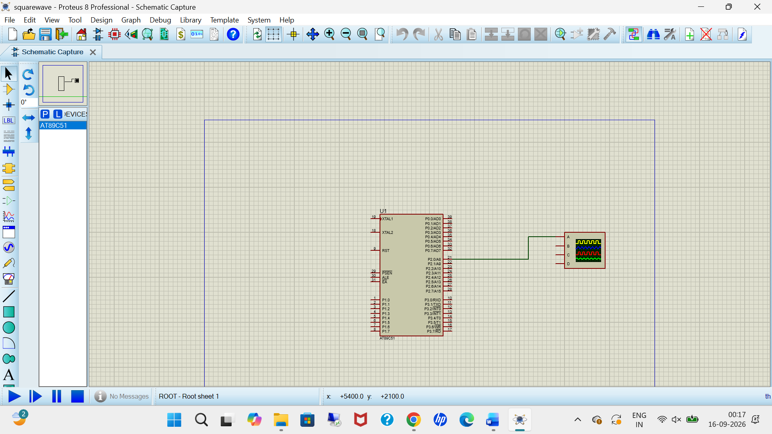

4a,5b,10b,12a,13a,20a .Stepper motor
Code:-
ORG 0000H

START:
MOV P2,#09H
ACALL DELAY

MOV P2,#0CH
ACALL DELAY

MOV P2,#06H
ACALL DELAY

MOV P2,#03H
ACALL DELAY

SJMP START

DELAY:
MOV R4,#50

D1:
MOV R3,#255

D2:
DJNZ R3,D2
DJNZ R4,D1

RET

END
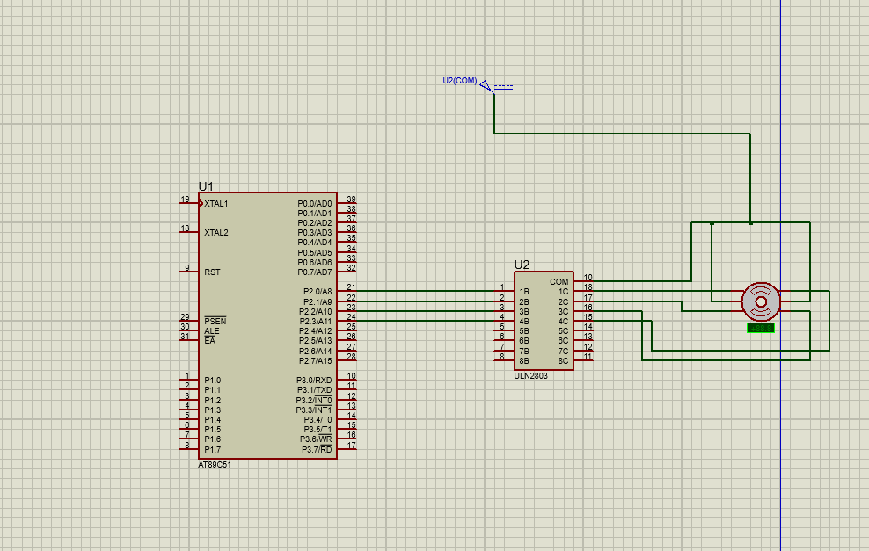
7a,14a.7-segment
Code:-
ORG 0000H

START:
MOV P2,#0C0H
ACALL DELAY

MOV P2,#0F9H
ACALL DELAY

MOV P2,#0A4H
ACALL DELAY

MOV P2,#0B0H
ACALL DELAY

MOV P2,#99H
ACALL DELAY

MOV P2,#92H
ACALL DELAY

MOV P2,#82H
ACALL DELAY

MOV P2,#0F8H
ACALL DELAY

MOV P2,#80H
ACALL DELAY

MOV P2,#90H
ACALL DELAY

SJMP START

DELAY:
MOV R5,#10

H1:
MOV R4,#180

H2:
MOV R3,#255

H3:
DJNZ R3,H3
DJNZ R4,H2
DJNZ R5,H1

RET

END

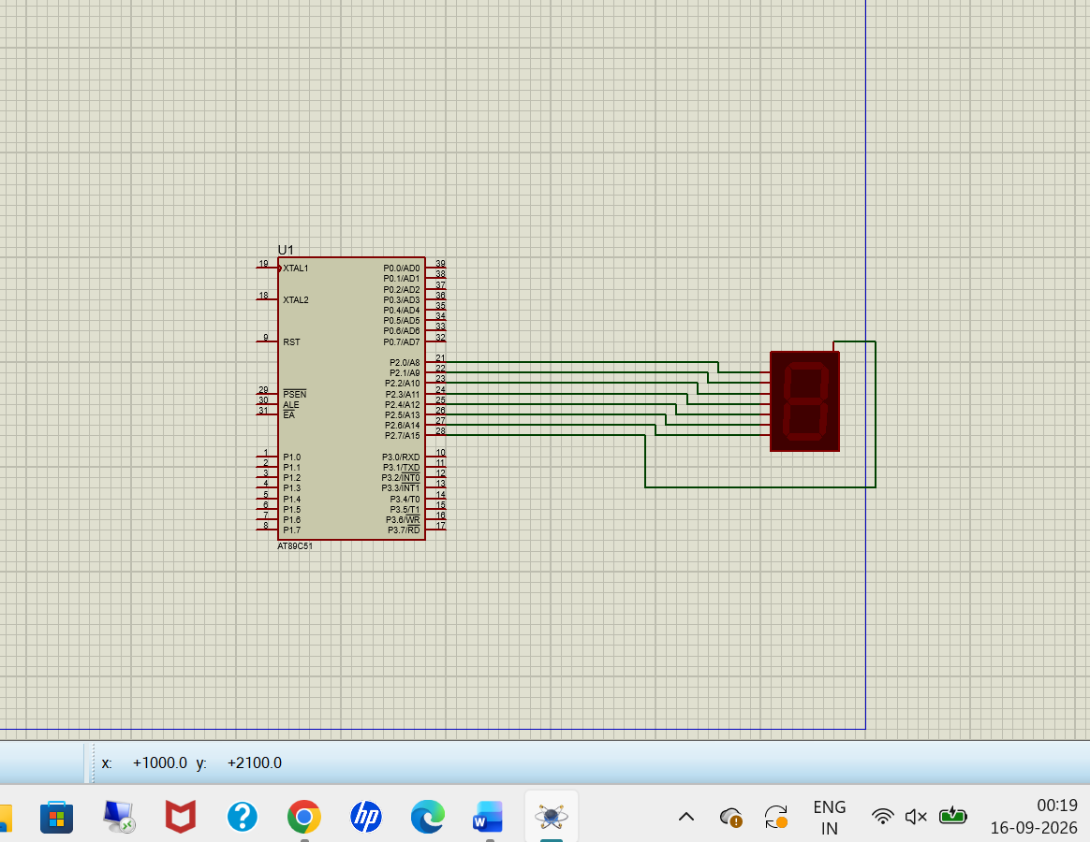
13b,15b. Arduino based manual count
int x0,x1,x2,x3,x4,x5,x6,x7,x8,x9;
int delay_time = 200;

void setup()
{
pinMode(12, INPUT_PULLUP);

pinMode(1, OUTPUT);
pinMode(2, OUTPUT);
pinMode(3, OUTPUT);
pinMode(4, OUTPUT);
pinMode(5, OUTPUT);
pinMode(6, OUTPUT);
pinMode(7, OUTPUT);
}

void loop()
{
int sensorVal = digitalRead(12);

if(sensorVal == LOW)
{
x0 = true;
}

while(x0)
{
zero();
sensorVal = digitalRead(12);

if(sensorVal == LOW)
{
x1 = true;
x0 = false;
}
}

while(x1)
{
one();
sensorVal = digitalRead(12);

if(sensorVal == LOW)
{
x2 = true;
x1 = false;
}
}

while(x2)
{
two();
sensorVal = digitalRead(12);

if(sensorVal == LOW)
{
x3 = true;
x2 = false;
}
}

while(x3)
{
three();
sensorVal = digitalRead(12);

if(sensorVal == LOW)
{
x4 = true;
x3 = false;
}
}

while(x4)
{
four();
sensorVal = digitalRead(12);

if(sensorVal == LOW)
{
x5 = true;
x4 = false;
}
}

while(x5)
{
five();
sensorVal = digitalRead(12);

if(sensorVal == LOW)
{
x6 = true;
x5 = false;
}
}

while(x6)
{
six();
sensorVal = digitalRead(12);

if(sensorVal == LOW)
{
x7 = true;
x6 = false;
}
}

while(x7)
{
seven();
sensorVal = digitalRead(12);

if(sensorVal == LOW)
{
x8 = true;
x7 = false;
}
}

while(x8)
{
eight();
sensorVal = digitalRead(12);

if(sensorVal == LOW)
{
x9 = true;
x8 = false;
}
}

while(x9)
{
nine();
sensorVal = digitalRead(12);

if(sensorVal == LOW)
{
x0 = true;
x9 = false;
}
}
}
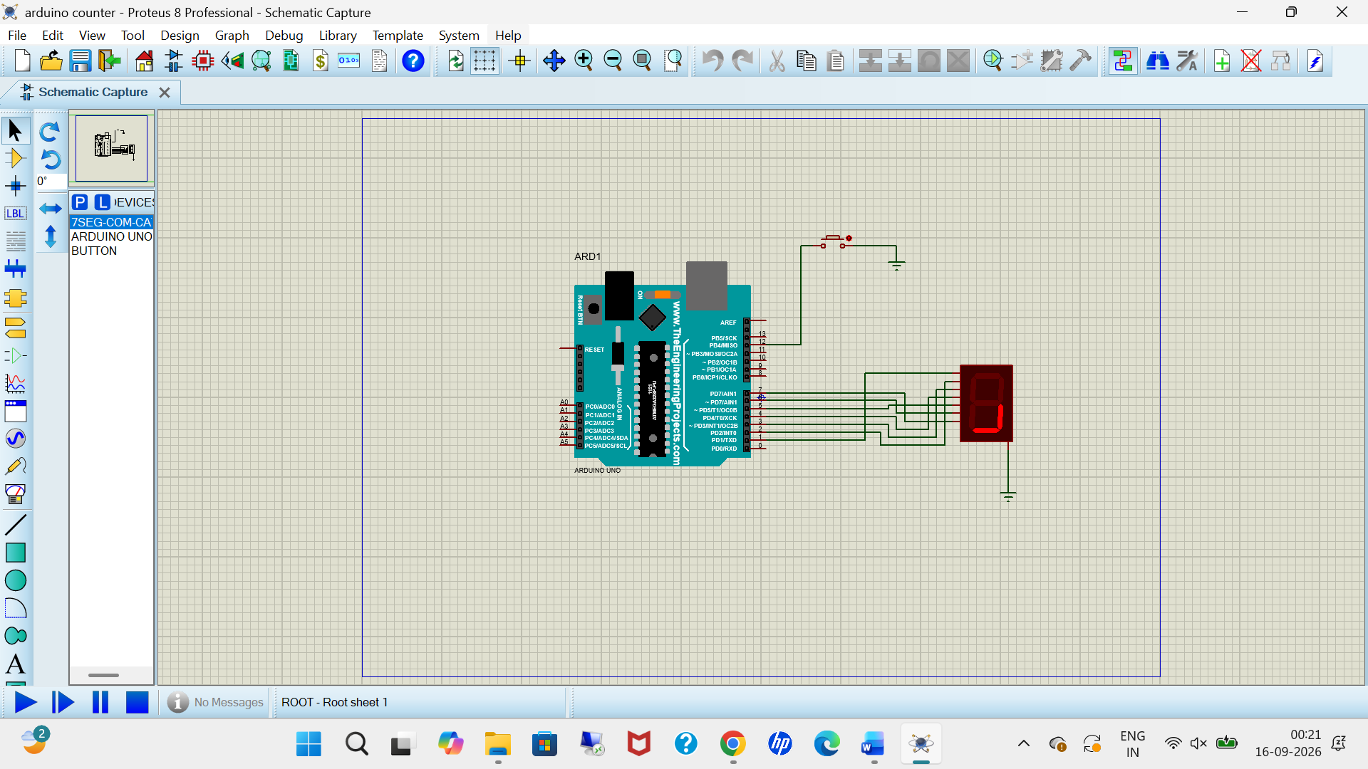
12b,18b.LCD Ardiuno
Code:-

#include <LiquidCrystal.h>

LiquidCrystal lcd(12, 11, 5, 4, 3, 2);

void setup()
{
lcd.begin(16, 2);

lcd.setCursor(0, 0);
lcd.print("Hello Arduino");

lcd.setCursor(0, 1);
lcd.print("Proteus LCD");
}

void loop()
{
}
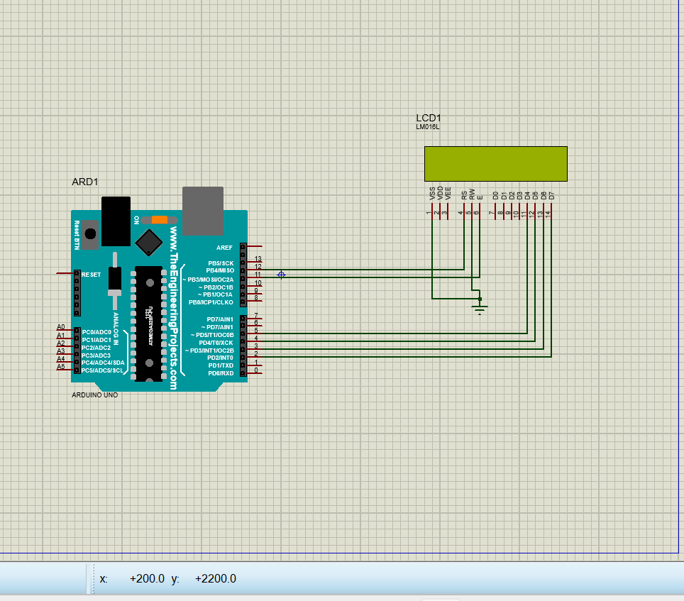
11b,17b.serialArdiuno
Code:-
void setup()
{
Serial.begin(9600); // send and receive at 9600 baud
}
int number = 0;
void loop()
{
Serial.print("Number is ");
Serial.println(number); // print the number
delay(500); // delay half second between numbers
number++; // to the next number
}

