Kadijatu Bah

11/3/2018

Lab 7

Questions:

1. What are the SSIDs of the two access points that are issuing most of the beacon frames in this trace?

* **The 2 access points are 30 Munroe St. and Linksys12.**





1. What are the intervals of time between the transmissions of the beacon frames the*linksys_ses_24086* access point? From the *30 Munroe St*. access point? (Hint: this interval of time is contained in the beacon frame itself).

* **The beacon intervals for both Linksys12 and 30 Munroe St are 0.102400 seconds.**

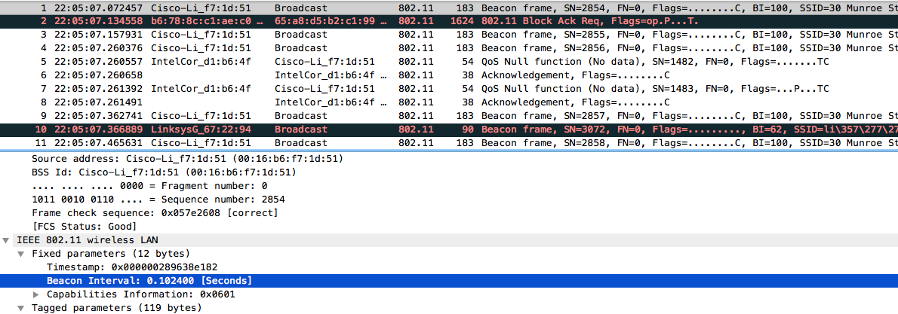

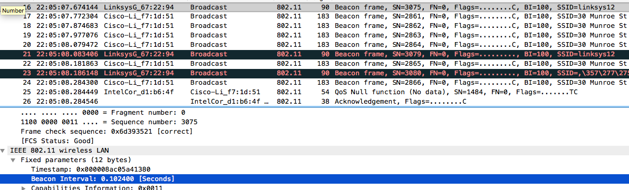

1. What (in hexadecimal notation) is the source MAC address on the beacon frame from *30 Munroe St*? Recall from Figure 7.13 in the text that the source, destination, and BSS are three addresses used in an 802.11 frame. For a detailed discussion of the 802.11 frame structure, see section 7 in the IEEE 802.11 standards document (cited above).

* **The source MAC address for 30 Munroe St is 00:16:b6:f7:1d:51.**

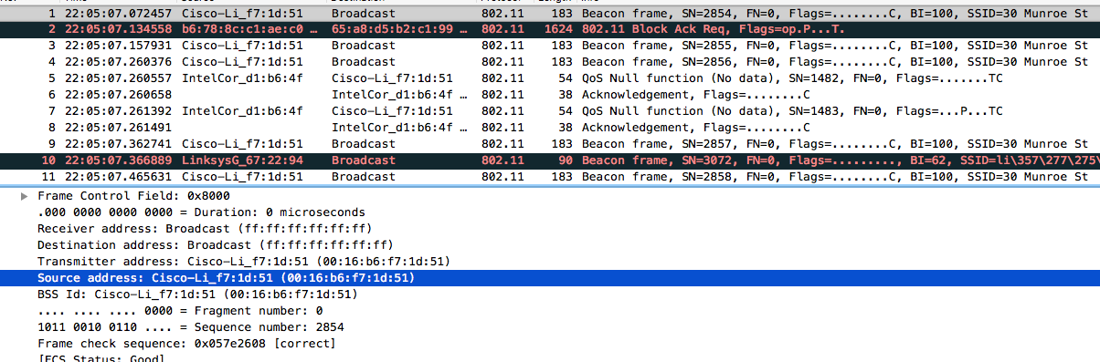

1. What (in hexadecimal notation) is the destination MAC address on the beacon frame from *30 Munroe St*??

* **The destination MAC address for 30 Munroe is ff:ff:ff:ff:ff:ff.**

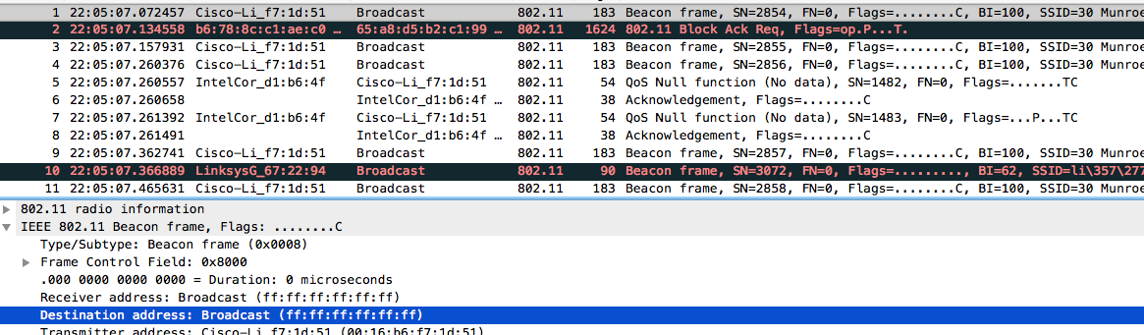

1. What (in hexadecimal notation) is the MAC BSS id on the beacon frame from *30 Munroe St*?

* **The MAC BSS id from 30 Munroe St is 00:16:b6:f7:1d:51.**

