SIT120 - Introduction to Responsive Web Apps

Week 2: Responsive web design, HTML, CSS and JavaScript

Name: Kadir Akdag

I.D: S222189388

Task 1

Responsive web design is to develop websites that adapt to the user’s platform to utilise the full functionality of the website across different devices. Responsive web design is important as it optimises user experience with the website across different landscapes.

**Reflection:** Knowing the meaning of responsive web design has allowed me to reflect on moments that I have utilised responsive websites.

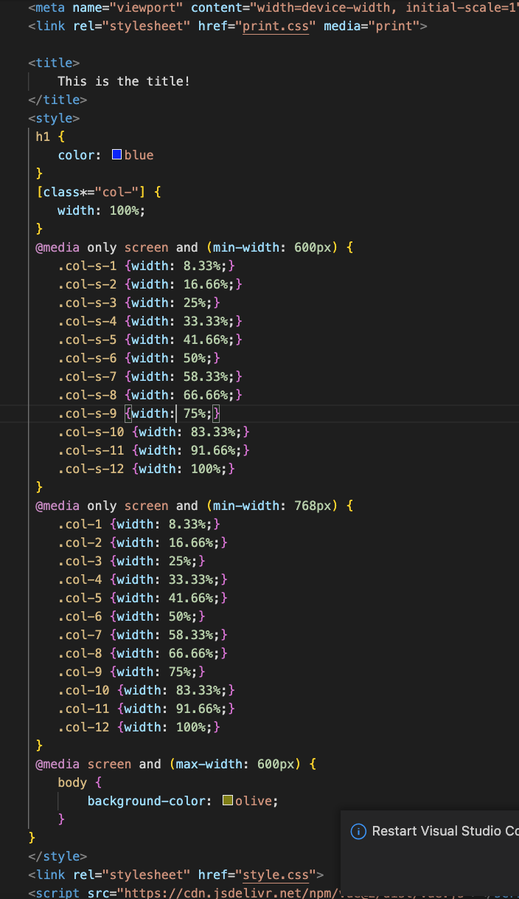Task 2

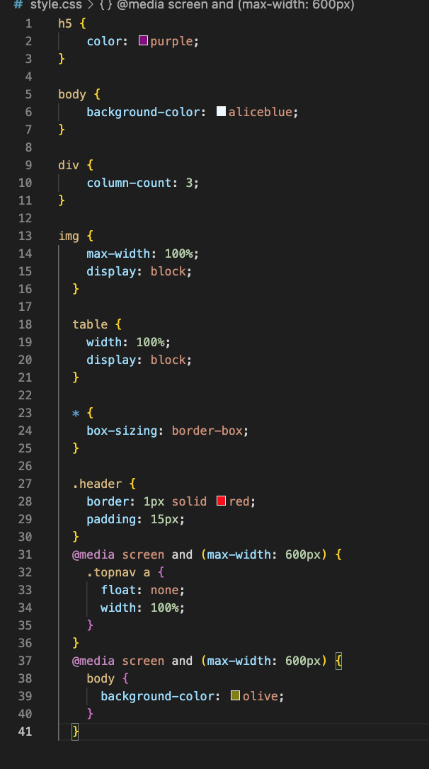

**Reflection:**

To implement responsive web design with CSS, measures need to be in place for the various aspect ratios and sizes of various viewing devices. The most appropriate way to ensure that functions are viewable in different devices is to utilise percentages. Additionally, media queries tailor the site to different devices. The @media rule is applied to use media queries across different devices.

Task 3

User Story 1: As a user, I want to be able to search so that I can locate key information.

User Story 2: As a user, I want to press buttons to direct me to different pages.

**Reflection:** The concept of User Stories is insightful as it allowed me to plan and create a page function piece by piece. With many User Stories, I can develop a page with various functions to cater to users.