**#Problem_statement2**

Working with YARN Commands

1. Run MapReduce Program and capture the application Id of the job

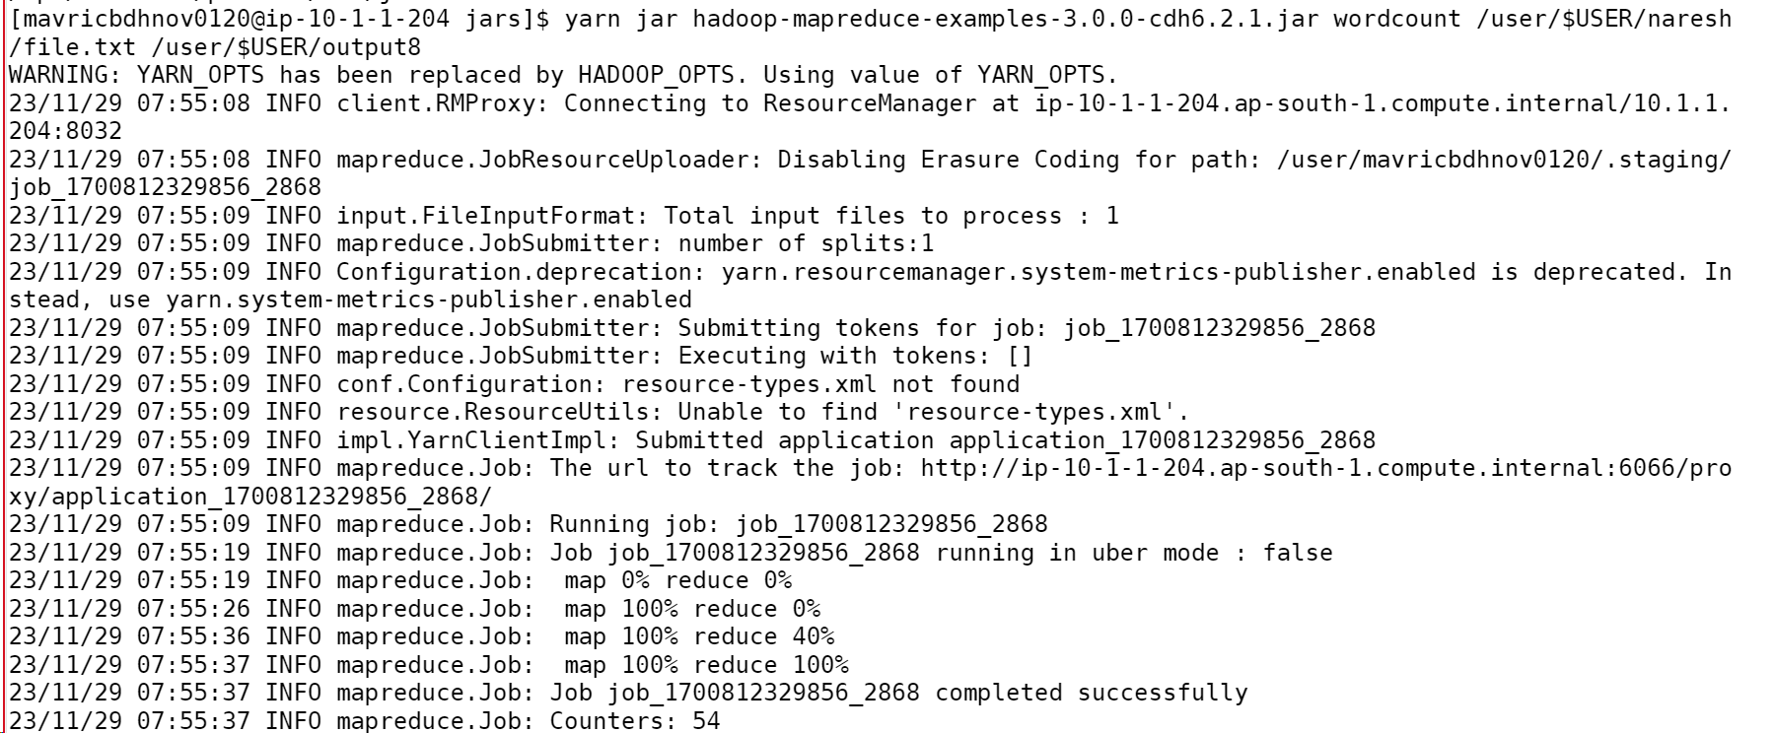

**2. Re-run the MapReduce program and kill the application using the yarn command.**

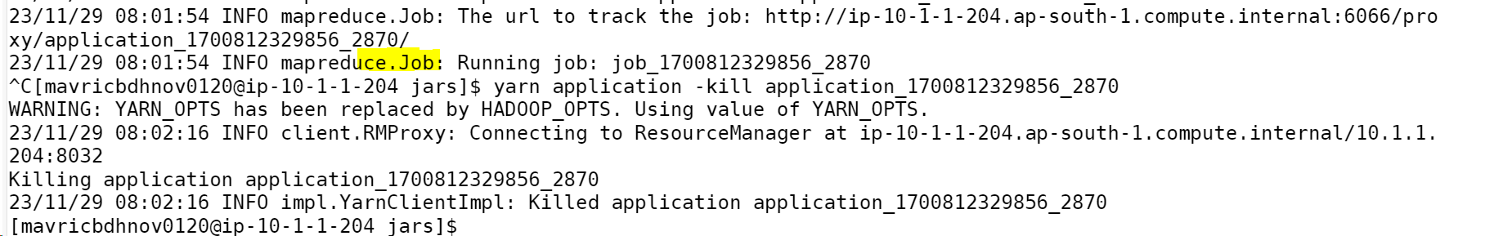

**3.List all the applications which are RUNNING state**

**4. View the logs of any of the jobs which are already completed.**

