**Hive Assignment 1**

**Create table Facebook:**

**Loading data into table facebook:**

**Q1: Find out the total no of users in the dataset**

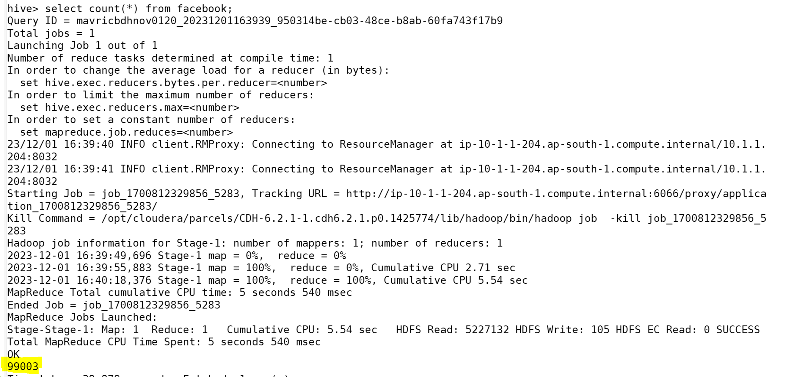

**Q2: Find out the no of users above the age of 25**

**Q3: Do male face book users tend to have more friends or female users**

**Q4: How many likes do young people receive on facebook as opposed to old people**

**Q5: Find out the count of facebook users for each birthday month**

**Q6: Do young members use mobile phones or computers for facebook browsing**

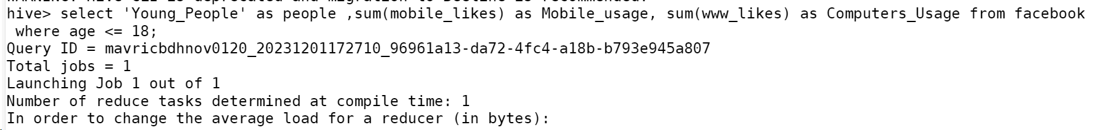

**Q7: Do adult members use mobile phones or computers for facebook browsing**



