CMPE483

Homework 2

Kadir Gökhan Sezer

Demet Yayla

Zeynep Aydoğan

In the first project of this course, we made a smart contract written in solidity. The purpose of this assignment was to write an interface that communicates with this contract and performs its functions.

**Frontend:**

Javascript already has two different libraries such as web3.js and ether.js that fulfill these connections. We've used both. We chose NextJS as the framework.

NextJS is actually a ReactJS framework. ReactJS is essentially a JS framework. In other words, we are using the framework of the framework.

**Backend:**

The backend is only used to save TX's. We chose Flask as the most convenient and simple way to do this.

**DB:**

To store the data, we chose postgresql, which is easy to communicate with python.



We deployed our interface to the internet. As a virtual machine, we chose EC2, a service of AWS. We get the domain from guzelhosting.com. We used the Route53 service where AWS registers the namespaces for the domain to IP connection.

url: bounance.online

If you want to run this UI for local, hardhat may help you.

Firstly, you need to install all the dependencies

* npm i

Then,

1. **If you did not change the mygov.sol file:**

You need two separate terminals to execute these commands:

To run a node:

1-> npx hardhat node

To deploy the contract to the local node

2-> npx hardhat run --network localhost scripts/deploy.js

To run the UI

3->npm run dev

1. **If you did:**

npx hardhat clean

npx hardhat compile

rm -rf artifacts

cp -rf src/artifacts .

Then you can go the option a.

**SCREEENSHOTS**

When we connect to an account:

Faucet:



balanceOf:

isMember:

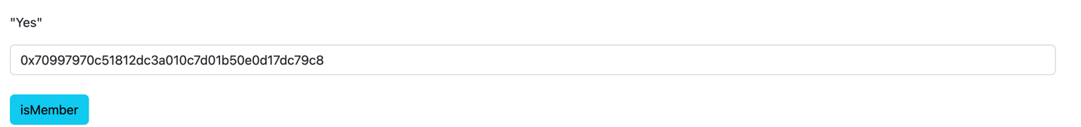

getUser:

