**Modeling and Discrete Simulation   
Term Project Report**

**Team members:**Muratcan Ünsal (150117851)

Kadir Hızarcı (150116004)  
Cem Güleç (150117828)

**CONTENTS**

1. Introduction 1

2. System Components 1

3. Relations between System Components 1

4. Basic Flow of the System 1

5. System Design in AnyLogic 2

6. Input Variables 2

7. Output Variables 2

8. Simulations  
 8.1. First Simulation 2  
 8.1.1. avgQueueTimeGate 3  
 8.1.2. avgServiceTimeGate 3  
 8.1.3. avgServTimeVehicle 3  
 8.1.4. avgTimePassInSystem 4

8.2. Second Simulation 4  
 8.2.1. avgQueueTimeGate 4  
 8.2.2. avgServiceTimeGate 5  
 8.2.3. avgServTimeVehicle 5  
 8.2.4. avgTimePassInSystem 5

9. Final Comments 6

1. **Introduction**In this project, we were asked to define a system that we want to model and simulate.   
   We, as a team, decided to simulate a model which calculates the transportation vehicles’ efficiency and suitability, according to the inputs we defined.   
   Our project consists of 2 phases: in the first phase we identified how the system works. Also, how system integrates as whole with the defined components.   
   After we embodied and finished the first phase, we needed to build the model of the system in the second phase then create the simulation in AnyLogic. We also had to collect data on the system we built. In regard to the input parameters, there were some calculations needed to be evaluated such as estimating mean values and computing 95% confidence intervals for the output parameters.
2. **System Components**

The system has four main components: Train, bus, faregate and pedestrian.

Pedestrians may use all the other system components.

Trains and buses are the vehicles that provide transportation between source station and destination station.

Faregate is the place where a pedestrian has to wait till it is their turn to enter the station.

1. **Relations Between System Components**

Simulation starts once the first pedestrian enters the system. At this point, pedestrians must proceed to faregates and enter the queue. Once a pedestrian finishes waiting in the queue, faregates service will start, which won’t be any longer than 2-3 seconds.

Next step, the pedestrian chooses either the train or the bus for the transportation.

At this point, if there is a train or bus waiting at the stop and it is not full then the pedestrian will be able to get on the vehicle. Or if there is no vehicle available, the pedestrian will proceed to the correct waiting area.

The moment a train or a bus arrives, they will only take passengers for a predefined amount of time. Then the vehicle will move forward to the next station. Once the vehicle arrives at the next station, pedestrians will get of the vehicle and proceed to the exit.

1. **Basic Flow of the System**

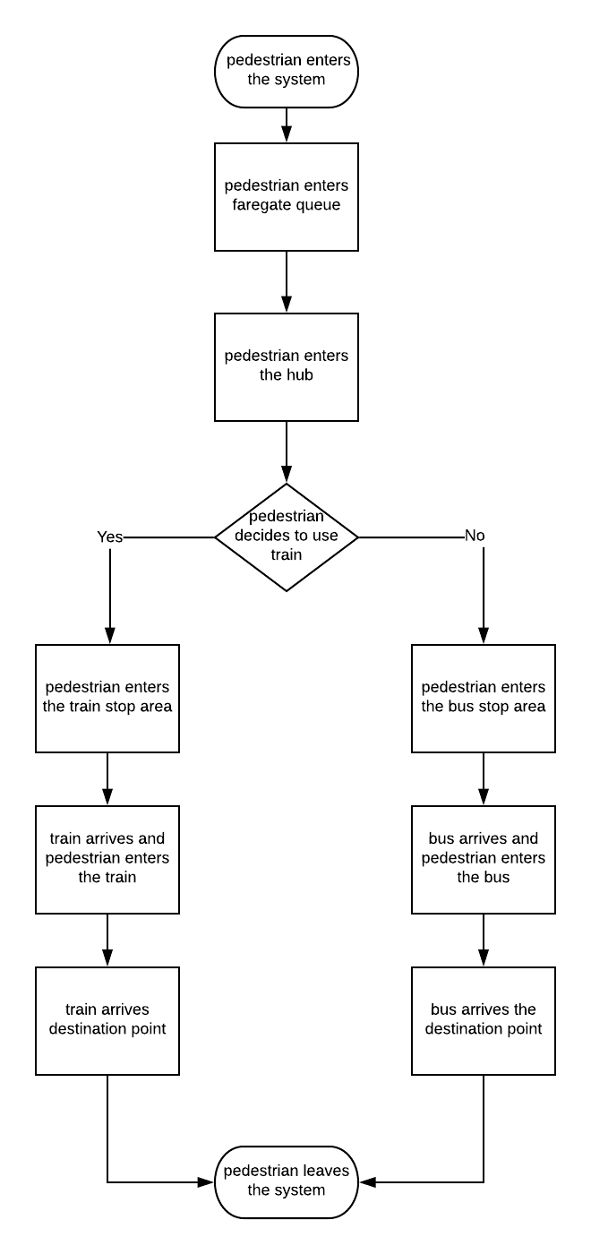

1. **System Design in AnyLogic**

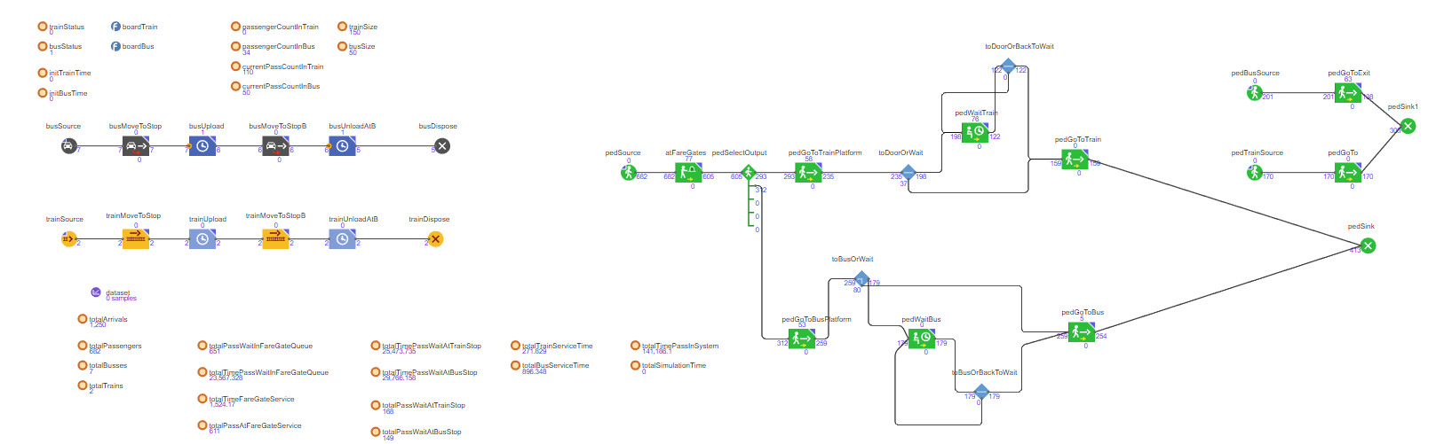

1. **Input Variables**

busSize: Value defined as the maximum passengers a bus can carry. It is of integer type.

trainSize: Value defined as the maximum passengers a train can carry. It is of integer type.

Interarrival times of the busses, trains and the pedestrians are uniformly distributed.

Buses arrive every 2 or 3 minutes. Trains arrive every 4, 5, or 6 minutes. Pedestrians arrive every 1 or 2 seconds.

A bus’ speed can change 40-60 km/h. Train’s speed can change 60-100 km/h during the transportation.

Both vehicles spend 1 minute each for letting passengers get on and get off.

There exists four faregates and each pedestrian spends 2 to 3 seconds during the service.

1. **Output Variables**

We will measure the average waiting time in faregates queue, average service time in the faregates, average service time of a train and a bus and the average time a customer spends in the system.

1. **Simulations**
   1. **First Simulation**

In the first simulation, pedestrians arrive every 1 or 2 seconds and spend 2 to 3 seconds in the faregates service. There exist 4 faregates services.

Buses arrive every 2 or 3 minutes with size of 50 people and speed of 40 to 60 kilometers per hour. They spend 1 minute each for letting passengers get on and get off.

Trains arrive every 4.5 or 6 minutes with a size of 200 people and speed of 60 to 100 kilometers per hour. They spend 1 minute each for letting passengers get on and get off.

The simulation stops after 59 minutes are spent in the system, due to the limited AnyLogic license or when the 1250th customer leaves the system.

Below are the values of our simulation, measured in seconds.

|  |  |  |  |  |  |
| --- | --- | --- | --- | --- | --- |
| **seed** | **avgQueueTimeGate** | **avgServiceTimeGate** | **avgServTimeVehicle** | **avgTimePassInSystem** | **totalSimulationTime** |
| 1 | 497.657 | 2.5 | 4.091 | 864.75 | 3356 |
| 2 | 509.164 | 2.491 | 3.952 | 889.32 | 3389 |
| 3 | 492.229 | 2.5 | 4.205 | 845.66 | 3326 |
| 5 | 503 | 2.495 | 4.086 | 869.547 | 3325 |
| 8 | 512 | 2.498 | 4.390 | 888.830 | 3569 |
|  |  |  |  |  |  |
| ***mean*** | 502.81 | 2.4968 | 4.1448 | 871.6214 | 3393 |
| ***s*** | 8.114 | 0.00383 | 0.1637 | 18.268 |  |
| $$s^{2}$$ | 65.844 | 1.47x ${10}^{-5}$ | 0.0268 | 333.7224 |  |

Figure 3 – First Simulation Output Values

**8.1.1 avgQueueTimeGate**

This output variable measures average wait time in faregates queue.

95% confidence interval for this variable is calculated as

$502.81 ± 10.07$

95% prediction interval for this variable is calculated as

$502.81 ± 24.674$

Replications

$R≥ {(\frac{1.96x8.114}{10.07x0.9})}^{2}= 3.079$

**8.1.2 avgServiceTimeGate**

This output variable measures average service times of faregates.

95% confidence interval for this variable is calculated as

$2.4968 ± 0.0047$

95% prediction interval for this variable is calculated as

$2.4968 ± 0.0116$

Replications

$R≥ {(\frac{1.96x0.00383}{0.0047x0.9})}^{2}= 3.14$

**8.1.3 avgServTimeVehicle**

This output variable measures average service time of vehicles.

95% confidence interval for this variable is calculated as

$4.1448 ± 0.203$

95% prediction interval for this variable is calculated as

$4.1448± 0.497$

Replications

$R≥ {(\frac{1.96x0.1637}{0.203x0.9})}^{2}= 3.084$

**8.1.4 avgTimePassInSystem**

This output variable measures average pedestrian spends in system.

95% confidence interval for this variable is calculated as

$871.6214± 22.67$

95% prediction interval for this variable is calculated as

Replications

* 1. **Second Simulation**

All input values are kept the same for the second simulation. Additionally, four more faregates are added to the system.

Values below are all measured in seconds.

|  |  |  |  |  |  |
| --- | --- | --- | --- | --- | --- |
| **seed** | **avgQueueTimeGate** | **avgServiceTimeGate** | **avgServTimeVehicle** | **avgTimePassInSystem** | **totalSimulationTime** |
| 1 | 77.676 | 2.49 | 2.772 | 399.47 | 2483 |
| 2 | 93.018 | 2.49 | 2.774 | 403.44 | 2486 |
| 3 | 78.525 | 2.5 | 2.779 | 390.44 | 2425 |
| 5 | 89.68 | 2.515 | 2.762 | 400.47 | 2368 |
| 8 | 87.706 | 2.49 | 2.909 | 396.75 | 2422 |
|  |  |  |  |  |  |
| ***mean*** | 85.321 | 2.497 | 2.7992 | 398.114 | 2436.8 |
| ***s*** | 6.865 | 0.0109 | 0.0616 | 4.911 |  |
| $$s^{2}$$ | 47.1411 | 0.00012 | 0.0038 | 24.1266 |  |

Figure 2 – Second Simulation Output Values

**8.2.1 avgQueueTimeGate**

95% confidence interval for this variable is calculated as

$85.321 ± 8.522$

95% prediction interval for this variable is calculated as

$85.321 ± 20.87$

Replications

$R≥ {(\frac{1.96x6.865}{8.522x0.9})}^{2}= 3.077$

**8.2.2 avgServiceTimeGate**

95% confidence interval for this variable is calculated as

$2.497 ± 13.531$

95% prediction interval for this variable is calculated as

$2.497 ± 33.146$

Replications

$R≥ {(\frac{1.96x0.0109}{13.531x0.9})}^{2}= 0.000003$

**8.2.3 avgServTimeVehicle**

95% confidence interval for this variable is calculated as

$2.7992 ± 0.076$

95% prediction interval for this variable is calculated as

$2.7992 ± 0.187$

Replications

$R≥ {(\frac{1.96x0.0616}{0.076x0.9})}^{2}= 3.115$

**8.2.4 avgTimePassInSystem**

95% confidence interval for this variable is calculated as

$398.114 ± 6.096$

95% prediction interval for this variable is calculated as

$398.114 ± 14.934$

Replications

$R≥ {(\frac{1.96x4.911}{6.096x0.9})}^{2}= 3.07$

1. **Final Comments**

We can safely say that except avgServiceTimeGate variable, none of the other variables’ confidence intervals fall into 95% confidence interval of the second simulation’s output variables.

As a result, we can say that both these systems are statistically different than each other.