**PART-3**

**Question:** Create a MongoDB document collection in MongoDB Atlas that includes the documents reflecting the data contained in the attached file. Each row in the file is a document. Then use the MongoDB Compass, JavaScript and MongoDB Aggregation Pipeline to calculate the total purchase value and the total purchase quantity for each customer.  
Submit your code, a screenshot of the code execution results, and the totals for each customer.

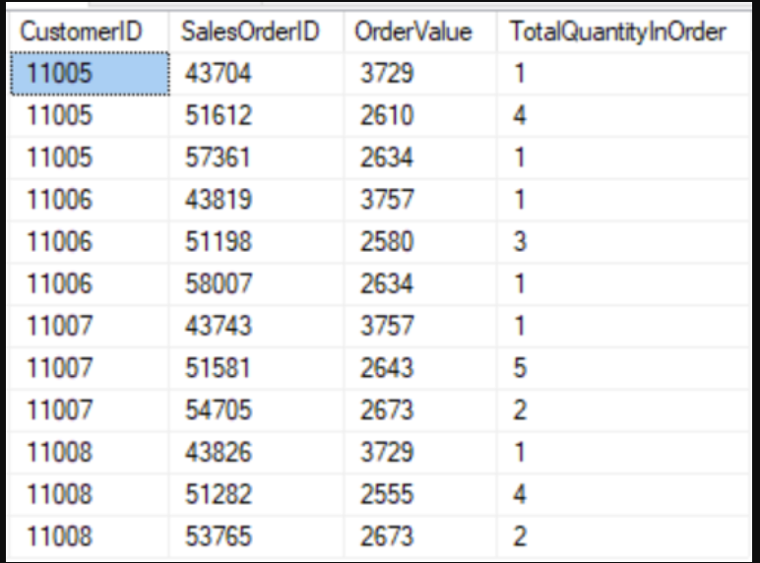

**CONTENTS OF THE DOCUMENT:**

**I solved this question Using :**

1. **MongoDB Atlas**
2. **MongoDB Compass**

**I have included the screenshots of the following:**

1. **Input**
2. **Code**
3. **Output Results**

**MONGODB INPUT**

{

"_id": {

"$oid": "5f0aee45e5fa31b8aea5feb1"

},

"CustomerID": 11005,

"SalesOrderID": 43704,

"OrderValue": 3729,

"TotalQuantityInOrder": 1

}

{

"_id": {

"$oid": "5f0afd92e5fa31b8aea5feb2"

},

"CustomerID": 11005,

"SalesOrderID": 51612,

"OrderValue": 2610,

"TotalQuantityInOrder": 4

}

{

"_id": {

"$oid": "5f0b0087e5fa31b8aea5feb3"

},

"CustomerID": 11005,

"SalesOrderID": 57361,

"OrderValue": 2634,

"TotalQuantityInOrder": 1

}

{

"_id": {

"$oid": "5f0b0183e5fa31b8aea5feb4"

},

"CustomerID": 11006,

"SalesOrderID": 43819,

"OrderValue": 3757,

"TotalQuantityInOrder": 1

}

{

"_id": {

"$oid": "5f0b02bae5fa31b8aea5feb5"

},

"CustomerID": 11006,

"SalesOrderID": 51198,

"OrderValue": 2580,

"TotalQuantityInOrder": 3

}

{

"_id": {

"$oid": "5f0b033ae5fa31b8aea5feb6"

},

"CustomerID": 11006,

"SalesOrderID": 58007,

"OrderValue": 2634,

"TotalQuantityInOrder": 1

}

{

"_id": {

"$oid": "5f0b03d2e5fa31b8aea5feb7"

},

"CustomerID": 11007,

"SalesOrderID": 43743,

"OrderValue": 3757,

"TotalQuantityInOrder": 1

}

{

"_id": {

"$oid": "5f0b0519e5fa31b8aea5feb8"

},

"CustomerID": 11007,

"SalesOrderID": 51581,

"OrderValue": 2643,

"TotalQuantityInOrder": 5

}

{

"_id": {

"$oid": "5f0b0596e5fa31b8aea5feb9"

},

"CustomerID": 11007,

"SalesOrderID": 54705,

"OrderValue": 2673,

"TotalQuantityInOrder": 2

}

{

"_id": {

"$oid": "5f0b0606e5fa31b8aea5feba"

},

"CustomerID": 11008,

"SalesOrderID": 43826,

"OrderValue": 3729,

"TotalQuantityInOrder": 1

}

{

"_id": {

"$oid": "5f0b0697e5fa31b8aea5febb"

},

"CustomerID": 11008,

"SalesOrderID": 51282,

"OrderValue": 2555,

"TotalQuantityInOrder": 4

}

{

"_id": {

"$oid": "5f0b0717e5fa31b8aea5febc"

},

"CustomerID": 11008,

"SalesOrderID": 53765,

"OrderValue": 2673,

"TotalQuantityInOrder": 2

}

**MongoDB : (inputs)**

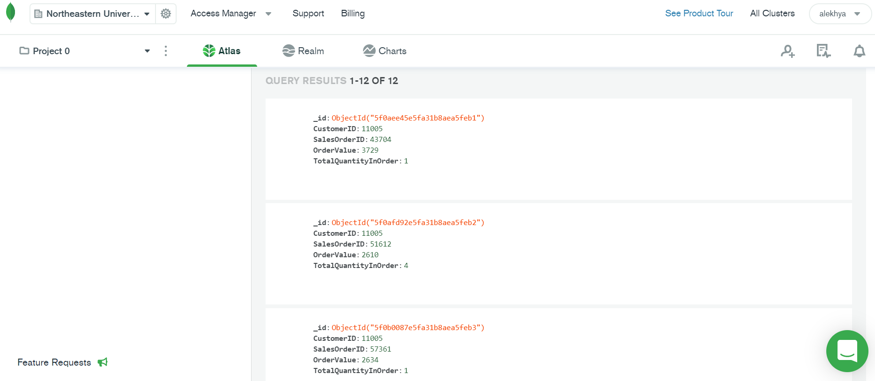

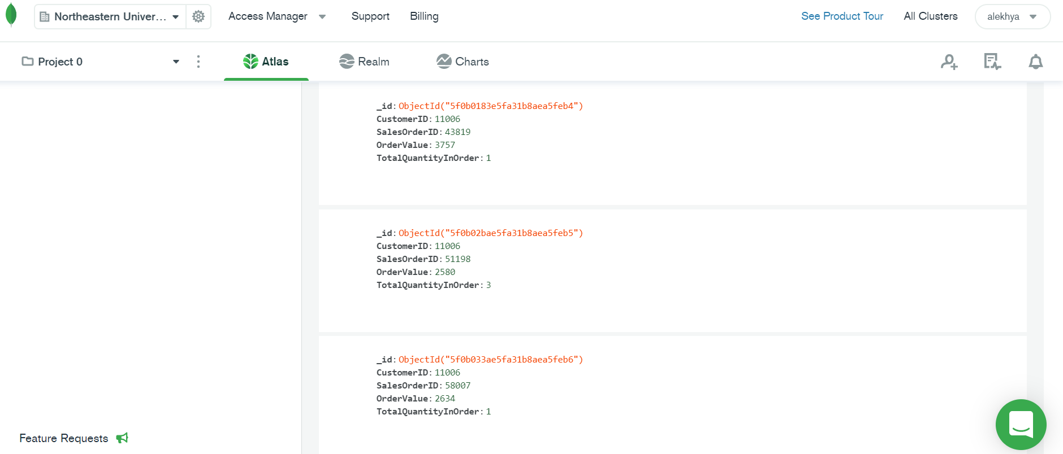

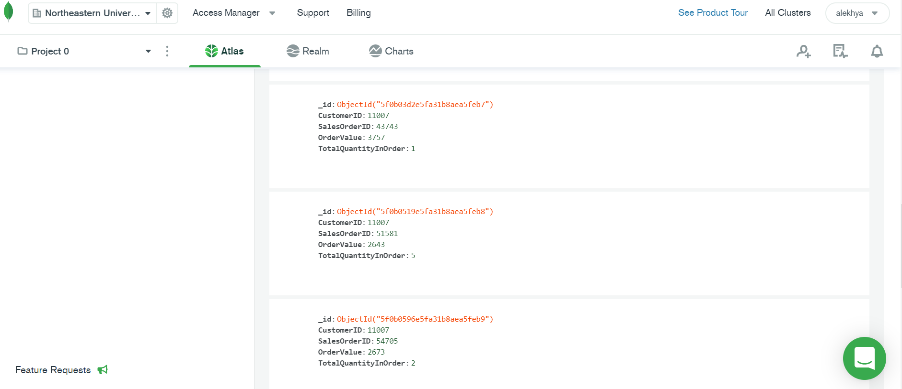

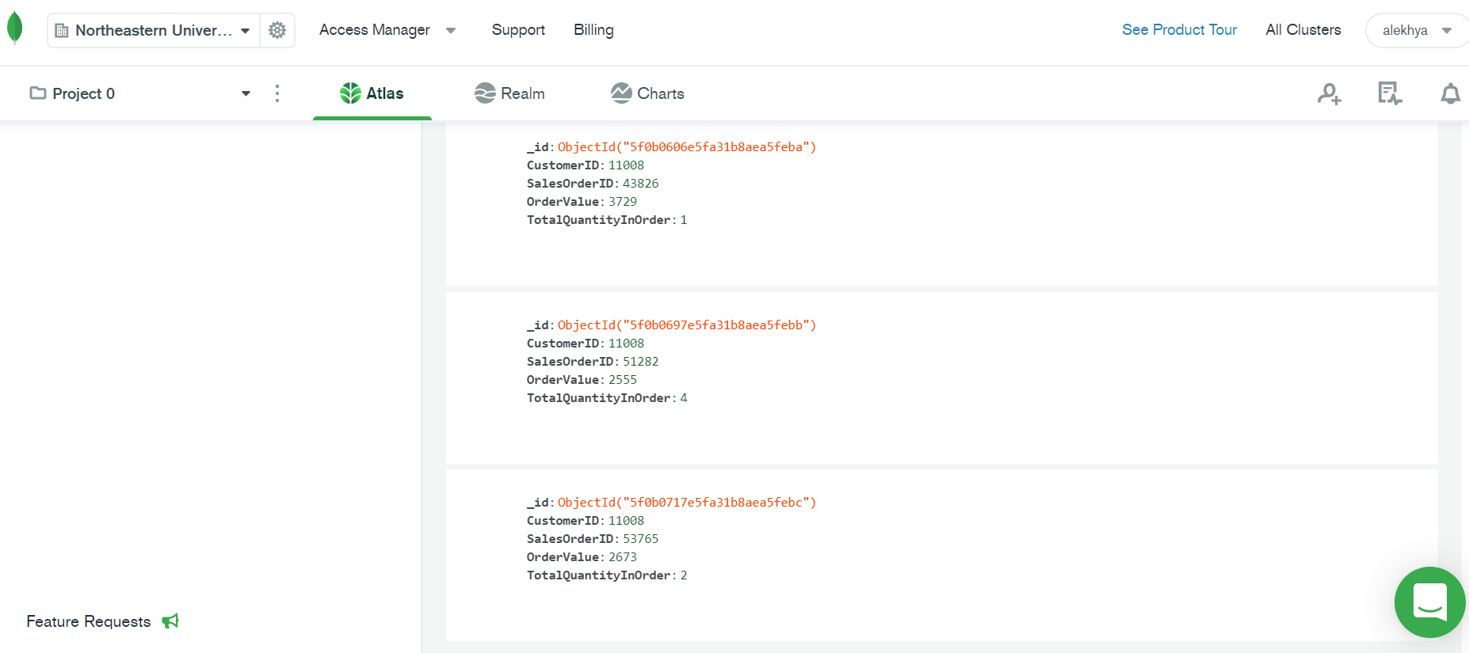

**Total Purchase Quantity and Total Order Value Code using MongoDB $group Aggregation:**

[{$group: {

_id: "$CustomerID",

TotalPurchaseQuantity: {

$sum: "$TotalQuantityInOrder"

},

TotalOrderValue: {

$sum: "$OrderValue"

},

}}]

Screenshot:

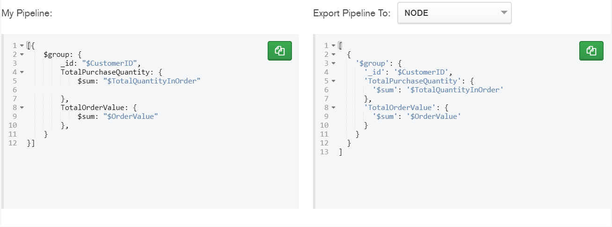

**MogoDB Result:**

_id:11005

TotalPurchaseQuantity:6

TotalOrderValue:8973

_id:11006

TotalPurchaseQuantity:5

TotalOrderValue:8971

_id:11007

TotalPurchaseQuantity:8

TotalOrderValue:9073

_id:11008

TotalPurchaseQuantity:7

TotalOrderValue:8957

OUTPUT RESULTS:

