**PART-3**

**Question:** Create a MongoDB document collection in MongoDB Atlas that includes the documents reflecting the data contained in the attached file. Each row in the file is a document. Then use the MongoDB Compass, JavaScript and MongoDB Aggregation Pipeline to calculate the total purchase value and the total purchase quantity for each customer.  
Submit your code, a screenshot of the code execution results, and the totals for each customer.

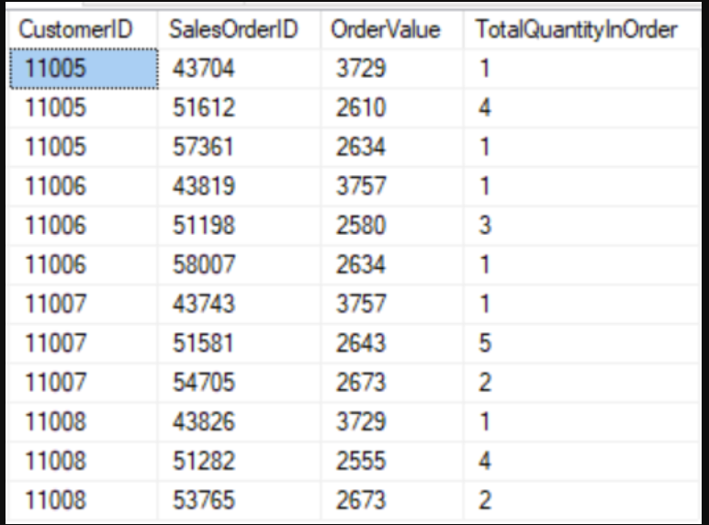

**CONTENTS OF THE DOCUMENT:**

**I solved this question Using both MongoDB Atlas and MongoDB Compass.**

1. **MongoDB Atlas**
2. **MongoDB Compass**

**I have included the screenshots of the following:**

1. **Input**
2. **Code**
3. **Output Results**

**MONGODB ATLAS**

**INPUT:**

|  |
| --- |
| {  "_id": {  "$oid": "5f0aee45e5fa31b8aea5feb1"  },  "CustomerID": {  "$numberInt": "11005"  },  "SalesOrderID": {  "$numberInt": "43704"  },  "OrderValue": {  "$numberInt": "3729"  },  "TotalQuantityInOrder": {  "$numberInt": "1"  }  } |

**Similarly each row given in the table is a document as seen in the below screenshots:**

**MongoDB Atlas: (inputs)**

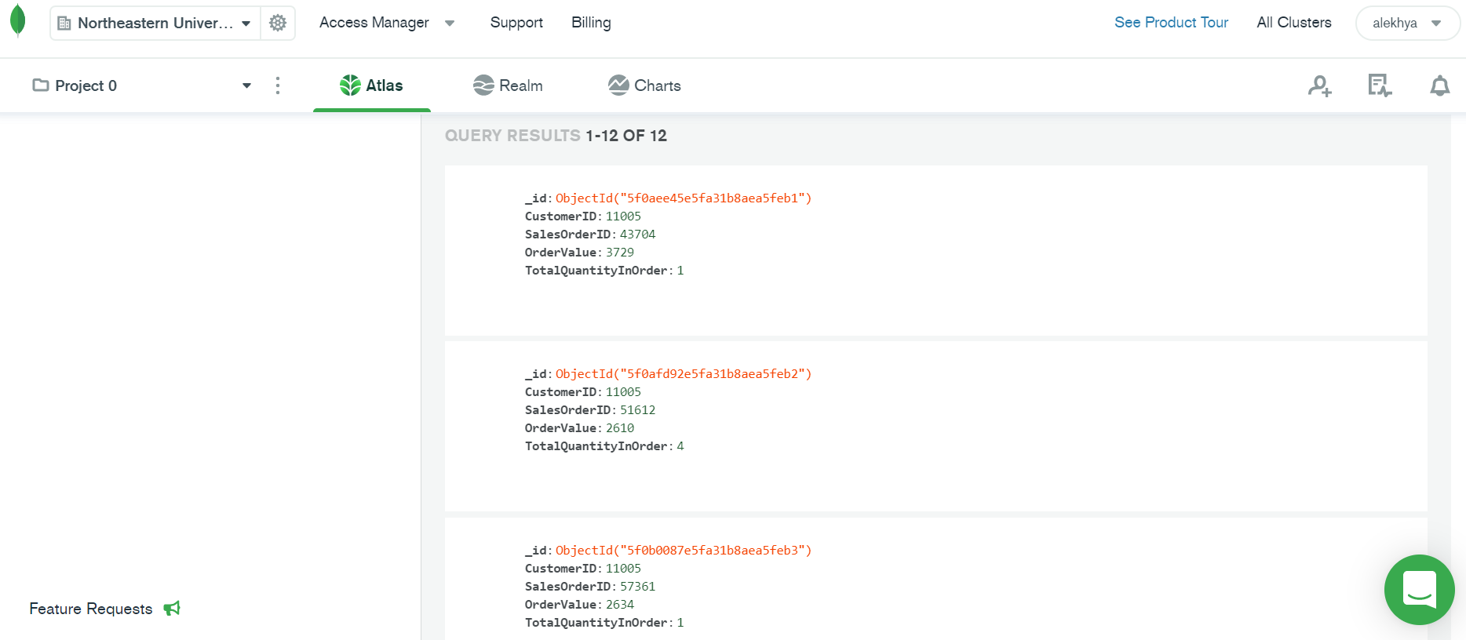

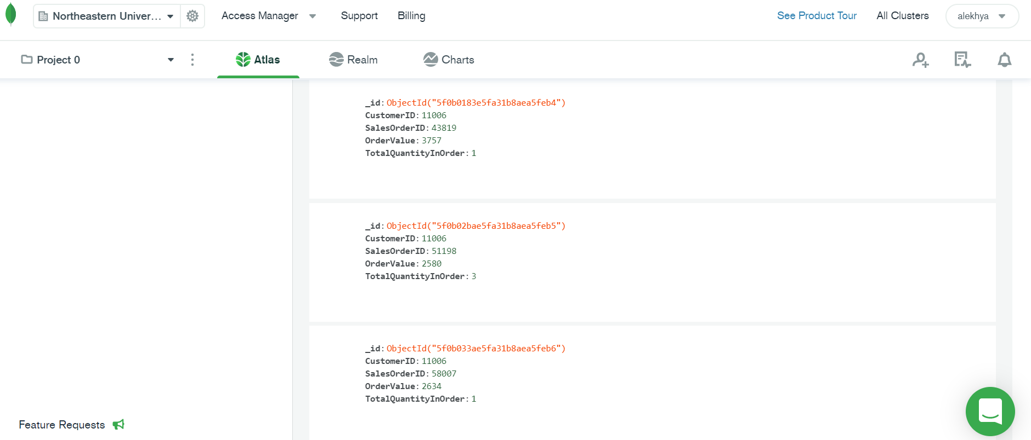

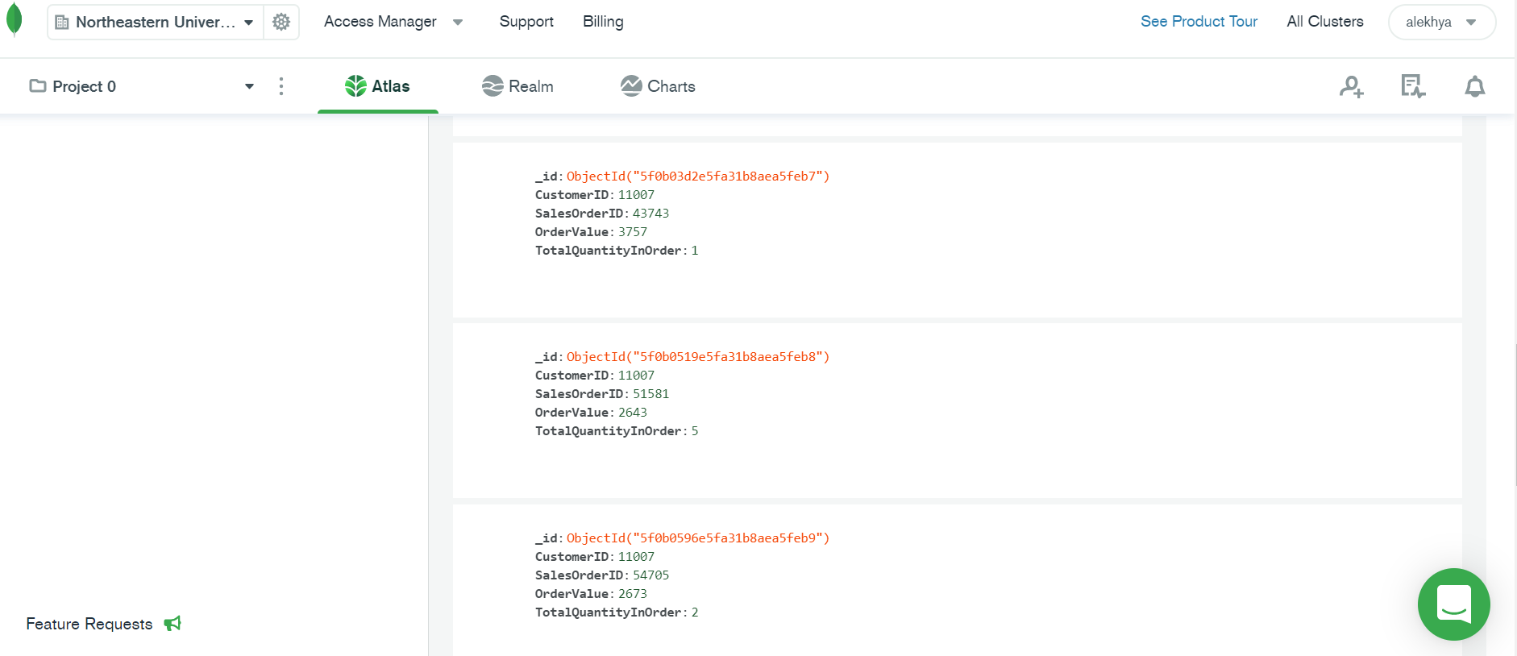

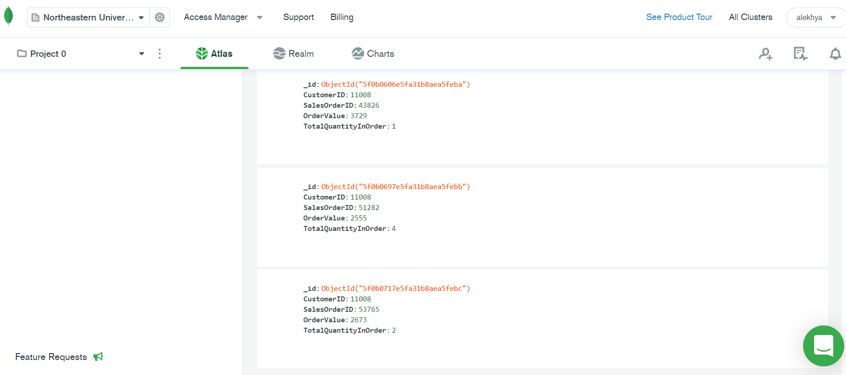

**CODE FOR TOTAL PURCHASE VALUE:**

[{$group: {

_id: "$CustomerID",

Total PurchaseValue: {

$sum: "$OrderValue"

}

}}]

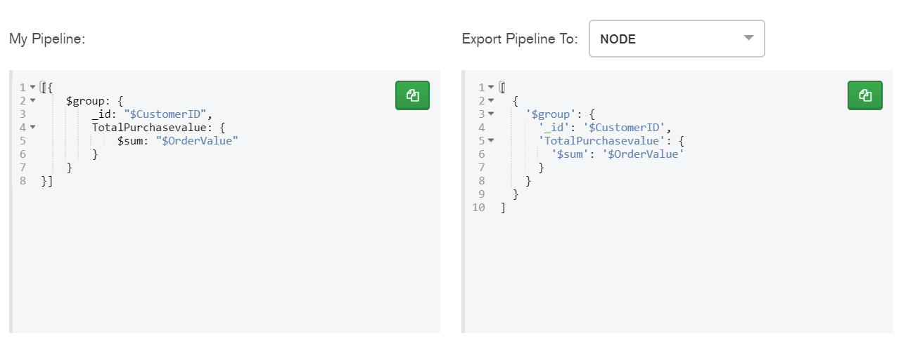

**OUTPUT FOR TOTAL PURCHASE VALUE: in MongoDB Atlas**

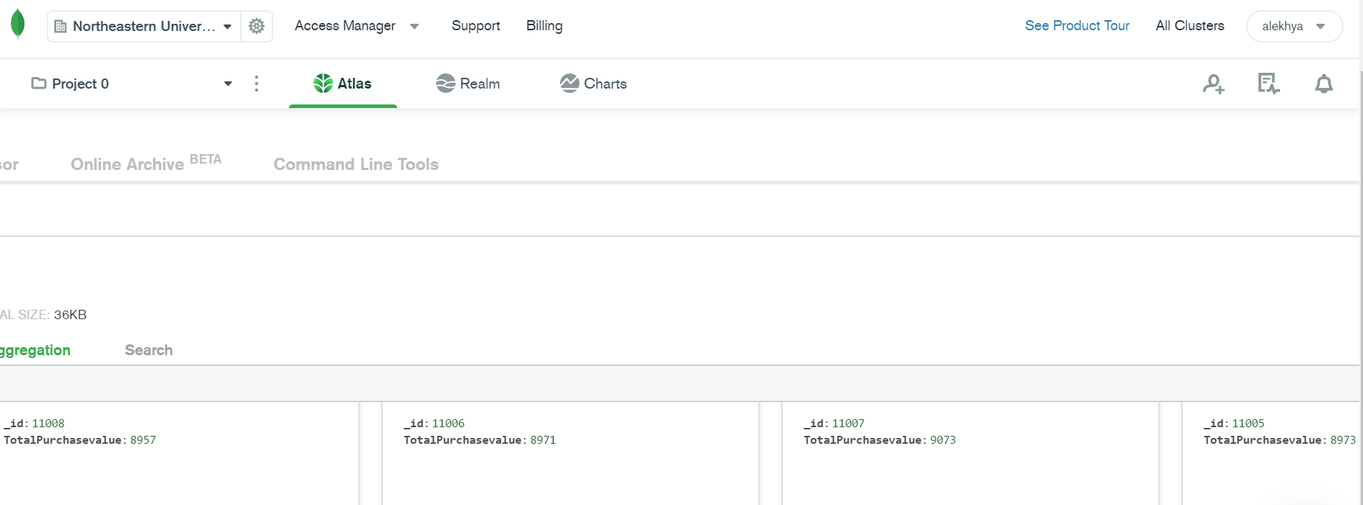

**CODE FOR TOTAL PURCHASE ORDER:**

[{$group: {

_id: "$CustomerID",

TotalPurchaseQuantity: {

$sum: "$TotalQuantityInOrder"

}

}}]

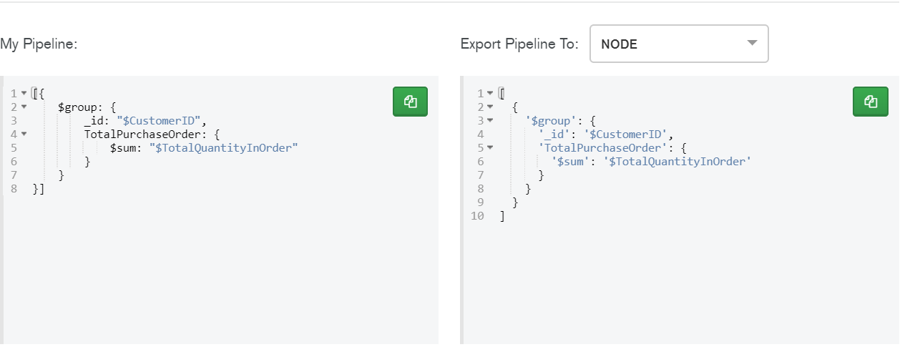

**OUTPUT FOR TOTAL PURCHASE ORDER: in MongoDB Atlas**

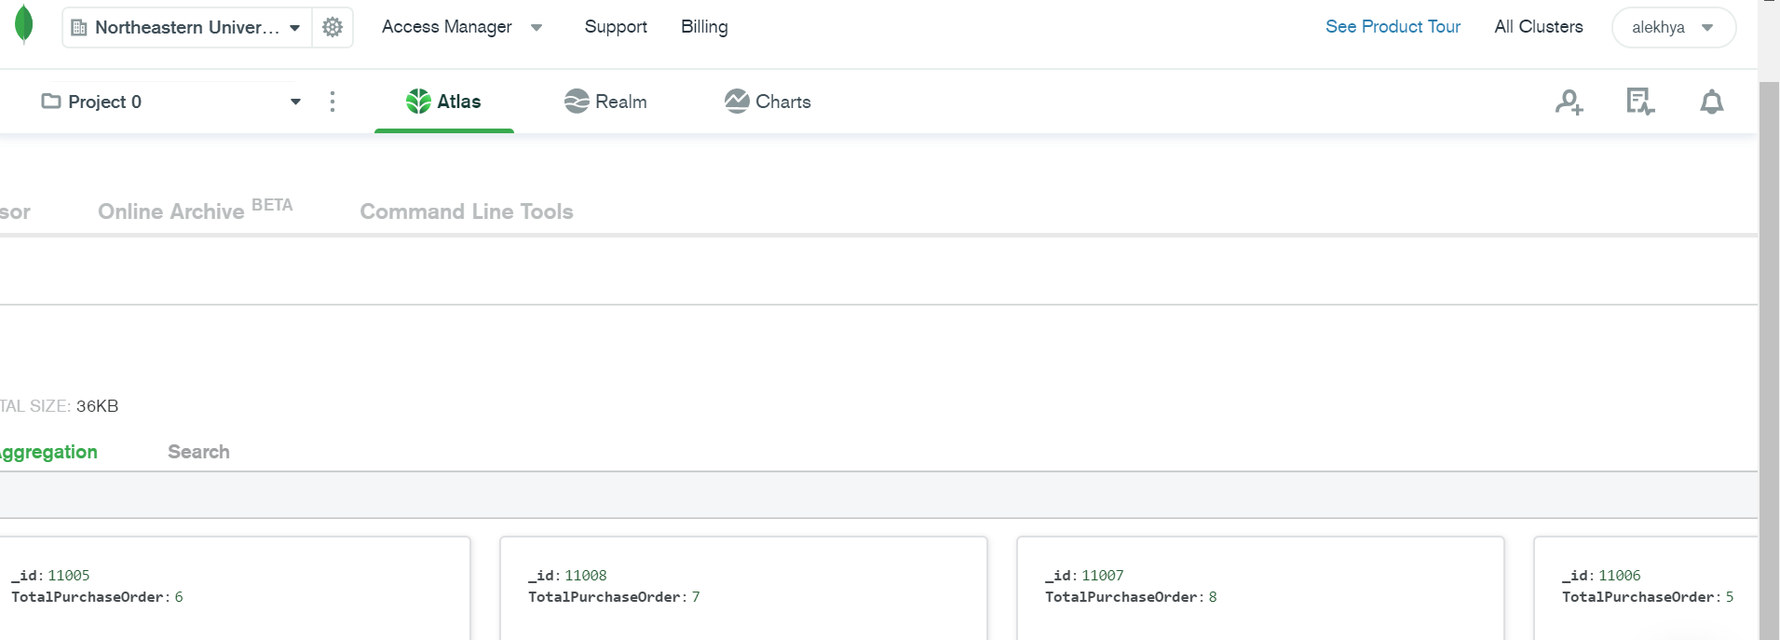

**MONGODB COMPASS**

Created a connection for MongoDB Atlas and MongoDB Compass

* We can import the data from excel(.csv format file or Json file)
* If we inserted data using Atlas when we create a connection we can see the data here in compass as well

**Below is the input in MongoDB Compass:**

|  |
| --- |
| {  "_id": {  "$oid": "5f0aee45e5fa31b8aea5feb1"  },  "CustomerID": {  "$numberInt": "11005"  },  "SalesOrderID": {  "$numberInt": "43704"  },  "OrderValue": {  "$numberInt": "3729"  },  "TotalQuantityInOrder": {  "$numberInt": "1"  }  } |

**Similarly each row in the file is a document as shown in the below screenshots:**

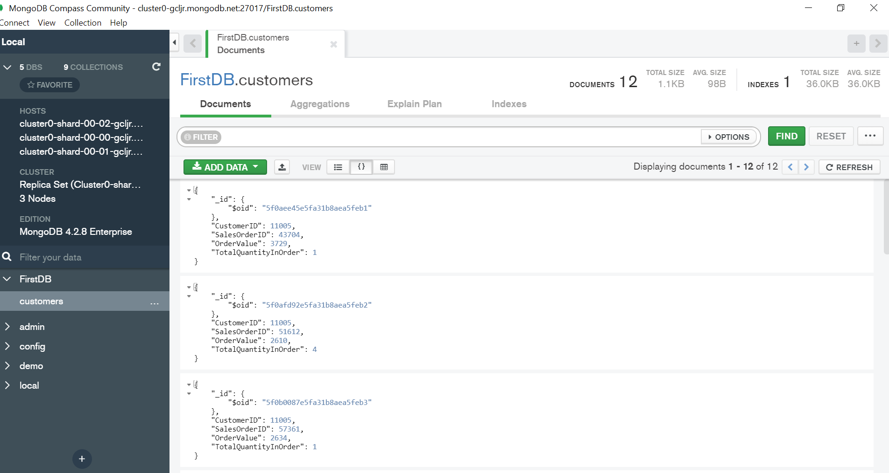

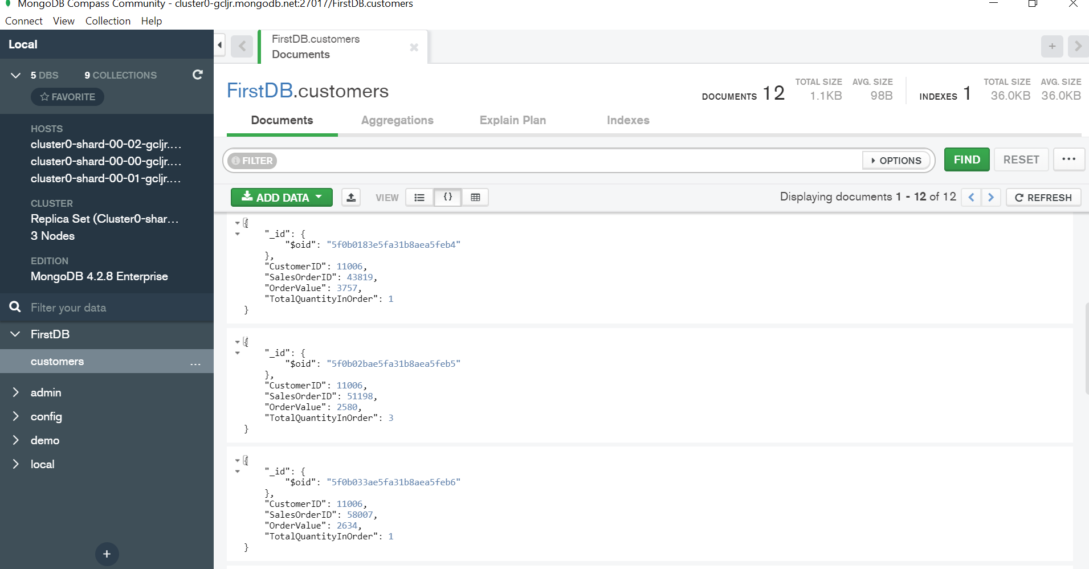

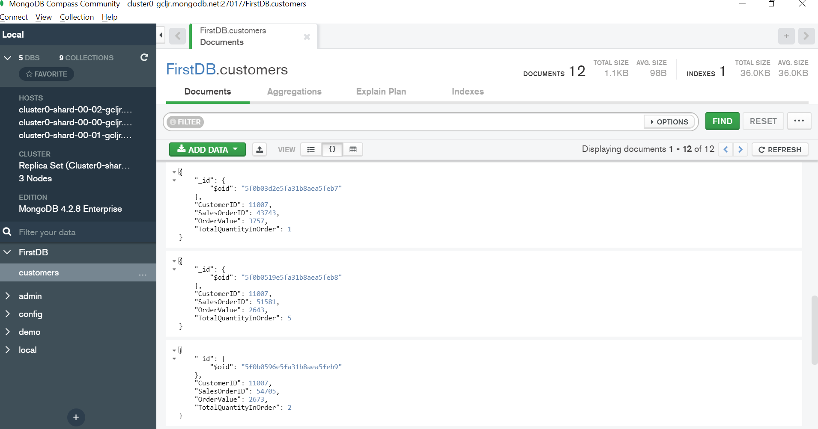

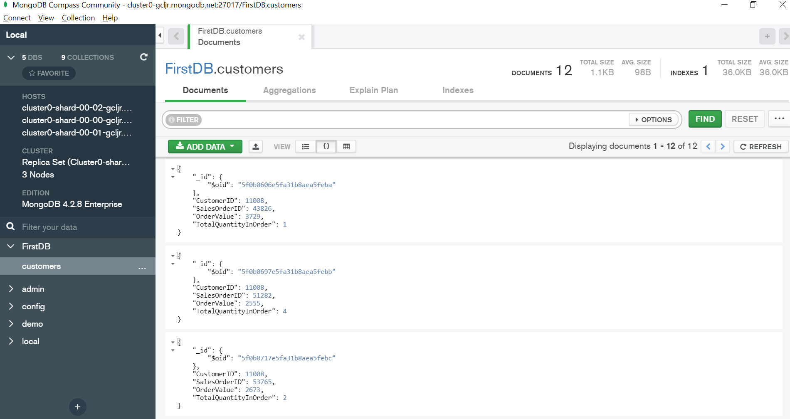

**Total Purchase Value Code using MongoDB Compass:**

[{$group: {

_id: "$CustomerID",

Total PurchaseValue: {

$sum: "$OrderValue"

}

}}]

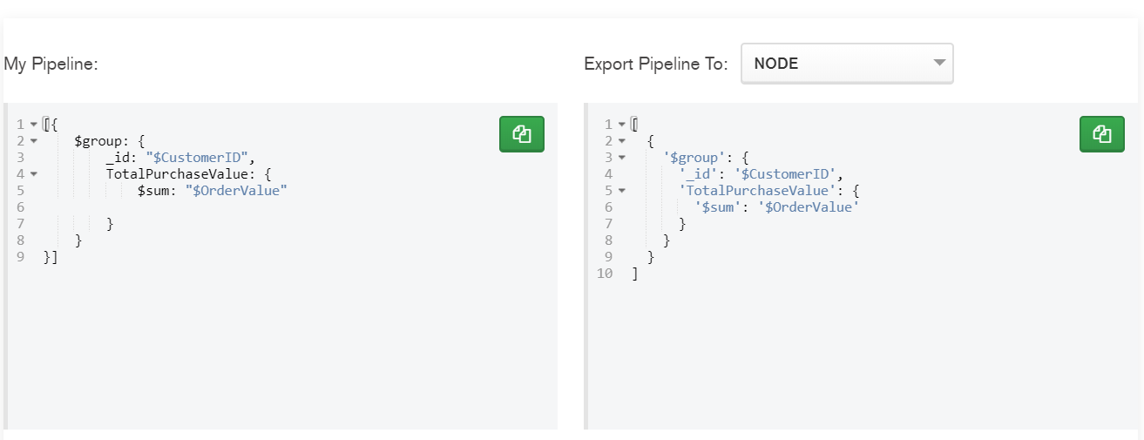

**Total Purchase Quantity Code using MongoDB Compass:**

[{$group: {

_id: "$CustomerID",

TotalPurchaseQuantity: {

$sum: "$TotalQuantityInOrder"

}

}}]

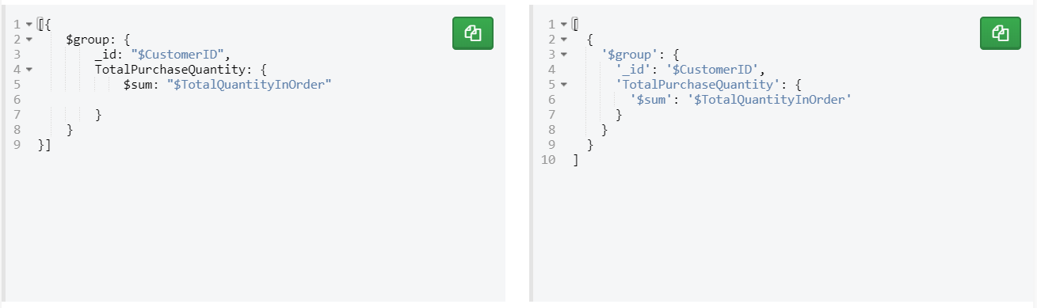

**OUTPUT USING MONGODB COMPASS FOR TOTAL PURCHASE QUANTITY:**

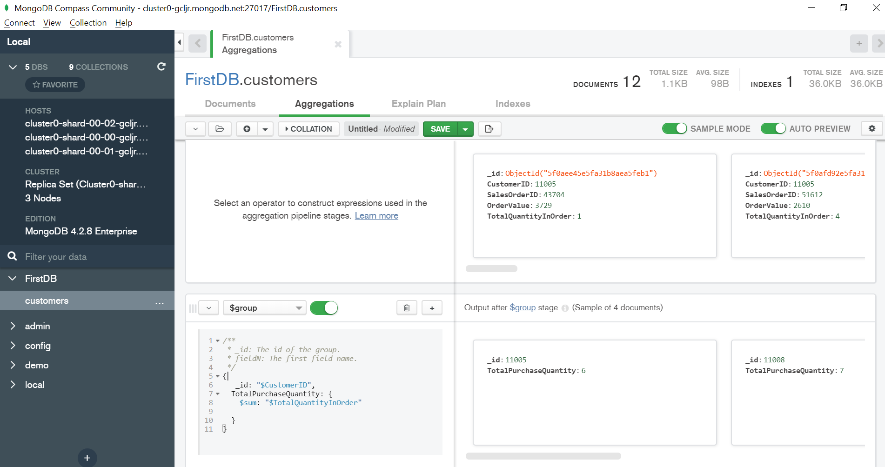

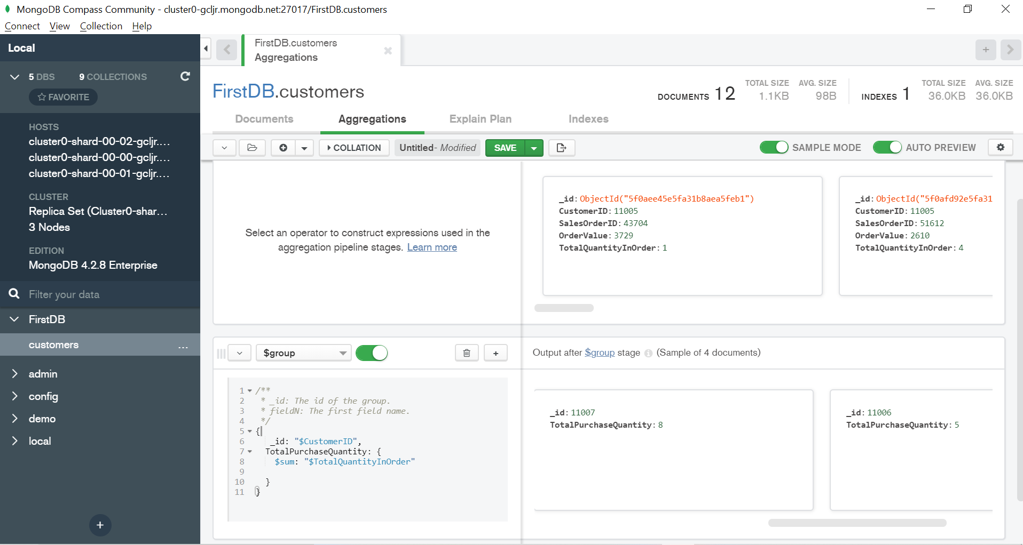

**OUTPUT USING MONGODB COMPASS FOR TOTAL PURCHASE VALUE:**

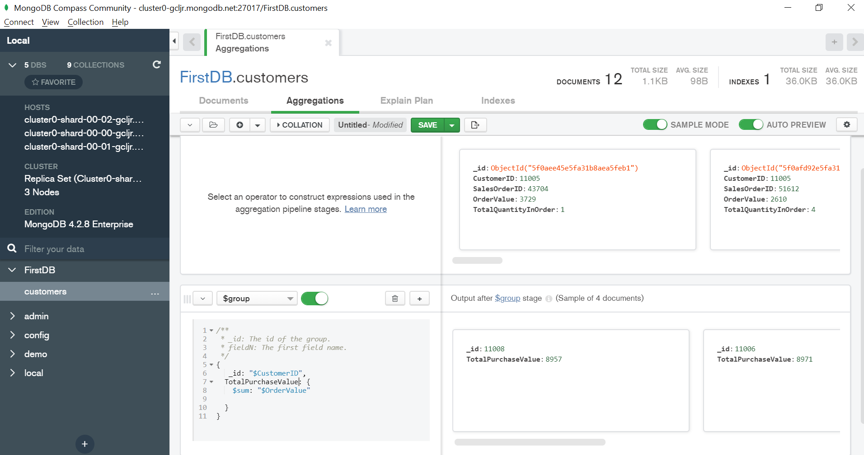

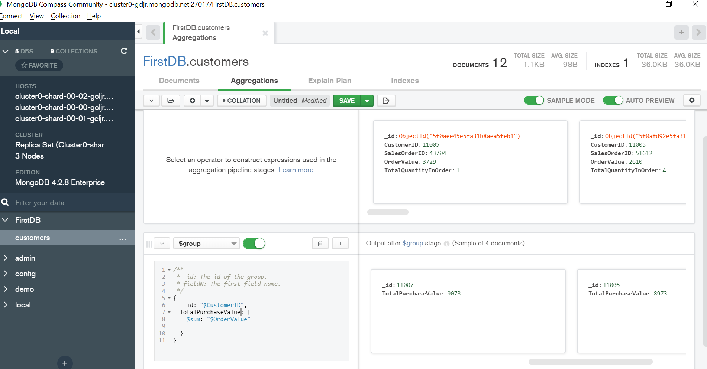

CODE TO GET BOTH THE OUTPUT IN THE SAME:

[{$group: {

_id: "$CustomerID",

TotalPurchaseQuantity: {

$sum: "$TotalQuantityInOrder"

},

totalQuantity: {

$sum: "$TotalQuantityInOrder"

}

}}]

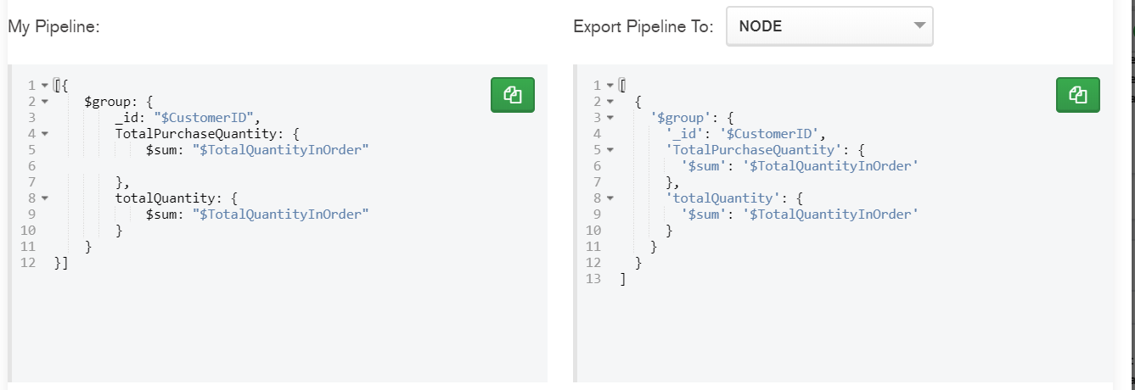

OUTPUT RESULTS:

