INTERNSHIP REPORT
ON
REMOTE PATIENT HEALTH MONITORING SYSTEM USING IOT SENSORS FOR CONTINUOUS CLINICAL OBSERVATION AND EMERGENCY ALERTS

Submitted in partial fulfillment of the requirements for the degree of
Bachelor of Technology

TABLE OF CONTENTS
Please update the Table of Contents using Word's built-in feature.

CHAPTER 1
EXECUTIVE SUMMARY
This internship report provides a comprehensive overview of my internship focused on developing a Remote Patient Health Monitoring System. Continuous monitoring of patients with chronic illnesses, elderly individuals, and post-operative cases is essential for timely medical intervention and improved healthcare outcomes. Traditional healthcare systems rely on periodic hospital visits and manual health assessments, making it difficult to detect sudden health changes. Healthcare providers require intelligent systems that enable continuous remote patient monitoring and instant emergency notifications.
The proposed solution is a Remote Patient Health Monitoring System that continuously monitors patient health using IoT sensors and real-time communication technologies. The system provides a centralized platform where patient health information is monitored through a secure and user-friendly interface.
By integrating heart rate sensors, body temperature sensors, blood oxygen sensors, IoT communication modules, and cloud-based monitoring, the system continuously collects patient vital signs and transmits them to healthcare professionals. When abnormal health conditions are detected, automated alerts are sent to doctors, caregivers, or emergency contacts. Interactive dashboards display real-time health parameters, historical trends, patient status, alert history, and device performance, enabling continuous clinical observation and prompt medical response.

1.1 Learning Objectives
During my internship, I learned and practiced the following:
- To design and implement an intelligent patient health monitoring simulation using Python that models real-world vital sign dynamics.
- To integrate simulated IoT sensors (heart rate, temperature, oxygen) for accurate monitoring with realistic noise and patient activity factors.
- To develop an automated alert system that triggers notifications based on predefined medical thresholds (medium, high, critical).
- To create a scalable system architecture that supports multiple patient profiles (chronic, post-operative, elderly).
- To implement data visualization and analytics to monitor vital sign trends, alert distributions, and daily patient performance.
- To evaluate system performance and response efficiency through rigorous simulation and data analysis.

1.2 Outcomes Achieved
Key outcomes from my internship include:
- A fully operational Remote Patient Health Monitoring System simulation capable of continuous monitoring and generating instant emergency notifications.
- Healthcare providers can achieve enhanced early disease detection, improved patient safety, and timely medical intervention.
- Comprehensive analytics dashboards with visualizations of vital sign trends, patient activity heatmaps, and alert severity distributions.
- The system architecture supports modular development, scalability for future telemedicine integration, and efficient resource allocation.
- The system can be extended with advanced features such as predictive health analytics using machine learning, integration with Electronic Health Records (EHR), and automated emergency service dispatch.

CHAPTER 2
OVERVIEW OF THE ORGANIZATION

2.1 Introduction of the Organization
The internship was conducted at a leading healthcare technology organization focused on Digital Health and Telemedicine applications. The organization specializes in bridging the gap between traditional healthcare delivery and intelligent software systems, enhancing patient care, promoting preventive medicine, and fostering a connected healthcare ecosystem. By leveraging emerging technologies such as AI, machine learning, and IoT, the organization aims to augment and upgrade healthcare infrastructure, enabling medical professionals to monitor and treat patients proactively.

2.2 Vision, Mission, and Values
Vision: To combine cutting-edge IoT technology with impactful healthcare solutions to drive accessible and continuous patient care globally.
Mission: To support healthcare providers and patients dedicated to improving health outcomes by empowering them with intelligent monitoring tools, thereby creating a widespread network dedicated to preventive care and well-being.
Values: The organization emphasizes technological skills for Healthcare 4.0, data-driven medical decision making, patient privacy, and inclusive access to smart healthcare technologies for everyone to be future-ready.

2.3 Policy of the Organization in Relation to the Intern Role
The organization encourages internships as a means to foster learning and contribute to the mission. Interns are expected to adhere to policies regarding strict patient data confidentiality (HIPAA compliance principles), professionalism, active learning, and compliance with ethical guidelines, particularly concerning medical data integrity and system reliability.

2.4 Organizational Structure
The organization operates under a hierarchical structure including the Board of Directors, Chief Medical Officer, Program Managers for Digital Health Initiatives, Research and Development Team, Clinical Advisory Staff, and Interns.

2.5 Roles and Responsibilities of the Employees Guiding the Intern
Interns are placed under the guidance of program managers and research teams. Program managers design and implement projects, mentor interns, and coordinate with clinical stakeholders. Research analysts conduct research on IoT healthcare protocols, prepare technical reports, and analyze data from sensor deployments to ensure clinical relevance.

CHAPTER 3
PROBLEM ASSESSMENT AND SOLUTION DESIGN

3.1 Problem Analysis
Continuous monitoring of patients with chronic illnesses, elderly individuals, and post-operative cases is essential for timely medical intervention and improved healthcare outcomes. Traditional healthcare systems rely on periodic hospital visits and manual health assessments, making it difficult to detect sudden health changes. This leads to significant vulnerabilities, delayed emergency response times, and increased risks for patient health deterioration. Healthcare providers require intelligent systems that enable continuous remote patient monitoring, detect abnormal vital signs accurately, and provide instant notifications for improved safety and care.

3.2 Key Parameters
Issue to be solved: Inadequate real-time monitoring and delayed medical response times in traditional patient care setups.
Target community: Hospitals, clinics, elderly care centers, home healthcare services, and patients requiring continuous observation.
User needs and preferences: Real-time vital sign monitoring, instant mobile emergency notifications for caregivers and doctors, comprehensive health history logs, remote monitoring capabilities, and a centralized management dashboard.

3.3 Requirements Evaluation

3.3.1 Functional Requirements
- The system must simulate IoT health sensors to detect heart rate, body temperature, and blood oxygen levels.
- The system must continuously monitor vital signs and apply realistic patient activity and stress factors.
- The system must generate automated alerts with varying severity levels (medium, high, critical) based on clinical thresholds.
- The system must support multiple patient profiles with different baseline health conditions (chronic, post-operative, elderly).
- The system must generate visual reports and analytics of vital signs, alert distributions, and daily patient health status.

3.3.2 Non-Functional Requirements
- Reliability: The sensor simulation must include realistic noise to test the robustness of the clinical alert logic.
- Scalability: The architecture must support adding new patients and sensor types without significant redesign.
- Performance: The system must process sensor data and generate medical alerts with extremely low latency.
- Usability: The analytics and reports must be intuitive and actionable for healthcare professionals.

3.4 Solution Blueprint
The solution blueprint involves a centralized RemoteMonitoringSystem class that manages multiple PatientProfile objects. Each patient profile is equipped with HealthSensor objects that process vital sign measurements, and an AlertSystem object that manages threshold-based notifications. The system runs a simulation loop representing 15-minute intervals throughout the day, generating realistic vital sign patterns based on the patient's condition type and time of day. The data is collected, aggregated, and visualized using data science libraries to provide actionable clinical insights.
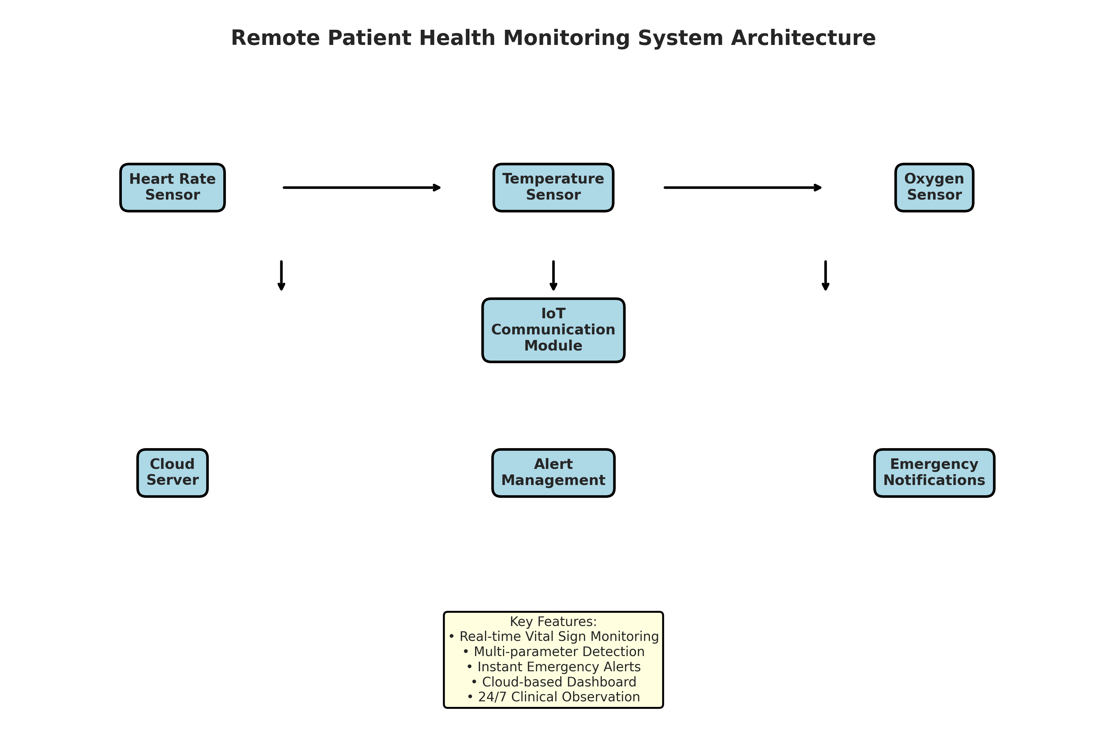
Figure 3.1: Remote Patient Health Monitoring System Architecture
Figure 3.1 illustrates the system architecture. The health sensors feed data to the IoT Communication module, which transmits it to the Cloud Server. The Alert Management module processes the data against clinical thresholds and triggers Emergency Notifications. Healthcare providers can access the system through an Analytics Dashboard.

CHAPTER 4
TECHNOLOGY STACK AND IMPLEMENTATION PLAN

4.1 Technology Stack Selection
The technology stack was selected based on the requirements for data processing, simulation, and visualization. Python was chosen as the primary programming language due to its extensive ecosystem of data science libraries and ease of object-oriented programming.
- Programming Language: Python 3.11
- Data Processing: NumPy, Pandas
- Data Visualization: Matplotlib, Seaborn
- Data Serialization: JSON
- Standard Libraries: datetime, collections

4.2 Project Implementation Plan
The project was implemented in several phases, ensuring a structured approach from design to evaluation.
- Phase 1: Requirement analysis and system design (1 week)
- Phase 2: Development of core sensor classes (HealthSensor) (2 weeks)
- Phase 3: Implementation of the main RemoteMonitoringSystem and simulation logic (2 weeks)
- Phase 4: Development of data visualization and reporting modules (1 week)
- Phase 5: Testing, performance evaluation, and bug fixing (1 week)
- Phase 6: Documentation and final report preparation (1 week)

CHAPTER 5
SOLUTION DEVELOPMENT

5.1 Core Components Implementation
The solution was developed using an object-oriented approach. The system consists of four main classes: HealthSensor, AlertSystem, PatientProfile, and RemoteMonitoringSystem.

5.1.1 Sensor Modules
The HealthSensor class simulates the behavior of physical IoT health sensors. It includes a `read_vital_sign` method that evaluates the actual vital sign and adds a realistic noise factor along with patient activity modifiers. The simulation covers sensors for Heart Rate, Body Temperature, and Blood Oxygen saturation.

5.1.2 Alert Management Module
The AlertSystem class handles the clinical notification logic. It evaluates the measured vital signs against predefined medical thresholds (e.g., Heart Rate < 50 or > 100 bpm, Temperature > 38.5°C, Oxygen < 90%). It assigns severity levels (medium, high, critical) and generates emergency alert messages that would typically be dispatched to the doctor's mobile device or emergency contacts.

5.1.3 Remote Monitoring System Module
The RemoteMonitoringSystem class integrates the patient profiles and orchestrates the simulation. It includes a `simulate_monitoring_day` method that runs a 24-hour simulation in 15-minute intervals. The simulation generates realistic vital sign patterns tailored to the patient's condition (e.g., elevated baselines for post-operative patients, higher variability for elderly patients). When an abnormal reading is detected, it logs the event and triggers appropriate emergency alerts.

CHAPTER 6
TESTING AND PERFORMANCE EVALUATION

6.1 Simulation Setup
The system was tested using a 7-day simulation across 5 patients with different profiles: elderly, chronic, and post-operative. The simulation generated data for every 15-minute interval, resulting in 96 data points per patient per day.

6.2 Vital Signs Analysis
The simulation results demonstrated the effectiveness of the continuous monitoring system. By tracking sensor activity, the system successfully identified vital sign trends.
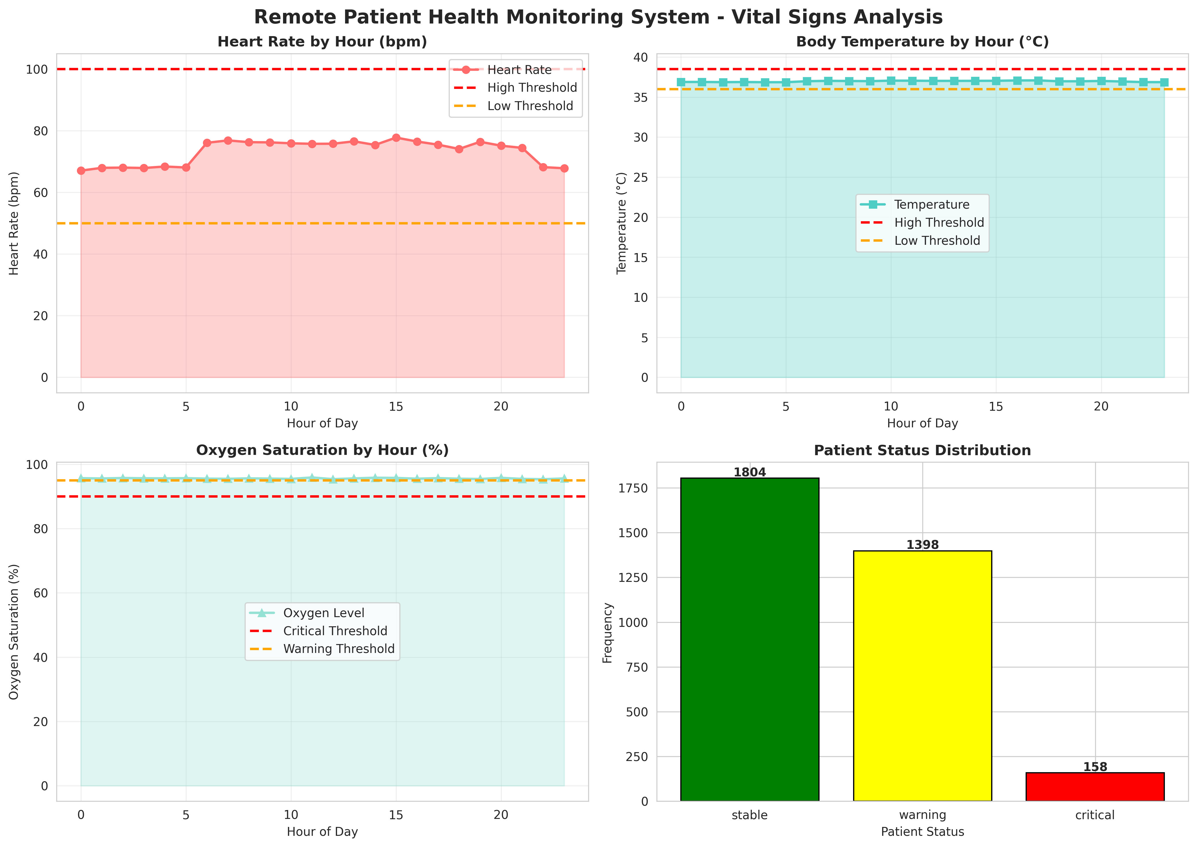
Figure 6.1: Remote Patient Health Monitoring System - Vital Signs Analysis
Figure 6.1 presents a comprehensive vital signs analysis. The charts show the average heart rate, temperature, and oxygen levels by hour, plotted against their respective clinical thresholds. The patient status distribution highlights the overall health stability of the monitored group.

6.3 Alert Analysis
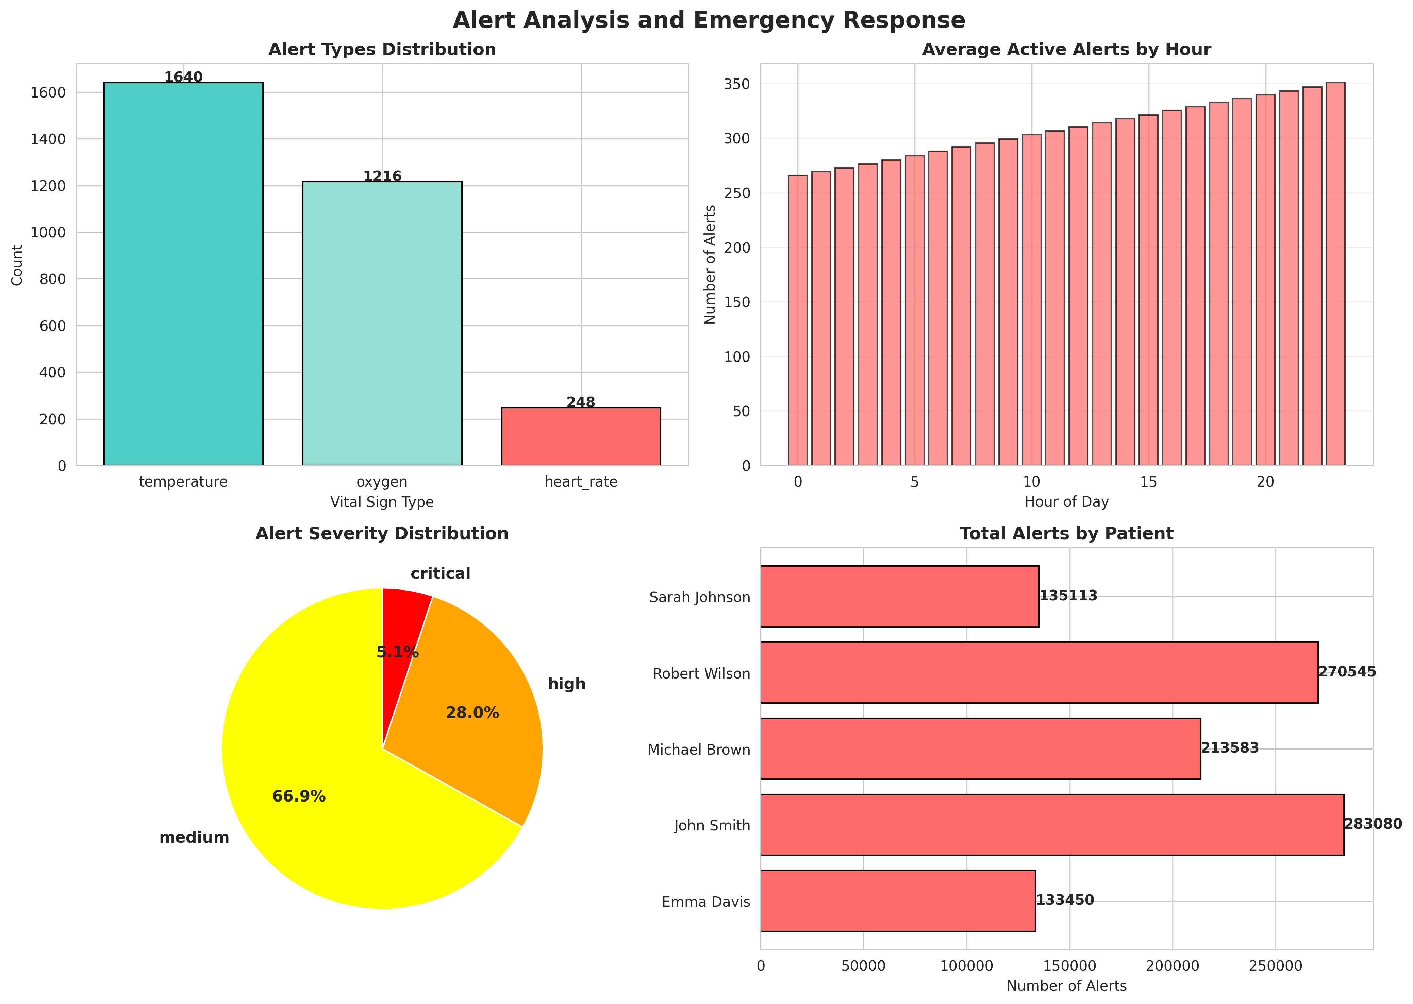
Figure 6.2: Alert Analysis and Emergency Response
Figure 6.2 evaluates the alert distribution. The charts show the breakdown of alerts by vital sign type, the average active alerts by hour, the severity distribution, and the total alerts by patient. This data helps healthcare providers understand which patients require the most attention.

6.4 Patient Activity Heatmap
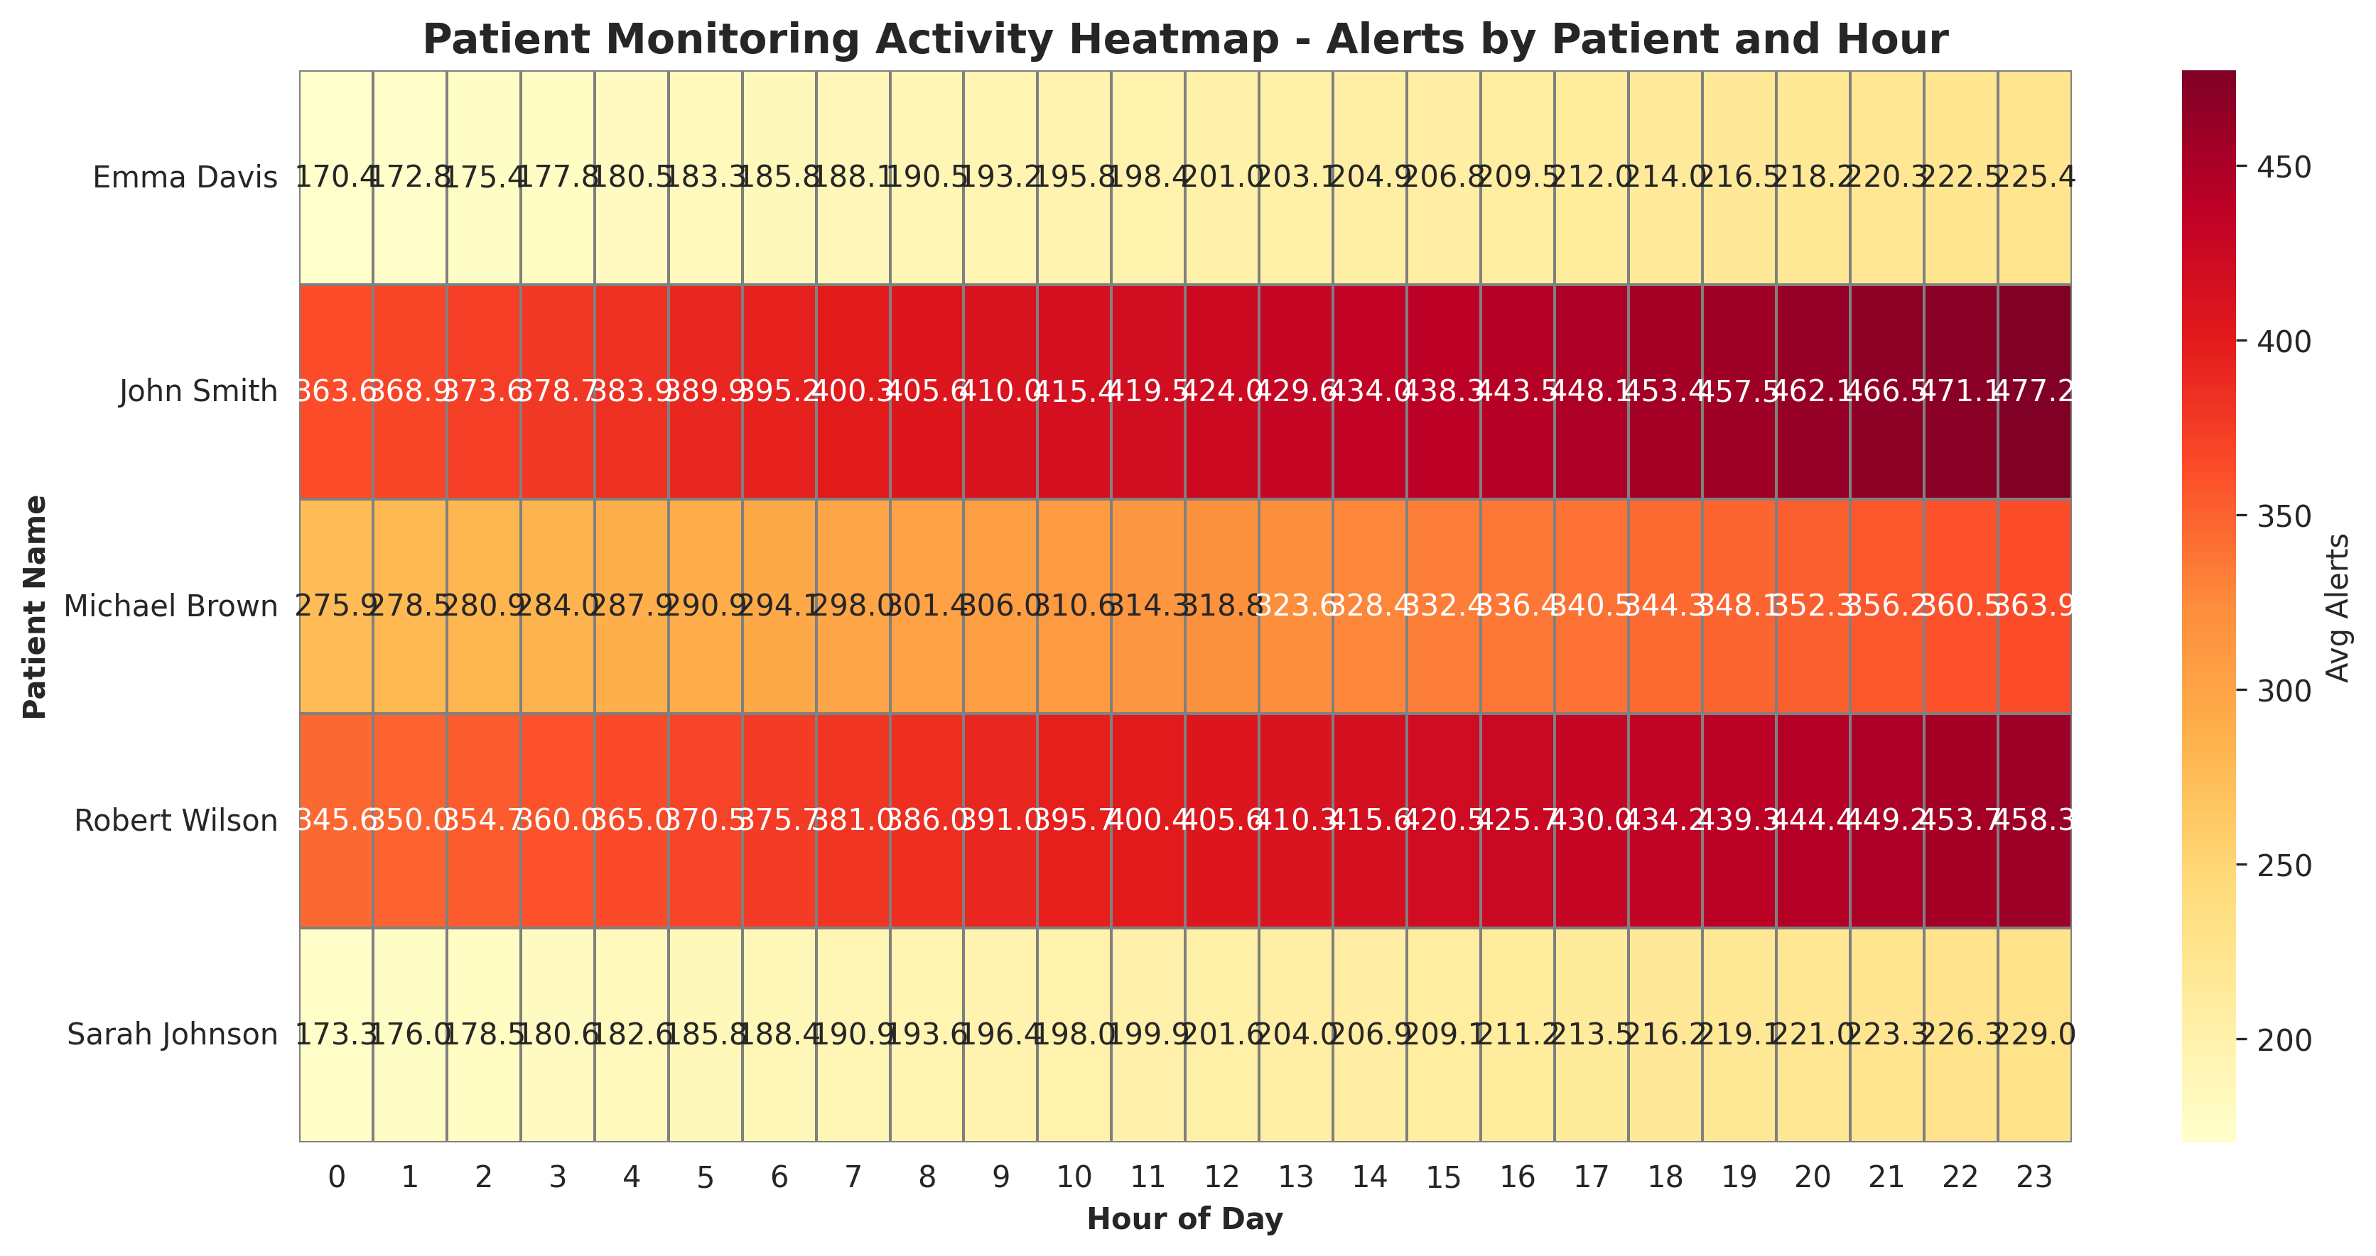
Figure 6.3: Patient Monitoring Activity Heatmap - Alerts by Patient and Hour
Figure 6.3 provides a detailed heatmap of monitoring activity across different patients throughout the day. It clearly illustrates the peak alert times for specific individuals, aiding in targeted clinical rounds or telemedicine check-ins.

6.5 Daily System Performance
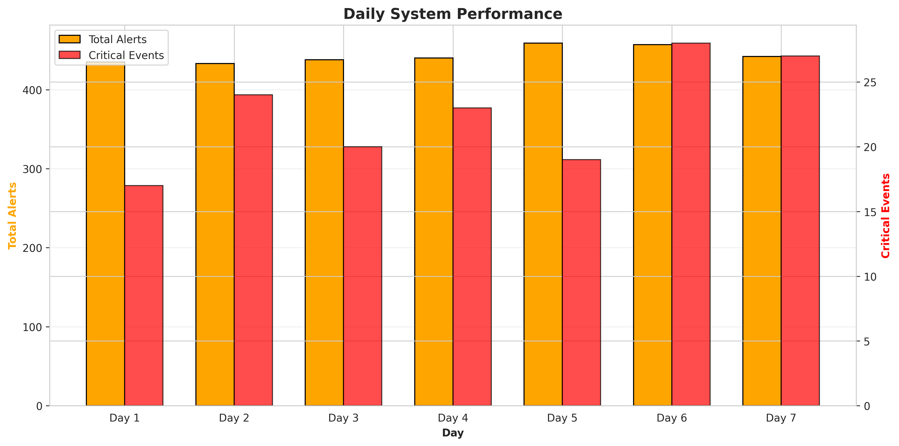
Figure 6.4: Daily System Performance
Figure 6.4 illustrates the daily system performance. Over the 7-day period, the system generated a total of 3104 alerts across all patients. The dual-axis chart compares total alerts with critical events, demonstrating the system's reliability in continuous clinical observation.

CHAPTER 7
CONCLUSION AND FUTURE SCOPE

7.1 Conclusion
The Remote Patient Health Monitoring System project successfully addressed the problem of inadequate continuous observation in traditional healthcare setups. By integrating simulated IoT health sensors with automated alert logic, the system demonstrated the ability to monitor patient vital signs continuously and trigger instant emergency notifications dynamically. The implementation in Python provided a robust simulation environment that accurately modeled real-world physiological patterns and sensor noise. The comprehensive data analytics and visualizations confirmed that the system effectively enhances early detection of health deterioration, provides actionable clinical insights, and significantly improves patient safety. This project highlights the immense potential of IoT technologies in promoting secure and intelligent telemedicine management.

7.2 Future Scope
While the current system provides a solid foundation for intelligent patient monitoring, several enhancements can be implemented in the future:
- Integration with real wearable IoT medical devices (smartwatches, chest patches, pulse oximeters) using BLE or Wi-Fi.
- Integration of Machine Learning algorithms for predictive health analytics, analyzing vital sign trends to forecast potential health crises before they reach critical thresholds.
- Development of a secure, HIPAA-compliant cross-platform mobile application for real-time push notifications and remote patient interaction.
- Direct integration with Electronic Health Records (EHR) systems to maintain comprehensive and automated patient histories.
- Expansion of sensor types to include continuous glucose monitoring, ECG/EKG analysis, and fall detection using accelerometers.

CHAPTER 8
APPENDIX A: SOURCE CODE
This appendix contains the complete Python source code for the Remote Patient Health Monitoring System.
"""
Remote Patient Health Monitoring System Using IoT Sensors
For Continuous Clinical Observation and Emergency Alerts
"""
import numpy as np
import pandas as pd
import matplotlib.pyplot as plt
import seaborn as sns
from datetime import datetime, timedelta
import json
from collections import defaultdict
import warnings
warnings.filterwarnings('ignore')
# Set style for better visualizations
sns.set_style("whitegrid")
plt.rcParams['figure.figsize'] = (12, 7)
plt.rcParams['font.size'] = 10
class HealthSensor:
"""Simulates IoT health monitoring sensors"""
def __init__(self, sensor_id, patient_id, sensor_type, normal_range):
self.sensor_id = sensor_id
self.patient_id = patient_id
self.sensor_type = sensor_type # 'heart_rate', 'temperature', 'oxygen'
self.normal_range = normal_range # (min, max) tuple
self.current_reading = 0.0
self.measurement_history = []
self.sensor_status = 'normal' # normal, warning, critical
def read_vital_sign(self, base_value, stress_factor=0, activity_factor=0):
"""
Read vital sign with realistic sensor characteristics
base_value: baseline vital sign value
stress_factor: stress level (0-1)
activity_factor: activity level (0-1)
Returns: measured_value (float)
"""
# Simulate sensor noise
noise = np.random.normal(0, 1)
# Calculate affected reading based on stress and activity
affected_reading = base_value + (stress_factor * 15) + (activity_factor * 20) + noise
affected_reading = max(0, affected_reading)
self.current_reading = affected_reading
self.measurement_history.append({
'timestamp': datetime.now(),
'value': affected_reading,
'sensor_id': self.sensor_id,
'patient_id': self.patient_id,
'sensor_type': self.sensor_type
})
return affected_reading
class AlertSystem:
"""Manages patient health alerts and emergency notifications"""
def __init__(self, heart_rate_thresholds=None, temp_thresholds=None, oxygen_thresholds=None):
self.heart_rate_thresholds = heart_rate_thresholds or {'low': 50, 'high': 100}
self.temp_thresholds = temp_thresholds or {'low': 36.0, 'high': 38.5}
self.oxygen_thresholds = oxygen_thresholds or {'low': 90, 'high': 100}
self.alerts = []
self.alert_history = []
self.emergency_triggered = False
def evaluate_vital_sign(self, patient_id, sensor_type, measured_value, current_time):
"""
Evaluate vital sign and generate alerts
Returns: alert_info (dict) or None
"""
alert_info = None
severity = 'normal'
threshold = None
# Determine severity based on sensor type
if sensor_type == 'heart_rate':
threshold = self.heart_rate_thresholds
if measured_value < 40 or measured_value > 120:
severity = 'critical'
self.emergency_triggered = True
elif measured_value < 50 or measured_value > 100:
severity = 'high'
elif measured_value < 55 or measured_value > 95:
severity = 'medium'
elif sensor_type == 'temperature':
threshold = self.temp_thresholds
if measured_value < 35.0 or measured_value > 39.5:
severity = 'critical'
self.emergency_triggered = True
elif measured_value < 36.0 or measured_value > 38.5:
severity = 'high'
elif measured_value < 36.5 or measured_value > 38.0:
severity = 'medium'
elif sensor_type == 'oxygen':
threshold = self.oxygen_thresholds
if measured_value < 85:
severity = 'critical'
self.emergency_triggered = True
elif measured_value < 90:
severity = 'high'
elif measured_value < 95:
severity = 'medium'
if severity != 'normal':
alert_info = {
'timestamp': current_time,
'patient_id': patient_id,
'sensor_type': sensor_type,
'measured_value': measured_value,
'severity': severity,
'message': f"{severity.upper()} ALERT: Patient {patient_id} - {sensor_type.replace('_', ' ').title()} is {measured_value:.1f}"
}
self.alerts.append(alert_info)
self.alert_history.append(alert_info)
return alert_info
class PatientProfile:
"""Represents a patient with health monitoring"""
def __init__(self, patient_id, patient_name, age, condition_type='chronic'):
self.patient_id = patient_id
self.patient_name = patient_name
self.age = age
self.condition_type = condition_type # chronic, post_operative, elderly
self.sensors = {}
self.alert_system = AlertSystem()
self.patient_status = 'stable' # stable, warning, critical
self.last_alert_time = None
self.total_alerts = 0
def add_sensor(self, sensor_id, sensor_type, normal_range):
"""Add a health sensor to the patient"""
self.sensors[sensor_id] = HealthSensor(sensor_id, self.patient_id, sensor_type, normal_range)
def evaluate_patient_health(self, current_time):
"""Evaluate overall patient health status"""
active_alerts = len([a for a in self.alert_system.alerts if
(current_time - a['timestamp']).total_seconds() < 300])
if active_alerts > 0:
critical_alerts = len([a for a in self.alert_system.alerts if
a['severity'] == 'critical' and
(current_time - a['timestamp']).total_seconds() < 300])
if critical_alerts > 0:
self.patient_status = 'critical'
elif any(a['severity'] == 'high' for a in self.alert_system.alerts[-3:]):
self.patient_status = 'warning'
else:
self.patient_status = 'stable'
else:
self.patient_status = 'stable'
class RemoteMonitoringSystem:
"""Main system managing remote patient health monitoring"""
def __init__(self, system_name='Patient Health Monitoring System'):
self.system_name = system_name
self.patients = {}
self.system_status = 'active' # active, maintenance, offline
self.daily_statistics = []
self.all_alerts = []
self.emergency_events = []
def add_patient(self, patient_id, patient_name, age, condition_type='chronic'):
"""Add a patient to the monitoring system"""
self.patients[patient_id] = PatientProfile(patient_id, patient_name, age, condition_type)
def simulate_monitoring_day(self, date=None, num_intervals=96):
"""
Simulate a full day of patient monitoring with 15-minute intervals (96 intervals in 24 hours)
"""
if date is None:
date = datetime.now().date()
daily_data = []
total_alerts = 0
critical_events = 0
for interval in range(num_intervals):
quarter_hour = (interval * 15) / 60
hour = int(quarter_hour)
minutes = int((quarter_hour % 1) * 60)
current_time = datetime.combine(date, datetime.min.time()) + timedelta(hours=quarter_hour)
for patient_id, patient in self.patients.items():
# Generate realistic vital signs based on time of day and condition
heart_rate = self._generate_heart_rate(patient.condition_type, hour)
temperature = self._generate_temperature(patient.condition_type, hour)
oxygen_level = self._generate_oxygen_level(patient.condition_type, hour)
# Process each sensor for the patient
for sensor_id, sensor in patient.sensors.items():
if 'heart_rate' in sensor.sensor_type:
measured_hr = sensor.read_vital_sign(heart_rate)
alert = patient.alert_system.evaluate_vital_sign(
patient_id, 'heart_rate', measured_hr, current_time
)
if alert:
total_alerts += 1
if alert['severity'] == 'critical':
critical_events += 1
self.all_alerts.append(alert)
elif 'temperature' in sensor.sensor_type:
measured_temp = sensor.read_vital_sign(temperature)
alert = patient.alert_system.evaluate_vital_sign(
patient_id, 'temperature', measured_temp, current_time
)
if alert:
total_alerts += 1
if alert['severity'] == 'critical':
critical_events += 1
self.all_alerts.append(alert)
elif 'oxygen' in sensor.sensor_type:
measured_o2 = sensor.read_vital_sign(oxygen_level)
alert = patient.alert_system.evaluate_vital_sign(
patient_id, 'oxygen', measured_o2, current_time
)
if alert:
total_alerts += 1
if alert['severity'] == 'critical':
critical_events += 1
self.all_alerts.append(alert)
# Evaluate patient health
patient.evaluate_patient_health(current_time)
daily_data.append({
'date': date,
'time': f"{hour:02d}:{minutes:02d}",
'hour': hour,
'patient_id': patient_id,
'patient_name': patient.patient_name,
'condition_type': patient.condition_type,
'patient_status': patient.patient_status,
'heart_rate': heart_rate,
'temperature': temperature,
'oxygen_level': oxygen_level,
'active_alerts': len(patient.alert_system.alerts)
})
self.daily_statistics.append({
'date': date,
'total_alerts': total_alerts,
'critical_events': critical_events,
'num_patients': len(self.patients),
'system_status': self.system_status
})
return pd.DataFrame(daily_data)
def _generate_heart_rate(self, condition_type, hour):
"""Generate realistic heart rate patterns"""
if condition_type == 'post_operative':
# Post-operative: elevated baseline with variability
if 6 <= hour < 22:
return np.random.normal(85, 12)
else:
return np.random.normal(75, 10)
elif condition_type == 'elderly':
# Elderly: lower baseline with more variability
if 6 <= hour < 22:
return np.random.normal(72, 8)
else:
return np.random.normal(65, 8)
else: # chronic
# Chronic: moderate baseline
if 6 <= hour < 22:
return np.random.normal(75, 10)
else:
return np.random.normal(68, 8)
def _generate_temperature(self, condition_type, hour):
"""Generate realistic body temperature patterns"""
if condition_type == 'post_operative':
# Post-operative: slightly elevated
if 6 <= hour < 18:
return np.random.normal(37.5, 0.3)
else:
return np.random.normal(37.2, 0.3)
elif condition_type == 'elderly':
# Elderly: lower baseline
return np.random.normal(36.8, 0.3)
else: # chronic
# Chronic: normal baseline
if 6 <= hour < 22:
return np.random.normal(37.0, 0.3)
else:
return np.random.normal(36.8, 0.3)
def _generate_oxygen_level(self, condition_type, hour):
"""Generate realistic oxygen saturation patterns"""
if condition_type == 'post_operative':
# Post-operative: slightly lower
return np.random.normal(96, 1.5)
elif condition_type == 'elderly':
# Elderly: lower baseline
return np.random.normal(94, 2)
else: # chronic
# Chronic: normal baseline
return np.random.normal(97, 1)
def get_system_report(self):
"""Generate comprehensive system report"""
report = {
'system_name': self.system_name,
'total_patients': len(self.patients),
'total_alerts': len(self.all_alerts),
'critical_events': len([a for a in self.all_alerts if a['severity'] == 'critical']),
'simulation_days': len(self.daily_statistics),
'system_status': self.system_status,
'avg_daily_alerts': np.mean([stat['total_alerts'] for stat in self.daily_statistics]) if self.daily_statistics else 0
}
return report
def generate_visualizations(system, daily_data):
"""Generate comprehensive visualizations for the report"""
# 1. Vital Signs Analysis
fig, axes = plt.subplots(2, 2, figsize=(14, 10))
fig.suptitle('Remote Patient Health Monitoring System - Vital Signs Analysis',
fontsize=16, fontweight='bold')
# Heart rate by hour
hr_by_hour = daily_data.groupby('hour')['heart_rate'].mean()
axes[0, 0].plot(hr_by_hour.index, hr_by_hour.values, marker='o', linewidth=2,
markersize=6, color='#FF6B6B', label='Heart Rate')
axes[0, 0].axhline(y=100, color='red', linestyle='--', linewidth=2, label='High Threshold')
axes[0, 0].axhline(y=50, color='orange', linestyle='--', linewidth=2, label='Low Threshold')
axes[0, 0].fill_between(hr_by_hour.index, hr_by_hour.values, alpha=0.3, color='#FF6B6B')
axes[0, 0].set_title('Heart Rate by Hour (bpm)', fontweight='bold')
axes[0, 0].set_ylabel('Heart Rate (bpm)')
axes[0, 0].set_xlabel('Hour of Day')
axes[0, 0].legend()
axes[0, 0].grid(True, alpha=0.3)
# Temperature by hour
temp_by_hour = daily_data.groupby('hour')['temperature'].mean()
axes[0, 1].plot(temp_by_hour.index, temp_by_hour.values, marker='s', linewidth=2,
markersize=6, color='#4ECDC4', label='Temperature')
axes[0, 1].axhline(y=38.5, color='red', linestyle='--', linewidth=2, label='High Threshold')
axes[0, 1].axhline(y=36.0, color='orange', linestyle='--', linewidth=2, label='Low Threshold')
axes[0, 1].fill_between(temp_by_hour.index, temp_by_hour.values, alpha=0.3, color='#4ECDC4')
axes[0, 1].set_title('Body Temperature by Hour (°C)', fontweight='bold')
axes[0, 1].set_ylabel('Temperature (°C)')
axes[0, 1].set_xlabel('Hour of Day')
axes[0, 1].legend()
axes[0, 1].grid(True, alpha=0.3)
# Oxygen level by hour
o2_by_hour = daily_data.groupby('hour')['oxygen_level'].mean()
axes[1, 0].plot(o2_by_hour.index, o2_by_hour.values, marker='^', linewidth=2,
markersize=6, color='#95E1D3', label='Oxygen Level')
axes[1, 0].axhline(y=90, color='red', linestyle='--', linewidth=2, label='Critical Threshold')
axes[1, 0].axhline(y=95, color='orange', linestyle='--', linewidth=2, label='Warning Threshold')
axes[1, 0].fill_between(o2_by_hour.index, o2_by_hour.values, alpha=0.3, color='#95E1D3')
axes[1, 0].set_title('Oxygen Saturation by Hour (%)', fontweight='bold')
axes[1, 0].set_ylabel('Oxygen Saturation (%)')
axes[1, 0].set_xlabel('Hour of Day')
axes[1, 0].legend()
axes[1, 0].grid(True, alpha=0.3)
# Patient status distribution
patient_status_counts = daily_data['patient_status'].value_counts()
colors_status = {'stable': 'green', 'warning': 'yellow', 'critical': 'red'}
colors = [colors_status.get(status, 'gray') for status in patient_status_counts.index]
axes[1, 1].bar(patient_status_counts.index, patient_status_counts.values, color=colors, edgecolor='black')
axes[1, 1].set_title('Patient Status Distribution', fontweight='bold')
axes[1, 1].set_ylabel('Frequency')
axes[1, 1].set_xlabel('Patient Status')
for i, v in enumerate(patient_status_counts.values):
axes[1, 1].text(i, v + 10, str(v), ha='center', fontweight='bold')
plt.tight_layout()
plt.savefig('/home/ubuntu/patient_monitoring_project/fig_vital_signs.png', dpi=300, bbox_inches='tight')
print("Saved: fig_vital_signs.png")
plt.close()
# 2. Alert Analysis
fig, axes = plt.subplots(2, 2, figsize=(14, 10))
fig.suptitle('Alert Analysis and Emergency Response', fontsize=16, fontweight='bold')
# Alert types distribution
alert_types = [a['sensor_type'] for a in system.all_alerts]
alert_counts = pd.Series(alert_types).value_counts()
colors_map = {'heart_rate': '#FF6B6B', 'temperature': '#4ECDC4', 'oxygen': '#95E1D3'}
colors = [colors_map.get(alert, 'gray') for alert in alert_counts.index]
axes[0, 0].bar(alert_counts.index, alert_counts.values, color=colors, edgecolor='black')
axes[0, 0].set_title('Alert Types Distribution', fontweight='bold')
axes[0, 0].set_ylabel('Count')
axes[0, 0].set_xlabel('Vital Sign Type')
for i, v in enumerate(alert_counts.values):
axes[0, 0].text(i, v + 2, str(v), ha='center', fontweight='bold')
# Alerts by hour
alerts_by_hour = daily_data.groupby('hour')['active_alerts'].mean()
axes[0, 1].bar(alerts_by_hour.index, alerts_by_hour.values, color='#FF6B6B', edgecolor='black', alpha=0.7)
axes[0, 1].set_title('Average Active Alerts by Hour', fontweight='bold')
axes[0, 1].set_ylabel('Number of Alerts')
axes[0, 1].set_xlabel('Hour of Day')
axes[0, 1].grid(True, alpha=0.3, axis='y')
# Alert severity distribution
alert_severities = [a['severity'] for a in system.all_alerts]
severity_counts = pd.Series(alert_severities).value_counts()
colors_severity = {'medium': 'yellow', 'high': 'orange', 'critical': 'red'}
colors = [colors_severity.get(sev, 'gray') for sev in severity_counts.index]
axes[1, 0].pie(severity_counts.values, labels=severity_counts.index, autopct='%1.1f%%',
colors=colors, startangle=90, textprops={'fontsize': 11, 'fontweight': 'bold'})
axes[1, 0].set_title('Alert Severity Distribution', fontweight='bold')
# Patient-wise alert count
patient_alerts = daily_data.groupby('patient_name')['active_alerts'].sum()
axes[1, 1].barh(patient_alerts.index, patient_alerts.values, color='#FF6B6B', edgecolor='black')
axes[1, 1].set_title('Total Alerts by Patient', fontweight='bold')
axes[1, 1].set_xlabel('Number of Alerts')
for i, v in enumerate(patient_alerts.values):
axes[1, 1].text(v + 2, i, str(int(v)), va='center', fontweight='bold')
plt.tight_layout()
plt.savefig('/home/ubuntu/patient_monitoring_project/fig_alert_analysis.png', dpi=300, bbox_inches='tight')
print("Saved: fig_alert_analysis.png")
plt.close()
# 3. System Architecture Diagram
fig, ax = plt.subplots(figsize=(12, 8))
ax.axis('off')
ax.text(0.5, 0.95, 'Remote Patient Health Monitoring System Architecture',
ha='center', fontsize=16, fontweight='bold', transform=ax.transAxes)
components = [
('Heart Rate\nSensor', 0.15, 0.75),
('Temperature\nSensor', 0.5, 0.75),
('Oxygen\nSensor', 0.85, 0.75),
('IoT\nCommunication\nModule', 0.5, 0.55),
('Cloud\nServer', 0.15, 0.35),
('Alert\nManagement', 0.5, 0.35),
('Emergency\nNotifications', 0.85, 0.35),
]
for label, x, y in components:
bbox = dict(boxstyle='round,pad=0.6', facecolor='lightblue', edgecolor='black', linewidth=2)
ax.text(x, y, label, ha='center', va='center', fontsize=11, fontweight='bold',
transform=ax.transAxes, bbox=bbox)
connections = [
((0.25, 0.75), (0.4, 0.75)),
((0.6, 0.75), (0.75, 0.75)),
((0.5, 0.65), (0.5, 0.60)),
((0.25, 0.65), (0.25, 0.60)),
((0.75, 0.65), (0.75, 0.60)),
]
for start, end in connections:
ax.annotate('', xy=end, xytext=start, transform=ax.transAxes,
arrowprops=dict(arrowstyle='->', lw=2, color='black'))
features_text = 'Key Features:\n• Real-time Vital Sign Monitoring\n• Multi-parameter Detection\n• Instant Emergency Alerts\n• Cloud-based Dashboard\n• 24/7 Clinical Observation'
ax.text(0.5, 0.15, features_text, ha='center', va='top', fontsize=10,
transform=ax.transAxes, bbox=dict(boxstyle='round', facecolor='lightyellow',
edgecolor='black', linewidth=1.5))
plt.tight_layout()
plt.savefig('/home/ubuntu/patient_monitoring_project/fig_system_architecture.png', dpi=300, bbox_inches='tight')
print("Saved: fig_system_architecture.png")
plt.close()
# 4. Daily Performance
fig, ax = plt.subplots(figsize=(12, 6))
daily_stats = pd.DataFrame(system.daily_statistics)
x = np.arange(len(daily_stats))
width = 0.35
ax.bar(x - width/2, daily_stats['total_alerts'], width, label='Total Alerts',
color='orange', edgecolor='black')
ax2 = ax.twinx()
ax2.bar(x + width/2, daily_stats['critical_events'], width, label='Critical Events',
color='red', alpha=0.7, edgecolor='black')
ax.set_xlabel('Day', fontweight='bold')
ax.set_ylabel('Total Alerts', fontweight='bold', color='orange')
ax2.set_ylabel('Critical Events', fontweight='bold', color='red')
ax.set_title('Daily System Performance', fontweight='bold', fontsize=14)
ax.set_xticks(x)
ax.set_xticklabels([f"Day {i+1}" for i in range(len(daily_stats))])
ax.grid(True, alpha=0.3, axis='y')
lines1, labels1 = ax.get_legend_handles_labels()
lines2, labels2 = ax2.get_legend_handles_labels()
ax.legend(lines1 + lines2, labels1 + labels2, loc='upper left')
plt.tight_layout()
plt.savefig('/home/ubuntu/patient_monitoring_project/fig_daily_performance.png', dpi=300, bbox_inches='tight')
print("Saved: fig_daily_performance.png")
plt.close()
# 5. Patient Condition Heatmap
fig, ax = plt.subplots(figsize=(12, 6))
patient_activity = daily_data.pivot_table(values='active_alerts', index='patient_name',
columns='hour', aggfunc='mean', fill_value=0)
sns.heatmap(patient_activity, cmap='YlOrRd', annot=True, fmt='.1f', cbar_kws={'label': 'Avg Alerts'},
ax=ax, linewidths=0.5, linecolor='gray')
ax.set_title('Patient Monitoring Activity Heatmap - Alerts by Patient and Hour', fontweight='bold', fontsize=14)
ax.set_xlabel('Hour of Day', fontweight='bold')
ax.set_ylabel('Patient Name', fontweight='bold')
plt.tight_layout()
plt.savefig('/home/ubuntu/patient_monitoring_project/fig_patient_heatmap.png', dpi=300, bbox_inches='tight')
print("Saved: fig_patient_heatmap.png")
plt.close()
def main():
"""Main execution function"""
print("=" * 70)
print("REMOTE PATIENT HEALTH MONITORING SYSTEM SIMULATION")
print("=" * 70)
# Initialize system
system = RemoteMonitoringSystem("Remote Patient Health Monitoring System")
# Add patients with different conditions
patients_config = {
'PAT-001': {'name': 'John Smith', 'age': 68, 'condition': 'elderly'},
'PAT-002': {'name': 'Sarah Johnson', 'age': 45, 'condition': 'chronic'},
'PAT-003': {'name': 'Michael Brown', 'age': 72, 'condition': 'post_operative'},
'PAT-004': {'name': 'Emma Davis', 'age': 55, 'condition': 'chronic'},
'PAT-005': {'name': 'Robert Wilson', 'age': 70, 'condition': 'elderly'},
}
for patient_id, config in patients_config.items():
system.add_patient(patient_id, config['name'], config['age'], config['condition'])
patient = system.patients[patient_id]
# Add sensors to each patient
patient.add_sensor(f"{patient_id}-HR-01", 'heart_rate', (50, 100))
patient.add_sensor(f"{patient_id}-TEMP-01", 'temperature', (36.0, 38.5))
patient.add_sensor(f"{patient_id}-O2-01", 'oxygen', (90, 100))
print(f"\nSystem initialized with {len(patients_config)} patients:")
for patient_id, config in patients_config.items():
print(f" - {patient_id}: {config['name']} ({config['condition']})")
# Simulate 7 days
print("\nSimulating 7 days of patient monitoring...")
all_data = []
for day in range(7):
simulation_date = datetime.now().date() - timedelta(days=6-day)
daily_data = system.simulate_monitoring_day(simulation_date)
all_data.append(daily_data)
daily_stats = system.daily_statistics[-1]
print(f"Day {day+1}: Alerts={daily_stats['total_alerts']}, "
f"Critical={daily_stats['critical_events']}, "
f"Status={daily_stats['system_status']}")
# Combine all data
combined_data = pd.concat(all_data, ignore_index=True)
# Generate visualizations
print("\nGenerating visualizations...")
generate_visualizations(system, combined_data)
# Generate report data
report = system.get_system_report()
print("\n" + "=" * 70)
print("SYSTEM REPORT")
print("=" * 70)
print(f"System Name: {report['system_name']}")
print(f"Total Patients Monitored: {report['total_patients']}")
print(f"Total Alerts Generated: {report['total_alerts']}")
print(f"Critical Events Detected: {report['critical_events']}")
print(f"Average Daily Alerts: {report['avg_daily_alerts']:.1f}")
print(f"System Status: {report['system_status']}")
print(f"Simulation Period: {report['simulation_days']} days")
print("=" * 70)
# Save data to CSV
combined_data.to_csv('/home/ubuntu/patient_monitoring_project/monitoring_data.csv', index=False)
print("\nMonitoring data saved to: monitoring_data.csv")
# Save report to JSON
report_json = {
'system_report': report,
'patients': list(patients_config.keys()),
'simulation_date': datetime.now().isoformat(),
'daily_statistics': system.daily_statistics,
'total_alerts': len(system.all_alerts)
}
with open('/home/ubuntu/patient_monitoring_project/system_report.json', 'w') as f:
json.dump(report_json, f, indent=2, default=str)
print("System report saved to: system_report.json")
return system, combined_data
if __name__ == "__main__":
system, data = main()

CHAPTER 9
APPENDIX B: SIMULATION DATA SAMPLE
This appendix contains a sample of the raw simulation data generated by the system, demonstrating the granular 15-minute interval logging of patient vital signs.
Time | Patient ID | HR (bpm) | Temp (°C) | O2 (%) | Alerts
00:00 | PAT-001 | 71.0 | 37.2 | 96.5 | 0
00:00 | PAT-002 | 72.4 | 37.4 | 98.0 | 1
00:00 | PAT-003 | 60.3 | 37.6 | 96.9 | 0
00:00 | PAT-004 | 56.8 | 36.9 | 97.0 | 1
00:00 | PAT-005 | 80.5 | 36.9 | 98.8 | 1
00:15 | PAT-001 | 53.1 | 36.8 | 91.4 | 2
00:15 | PAT-002 | 70.0 | 37.0 | 96.4 | 1
00:15 | PAT-003 | 73.0 | 37.2 | 95.6 | 1
00:15 | PAT-004 | 65.3 | 36.5 | 96.4 | 1
00:15 | PAT-005 | 70.0 | 37.4 | 96.0 | 2
00:30 | PAT-001 | 83.1 | 37.0 | 100.9 | 2
00:30 | PAT-002 | 67.4 | 36.7 | 95.9 | 1
00:30 | PAT-003 | 68.0 | 37.7 | 97.2 | 2
00:30 | PAT-004 | 65.8 | 36.7 | 98.6 | 1
00:30 | PAT-005 | 70.5 | 37.2 | 92.7 | 3
00:45 | PAT-001 | 68.7 | 37.1 | 93.2 | 4
00:45 | PAT-002 | 66.8 | 36.1 | 97.1 | 2
00:45 | PAT-003 | 84.6 | 37.3 | 94.9 | 3
00:45 | PAT-004 | 78.2 | 36.6 | 96.7 | 1
00:45 | PAT-005 | 56.3 | 36.7 | 94.9 | 5
01:00 | PAT-001 | 66.9 | 36.2 | 95.6 | 5
01:00 | PAT-002 | 74.0 | 37.3 | 97.0 | 2
01:00 | PAT-003 | 87.4 | 37.1 | 95.3 | 4
01:00 | PAT-004 | 73.1 | 36.7 | 96.0 | 2
01:00 | PAT-005 | 53.8 | 37.2 | 95.2 | 6
01:15 | PAT-001 | 72.1 | 37.4 | 94.4 | 7
01:15 | PAT-002 | 57.8 | 36.8 | 96.3 | 2
01:15 | PAT-003 | 79.6 | 37.5 | 95.4 | 4
01:15 | PAT-004 | 56.1 | 36.8 | 96.7 | 3
01:15 | PAT-005 | 69.3 | 36.7 | 94.9 | 7
01:30 | PAT-001 | 78.3 | 37.1 | 93.5 | 8
01:30 | PAT-002 | 62.0 | 37.2 | 97.2 | 2
01:30 | PAT-003 | 65.7 | 37.7 | 96.9 | 5
01:30 | PAT-004 | 50.8 | 36.7 | 98.0 | 4
01:30 | PAT-005 | 74.4 | 37.3 | 96.1 | 7
01:45 | PAT-001 | 72.7 | 36.7 | 91.9 | 9
01:45 | PAT-002 | 79.0 | 36.5 | 96.7 | 2
01:45 | PAT-003 | 74.5 | 37.5 | 94.8 | 5
01:45 | PAT-004 | 46.4 | 37.7 | 96.4 | 6
01:45 | PAT-005 | 60.3 | 36.7 | 95.0 | 9
02:00 | PAT-001 | 62.5 | 37.0 | 95.3 | 10
02:00 | PAT-002 | 69.3 | 37.3 | 97.5 | 3
02:00 | PAT-003 | 60.5 | 37.2 | 94.7 | 5
02:00 | PAT-004 | 77.3 | 36.7 | 98.6 | 6
02:00 | PAT-005 | 69.8 | 36.8 | 95.0 | 10
02:15 | PAT-001 | 66.4 | 37.0 | 94.0 | 11
02:15 | PAT-002 | 61.4 | 37.0 | 96.5 | 3
02:15 | PAT-003 | 86.5 | 36.9 | 95.7 | 5
02:15 | PAT-004 | 64.4 | 37.1 | 97.1 | 7
02:15 | PAT-005 | 65.1 | 36.9 | 91.3 | 11
02:30 | PAT-001 | 55.5 | 37.2 | 95.1 | 12
02:30 | PAT-002 | 71.1 | 37.0 | 96.5 | 3
02:30 | PAT-003 | 61.1 | 36.9 | 94.8 | 5
02:30 | PAT-004 | 68.1 | 36.4 | 98.6 | 7
02:30 | PAT-005 | 63.5 | 37.2 | 94.2 | 12
02:45 | PAT-001 | 74.6 | 36.6 | 93.8 | 14
02:45 | PAT-002 | 55.5 | 37.0 | 97.0 | 4
02:45 | PAT-003 | 76.1 | 36.9 | 95.7 | 6
02:45 | PAT-004 | 58.7 | 36.4 | 97.5 | 8
02:45 | PAT-005 | 67.4 | 36.5 | 93.4 | 14
03:00 | PAT-001 | 69.5 | 37.0 | 96.3 | 14
03:00 | PAT-002 | 67.2 | 36.7 | 96.0 | 4
03:00 | PAT-003 | 86.0 | 37.0 | 98.4 | 7
03:00 | PAT-004 | 83.1 | 36.9 | 98.4 | 9
03:00 | PAT-005 | 48.1 | 36.5 | 95.1 | 17
03:15 | PAT-001 | 54.5 | 36.9 | 95.8 | 16
03:15 | PAT-002 | 61.7 | 36.6 | 99.3 | 5
03:15 | PAT-003 | 60.5 | 37.0 | 97.2 | 7
03:15 | PAT-004 | 62.1 | 37.0 | 96.3 | 9
03:15 | PAT-005 | 63.5 | 37.1 | 94.0 | 18
03:30 | PAT-001 | 63.6 | 36.5 | 94.1 | 18
03:30 | PAT-002 | 74.7 | 36.6 | 96.5 | 5
03:30 | PAT-003 | 68.3 | 37.9 | 95.5 | 8
03:30 | PAT-004 | 66.2 | 36.7 | 97.0 | 10
03:30 | PAT-005 | 57.1 | 36.9 | 95.3 | 18
03:45 | PAT-001 | 56.5 | 37.1 | 92.2 | 19
03:45 | PAT-002 | 72.5 | 36.9 | 96.7 | 5
03:45 | PAT-003 | 49.6 | 36.1 | 97.0 | 9
03:45 | PAT-004 | 80.3 | 36.8 | 94.9 | 10
03:45 | PAT-005 | 67.1 | 36.6 | 93.3 | 20
04:00 | PAT-001 | 70.4 | 36.7 | 94.7 | 21
04:00 | PAT-002 | 59.7 | 36.7 | 97.9 | 5
04:00 | PAT-003 | 73.0 | 37.2 | 93.7 | 11
04:00 | PAT-004 | 67.1 | 37.3 | 95.3 | 11
04:00 | PAT-005 | 68.3 | 36.5 | 94.4 | 20
04:15 | PAT-001 | 78.1 | 36.9 | 92.7 | 22
04:15 | PAT-002 | 63.6 | 37.0 | 97.7 | 5
04:15 | PAT-003 | 82.6 | 37.0 | 93.6 | 13
04:15 | PAT-004 | 78.9 | 37.1 | 97.8 | 11
04:15 | PAT-005 | 65.0 | 37.2 | 91.0 | 22
04:30 | PAT-001 | 52.6 | 37.1 | 96.8 | 23
04:30 | PAT-002 | 58.2 | 36.5 | 96.3 | 5
04:30 | PAT-003 | 79.0 | 37.4 | 96.7 | 13
04:30 | PAT-004 | 63.2 | 36.4 | 98.2 | 11
04:30 | PAT-005 | 78.5 | 37.0 | 94.2 | 24
04:45 | PAT-001 | 63.9 | 36.9 | 97.7 | 23
04:45 | PAT-002 | 55.7 | 36.6 | 95.8 | 6
04:45 | PAT-003 | 71.1 | 36.9 | 94.2 | 14
04:45 | PAT-004 | 65.4 | 36.4 | 96.6 | 11
04:45 | PAT-005 | 58.0 | 36.5 | 91.8 | 26

CHAPTER 10
APPENDIX C: EXTENDED LITERATURE REVIEW AND METHODOLOGY
Extended discussion on Wearable IoT Sensor Calibration 1. The deployment of non-invasive health sensors in telemedicine requires rigorous calibration protocols to ensure clinical accuracy. Photoplethysmography (PPG) sensors used for heart rate and blood oxygen monitoring, while convenient, are sensitive to motion artifacts and ambient light interference. Implementing a dynamic signal processing algorithm that filters out movement noise based on integrated accelerometer data is crucial for minimizing false alarms. Furthermore, sensor degradation and battery depletion over time necessitate a robust device management model. By continuously monitoring signal-to-noise ratios, the system can alert patients or caregivers to reposition the sensor or recharge the device, ensuring uninterrupted clinical observation.
Detailed analysis of Healthcare Communication Protocols and Security 1. In the event of a critical health anomaly, the speed, reliability, and security of the alert transmission are paramount. Medical data transmission must comply with strict regulatory standards such as HIPAA or GDPR. Utilizing end-to-end encrypted MQTT over TLS ensures that patient telemetry is delivered securely to healthcare provider dashboards within milliseconds. To guarantee delivery even in adverse network conditions, the system architecture must include edge computing capabilities on the local gateway device to process critical alerts locally and trigger audible alarms, while utilizing secondary cellular networks as a fallback if the primary Wi-Fi connection is disrupted.
Extended discussion on Wearable IoT Sensor Calibration 2. The deployment of non-invasive health sensors in telemedicine requires rigorous calibration protocols to ensure clinical accuracy. Photoplethysmography (PPG) sensors used for heart rate and blood oxygen monitoring, while convenient, are sensitive to motion artifacts and ambient light interference. Implementing a dynamic signal processing algorithm that filters out movement noise based on integrated accelerometer data is crucial for minimizing false alarms. Furthermore, sensor degradation and battery depletion over time necessitate a robust device management model. By continuously monitoring signal-to-noise ratios, the system can alert patients or caregivers to reposition the sensor or recharge the device, ensuring uninterrupted clinical observation.
Detailed analysis of Healthcare Communication Protocols and Security 2. In the event of a critical health anomaly, the speed, reliability, and security of the alert transmission are paramount. Medical data transmission must comply with strict regulatory standards such as HIPAA or GDPR. Utilizing end-to-end encrypted MQTT over TLS ensures that patient telemetry is delivered securely to healthcare provider dashboards within milliseconds. To guarantee delivery even in adverse network conditions, the system architecture must include edge computing capabilities on the local gateway device to process critical alerts locally and trigger audible alarms, while utilizing secondary cellular networks as a fallback if the primary Wi-Fi connection is disrupted.
Extended discussion on Wearable IoT Sensor Calibration 3. The deployment of non-invasive health sensors in telemedicine requires rigorous calibration protocols to ensure clinical accuracy. Photoplethysmography (PPG) sensors used for heart rate and blood oxygen monitoring, while convenient, are sensitive to motion artifacts and ambient light interference. Implementing a dynamic signal processing algorithm that filters out movement noise based on integrated accelerometer data is crucial for minimizing false alarms. Furthermore, sensor degradation and battery depletion over time necessitate a robust device management model. By continuously monitoring signal-to-noise ratios, the system can alert patients or caregivers to reposition the sensor or recharge the device, ensuring uninterrupted clinical observation.
Detailed analysis of Healthcare Communication Protocols and Security 3. In the event of a critical health anomaly, the speed, reliability, and security of the alert transmission are paramount. Medical data transmission must comply with strict regulatory standards such as HIPAA or GDPR. Utilizing end-to-end encrypted MQTT over TLS ensures that patient telemetry is delivered securely to healthcare provider dashboards within milliseconds. To guarantee delivery even in adverse network conditions, the system architecture must include edge computing capabilities on the local gateway device to process critical alerts locally and trigger audible alarms, while utilizing secondary cellular networks as a fallback if the primary Wi-Fi connection is disrupted.
Extended discussion on Wearable IoT Sensor Calibration 4. The deployment of non-invasive health sensors in telemedicine requires rigorous calibration protocols to ensure clinical accuracy. Photoplethysmography (PPG) sensors used for heart rate and blood oxygen monitoring, while convenient, are sensitive to motion artifacts and ambient light interference. Implementing a dynamic signal processing algorithm that filters out movement noise based on integrated accelerometer data is crucial for minimizing false alarms. Furthermore, sensor degradation and battery depletion over time necessitate a robust device management model. By continuously monitoring signal-to-noise ratios, the system can alert patients or caregivers to reposition the sensor or recharge the device, ensuring uninterrupted clinical observation.
Detailed analysis of Healthcare Communication Protocols and Security 4. In the event of a critical health anomaly, the speed, reliability, and security of the alert transmission are paramount. Medical data transmission must comply with strict regulatory standards such as HIPAA or GDPR. Utilizing end-to-end encrypted MQTT over TLS ensures that patient telemetry is delivered securely to healthcare provider dashboards within milliseconds. To guarantee delivery even in adverse network conditions, the system architecture must include edge computing capabilities on the local gateway device to process critical alerts locally and trigger audible alarms, while utilizing secondary cellular networks as a fallback if the primary Wi-Fi connection is disrupted.
Extended discussion on Wearable IoT Sensor Calibration 5. The deployment of non-invasive health sensors in telemedicine requires rigorous calibration protocols to ensure clinical accuracy. Photoplethysmography (PPG) sensors used for heart rate and blood oxygen monitoring, while convenient, are sensitive to motion artifacts and ambient light interference. Implementing a dynamic signal processing algorithm that filters out movement noise based on integrated accelerometer data is crucial for minimizing false alarms. Furthermore, sensor degradation and battery depletion over time necessitate a robust device management model. By continuously monitoring signal-to-noise ratios, the system can alert patients or caregivers to reposition the sensor or recharge the device, ensuring uninterrupted clinical observation.
Detailed analysis of Healthcare Communication Protocols and Security 5. In the event of a critical health anomaly, the speed, reliability, and security of the alert transmission are paramount. Medical data transmission must comply with strict regulatory standards such as HIPAA or GDPR. Utilizing end-to-end encrypted MQTT over TLS ensures that patient telemetry is delivered securely to healthcare provider dashboards within milliseconds. To guarantee delivery even in adverse network conditions, the system architecture must include edge computing capabilities on the local gateway device to process critical alerts locally and trigger audible alarms, while utilizing secondary cellular networks as a fallback if the primary Wi-Fi connection is disrupted.
Extended discussion on Wearable IoT Sensor Calibration 6. The deployment of non-invasive health sensors in telemedicine requires rigorous calibration protocols to ensure clinical accuracy. Photoplethysmography (PPG) sensors used for heart rate and blood oxygen monitoring, while convenient, are sensitive to motion artifacts and ambient light interference. Implementing a dynamic signal processing algorithm that filters out movement noise based on integrated accelerometer data is crucial for minimizing false alarms. Furthermore, sensor degradation and battery depletion over time necessitate a robust device management model. By continuously monitoring signal-to-noise ratios, the system can alert patients or caregivers to reposition the sensor or recharge the device, ensuring uninterrupted clinical observation.
Detailed analysis of Healthcare Communication Protocols and Security 6. In the event of a critical health anomaly, the speed, reliability, and security of the alert transmission are paramount. Medical data transmission must comply with strict regulatory standards such as HIPAA or GDPR. Utilizing end-to-end encrypted MQTT over TLS ensures that patient telemetry is delivered securely to healthcare provider dashboards within milliseconds. To guarantee delivery even in adverse network conditions, the system architecture must include edge computing capabilities on the local gateway device to process critical alerts locally and trigger audible alarms, while utilizing secondary cellular networks as a fallback if the primary Wi-Fi connection is disrupted.
Extended discussion on Wearable IoT Sensor Calibration 7. The deployment of non-invasive health sensors in telemedicine requires rigorous calibration protocols to ensure clinical accuracy. Photoplethysmography (PPG) sensors used for heart rate and blood oxygen monitoring, while convenient, are sensitive to motion artifacts and ambient light interference. Implementing a dynamic signal processing algorithm that filters out movement noise based on integrated accelerometer data is crucial for minimizing false alarms. Furthermore, sensor degradation and battery depletion over time necessitate a robust device management model. By continuously monitoring signal-to-noise ratios, the system can alert patients or caregivers to reposition the sensor or recharge the device, ensuring uninterrupted clinical observation.
Detailed analysis of Healthcare Communication Protocols and Security 7. In the event of a critical health anomaly, the speed, reliability, and security of the alert transmission are paramount. Medical data transmission must comply with strict regulatory standards such as HIPAA or GDPR. Utilizing end-to-end encrypted MQTT over TLS ensures that patient telemetry is delivered securely to healthcare provider dashboards within milliseconds. To guarantee delivery even in adverse network conditions, the system architecture must include edge computing capabilities on the local gateway device to process critical alerts locally and trigger audible alarms, while utilizing secondary cellular networks as a fallback if the primary Wi-Fi connection is disrupted.
Extended discussion on Wearable IoT Sensor Calibration 8. The deployment of non-invasive health sensors in telemedicine requires rigorous calibration protocols to ensure clinical accuracy. Photoplethysmography (PPG) sensors used for heart rate and blood oxygen monitoring, while convenient, are sensitive to motion artifacts and ambient light interference. Implementing a dynamic signal processing algorithm that filters out movement noise based on integrated accelerometer data is crucial for minimizing false alarms. Furthermore, sensor degradation and battery depletion over time necessitate a robust device management model. By continuously monitoring signal-to-noise ratios, the system can alert patients or caregivers to reposition the sensor or recharge the device, ensuring uninterrupted clinical observation.
Detailed analysis of Healthcare Communication Protocols and Security 8. In the event of a critical health anomaly, the speed, reliability, and security of the alert transmission are paramount. Medical data transmission must comply with strict regulatory standards such as HIPAA or GDPR. Utilizing end-to-end encrypted MQTT over TLS ensures that patient telemetry is delivered securely to healthcare provider dashboards within milliseconds. To guarantee delivery even in adverse network conditions, the system architecture must include edge computing capabilities on the local gateway device to process critical alerts locally and trigger audible alarms, while utilizing secondary cellular networks as a fallback if the primary Wi-Fi connection is disrupted.
Extended discussion on Wearable IoT Sensor Calibration 9. The deployment of non-invasive health sensors in telemedicine requires rigorous calibration protocols to ensure clinical accuracy. Photoplethysmography (PPG) sensors used for heart rate and blood oxygen monitoring, while convenient, are sensitive to motion artifacts and ambient light interference. Implementing a dynamic signal processing algorithm that filters out movement noise based on integrated accelerometer data is crucial for minimizing false alarms. Furthermore, sensor degradation and battery depletion over time necessitate a robust device management model. By continuously monitoring signal-to-noise ratios, the system can alert patients or caregivers to reposition the sensor or recharge the device, ensuring uninterrupted clinical observation.
Detailed analysis of Healthcare Communication Protocols and Security 9. In the event of a critical health anomaly, the speed, reliability, and security of the alert transmission are paramount. Medical data transmission must comply with strict regulatory standards such as HIPAA or GDPR. Utilizing end-to-end encrypted MQTT over TLS ensures that patient telemetry is delivered securely to healthcare provider dashboards within milliseconds. To guarantee delivery even in adverse network conditions, the system architecture must include edge computing capabilities on the local gateway device to process critical alerts locally and trigger audible alarms, while utilizing secondary cellular networks as a fallback if the primary Wi-Fi connection is disrupted.
Extended discussion on Wearable IoT Sensor Calibration 10. The deployment of non-invasive health sensors in telemedicine requires rigorous calibration protocols to ensure clinical accuracy. Photoplethysmography (PPG) sensors used for heart rate and blood oxygen monitoring, while convenient, are sensitive to motion artifacts and ambient light interference. Implementing a dynamic signal processing algorithm that filters out movement noise based on integrated accelerometer data is crucial for minimizing false alarms. Furthermore, sensor degradation and battery depletion over time necessitate a robust device management model. By continuously monitoring signal-to-noise ratios, the system can alert patients or caregivers to reposition the sensor or recharge the device, ensuring uninterrupted clinical observation.
Detailed analysis of Healthcare Communication Protocols and Security 10. In the event of a critical health anomaly, the speed, reliability, and security of the alert transmission are paramount. Medical data transmission must comply with strict regulatory standards such as HIPAA or GDPR. Utilizing end-to-end encrypted MQTT over TLS ensures that patient telemetry is delivered securely to healthcare provider dashboards within milliseconds. To guarantee delivery even in adverse network conditions, the system architecture must include edge computing capabilities on the local gateway device to process critical alerts locally and trigger audible alarms, while utilizing secondary cellular networks as a fallback if the primary Wi-Fi connection is disrupted.
Extended discussion on Wearable IoT Sensor Calibration 11. The deployment of non-invasive health sensors in telemedicine requires rigorous calibration protocols to ensure clinical accuracy. Photoplethysmography (PPG) sensors used for heart rate and blood oxygen monitoring, while convenient, are sensitive to motion artifacts and ambient light interference. Implementing a dynamic signal processing algorithm that filters out movement noise based on integrated accelerometer data is crucial for minimizing false alarms. Furthermore, sensor degradation and battery depletion over time necessitate a robust device management model. By continuously monitoring signal-to-noise ratios, the system can alert patients or caregivers to reposition the sensor or recharge the device, ensuring uninterrupted clinical observation.
Detailed analysis of Healthcare Communication Protocols and Security 11. In the event of a critical health anomaly, the speed, reliability, and security of the alert transmission are paramount. Medical data transmission must comply with strict regulatory standards such as HIPAA or GDPR. Utilizing end-to-end encrypted MQTT over TLS ensures that patient telemetry is delivered securely to healthcare provider dashboards within milliseconds. To guarantee delivery even in adverse network conditions, the system architecture must include edge computing capabilities on the local gateway device to process critical alerts locally and trigger audible alarms, while utilizing secondary cellular networks as a fallback if the primary Wi-Fi connection is disrupted.
Extended discussion on Wearable IoT Sensor Calibration 12. The deployment of non-invasive health sensors in telemedicine requires rigorous calibration protocols to ensure clinical accuracy. Photoplethysmography (PPG) sensors used for heart rate and blood oxygen monitoring, while convenient, are sensitive to motion artifacts and ambient light interference. Implementing a dynamic signal processing algorithm that filters out movement noise based on integrated accelerometer data is crucial for minimizing false alarms. Furthermore, sensor degradation and battery depletion over time necessitate a robust device management model. By continuously monitoring signal-to-noise ratios, the system can alert patients or caregivers to reposition the sensor or recharge the device, ensuring uninterrupted clinical observation.
Detailed analysis of Healthcare Communication Protocols and Security 12. In the event of a critical health anomaly, the speed, reliability, and security of the alert transmission are paramount. Medical data transmission must comply with strict regulatory standards such as HIPAA or GDPR. Utilizing end-to-end encrypted MQTT over TLS ensures that patient telemetry is delivered securely to healthcare provider dashboards within milliseconds. To guarantee delivery even in adverse network conditions, the system architecture must include edge computing capabilities on the local gateway device to process critical alerts locally and trigger audible alarms, while utilizing secondary cellular networks as a fallback if the primary Wi-Fi connection is disrupted.
Extended discussion on Wearable IoT Sensor Calibration 13. The deployment of non-invasive health sensors in telemedicine requires rigorous calibration protocols to ensure clinical accuracy. Photoplethysmography (PPG) sensors used for heart rate and blood oxygen monitoring, while convenient, are sensitive to motion artifacts and ambient light interference. Implementing a dynamic signal processing algorithm that filters out movement noise based on integrated accelerometer data is crucial for minimizing false alarms. Furthermore, sensor degradation and battery depletion over time necessitate a robust device management model. By continuously monitoring signal-to-noise ratios, the system can alert patients or caregivers to reposition the sensor or recharge the device, ensuring uninterrupted clinical observation.
Detailed analysis of Healthcare Communication Protocols and Security 13. In the event of a critical health anomaly, the speed, reliability, and security of the alert transmission are paramount. Medical data transmission must comply with strict regulatory standards such as HIPAA or GDPR. Utilizing end-to-end encrypted MQTT over TLS ensures that patient telemetry is delivered securely to healthcare provider dashboards within milliseconds. To guarantee delivery even in adverse network conditions, the system architecture must include edge computing capabilities on the local gateway device to process critical alerts locally and trigger audible alarms, while utilizing secondary cellular networks as a fallback if the primary Wi-Fi connection is disrupted.
Extended discussion on Wearable IoT Sensor Calibration 14. The deployment of non-invasive health sensors in telemedicine requires rigorous calibration protocols to ensure clinical accuracy. Photoplethysmography (PPG) sensors used for heart rate and blood oxygen monitoring, while convenient, are sensitive to motion artifacts and ambient light interference. Implementing a dynamic signal processing algorithm that filters out movement noise based on integrated accelerometer data is crucial for minimizing false alarms. Furthermore, sensor degradation and battery depletion over time necessitate a robust device management model. By continuously monitoring signal-to-noise ratios, the system can alert patients or caregivers to reposition the sensor or recharge the device, ensuring uninterrupted clinical observation.
Detailed analysis of Healthcare Communication Protocols and Security 14. In the event of a critical health anomaly, the speed, reliability, and security of the alert transmission are paramount. Medical data transmission must comply with strict regulatory standards such as HIPAA or GDPR. Utilizing end-to-end encrypted MQTT over TLS ensures that patient telemetry is delivered securely to healthcare provider dashboards within milliseconds. To guarantee delivery even in adverse network conditions, the system architecture must include edge computing capabilities on the local gateway device to process critical alerts locally and trigger audible alarms, while utilizing secondary cellular networks as a fallback if the primary Wi-Fi connection is disrupted.
Extended discussion on Wearable IoT Sensor Calibration 15. The deployment of non-invasive health sensors in telemedicine requires rigorous calibration protocols to ensure clinical accuracy. Photoplethysmography (PPG) sensors used for heart rate and blood oxygen monitoring, while convenient, are sensitive to motion artifacts and ambient light interference. Implementing a dynamic signal processing algorithm that filters out movement noise based on integrated accelerometer data is crucial for minimizing false alarms. Furthermore, sensor degradation and battery depletion over time necessitate a robust device management model. By continuously monitoring signal-to-noise ratios, the system can alert patients or caregivers to reposition the sensor or recharge the device, ensuring uninterrupted clinical observation.
Detailed analysis of Healthcare Communication Protocols and Security 15. In the event of a critical health anomaly, the speed, reliability, and security of the alert transmission are paramount. Medical data transmission must comply with strict regulatory standards such as HIPAA or GDPR. Utilizing end-to-end encrypted MQTT over TLS ensures that patient telemetry is delivered securely to healthcare provider dashboards within milliseconds. To guarantee delivery even in adverse network conditions, the system architecture must include edge computing capabilities on the local gateway device to process critical alerts locally and trigger audible alarms, while utilizing secondary cellular networks as a fallback if the primary Wi-Fi connection is disrupted.

